Additional file 2

Expanding the Pig Metabolomics QTL Catalog
Emil Ibragimov¹, Malene Kjelin Morsing¹, Martin Peter Rydal¹, Zexi Cai², Hans Stenlund³, Jens Peter Nielsen¹, Merete Fredholm¹, Peter Karlskov-Mortensen¹

¹Depatment of Veterinary and Animal Sciences, University of Copenhagen, Denmark
²Center for Quantitative Genetics and Genomics, Aarhus University, Denmark
³Department of Plant Physiology, Umeå University

Figure S1 - Linkage disequilibrium between lead variants in the same super-QTL. Tick number indicate lead variant number as it appears in Table S2.

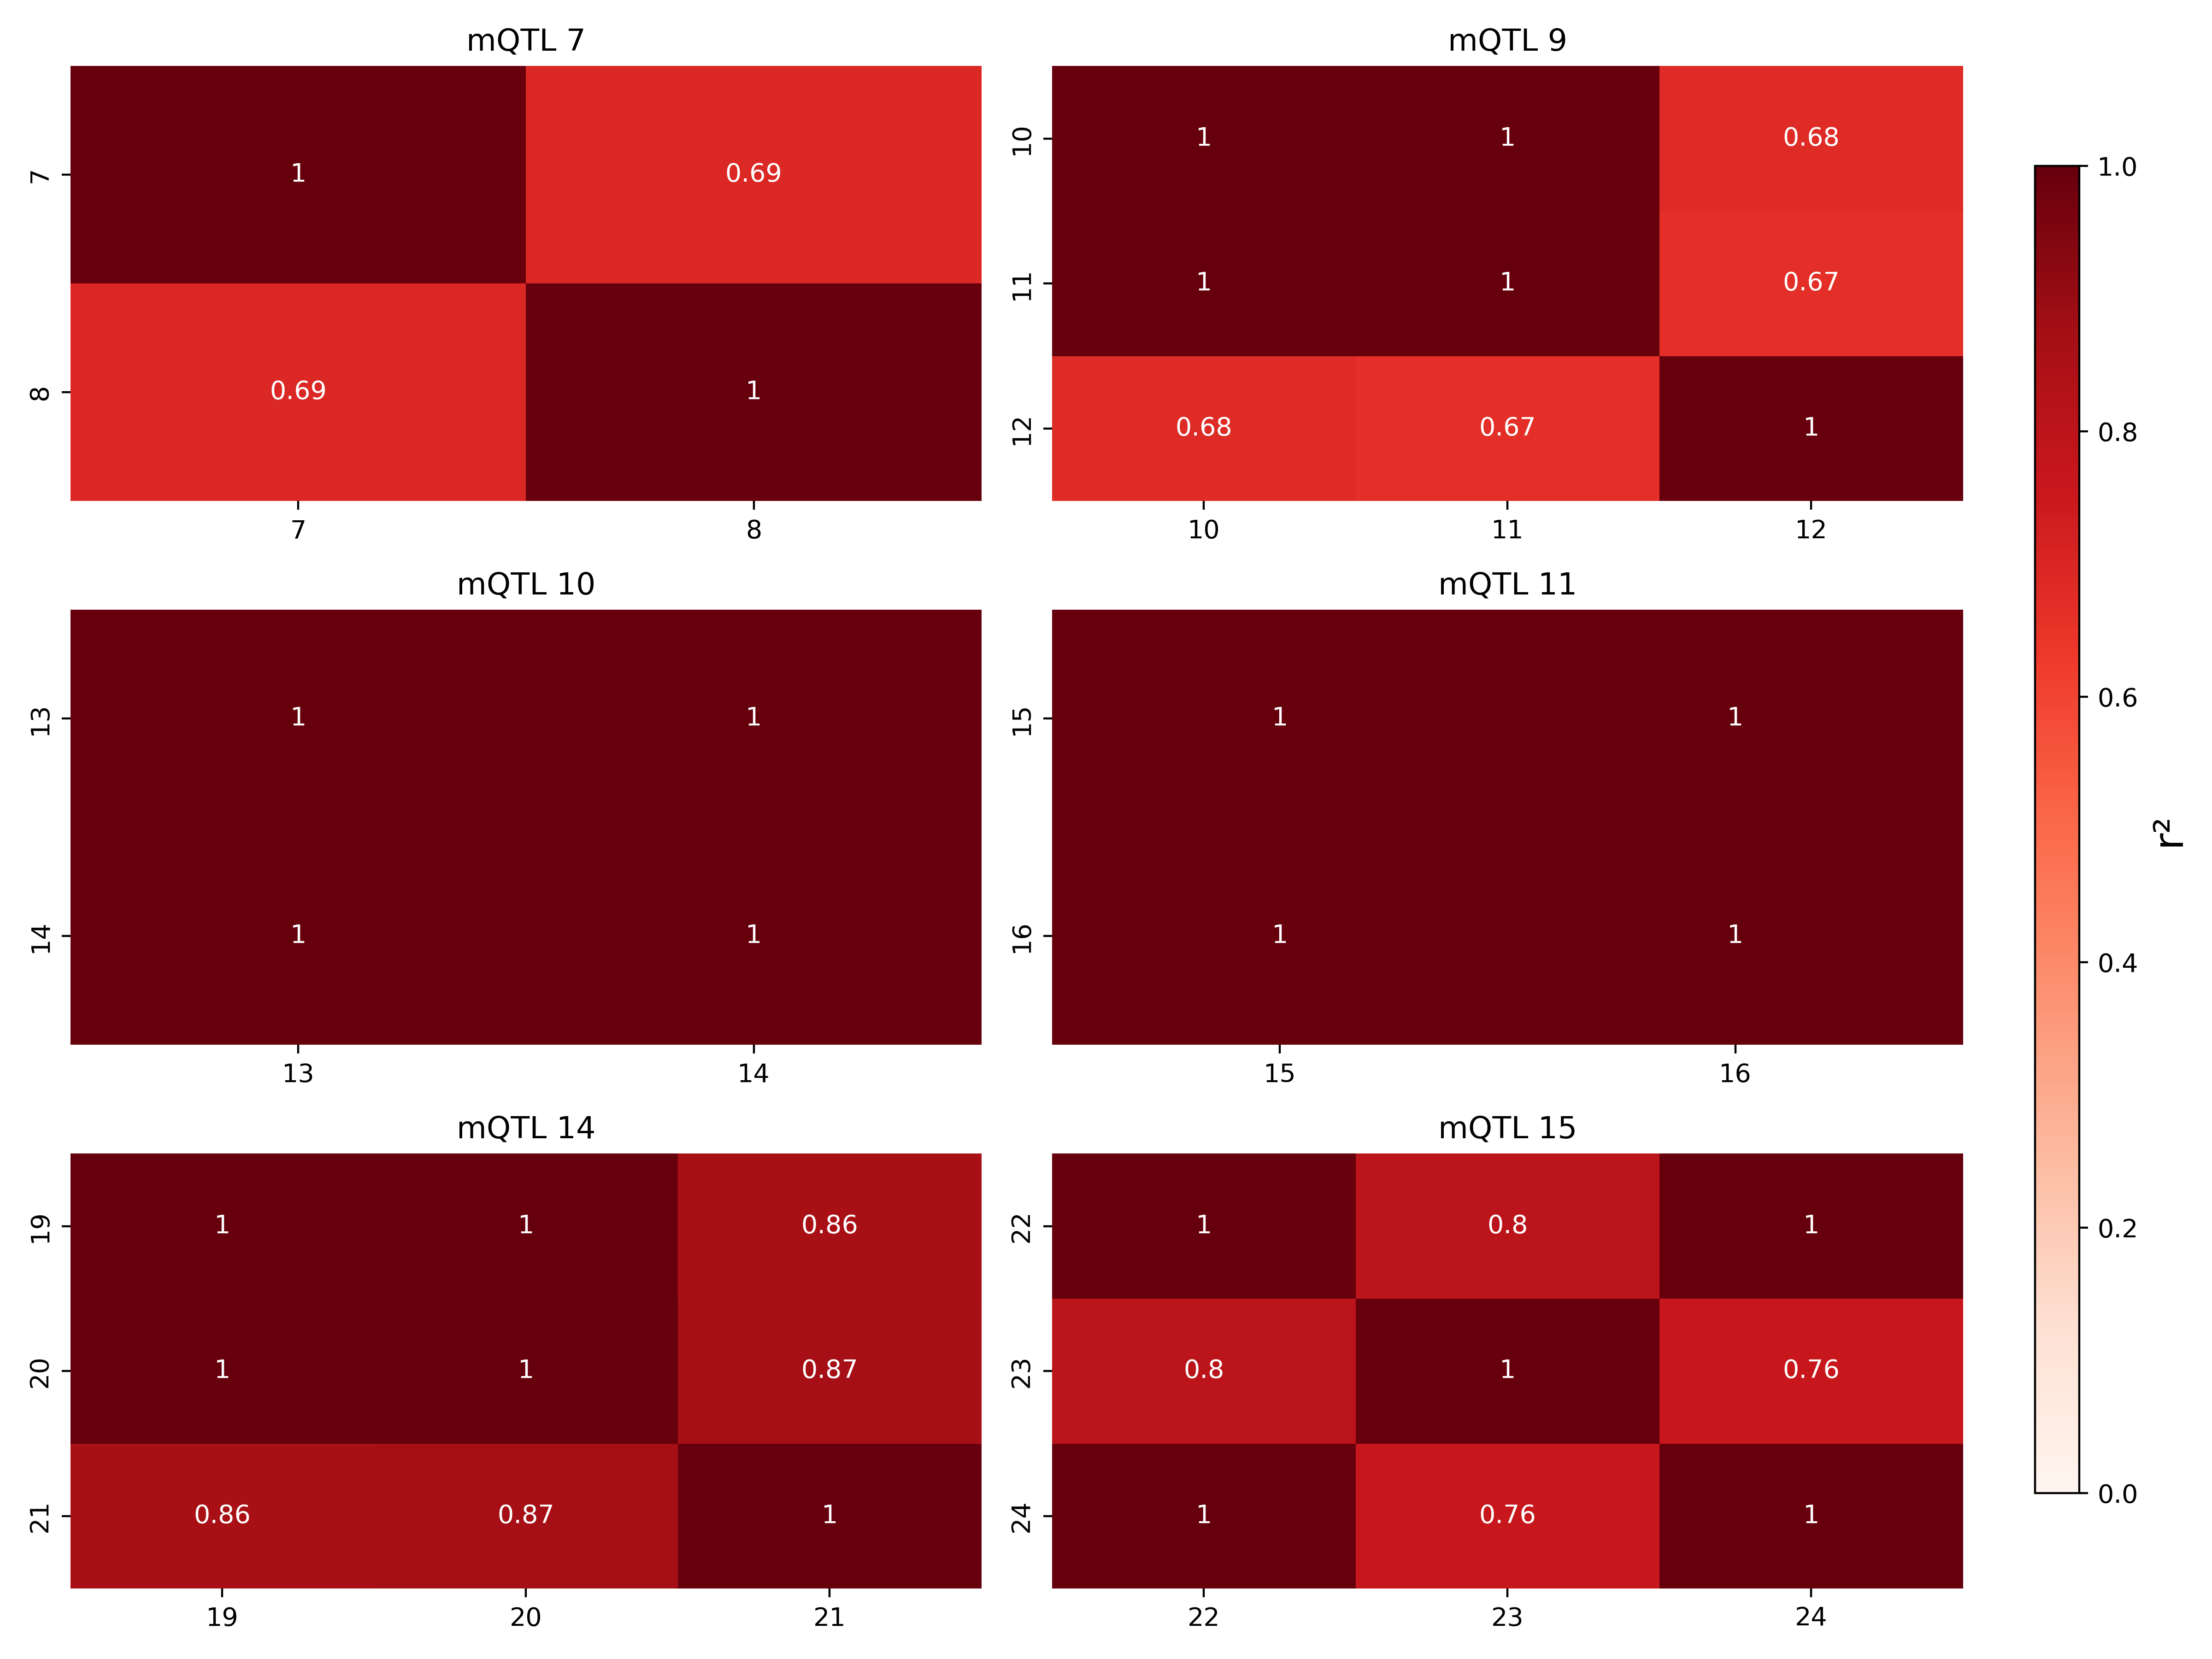
Figure S2 – Correlation between traits within same super-QTL. Tick numbers indicate metabolite number (see Table S1).

