Estimating cumulative pathway effects on risk for

age-related macular degeneration using mixed linear models

Jacob B Hall, Jessica N Cooke Bailey, Joshua D Hoffman, Margaret A Pericak-Vance, William K Scott, Jaclyn L Kovach, Stephen G Schwartz, Anita Agarwal,
Milam A Brantley, Jr., Jonathan L Haines, William S Bush

Table of Contents Page No.

Figures

Figure S1. Genetic ancestry from principal component analysis. 2
Figure S2. Histogram of age, by case status. 3
Figure S3. Details of subsets of gene regions analyzed. 4
Figure S4. Number of overlapping SNPs between pathway pairs. 5
Figure S5. P-value for overlapping SNPs between pathway pairs. 6
Figure S6. Effect of smoking adjustment on pathway risk explained. 7
Figure S7. Risk explained from each pathway by AMD subtype. 7

Tables

Table S1. Weighted-by-age, expected population prevalence calculation. 8
Table S2. 19 known risk SNPs and nearby gene information. 9
Table S3. Risk explained excluding known risk SNPs and SNP in LD. 10
Table S4. SNP counts, PRE, and p-values for partitioned regions. 10
Figure S1. Genetic ancestry from principal component analysis.

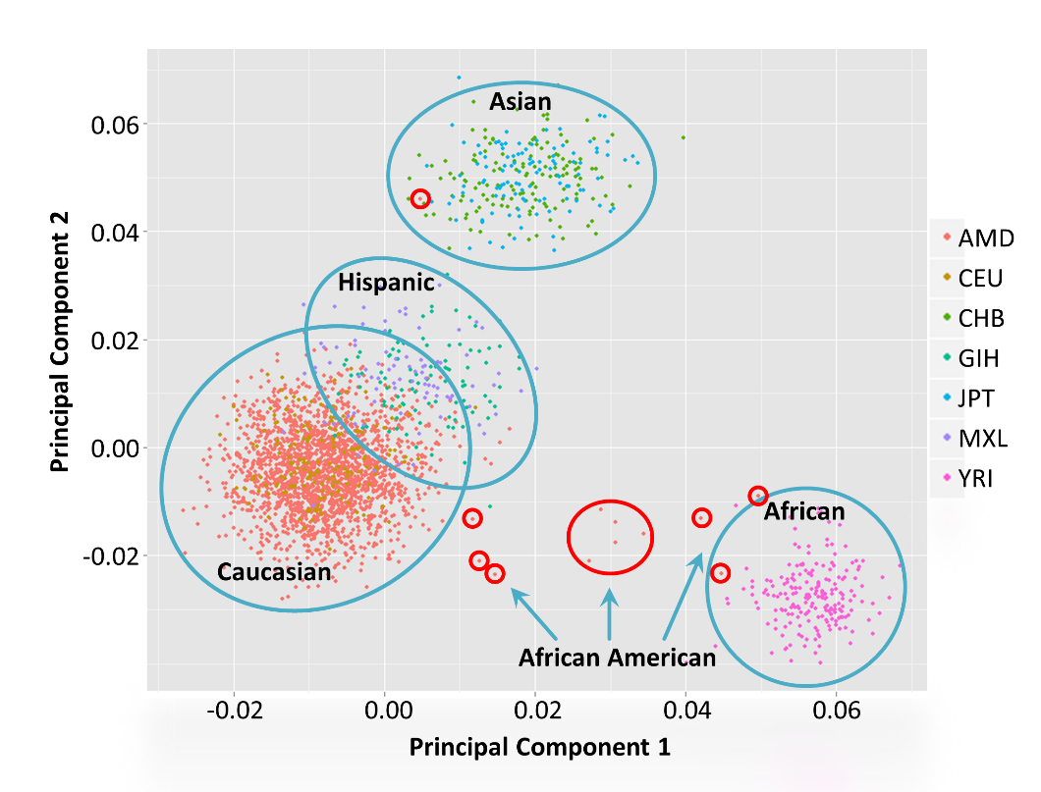

1,983 AMD dataset individuals (pre-QC)
805 HapMap individuals
- 165 CEU - Utah residents with Northern and Western European ancestry
- 137 CHB - Han Chinese in Beijing China
- 101 GIH - Gujarati Indians in Houston, Texas
- 113 JPT - Japanese in Tokyo, Japan
- 86 MXL - Mexican ancestry in Los Angeles, California
- 203 YRI - Yoruba in Ibadan, Nigeria

To calculate principal components, we used 71 ancestry-informative markers (AIMs) that were present in both HapMap and AMD individuals. 1 Asian-descent and 11 African American individuals were excluded from analysis (circled in red).

Reference SNP (rs) numbers for 71 AIMs:
rs3845596, rs2007350, rs1229133, rs1409778, rs2291409, rs6426327, rs520354, rs1868092, rs975612, rs972881, rs1521527, rs1435850, rs1320131, rs737516, rs1996818, rs1479371, rs1461131, rs1147696, rs2686085, rs225160, rs999634, rs736201, rs173686, rs1807912, rs1560550, rs31251, rs2296412, rs169125, rs942150, rs839556, rs369643, rs1080085, rs3294, rs901170, rs4107736, rs1440369, rs1868280, rs4246828, rs6474795, rs2151065, rs878400, rs7860423, rs11813505, rs722317, rs540819, rs236919, rs1630675, rs916041, rs1548837, rs903770, rs310935, rs1372177, rs981270, rs4904574, rs2873, rs1648282, rs1030588, rs936013, rs461785, rs168206, rs2164062, rs1019977, rs1426311, rs959419, rs1981431, rs186659, rs354731, rs816943, rs2837956, rs756658, rs739096
Figure S2. Histogram of age, by case status.

Age in years recorded at time of examination. Histogram for 668 controls and 1,145 cases. Individuals with no smoking status not excluded.

Figure S3. Details of subsets of gene regions analyzed.

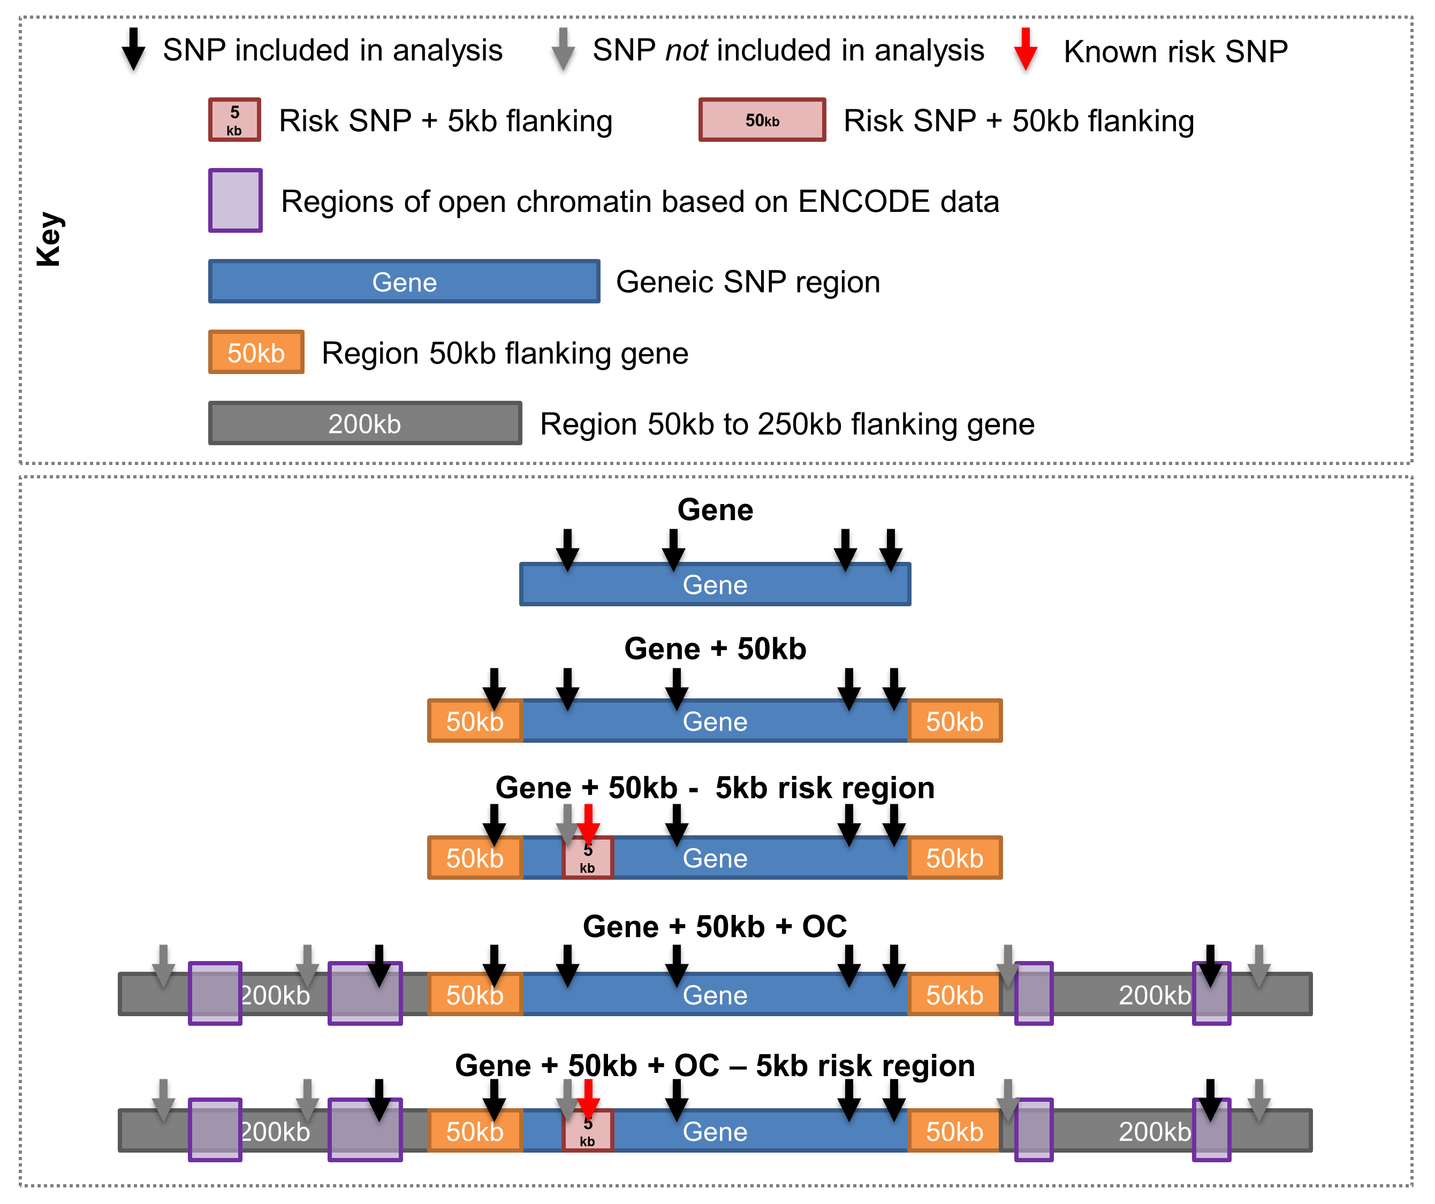
Open chromatin regions determined using narrow peak windows from ENCODE DNaseI hypersensitivity analyses in human RPE cells.
Figure S4. Number of overlapping SNPs between pathway pairs.
 | Angiogenesis | Antioxidant | Apoptosis | Complement | Inflammatory | Nicotine | OxPhos
Antioxidant | 30
Apoptosis | 6,542 | 583
Complement | 316 | - | 349
Inflammatory | 2,835 | 342 | 6,465 | 955
Nicotine | 148 | 11 | 538 | - | 281
OxPhos | 116 | 16 | 513 | - | 118 | -
TCA | 33 | - | 44 | - | 44 | - | 47
Pathway pairs with little or no overlapping SNPs shown as green, fading to red for pathway pairs with the most overlapping SNPs.

Figure S5. P-value for overlapping SNPs between pathway pairs.
 | Angiogenesis | Antioxidant | Apoptosis | Complement | Inflammatory | Nicotine | OxPhos
Antioxidant | 0.5
Apoptosis | 0.5 | 0.239
Complement | 0.019 | - | 0.5
Inflammatory | 0.5 | 0.049 | 0.294 | 1.11⁻²⁵
Nicotine | 0.130 | 0.127 | 0.491 | - | 0.380
OxPhos | 0.116 | 0.5 | 0.5 | - | 0.5 | -
TCA | 0.5 | - | 0.5 | - | 0.5 | - | 0.221
Pathway pairs with overlapping SNPs contributing to smaller p-values shown as red, fading to green for pathway pairs with overlapping SNPs resulting large, non-significant p-values. Three pathway pairs shown have significant (< 0.05) p-values.

Figure S6. Effect of smoking adjustment on pathway risk explained.

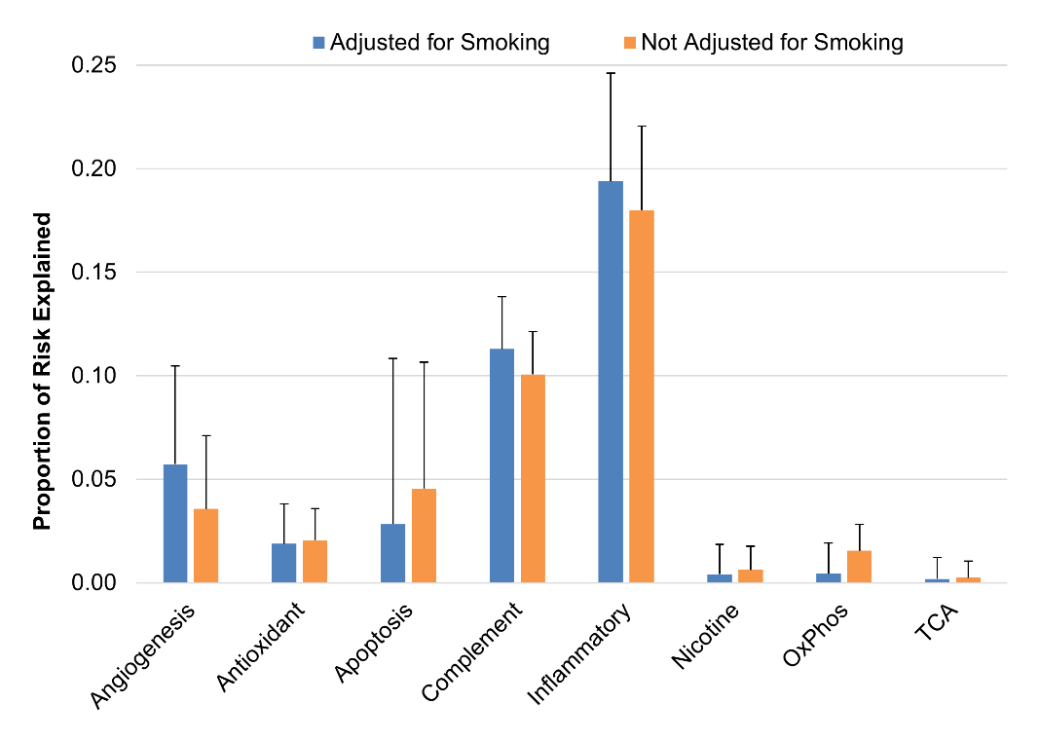
Gene plus 5kb flanking, minus risk plus 5kb flanking regions excluded.

Figure S7. Risk explained from the angiogenesis pathway by AMD subtype.

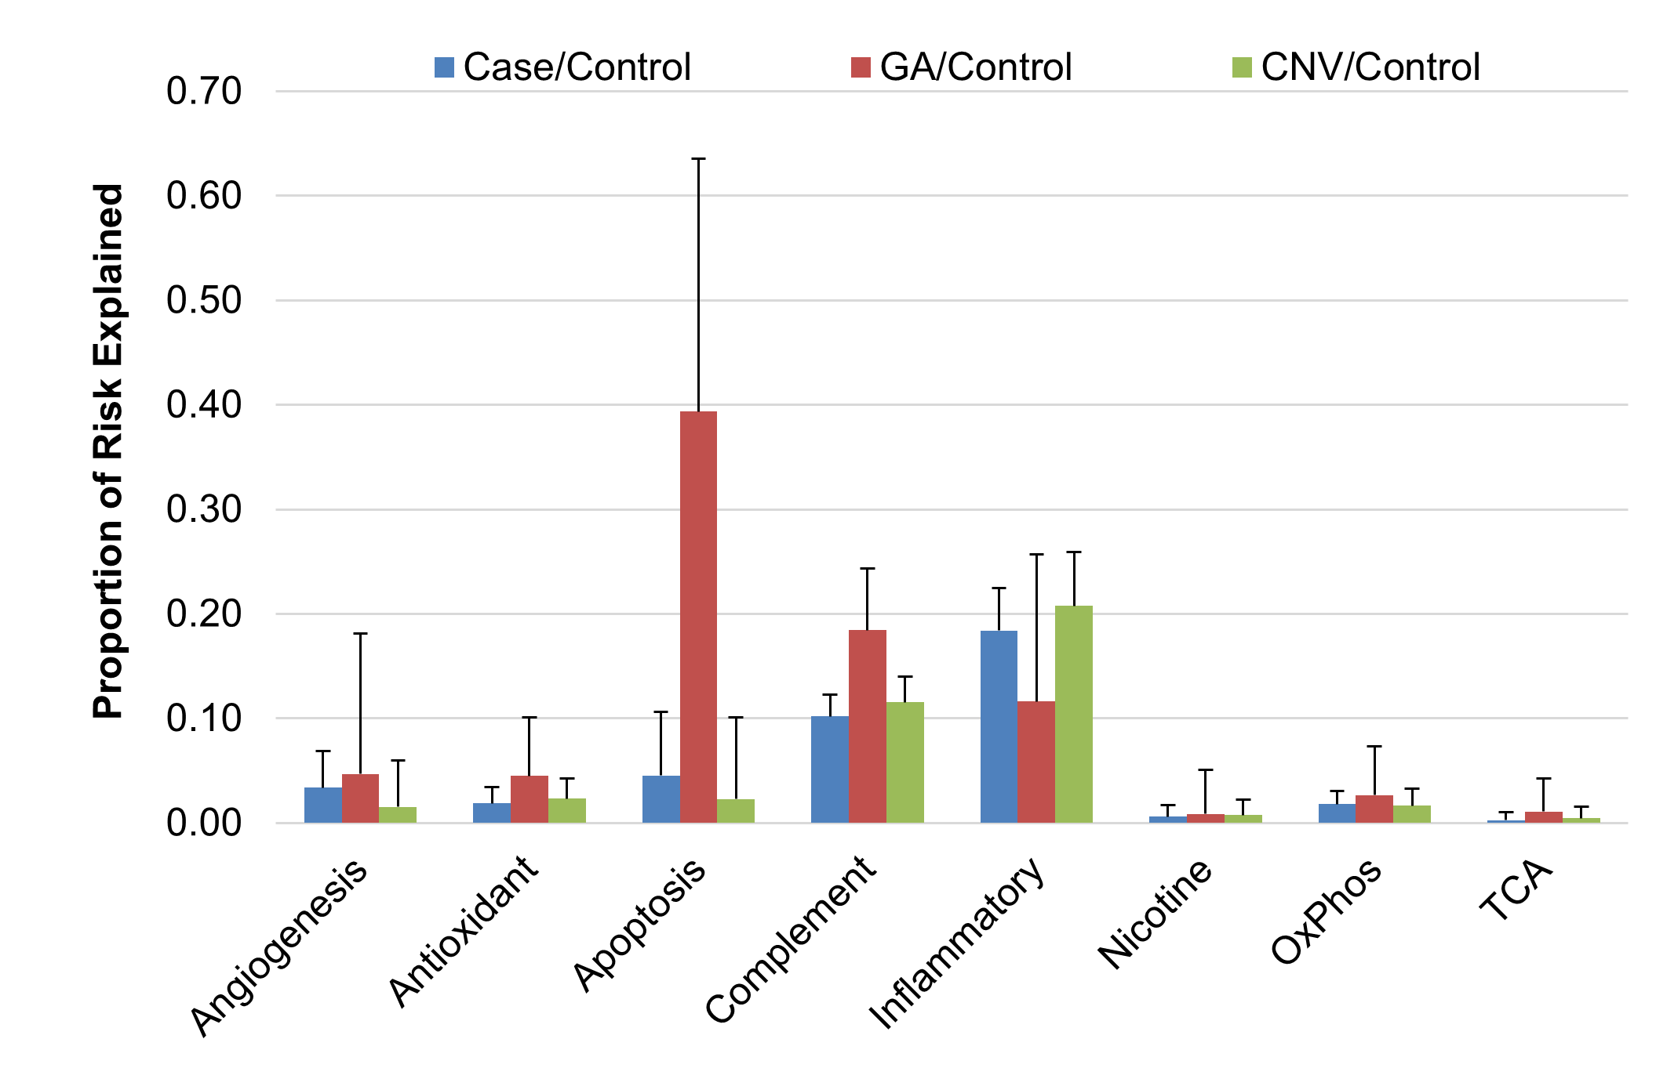
Genic SNPs plus 50kb plus open chromatin SNPs included in analyses. Standard error is very large for GA versus controls because of the low sample size of cases with GA in our dataset.
Table S1. Weighted-by-age, expected population prevalence calculation.
Age Range | U.S. Prev. | Count | Count × Prev.
40-49 | 0.05 | 4 | 0.2
50-54 | 0.34 | 3 | 1.0
55-59 | 0.39 | 62 | 24.2
60-64 | 0.56 | 140 | 78.4
65-69 | 0.91 | 262 | 238.4
70-74 | 1.66 | 352 | 584.3
75-49 | 3.24 | 398 | 1289.5
80+ | 11.77 | 592 | 6967.8
Total |  | 1813 | 9183.9
United States prevalence rates (percent of population for given age range) from Friedman et al. 2011 - PMID: 15078675.
[9183.9 / 1813] = 5.07% weighted, expected AMD prevalence rate
Table S2. 19 known risk SNPs and nearby gene information.
RS Number | Chromosome | Position | Nearby Genes | Distance to index SNP (kb) | Location
rs10490924 | 10 | 124214448 | ARMS2 | 0 | Coding
rs10490924 | 10 | 124214448 | HTRA1 | 6.6 | Upstream
rs10737680 | 1 | 194946078 | CFH | 0 | Intronic
rs429608 | 6 | 32038441 | C2 | 17 | Downstream
rs429608 | 6 | 32038441 | CFB | 10.6 | Downstream
rs429608 | 6 | 32038441 | SKIV2L | 0 | Intronic
rs2230199 | 19 | 6718387 | C3 | 0 | Coding
rs5749482 | 22 | 31389665 | TIMP3 | 137.1 | Upstream
rs5749482 | 22 | 31389665 | SYN3 | 0 | Intronic
rs4420638 | 19 | 45422946 | APOE | 10.3 | Downstream
rs4420638 | 19 | 45422946 | APOC1 | 5 | Downstream
rs1864163 | 16 | 55554734 | CETP | 0 | Intronic
rs943080 | 6 | 43934605 | VEGFA | 72.4 | Downstream
rs13278062 | 8 | 23082971 | TNFRSF10A | 0.3 | Upstream
rs920915 | 15 | 58688467 | LIPC | 35.7 | Upstream
rs4698775 | 4 | 110590479 | CFI | 71.4 | Downstream
rs4698775 | 4 | 110590479 | CCDC109B | 0 | Intronic
rs3812111 | 6 | 116443735 | COL10A1 | 0 | Intronic
rs13081855 | 3 | 99481539 | COL8A1 | 0 | Intronic
rs3130783 | 6 | 30774357 | IER3 | 62 | Upstream
rs3130783 | 6 | 30774357 | DDR1 | 77.5 | Upstream
rs8135665 | 22 | 38476276 | SLC16A8 | 0 | Intronic
rs334353 | 9 | 100948186 | TGFBR1 | 0 | Intronic
rs8017304 | 14 | 68785077 | RAD51B | 0 | Intronic
rs6795735 | 3 | 64705365 | ADAMTS9 | 32 | Upstream
rs6795735 | 3 | 64705365 | ADAMTS9-AS2 | 0 | Intronic
rs6795735 | 3 | 64705365 | MIR548A2 | 0.3 | Upstream
rs9542236 | 13 | 30717325 | B3GALTL | 0 | Intronic
Adapted from Fritsche 2013 (doi:10.1038/ng.2578).

Table S3. Risk explained excluding known risk SNPs and SNP in LD.
Exclusion Criteria | Number of SNPs Excluded | PVE (%) | SE (%) | p-val.
None | 0 | 36.72 | 16.13 | 0.0042
R² ≥ 10% | 1,183 | 35.25 | 14.75 | 0.0063
R² ≥ 5% | 1,684 | 35.19 | 14.75 | 0.0064
R² ≥ 1% | 1,925 | 35.12 | 14.75 | 0.0064
1MB flanking | 9,938 | 31.33 | 14.70 | 0.0145
19 known risk SNPs: PVE ~13.3%, SE ~3.92%, p-val. < 1.35×10⁻⁶¹ for all
Remainder SNPs with none excluded: 659,162
PVE, SE, and p-values shown for non-known risk SNPs, excluding specified SNPs
R²: 0 = linkage equilibrium ; 1 = perfect linkage disequilibrium

Table S4. SNP counts, proportion of risk explained, and p-values for partitioned regions.
 | GO Term Pathway | G | G+50 | G+50+OC | G+50+OC  minus R+5
Number of SNP | Angiogenesis | 8,853 | 16,907 | 17,465 | 17,455
Number of SNP | Antioxidant Activity | 616 | 2,014 | 2,115 | 2,114
Number of SNP | Apoptotic Signaling | 26,682 | 54,417 | 56,136 | 56,130
Number of SNP | Complement Activation | 478 | 1,343 | 1,374 | 1,370
Number of SNP | Inflammatory Response | 5,883 | 15,993 | 16,635 | 16,630
Number of SNP | Response to Nicotine | 426 | 1,101 | 1,150 | 1,150
Number of SNP | Oxidative Phosphorylation | 350 | 1,451 | 1,548 | 1,548
Number of SNP | Tricarboxylic Acid Cycle | 342 | 981 | 1,019 | 1,019
Proportion of Risk Explained | Angiogenesis | 0.0427 | 0.0356 | 0.0337 | 0.0309
Proportion of Risk Explained | Antioxidant Activity | 0.0059 | 0.0205 | 0.0189 | 0.0178
Proportion of Risk Explained | Apoptotic Signaling | 0.0405 | 0.0454 | 0.0454 | 0.0438
Proportion of Risk Explained | Complement Activation | 0.0715 | 0.1006 | 0.1020 | 0.0976
Proportion of Risk Explained | Inflammatory Response | 0.1346 | 0.1799 | 0.1839 | 0.1786
Proportion of Risk Explained | Response to Nicotine | 0.0020 | 0.0063 | 0.0060 | 0.0060
Proportion of Risk Explained | Oxidative Phosphorylation | 0.0093 | 0.0154 | 0.0179 | 0.0179
Proportion of Risk Explained | Tricarboxylic Acid Cycle | 0.0057 | 0.0024 | 0.0026 | 0.0026
P-value | Angiogenesis | 0.0797 | 0.3017 | 0.3592 | 0.4410
P-value | Antioxidant Activity | 0.5000 | 0.1081 | 0.1439 | 0.1631
P-value | Apoptotic Signaling | 0.2828 | 0.5000 | 0.5000 | 0.5000
P-value | Complement Activation | 1.2E-28 | 7.1E-27 | 6.3E-27 | 6.8E-26
P-value | Inflammatory Response | 6.3E-11 | 3.1E-08 | 4.4E-08 | 9.5E-08
P-value | Response to Nicotine | 0.5000 | 0.5000 | 0.5000 | 0.5000
P-value | Oxidative Phosphorylation | 0.2232 | 0.1103 | 0.0802 | 0.0804
P-value | Tricarboxylic Acid Cycle | 0.4602 | 0.5000 | 0.5000 | 0.5000
G=Gene; 50=50kb flanking gene; OC=SNPs in open chromatin 50kb to 250kb flanking; R+5=Risk SNPs plus 5kb flanking

