Supplementary Material for the manuscript “A comparative evaluation of data-merging and meta-analysis methods for reconstructing gene-gene interactions”

Studies included in the E. Coli, Yeast and PBMC compendia

Table S 1: characteristics of the studies included in the Escherichia Coli dataset collection. Each study can be retrieved in the Gene Expression Omnibus (GEO) through its reference. For each dataset the total number of samples is reported, as well as the number of samples included in our comparison and a short description of the data.
GEO reference | Number of Samples | Number of relevant sample | Notes
GSE4778 | 20 | 20 | Aerobically Grown Escherichia coli K-12
GSE6425 | 44 | 44 | Time courses of E. coli MG1655 and UTI89 in vitro
GSE6836 | 266 | 266 | Compendium of Expression Profiles
GSE7326 | 24 | 24 | Cell death programmed by a restriction-modification system in E. coli
GSE7398 | 24 | 8 | four phases of growth in Fis KO and WT (Fis+) strains
GSE10158 | 43 | 43 | cefsulodin and mecillinam, alone and in combination
GSE11183 | 26 | 26 | Identification of HU regulon
GSE12411 | 28 | 28 | Time course data induced with differential amounts of IPTG
GSE17505 | 30 | 30 | High-Cell-Density Recombinant and Wild-Type E. coli
GSE21869 | 33 | 33 | Evolved clones isolated at various stages during adaptive experimental evolution
GSE33147 | 96 | 96 | Laboratory evolution on lactate or glycerol

Table S 2: characteristics of the studies included in the Yeast dataset collection. Each study can be retrieved in the Gene Expression Omnibus (GEO) through its reference. For each dataset the total number of samples is reported, as well as the number of samples included in our comparison and a short description of the data.
GEO reference | Number of Samples | Number of relevant sample | Notes
GSE1311 | 21 | 21 | Yeast desiccation / rehydration time course
GSE1312 | 21 | 21 | Yeast desiccation / rehydration time course
GSE1313 | 24 | 24 | Yeast desiccation / rehydration time course
GSE3076 | 96 | 96 | Budding Yeast
GSE15254 | 72 | 72 | yeast nitrogen assimilation
GSE18121 | 42 | 42 | Heat stress in different yeast strains
GSE25582 | 151 | 151 | Time course expression data

Table S 3: characteristics of the studies included in the Peripheral Blood Mononuclear Cell (PBMC) dataset collection. Each study can be retrieved in the Gene Expression Omnibus (GEO) through its reference. For each dataset the total number of samples is reported, as well as the number of samples included in our comparison and a short description of the data.
GEO reference | Number of Samples | Number of relevant sample | Notes
GSE46480 | 196 | 98 | Healthy individuals rapidly transported to high altitude
GSE27034 | 37 | 18 | Arterial Disease
GSE21942 | 29 | 15 | Multiple Sclerosis
GSE37567 | 102 | 7 | -
GSE17114 | 29 | 14 | Behçet’s disease.
GSE22224 | 46 | 9 | Kidney Recipients
GSE22255 | 40 | 20 | Ischemic Stroke

Supplementary results on the E. Coli and Yeast compendia

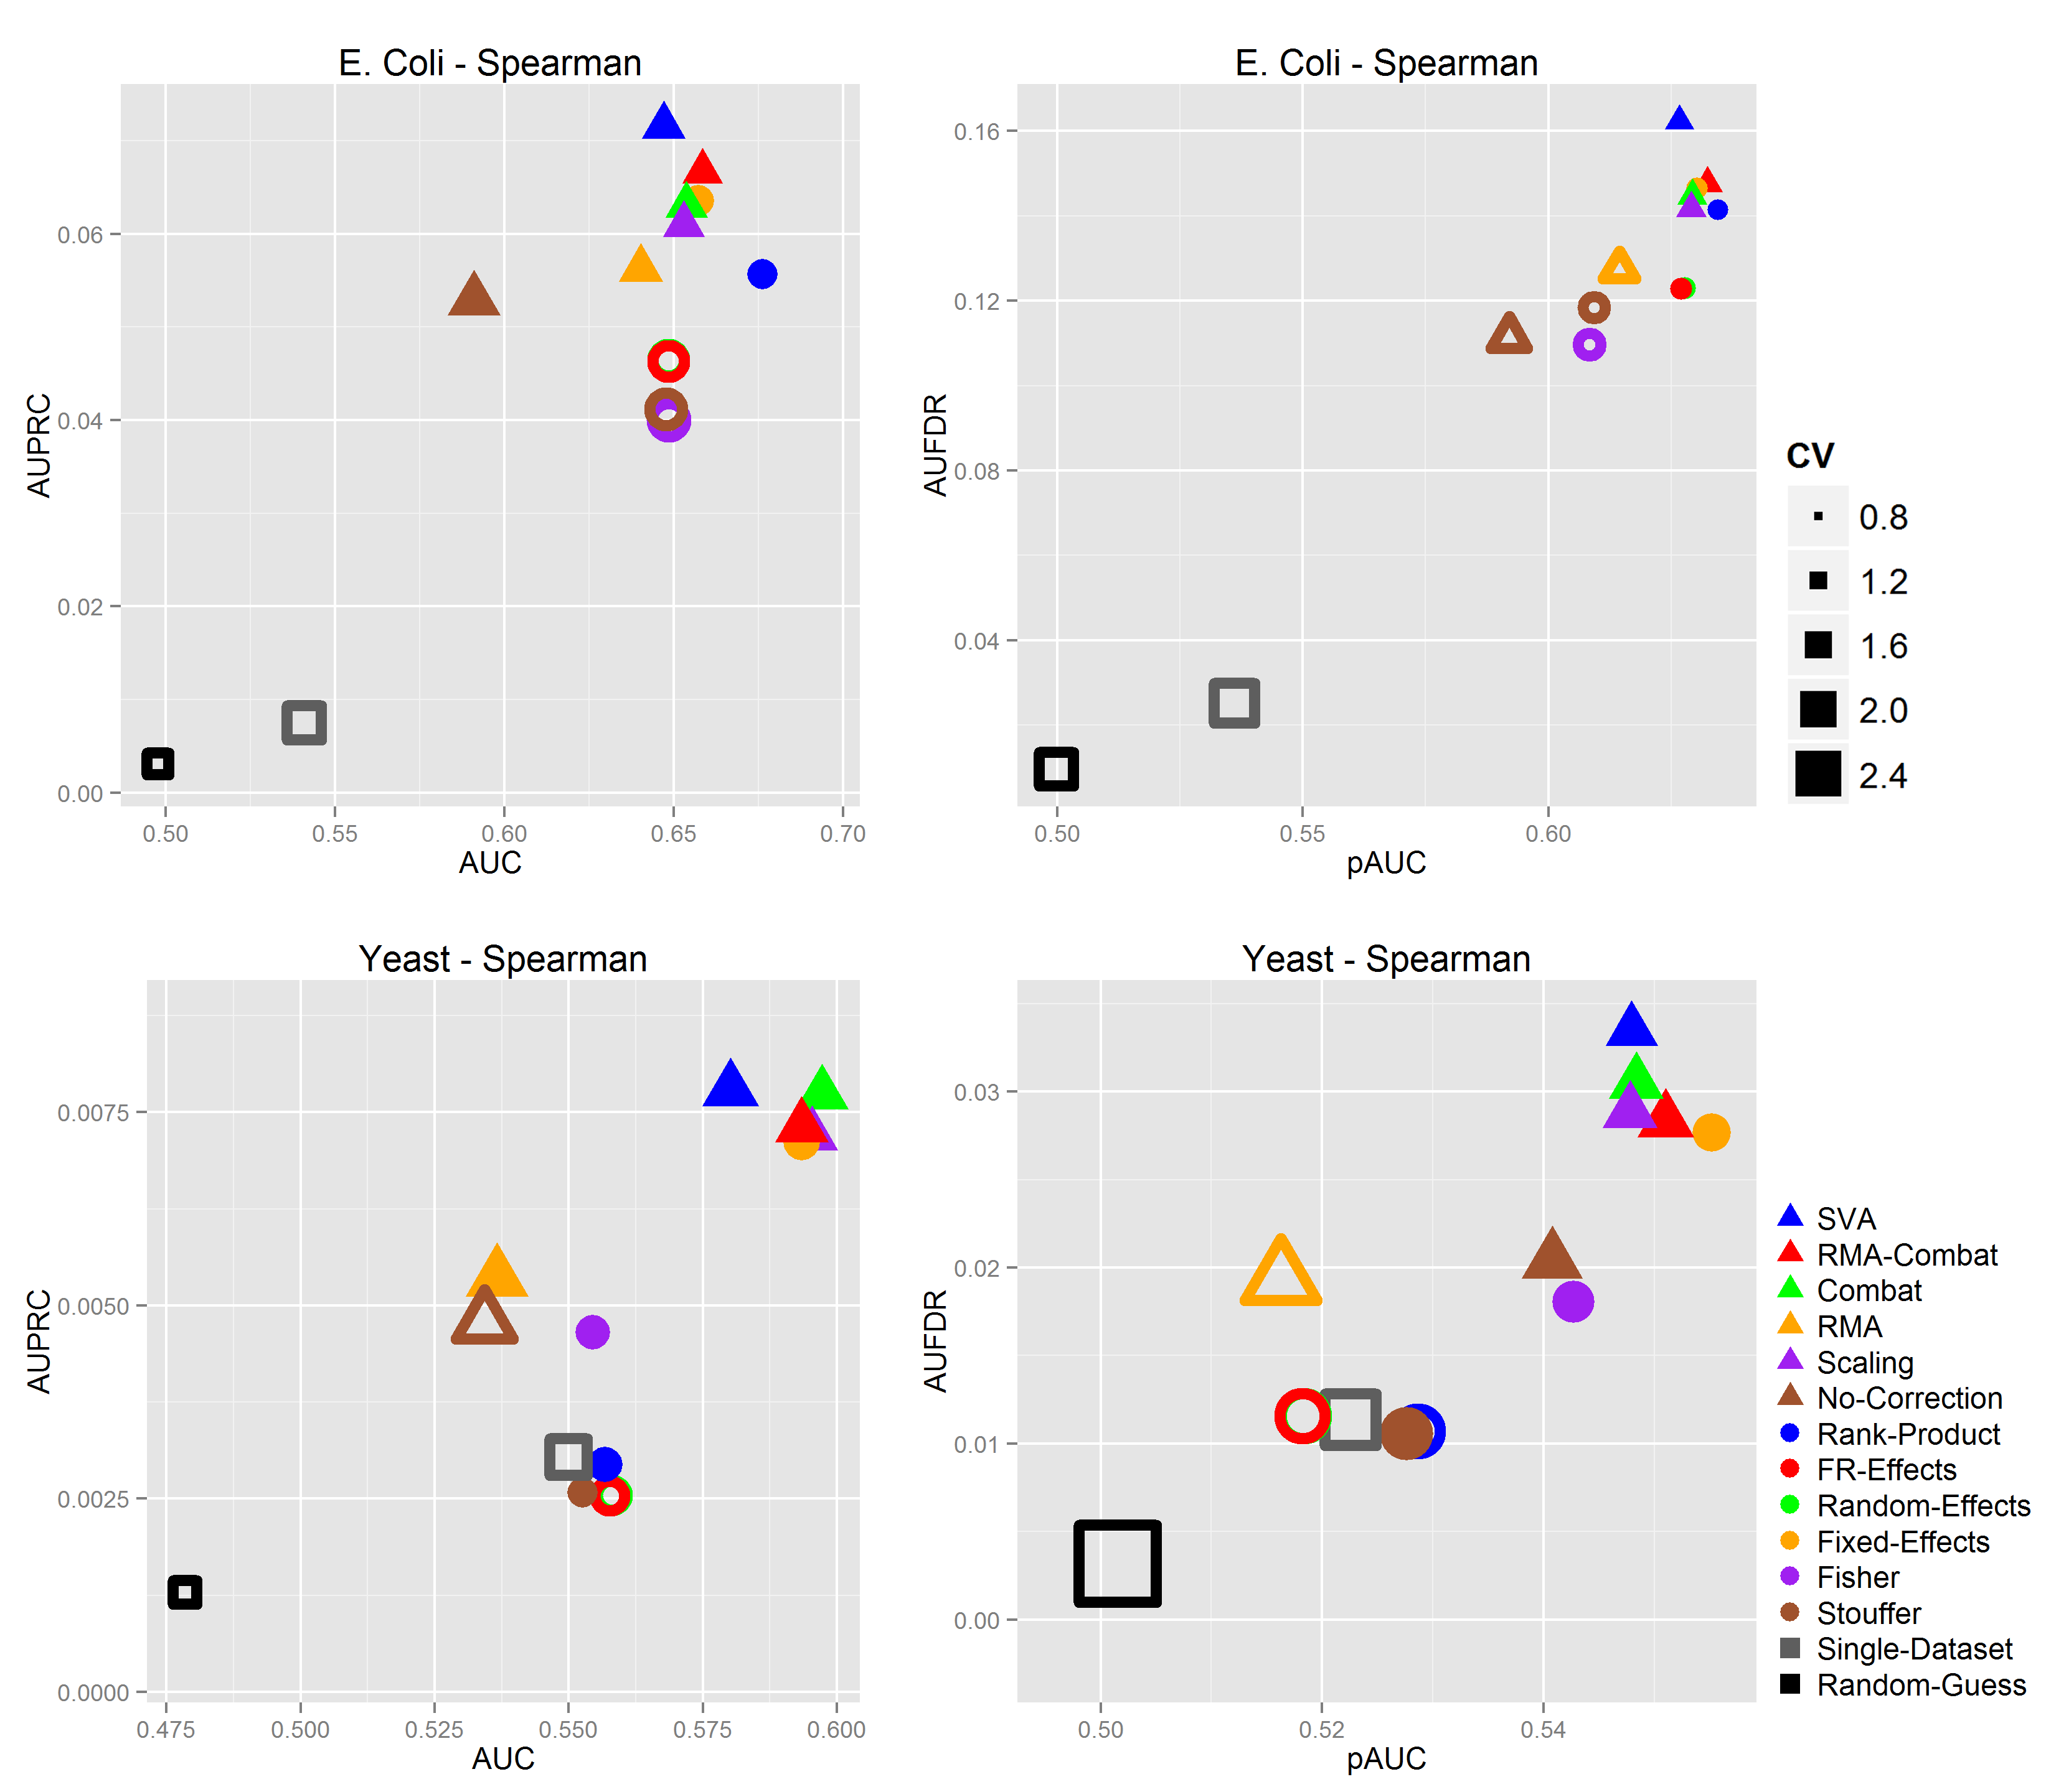
Figure S 1: results of the experimentations on E.Coli and Yeast compendia using the Spearman correlation. Panels on the left side report global performance metrics (x-axis: AUC, y-axis: AUPRC), while panels on the right report partial performance information (x-axis: pAUC, y-axis: AUFDR). Results in the top row are computed on the E. Coli dataset compendium, while results on the Yeast dataset collection are reported in the other two panels. MA, DM and baseline methods are indicated with square, triangular and circular markers, respectively. Non-filled markers indicate methods that are statistically significantly different with respect to the best performing ones in both metrics (p-value < 0.05, one-tail paired t-test).

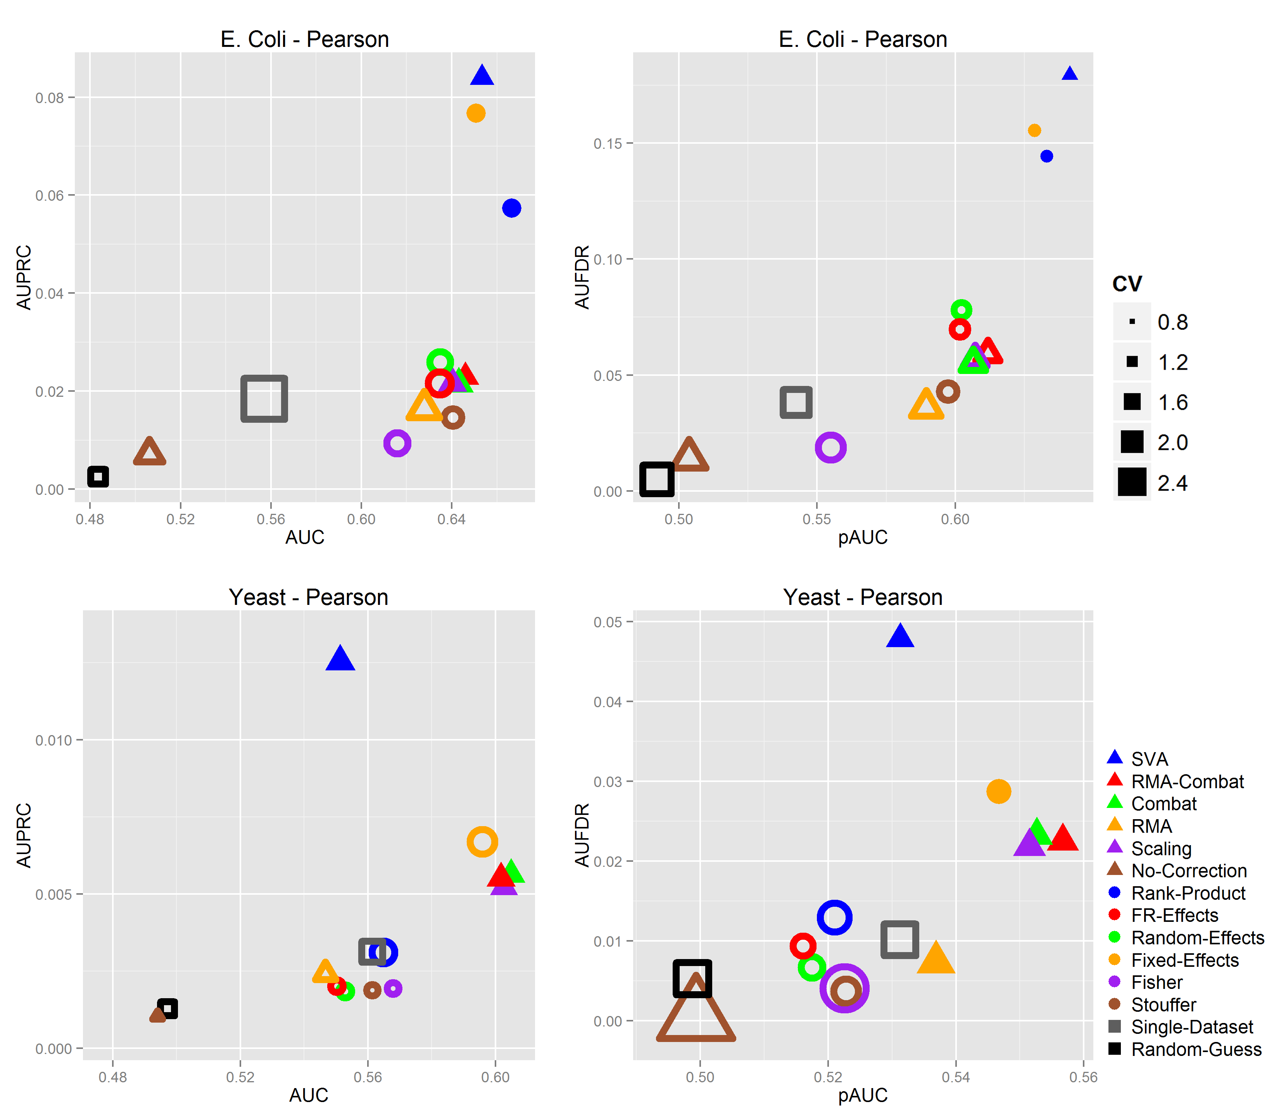
Figure S 2: results of the experimentations on E.Coli and Yeast compendia using the Pearson correlation p-values. Details as in Figure S 1. Methods generally achieve lower performances when p-values are used instead of correlations for ranking candidate gene-gene interactions. This is mainly due to the prevalence of close-to-zero p-values that create ties negatively affecting the performance metrics.

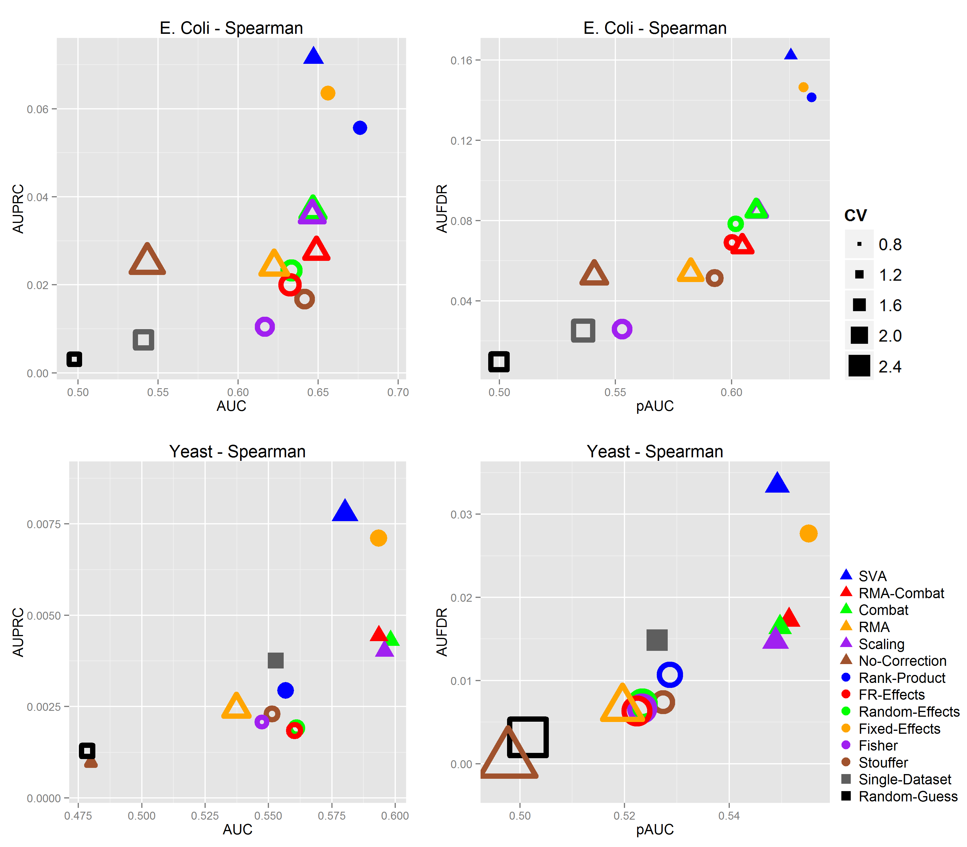
Figure S 3: results of the experimentations on E.Coli and Yeast compendia using the Spearman correlation p-values. Details as in Figure S 1. Methods generally achieve lower performances when p-values are used instead of correlations for ranking candidate gene-gene interactions. This is mainly due to the prevalence of close-to-zero p-values that create ties negatively affecting the performance metrics.

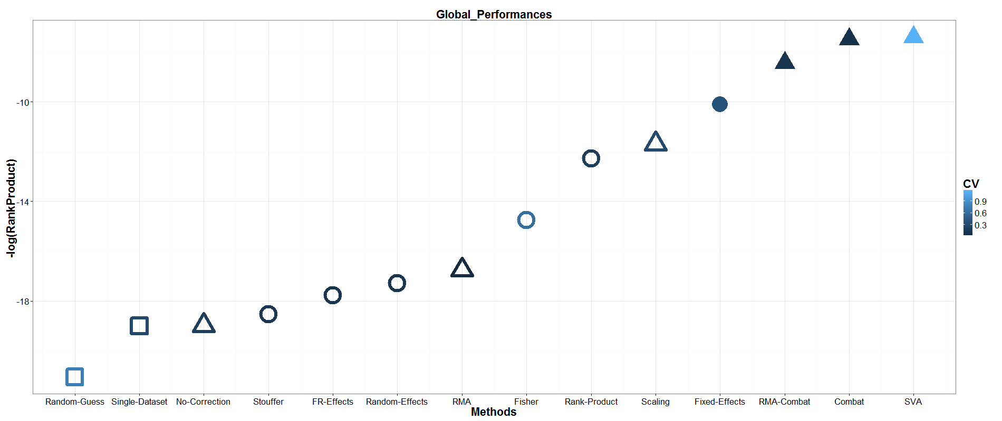
Figure S 4: rank-product analysis of MA and BER methods over AUC and AUPRC metrics (global metrics) Methods are ranked according to their performances, separately for each combination of data compendium (E. Coli and Yeast), correlation measure (Pearson and Spearman) and performance metric (AUC, AUPRC,), for a total of 8 different ranks. These ranks are then combined using the Rank-Product method, and the statistical significance of the ranks are evaluated with the method reported in [74]. The negative logarithm of the Rank-Product score is reported on the y-axis, while methods are listed on the x-axis. Triangular markers indicate BER methods, round markers MA methods, square markers baseline approaches. The color of each marker is directly proportional to the Coefficient of Variation (CV) of the respective log-transformed rank-product score (lighter color corresponds to higher variability). Methods that tend to be consistently ranked in the top positions are placed on the top-right of the plots, while poorly performing methods remain the in the bottom-left corner.

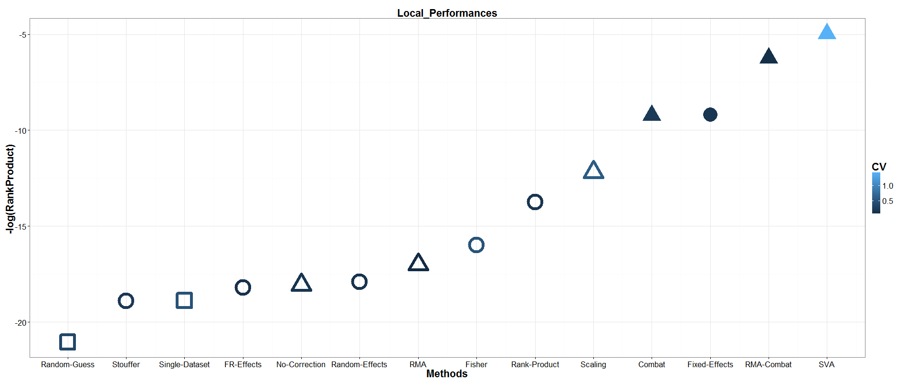
Figure S 5: rank-product analysis of MA and BER methods over pAUC and AUFDR metrics (local metrics). Details as reported in Figure S 3

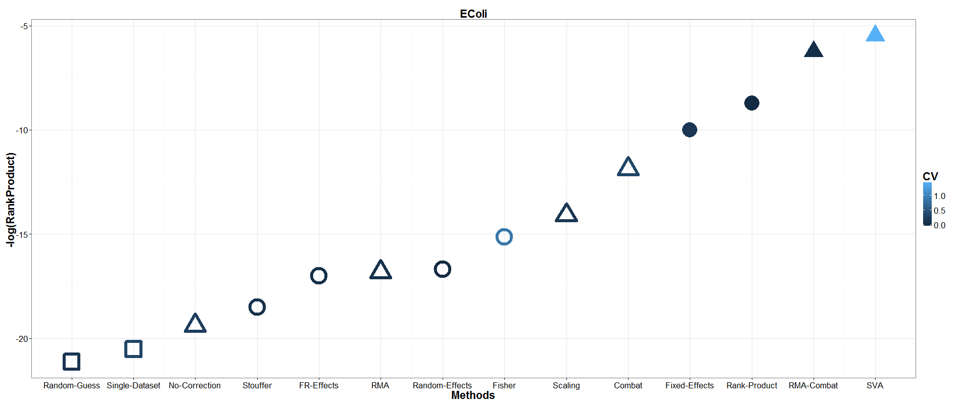
Figure S 6: rank-product analysis of MA and BER methods overall all metrics in the E. Coli compendium. Details as reported in Figure S 3

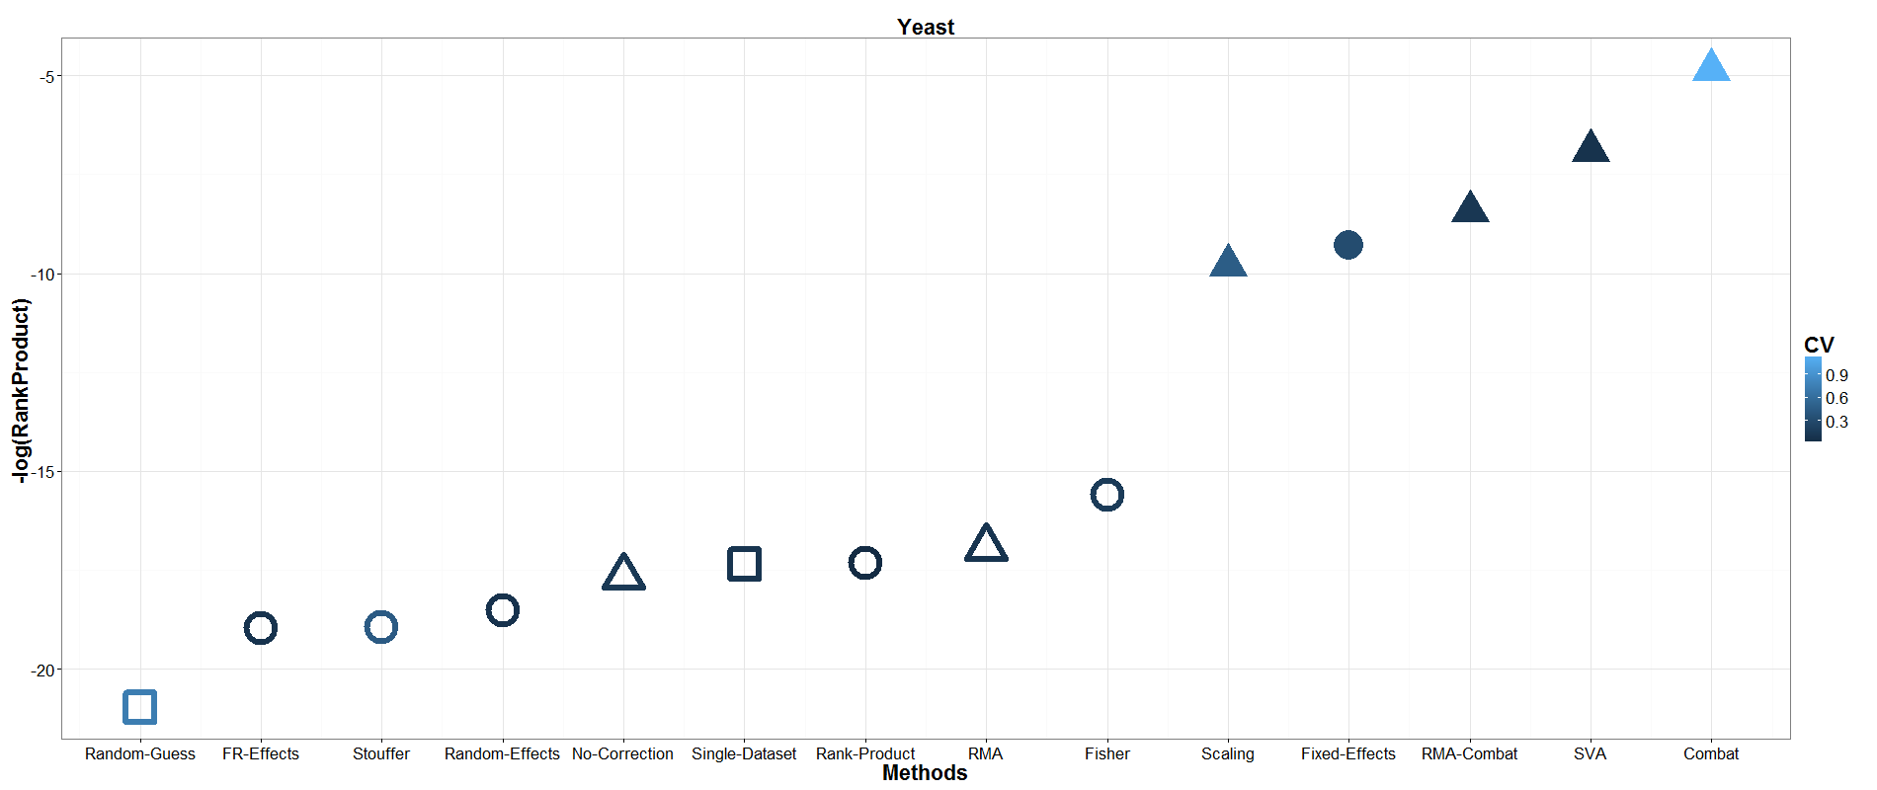
Figure S 7: rank-product analysis of MA and BER methods overall all metrics in the Yeast compendium. Details as reported in Figure S 3

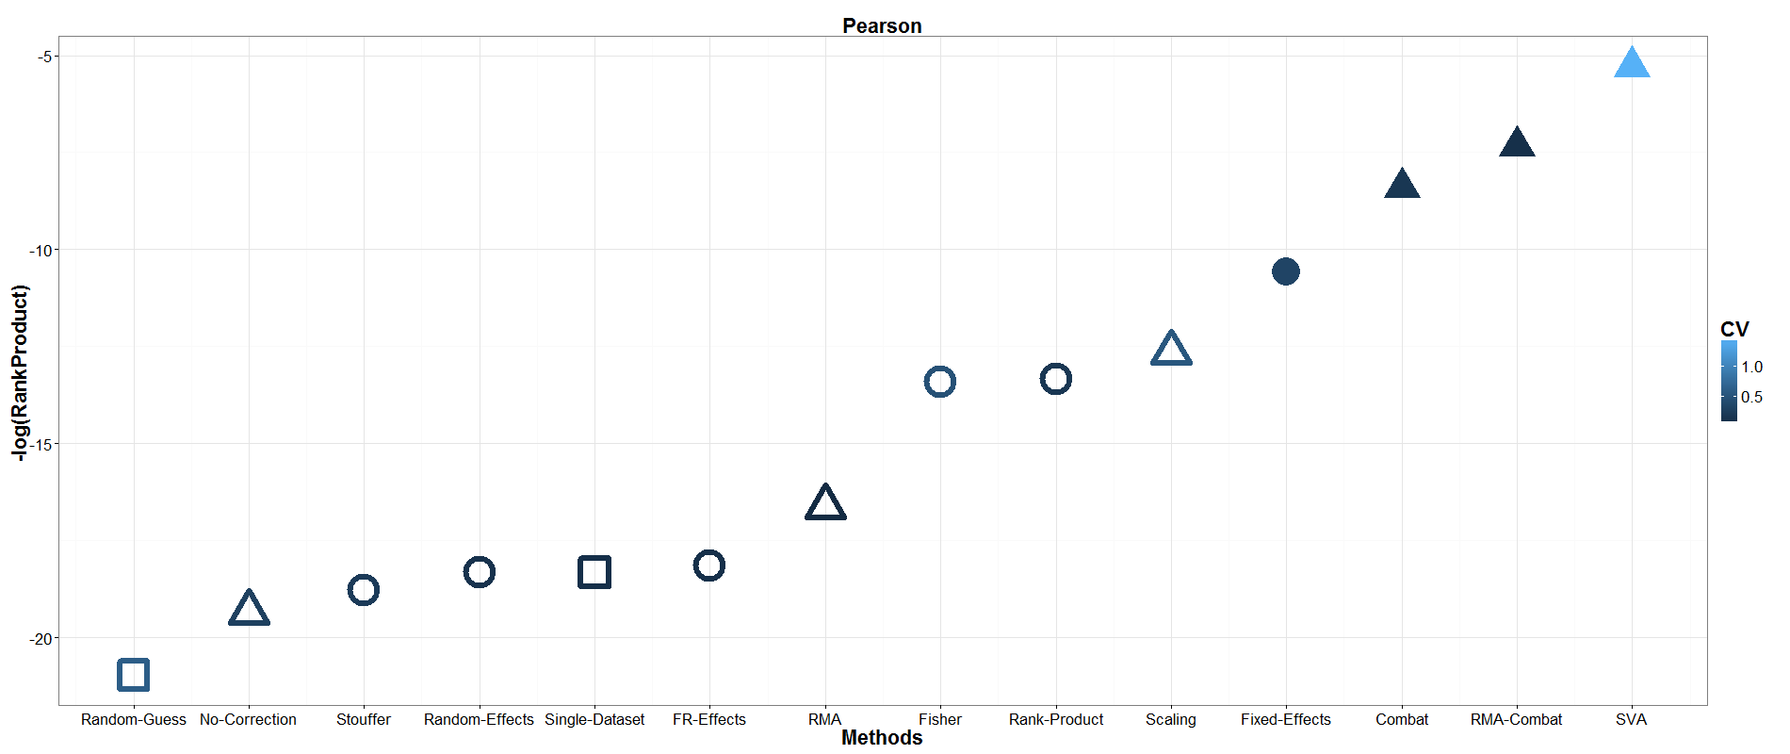
Figure S 8: rank-product analysis of MA and BER methods overall all metrics restricted only to the Pearson correlation measure. Details as reported in Figure S 3

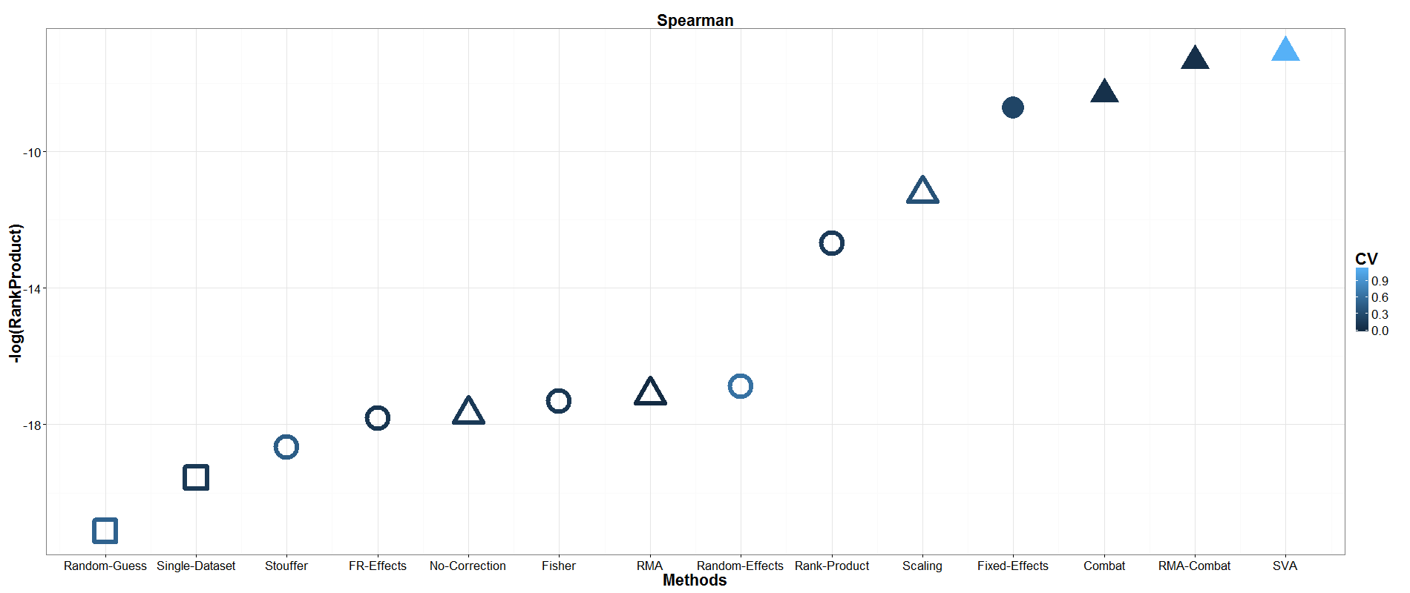
Figure S 9: rank-product analysis of MA and BER methods overall all metrics restricted only to the Spearman correlation measure. Details as reported in Figure S 3

Table S 4: details of the results on the E. Coli compendium. The table is subdivided in eight sub-tables delimited by black borders, one sub-table for each combination of the four metrics (AUC, pAUC, AUPRC and AUFDR) and correlation methods (Pearson and Spearman). Within each sub-table, methods are sorted according to their average performances. One-side, paired t-test p-values are reported as well, comparing each method with the first one and with the method immediately preceding. Performances are averaged over all transcript factors of the data compendium.
Method | Average Performance | Performance St. Dev. | p-value vs. best method | p-value vs. previous method | Metric | Correlation method
Rank-Product | 0.66633 | 0.19953 | 1 | 1 | AUC | Pearson
Fisher | 0.65519 | 0.20041 | 0.12755 | 0.12755 | AUC | Pearson
SVA | 0.6518 | 0.19173 | 0.21566 | 0.43364 | AUC | Pearson
RMA-Combat | 0.65105 | 0.21093 | 0.16634 | 0.48602 | AUC | Pearson
Fixed-Effects | 0.64922 | 0.21194 | 0.13611 | 0.21335 | AUC | Pearson
FR-Effects | 0.64865 | 0.19788 | 0.0885 | 0.48084 | AUC | Pearson
Combat | 0.64855 | 0.21543 | 0.1368 | 0.49684 | AUC | Pearson
Random-Effects | 0.64845 | 0.19779 | 0.08567 | 0.49681 | AUC | Pearson
Stouffer | 0.6478 | 0.20289 | 0.00169 | 0.48023 | AUC | Pearson
Scaling | 0.64746 | 0.21434 | 0.12057 | 0.49068 | AUC | Pearson
RMA | 0.63599 | 0.20616 | 0.04442 | 0.1789 | AUC | Pearson
No-Correction | 0.56086 | 0.2303 | 0 | 0.00003 | AUC | Pearson
Single-Dataset | 0.55706 | 0.17079 | 0 | 0.43783 | AUC | Pearson
Random-Guess | 0.48355 | 0.0955 | 0 | 0.00007 | AUC | Pearson
Rank-Product | 0.6742 | 0.19092 | 1 | 1 | AUC | Spearman
RMA-Combat | 0.65831 | 0.19725 | 0.125 | 0.125 | AUC | Spearman
Fixed-Effects | 0.65618 | 0.19864 | 0.09165 | 0.29956 | AUC | Spearman
Combat | 0.653 | 0.19956 | 0.06841 | 0.168 | AUC | Spearman
Scaling | 0.65218 | 0.19939 | 0.05867 | 0.20034 | AUC | Spearman
Fisher | 0.6485 | 0.18609 | 0.00565 | 0.37467 | AUC | Spearman
Random-Effects | 0.6485 | 0.20333 | 0.03199 | 0.49998 | AUC | Spearman
FR-Effects | 0.64845 | 0.20351 | 0.03191 | 0.34023 | AUC | Spearman
Stouffer | 0.64772 | 0.19211 | 0.00001 | 0.47843 | AUC | Spearman
SVA | 0.64631 | 0.20838 | 0.09036 | 0.47252 | AUC | Spearman
RMA | 0.63783 | 0.21341 | 0.02053 | 0.34127 | AUC | Spearman
No-Correction | 0.58894 | 0.24177 | 0.0001 | 0.00584 | AUC | Spearman
Single-Dataset | 0.54097 | 0.16164 | 0 | 0.0249 | AUC | Spearman
Random-Guess | 0.49781 | 0.11517 | 0 | 0.01215 | AUC | Spearman
SVA | 0.17939 | 0.23384 | 1 | 1 | AUFDR | Pearson
RMA-Combat | 0.15616 | 0.2272 | 0.07538 | 0.07538 | AUFDR | Pearson
Fixed-Effects | 0.15546 | 0.22691 | 0.06645 | 0.41983 | AUFDR | Pearson
Combat | 0.15372 | 0.22783 | 0.05023 | 0.22885 | AUFDR | Pearson
Scaling | 0.15168 | 0.22396 | 0.03866 | 0.09858 | AUFDR | Pearson
Rank-Product | 0.14443 | 0.20325 | 0.01032 | 0.17734 | AUFDR | Pearson
Fisher | 0.14137 | 0.21628 | 0.00915 | 0.36774 | AUFDR | Pearson
RMA | 0.13895 | 0.23046 | 0.00677 | 0.3868 | AUFDR | Pearson
Random-Effects | 0.13381 | 0.19554 | 0.00092 | 0.31036 | AUFDR | Pearson
FR-Effects | 0.13357 | 0.19555 | 0.00086 | 0.07599 | AUFDR | Pearson
Stouffer | 0.11968 | 0.18101 | 0.00009 | 0.00556 | AUFDR | Pearson
No-Correction | 0.08711 | 0.17757 | 0 | 0.00198 | AUFDR | Pearson
Single-Dataset | 0.03812 | 0.11187 | 0 | 0.00016 | AUFDR | Pearson
Random-Guess | 0.00498 | 0.01687 | 0 | 0.00137 | AUFDR | Pearson
SVA | 0.16228 | 0.22773 | 1 | 1 | AUFDR | Spearman
RMA-Combat | 0.14759 | 0.21766 | 0.14054 | 0.14054 | AUFDR | Spearman
Fixed-Effects | 0.14638 | 0.21436 | 0.13361 | 0.39069 | AUFDR | Spearman
Combat | 0.14464 | 0.21486 | 0.09264 | 0.32835 | AUFDR | Spearman
Scaling | 0.14175 | 0.21185 | 0.06261 | 0.00318 | AUFDR | Spearman
Rank-Product | 0.1414 | 0.20117 | 0.07196 | 0.48035 | AUFDR | Spearman
RMA | 0.12731 | 0.20228 | 0.00906 | 0.08382 | AUFDR | Spearman
Random-Effects | 0.12295 | 0.18499 | 0.00213 | 0.3145 | AUFDR | Spearman
FR-Effects | 0.12281 | 0.18477 | 0.00203 | 0.13004 | AUFDR | Spearman
Stouffer | 0.11841 | 0.17908 | 0.0009 | 0.20312 | AUFDR | Spearman
No-Correction | 0.11129 | 0.20158 | 0.0001 | 0.27693 | AUFDR | Spearman
Fisher | 0.10958 | 0.16952 | 0.00007 | 0.445 | AUFDR | Spearman
Single-Dataset | 0.0252 | 0.07253 | 0 | 0 | AUFDR | Spearman
Random-Guess | 0.00967 | 0.02363 | 0 | 0.01766 | AUFDR | Spearman
SVA | 0.08398 | 0.16291 | 1 | 1 | AUPRC | Pearson
RMA-Combat | 0.07719 | 0.16008 | 0.30753 | 0.30753 | AUPRC | Pearson
Fixed-Effects | 0.07675 | 0.16036 | 0.28617 | 0.43853 | AUPRC | Pearson
Combat | 0.07587 | 0.15932 | 0.25286 | 0.39525 | AUPRC | Pearson
RMA | 0.07458 | 0.16474 | 0.20814 | 0.43142 | AUPRC | Pearson
Scaling | 0.07341 | 0.15594 | 0.2011 | 0.44419 | AUPRC | Pearson
Fisher | 0.06576 | 0.14786 | 0.03637 | 0.20284 | AUPRC | Pearson
Rank-Product | 0.05738 | 0.12033 | 0.01272 | 0.17024 | AUPRC | Pearson
Random-Effects | 0.05247 | 0.11285 | 0.00254 | 0.03444 | AUPRC | Pearson
FR-Effects | 0.05242 | 0.11287 | 0.0025 | 0.14791 | AUPRC | Pearson
Stouffer | 0.04396 | 0.09992 | 0.0006 | 0.00729 | AUPRC | Pearson
No-Correction | 0.0429 | 0.12339 | 0.00133 | 0.43132 | AUPRC | Pearson
Single-Dataset | 0.01843 | 0.08565 | 0 | 0.00284 | AUPRC | Pearson
Random-Guess | 0.00252 | 0.00401 | 0 | 0.02666 | AUPRC | Pearson
SVA | 0.07157 | 0.15577 | 1 | 1 | AUPRC | Spearman
RMA-Combat | 0.0667 | 0.1348 | 0.34103 | 0.34103 | AUPRC | Spearman
Fixed-Effects | 0.06356 | 0.13561 | 0.24896 | 0.22119 | AUPRC | Spearman
Combat | 0.06307 | 0.13272 | 0.22114 | 0.43662 | AUPRC | Spearman
Scaling | 0.06097 | 0.12786 | 0.17288 | 0.00642 | AUPRC | Spearman
RMA | 0.05625 | 0.12289 | 0.10501 | 0.22445 | AUPRC | Spearman
Rank-Product | 0.05565 | 0.11512 | 0.06981 | 0.46568 | AUPRC | Spearman
No-Correction | 0.05287 | 0.1363 | 0.06222 | 0.36747 | AUPRC | Spearman
Random-Effects | 0.04641 | 0.09965 | 0.00908 | 0.20244 | AUPRC | Spearman
FR-Effects | 0.0463 | 0.09956 | 0.00879 | 0.09631 | AUPRC | Spearman
Stouffer | 0.04112 | 0.09157 | 0.00418 | 0.06518 | AUPRC | Spearman
Fisher | 0.04001 | 0.09179 | 0.00297 | 0.40483 | AUPRC | Spearman
Single-Dataset | 0.0075 | 0.01727 | 0.00001 | 0.00012 | AUPRC | Spearman
Random-Guess | 0.00307 | 0.00437 | 0 | 0.00347 | AUPRC | Spearman
SVA | 0.64061 | 0.15798 | 1 | 1 | pAUC | Pearson
RMA-Combat | 0.63109 | 0.1596 | 0.24704 | 0.24704 | pAUC | Pearson
Rank-Product | 0.63094 | 0.15537 | 0.22958 | 0.49273 | pAUC | Pearson
Fisher | 0.62835 | 0.14891 | 0.17403 | 0.36045 | pAUC | Pearson
Combat | 0.62818 | 0.1578 | 0.18132 | 0.48632 | pAUC | Pearson
Fixed-Effects | 0.62807 | 0.15736 | 0.17989 | 0.44854 | pAUC | Pearson
Scaling | 0.62745 | 0.15765 | 0.16896 | 0.26991 | pAUC | Pearson
FR-Effects | 0.62561 | 0.15639 | 0.12545 | 0.3672 | pAUC | Pearson
Random-Effects | 0.62561 | 0.15641 | 0.12536 | 0.47676 | pAUC | Pearson
Stouffer | 0.61732 | 0.1526 | 0.04525 | 0.10892 | pAUC | Pearson
RMA | 0.61382 | 0.15243 | 0.02537 | 0.33586 | pAUC | Pearson
No-Correction | 0.5687 | 0.14167 | 0 | 0.00001 | pAUC | Pearson
Single-Dataset | 0.54251 | 0.10661 | 0 | 0.02451 | pAUC | Pearson
Random-Guess | 0.49215 | 0.04045 | 0 | 0.00001 | pAUC | Pearson
Rank-Product | 0.63377 | 0.15181 | 1 | 1 | pAUC | Spearman
RMA-Combat | 0.63088 | 0.15766 | 0.36649 | 0.36649 | pAUC | Spearman
Fixed-Effects | 0.62953 | 0.15678 | 0.30441 | 0.30885 | pAUC | Spearman
Combat | 0.62804 | 0.15706 | 0.25092 | 0.22143 | pAUC | Spearman
Scaling | 0.62744 | 0.15683 | 0.22813 | 0.07955 | pAUC | Spearman
Random-Effects | 0.62655 | 0.15516 | 0.15728 | 0.43137 | pAUC | Spearman
FR-Effects | 0.6265 | 0.15513 | 0.15544 | 0.06389 | pAUC | Spearman
SVA | 0.62473 | 0.16439 | 0.2278 | 0.43969 | pAUC | Spearman
RMA | 0.61448 | 0.15431 | 0.02313 | 0.20204 | pAUC | Spearman
Stouffer | 0.60932 | 0.14963 | 0.00002 | 0.26884 | pAUC | Spearman
Fisher | 0.60844 | 0.1472 | 0.0005 | 0.44576 | pAUC | Spearman
No-Correction | 0.59206 | 0.1522 | 0.00044 | 0.07676 | pAUC | Spearman
Single-Dataset | 0.5361 | 0.09204 | 0 | 0.00013 | pAUC | Spearman
Random-Guess | 0.49982 | 0.05856 | 0 | 0.00053 | pAUC | Spearman

Table S 5 details of the results on the Yeast compendium. Details as reported in Table S 4
Method | Average Performance | Performance St. Dev. | p-value vs. best method | p-value vs. previous method | Metric | Correlation method
Combat | 0.60413 | 0.1579 | 1 | 1 | AUC | Pearson
Scaling | 0.60056 | 0.15762 | 0.18012 | 0.18012 | AUC | Pearson
RMA-Combat | 0.60037 | 0.16394 | 0.22236 | 0.48744 | AUC | Pearson
Fixed-Effects | 0.59584 | 0.15889 | 0.03456 | 0.24406 | AUC | Pearson
Fisher | 0.57104 | 0.15141 | 0.04996 | 0.11103 | AUC | Pearson
Rank-Product | 0.56491 | 0.14564 | 0.03599 | 0.30938 | AUC | Pearson
Single-Dataset | 0.56149 | 0.16477 | 0.02825 | 0.45044 | AUC | Pearson
Stouffer | 0.56074 | 0.14677 | 0.02859 | 0.48867 | AUC | Pearson
Random-Effects | 0.55092 | 0.16774 | 0.00767 | 0.34439 | AUC | Pearson
FR-Effects | 0.55046 | 0.16711 | 0.00708 | 0.16234 | AUC | Pearson
SVA | 0.54991 | 0.15389 | 0.0077 | 0.49177 | AUC | Pearson
RMA | 0.54025 | 0.1973 | 0.02049 | 0.3802 | AUC | Pearson
Random-Guess | 0.49716 | 0.12891 | 0.0005 | 0.13352 | AUC | Pearson
No-Correction | 0.47817 | 0.19389 | 0.00002 | 0.30107 | AUC | Pearson
Combat | 0.59492 | 0.1586 | 1 | 1 | AUC | Spearman
Scaling | 0.5933 | 0.15555 | 0.26326 | 0.26326 | AUC | Spearman
Fixed-Effects | 0.59289 | 0.15556 | 0.38703 | 0.47437 | AUC | Spearman
RMA-Combat | 0.5918 | 0.16207 | 0.27122 | 0.44566 | AUC | Spearman
SVA | 0.57934 | 0.18016 | 0.24971 | 0.29862 | AUC | Spearman
Random-Effects | 0.55805 | 0.15803 | 0.02632 | 0.21584 | AUC | Spearman
FR-Effects | 0.55762 | 0.15654 | 0.02488 | 0.34285 | AUC | Spearman
Rank-Product | 0.55559 | 0.15487 | 0.03713 | 0.46084 | AUC | Spearman
Fisher | 0.55429 | 0.1707 | 0.03733 | 0.46346 | AUC | Spearman
Stouffer | 0.55061 | 0.16131 | 0.02028 | 0.351 | AUC | Spearman
Single-Dataset | 0.54994 | 0.17077 | 0.0352 | 0.48915 | AUC | Spearman
RMA | 0.53646 | 0.20119 | 0.01349 | 0.36114 | AUC | Spearman
No-Correction | 0.53425 | 0.18923 | 0.02057 | 0.47407 | AUC | Spearman
Random-Guess | 0.47846 | 0.15289 | 0.00161 | 0.08389 | AUC | Spearman
SVA | 0.01253 | 0.03127 | 1 | 1 | AUPRC | Pearson
Combat | 0.00723 | 0.02105 | 0.06384 | 0.06384 | AUPRC | Pearson
Fixed-Effects | 0.0067 | 0.01868 | 0.0464 | 0.12922 | AUPRC | Pearson
RMA-Combat | 0.00657 | 0.01879 | 0.04974 | 0.4222 | AUPRC | Pearson
Scaling | 0.00625 | 0.01511 | 0.04094 | 0.39191 | AUPRC | Pearson
RMA | 0.00611 | 0.02024 | 0.02935 | 0.47446 | AUPRC | Pearson
Fisher | 0.00586 | 0.01613 | 0.02652 | 0.42417 | AUPRC | Pearson
Rank-Product | 0.00311 | 0.00799 | 0.01277 | 0.03143 | AUPRC | Pearson
Single-Dataset | 0.00306 | 0.00739 | 0.01277 | 0.47895 | AUPRC | Pearson
No-Correction | 0.00288 | 0.00753 | 0.01167 | 0.29908 | AUPRC | Pearson
Random-Effects | 0.00204 | 0.0037 | 0.01279 | 0.25247 | AUPRC | Pearson
FR-Effects | 0.00204 | 0.0037 | 0.01277 | 0.34247 | AUPRC | Pearson
Stouffer | 0.00183 | 0.00226 | 0.01209 | 0.33853 | AUPRC | Pearson
Random-Guess | 0.00128 | 0.00183 | 0.01136 | 0.1041 | AUPRC | Pearson
SVA | 0.00778 | 0.02247 | 1 | 1 | AUPRC | Spearman
Combat | 0.00773 | 0.02119 | 0.48076 | 0.48076 | AUPRC | Spearman
RMA-Combat | 0.00731 | 0.02023 | 0.33164 | 0.04508 | AUPRC | Spearman
Scaling | 0.0072 | 0.01932 | 0.33978 | 0.40277 | AUPRC | Spearman
Fixed-Effects | 0.00711 | 0.0183 | 0.3669 | 0.44516 | AUPRC | Spearman
RMA | 0.00535 | 0.01695 | 0.06974 | 0.11344 | AUPRC | Spearman
No-Correction | 0.00478 | 0.01366 | 0.03267 | 0.34931 | AUPRC | Spearman
Fisher | 0.00465 | 0.01105 | 0.11349 | 0.4729 | AUPRC | Spearman
Single-Dataset | 0.00304 | 0.00752 | 0.03648 | 0.11899 | AUPRC | Spearman
Rank-Product | 0.00294 | 0.0072 | 0.05536 | 0.46652 | AUPRC | Spearman
Stouffer | 0.00257 | 0.0053 | 0.0529 | 0.25672 | AUPRC | Spearman
Random-Effects | 0.00254 | 0.00517 | 0.04655 | 0.47825 | AUPRC | Spearman
FR-Effects | 0.00254 | 0.00517 | 0.04647 | 0.19197 | AUPRC | Spearman
Random-Guess | 0.00129 | 0.0019 | 0.033 | 0.07209 | AUPRC | Spearman
RMA-Combat | 0.55477 | 0.11181 | 1 | 1 | pAUC | Pearson
Combat | 0.5527 | 0.1169 | 0.29276 | 0.29276 | pAUC | Pearson
Scaling | 0.54847 | 0.11387 | 0.08499 | 0.04117 | pAUC | Pearson
Fixed-Effects | 0.54579 | 0.11242 | 0.05188 | 0.22889 | pAUC | Pearson
Single-Dataset | 0.53164 | 0.10486 | 0.03118 | 0.11871 | pAUC | Pearson
SVA | 0.5299 | 0.12035 | 0.01356 | 0.4539 | pAUC | Pearson
Fisher | 0.52969 | 0.11101 | 0.03237 | 0.49426 | pAUC | Pearson
RMA | 0.52804 | 0.10552 | 0.05035 | 0.45928 | pAUC | Pearson
Stouffer | 0.52181 | 0.09621 | 0.01231 | 0.35131 | pAUC | Pearson
Rank-Product | 0.52102 | 0.08989 | 0.01002 | 0.43755 | pAUC | Pearson
No-Correction | 0.51309 | 0.10614 | 0.00084 | 0.31627 | pAUC | Pearson
FR-Effects | 0.50953 | 0.07963 | 0.00247 | 0.42054 | pAUC | Pearson
Random-Effects | 0.50914 | 0.07969 | 0.00232 | 0.06966 | pAUC | Pearson
Random-Guess | 0.4988 | 0.05739 | 0.00399 | 0.26914 | pAUC | Pearson
Fixed-Effects | 0.55508 | 0.11176 | 1 | 1 | pAUC | Spearman
RMA-Combat | 0.55014 | 0.11195 | 0.17036 | 0.17036 | pAUC | Spearman
SVA | 0.54713 | 0.12691 | 0.2432 | 0.37742 | pAUC | Spearman
Combat | 0.54633 | 0.11577 | 0.03765 | 0.46575 | pAUC | Spearman
Scaling | 0.54598 | 0.1132 | 0.01501 | 0.42969 | pAUC | Spearman
Fisher | 0.54179 | 0.11845 | 0.10458 | 0.36775 | pAUC | Spearman
No-Correction | 0.53982 | 0.12513 | 0.12225 | 0.45478 | pAUC | Spearman
Rank-Product | 0.52862 | 0.09925 | 0.00557 | 0.24123 | pAUC | Spearman
Stouffer | 0.52655 | 0.09891 | 0.00363 | 0.37425 | pAUC | Spearman
Single-Dataset | 0.52257 | 0.09308 | 0.0059 | 0.38937 | pAUC | Spearman
Random-Effects | 0.51833 | 0.09673 | 0.00466 | 0.39985 | pAUC | Spearman
FR-Effects | 0.51826 | 0.09684 | 0.00461 | 0.36913 | pAUC | Spearman
RMA | 0.51628 | 0.11519 | 0.00037 | 0.44382 | pAUC | Spearman
Random-Guess | 0.50155 | 0.06804 | 0.00804 | 0.23157 | pAUC | Spearman
SVA | 0.04784 | 0.1136 | 1 | 1 | AUFDR | Pearson
Combat | 0.02993 | 0.08888 | 0.04371 | 0.04371 | AUFDR | Pearson
Fixed-Effects | 0.02866 | 0.08298 | 0.03467 | 0.24648 | AUFDR | Pearson
RMA-Combat | 0.02822 | 0.08633 | 0.03505 | 0.41898 | AUFDR | Pearson
Scaling | 0.02484 | 0.07116 | 0.02658 | 0.15301 | AUFDR | Pearson
RMA | 0.02343 | 0.08641 | 0.00881 | 0.42755 | AUFDR | Pearson
Fisher | 0.02298 | 0.0694 | 0.0156 | 0.47321 | AUFDR | Pearson
No-Correction | 0.01865 | 0.0533 | 0.0112 | 0.24521 | AUFDR | Pearson
Rank-Product | 0.0129 | 0.04366 | 0.00732 | 0.16867 | AUFDR | Pearson
Single-Dataset | 0.01284 | 0.0433 | 0.00858 | 0.49488 | AUFDR | Pearson
FR-Effects | 0.00717 | 0.02818 | 0.00735 | 0.23836 | AUFDR | Pearson
Random-Effects | 0.00716 | 0.02818 | 0.00734 | 0.16145 | AUFDR | Pearson
Random-Guess | 0.00527 | 0.02017 | 0.00987 | 0.3641 | AUFDR | Pearson
Stouffer | 0.00364 | 0.01242 | 0.00586 | 0.32988 | AUFDR | Pearson
SVA | 0.03347 | 0.09183 | 1 | 1 | AUFDR | Spearman
Combat | 0.0305 | 0.08822 | 0.3029 | 0.3029 | AUFDR | Spearman
Scaling | 0.02884 | 0.08383 | 0.23295 | 0.19651 | AUFDR | Spearman
RMA-Combat | 0.02833 | 0.08597 | 0.18794 | 0.39033 | AUFDR | Spearman
Fixed-Effects | 0.02767 | 0.077 | 0.21901 | 0.42102 | AUFDR | Spearman
No-Correction | 0.02038 | 0.06614 | 0.02898 | 0.21072 | AUFDR | Spearman
RMA | 0.01929 | 0.07357 | 0.00914 | 0.43665 | AUFDR | Spearman
Fisher | 0.01804 | 0.0549 | 0.0587 | 0.42687 | AUFDR | Spearman
Random-Effects | 0.01156 | 0.03802 | 0.04315 | 0.08679 | AUFDR | Spearman
FR-Effects | 0.01154 | 0.03801 | 0.04302 | 0.16145 | AUFDR | Spearman
Single-Dataset | 0.01136 | 0.0419 | 0.01502 | 0.48875 | AUFDR | Spearman
Rank-Product | 0.01069 | 0.03463 | 0.02663 | 0.451 | AUFDR | Spearman
Stouffer | 0.01056 | 0.04113 | 0.05366 | 0.48542 | AUFDR | Spearman
Random-Guess | 0.00317 | 0.018 | 0.01984 | 0.14437 | AUFDR | Spearman

Table S 6: results on the E. Coli compendium, performance calculated on the basis of the p-values. Details as in Table S 4.
Method | Average Performance | Performance St. Dev. | p-value vs. best method | p-value vs. previous method | Metric | Correlation method
Rank-Product | 0.66633 | 0.19953 | 1 | 1 | AUC | Pearson
SVA | 0.6518 | 0.19173 | 0.21566 | 0.21566 | AUC | Pearson
Fixed-Effects | 0.64922 | 0.21194 | 0.13611 | 0.45285 | AUC | Pearson
RMA-Combat | 0.64451 | 0.20583 | 0.08584 | 0.06155 | AUC | Pearson
Combat | 0.64088 | 0.20915 | 0.06013 | 0.03607 | AUC | Pearson
Stouffer | 0.64056 | 0.19617 | 0.00005 | 0.49128 | AUC | Pearson
Scaling | 0.64022 | 0.20823 | 0.05392 | 0.49063 | AUC | Pearson
Random-Effects | 0.63485 | 0.19666 | 0.02092 | 0.32931 | AUC | Pearson
FR-Effects | 0.63459 | 0.19693 | 0.02121 | 0.31444 | AUC | Pearson
RMA | 0.62784 | 0.1977 | 0.01472 | 0.3271 | AUC | Pearson
Fisher | 0.6159 | 0.17527 | 0 | 0.21446 | AUC | Pearson
Single-Dataset | 0.55706 | 0.17079 | 0 | 0.00104 | AUC | Pearson
No-Correction | 0.50622 | 0.09643 | 0 | 0.00261 | AUC | Pearson
Random-Guess | 0.48355 | 0.0955 | 0 | 0.04412 | AUC | Pearson
Rank-Product | 0.6742 | 0.19092 | 1 | 1 | AUC | Spearman
Fixed-Effects | 0.65618 | 0.19864 | 0.09165 | 0.09165 | AUC | Spearman
RMA-Combat | 0.64881 | 0.1917 | 0.03641 | 0.05323 | AUC | Spearman
Combat | 0.64665 | 0.19567 | 0.02892 | 0.21981 | AUC | Spearman
SVA | 0.64631 | 0.20838 | 0.09036 | 0.49306 | AUC | Spearman
Scaling | 0.64623 | 0.19562 | 0.02526 | 0.49824 | AUC | Spearman
Stouffer | 0.64158 | 0.18685 | 0 | 0.3603 | AUC | Spearman
Random-Effects | 0.63332 | 0.20354 | 0.00519 | 0.29659 | AUC | Spearman
FR-Effects | 0.63232 | 0.20363 | 0.00456 | 0.0063 | AUC | Spearman
RMA | 0.62249 | 0.20537 | 0.00209 | 0.29189 | AUC | Spearman
Fisher | 0.61682 | 0.15978 | 0 | 0.35479 | AUC | Spearman
No-Correction | 0.54328 | 0.18849 | 0 | 0.00028 | AUC | Spearman
Single-Dataset | 0.54097 | 0.16164 | 0 | 0.45563 | AUC | Spearman
Random-Guess | 0.49781 | 0.11517 | 0 | 0.01216 | AUC | Spearman
SVA | 0.08398 | 0.16291 | 1 | 1 | AUPRC | Pearson
Fixed-Effects | 0.07675 | 0.16036 | 0.28617 | 0.28617 | AUPRC | Pearson
Rank-Product | 0.05738 | 0.12033 | 0.01272 | 0.00861 | AUPRC | Pearson
Random-Effects | 0.02591 | 0.05888 | 0.00002 | 0.00006 | AUPRC | Pearson
RMA-Combat | 0.02287 | 0.0493 | 0.00006 | 0.32622 | AUPRC | Pearson
FR-Effects | 0.02162 | 0.0553 | 0.00001 | 0.42544 | AUPRC | Pearson
Scaling | 0.02162 | 0.05119 | 0.00004 | 0.49972 | AUPRC | Pearson
Combat | 0.02147 | 0.05121 | 0.00004 | 0.34393 | AUPRC | Pearson
Single-Dataset | 0.01843 | 0.08565 | 0 | 0.37332 | AUPRC | Pearson
RMA | 0.01638 | 0.0405 | 0.00001 | 0.4093 | AUPRC | Pearson
Stouffer | 0.01466 | 0.02776 | 0 | 0.24682 | AUPRC | Pearson
Fisher | 0.00936 | 0.02183 | 0 | 0.00029 | AUPRC | Pearson
No-Correction | 0.0071 | 0.01565 | 0 | 0.13685 | AUPRC | Pearson
Random-Guess | 0.00252 | 0.00401 | 0 | 0.00094 | AUPRC | Pearson
SVA | 0.07157 | 0.15577 | 1 | 1 | AUPRC | Spearman
Fixed-Effects | 0.06356 | 0.13561 | 0.24896 | 0.24896 | AUPRC | Spearman
Rank-Product | 0.05565 | 0.11512 | 0.06981 | 0.03145 | AUPRC | Spearman
Combat | 0.03683 | 0.09496 | 0.00671 | 0.0214 | AUPRC | Spearman
Scaling | 0.03586 | 0.09028 | 0.00562 | 0.0622 | AUPRC | Spearman
RMA-Combat | 0.02758 | 0.06811 | 0.001 | 0.16268 | AUPRC | Spearman
No-Correction | 0.02494 | 0.08723 | 0.00077 | 0.36477 | AUPRC | Spearman
RMA | 0.02421 | 0.06886 | 0.00018 | 0.46391 | AUPRC | Spearman
Random-Effects | 0.02331 | 0.0572 | 0.00016 | 0.45273 | AUPRC | Spearman
FR-Effects | 0.02002 | 0.05275 | 0.00007 | 0.0017 | AUPRC | Spearman
Stouffer | 0.01676 | 0.0378 | 0.0001 | 0.29311 | AUPRC | Spearman
Fisher | 0.01045 | 0.0228 | 0.00003 | 0.0005 | AUPRC | Spearman
Single-Dataset | 0.0075 | 0.01727 | 0.00001 | 0.12822 | AUPRC | Spearman
Random-Guess | 0.00307 | 0.00437 | 0 | 0.00347 | AUPRC | Spearman
SVA | 0.64061 | 0.15798 | 1 | 1 | pAUC | Pearson
Rank-Product | 0.63094 | 0.15537 | 0.22958 | 0.22958 | pAUC | Pearson
Fixed-Effects | 0.62807 | 0.15736 | 0.17989 | 0.3547 | pAUC | Pearson
RMA-Combat | 0.61172 | 0.13927 | 0.02161 | 0.00108 | pAUC | Pearson
Scaling | 0.60716 | 0.13478 | 0.00812 | 0.00641 | pAUC | Pearson
Combat | 0.60646 | 0.13452 | 0.00705 | 0.1327 | pAUC | Pearson
Random-Effects | 0.60223 | 0.14385 | 0.00221 | 0.29147 | pAUC | Pearson
FR-Effects | 0.60168 | 0.14349 | 0.00197 | 0.19528 | pAUC | Pearson
Stouffer | 0.59738 | 0.12949 | 0.00124 | 0.31631 | pAUC | Pearson
RMA | 0.58943 | 0.12544 | 0.00019 | 0.17441 | pAUC | Pearson
Fisher | 0.55506 | 0.09323 | 0 | 0.00007 | pAUC | Pearson
Single-Dataset | 0.54251 | 0.10661 | 0 | 0.11735 | pAUC | Pearson
No-Correction | 0.50376 | 0.02685 | 0 | 0.00007 | pAUC | Pearson
Random-Guess | 0.49215 | 0.04045 | 0 | 0.00711 | pAUC | Pearson
Rank-Product | 0.63377 | 0.15181 | 1 | 1 | pAUC | Spearman
Fixed-Effects | 0.62953 | 0.15678 | 0.30441 | 0.30441 | pAUC | Spearman
SVA | 0.62473 | 0.16439 | 0.2278 | 0.3352 | pAUC | Spearman
Scaling | 0.61108 | 0.14403 | 0.00972 | 0.13138 | pAUC | Spearman
Combat | 0.61062 | 0.14408 | 0.00966 | 0.21394 | pAUC | Spearman
RMA-Combat | 0.60468 | 0.1377 | 0.0021 | 0.09711 | pAUC | Spearman
Random-Effects | 0.60184 | 0.14158 | 0.00047 | 0.37586 | pAUC | Spearman
FR-Effects | 0.60017 | 0.14076 | 0.00029 | 0.01105 | pAUC | Spearman
Stouffer | 0.59266 | 0.13165 | 0 | 0.1834 | pAUC | Spearman
RMA | 0.58238 | 0.13263 | 0.00001 | 0.13428 | pAUC | Spearman
Fisher | 0.55287 | 0.09613 | 0 | 0.00079 | pAUC | Spearman
No-Correction | 0.54086 | 0.11075 | 0 | 0.17961 | pAUC | Spearman
Single-Dataset | 0.53609 | 0.09203 | 0 | 0.35838 | pAUC | Spearman
Random-Guess | 0.49982 | 0.05856 | 0 | 0.00053 | pAUC | Spearman
SVA | 0.17939 | 0.23384 | 1 | 1 | AUFDR | Pearson
Fixed-Effects | 0.15546 | 0.22691 | 0.06645 | 0.06645 | AUFDR | Pearson
Rank-Product | 0.14443 | 0.20325 | 0.01032 | 0.08685 | AUFDR | Pearson
Random-Effects | 0.07807 | 0.12981 | 0 | 0 | AUFDR | Pearson
FR-Effects | 0.06962 | 0.12084 | 0 | 0 | AUFDR | Pearson
RMA-Combat | 0.05909 | 0.11666 | 0 | 0.21661 | AUFDR | Pearson
Scaling | 0.05697 | 0.11211 | 0 | 0.19734 | AUFDR | Pearson
Combat | 0.05502 | 0.11102 | 0 | 0.01907 | AUFDR | Pearson
Stouffer | 0.0429 | 0.08546 | 0 | 0.02949 | AUFDR | Pearson
Single-Dataset | 0.03812 | 0.11187 | 0 | 0.35487 | AUFDR | Pearson
RMA | 0.03593 | 0.08995 | 0 | 0.43434 | AUFDR | Pearson
Fisher | 0.01871 | 0.05527 | 0 | 0.00056 | AUFDR | Pearson
No-Correction | 0.01401 | 0.04174 | 0 | 0.17281 | AUFDR | Pearson
Random-Guess | 0.00498 | 0.01687 | 0 | 0.01838 | AUFDR | Pearson
SVA | 0.16228 | 0.22773 | 1 | 1 | AUFDR | Spearman
Fixed-Effects | 0.14638 | 0.21436 | 0.13361 | 0.13361 | AUFDR | Spearman
Rank-Product | 0.1414 | 0.20117 | 0.07196 | 0.24512 | AUFDR | Spearman
Combat | 0.08502 | 0.16325 | 0.00008 | 0.00047 | AUFDR | Spearman
Scaling | 0.08481 | 0.16133 | 0.00007 | 0.40896 | AUFDR | Spearman
Random-Effects | 0.0784 | 0.12784 | 0 | 0.32192 | AUFDR | Spearman
FR-Effects | 0.06912 | 0.11546 | 0 | 0 | AUFDR | Spearman
RMA-Combat | 0.06716 | 0.13644 | 0 | 0.44409 | AUFDR | Spearman
RMA | 0.05399 | 0.13368 | 0 | 0.04274 | AUFDR | Spearman
No-Correction | 0.05253 | 0.14215 | 0 | 0.45854 | AUFDR | Spearman
Stouffer | 0.05135 | 0.09698 | 0 | 0.46699 | AUFDR | Spearman
Fisher | 0.02586 | 0.06069 | 0 | 0.00002 | AUFDR | Spearman
Single-Dataset | 0.0252 | 0.07253 | 0 | 0.47006 | AUFDR | Spearman
Random-Guess | 0.00967 | 0.02363 | 0 | 0.01768 | AUFDR | Spearman

Table S 7: results on the Yeast compendium, performance calculated on the basis of the p-values. Details as in Table S 4.
Method | Average Performance | Performance St. Dev. | p-value vs. best method | p-value vs. previous method | Metric | Correlation method
Combat | 0.60405 | 0.15761 | 1 | 1 | AUC | Pearson
Scaling | 0.60074 | 0.15766 | 0.19981 | 0.19981 | AUC | Pearson
RMA-Combat | 0.60019 | 0.16347 | 0.21633 | 0.46225 | AUC | Pearson
Fixed-Effects | 0.59584 | 0.15889 | 0.03703 | 0.25353 | AUC | Pearson
Fisher | 0.56794 | 0.13822 | 0.0371 | 0.08646 | AUC | Pearson
Rank-Product | 0.56491 | 0.14564 | 0.03635 | 0.41029 | AUC | Pearson
Single-Dataset | 0.56135 | 0.16449 | 0.02833 | 0.44844 | AUC | Pearson
Stouffer | 0.56134 | 0.14592 | 0.03002 | 0.49974 | AUC | Pearson
Random-Effects | 0.55286 | 0.16437 | 0.01085 | 0.3849 | AUC | Pearson
FR-Effects | 0.5503 | 0.16376 | 0.00823 | 0.00013 | AUC | Pearson
SVA | 0.54991 | 0.15389 | 0.00771 | 0.49434 | AUC | Pearson
RMA | 0.5467 | 0.18909 | 0.03012 | 0.45967 | AUC | Pearson
Random-Guess | 0.49716 | 0.12891 | 0.0005 | 0.09377 | AUC | Pearson
No-Correction | 0.49401 | 0.04329 | 0.00001 | 0.43949 | AUC | Pearson
Combat | 0.59584 | 0.15892 | 1 | 1 | AUC | Spearman
Scaling | 0.59368 | 0.15533 | 0.20548 | 0.20548 | AUC | Spearman
Fixed-Effects | 0.59289 | 0.15556 | 0.34355 | 0.45205 | AUC | Spearman
RMA-Combat | 0.59196 | 0.16164 | 0.22554 | 0.45367 | AUC | Spearman
SVA | 0.57934 | 0.18016 | 0.23665 | 0.29614 | AUC | Spearman
Random-Effects | 0.56094 | 0.16594 | 0.04815 | 0.25952 | AUC | Spearman
FR-Effects | 0.56026 | 0.16387 | 0.04507 | 0.32391 | AUC | Spearman
Rank-Product | 0.55559 | 0.15487 | 0.03592 | 0.43115 | AUC | Spearman
Stouffer | 0.55131 | 0.16094 | 0.02023 | 0.32149 | AUC | Spearman
Single-Dataset | 0.55083 | 0.17088 | 0.03572 | 0.49224 | AUC | Spearman
Fisher | 0.54744 | 0.15553 | 0.01833 | 0.44391 | AUC | Spearman
RMA | 0.53728 | 0.1877 | 0.01041 | 0.38074 | AUC | Spearman
No-Correction | 0.47994 | 0.06658 | 0.00002 | 0.02568 | AUC | Spearman
Random-Guess | 0.47846 | 0.15289 | 0.00146 | 0.47839 | AUC | Spearman
SVA | 0.01253 | 0.03127 | 1 | 1 | AUPRC | Pearson
Fixed-Effects | 0.0067 | 0.01868 | 0.0464 | 0.0464 | AUPRC | Pearson
Combat | 0.00563 | 0.01308 | 0.04059 | 0.20906 | AUPRC | Pearson
RMA-Combat | 0.00552 | 0.013 | 0.04067 | 0.24796 | AUPRC | Pearson
Scaling | 0.00524 | 0.01207 | 0.02683 | 0.36581 | AUPRC | Pearson
Single-Dataset | 0.00313 | 0.00709 | 0.01523 | 0.02749 | AUPRC | Pearson
Rank-Product | 0.00311 | 0.00799 | 0.01277 | 0.49136 | AUPRC | Pearson
RMA | 0.00242 | 0.0037 | 0.01395 | 0.22624 | AUPRC | Pearson
FR-Effects | 0.00202 | 0.00258 | 0.0156 | 0.28357 | AUPRC | Pearson
Fisher | 0.00194 | 0.00243 | 0.01101 | 0.44307 | AUPRC | Pearson
Stouffer | 0.00188 | 0.00229 | 0.0129 | 0.44042 | AUPRC | Pearson
Random-Effects | 0.00185 | 0.00253 | 0.01413 | 0.45526 | AUPRC | Pearson
Random-Guess | 0.00128 | 0.00183 | 0.01136 | 0.11822 | AUPRC | Pearson
No-Correction | 0.00103 | 0.00085 | 0.00895 | 0.21229 | AUPRC | Pearson
SVA | 0.00778 | 0.02247 | 1 | 1 | AUPRC | Spearman
Fixed-Effects | 0.00711 | 0.0183 | 0.3669 | 0.3669 | AUPRC | Spearman
RMA-Combat | 0.00444 | 0.00887 | 0.08708 | 0.04706 | AUPRC | Spearman
Combat | 0.00431 | 0.00852 | 0.07563 | 0.25057 | AUPRC | Spearman
Scaling | 0.00402 | 0.00842 | 0.05421 | 0.20728 | AUPRC | Spearman
Single-Dataset | 0.00376 | 0.00839 | 0.10257 | 0.4251 | AUPRC | Spearman
Rank-Product | 0.00294 | 0.0072 | 0.05536 | 0.30603 | AUPRC | Spearman
RMA | 0.00244 | 0.0065 | 0.03922 | 0.01659 | AUPRC | Spearman
Stouffer | 0.0023 | 0.00381 | 0.03973 | 0.41292 | AUPRC | Spearman
Fisher | 0.00208 | 0.00269 | 0.04727 | 0.35085 | AUPRC | Spearman
Random-Effects | 0.00191 | 0.0033 | 0.03826 | 0.39603 | AUPRC | Spearman
FR-Effects | 0.00184 | 0.00312 | 0.03687 | 0.07627 | AUPRC | Spearman
Random-Guess | 0.00129 | 0.0019 | 0.033 | 0.16654 | AUPRC | Spearman
No-Correction | 0.00096 | 0.00083 | 0.02508 | 0.15486 | AUPRC | Spearman
RMA-Combat | 0.55427 | 0.10973 | 1 | 1 | pAUC | Pearson
Combat | 0.55247 | 0.11564 | 0.31579 | 0.31579 | pAUC | Pearson
Scaling | 0.54899 | 0.11357 | 0.12359 | 0.07906 | pAUC | Pearson
Fixed-Effects | 0.54579 | 0.11242 | 0.06456 | 0.2022 | pAUC | Pearson
RMA | 0.53673 | 0.09709 | 0.14555 | 0.29735 | pAUC | Pearson
Single-Dataset | 0.53126 | 0.10368 | 0.03248 | 0.37883 | pAUC | Pearson
SVA | 0.5299 | 0.12035 | 0.0161 | 0.46394 | pAUC | Pearson
Stouffer | 0.52281 | 0.0923 | 0.01173 | 0.31987 | pAUC | Pearson
Fisher | 0.52253 | 0.07755 | 0.00767 | 0.48149 | pAUC | Pearson
Rank-Product | 0.52102 | 0.08989 | 0.01073 | 0.42317 | pAUC | Pearson
Random-Effects | 0.51749 | 0.07518 | 0.00288 | 0.41258 | pAUC | Pearson
FR-Effects | 0.51609 | 0.07514 | 0.00241 | 0.16081 | pAUC | Pearson
No-Correction | 0.49934 | 0.00483 | 0.00087 | 0.07332 | pAUC | Pearson
Random-Guess | 0.4988 | 0.05739 | 0.00381 | 0.47555 | pAUC | Pearson
Fixed-Effects | 0.55508 | 0.11176 | 1 | 1 | pAUC | Spearman
RMA-Combat | 0.55052 | 0.10929 | 0.21241 | 0.21241 | pAUC | Spearman
Combat | 0.54886 | 0.1141 | 0.17007 | 0.32973 | pAUC | Spearman
SVA | 0.54713 | 0.12691 | 0.2432 | 0.41924 | pAUC | Spearman
Scaling | 0.547 | 0.11061 | 0.0566 | 0.49414 | pAUC | Spearman
Rank-Product | 0.52862 | 0.09925 | 0.00557 | 0.05191 | pAUC | Spearman
Stouffer | 0.52735 | 0.09722 | 0.00509 | 0.4257 | pAUC | Spearman
Single-Dataset | 0.5254 | 0.09252 | 0.01335 | 0.44482 | pAUC | Spearman
Random-Effects | 0.5234 | 0.08644 | 0.01851 | 0.45317 | pAUC | Spearman
Fisher | 0.52338 | 0.07851 | 0.01018 | 0.49945 | pAUC | Spearman
FR-Effects | 0.52236 | 0.08546 | 0.01831 | 0.47611 | pAUC | Spearman
RMA | 0.51961 | 0.09528 | 0.00077 | 0.40441 | pAUC | Spearman
Random-Guess | 0.50155 | 0.06804 | 0.00804 | 0.15369 | pAUC | Spearman
No-Correction | 0.49771 | 0.00765 | 0.00065 | 0.35734 | pAUC | Spearman
SVA | 0.04784 | 0.1136 | 1 | 1 | AUFDR | Pearson
Fixed-Effects | 0.02866 | 0.08298 | 0.03467 | 0.03467 | AUFDR | Pearson
Combat | 0.02321 | 0.06313 | 0.02869 | 0.12366 | AUFDR | Pearson
RMA-Combat | 0.0225 | 0.06132 | 0.02998 | 0.21606 | AUFDR | Pearson
Scaling | 0.02182 | 0.06052 | 0.01837 | 0.40423 | AUFDR | Pearson
Rank-Product | 0.0129 | 0.04366 | 0.00732 | 0.05606 | AUFDR | Pearson
Single-Dataset | 0.01014 | 0.03709 | 0.00624 | 0.2691 | AUFDR | Pearson
FR-Effects | 0.00939 | 0.02184 | 0.01706 | 0.45621 | AUFDR | Pearson
RMA | 0.00734 | 0.02473 | 0.00766 | 0.35009 | AUFDR | Pearson
Random-Effects | 0.00668 | 0.01697 | 0.01105 | 0.44559 | AUFDR | Pearson
Random-Guess | 0.00527 | 0.02017 | 0.00987 | 0.36636 | AUFDR | Pearson
Fisher | 0.00407 | 0.02104 | 0.00478 | 0.39369 | AUFDR | Pearson
Stouffer | 0.00369 | 0.01055 | 0.00644 | 0.4565 | AUFDR | Pearson
No-Correction | 0.00042 | 0.00276 | 0.00387 | 0.02795 | AUFDR | Pearson
SVA | 0.03347 | 0.09183 | 1 | 1 | AUFDR | Spearman
Fixed-Effects | 0.02767 | 0.077 | 0.21901 | 0.21901 | AUFDR | Spearman
RMA-Combat | 0.01729 | 0.04413 | 0.05066 | 0.05646 | AUFDR | Spearman
Combat | 0.01641 | 0.04296 | 0.03745 | 0.21741 | AUFDR | Spearman
Single-Dataset | 0.01485 | 0.04816 | 0.08092 | 0.42771 | AUFDR | Spearman
Scaling | 0.01474 | 0.04433 | 0.02124 | 0.49471 | AUFDR | Spearman
Rank-Product | 0.01069 | 0.03463 | 0.02663 | 0.23081 | AUFDR | Spearman
Stouffer | 0.0074 | 0.02137 | 0.02812 | 0.21793 | AUFDR | Spearman
Random-Effects | 0.00719 | 0.02871 | 0.03071 | 0.48186 | AUFDR | Spearman
RMA | 0.0067 | 0.0306 | 0.01699 | 0.4317 | AUFDR | Spearman
Fisher | 0.00665 | 0.02596 | 0.03266 | 0.49668 | AUFDR | Spearman
FR-Effects | 0.00637 | 0.02563 | 0.02647 | 0.48021 | AUFDR | Spearman
Random-Guess | 0.00317 | 0.018 | 0.01984 | 0.25466 | AUFDR | Spearman
No-Correction | 0.00046 | 0.00306 | 0.01051 | 0.16621 | AUFDR | Spearman

Supplementary results on simulated data
Additional Files 2 and 3 report the numerical results on all simulated scenarios.

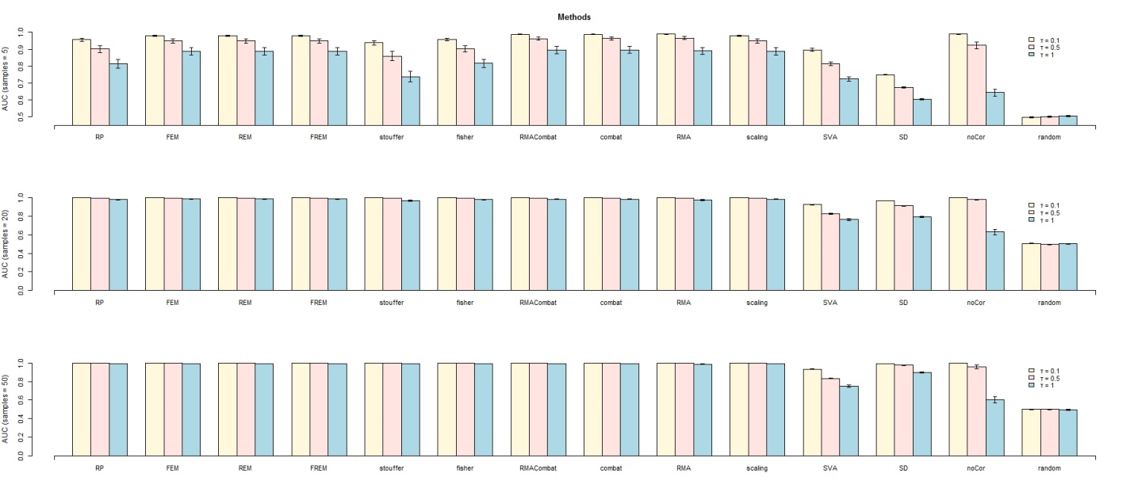
Figure S 10: AUC results on simulated data for different sample sizes using Pearson Correlations.

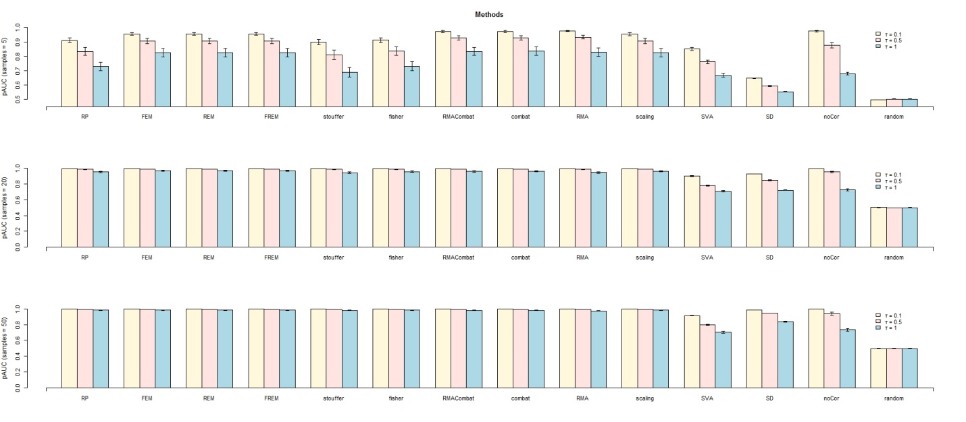
Figure S 11: pAUC results on simulated data for different sample sizes using Pearson Correlations.
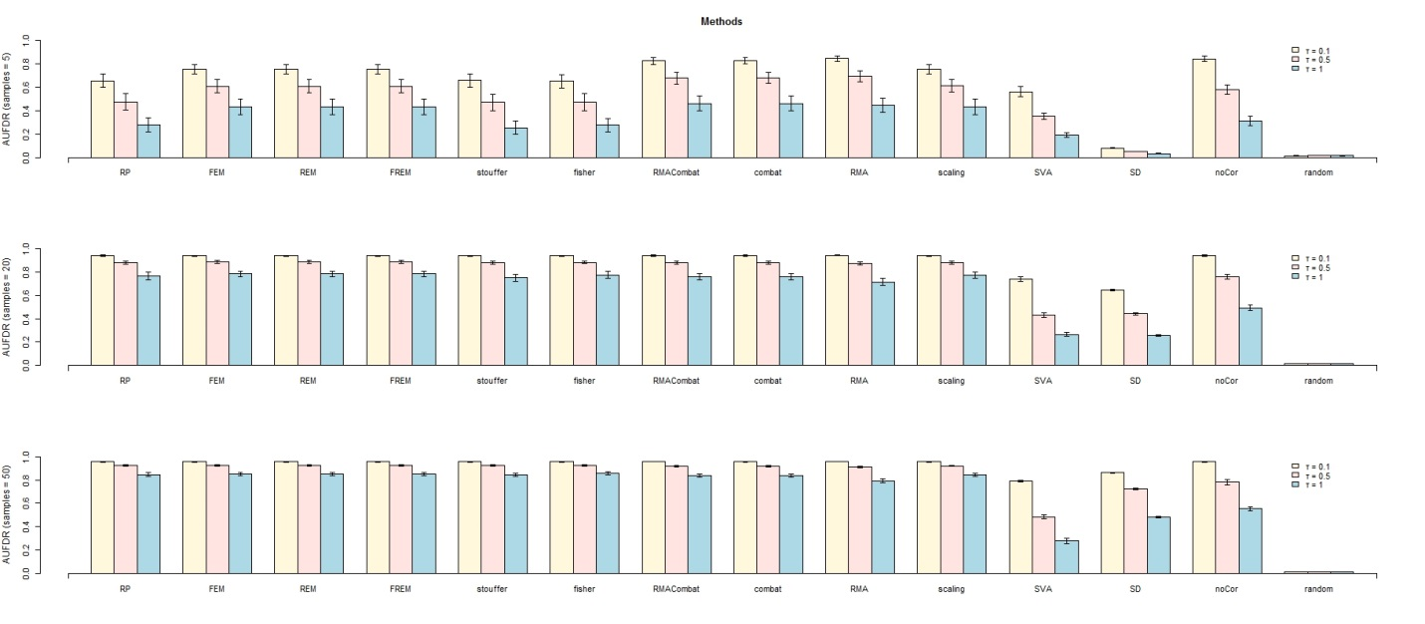
Figure S 12: AUFDR results on simulated data for different sample sizes using Pearson Correlations.

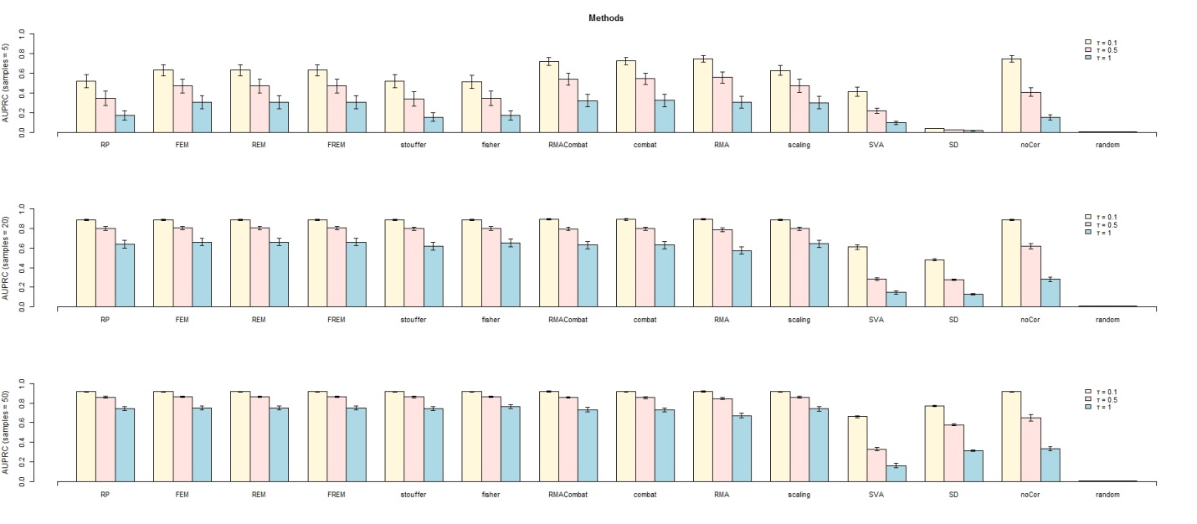
Figure S 13: AUPRC results on simulated data for different sample sizes using Pearson Correlations.

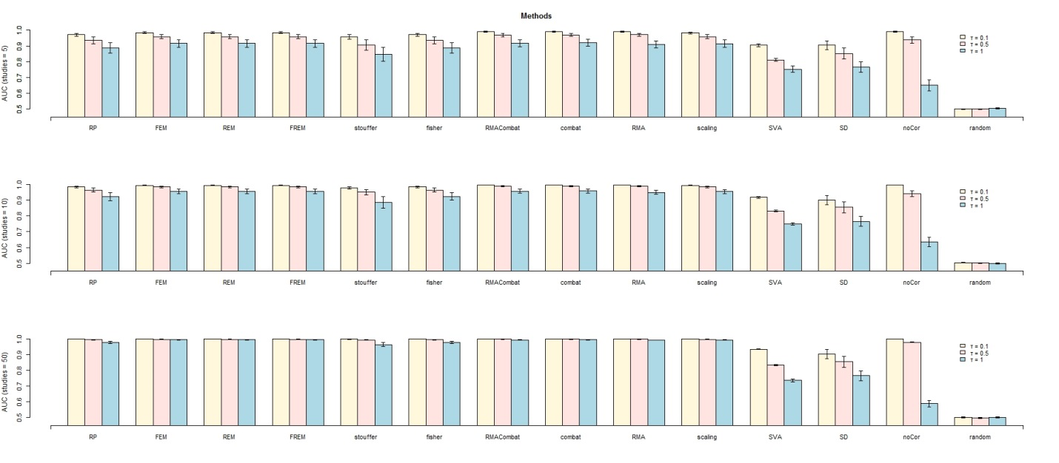
Figure S 14: AUC results on simulated data across different number of studies using Pearson Correlations

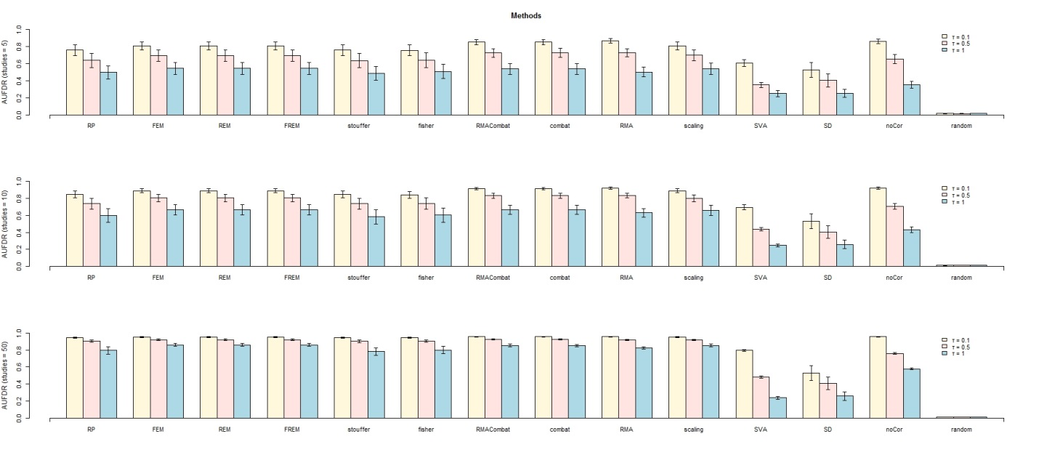
Figure S 15: AUFDR results on simulated data across different number of studies using Pearson Correlations

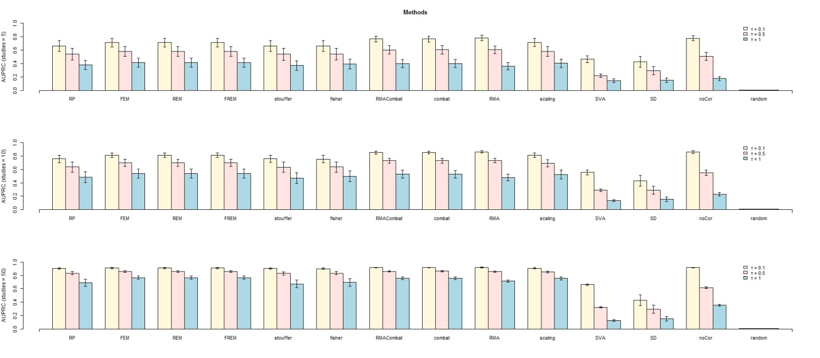
Figure S 16: AUPRC results on simulated data across different number of studies using Pearson Correlations
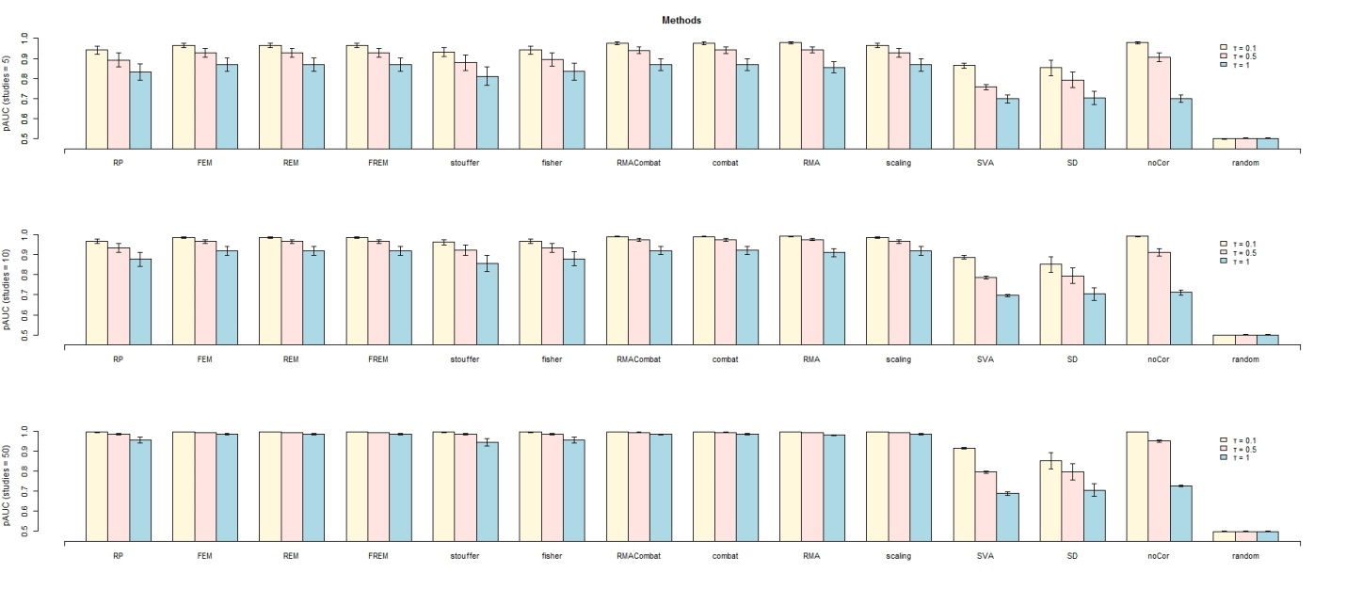
Figure S 17: pAUC results on simulated data across different number of studies using Pearson Correlations
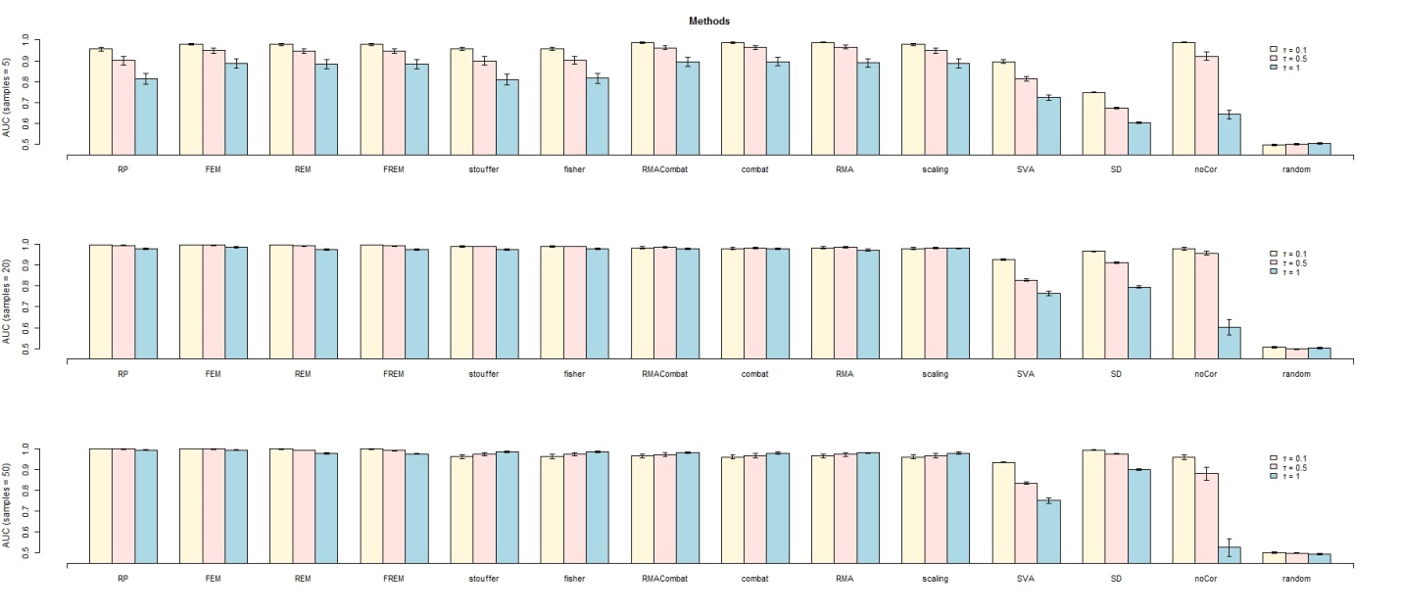
Figure S 18: AUC results on simulated data across different number of samples using Pearson p-values
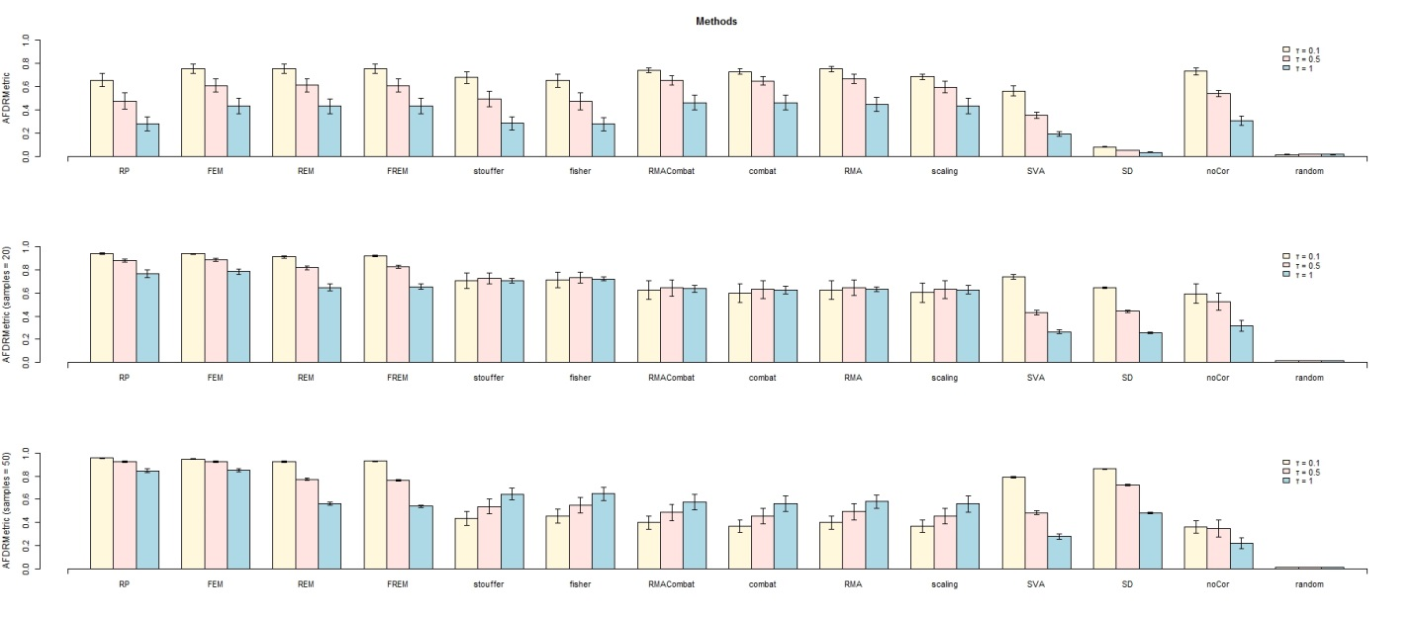
Figure S 19: AUFDR results on simulated data across different number of samples using Pearson p-values

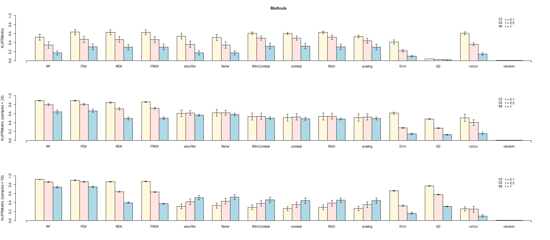
Figure S 20: AUPRC results on simulated data across different number of samples using Pearson p-values
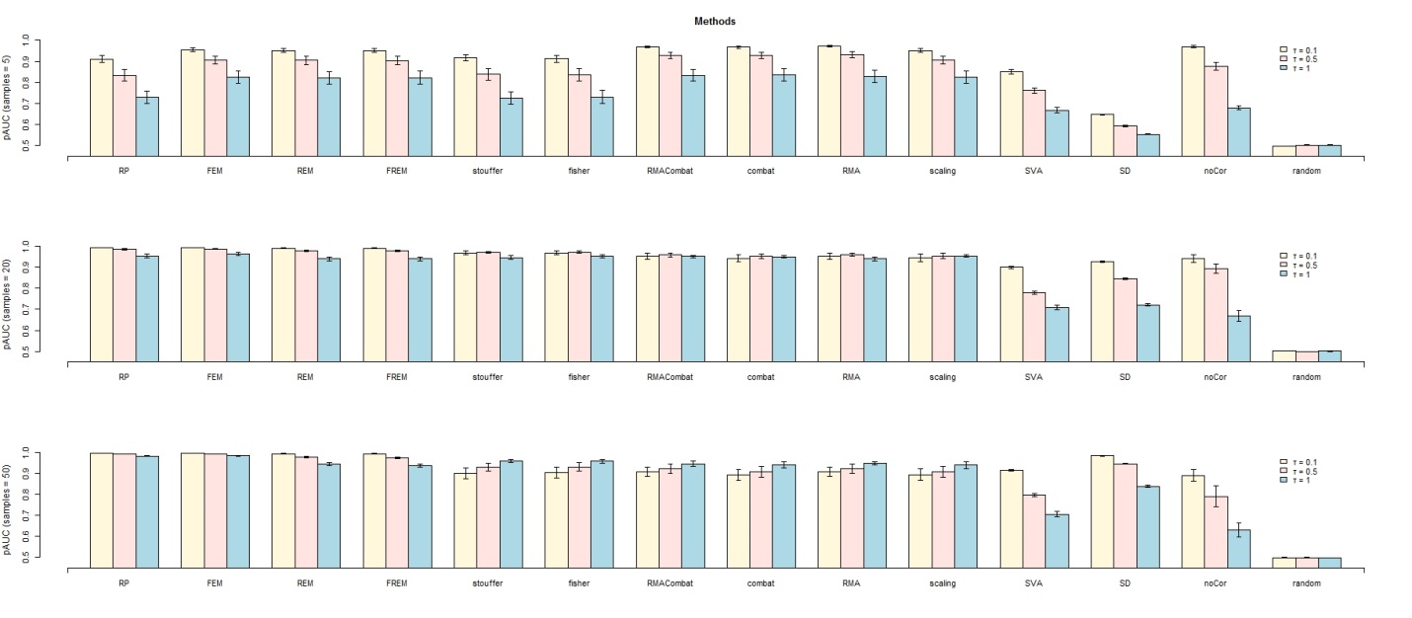
Figure S 21: pAUC results on simulated data across different number of samples using Pearson p-values
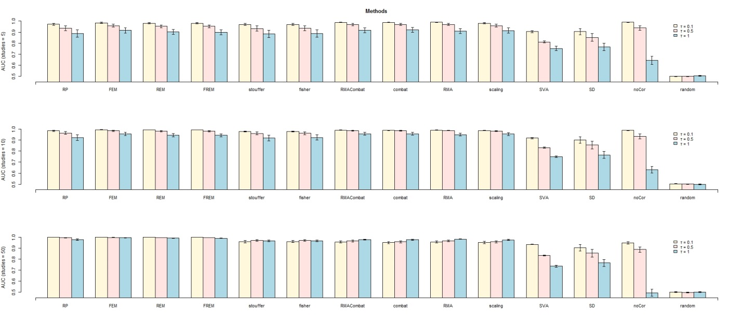
Figure S 22: AUC results on simulated data across different number of studies using Pearson p-values
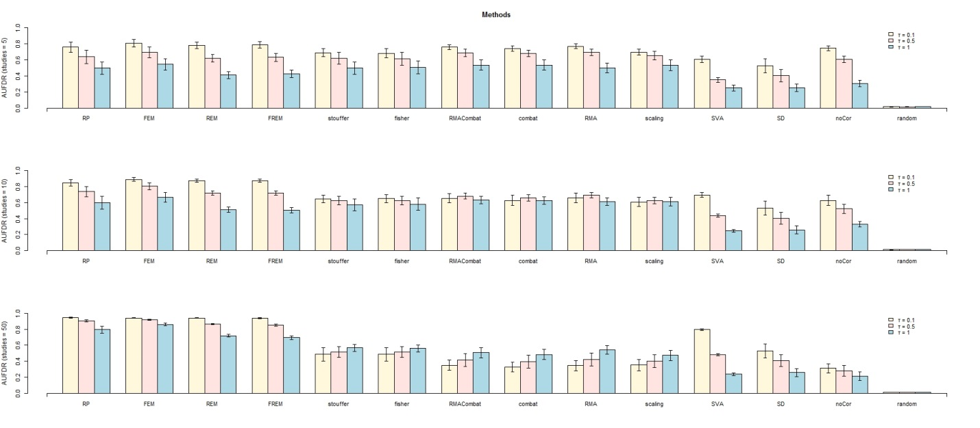
Figure S 23: AUFDR results on simulated data across different number of studies using Pearson p-values

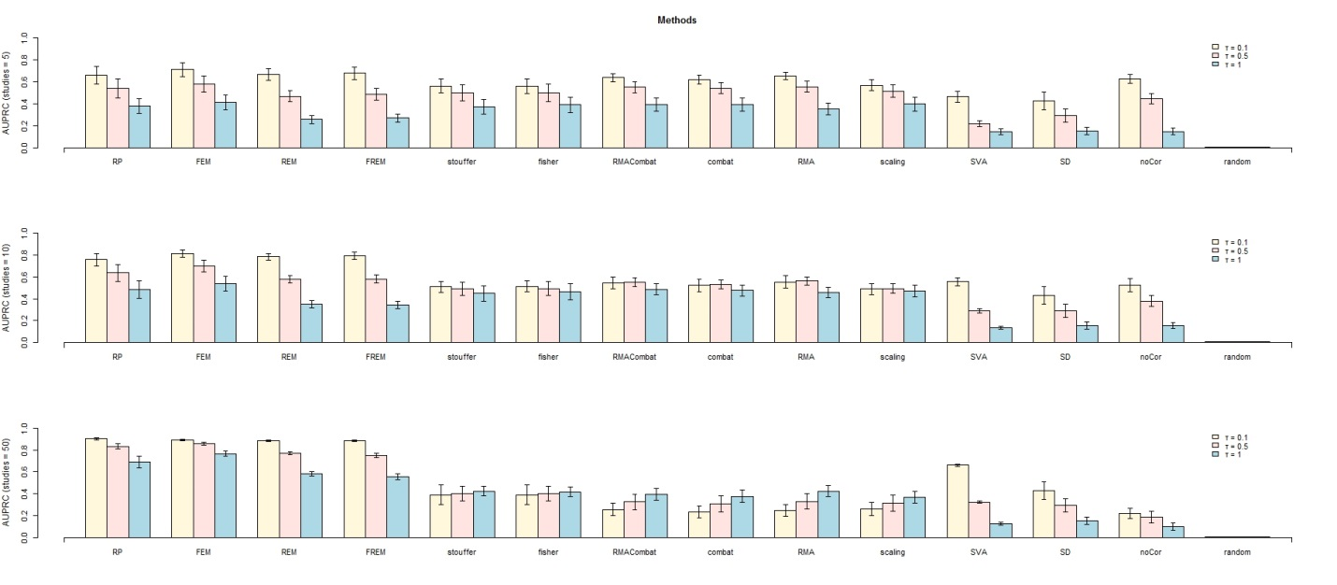
Figure S 24: AUPRC results on simulated data across different number of studies using Pearson p-values

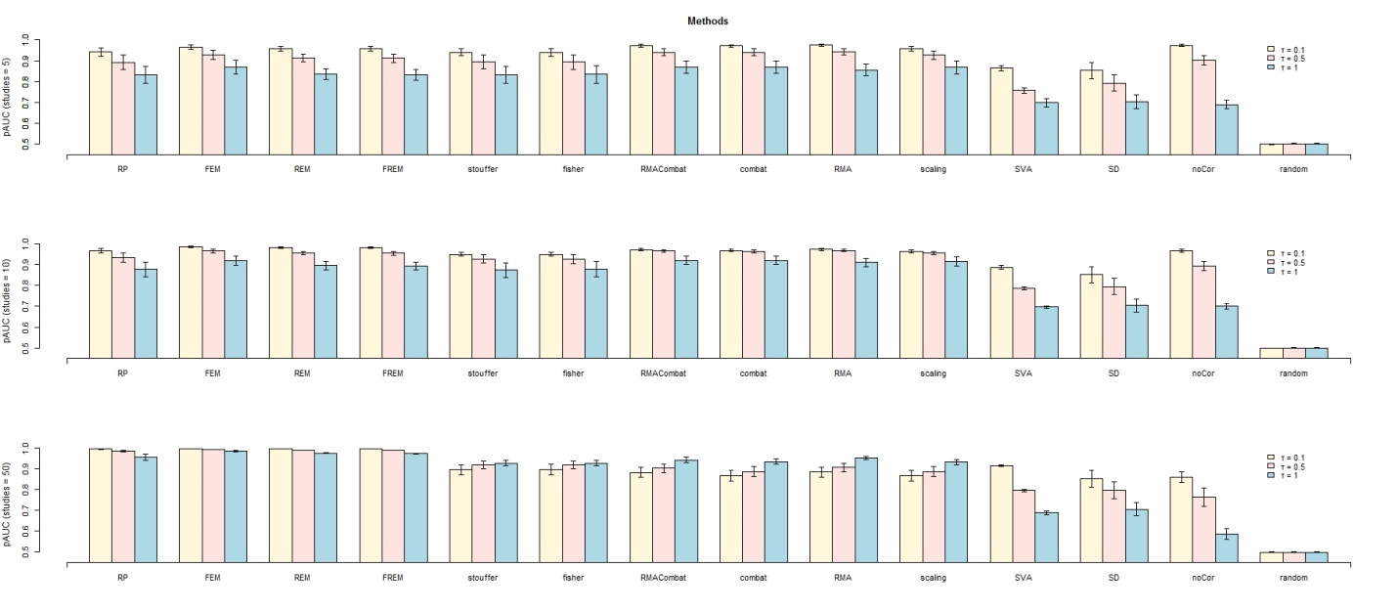
Figure S 25: pAUC results on simulated data across different number of studies using Pearson p-values
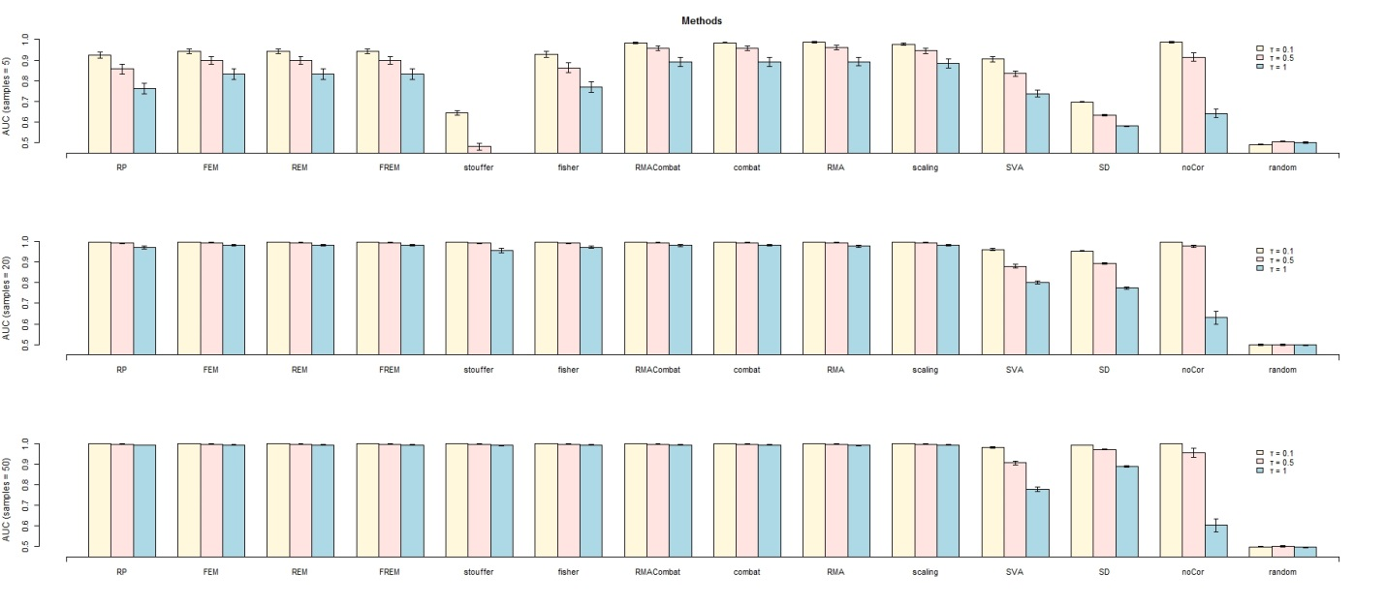
Figure S 26: AUC results on simulated data across different sample sizes using Spearman Correlation

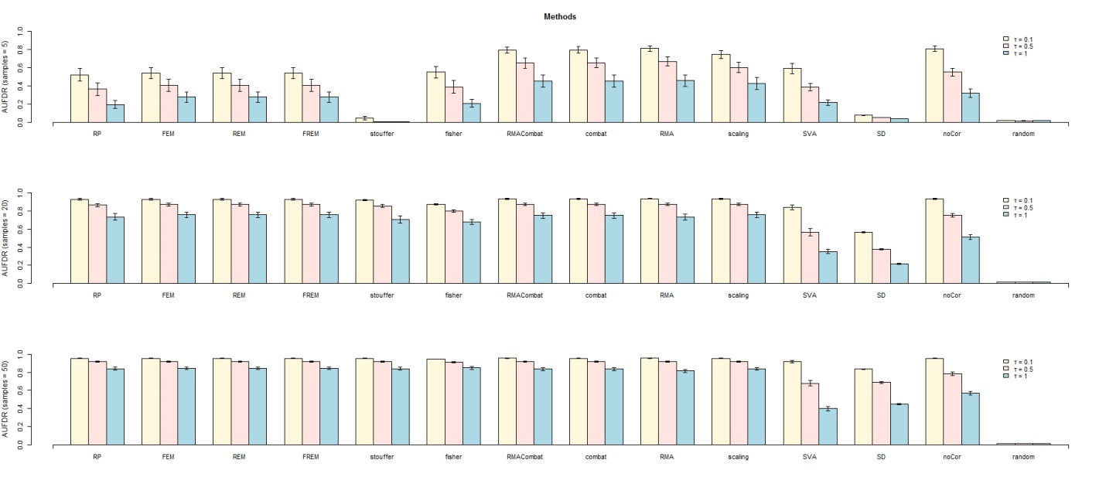
Figure S 27: AUFDR results on simulated data across different sample sizes using Spearman Correlation

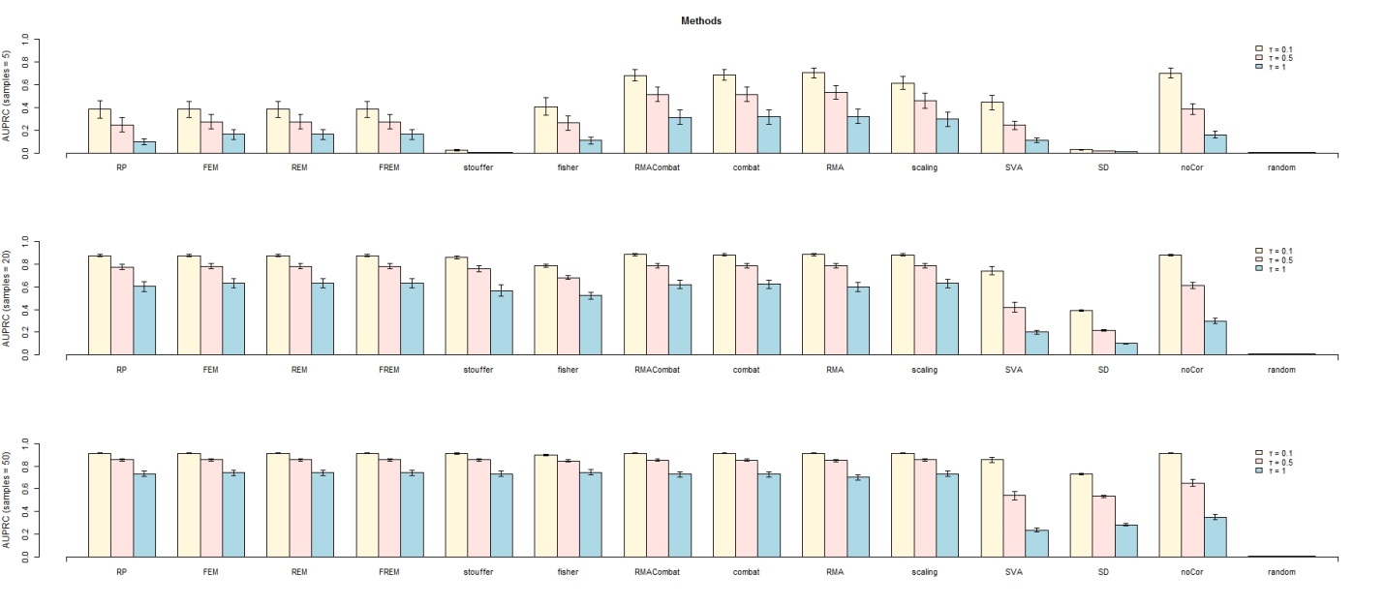
Figure S 28: AUPRC results on simulated data across different sample sizes using Spearman Correlation

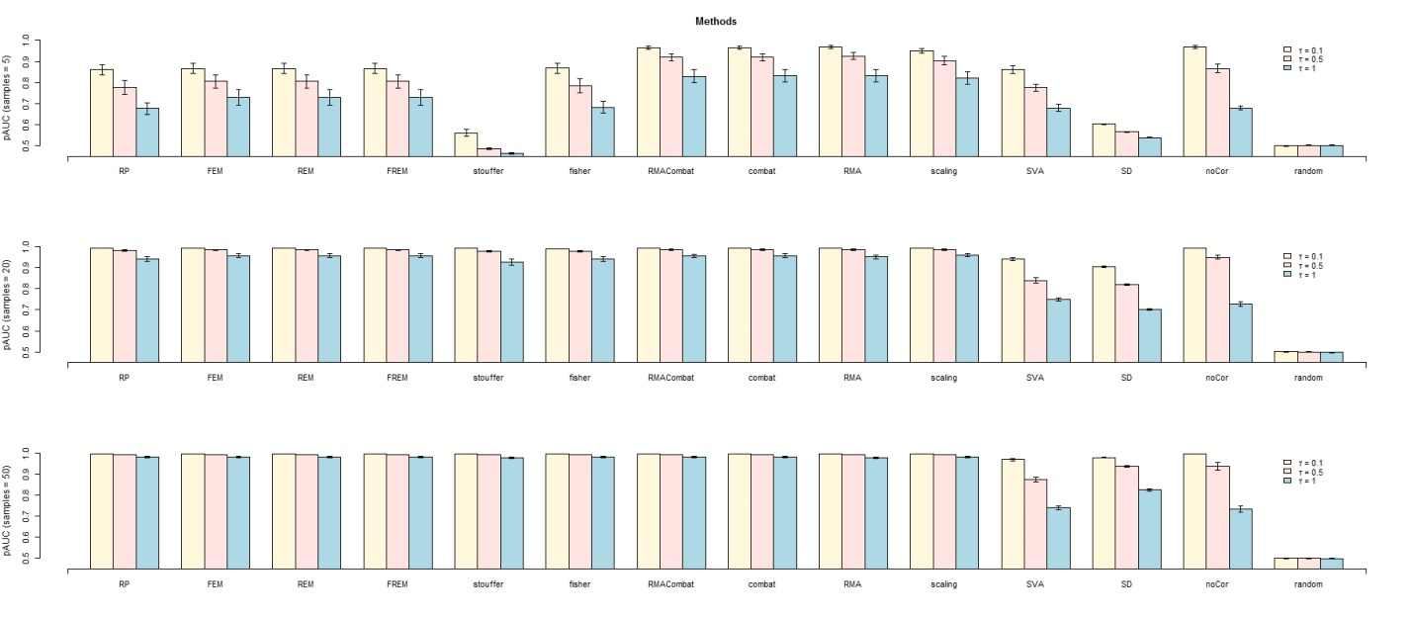
Figure S 29: pAUC results on simulated data across different sample sizes using Spearman Correlation

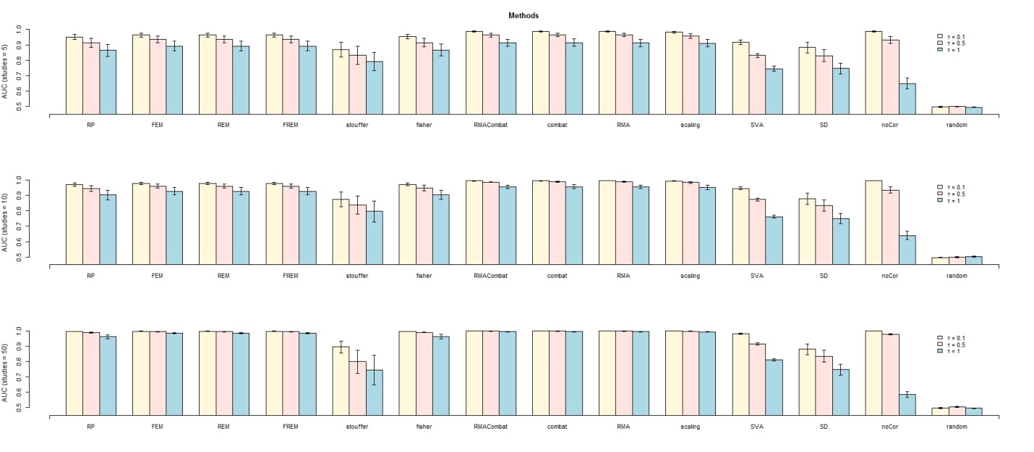
Figure S 30: AUC results on simulated data across different number of studies using Spearman Correlation
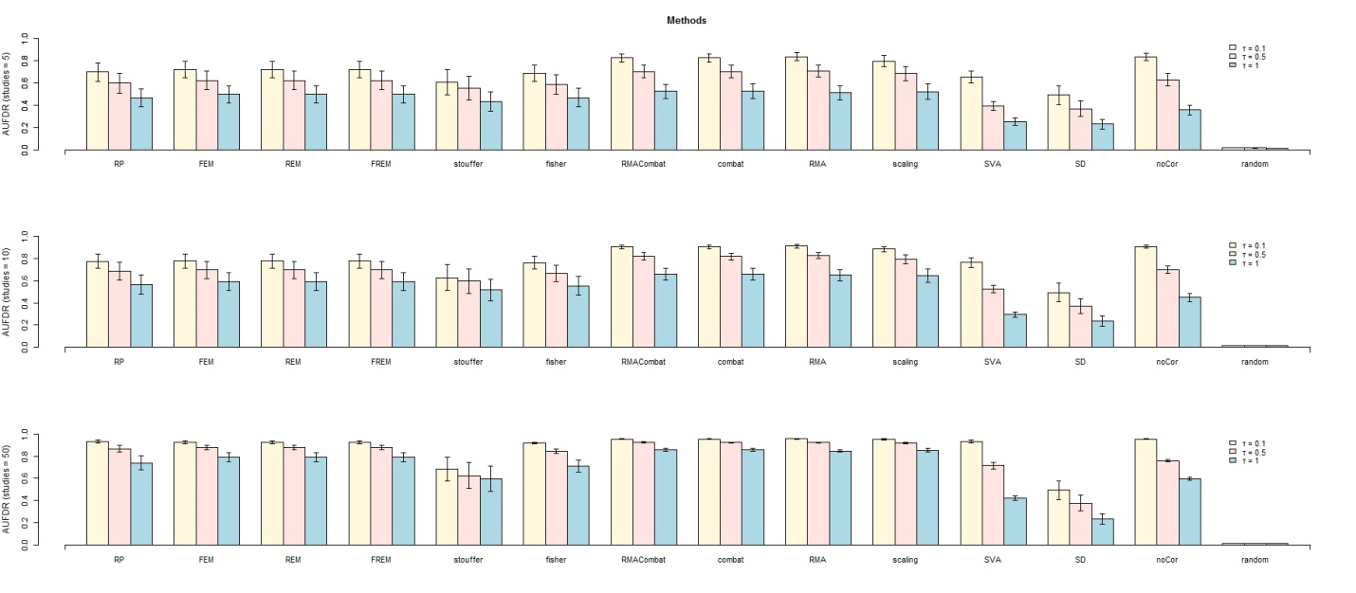
Figure S 31: AUFDR results on simulated data across different number of studies using Spearman Correlation
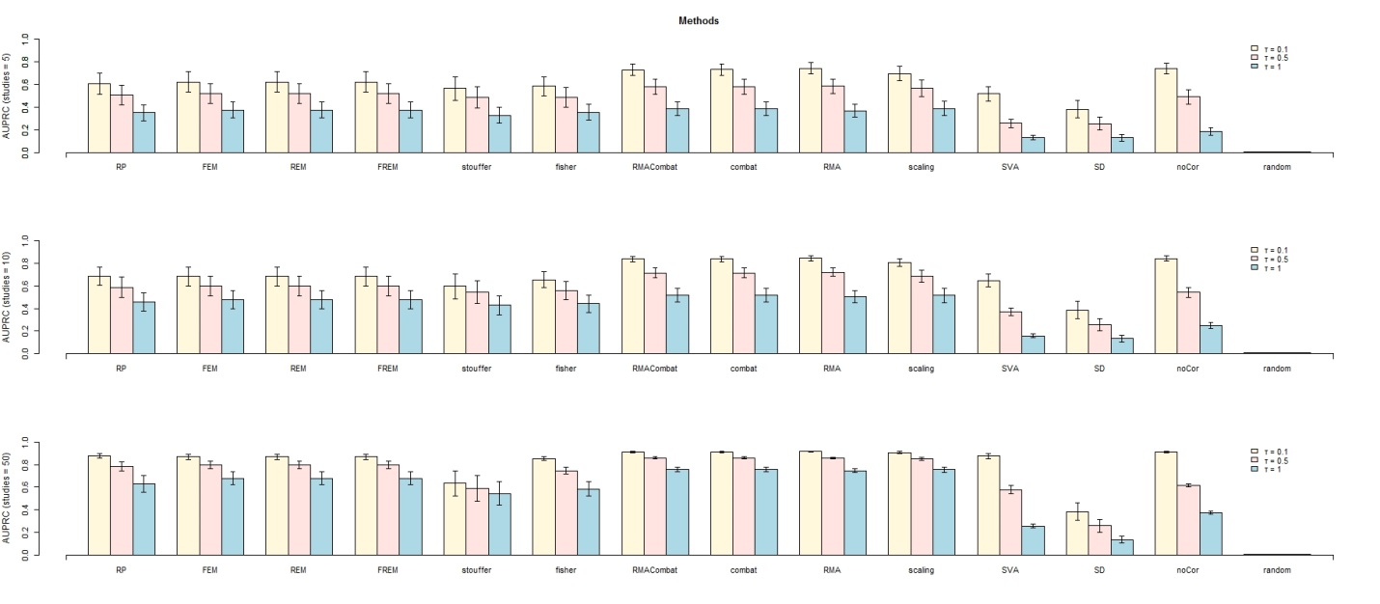
Figure S 32: AUPRC results on simulated data across different number of studies using Spearman Correlation

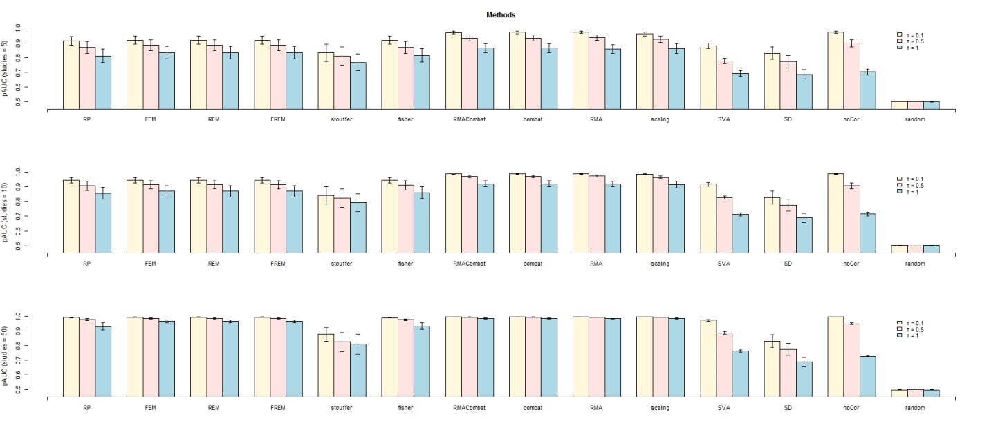
Figure S 33: pAUC results on simulated data across different number of studies using Spearman Correlation

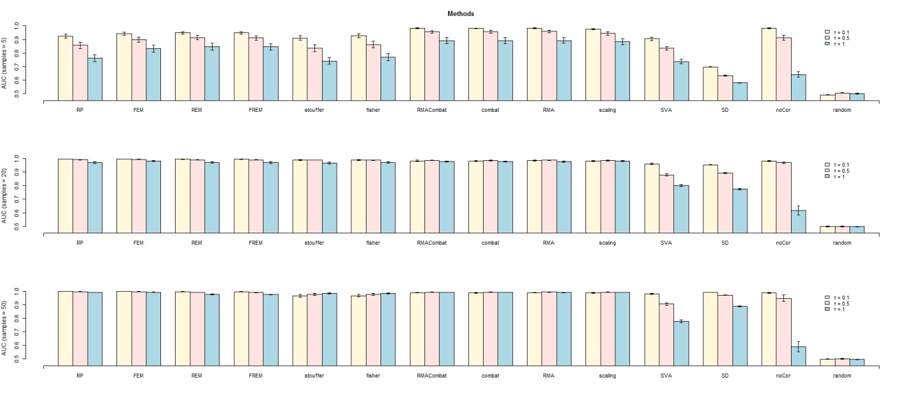
Figure S 34: AUC results on simulated data across different sample sizes using Spearman Correlation p-values.
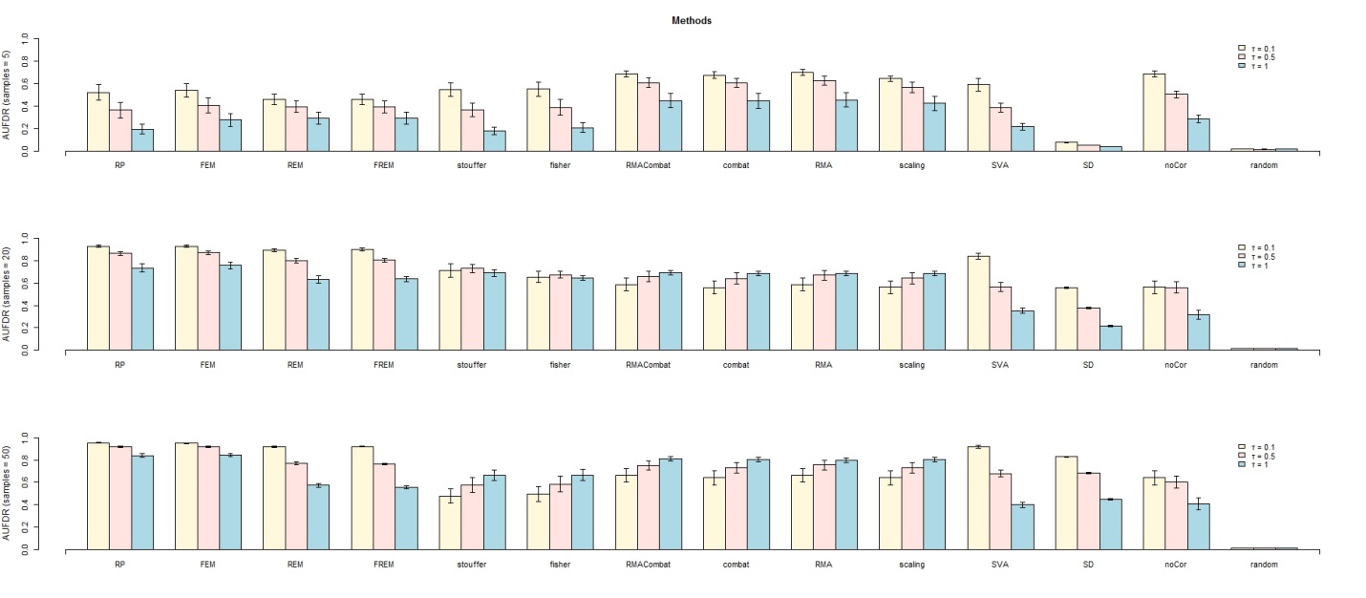
Figure S 35: AUFDR results on simulated data across different sample sizes using Spearman Correlation p-values.

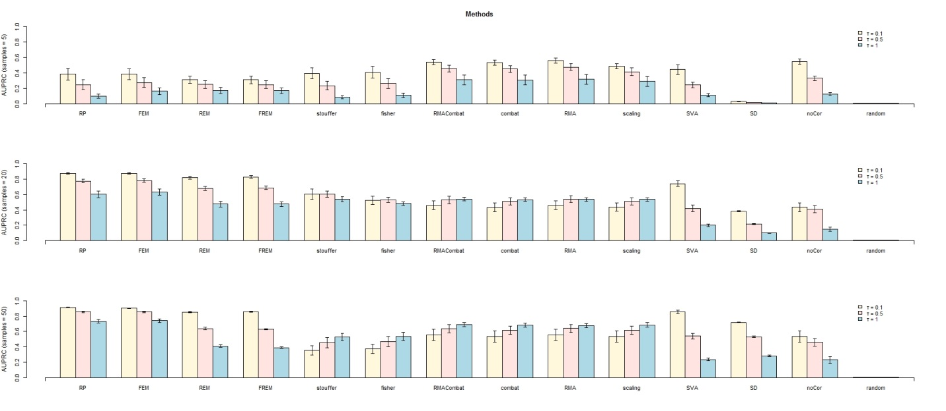
Figure S 36: AUPRC results on simulated data across different sample sizes using Spearman Correlation p-values.
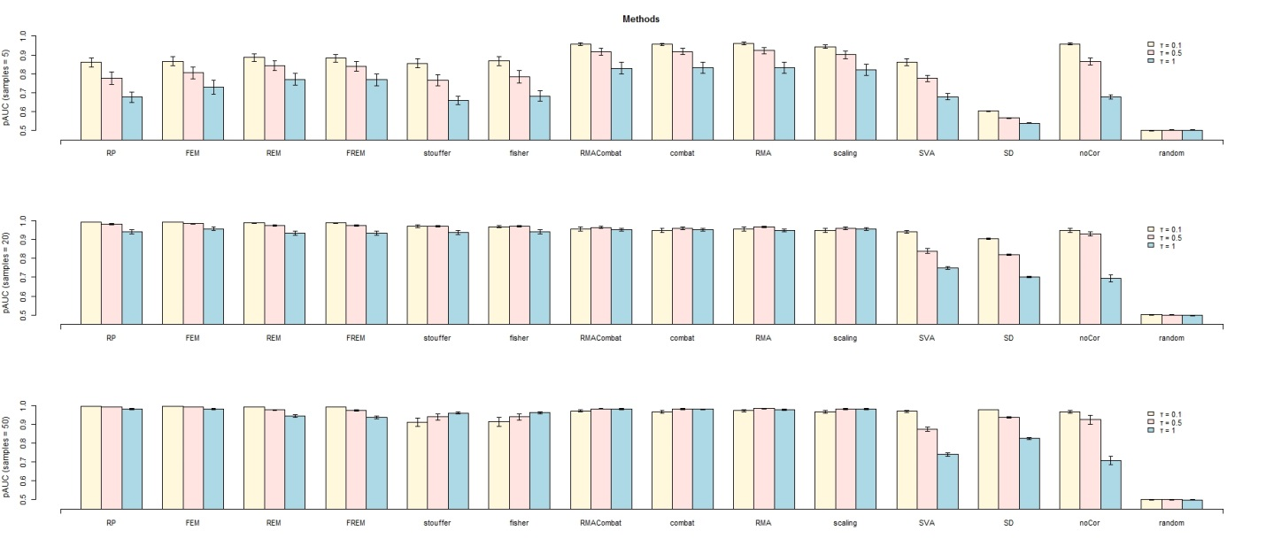
Figure S 37: pAUC results on simulated data across different sample sizes using Spearman Correlation p-values.

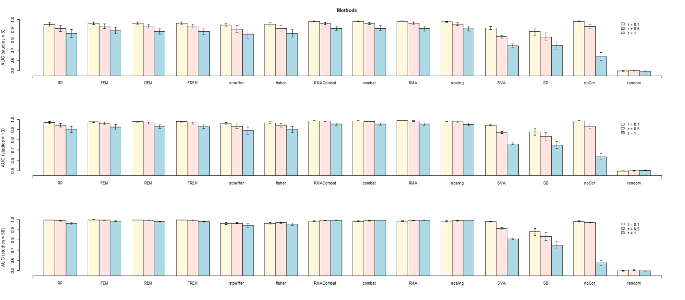
Figure S 38: AUC results on simulated data across different number of studies using Spearman Correlation p-values.
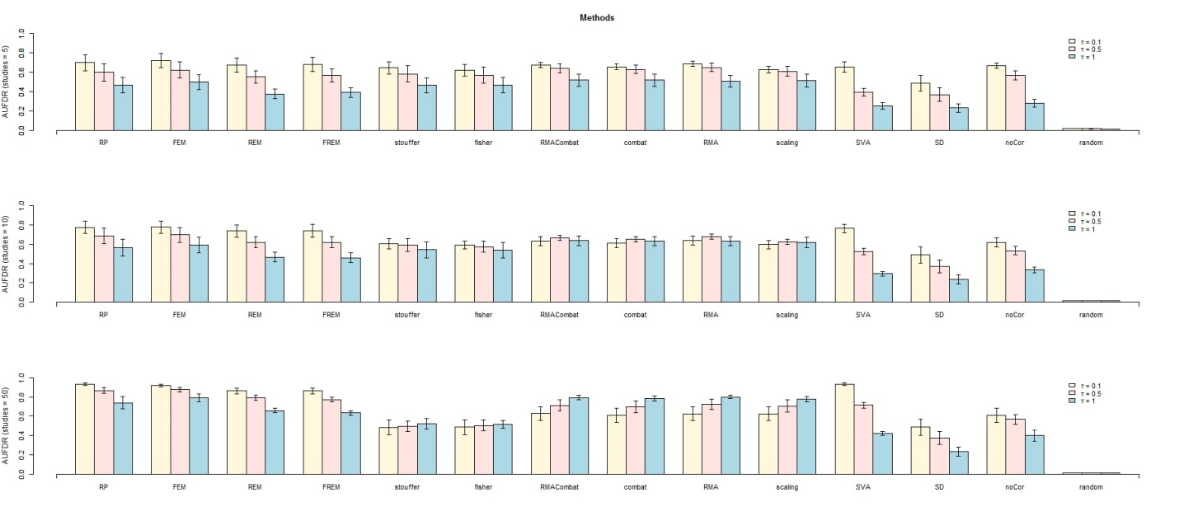
Figure S 39 AUFDR results on simulated data across different number of studies using Spearman Correlation p-value
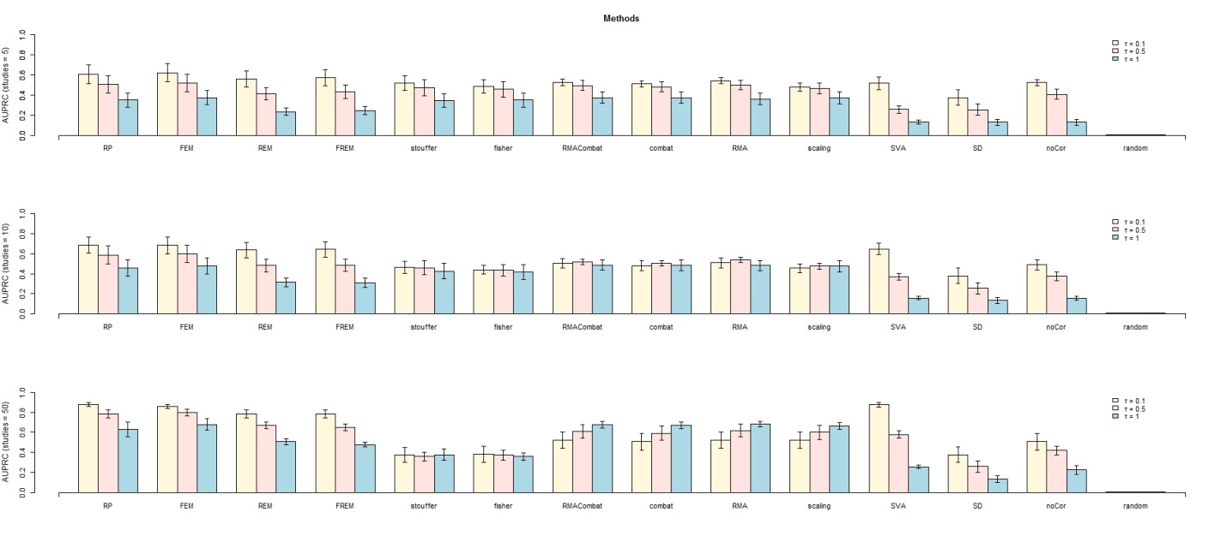
Figure S 40 AUPRC results on simulated data across different number of studies using Spearman Correlation p-value
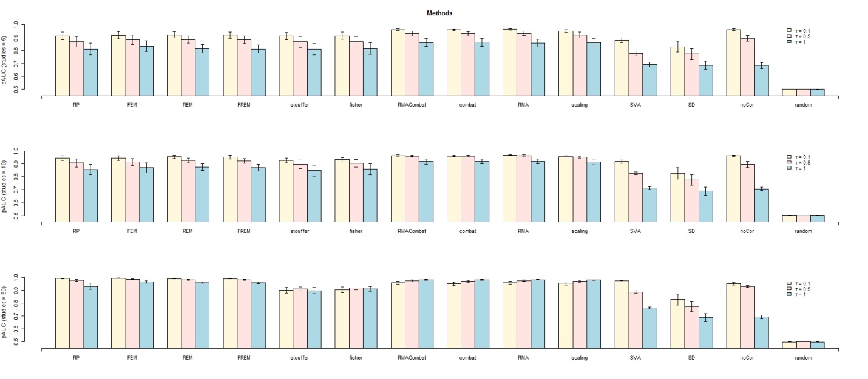
Figure S 41 pAUC results on simulated data across different number of studies using Spearman Correlation p-value

