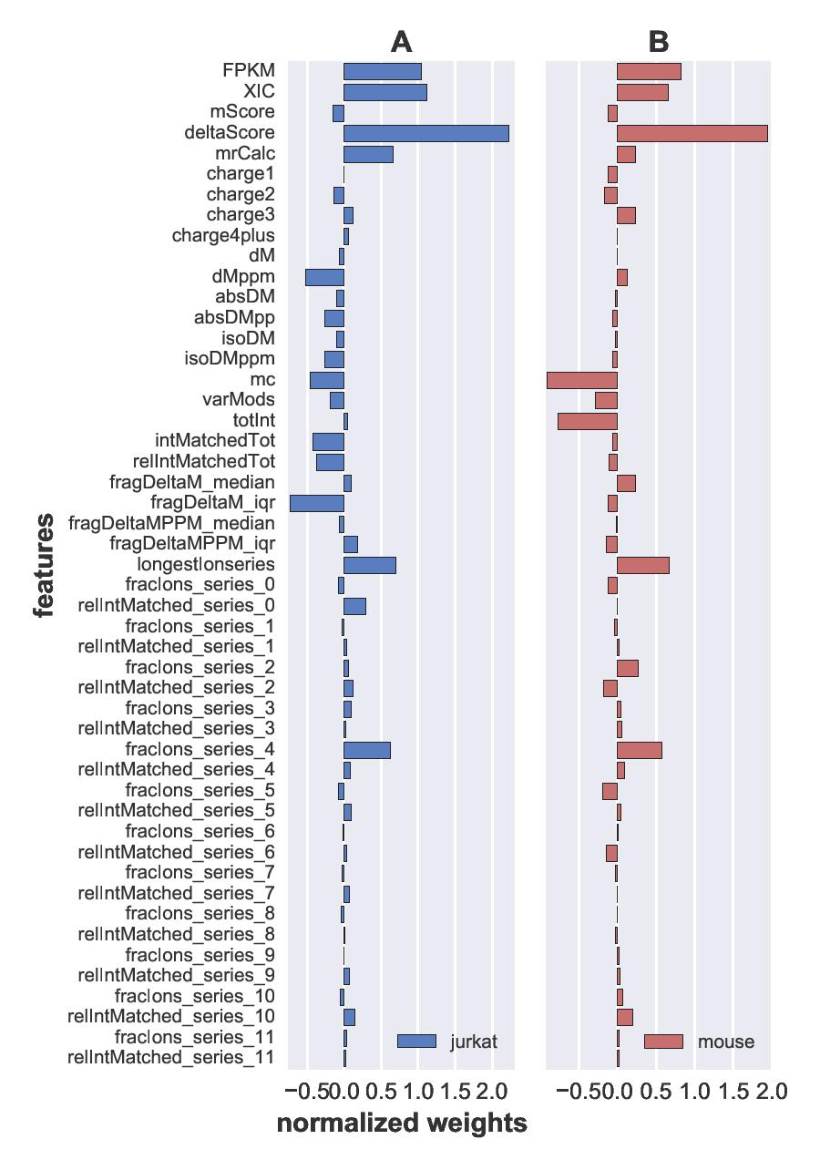
Figure S1. The weights of features for (A) Jurcat cell line and (B) mouse liver datasets.

