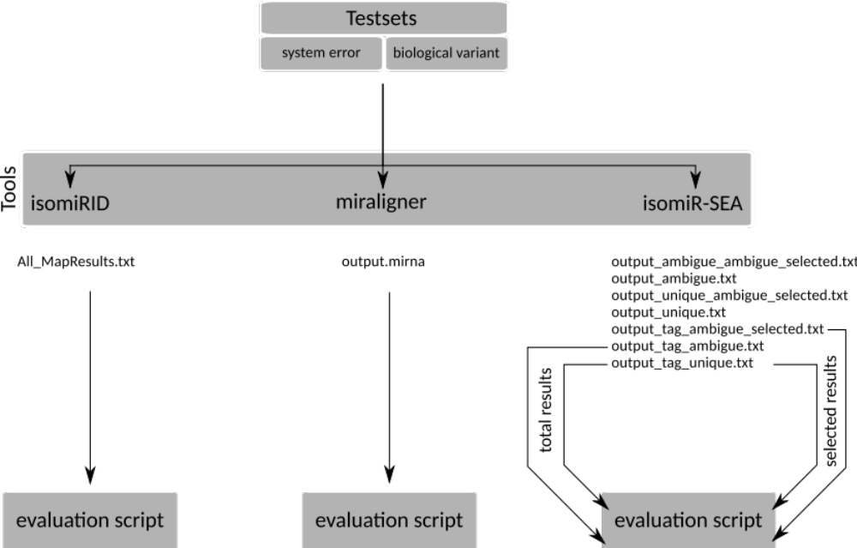
Figure S1 Analysis scheme for artificial test set evaluation
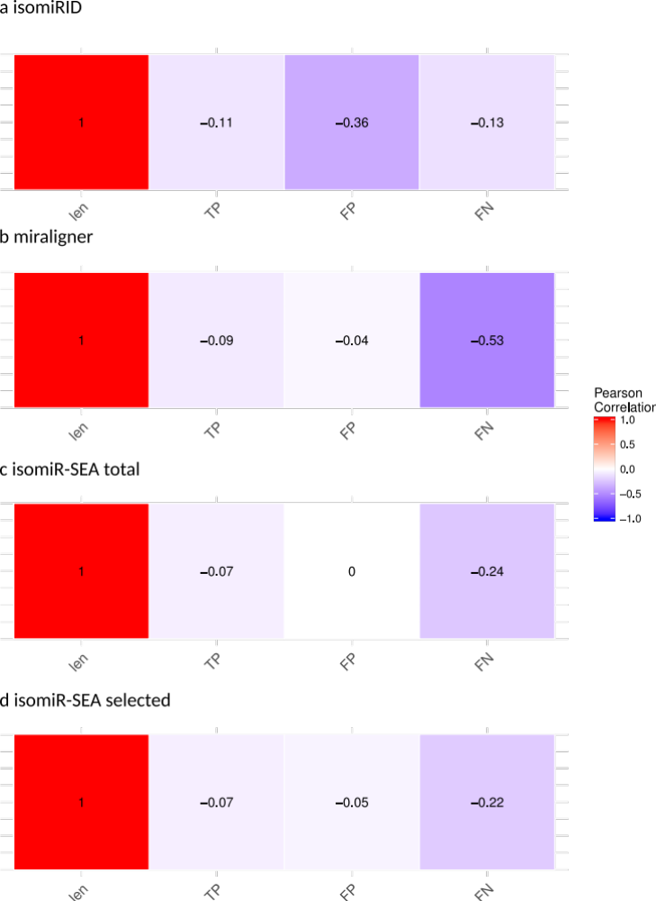
Figure S2 Pearson correlation of the length against the true positive, false positive and false negative rate. IsomiRID has a weak anti-correlation of length and false positive rate. Miraligner has a moderate anti-correlation of length and false negative rate. IsomiR-SEA has in both variations a weak anti-correlation of length and false negative rate.

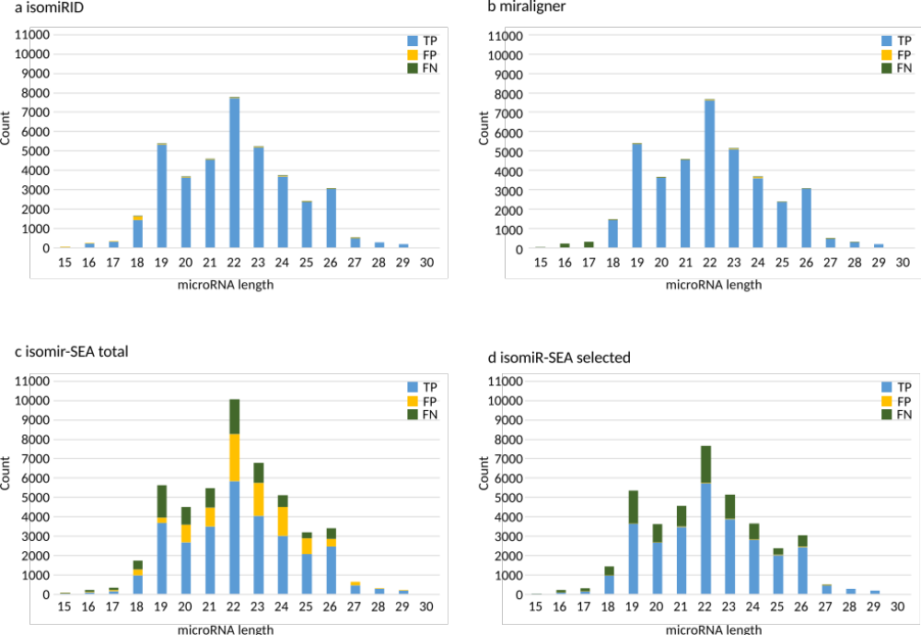
Figure S3 Detail view on the various lengths and their individual TP, FP and FN rates
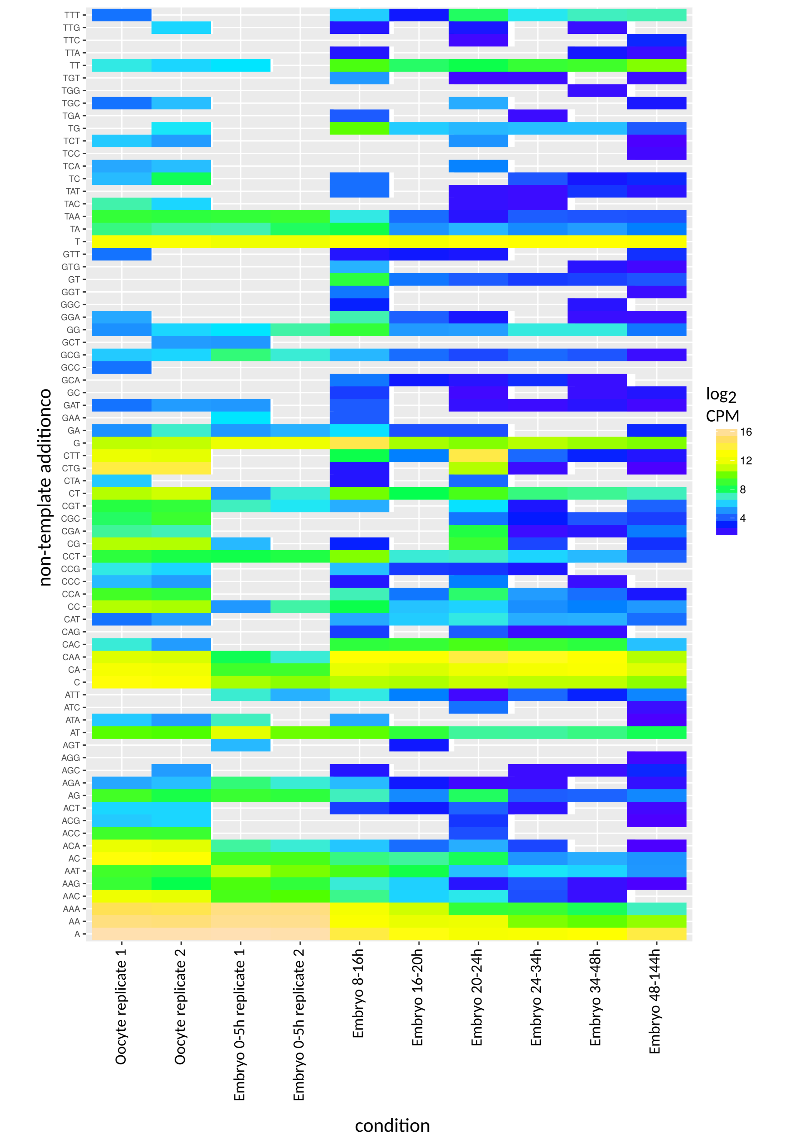
Figure S4 Non-templated 3' additions over all conditions. Strong expression of isomiRs with polyadenylate tails was observed in the oocyte and during the first embryonic phase.
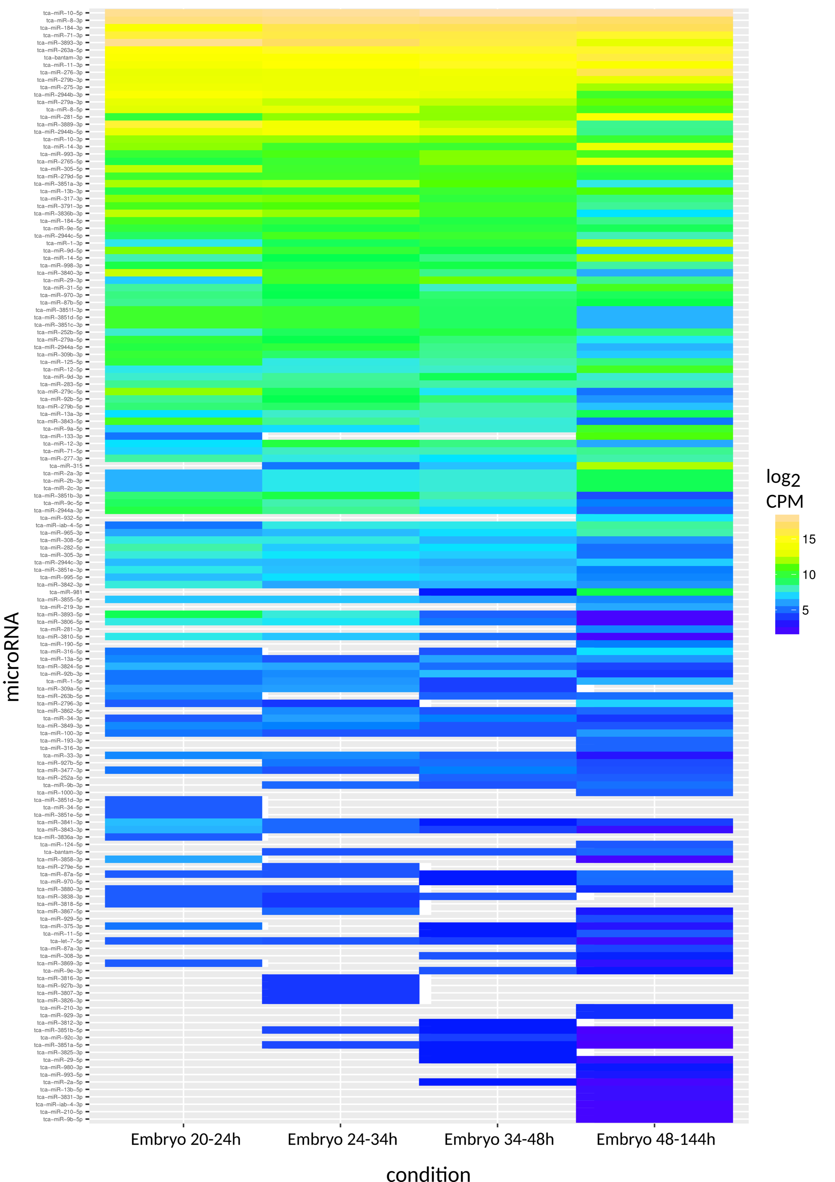
Figure S5 Expression of mature miRNAs during the last four embryonic phases. The number of mature miRNAs increases between the 20–24h and 48–144h phases.

