Materials and Methods:

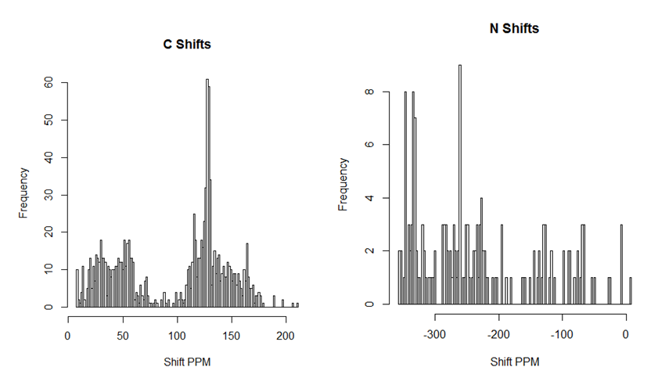
Figure S1. Distribution of NMR chemical shifts for carbon (left) and nitrogen (right)

