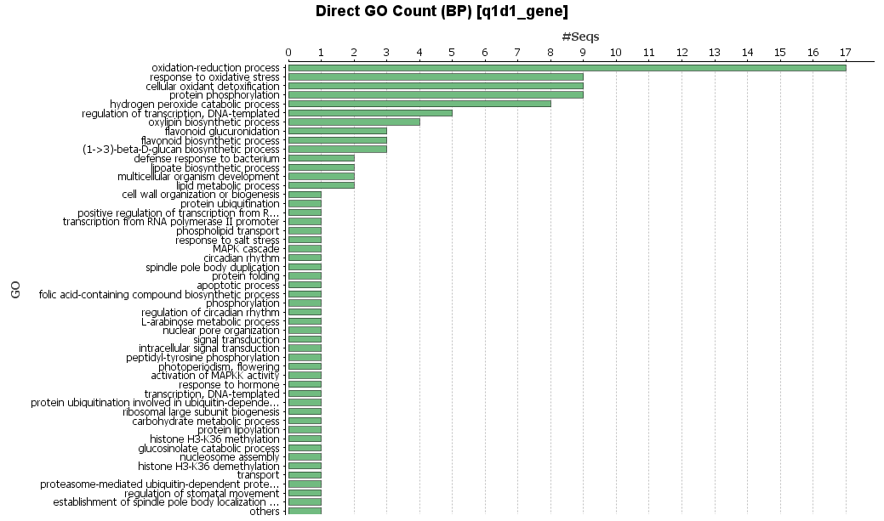
Fig. S1 Biological process GO category for the genes within the region of QTL Q1D1.

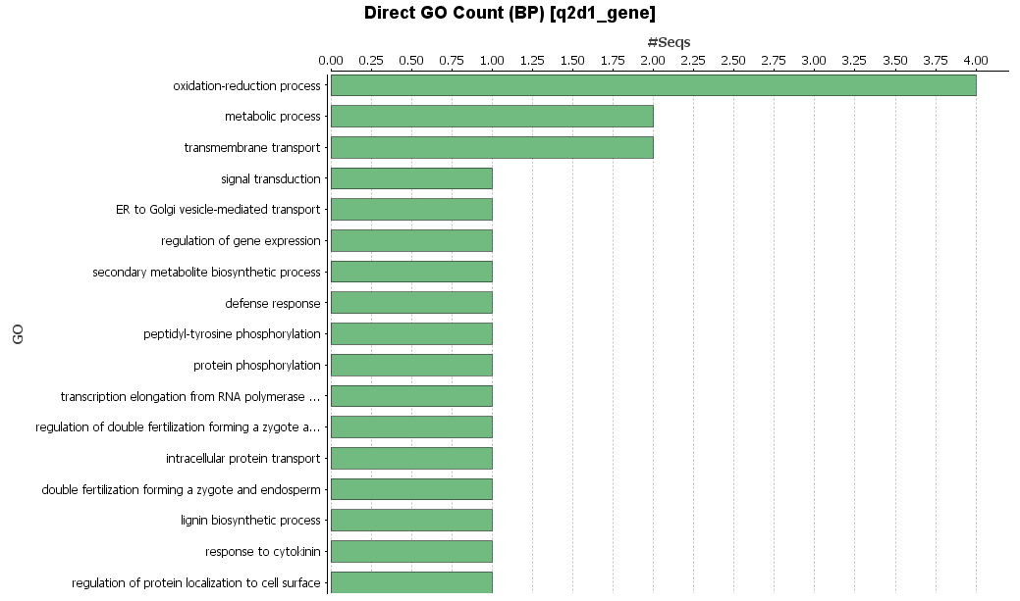
Fig. S2 Biological process GO category for the genes within the region of QTL Q2D1.

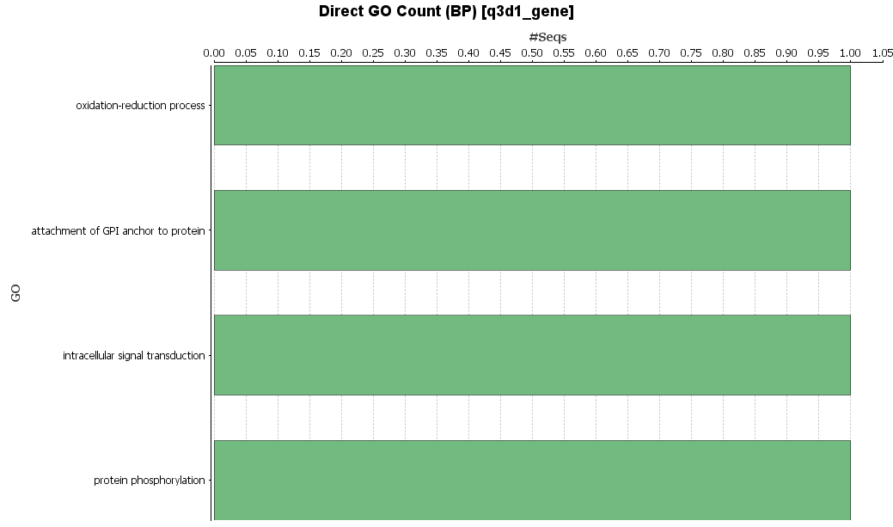
Fig. S3 Biological process GO category for the genes within the region of QTL Q3D1.

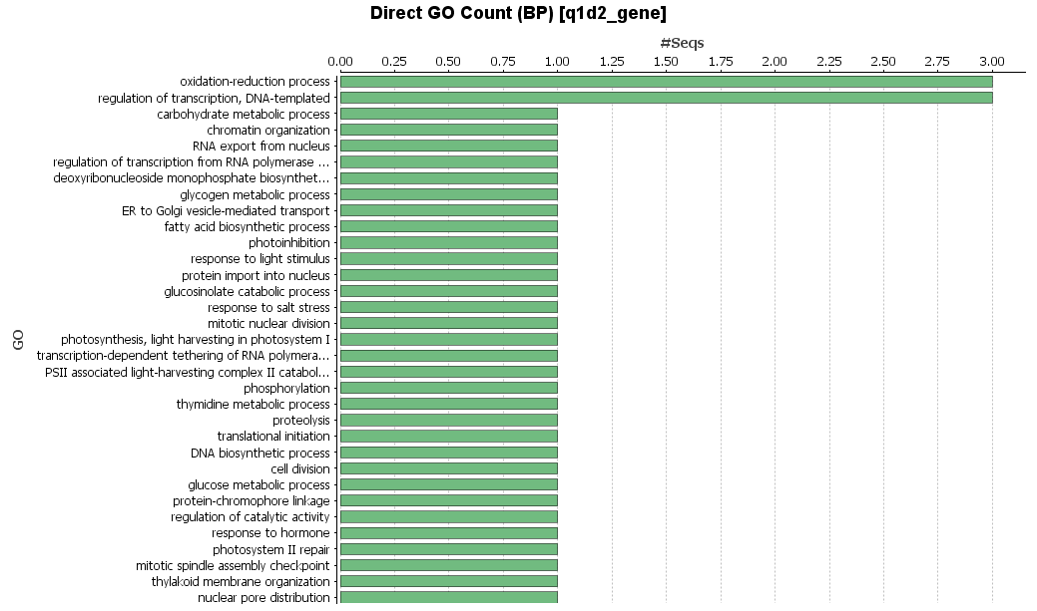
Fig. S4 Biological process GO category for the genes within the region of QTL Q1D2.

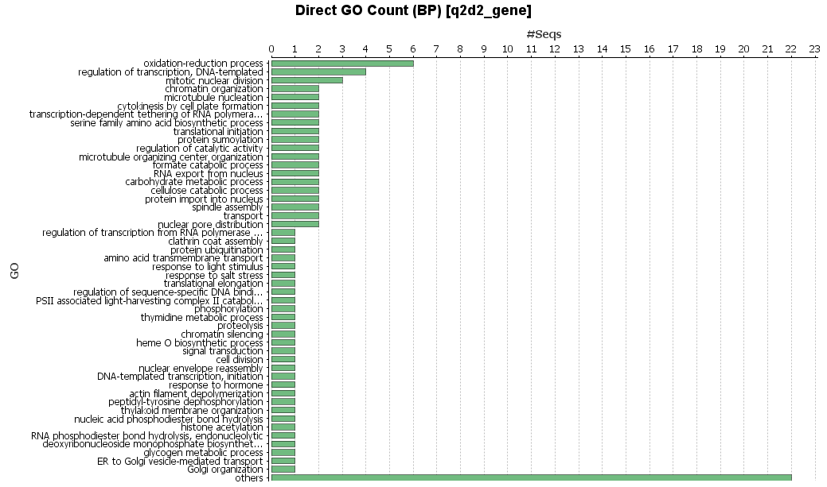
Fig. S5 Biological process GO category for the genes within the region of QTL Q2D2.

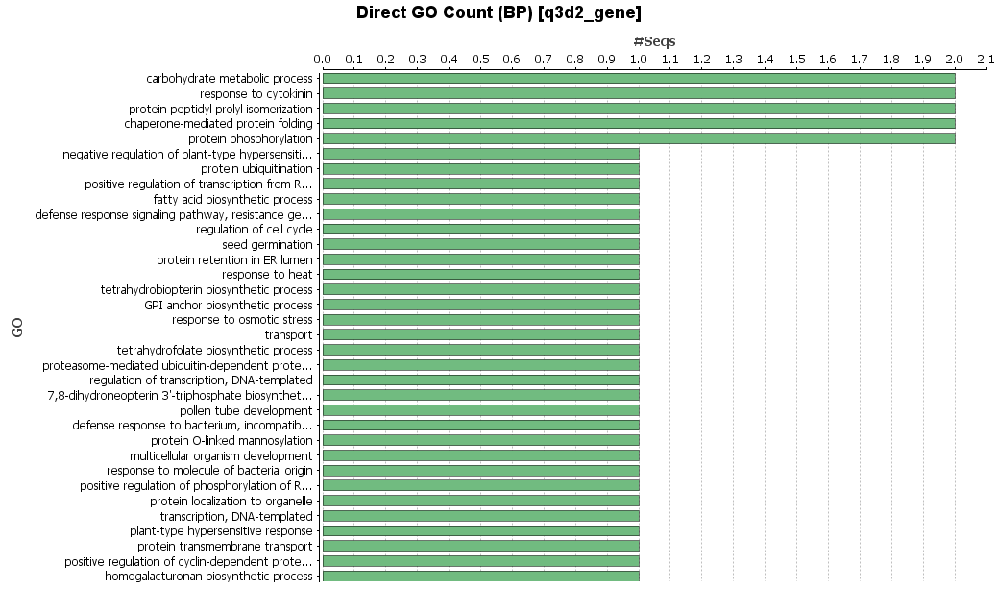
Fig. S6 Biological process GO category for the genes within the region of QTL Q3D2.

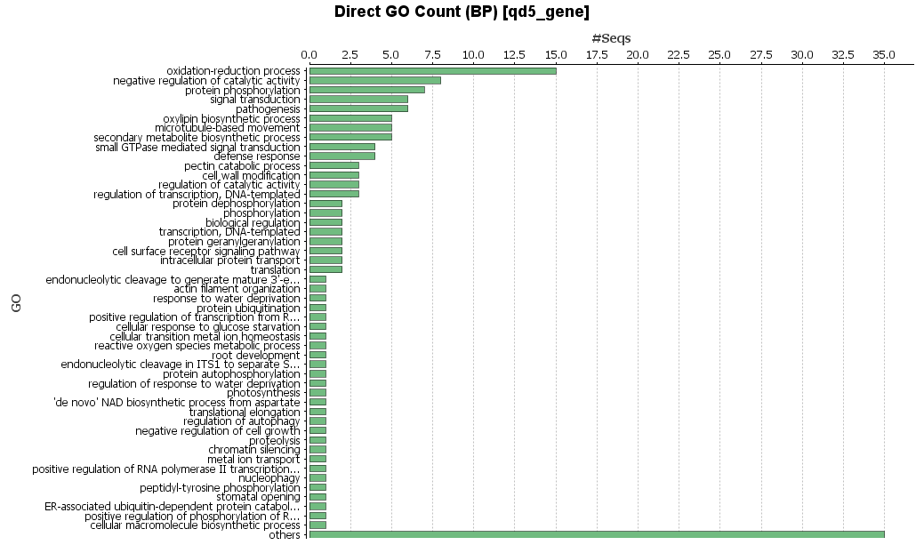
Fig. S7 Biological process GO category for the genes within the region of QTL QD5.

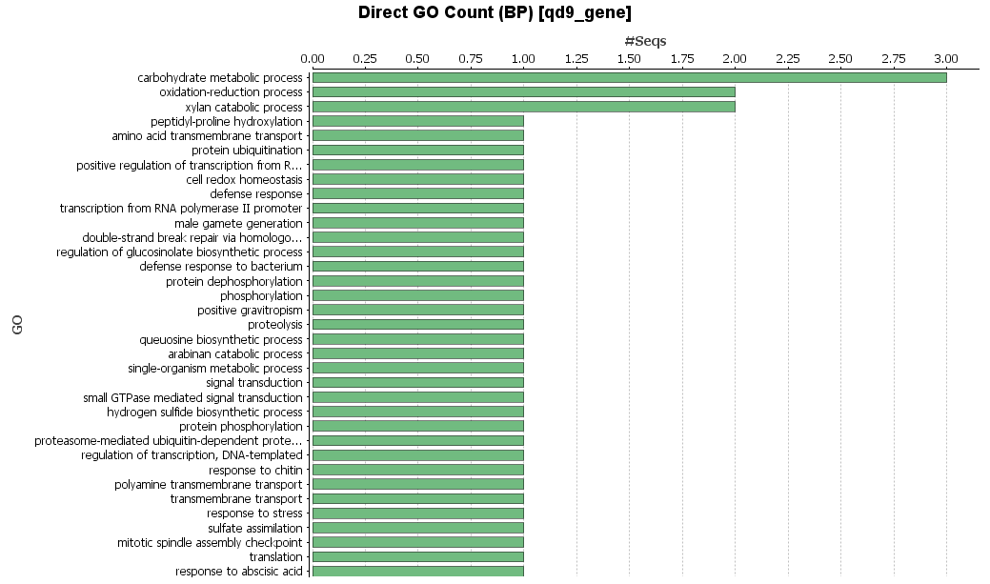
Fig. S8 Biological process GO category for the genes within the region of QTL QD9.

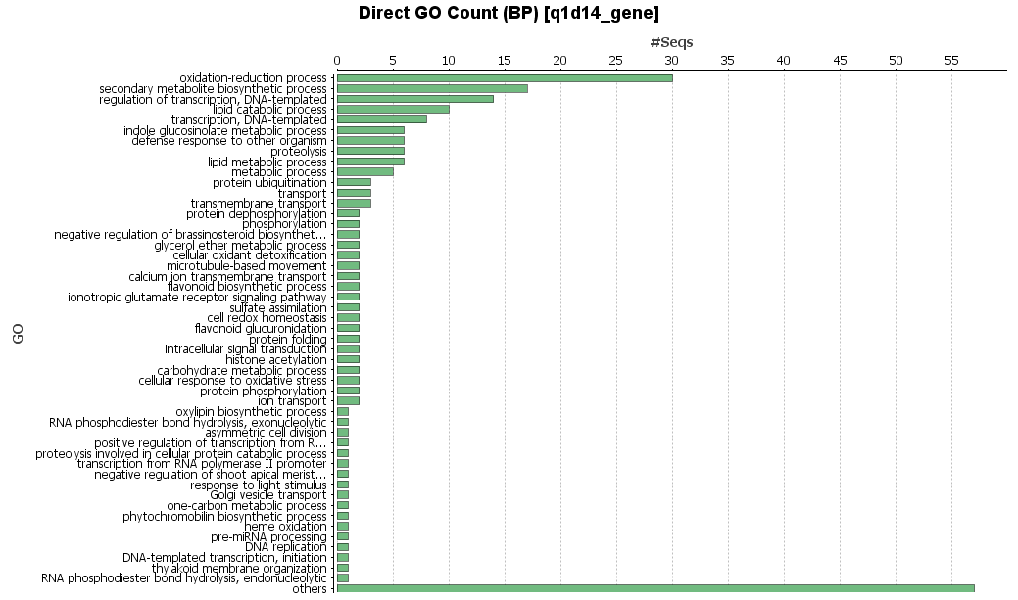
Fig. S9 Biological process GO category for the genes within the region of QTL Q1D14.

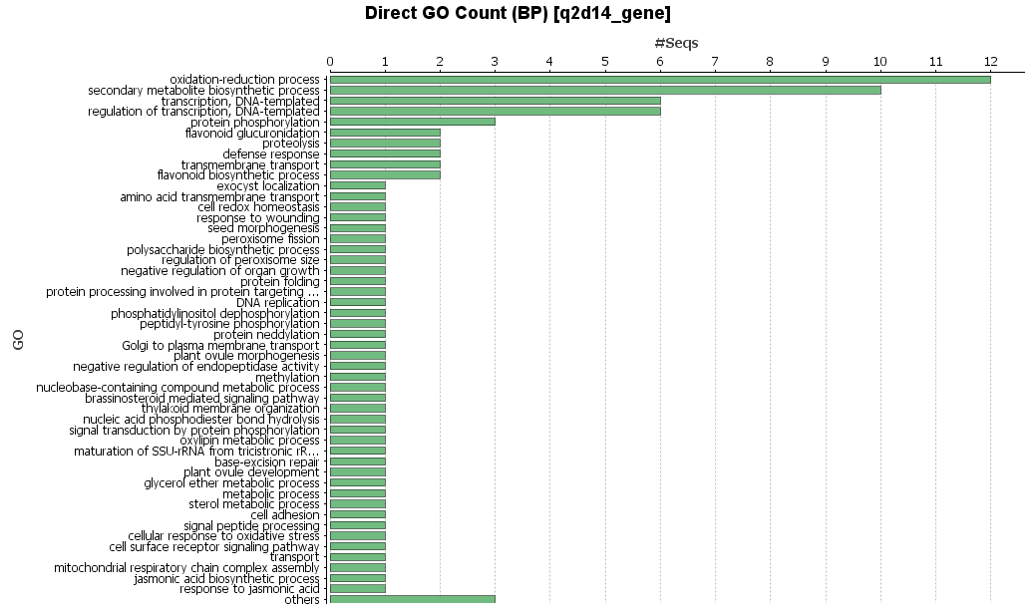
Fig. S10 Biological process GO category for the genes within the region of QTL Q2D14.

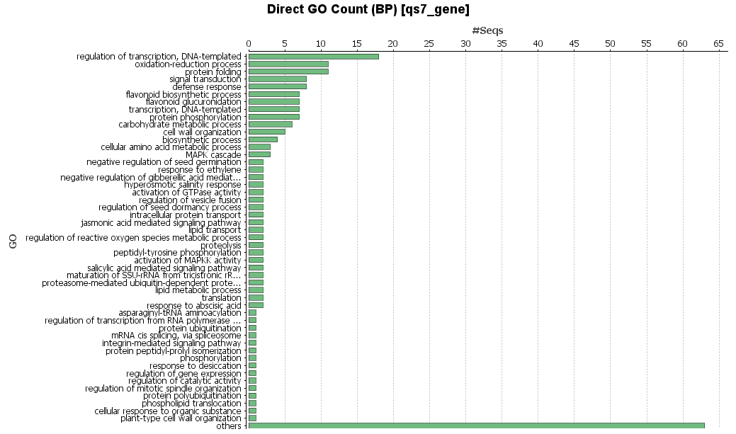
Fig. S11 Biological process GO category for the genes within the region of QTL QS7.

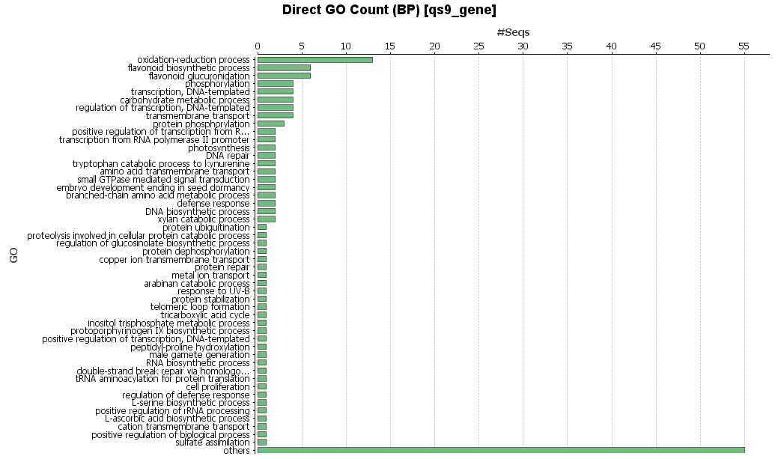
Fig. S12 Biological process GO category for the genes within the region of QTL QS9.

