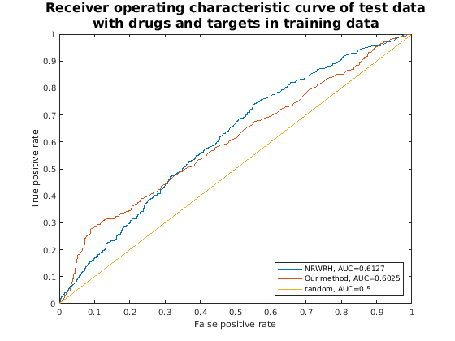
Figure S1. Receiver operating characteristic curve of test data with drugs and targets in training data.
ROC curves for NRWRH method (blue line) and our method (red line) and random(yellow line)

Supplementary Figure 2. Pazopanib and its targets during a STITCH prediction
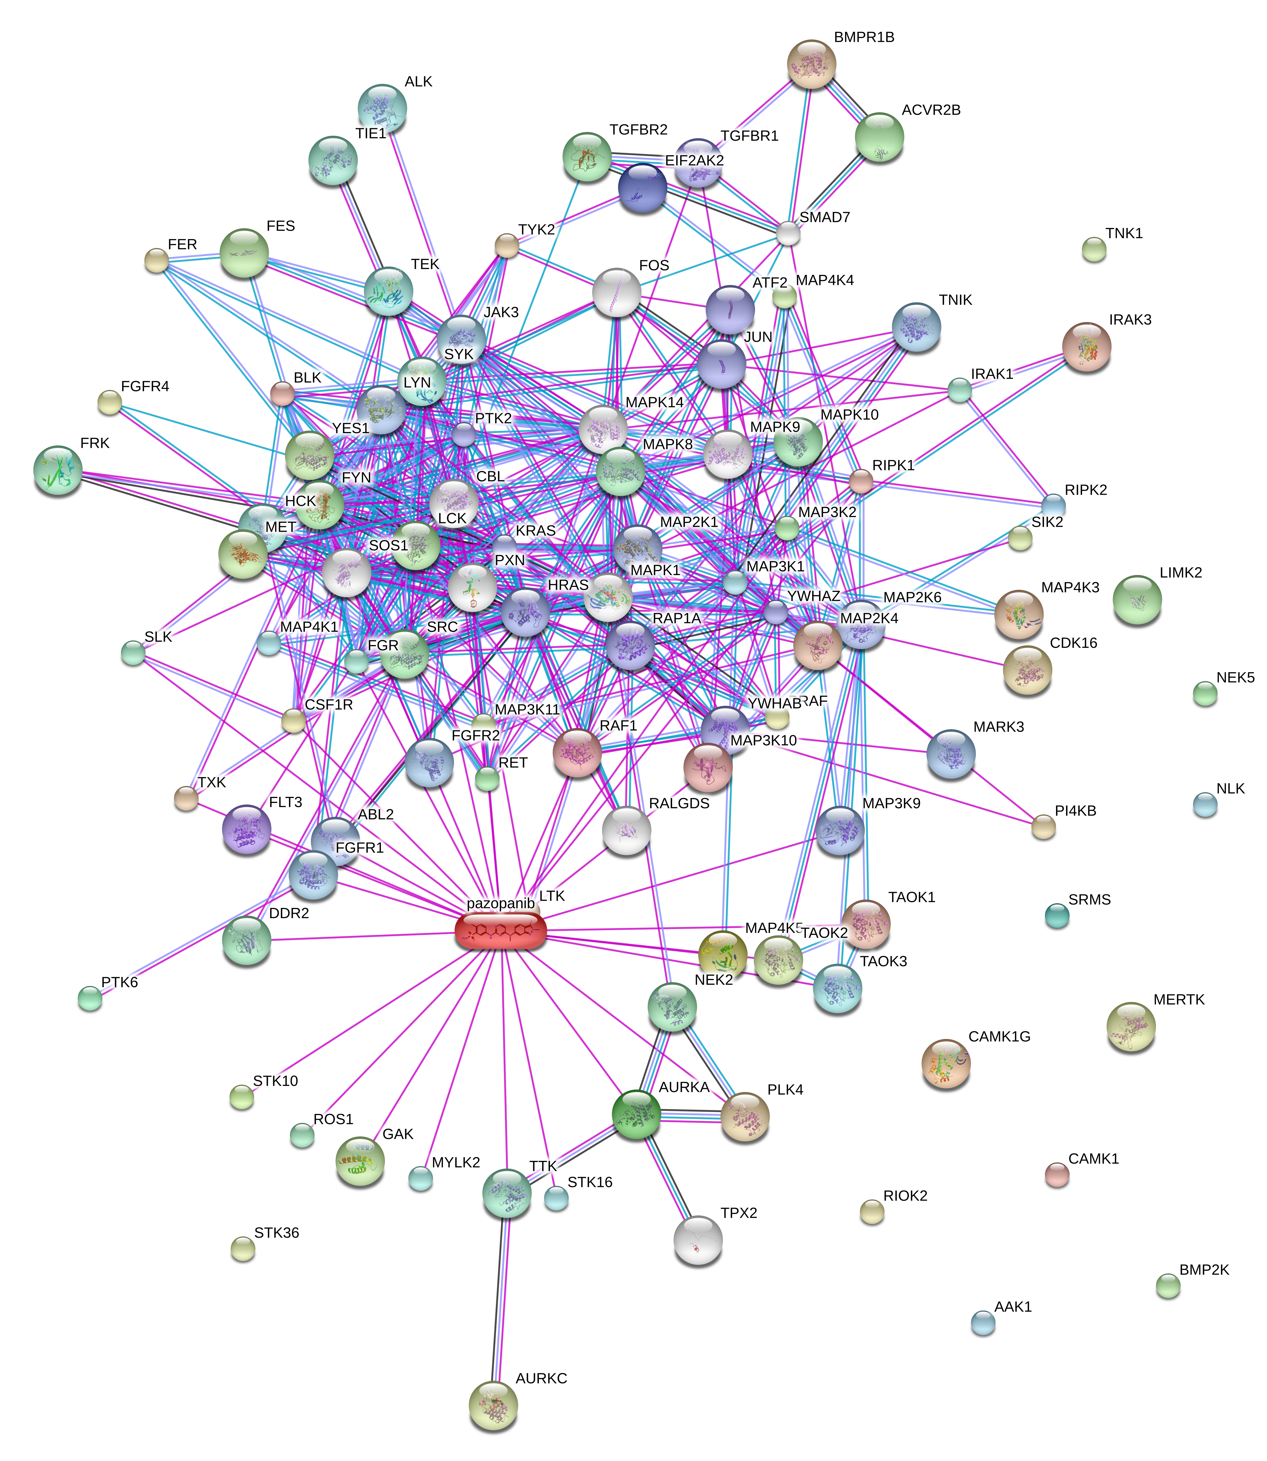
We constructed the PPI and DTI from correctly predicted drug-target interaction. Subnetwork are densely connected, which gives a reason why pazopanib is well predicted.

