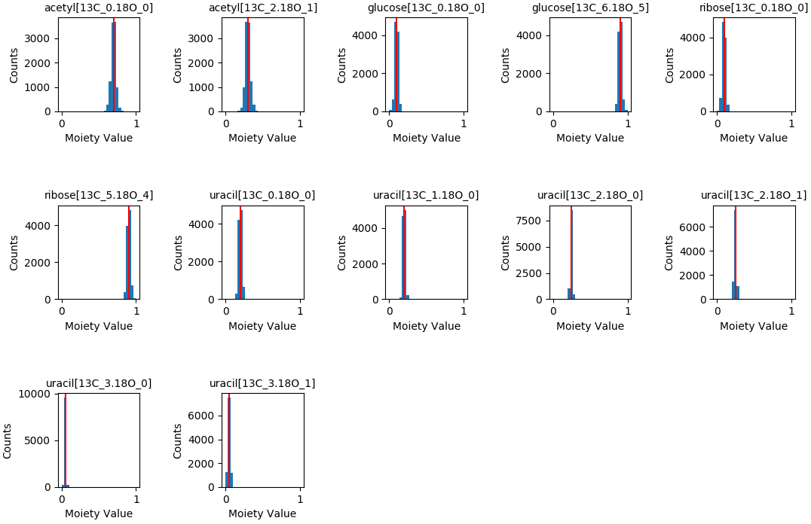
Multi-tracer Optimization Results (additive error σ = 0.001, estimated error propagation = 0.02)

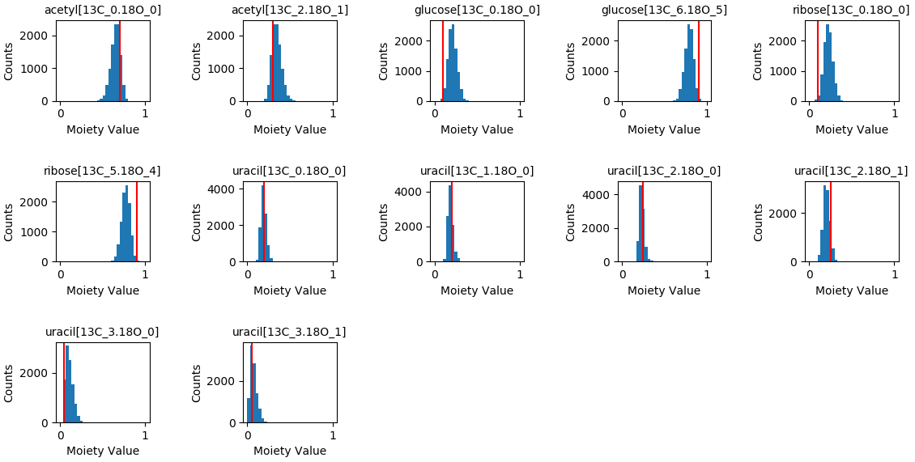
Multi-tracer Optimization Results (additive error σ = 0.01, estimated error propagation = 0.73)

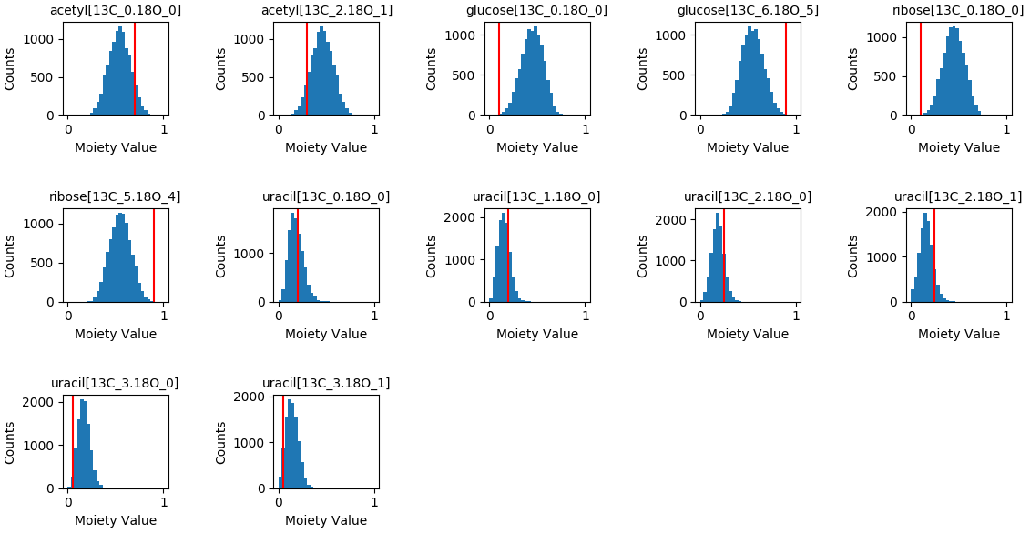
Multi-tracer Optimization Results (additive error σ = 0.1, estimated error propagation = 8.97)

