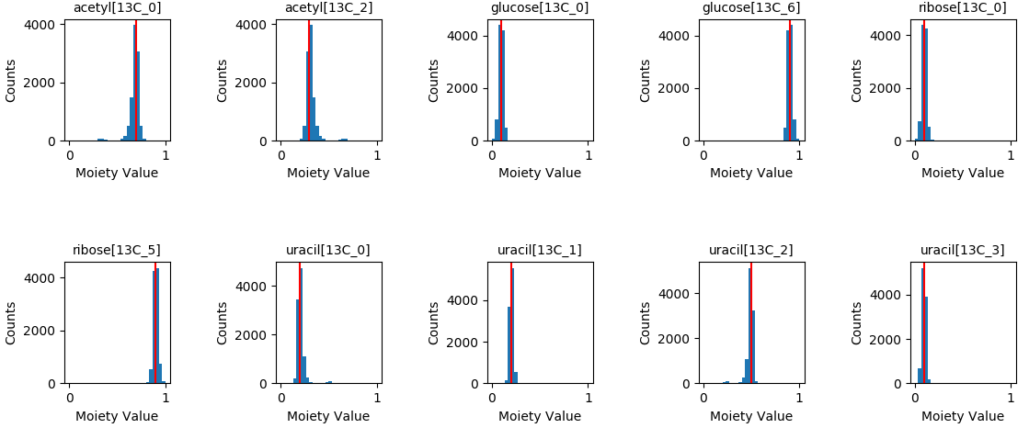
Single-tracer Optimization Results (additive error σ=0.001, estimated error propagation = 0.01)

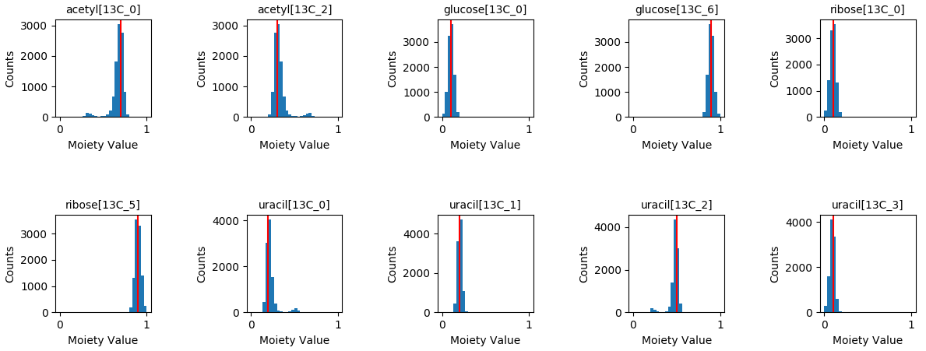
Single-tracer Optimization Results (additive error σ = 0.01, estimated error propagation = 0.02)

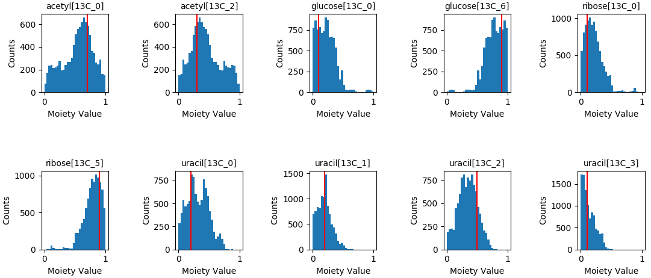
Single-tracer Optimization Results (additive error σ = 0.1, estimated error propagation = 0.50)

