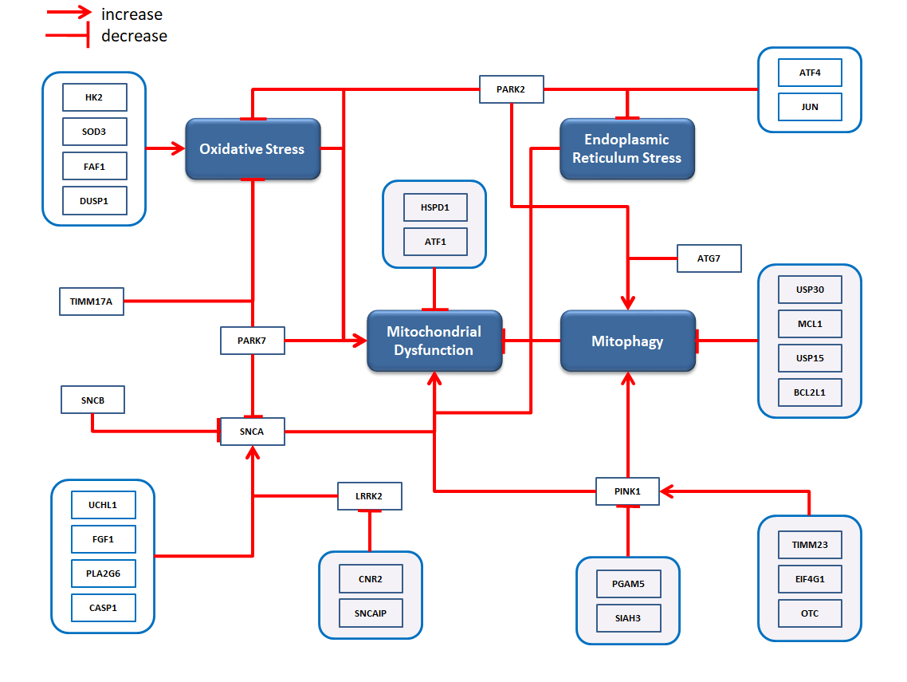
Figure S1. Mitochondrial dysfunction in PD manifests as a consequence of increased oxidative stress and endoplasmic reticulum stress and decreased regulation of mitophagy.

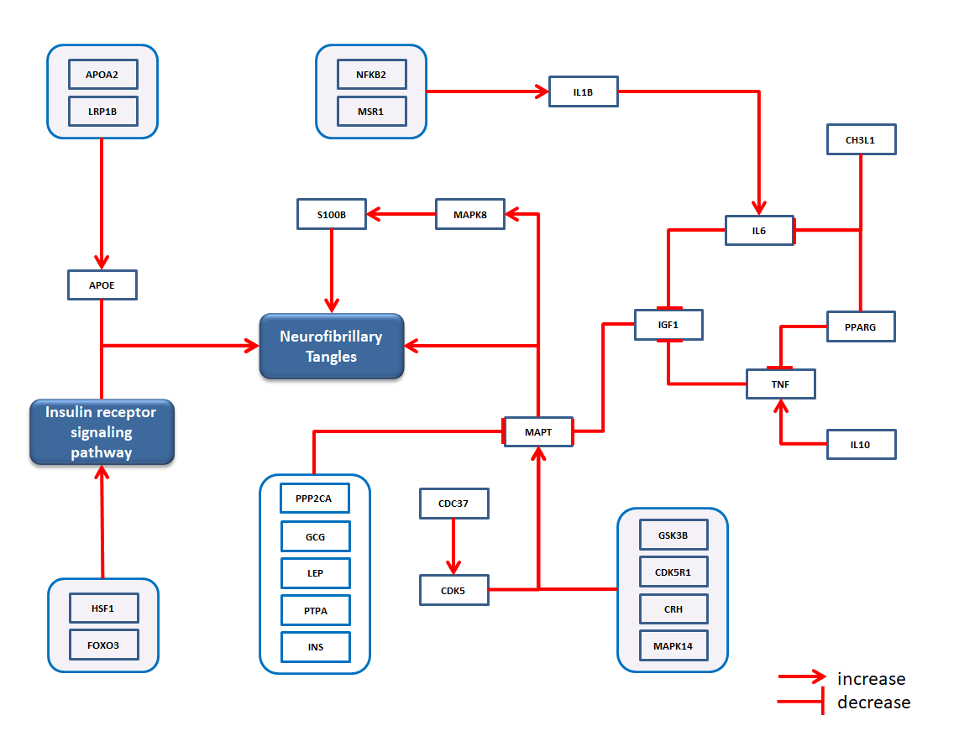
Figure S2. The aggregation of NFTs in AD is triggered by the insulin receptor signaling pathway and several genes that destabilize MAPT activity.

