Additional files：
Notes: These two tables list the differentially expressed genes identified by all compared methods on two datasets, and the relative scores of each gene associated with the disease. Among them, the red is a unique gene for one method.
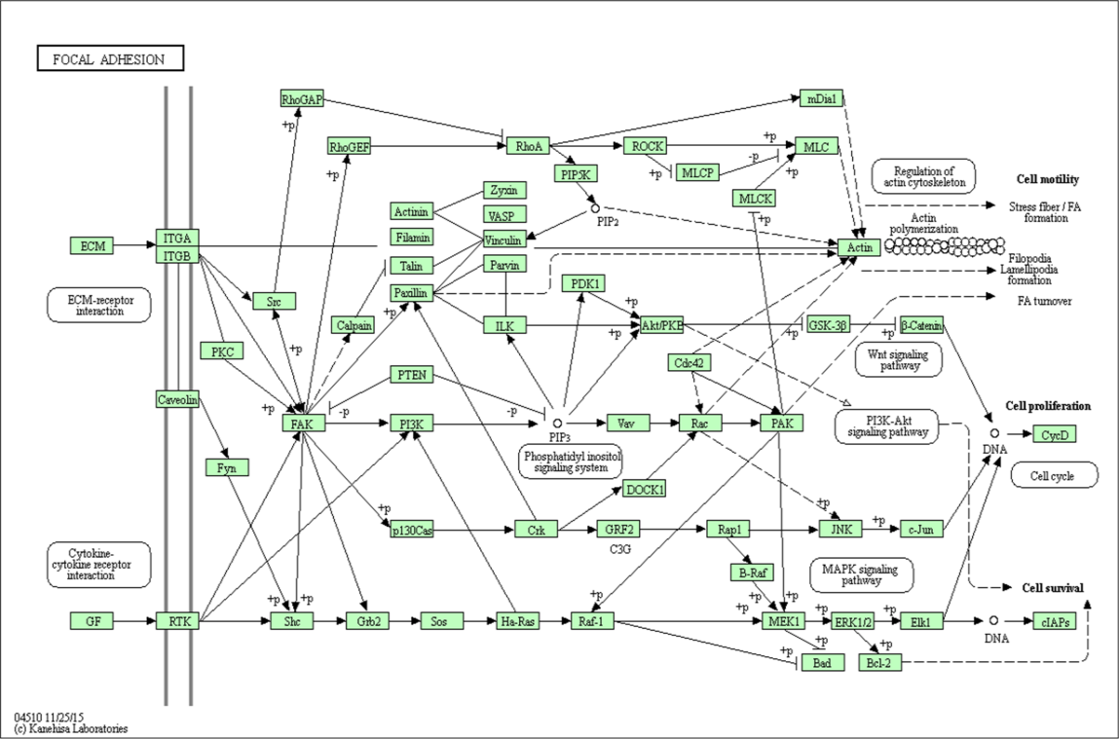
The pathway of focal adhesion. Graphical presentation of the essential role of focal adhesion plays in biological processes.
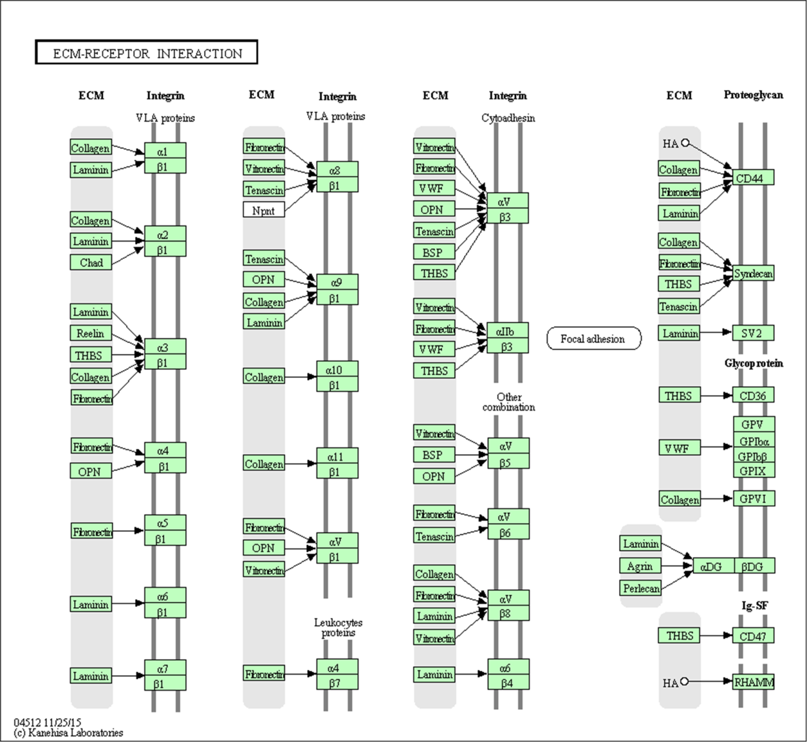
The pathway of ECM-receptor interaction. The extracellular matrix (ECM) is made up of various structural and functional macromolecules, and it also plays a vital role in tissue and organ morphogenesis, as well as the holding of cell and tissue structure and function.
result on HNSC dataset
Z-SPCA | Relevance score | GPower | Relevance score | PathSPCA | Relevance score | SPCArt | Relevance score | GLPCA | Relevance score | GLSPCA | Relevance score
CD44 | 37.28 | KRT19 | 27.05 | CD44 | 37.28 | CD44 | 37.28 | CD44 | 37.28 | CD44 | 37.28
GSTP1 | 32.16 | KRT5 | 21.85 | GSTP1 | 32.16 | GSTP1 | 32.16 | GSTP1 | 32.16 | GSTP1 | 32.16
SLC2A1 | 29.08 | KRT14 | 21.33 | SLC2A1 | 29.08 | SLC2A1 | 29.08 | SLC2A1 | 29.08 | SLC2A1 | 29.08
KRT5 | 21.85 | FN1 | 17.81 | KRT5 | 21.85 | KRT5 | 21.85 | KRT5 | 21.85 | KRT19 | 27.05
KRT14 | 21.33 | GJB2 | 17.25 | KRT14 | 21.33 | KRT14 | 21.33 | KRT14 | 21.33 | KRT5 | 21.85
FN1 | 17.81 | KRT10 | 16.96 | FN1 | 17.81 | FN1 | 17.81 | FN1 | 17.81 | KRT14 | 21.33
CTSD | 17.42 | KRT13 | 16.62 | CTSD | 17.42 | CTSD | 17.42 | HLA-B | 17.38 | FN1 | 17.81
HLA-B | 17.38 | LY6D | 15.88 | HLA-B | 17.38 | HLA-B | 17.38 | GJB2 | 17.25 | CTSD | 17.42
GJB2 | 17.25 | CXCL14 | 14.32 | GJB2 | 17.25 | GJB2 | 17.25 | KRT10 | 16.96 | HLA-B | 17.38
KRT10 | 16.96 | HSPB1 | 13.02 | KRT13 | 16.62 | KRT10 | 16.96 | KRT13 | 16.62 | GJB2 | 17.25
KRT13 | 16.62 | S100A2 | 11.43 | HSP90AA1 | 16.62 | KRT13 | 16.62 | HLA-A | 16.55 | KRT13 | 16.62
HSP90AA1 | 16.62 | CSTA | 10.85 | HLA-A | 16.55 | HSP90AA1 | 16.62 | SDC1 | 14.89 | HSP90AA1 | 16.62
HLA-A | 16.55 | IVL | 9.09 | SDC1 | 14.89 | HLA-A | 16.55 | CTSB | 13.61 | HLA-A | 16.55
SDC1 | 14.89 | S100A9 | 8.87 | CTSB | 13.61 | SDC1 | 14.89 | HSPB1 | 13.02 | SDC1 | 14.89
CTSB | 13.61 | SFN | 8.82 | HSPB1 | 13.02 | CTSB | 13.61 | SPARC | 12.76 | CTSB | 13.61
HSPB1 | 13.02 | ANXA1 | 8.72 | SPARC | 12.76 | HSPB1 | 13.02 | S100A2 | 11.43 | HSPB1 | 13.02
SPARC | 12.76 | KRT4 | 8.22 | H19 | 11.51 | SPARC | 12.76 | LAMC2 | 11.06 | SPARC | 12.76
S100A2 | 11.43 | PKP1 | 7.71 | S100A2 | 11.43 | S100A2 | 11.43 | CSTA | 10.85 | H19 | 11.51
LAMC2 | 11.06 | KRT1 | 7.57 | LAMC2 | 11.06 | LAMC2 | 11.06 | ANXA2 | 9.14 | S100A2 | 11.43
ANXA2 | 9.14 | SLPI | 7.27 | ITGA6 | 10.52 | ANXA2 | 9.14 | S100A9 | 8.87 | LAMC2 | 11.06
S100A9 | 8.87 | PKM | 7.22 | ANXA2 | 9.14 | S100A9 | 8.87 | SFN | 8.82 | ITGA6 | 10.52
SFN | 8.82 | KRT16 | 6.98 | S100A9 | 8.87 | SFN | 8.82 | ANXA1 | 8.72 | ANXA2 | 9.14
ANXA1 | 8.72 | DSG3 | 6.88 | SFN | 8.82 | ANXA1 | 8.72 | KRT4 | 8.22 | S100A9 | 8.87
KRT4 | 8.22 | S100A7 | 6.84 | ANXA1 | 8.72 | KRT4 | 8.22 | PLEC | 8.18 | SFN | 8.82
PLEC | 8.18 | KLK10 | 5.91 | KRT4 | 8.22 | PLEC | 8.18 | PKP1 | 7.71 | ANXA1 | 8.72
PKP1 | 7.71 | TGM3 | 5.84 | PLEC | 8.18 | PKP1 | 7.71 | KRT1 | 7.57 | PLEC | 8.18
KRT1 | 7.57 | LGALS7 | 5.56 | TUBB | 8.03 | KRT1 | 7.57 | HLA-C | 7.46 | TUBB | 8.03
HLA-C | 7.46 | COL1A1 | 5.56 | PKP1 | 7.71 | HLA-C | 7.46 | PKM | 7.22 | PKP1 | 7.71
PKM | 7.22 | YWHAZ | 5.36 | KRT1 | 7.57 | PKM | 7.22 | KRT16 | 6.98 | HSPA1A | 7.67
KRT16 | 6.98 | KRT6A | 5.16 | HLA-C | 7.46 | KRT16 | 6.98 | DSG3 | 6.88 | HLA-C | 7.46
DSG3 | 6.88 | DSG1 | 5.1 | PKM | 7.22 | DSG3 | 6.88 | S100A7 | 6.84 | PKM | 7.22
ENO1 | 6.61 | DSP | 4.94 | KRT16 | 6.98 | ENO1 | 6.61 | ENO1 | 6.61 | KRT16 | 6.98
GNAS | 6.23 | PI3 | 4.93 | DSG3 | 6.88 | GNAS | 6.23 | LDHA | 6.14 | DSG3 | 6.88
LDHA | 6.14 | CSTB | 4.58 | S100A7 | 6.84 | LDHA | 6.14 | CFL1 | 5.56 | ENO1 | 6.61
CFL1 | 5.56 | KRT15 | 4.3 | ENO1 | 6.61 | CFL1 | 5.56 | COL1A1 | 5.56 | LDHA | 6.14
COL1A1 | 5.56 | CRNN | 3.9 | LDHA | 6.14 | COL1A1 | 5.56 | YWHAZ | 5.36 | APP | 5.71
YWHAZ | 5.36 | ACTG1 | 3.75 | APP | 5.71 | YWHAZ | 5.36 | KRT6A | 5.16 | TUBA1B | 5.58
KRT6A | 5.16 | KRT17 | 3.25 | TUBA1B | 5.58 | KRT6A | 5.16 | DSP | 4.94 | CFL1 | 5.56
DSP | 4.94 | TGM1 | 3.12 | CFL1 | 5.56 | DSP | 4.94 | PI3 | 4.93 | COL1A1 | 5.56
PI3 | 4.93 | FTL | 2.56 | COL1A1 | 5.56 | PI3 | 4.93 | CD74 | 4.79 | YWHAZ | 5.36
CD74 | 4.79 | JUP | 2.44 | YWHAZ | 5.36 | CD74 | 4.79 | CSTB | 4.58 | KRT6A | 5.16
CSTB | 4.58 | KRT6B | 2.16 | KRT6A | 5.16 | CSTB | 4.58 | ACTG1 | 3.75 | DSP | 4.94
ACTG1 | 3.75 | COL17A1 | 1.72 | DSP | 4.94 | ACTG1 | 3.75 | ALDOA | 3.42 | PI3 | 4.93
ALDOA | 3.42 | total socres | 378.7 | PI3 | 4.93 | ALDOA | 3.42 | P4HB | 3.38 | CD74 | 4.79
P4HB | 3.38 |  |  | CD74 | 4.79 | P4HB | 3.38 | KRT17 | 3.25 | LAMB3 | 4.51
KRT17 | 3.25 |  |  | CSTB | 4.58 | KRT17 | 3.25 | B2M | 2.91 | KRT15 | 4.3
B2M | 2.91 |  |  | LAMB3 | 4.51 | B2M | 2.91 | MYH9 | 2.78 | COL6A1 | 4.05
MYH9 | 2.78 |  |  | ACTG1 | 3.75 | MYH9 | 2.78 | JUP | 2.44 | ACTG1 | 3.75
FTL | 2.56 |  |  | ITGB4 | 3.61 | FTL | 2.56 | KRT6B | 2.16 | ALDOA | 3.42
JUP | 2.44 |  |  | ALDOA | 3.42 | JUP | 2.44 | COL17A1 | 1.72 | P4HB | 3.38
KRT6B | 2.16 |  |  | P4HB | 3.38 | KRT6B | 2.16 | total socres | 513.94 | TAGLN2 | 3.3
PSAP | 1.83 |  |  | TAGLN2 | 3.3 | PSAP | 1.83 |  |  | KRT17 | 3.25
COL17A1 | 1.72 |  |  | KRT17 | 3.25 | COL17A1 | 1.72 |  |  | B2M | 2.91
total socres | 540.91 |  |  | B2M | 2.91 | total socres | 540.91 |  |  | MYH9 | 2.78
 |  |  |  | MYH9 | 2.78 |  |  |  |  | FTL | 2.56
 |  |  |  | FTL | 2.56 |  |  |  |  | JUP | 2.44
 |  |  |  | JUP | 2.44 |  |  |  |  | KRT6B | 2.16
 |  |  |  | KRT6B | 2.16 |  |  |  |  | PSAP | 1.83
 |  |  |  | PSAP | 1.83 |  |  |  |  | TNC | 1.73
 |  |  |  | TNC | 1.73 |  |  |  |  | COL17A1 | 1.72
 |  |  |  | COL17A1 | 1.72 |  |  |  |  | total socres | 591.31
 |  |  |  | total socres | 579.06
result on PAAD dataset
Z-SPCA | Relevance score | GPower | Relevance score | PathSPCA | Relevance score | SPCArt | Relevance score | GLPCA | Relevance score | GLSPCA | Relevance score
CD44 | 37.28 | KRT19 | 27.05 | CD44 | 37.28 | CD44 | 37.28 | CD44 | 37.28 | CD44 | 37.28
GSTP1 | 32.16 | KRT5 | 21.85 | GSTP1 | 32.16 | GSTP1 | 32.16 | GSTP1 | 32.16 | GSTP1 | 32.16
SLC2A1 | 29.08 | KRT14 | 21.33 | SLC2A1 | 29.08 | SLC2A1 | 29.08 | SLC2A1 | 29.08 | SLC2A1 | 29.08
KRT5 | 21.85 | FN1 | 17.81 | KRT5 | 21.85 | KRT5 | 21.85 | KRT5 | 21.85 | KRT19 | 27.05
KRT14 | 21.33 | GJB2 | 17.25 | KRT14 | 21.33 | KRT14 | 21.33 | KRT14 | 21.33 | KRT5 | 21.85
FN1 | 17.81 | KRT10 | 16.96 | FN1 | 17.81 | FN1 | 17.81 | FN1 | 17.81 | KRT14 | 21.33
CTSD | 17.42 | KRT13 | 16.62 | CTSD | 17.42 | CTSD | 17.42 | HLA-B | 17.38 | FN1 | 17.81
HLA-B | 17.38 | LY6D | 15.88 | HLA-B | 17.38 | HLA-B | 17.38 | GJB2 | 17.25 | CTSD | 17.42
GJB2 | 17.25 | CXCL14 | 14.32 | GJB2 | 17.25 | GJB2 | 17.25 | KRT10 | 16.96 | HLA-B | 17.38
KRT10 | 16.96 | HSPB1 | 13.02 | KRT13 | 16.62 | KRT10 | 16.96 | KRT13 | 16.62 | GJB2 | 17.25
KRT13 | 16.62 | S100A2 | 11.43 | HSP90AA1 | 16.62 | KRT13 | 16.62 | HLA-A | 16.55 | KRT13 | 16.62
HSP90AA1 | 16.62 | CSTA | 10.85 | HLA-A | 16.55 | HSP90AA1 | 16.62 | SDC1 | 14.89 | HSP90AA1 | 16.62
HLA-A | 16.55 | IVL | 9.09 | SDC1 | 14.89 | HLA-A | 16.55 | CTSB | 13.61 | HLA-A | 16.55
SDC1 | 14.89 | S100A9 | 8.87 | CTSB | 13.61 | SDC1 | 14.89 | HSPB1 | 13.02 | SDC1 | 14.89
CTSB | 13.61 | SFN | 8.82 | HSPB1 | 13.02 | CTSB | 13.61 | SPARC | 12.76 | CTSB | 13.61
HSPB1 | 13.02 | ANXA1 | 8.72 | SPARC | 12.76 | HSPB1 | 13.02 | S100A2 | 11.43 | HSPB1 | 13.02
SPARC | 12.76 | KRT4 | 8.22 | H19 | 11.51 | SPARC | 12.76 | LAMC2 | 11.06 | SPARC | 12.76
S100A2 | 11.43 | PKP1 | 7.71 | S100A2 | 11.43 | S100A2 | 11.43 | CSTA | 10.85 | H19 | 11.51
LAMC2 | 11.06 | KRT1 | 7.57 | LAMC2 | 11.06 | LAMC2 | 11.06 | ANXA2 | 9.14 | S100A2 | 11.43
ANXA2 | 9.14 | SLPI | 7.27 | ITGA6 | 10.52 | ANXA2 | 9.14 | S100A9 | 8.87 | LAMC2 | 11.06
S100A9 | 8.87 | PKM | 7.22 | ANXA2 | 9.14 | S100A9 | 8.87 | SFN | 8.82 | ITGA6 | 10.52
SFN | 8.82 | KRT16 | 6.98 | S100A9 | 8.87 | SFN | 8.82 | ANXA1 | 8.72 | ANXA2 | 9.14
ANXA1 | 8.72 | DSG3 | 6.88 | SFN | 8.82 | ANXA1 | 8.72 | KRT4 | 8.22 | S100A9 | 8.87
KRT4 | 8.22 | S100A7 | 6.84 | ANXA1 | 8.72 | KRT4 | 8.22 | PLEC | 8.18 | SFN | 8.82
PLEC | 8.18 | KLK10 | 5.91 | KRT4 | 8.22 | PLEC | 8.18 | PKP1 | 7.71 | ANXA1 | 8.72
PKP1 | 7.71 | TGM3 | 5.84 | PLEC | 8.18 | PKP1 | 7.71 | KRT1 | 7.57 | PLEC | 8.18
KRT1 | 7.57 | LGALS7 | 5.56 | TUBB | 8.03 | KRT1 | 7.57 | HLA-C | 7.46 | TUBB | 8.03
HLA-C | 7.46 | COL1A1 | 5.56 | PKP1 | 7.71 | HLA-C | 7.46 | PKM | 7.22 | PKP1 | 7.71
PKM | 7.22 | YWHAZ | 5.36 | KRT1 | 7.57 | PKM | 7.22 | KRT16 | 6.98 | HSPA1A | 7.67
KRT16 | 6.98 | KRT6A | 5.16 | HLA-C | 7.46 | KRT16 | 6.98 | DSG3 | 6.88 | HLA-C | 7.46
DSG3 | 6.88 | DSG1 | 5.1 | PKM | 7.22 | DSG3 | 6.88 | S100A7 | 6.84 | PKM | 7.22
ENO1 | 6.61 | DSP | 4.94 | KRT16 | 6.98 | ENO1 | 6.61 | ENO1 | 6.61 | KRT16 | 6.98
GNAS | 6.23 | PI3 | 4.93 | DSG3 | 6.88 | GNAS | 6.23 | LDHA | 6.14 | DSG3 | 6.88
LDHA | 6.14 | CSTB | 4.58 | S100A7 | 6.84 | LDHA | 6.14 | CFL1 | 5.56 | ENO1 | 6.61
CFL1 | 5.56 | KRT15 | 4.3 | ENO1 | 6.61 | CFL1 | 5.56 | COL1A1 | 5.56 | LDHA | 6.14
COL1A1 | 5.56 | CRNN | 3.9 | LDHA | 6.14 | COL1A1 | 5.56 | YWHAZ | 5.36 | APP | 5.71
YWHAZ | 5.36 | ACTG1 | 3.75 | APP | 5.71 | YWHAZ | 5.36 | KRT6A | 5.16 | TUBA1B | 5.58
KRT6A | 5.16 | KRT17 | 3.25 | TUBA1B | 5.58 | KRT6A | 5.16 | DSP | 4.94 | CFL1 | 5.56
DSP | 4.94 | TGM1 | 3.12 | CFL1 | 5.56 | DSP | 4.94 | PI3 | 4.93 | COL1A1 | 5.56
PI3 | 4.93 | FTL | 2.56 | COL1A1 | 5.56 | PI3 | 4.93 | CD74 | 4.79 | YWHAZ | 5.36
CD74 | 4.79 | JUP | 2.44 | YWHAZ | 5.36 | CD74 | 4.79 | CSTB | 4.58 | KRT6A | 5.16
CSTB | 4.58 | KRT6B | 2.16 | KRT6A | 5.16 | CSTB | 4.58 | ACTG1 | 3.75 | DSP | 4.94
ACTG1 | 3.75 | COL17A1 | 1.72 | DSP | 4.94 | ACTG1 | 3.75 | ALDOA | 3.42 | PI3 | 4.93
ALDOA | 3.42 | total socres | 378.7 | PI3 | 4.93 | ALDOA | 3.42 | P4HB | 3.38 | CD74 | 4.79
P4HB | 3.38 |  |  | CD74 | 4.79 | P4HB | 3.38 | KRT17 | 3.25 | LAMB3 | 4.51
KRT17 | 3.25 |  |  | CSTB | 4.58 | KRT17 | 3.25 | B2M | 2.91 | KRT15 | 4.3
B2M | 2.91 |  |  | LAMB3 | 4.51 | B2M | 2.91 | MYH9 | 2.78 | COL6A1 | 4.05
MYH9 | 2.78 |  |  | ACTG1 | 3.75 | MYH9 | 2.78 | JUP | 2.44 | ACTG1 | 3.75
FTL | 2.56 |  |  | ITGB4 | 3.61 | FTL | 2.56 | KRT6B | 2.16 | ALDOA | 3.42
JUP | 2.44 |  |  | ALDOA | 3.42 | JUP | 2.44 | COL17A1 | 1.72 | P4HB | 3.38
KRT6B | 2.16 |  |  | P4HB | 3.38 | KRT6B | 2.16 | total socres | 513.94 | TAGLN2 | 3.3
PSAP | 1.83 |  |  | TAGLN2 | 3.3 | PSAP | 1.83 |  |  | KRT17 | 3.25
COL17A1 | 1.72 |  |  | KRT17 | 3.25 | COL17A1 | 1.72 |  |  | B2M | 2.91
total socres | 540.91 |  |  | B2M | 2.91 | total socres | 540.91 |  |  | MYH9 | 2.78
 |  |  |  | MYH9 | 2.78 |  |  |  |  | FTL | 2.56
 |  |  |  | FTL | 2.56 |  |  |  |  | JUP | 2.44
 |  |  |  | JUP | 2.44 |  |  |  |  | KRT6B | 2.16
 |  |  |  | KRT6B | 2.16 |  |  |  |  | PSAP | 1.83
 |  |  |  | PSAP | 1.83 |  |  |  |  | TNC | 1.73
 |  |  |  | TNC | 1.73 |  |  |  |  | COL17A1 | 1.72
 |  |  |  | COL17A1 | 1.72 |  |  |  |  | total socres | 591.31
 |  |  |  | total socres | 579.06

