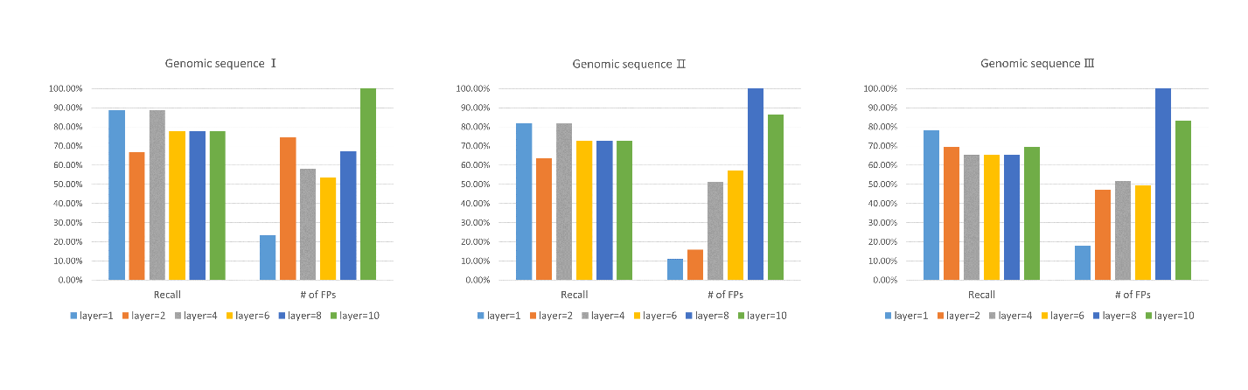
Figure S1 The performance of models with different number of layers. The models with different number of layers are applied to three randomly chosen genomic sequences; the value of recall and number of false positives are calculated.

