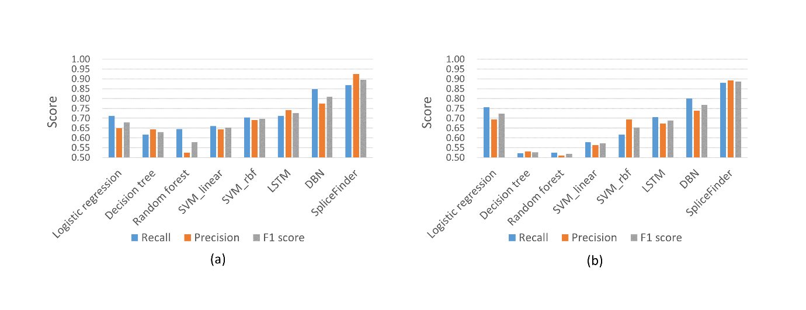
Figure S2 Evaluation of different methods with various metrics. Recall, precision and F1 score for (a) donor sites and (b) acceptor sites are compared among different methods respectively.

