NIMBus Supplementary Document:
Table of Contents
Table S1 2
Figure S1 2
Figure S2 3
Text S1 3
Figure S3 4
Figure S4 5
Table S2 5
Table S3 6
Figure S6 6
Figure S7 7
Figure S8 8
Figure S9 9
Table S4 9
Figure S10 10
Table S5 11
Text S2 13
Citations 14

Table S1. Summary of WGS data
cancer | median | sd
BRCA | 3705 | 7300.526
GACA | 14429.5 | 71372.080
LICA | 8706.5 | 5522.917
LUAD | 21287 | 35610.839
MB | 965 | 1196.036
PA | 70 | 114.414
PRAD | 4927 | 2764.873

Figure S1. Pie chart of sample numbers of the WGS data
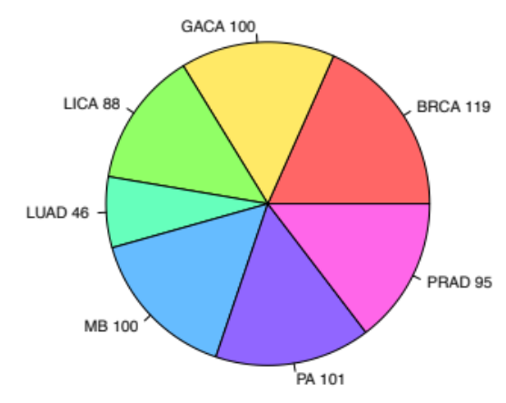

Text S1: Data Sources
Among these samples, 100 stomach cancer samples were from Wang et al [1] and 95 prostate cancer samples were obtained from our collaborators. The remaining comes from samples published by Alexandrov et al [2].

Figure S2. Schematic sketch of optimal and approximate local mutation rate estimation
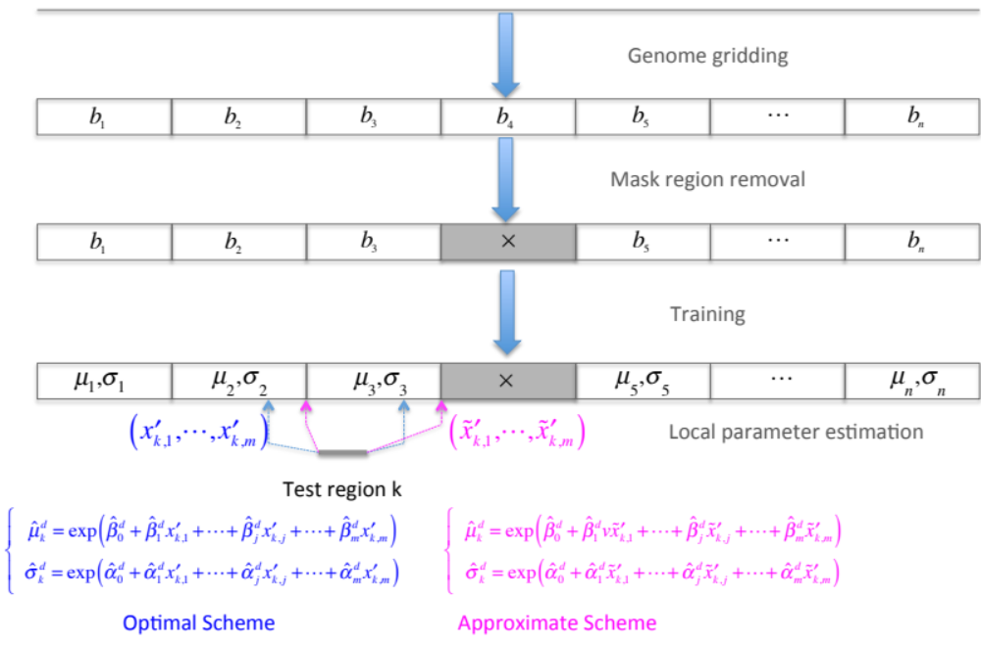

Text S1. Overview of approximation scheme
In real data analysis there are usually millions of regions to be tested and for each region it needs to process 381 features. Hence, the above optimal scheme is usually computational expensive. Here we proposed an approximation scheme to calculate ${\hat{μ}}_{k}^{d}$ and ${\hat{σ}}_{k}^{d}$. Instead of using covariates for the extended bin centered at target region $k$, we used the values for the nearest training bin $\left({\tilde{x}}_{k,1}^{'},⋯,{\tilde{x}}_{k,m}^{'}\right)$ (magenta parts in Fig. S2), and burden tests are performed after length adjustment. Since $\left({\tilde{x}}_{k,1}^{'},⋯,{\tilde{x}}_{k,m}^{'}\right)$ has already been pre-calculated during the training process, our approximation scheme significantly reduced the computation burden for tests.

Figure S3. KS statistic of the observed and fitted mutation counts using Binomial distribution
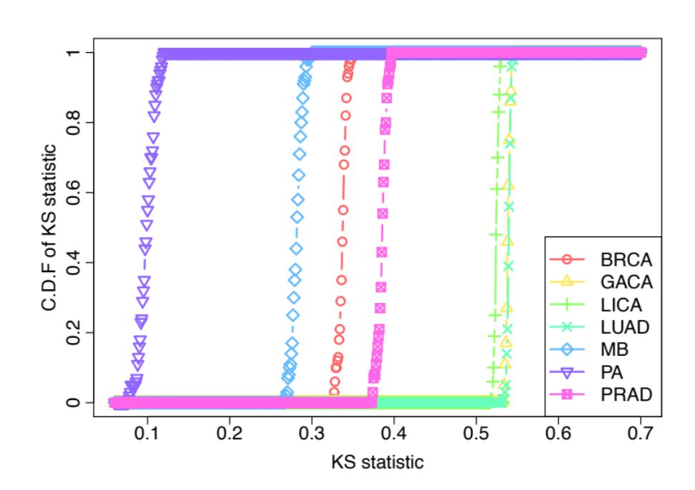
Figure S4. Mutation rates are severely affected by many genomic features in breast cancer in the first 70 1mb bins on chromosome 1. Mutation counts (black line and left y axis) and other genomic features (red line and right y axis) are normalized in a genome-wide way.
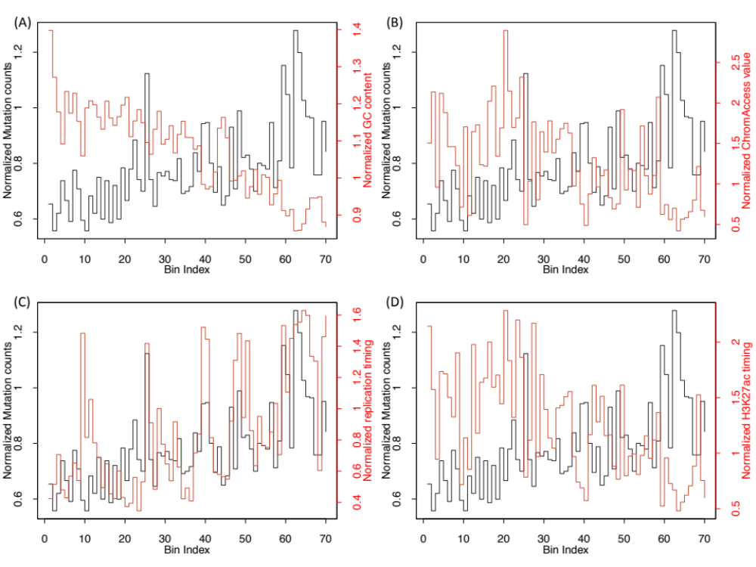

Table S2. Four regression models using matched and unmatched genomic features
_{Mutations} ^{Covariates} | BRCA | MB
BRCA | 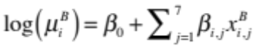 | 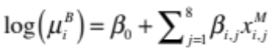
MB | 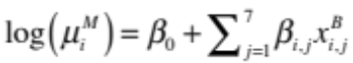 | 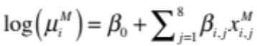

Table S3. Relative error for models using matched and unmatched genomic features
_{Mutations} ^{Covariates} | BRCA | MB
BRCA | 0.128 | 0.135
MB | 0.195 | 0.183

Figure S6. (A) Features in breast and brain related tissues are correlated; (B) scatter plot of observed and predicted mutations by regression for all four models. Red line represents the diagonal line and Pearson correlations are also given.
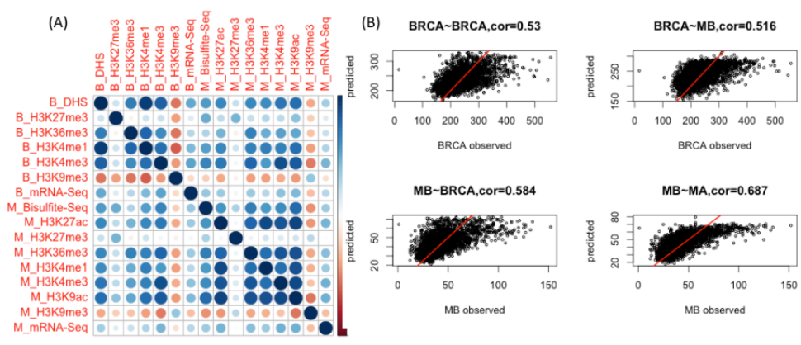
Figure S7. (A) Cumulative proportion of variance explained by the number of PCs; (B) Boxplot of Pearson correlations of top PCs to mutation counts data in different cancer types.
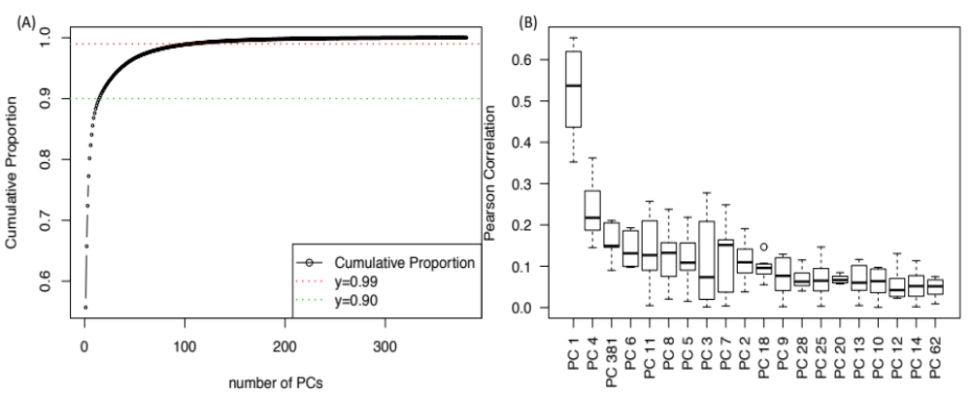

Figure S8. Scatter plot of observed and predicted mutation rate. Red line represents the diagonal line.
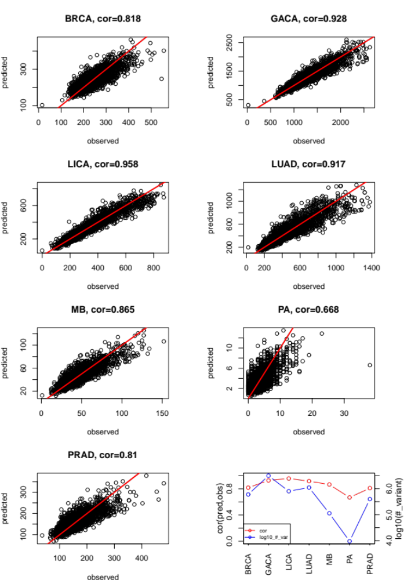

Figure S9. Example of protein coding gene merging
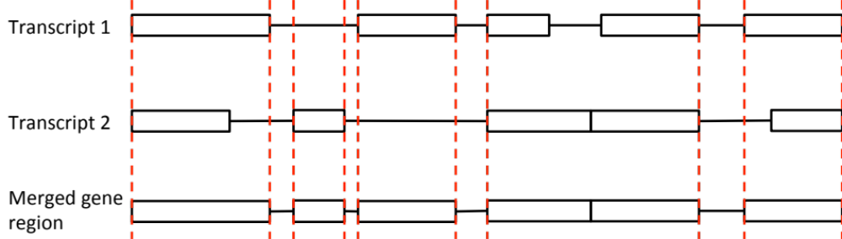

Table S4 significant genes after P value combination
Rank | Gene | Adjust P | PubMed ID
1 | TP53 | 4.33E-139 | 17401424
2 | DDX3X | 3.65E-18 | 22820256
3 | KRAS | 2.56097E-06 | 19847166
4 | MUC4 | 4.46636E-06 | 19935676
5 | CDH1 | 3.06519E-05 | 10973239
6 | ARID1A | 0.000236255 | 22037554
7 | SMARCA4 | 0.000377726 | 18386774
8 | FGFR1 | 0.000742868 | 23817572
9 | OTOP1 | 0.003694811 | NA
10 | SPOP | 0.004493795 | 22610119
11 | STK11 | 0.004493795 | 15021901
12 | PTEN | 0.004812088 | 9697695
13 | SMO | 0.012684045 | 9422511
14 | TAS2R31 | 0.033983962 | NA
15 | TBC1D29 | 0.034276895 | NA

Figure S10. Q-Q plots of gene regions on real and simulated data

Table S5. Cancer type and assay matching

ENCODE DNase | PCAWG cancer type
SK-MEL-5_ENCSR000FEK_rep1 | Skin-Melanoma
SK-MEL-5_ENCSR000FEK_rep2 | Skin-Melanoma
HeLa-S3_ENCSR000ENO_rep1 | Cervix-AdenoCA
HeLa-S3_ENCSR000ENO_rep2 | Cervix-AdenoCA
HeLa-S3_ENCSR000EJT_rep1 | Cervix-AdenoCA
MCF-7_ENCSR000EPH_rep1 | Breast-AdenoCa
MCF-7_ENCSR000EPH_rep2 | Breast-AdenoCa
MCF-7_ENCSR000EPJ_rep1 | Breast-AdenoCa
MCF-7_ENCSR000EPJ_rep2 | Breast-AdenoCa
MCF-7_ENCSR000EKX_rep1 | Breast-AdenoCa
MCF-7_ENCSR000EKW_rep1 | Breast-AdenoCa
MCF-7_ENCSR000EKV_rep1 | Breast-AdenoCa
MCF-7_ENCSR000EKZ_rep1 | Breast-AdenoCa
T47D_ENCSR000ELT_rep1 | Breast-AdenoCa
PC-9_ENCSR940NLN_rep1 | Lung-AdenoCA
PC-9_ENCSR940NLN_rep2 | Lung-AdenoCA
Karpas-422_ENCSR019JDO_rep2 | Lymph-BNHL
Karpas-422_ENCSR019JDO_rep1 | Lymph-BNHL
CMK_ENCSR000EMN_rep1 | Myeloid-AML
Caco-2_ENCSR000EMI_rep1 | ColoRect-AdenoCA
Caco-2_ENCSR000EMI_rep2 | ColoRect-AdenoCA
K562_ENCSR000EKP_rep1 | Myeloid-AML
K562_ENCSR000EKQ_rep1 | Myeloid-AML
K562_ENCSR000EKS_rep1 | Myeloid-AML
K562_ENCSR000EPC_rep1 | Myeloid-AML
K562_ENCSR000EPC_rep2 | Myeloid-AML
K562_ENCSR921NMD_rep1 | Myeloid-AML
K562_ENCSR921NMD_rep2 | Myeloid-AML
Panc1_ENCSR000EPT_rep1 | Panc-AdenoCA
Panc1_ENCSR000EPT_rep2 | Panc-AdenoCA
HCT116_ENCSR000ENM_rep2 | ColoRect-AdenoCA
HCT116_ENCSR000ENM_rep1 | ColoRect-AdenoCA
WERI-Rb-1_ENCSR000EQL_rep1 | ###
WERI-Rb-1_ENCSR000EQL_rep2 | ###
OCI-LY7_ENCSR489NAM_rep1 | Lymph-BNHL
OCI-LY7_ENCSR489NAM_rep2 | Lymph-BNHL
HepG2_ENCSR000EJV_rep1 | Liver-HCC
HepG2_ENCSR000ENP_rep1 | Liver-HCC
HepG2_ENCSR000ENP_rep2 | Liver-HCC
HAP-1_ENCSR620QNS_rep1 | Myeloid-MPN
HAP-1_ENCSR620QNS_rep2 | Myeloid-MPN
A549_ENCSR000EIE_rep1 | Lung-SCC
A549_ENCSR000ELW_rep1 | Lung-SCC
A549_ENCSR000ELW_rep2 | Lung-SCC
NT2-D1_ENCSR000EPS_rep2 | ###
NT2-D1_ENCSR000EPS_rep1 | ###
SJCRH30_ENCSR700ILE_rep1 | ###
BE2C_ENCSR000EMD_rep1 | ###
BE2C_ENCSR000EMD_rep2 | ###
HL-60_ENCSR000ENU_rep2 | Myeloid-AML
HL-60_ENCSR000ENU_rep1 | Myeloid-AML
SK-N-MC_ENCSR000EPY_rep1 | ###
SK-N-MC_ENCSR000EPY_rep2 | ###
LNCaP-clone-FGC_ENCSR000EKT_rep1 | Prost-AdenoCA
LNCaP-clone-FGC_ENCSR000EPF_rep1 | Prost-AdenoCA
LNCaP-clone-FGC_ENCSR000EPF_rep2 | Prost-AdenoCA
Daoy_ENCSR346IHH_rep2 | CNS-Medullo
Daoy_ENCSR346IHH_rep1 | CNS-Medullo
KBM-7_ENCSR426IEA_rep2 | Myeloid-MPN
KBM-7_ENCSR426IEA_rep1 | Myeloid-MPN

Text S2: Benchmarking Methods Details
First, the intersection was found between burdened noncoding regions identified by NIMBus and identified by using OncodriveFML. Secondly, the intersection was found between burdened noncoding regions identified by NIMBus and the PCAWG Consortium [3]. The CDS regions from the PCAWG data were not used for this comparison. Furthermore, two cancers analyzed by NIMBus (Cervix-AdenoCA and Myeloid-AML) were not available for direct comparison in the PCAWG data. Meta-Adenocarcinoma and Meta-Myeloid were available in the PCAWG data, but are broader in scope than the cancer types used in NIMBus. Thus, Cervix-AdenoCA and Myeloid-AML were excluded from this comparison.
Lastly, the shared burdened regions and the regions unique to each method (NIMBus, OncodriveFML, and the PCAWG Consortium) were compared to the Tier 1 and Tier 2 cancer genes as identified by the COSMIC Cancer Gene Census [4]. Tier 1 genes possess strong experimental support as being related to cancer whereas Tier 2 genes possess developing experimental evidence.

Citations

1. Wang K, Yuen ST, Xu J, Lee SP, Yan HH, Shi ST, Siu HC, Deng S, Chu KM, Law S et al: Whole-genome sequencing and comprehensive molecular profiling identify new driver mutations in gastric cancer. Nat Genet 2014, 46(6):573-582.
2. Alexandrov LB, Nik-Zainal S, Wedge DC, Aparicio SA, Behjati S, Biankin AV, Bignell GR, Bolli N, Borg A, Borresen-Dale AL et al: Signatures of mutational processes in human cancer. Nature 2013, 500(7463):415-421.
3. Consortium ITP-CAoWG: Pan-cancer analysis of whole genomes. Nature 2020, 578(7793):82-93.
4. Tate JG, Bamford S, Jubb HC, Sondka Z, Beare DM, Bindal N, Boutselakis H, Cole CG, Creatore C, Dawson E et al: COSMIC: the Catalogue Of Somatic Mutations In Cancer. Nucleic Acids Res 2019, 47(D1):D941-D947.

