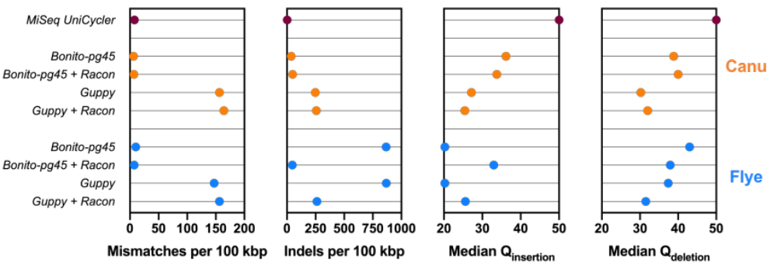
Supplementary Figure 1: In-depth analyses of de novo consensus genomes between the Canu and Flye assemblers, with or without four rounds of Racon. While both Canu and Flye result in a similar number of mismatches (per 100 kbp), significantly more indels (per 10 kbp) are observed when implementing the Flye assembler in the bioinformatics workflow. Decreased Flye performance is suggested to lie within decreased insertion accuracies as compared to Canu. Implementation of four rounds of Racon allows increased Flye insertion Q-scores when custom-pg45 basecalling is used. However, Canu without four rounds of Racon still results in an overall better performance.

