Supplementary Information

An automated protocol for modelling peptide substrates to proteases

Rodrigo Ochoa^{1,2}, Mikhail Magnitov^{2,#}, Roman A. Laskowski², Pilar Cossio^{1,3}, Janet M. Thornton²

¹Biophysics of Tropical Diseases, Max Planck Tandem Group, University of Antioquia, 050010 Medellín, Colombia.

²European Molecular Biology Laboratory, European Bioinformatics Institute (EMBL-EBI), Wellcome Trust Genome Campus, Hinxton, Cambridge CB10 1SD, United Kingdom

³Department of Theoretical Biophysics, Max Planck Institute of Biophysics, 60438 Frankfurt am Main, Germany.

#Current address: Department of Biological and Medical Physics, Moscow Institute of Physics and Technology (National Research University), Dolgoprudny 141701, Russia.

Supplementary Figures

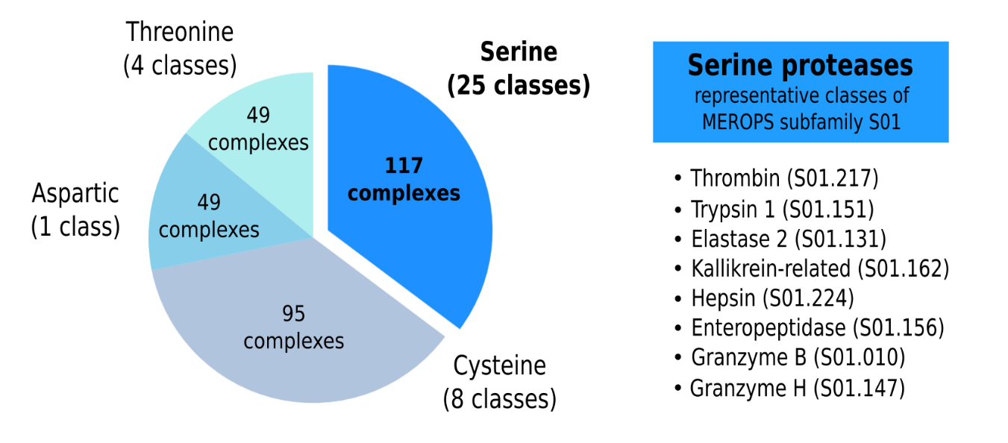
Fig. S1. Distribution of the structures detected during the annotation phase. The serine proteases are the most diverse group with 117 crystal structures covering 25 classes from MEROPS database, where the subfamily S01 of serine endopeptidases is the most representative.
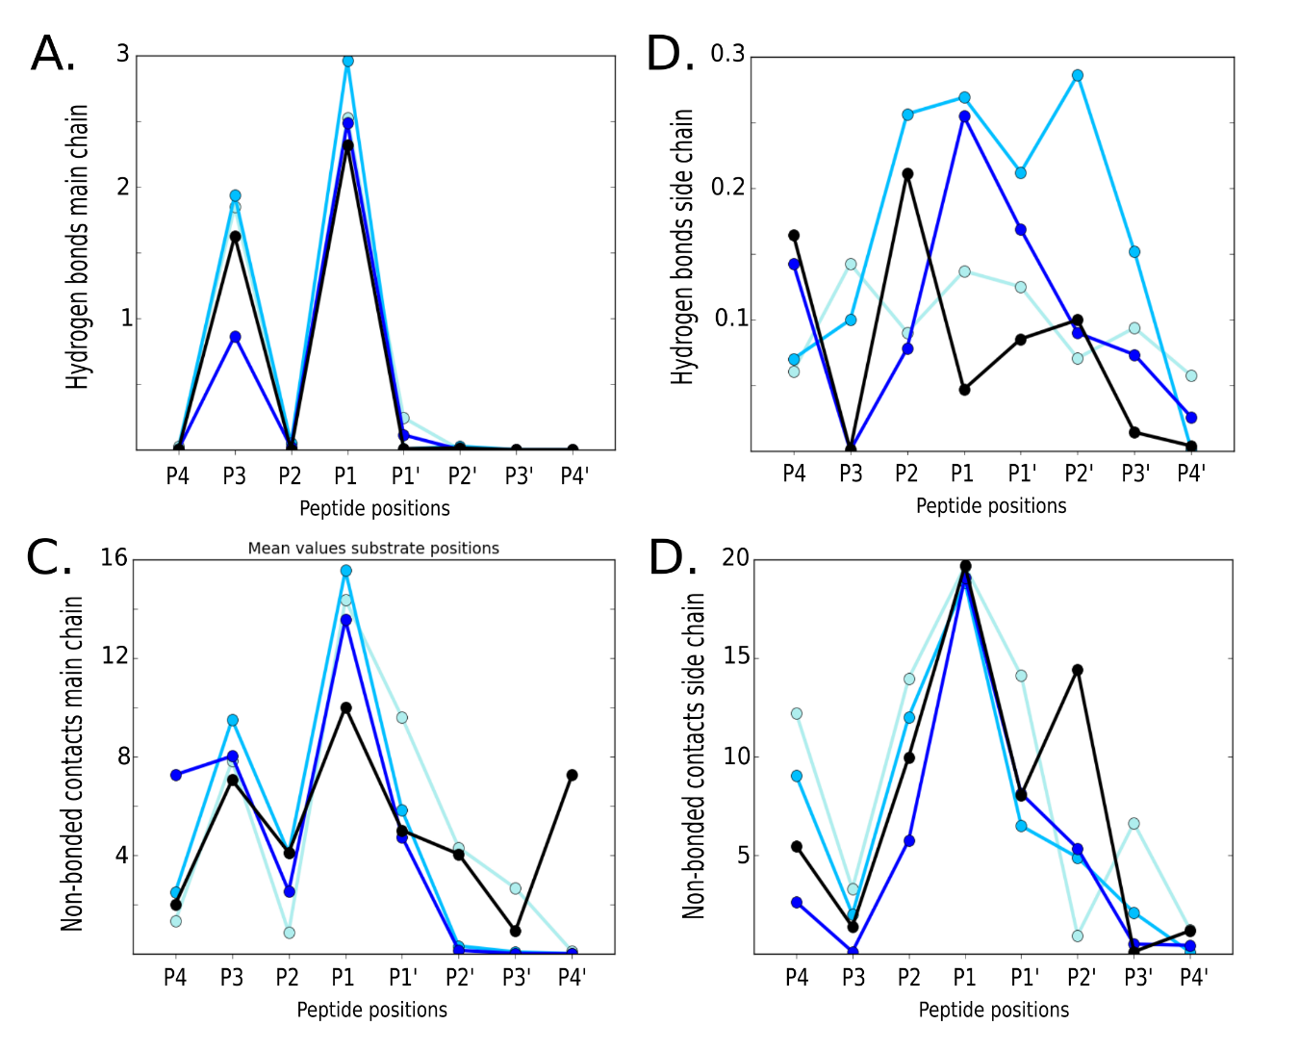
Fig. S2. Mean values of structural observables at each position of the peptides modelled for structures 4dt7 (MEROPS id S01.217) in turquoise, 1iau (MEROPS id S01.010) in sky blue, 1tps (MEROPS id S01.151) in blue, and 1ppg (MEROPS id S01.131) in black. The observables included are the number of hydrogen bonds between the protein and the peptide’s main chain (A) and side chain atoms, and the number of non-bonded contacts between the protein and the peptide’s main chain (C) and side chain atoms.

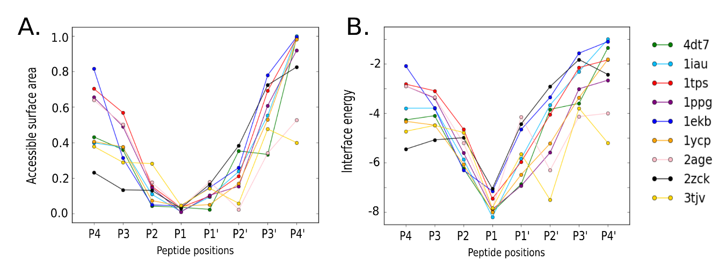
Fig. S3. Mean values of structural observables at each position of the peptides modelled for structures 4dt7 (MEROPS id S01.217) in green, 1iau (MEROPS id S01.010) in cyan, 1tps (MEROPS id S01.151) in red, 1ppg (MEROPS id S01.131) in purple, 1ekb (MEROPS id S01.156) in blue, 1ycp (MEROPS id S01.217) in gold, 2age (MEROPS id S01.151) in pink, 2zck (MEROPS id S01.162) in black, and 3tjv (MEROPS id S01.147) in yellow. The observables included are the interaction energy calculated using the Rosetta scoring function (A), and the relative accessible surface area -ASA (B).

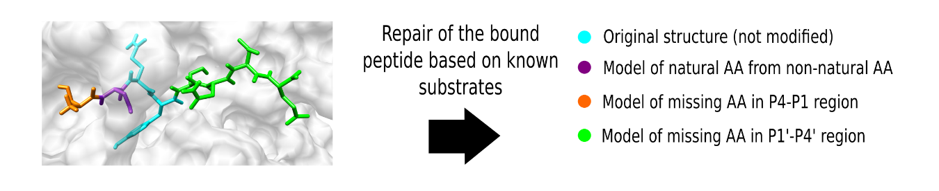
Fig. S4. Schematic of the substrate modelling, including the original crystal structure (cyan), the modelled natural AA instead of the non-natural AA present (purple), and the model of missing amino acids in the P4-P1 region (orange) and P1’-P4’ region (green).

Supplementary Tables
Table S1. List of annotated serine proteases structure from PDB, including the id, ligand sequence, ligand size, ligand chain, ligand residue numbers, protein chains, protein residues, EC number, CATH domains, Pfam domains, UniProt id, MEROPS id, catalytic residues, catalytic roles, structure index, truncated ligand sequence, truncated ligand numbering and. truncated pocket names. [The table is available as an external xlsx file].

Table S2. List of annotated cysteine proteases structure from PDB, including the id, ligand sequence, ligand size, ligand chain, ligand residue numbers, protein chains, protein residues, EC number, CATH domains, Pfam domains, UniProt id, MEROPS id, catalytic residues, catalytic roles, structure index, truncated ligand sequence, truncated ligand numbering and. truncated pocket names. [The table is available as an external xlsx file].

Table S3. List of annotated aspartic proteases structure from PDB, including the id, ligand sequence, ligand size, ligand chain, ligand residue numbers, protein chains, protein residues, EC number, CATH domains, Pfam domains, UniProt id, MEROPS id, catalytic residues, catalytic roles, structure index, truncated ligand sequence, truncated ligand numbering and. truncated pocket names. [The table is available as an external xlsx file].

Table S4. List of annotated threonine proteases structure from PDB, including the id, ligand sequence, ligand size, ligand chain, ligand residue numbers, protein chains, protein residues, EC number, CATH domains, Pfam domains, UniProt id, MEROPS id, catalytic residues, catalytic roles, structure index, truncated ligand sequence, truncated ligand numbering and. truncated pocket names. [The table is available as an external xlsx file].

Table S5. List of serine protease structures with peptides modelled. The MEROPS id, substrate UniProt id and the peptide sequences after modelling are provided.
PDB | MEROPS | Template | Model | Substrate UniProt id
1dx5 | S01.217 | -EGR---- | LEGRYFSG | P31431
1ekb | S01.156 | -DDK---- | DDDKIVGG | P35030
1iau | S01.010 | IEPD---- | IEPDTDAP | P50502
1iau | S01.010 | IEPE---- | IEPESGKS | Q8WXA9
1nrs | S01.217 | LDPR---- | LDPRSFLL | P25116
1ppg | S01.131 | AAPA---- | AAPAAAPP | P16403
1tmt | S01.217 | -EPR---- | IEPRSFSQ | P00451
1tmt | S01.217 | -DPR---- | VDPRLIDG | P04070
1tmt | S01.217 | -SPR---- | LSPRTFHP | P12259
1tps | S01.151 | -LTREL-- | FLTRELAE | P23396
1tps | S01.151 | -PTREL-- | APTRELAQ | P60842
1ycp | S01.217 | -GVRGP-- | GGVRGPRV | P02671
1z8g | S01.224 | KQLR---- | KQLRVVNG | P14210
2age | S01.151 | AAPR---- | AAPRELGL | Q9BTD8
2age | S01.151 | AAPR---- | AAPRERTT | Q13895
2age | S01.151 | AAPR---- | AAPRTFLR | Q9UDY2
2agg | S01.151 | AAPK---- | AAPKVRFM | P61088
2agg | S01.151 | AAPK---- | AAPKRVEI | Q9UHD8
2agi | S01.151 | -LLK---- | ALLKNYGL | P01242-3
2agi | S01.151 | -LLR---- | LLLRRKFF | Q9Y490
2agi | S01.151 | -LLR---- | ELLRSAQP | Q9Y490
2hgt | S01.217 | -NPR---- | FNPRTFGS | P00734
2hgt | S01.217 | -KPR---- | IKPRIVGG | P03951
2hgt | S01.217 | -RPR---- | LRPRFKII | P00749
2zck | S01.162 | -SQY---- | SSQYSNTE | P04279
3bf6 | S01.217 | -FPR---- | AFPRVKPA | Q12905
3hat | S01.217 | QGVR---- | QGVRGYPT | Q8NBS9
3qdz | S01.217 | PAPR---- | PAPRGYPG | Q96RI0
3vxe | S01.217 | -VPR---- | VVPRGVNL | P00488
3vxe | S01.217 | -SPR---- | LSPRGVHI | P17936
3vxe | S01.217 | -HPR---- | AHPRIISA | P24593
4boh | S01.217 | -KPR---- | IKPRIVGG | P03951
4boh | S01.217 | -KPR---- | LKPRVGKA | P42285
4dt7 | S01.217 | VDPRL--- | VDPRLIDG | P04070

Table S6. List of cysteine protease structures with peptides modelled. The MEROPS id, substrate UniProt id and the peptide sequences after modelling are provided.
PDB | MEROPS | Template | Model | Substrate UniProt id
4qu9 | C14.003 | DEVD---- | DEVDGVDE | P09874
4qu9 | C14.003 | DEVD---- | DEVDSKRL | Q01082
4qu9 | C14.003 | DEVD---- | DEVDNKVK | P78527
4jr2 | C14.004 | DEVD---- | DEVDGLGV | P46940
2j31 | C14.003 | DEVD---- | DEVDGMAG | P35251
2j31 | C14.003 | DEVD---- | DEVDSLMC | Q16513
2j31 | C14.003 | DEVD---- | DEVDKMCH | Q04759
2j30 | C14.003 | DEVD---- | DEVDGLGV | P46940
2j30 | C14.003 | DEVD---- | DEVDQDGN | Q9Y6H5
2j30 | C14.003 | DEVD---- | DEVDGEEQ | Q9UEE9
2j33 | C14.003 | DEVD---- | DEVDSLKE | Q15056
3d6m | C14.001 | CVAD---- | CVADALGA | Q96JH7
4dco | C14.003 | DEVD---- | DEVDGMAG | P35251
4hva | C14.005 | VEID---- | VEIDNGKQ | P02545
1f1j | C14.004 | DEVE---- | DEVELARI | O15355
2h5j | C14.003 | DMQD---- | DMQDNSGT | Q05655
2cnn | C14.003 | IETD---- | IETDKATI | P10515
2c2z | C14.009 | LETD---- | LETDGGGP | Q8WUI4
4jr0 | C14.003 | DEVD---- | DEVDGVDE | P09874
4dcp | C14.003 | DEVD---- | DEVDSLKE | Q15056
2ql7 | C14.004 | IEPD---- | IEPDTPGR | Q15149
3h11 | C14.009 | IETD---- | IETDSGVD | P42574
4jr1 | C14.004 | DEVE---- | DEVERVIT | P62269

Table S7. Average Spearman correlation between the structural observables and the entropy calculated from the experimental cleavage data for the four serine protease subfamily classes 4dt7 (MEROPS id S01.217), 1iau (MEROPS id S01.010), 1tps (MEROPS id S01.151) and 1ppg (MEROPS id S01.131).
Observable | Average Spearman correlation
Relative ASA | 0.3
Interface energy | 0.22
Hydrogen bonds main chain | -0.45
Hydrogen bonds side chain | -0.17
Non-bonded contacts main chain | -0.25
Non-bonded contacts side chain | -0.35

