Additional file 1

Supplementary Figures

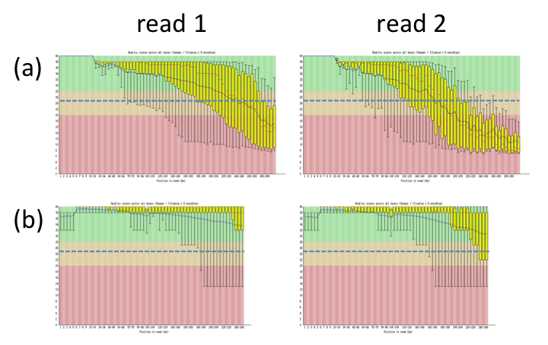
Figure S1. Quality profiles of (a) our real MiSeq 2×300 bp and (b) NCBI SRA HiSeq 2×250 bp reads obtained using FastQC. The blue solid lines indicate mean quality and the blue dashed lines stand for Q25.

- True positive rate  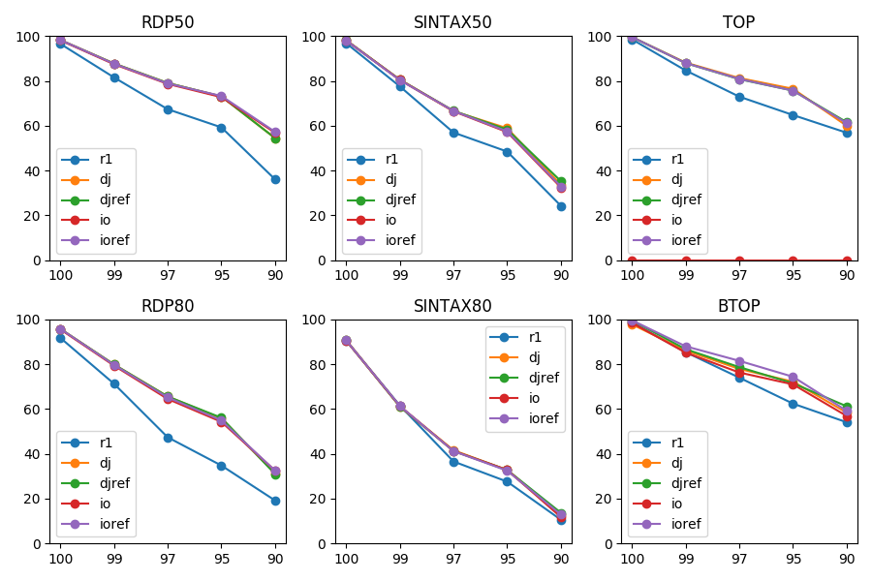 | - Under-classification rate  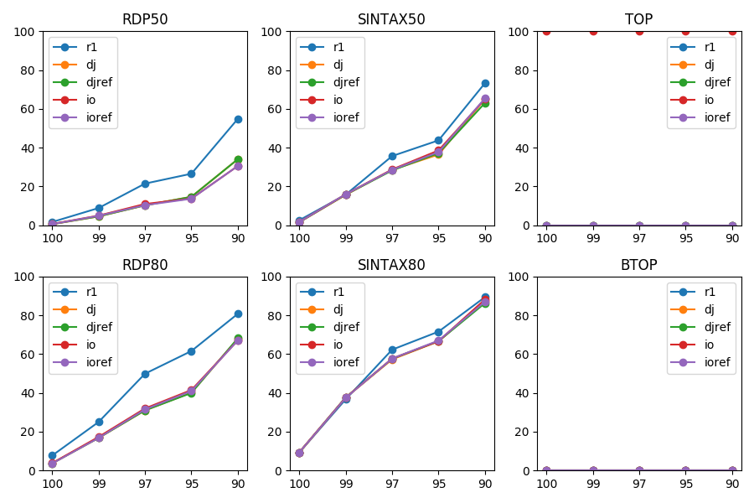
- Over-classification rate  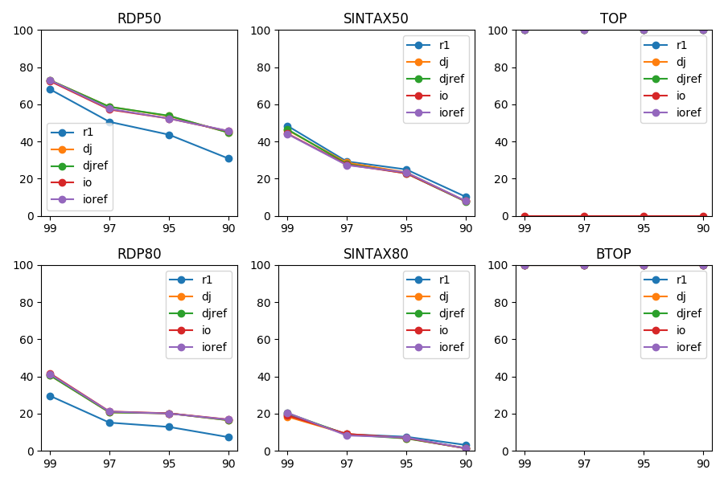 | - Misclassification rate  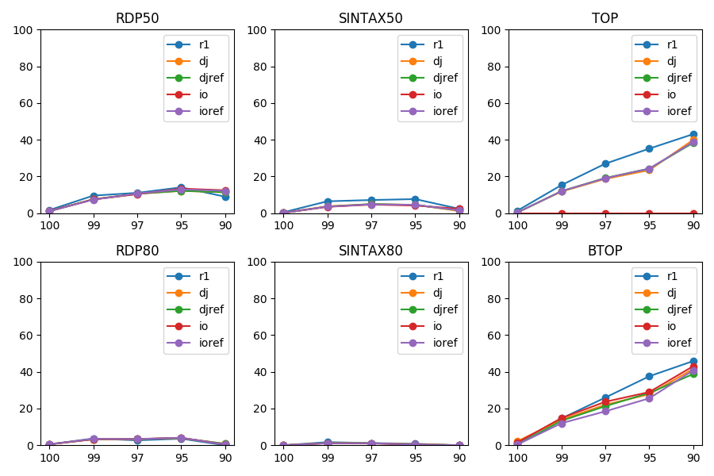
Figure S2. Performance metrics (y-axis) for genus prediction of different types of simulated MiSeq data by six classification methods at different top-hit identities (x-axis) for the V3-V5 primer pair.

- True positive rate  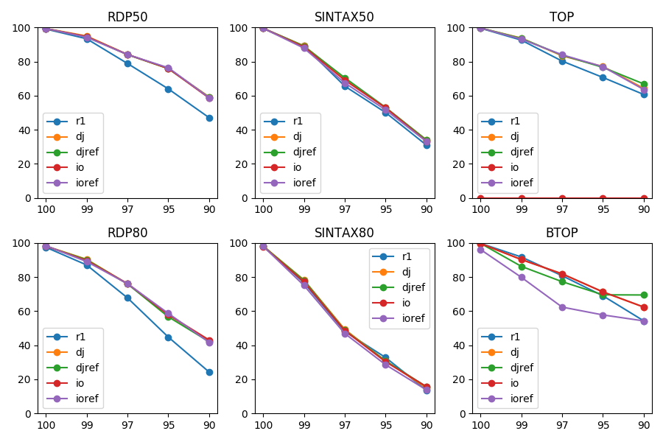 | - Under-classification rate  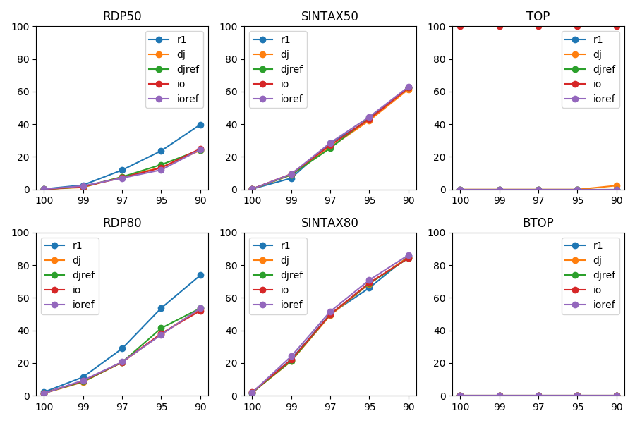
- Over-classification rate  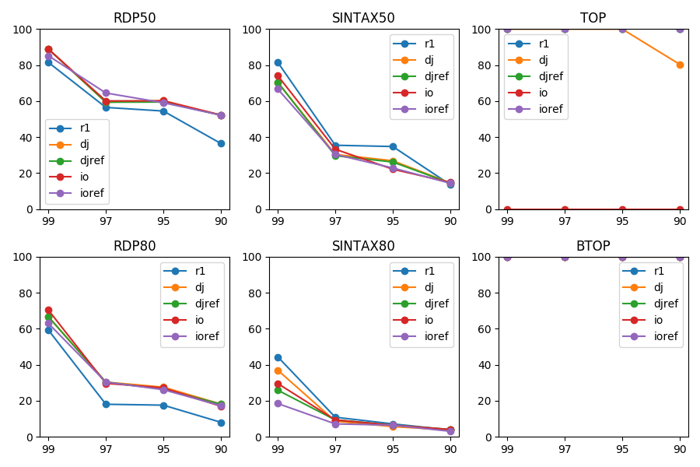 | - Misclassification rate  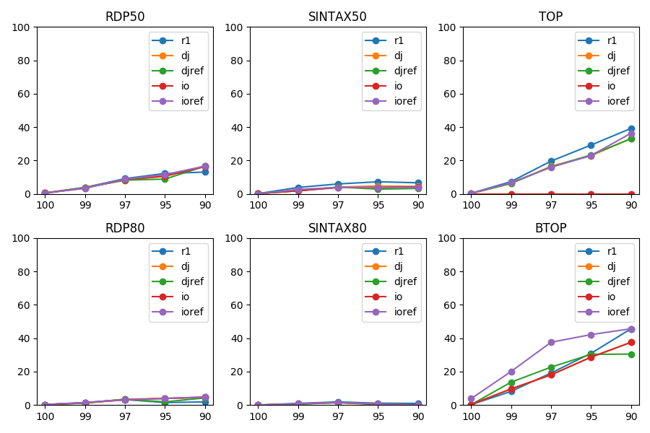
Figure S3. Performance metrics (y-axis) for genus prediction of different types of simulated MiSeq data by six classification methods at different top-hit identities (x-axis) for the V1-V3 primer pair.

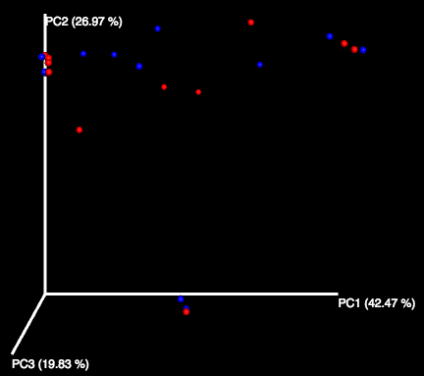
Figure S4. Principal coordinate analysis using weighted UniFrac distances between the samples during asthma attack (red) and in the recovery phase (blue).

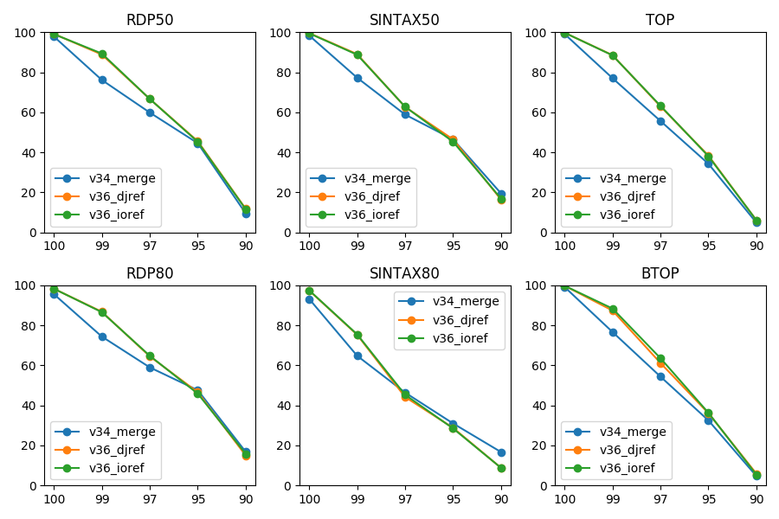
Figure S5. Accuracies (y-axis) of classifying merged reads of the V3-V4 amplicons, and directly joined and inside-out reads of the V3-V6 amplicons to the genus level at different top-hit identities (x-axis) by six classification methods using error-free MiSeq 2×300 bp data.

Supplementary Tables

patient | V1-V3 attack | V1-V3 recovery | V3-V5 attack | V3-V5 recovery
P1 | 232834; 106521 | 92717; 40760 | 18742; 67 | 2796; 150
P2 | 177653; 85162 | 176750; 84420 | 4579; 899 | 11949; 5768
P3 | 253322; 116256 | 228222; 103942 | 4663; 211 | 7938; 1399
P4 | 175690; 86412 | 237446; 118171 | 26947; 8454 | 11894; 2925
P5 | 230340; 111047 | 55306; 23257 | 16984; 5854 | 8785; 72
P6 | 231706; 108459 | 106585; 53762 | 20029; 3684 | 56137; 5120
P7 | 165959; 95249 | 69690; 32792 | 12601; 115 | 7976; 3609
P8 | 31997; 13242 | 67902; 30994 | 8062; 1447 | 2574; 486
P9 | 127839; 63587 | 104011; 59300 | 9693; 2227 | 4118; 179
P10 | 134483; 63576 | 123416; 59112 | 11312; 3058 | 4093; 1293
P11 | 194262; 104083 | 122585; 58261 | 20797; 922 | 2678; 364
P12 | 176354; 97358 | 42137; 23674 | 41071; 462 | 3751; 160
Table S1. Numbers of PEs and merged reads of the V1-V3 and V3-V5 data of the twelve asthmatic children during asthma attack and in the recovery phase.

Project ID | No. of experiments in the project | Representative experiment | % of PE reads that could be merged
SRP200733 | 10 | SRX5985117 | 0.28
SRP100723 | 264 | SRX2589613 | 1.65
SRP045730 | 7 | SRX685535 | 3.79
SRP226558 | 111 | SRX7032607 | 7.35
SRP136405 | 3 | SRX3843879 | 13.68
SRP159477 | 300 | SRX4635302 | 14.80
SRP188599 | 156 | SRX5528992 | 15.80
SRP074626 | 84 | SRX2241955 | 18.52
SRP082155 | 273 | SRX2023216 | 30.63
SRP064512 | 118 | SRX1307092 | 32.92
SRP110772 | 224 | SRX2977977 | 33.77
SRP069981 | 2 | SRX1583067 | 42.45
SRP108278 | 1 | SRX2869140 | 59.64
SRP153935 | 1 | SRX4395263 | 81.79
SRP152214 | 23 | SRX4342766 | 82.56
SRP117913 | 1 | SRX3195510 | 85.99
SRP166816 | 1 | SRX4935398 | 86.85
SRP065068 | 226 | SRX1360988 | 86.96
SRP166705 | 1 | SRX4927952 | 87.78
SRP162142 | 1 | SRX4717167 | 89.25
SRP057511 | 37 | SRX1004572 | 89.57
SRP149964 | 1 | SRX4182583 | 90.70
SRP152889 | 768 | SRX4371116 | 91.26
SRP114951 | 25 | SRX3067447 | 95.15
SRP125133 | 1 | SRX3400284 | 95.89
SRP111625 | 2 | SRX2996885 | 97.44
ERP009544 | 12 | ERX941623 | 97.61
SRP182765 | 1 | SRX5305177 | 97.66
SRP167862 | 1 | SRX4978622 | 97.91
SRP218505 | 1 | SRX6723040 | 98.67
SRP219247 | 1 | SRX6757474 | 98.82
SRP081324 | 1 | SRX2013860 | 99.17
SRP131935 | 14 | SRX3637932 | 99.69
Table S2. Percentage of PE reads that could be merged for the 33 metagenomics projects using the V3-V5 primer pair in NCBI Sequence Read Archive. For each project, one representative data (the last piece of query) was downloaded to estimate the percentage of merged data using USEARCH with a 25% maximal mismatch rate and minimal overlap as 16 bp.

OTU | P1 | P2 | P3 | P4 | P5 | P6 | P7 | P8 | P9 | P10 | P11 | P12 | genus
Otu1 | -3.65 | 0.13 | -9.23 | -2.40 | 61.79 | -0.12 | -37.73 | 0.45 | 69.74 | -1.81 | -0.05 | -3.82 | Rhodococcus
Otu7 | -0.45 | 1.01 | -1.14 | 4.17 | 7.49 | -0.01 | -2.73 | 0.02 | 6.63 | 0.53 | 0.02 | 0.03 | Sphingomonas
Otu119 | -0.23 | -1.28 | -0.55 | 1.92 | 4.01 | -0.01 | -2.78 | 0.05 | 3.38 | 2.21 | -0.01 | -0.46 | Rhodococcus
Otu11 | 0.01 | 1.02 | -0.04 | 1.02 | 2.24 | 0.00 | -0.29 | 0.00 | 0.80 | -0.32 | 0.00 | -0.06 | Bradyrhizobium
Otu13 | -1.51 | -0.24 | -0.08 | -2.55 | 0.04 | 25.17 | -4.19 | 0.35 | -0.06 | -0.19 | 0.00 | 0.02 | Staphylococcus
Otu12 | -0.09 | -0.49 | -0.05 | -1.41 | 1.65 | 0.00 | -0.43 | 0.01 | 1.12 | -0.08 | 0.00 | -0.02 | Delftia
Otu4 | -0.03 | 0.93 | -33.19 | -0.01 | -0.05 | 54.37 | -0.09 | -30.79 | -0.06 | -0.03 | -21.42 | 0.00 | Corynebacterium
Otu5 | 0.00 | 0.18 | 0.02 | -0.01 | -0.01 | -0.23 | 0.00 | 0.40 | -97.25 | -0.01 | 4.03 | -88.92 | Moraxella
Otu15 | 0.00 | -0.01 | -0.01 | -0.08 | 0.42 | -0.08 | -0.05 | 0.21 | 3.47 | 0.91 | -0.11 | -0.02 | Streptococcus
Otu35 | 0.00 | 0.00 | 0.00 | -0.03 | -0.06 | -0.01 | 0.09 | 0.03 | 1.32 | -0.04 | -0.03 | -0.01 | Streptococcus
Otu6 | -0.02 | 0.09 | 40.52 | -0.01 | -0.07 | -16.42 | -0.07 | 46.79 | -0.22 | -0.01 | -4.84 | 0.03 | Dolosigranulum
Otu28 | 0.01 | 0.90 | -0.01 | -0.01 | -0.03 | -0.03 | 0.04 | 0.04 | 1.23 | 0.01 | -0.03 | 0.02 | Rothia
Otu42 | 0.00 | 0.00 | 0.00 | 0.00 | 0.00 | 0.00 | 0.04 | 0.00 | 0.00 | 2.09 | 0.00 | 0.00 | Lautropia
Otu14 | 0.00 | 0.00 | 0.00 | 5.15 | 0.00 | 0.00 | 0.00 | 0.00 | 0.00 | 0.00 | 0.00 | 0.00 | Streptococcus
Otu24 | 0.00 | -0.01 | -0.01 | 0.00 | 0.00 | 0.00 | 1.72 | 0.00 | 0.00 | 0.00 | 0.00 | 0.00 | Neisseria
Otu3 | 6.30 | 0.95 | 0.09 | 1.67 | -95.38 | -0.15 | -0.15 | -0.03 | 0.30 | 0.03 | -0.05 | -0.04 | Staphylococcus
Otu39 | -0.02 | 0.17 | -0.01 | 0.21 | 1.73 | 0.41 | 0.00 | -6.62 | 3.42 | 0.26 | -0.01 | 0.01 | Corynebacterium
Otu22 | 0.00 | 2.09 | 0.00 | 0.00 | 0.00 | 0.00 | -0.38 | 0.00 | 0.00 | 0.00 | 0.00 | 0.00 | Simonsiella
Otu16 | 0.00 | 0.01 | 0.00 | 0.01 | 0.01 | 0.10 | 0.00 | -11.90 | 1.18 | 0.00 | 0.00 | 0.00 | Corynebacterium
Otu2 | -0.01 | 0.01 | 4.34 | 0.00 | -0.08 | -0.39 | 70.56 | 0.72 | 0.55 | 0.00 | 28.72 | 92.71 | Moraxella
Otu26 | 0.00 | 0.00 | 0.00 | -1.53 | 1.03 | 0.00 | 0.00 | 0.00 | 0.00 | 0.00 | 0.00 | 0.00 | Streptophyta
Otu18 | 0.02 | 0.00 | 0.00 | 3.27 | 0.00 | 0.00 | 0.00 | 0.00 | 0.00 | 0.00 | 0.00 | 0.00 | GpI
Otu32 | 0.00 | 0.00 | 0.00 | 0.00 | 1.44 | 0.00 | 0.00 | 0.00 | 0.00 | 0.00 | 0.00 | 0.00 | Gordonia
Otu20 | 0.00 | 0.00 | 0.00 | 0.00 | 2.63 | 0.00 | 0.00 | 0.00 | 0.00 | 0.00 | 0.00 | 0.00 | Corynebacterium
Table S3. Frequency difference (in %) of OTUs derived from the directly joined reads between attack and recovery states for nose samples of the twelve asthmatic children. Only OTUs with ≥1% difference in at least one sample are shown.

Read | RDP50 | RDP80 | SINTAX50 | SINTAX80 | TOP | BTOP
v34_merge | 57.62 | 58.68 | 60.12 | 50.42 | 54.24 | 53.5
v36_djref | 62.44 | 62.24 | 62.86 | 50.9 | 59.18 | 58.08
v36_ioref | 62.42 | 62.28 | 62.66 | 51.12 | 59.16 | 58.7
Table S4. Mean accuracies of classifying the perfect V3-V4 amplicons, and error-free directly joined and inside-out reads of the V3-V6 amplicons to the genus level by six classification methods.

