Supplementary Figures

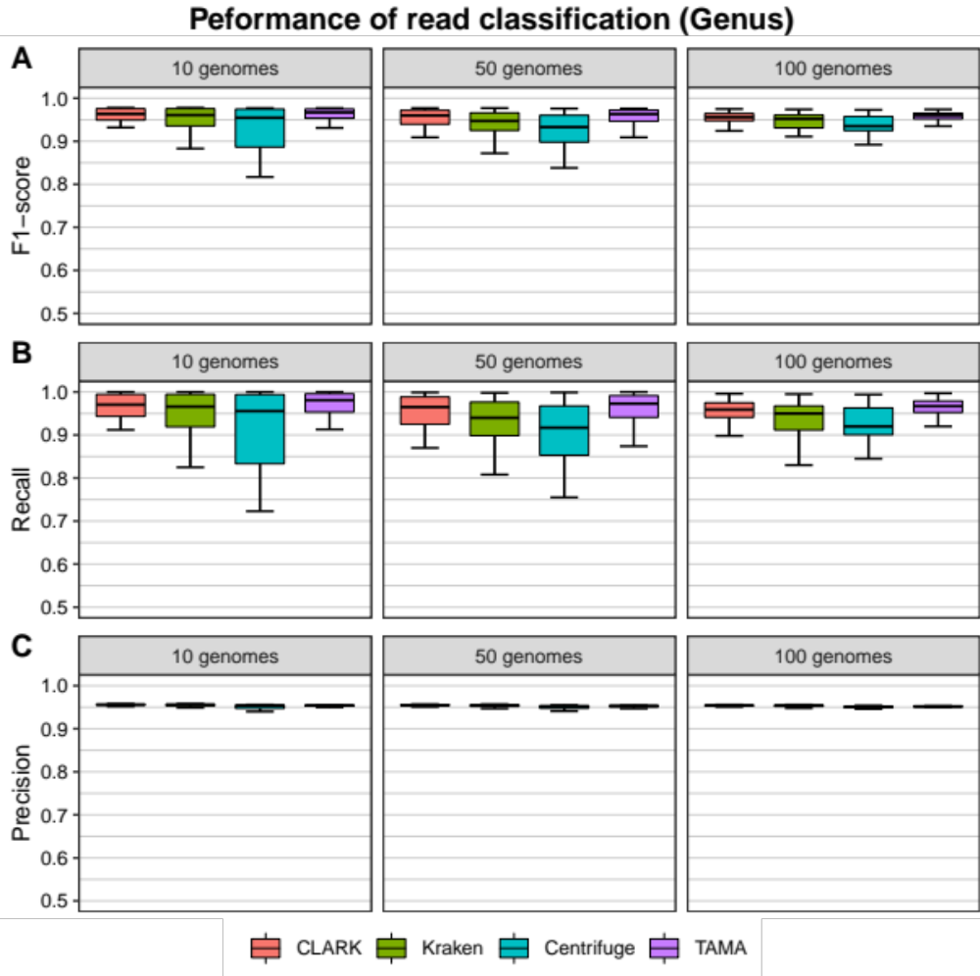
Supplementary Figure S1. Performance evaluation results of read classification for the genus rank. Boxplots indicate the distribution of (A) F1-score, (B) recall and (C) precision of read classification in 10 genomes dataset (left), 50 genomes dataset (center), and 100 genomes dataset (right).

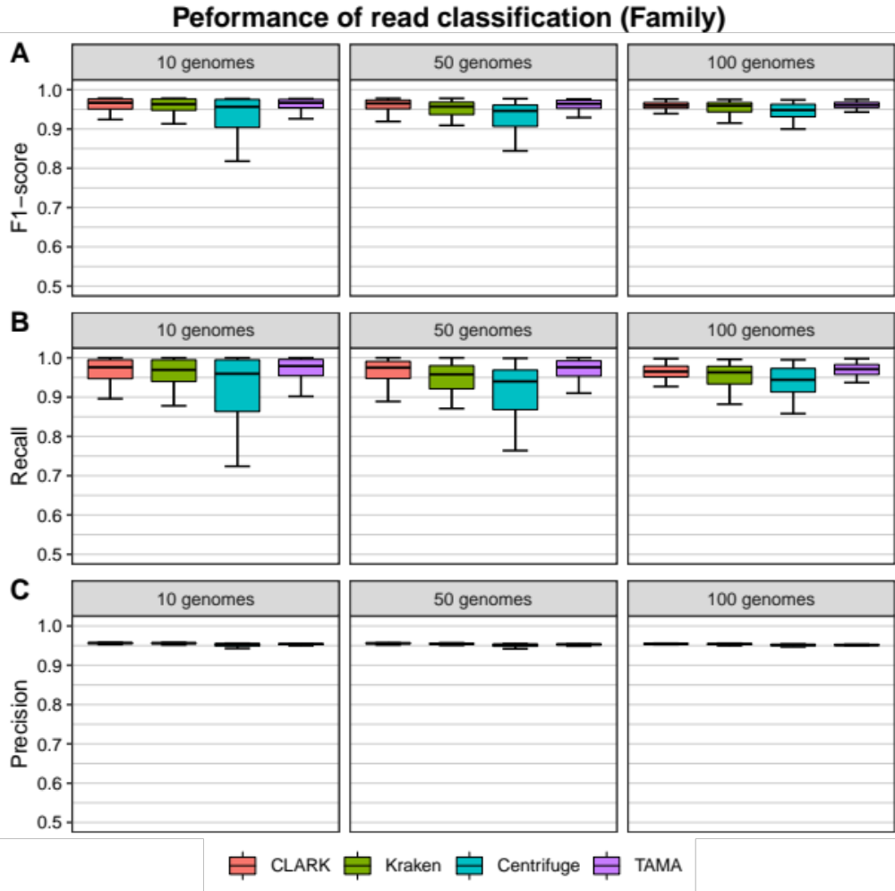
Supplementary Figure S2. Performance evaluation results of read classification for the family rank. Boxplots indicate the distribution of (A) F1-score, (B) recall and (C) precision of read classification in 10 genomes dataset (left), 50 genomes dataset (center), and 100 genomes dataset (right).

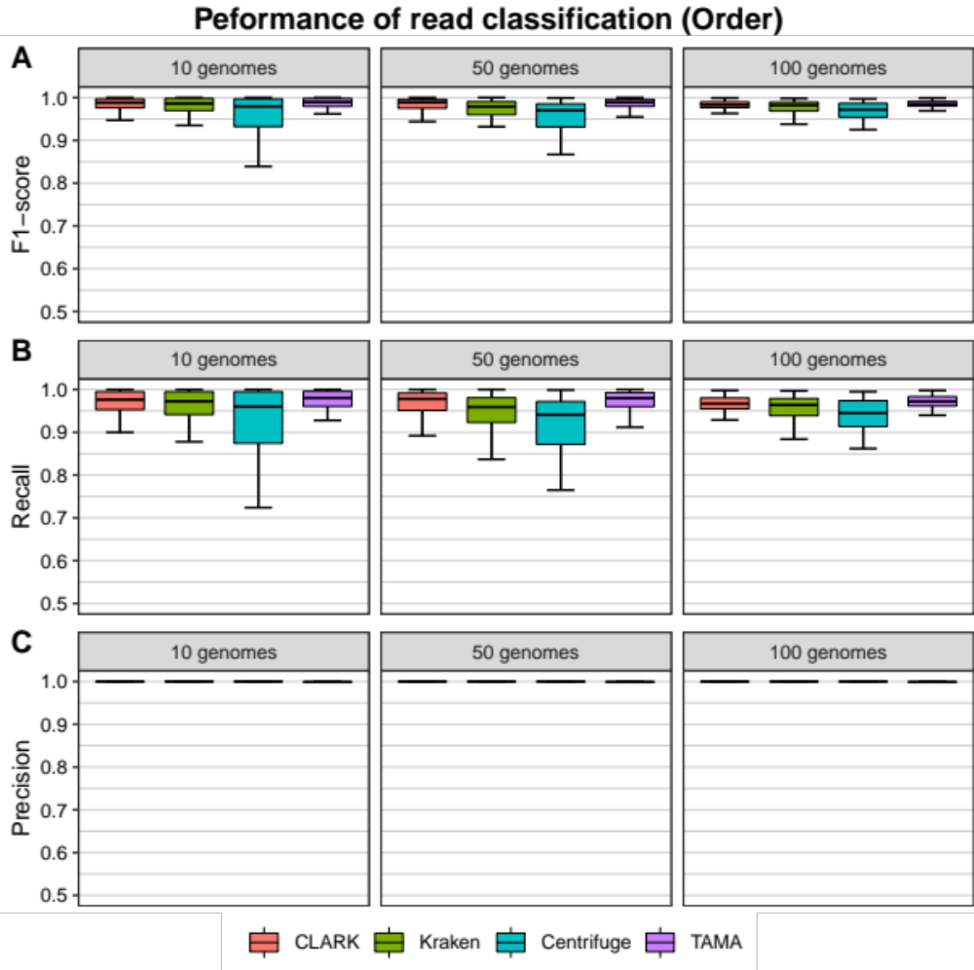
Supplementary Figure S3. Performance evaluation results of read classification for the order rank. Boxplots indicate the distribution of (A) F1-score, (B) recall and (C) precision of read classification in 10 genomes dataset (left), 50 genomes dataset (center), and 100 genomes dataset (right).

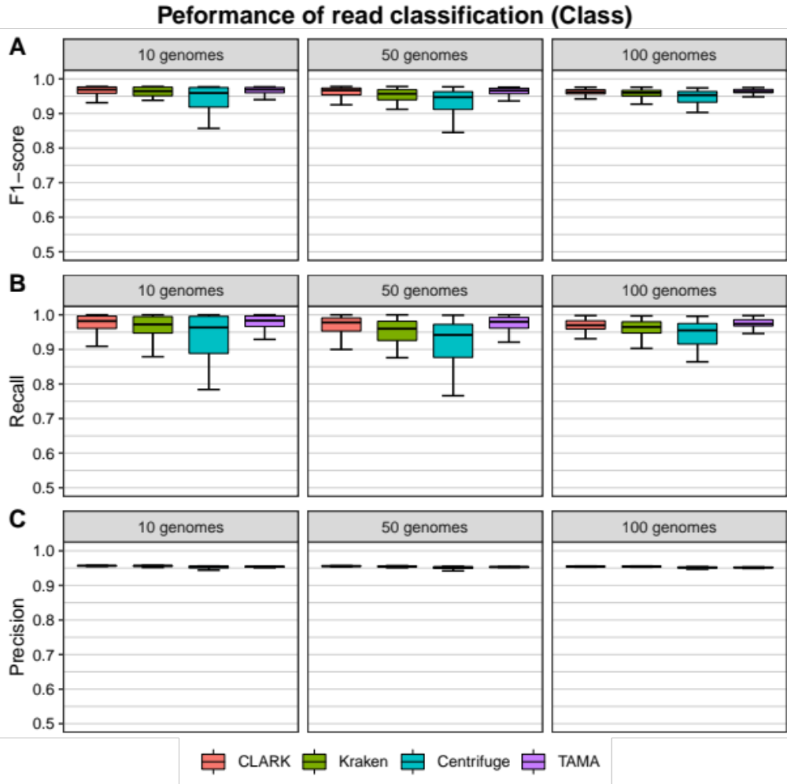
Supplementary Figure S4. Performance evaluation results of read classification for the class rank. Boxplots indicate the distribution of (A) F1-score, (B) recall and (C) precision of read classification in 10 genomes dataset (left), 50 genomes dataset (center), and 100 genomes dataset (right).

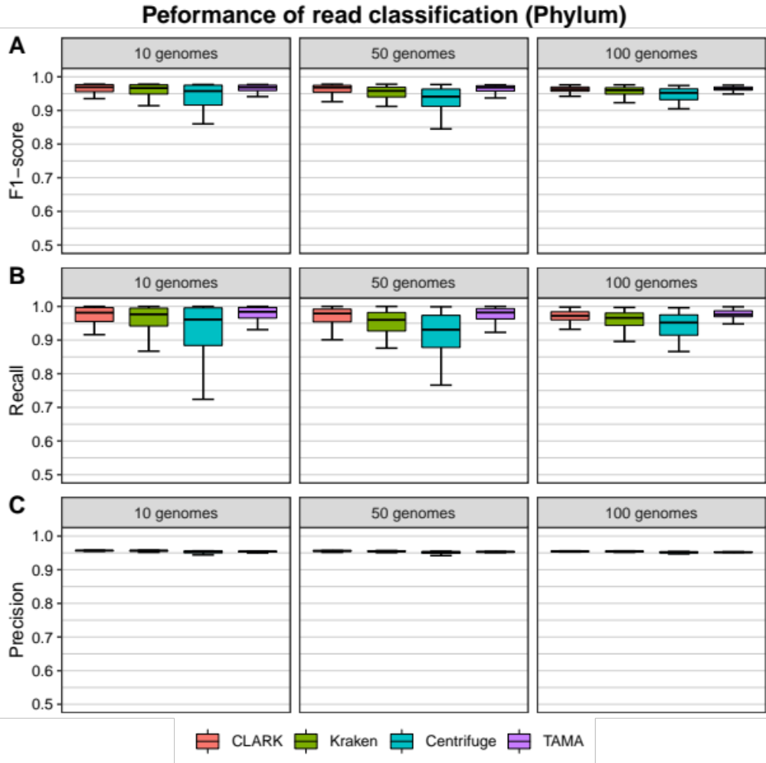
Supplementary Figure S5. Performance evaluation results of read classification for the phylum rank. Boxplots indicate the distribution of (A) F1-score, (B) recall and (C) precision of read classification in 10 genomes dataset (left), 50 genomes dataset (center), and 100 genomes dataset (right).

