Supplemental Figures

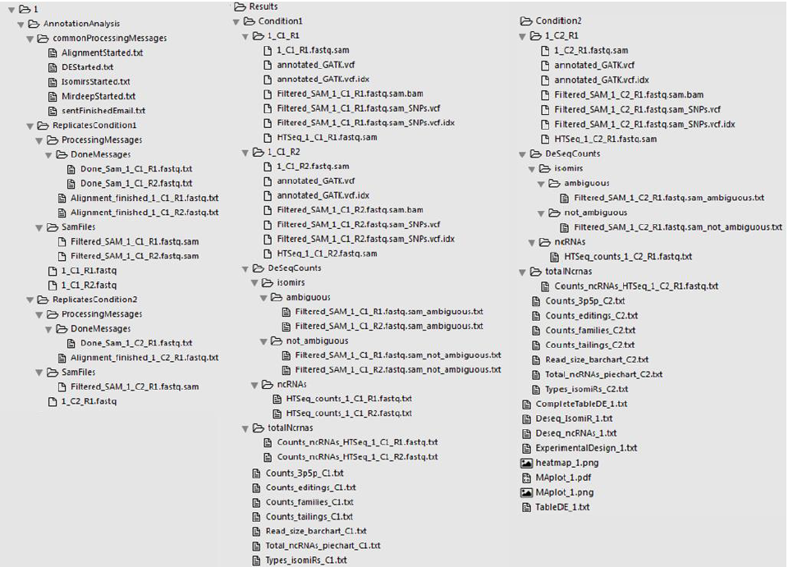

Figure S1- File organization of IsomiR Window of Annotation analysis module.

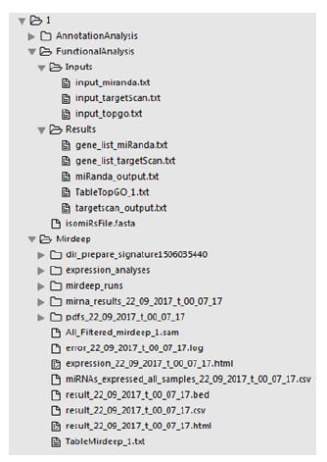

Figure S2- File organization of IsomiR Window of Functional analysis module.

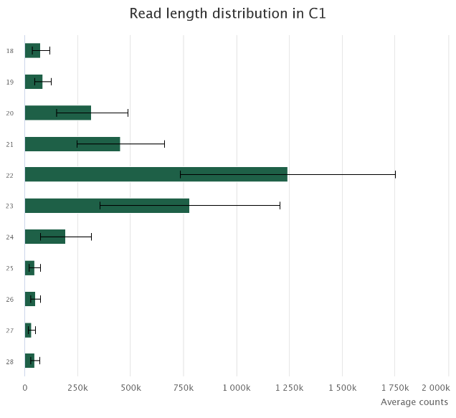
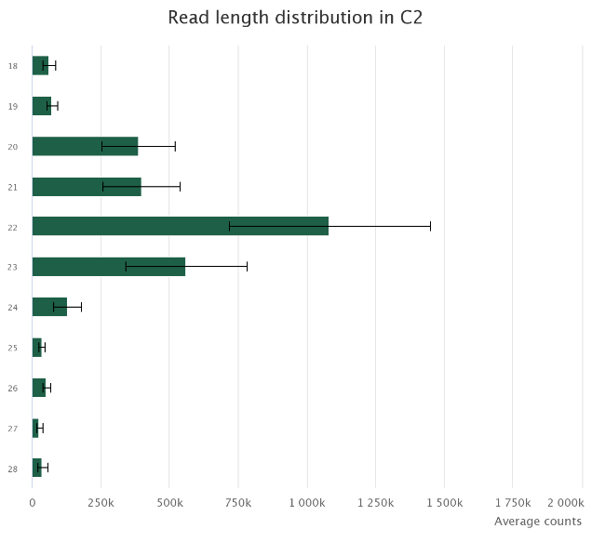

Figure S3 - Average read length distribution in each experimental condition. C1- Nodular BCCs; C2- Infiltrative BCCs. Bars represent the mean across biological replicates of each of the biological conditions. Vertical black lines represent the estimated standard deviation.

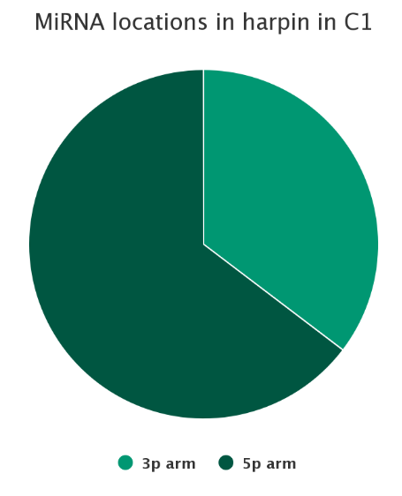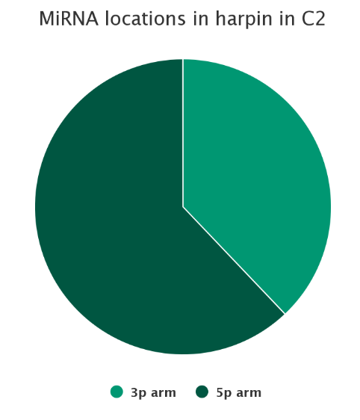
Fig. S4 - Proportion of miRNAs that are originated in the 3p arm or in the 5p arm of the miRNA hairpin in each experimental condition. C1- Nodular BCCs; C2- Infiltrative BCCs. The pie chart represent the estimated mean of each feature across the biological replicates.

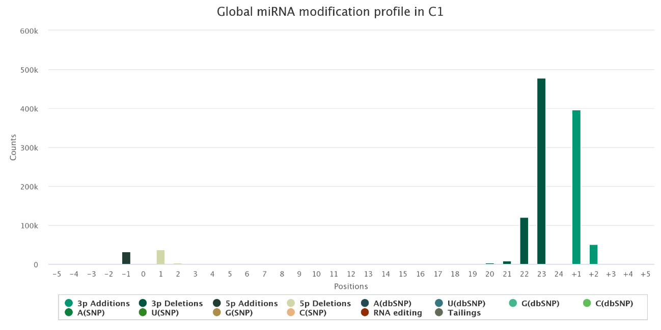

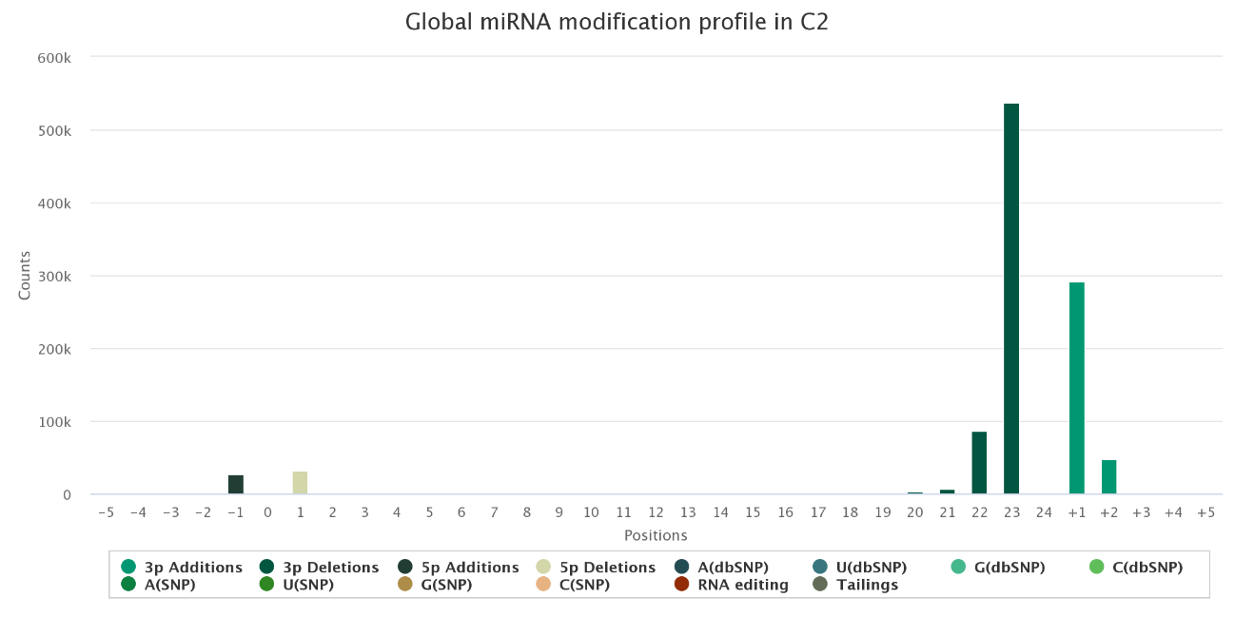
Fig. S5 - Global miRNA modification profile. C1- Nodular BCCs; C2- Infiltrative BCCs. Each bar represents the cumulative normalized counts. RNA editing correspond to potential ADAR editing’s.

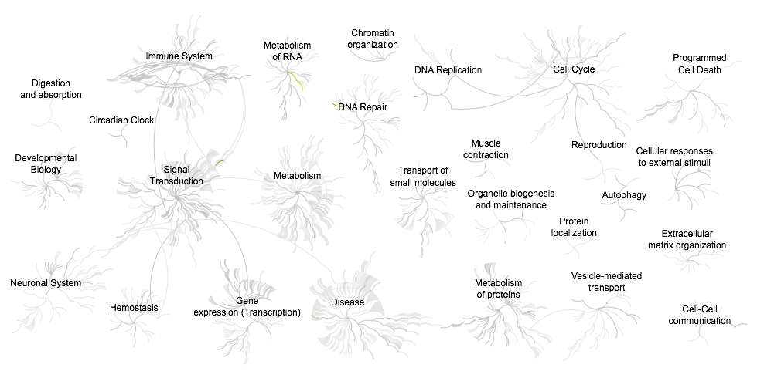

Fig. S6 - Genome-wide overview of pathway analysis of mRNA targets potentially targeted uniquely by differentially expressed IsomiRs.

(A)
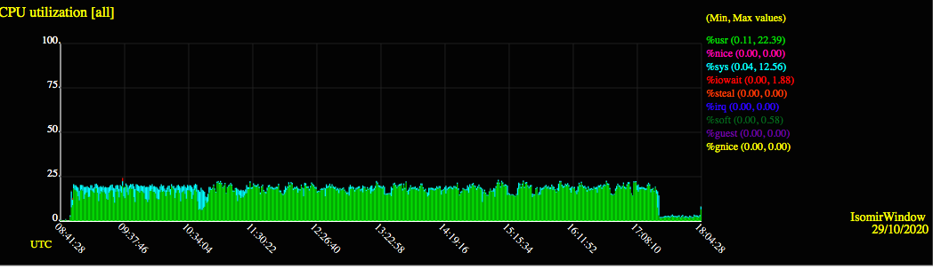

(B)

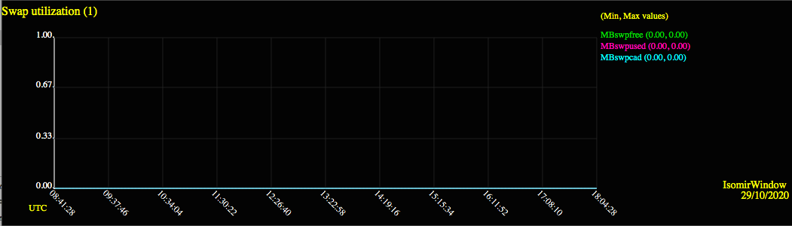

Fig. S7- IsomiR Window resource usage during demonstration analysis.

