Table 1-The Confusion matrix table in the 10-fold Cross-validation
T/P | S₁ | S₂ | S₃ | S₄ | S₅ | S₆ | S₇
S₁ | 2,274 | 26 | 25 | 1 | 2 | 0 | 216
S₂ | 185 | 2,074 | 18 | 20 | 69 | 9 | 138
S₃ | 228 | 76 | 1,985 | 36 | 105 | 19 | 128
S₄ | 143 | 62 | 47 | 2,139 | 66 | 31 | 70
S₅ | 201 | 17 | 20 | 3 | 2,240 | 5 | 76
S₆ | 186 | 48 | 24 | 36 | 45 | 2,092 | 76
S₇ | 56 | 0 | 0 | 0 | 1 | 2 | 2,516

Table 2-The DeLong test results in the 10-fold Cross-validation
DeLong's test | S₁ | S₂ | S₃ | S₄ | S₅ | S₆ | S₇
PCC+CWGAN+RF vs RF | < 2.2e-16 | < 2.2e-16 | < 2.2e-16 | < 2.2e-16 | < 2.2e-16 | < 2.2e-16 | < 2.2e-16
PCC+CWGAN+RF vs PCC+RF | 0.0008 | < 2.2e-16 | < 2.2e-16 | < 2.2e-16 | < 2.2e-16 | < 2.2e-16 | 1.374e-11
PCC+CWGAN+RF vs PCC+CGAN+RF | 2.213e-06 | 0.0149 | 0.0528 | 0.00739 | 0.3199 | 0.0423 | 0.5634

Table 3-Confusion matrix of independent test.
T/P | S₁ | S₂ | S₃ | S₄ | S₅ | S₆ | S₇
S₁ | 575 | 7 | 8 | 1 | 0 | 1 | 49
S₂ | 60 | 546 | 9 | 3 | 21 | 2 | 31
S₃ | 42 | 13 | 478 | 5 | 35 | 6 | 29
S₄ | 38 | 14 | 16 | 519 | 18 | 8 | 14
S₅ | 59 | 4 | 3 | 1 | 535 | 0 | 21
S₆ | 57 | 14 | 16 | 11 | 12 | 555 | 13
S₇ | 6 | 0 | 0 | 0 | 0 | 0 | 604

Table 4- The DeLong test results in the independent test
DeLong's test | S₁ | S₂ | S₃ | S₄ | S₅ | S₆ | S₇
PCC+CWGAN+RF vs RF | 5.9e-12 | 1.4e-07 | 2.48e-13 | 2.14e-11 | 6.88e-06 | 0.0003 | 1.51e-13
PCC+CWGAN+RF vs PCC+RF | 0.06257 | 1.67e-11 | 5.37e-14 | 8.35e-10 | 3.47e-06 | 1.68e-05 | 1.16e-05
PCC+CWGAN+RF vs PCC+CGAN+RF | 2.141e-06 | 0.0798 | 0.0114 | 0.2715 | 0.5324 | 0.2662 | 0.1862

Table 5- Comparisons of number of enrolled proteins and modification sites
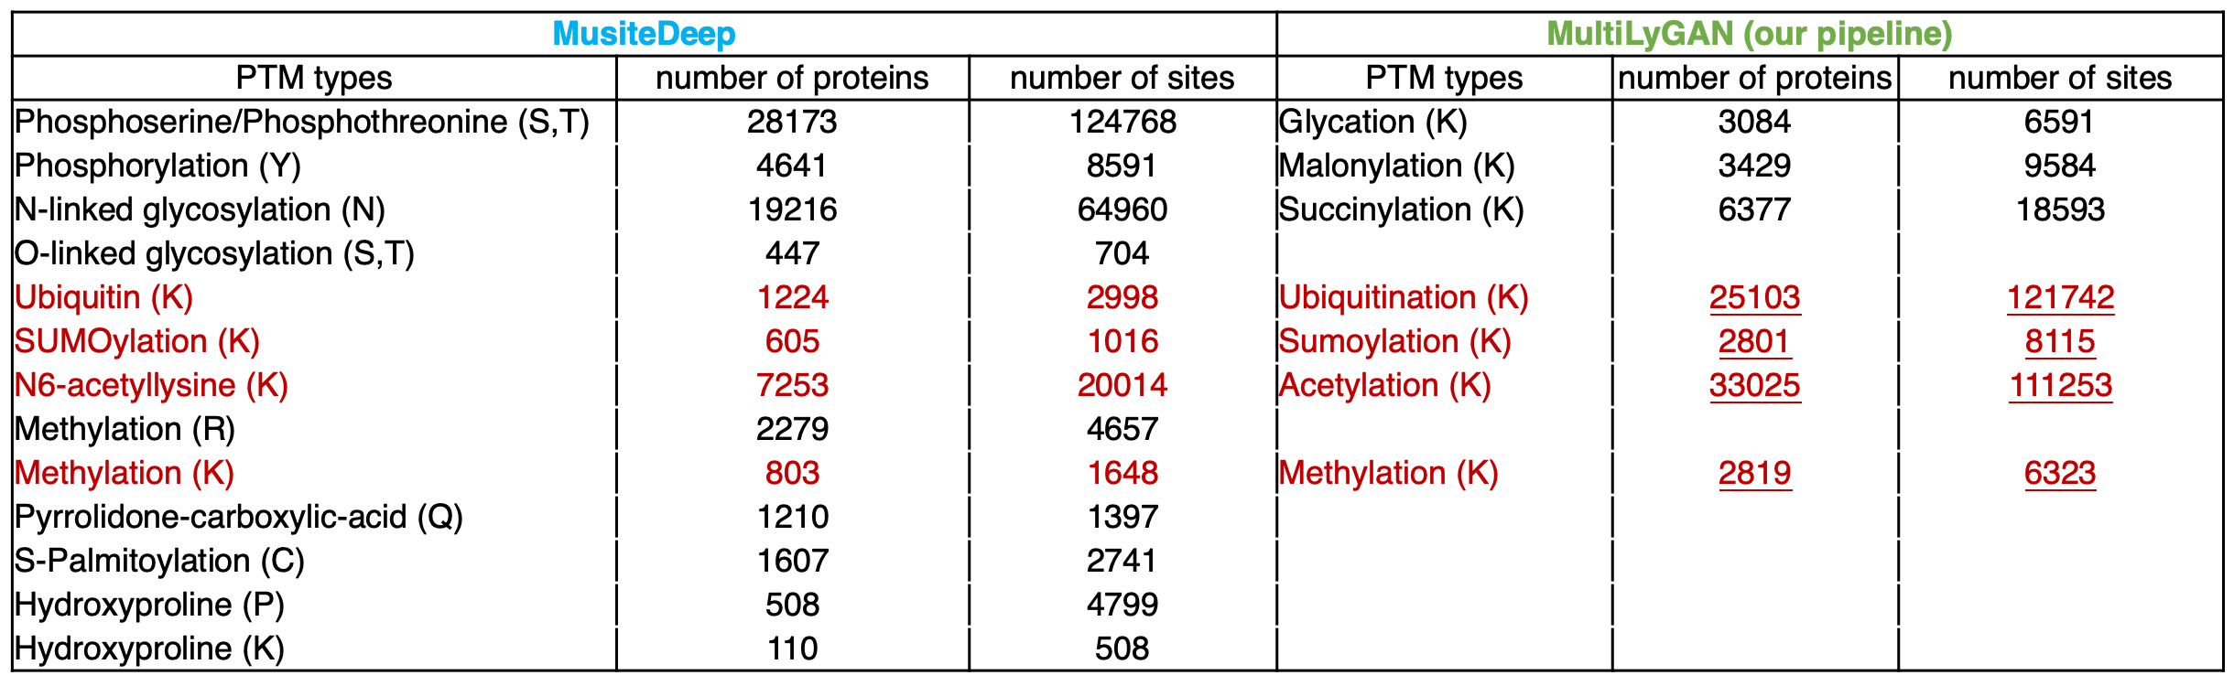

Table 6-The number of each modification type
Dataset | Number
$S_{1}$(Ace) | 3114
$S_{2}$(Glyca) | 1399
$S_{3}$(Malon) | 1224
$S_{4}$(Meth) | 1147
$S_{5}$(Succ) | 1645
$S_{6}$(Sumo) | 1174
$S_{7}$(Ubiq) | 3185

Table 7-The number of each feature (L=17)
Feature Construction | Dimension
AAindex | 238
CKSAAP | 1200
PWM | 17
Reduced Alphabet | 136
FoldAmyloid | 17
BE | 340
PC-PseAAC | 36
SC-PseAAC | 52
Structure | 323
Total | 2359

Table 8- Euclidean distance between simulated samples and real samples with different parameters.

Hidden dim | Learning  rate | S₁ | S₂ | S₃ | S₄ | S₅ | S₆ | Mean
64 | 0.01 | 0.0443 | 0.0399 | 0.0453 | 0.0403 | 0.0420 | 0.0420 | 0.0423
64 | 0.0001 | 0.0189 | 0.0118 | 0.0101 | 0.0110 | 0.0094 | 0.0129 | 0.0123
64 | 0.00001 | 0.0167 | 0.0123 | 0.0105 | 0.0113 | 0.0097 | 0.0144 | 0.0125
128 | 0.001 | 0.0349 | 0.0338 | 0.0350 | 0.0341 | 0.0339 | 0.0338 | 0.0343
128 | 0.0001 | 0.0163 | 0.0093 | 0.0089 | 0.0102 | 0.0090 | 0.0098 | 0.0106
128 | 0.00001 | 0.0161 | 0.0116 | 0.0101 | 0.0108 | 0.0102 | 0.0136 | 0.0121
256 | 0.001 | 0.0356 | 0.0349 | 0.0362 | 0.0360 | 0.0353 | 0.0362 | 0.0357
256 | 0.0001 | 0.0158 | 0.0095 | 0.0101 | 0.0101 | 0.0092 | 0.0097 | 0.0107
256 | 0.00001 | 0.0165 | 0.0124 | 0.0097 | 0.0109 | 0.0096 | 0.0144 | 0.0122

Table 9-The parameters of CWGAN
Parameter | Value
Learning rate | 1×e⁻⁴
Number of layers of G | 3
Number of nodes per G layer | 1,498/ 128/ 1
Number of layers of D | 3
Number of nodes per D layer | 101/ 128/ 1,497
Small batch size | 64
Number of iterations | 50,000
Optimization function | RMSProp
Clip | 0.01

Table 10-The parameters of random forest
Parameter | Value
Subtree number | 50
Subtree type | CART tree
Metrics | Gini index
Maximum characteristic number | Naught
Depth | No limit

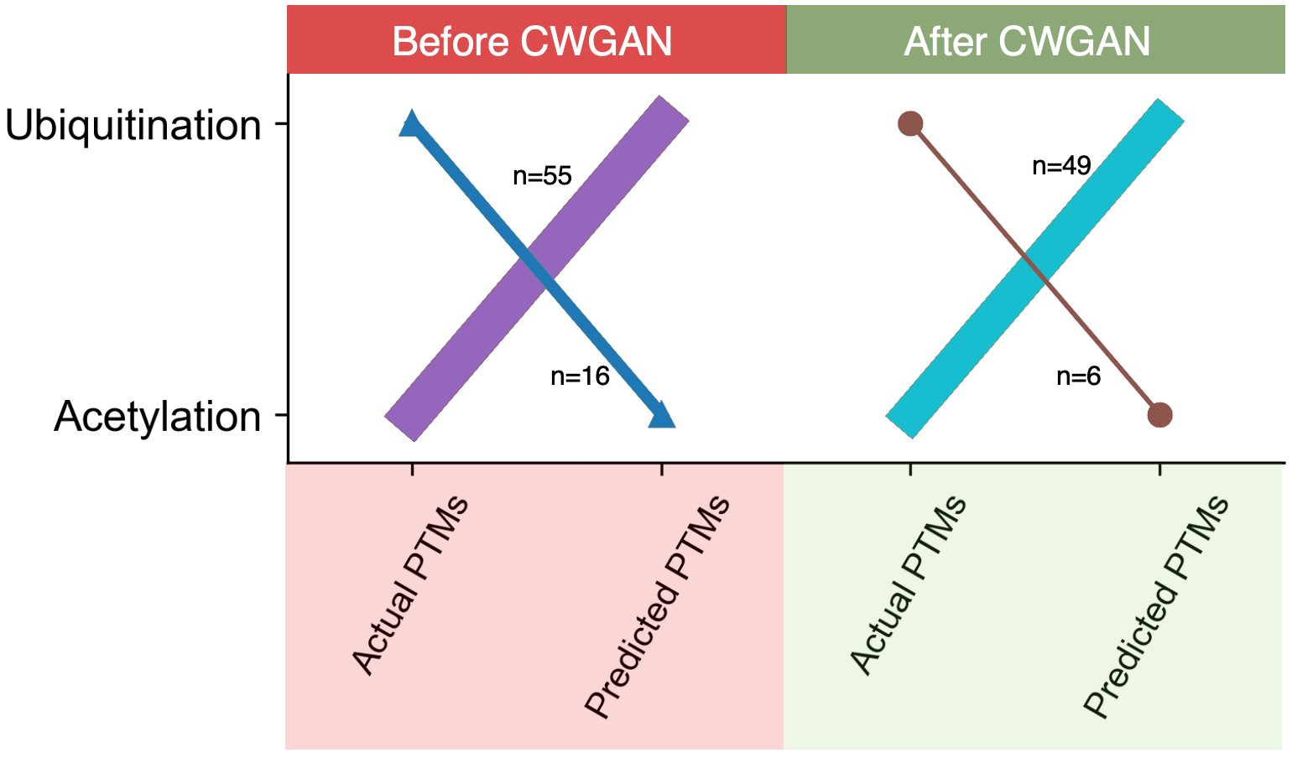
Figure 1-The comparison of two mislabeled PLMs between before CWGAN and after CWGAN.

