Additional file 1

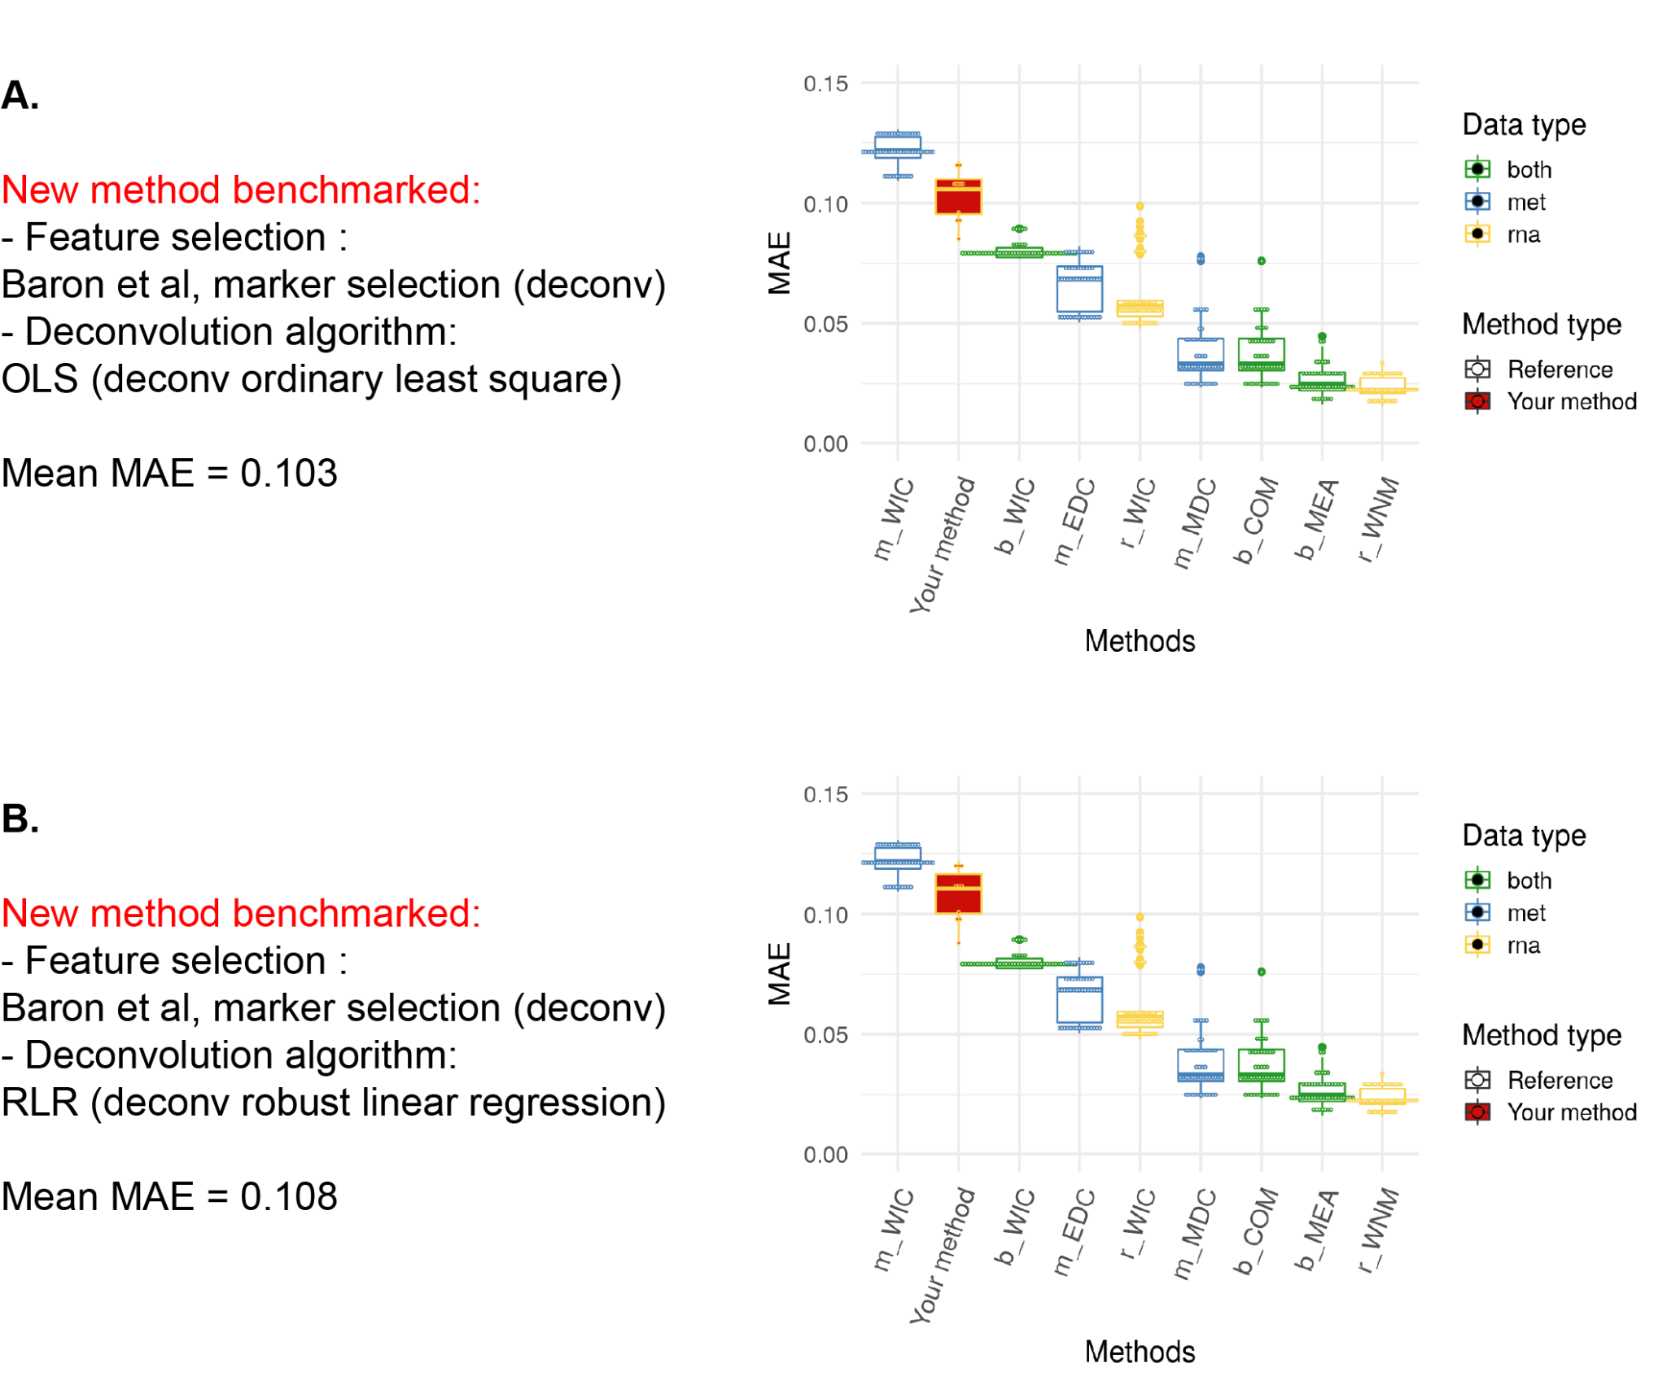
Figure S1: DECONbench benchmark of OLS and RLR methods: an example of graphical outputs of new contributions to the benchmark. For each novel submission, a graphical summary of the method performances is generated by the DECONbench platform, comparing performances of the participant’s method (“Your method”, in red), with the baseline methods. A. Boxplot of the Mean Absolute Error (MAE) of the estimation of the A matrices obtained by Ordinary Least Square deconvolution method (“Your method” in red), (OLS, from deconv pipeline analysis by Avila Cobos et al). B. Boxplot of the Mean Absolute Error (MAE) of the estimation of the A matrices obtained by Robust Linear Regression deconvolution method (“Your method”, in red), (RLR, from deconv pipeline analysis by Avila Cobos et al.).

SOURCE CODE

All codes used to generate the supplementary figure 1 are greatly inspired by:

Avila Cobos, F., Alquicira-Hernandez, J., Powell, J.E. et al. Benchmarking of cell type deconvolution pipelines for transcriptomics data. Nat Commun 11, 5650 (2020). https://doi.org/10.1038/s41467-020-19015-1

and corresponding source code available at: https://github.com/favilaco/deconv_benchmark

‘Baron_deconv_markers.rds and ‘baron_deconv_refC.rds’ were generated using deconv_benchmark Generator function on Baron et al dataset.
(Baron: https://www.ncbi.nlm.nih.gov/geo/query/acc.cgi?acc=GSE84133 )

DECONbench “OLS program” and “RLR program” are written below.

##################
### OLS program ###
##################

program <-
function(D_met = NULL, D_rna = NULL, k = 5) {
##
## YOUR CODE BEGINS HERE
##

#Loading the marker and the cell-type reference

marker_distrib = readRDS(paste0(submission_program ,"/baron_deconv_markers.rds"))
C = readRDS(paste0(submission_program ,"/baron_deconv_refC.rds"))
T = as.matrix(D_rna)

#Filtering C and T matrices

C = C[rownames(C) %in% marker_distrib$gene,]
T = T[rownames(T) %in% marker_distrib$gene,]

keep = intersect(rownames(C),rownames(T))
C = C[keep,]
T = T[keep,]

#Running deconvolution

RESULTS = apply(T,2,function(x) lm(x ~ as.matrix(C))$coefficients[-1])
RESULTS = apply(RESULTS,2,function(x) ifelse(x < 0, 0, x)) #explicit non-negativity constraint
RESULTS = apply(RESULTS,2,function(x) x/sum(x)) #explicit STO constraint
rownames(RESULTS) <- unlist(lapply(strsplit(rownames(RESULTS),")"),function(x) x[2]))

return(RESULTS)

##
## YOUR CODE ENDS HERE
##
}
dataType <-
"rna"

##################
### RLR program ###
##################

program <-
function(D_met = NULL, D_rna = NULL, k = 5) {
##
## YOUR CODE BEGINS HERE
##

#Loading the marker and the cell-type reference

marker_distrib = readRDS(paste0(submission_program ,"/baron_deconv_markers.rds"))
C = readRDS(paste0(submission_program ,"/baron_deconv_refC.rds"))
T = as.matrix(D_rna)

#Filtering C and T matrices

C = C[rownames(C) %in% marker_distrib$gene,]
T = T[rownames(T) %in% marker_distrib$gene,]

keep = intersect(rownames(C),rownames(T))
C = C[keep,]
T = T[keep,]

#Running deconvolution

require(MASS)
RESULTS = do.call(cbind.data.frame,lapply(apply(T,2,function(x) MASS::rlm(x ~ as.matrix(C), maxit=100)), function(y) y$coefficients[-1]))
RESULTS = apply(RESULTS,2,function(x) ifelse(x < 0, 0, x)) #explicit non-negativity constraint
RESULTS = apply(RESULTS,2,function(x) x/sum(x)) #explicit STO constraint
rownames(RESULTS) <- unlist(lapply(strsplit(rownames(RESULTS),")"),function(x) x[2]))

return(RESULTS)

##
## YOUR CODE ENDS HERE
##
}
dataType <-
"rna"

