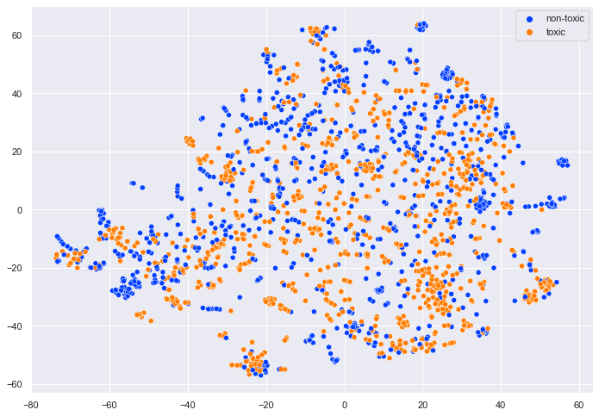
Figure S1. Applying t-SNE on final dataset and reducing dimensions from 90 to 2.

