Supplementary Materials
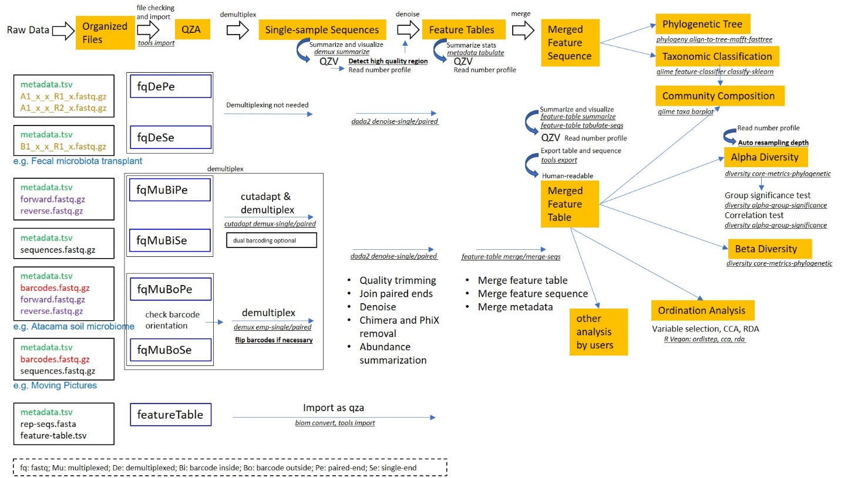
Figure S1. The detailed workflow of the pipeline ASAP 2. The pipeline first imports organized input data as QZA, which are then used for demultiplexing (if applicable). The single-sample sequences are then denoised and feature tables are generated. Multiple projects are then merged to one feature table and a feature sequence file which are used in the downstream analysis. The file naming of each supported data formats are listed at left side, with some examples of QIIME 2 tutorial. The detailed processing and commands used were shown. For the data format codes, fq represents FASTQ; Mu represents multiplexed; De represents demultiplexed; Bi represents barcode-inside; Bo represents barcode-outside; Pe represents paired-end; Se represents single-end.

