Additional file 1
Supplementary figures for “A population-level statistic for assessing Mendelian behavior of genotyping-by-sequencing data from highly duplicated genomes”
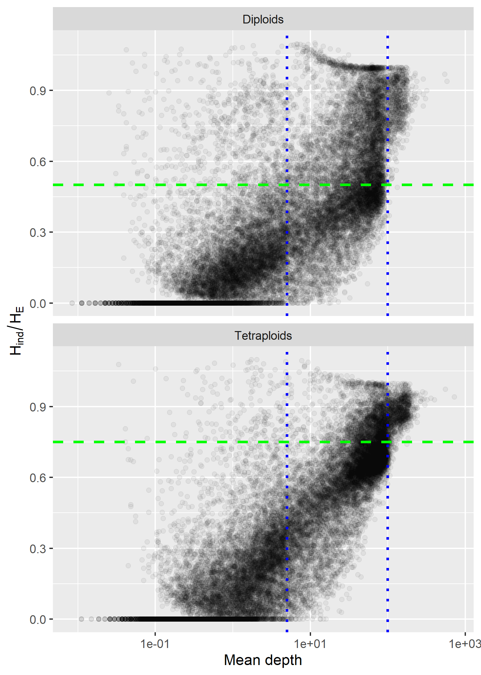
Figure S1. Relationship between H_{ind}/H_{E} statistic and mean sequence read depth per locus. Loci were called across 356 diploid and 268 tetraploid Miscanthus sacchariflorus based on alignments to the M. sinensis reference genome. The expected value for a Mendelian locus in Hardy-Weinberg equilibrium is shown with a green dashed line. Cutoffs of 5 and 100 used for Fig. 1 in the main manuscript are shown with blue dotted lines.
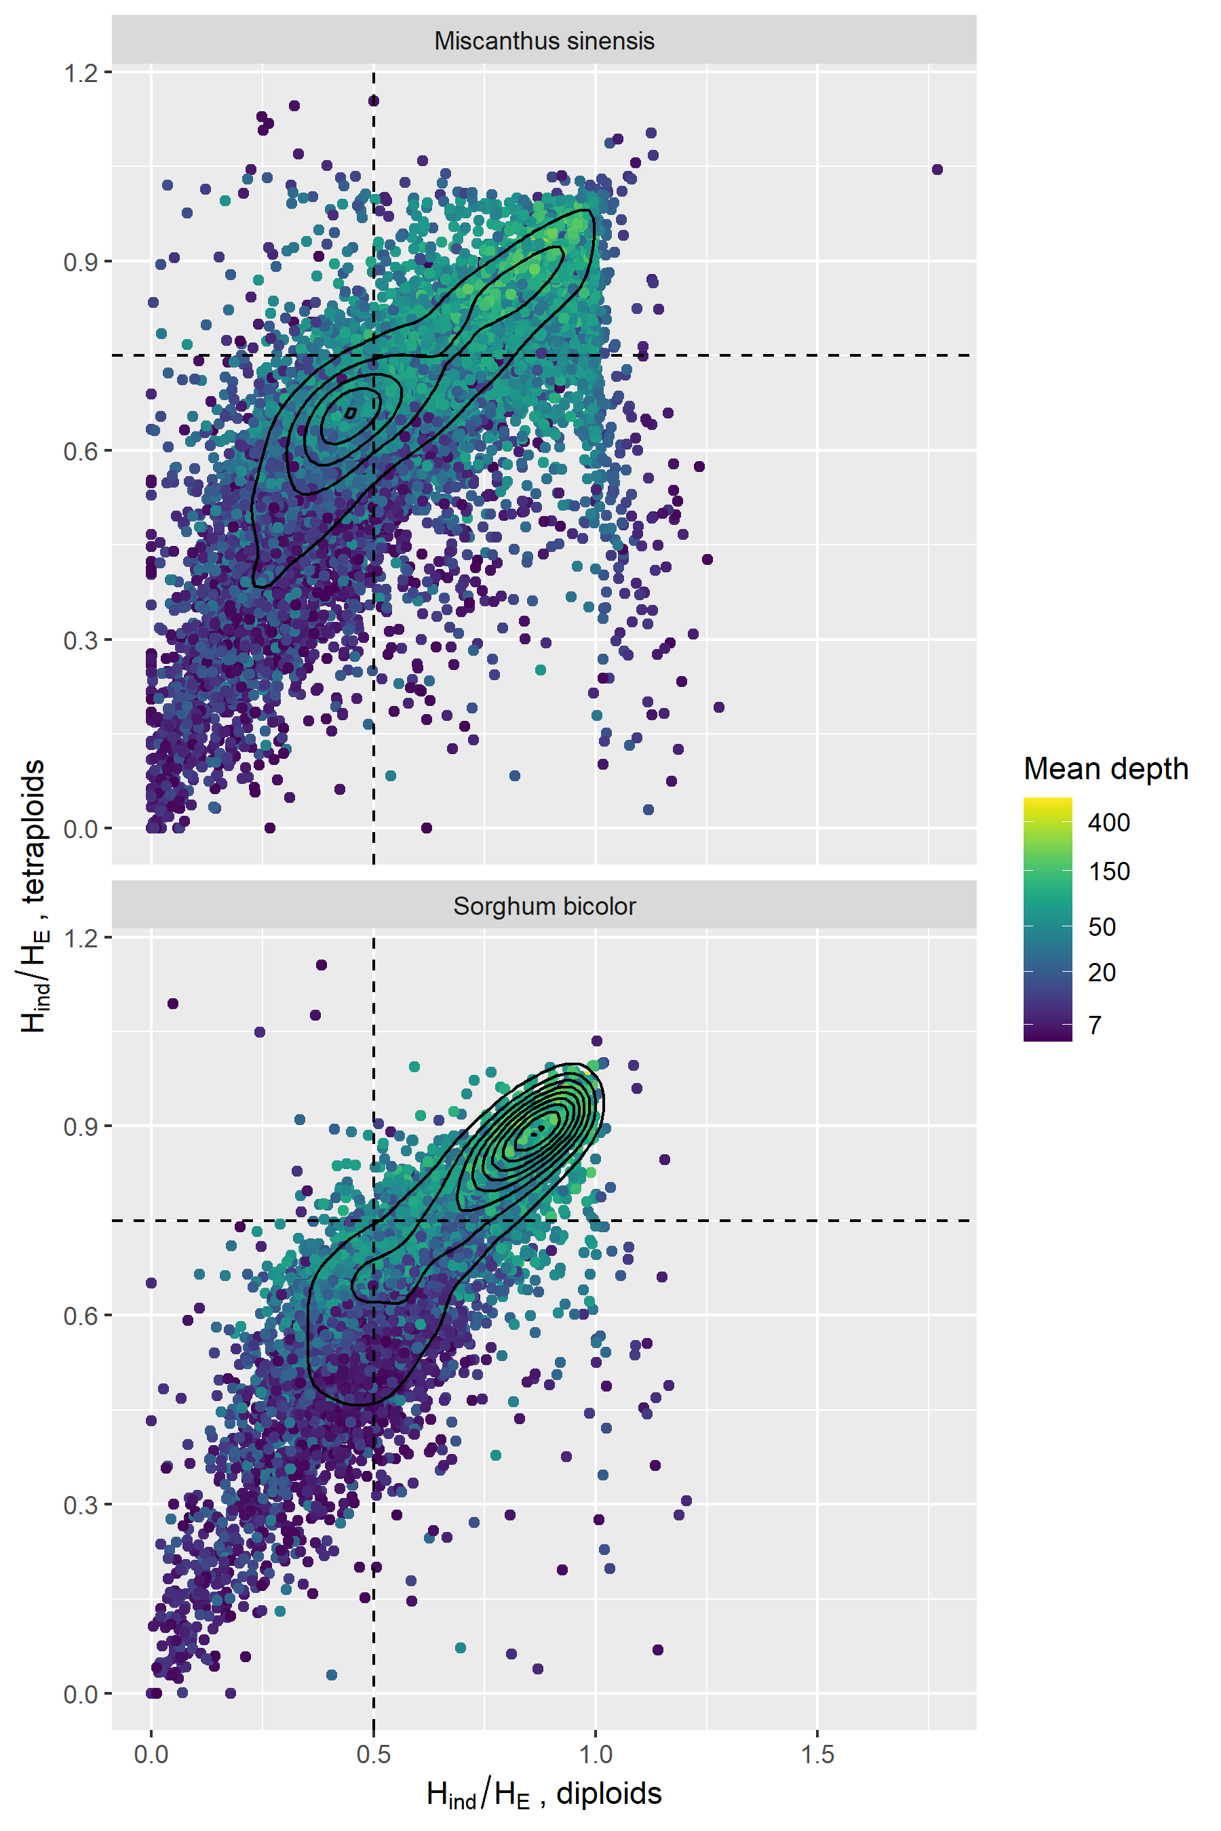
Figure S2. Correlation of H_{ind}/H_{E} between diploid and tetraploid datasets of Miscanthus sacchariflorus. Loci with a mean read depth below five were omitted, leaving 11,516 loci aligned to the M. sinensis reference and 8,820 loci aligned to the Sorghum bicolor reference. Expected values for Mendelian loci under Hardy-Weinberg equilibrium are shown with dashed lines. Solid lines are 2D density plots.

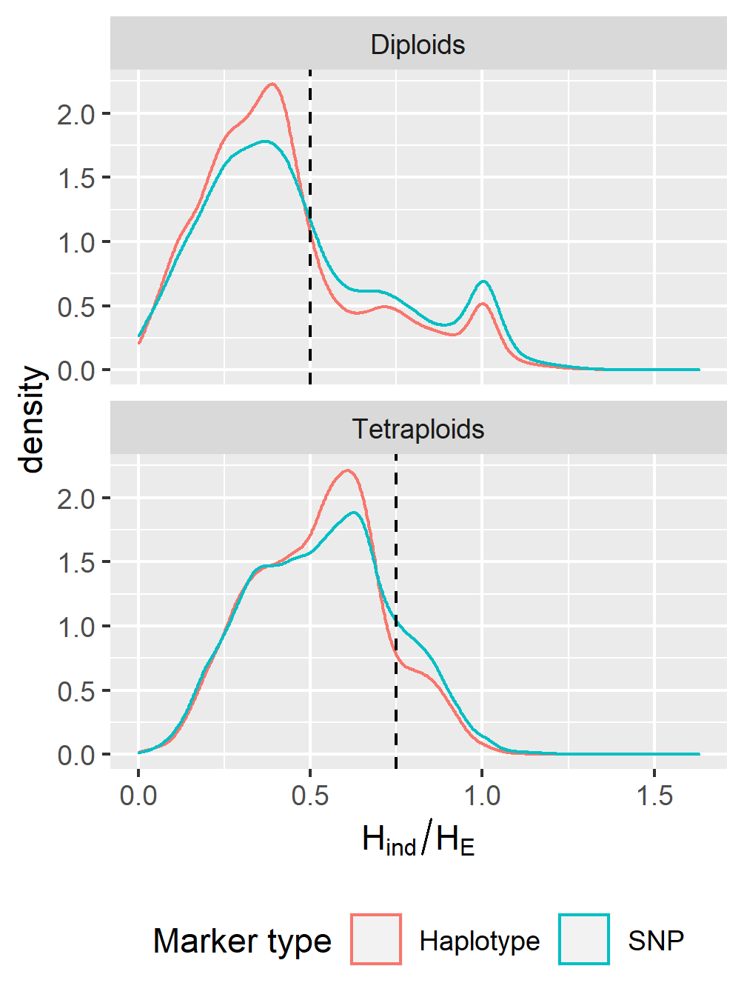
Figure S3. Distribution of H_{ind}/H_{E} among SNPs and haplotype-based loci in diploid and tetraploid M. sacchariflorus. The expected value for Mendelian loci under Hardy-Weinberg equilibrium is shown with the dashed line. The statistic was estimated for 10,458 SNPs, as well as those same SNPs phased into 3710 haplotype-based, multiallelic loci.

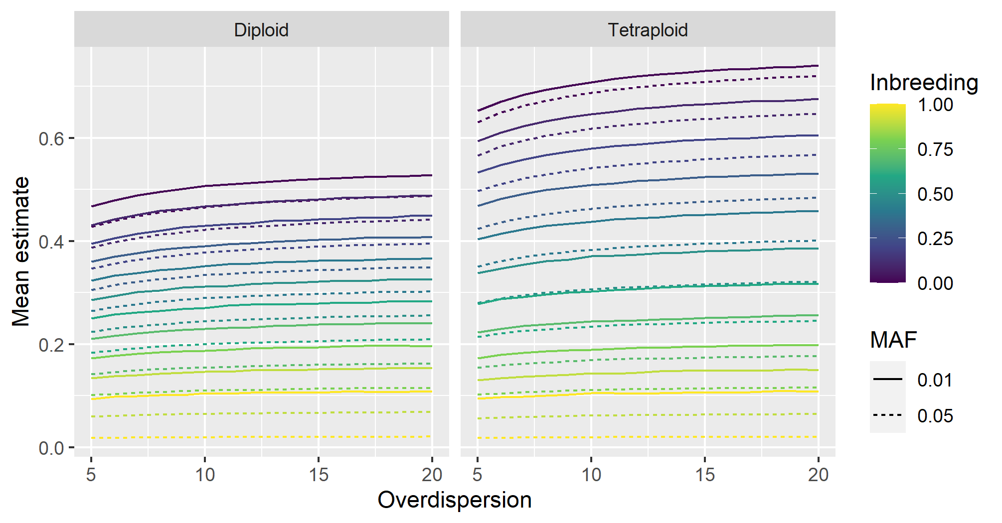
Figure S4. Mean estimates of H_{ind}/H_{E} in simulated datasets under varying inbreeding and overdispersion. For each ploidy, inbreeding level, overdispersion level, and minor allele frequency (MAF), 20,000 biallelic loci with a read depth of 20 and a sequencing error rate of 0.001 were simulated across 500 individuals, and allelic read depths were used for estimation of H_{ind}/H_{E}.

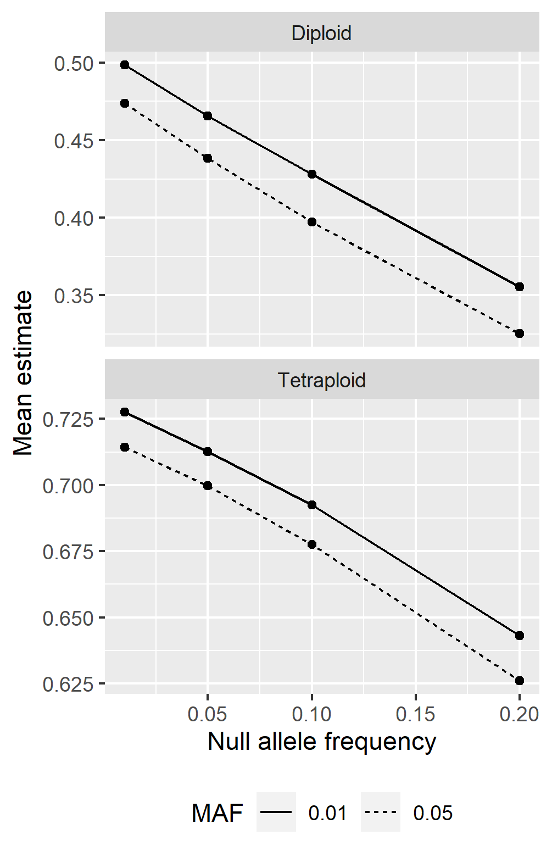
Figure S5. Mean estimates of H_{ind}/H_{E} under varying null allele frequencies. For each ploidy, null allele frequency, and non-null minor allele frequency (MAF), 5000 loci with a read depth of 20, overdispersion of 20, and sequence error rate of 0.001 were simulated across 500 individuals in a diversity panel or natural population.

