EMDLP: Ensemble multiscale deep learning model for RNA methylation site prediction
Honglei Wang^{1,2,3}, Hui Liu1^{1,2*}, Tao Huang², Gangshen Li^{1,2}, Lin Zhang^{1,2}, Yanjing Sun^{1,2*}
¹ Engineering Research Center of Intelligent Control for Underground Space, Ministry of Education, China University of Mining and Technology, Xuzhou 221116, China
² School of Information and Control Engineering, China University of Mining and Technology, Xuzhou 221116, China
³ School of Information Engineering, Xuzhou College of Industrial Technology, Xuzhou 221400, China

*To whom correspondence should be addressed.

Additional File 1
Supplementary Figures
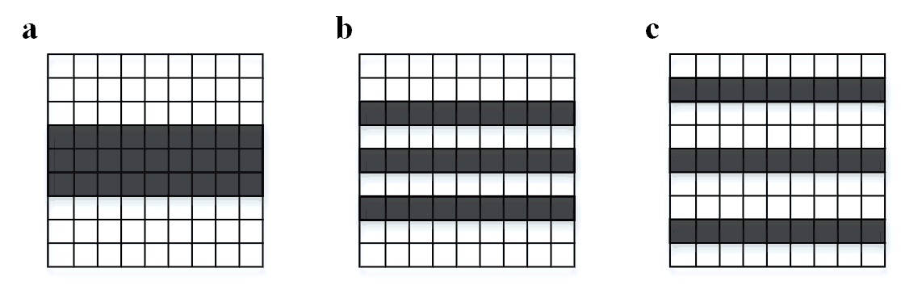
Fig. S1 Different dilation rates in 1-D DCNN with a kernel size of 3. a DR=1. b DR=2. c DR=3.

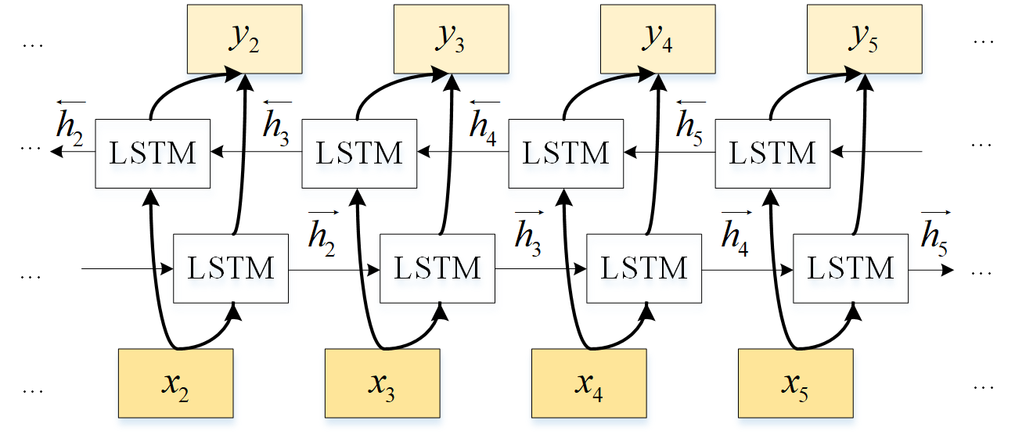
Fig. S2 Diagram of BiLSTM model.

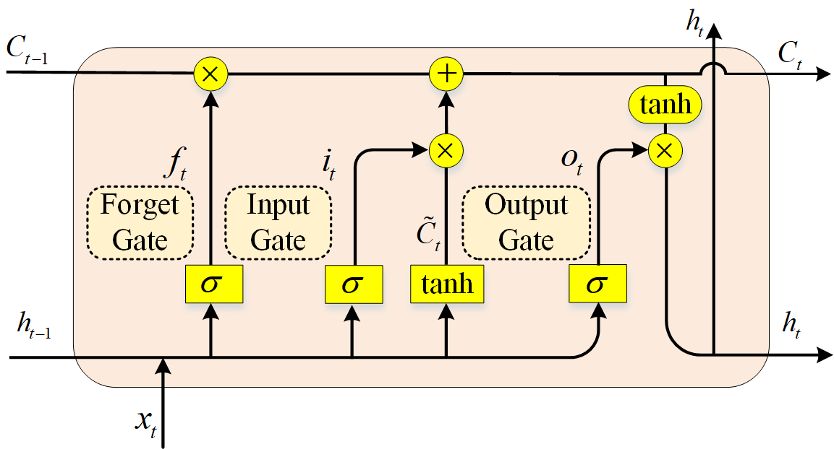
Fig. S3 There are three gates in the LSTM internal department control model diagram.

