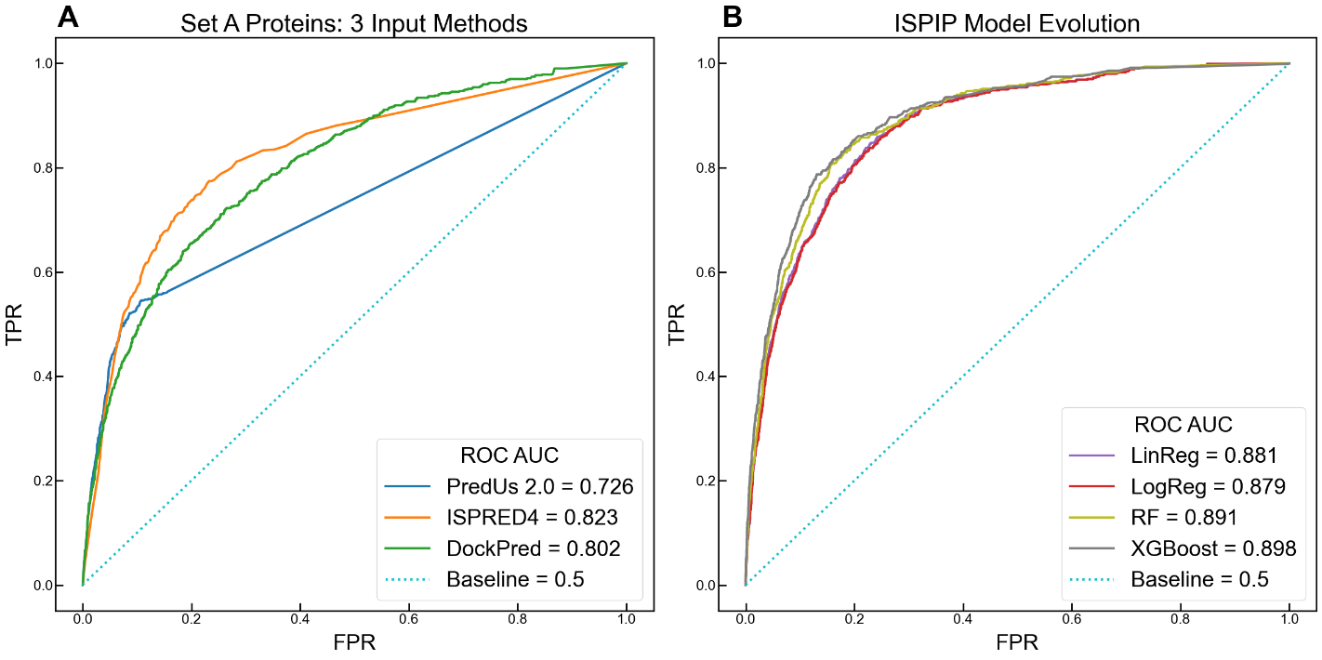
Supplementary Figure 1. ROC illustrates enhanced ISPIP’s enhanced prediction on Set A proteins: (A) The ROC curves of the 3 input methods indicate that DockPred and ISPRED4 perform better than PredUs 2.0. (B) All the ISPIP models significantly outperform the input predictors, and ROC-AUC is boosted as the model evolves from simple linear regression to more complex ensemble decision tree algorithms.
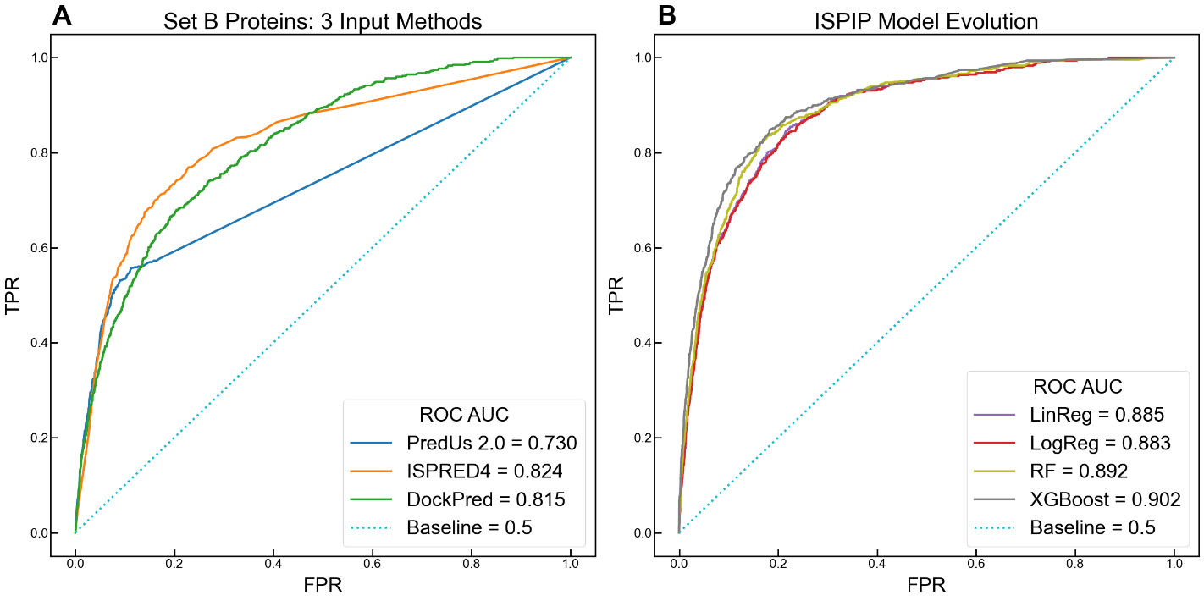
Supplementary Figure 2. ROC illustrates enhanced ISPIP’s enhanced prediction on Set B proteins: (A, B) Similar, but slightly improved, model improvement was observed for Set B proteins, from which proteins larger than 450 residues were removed.
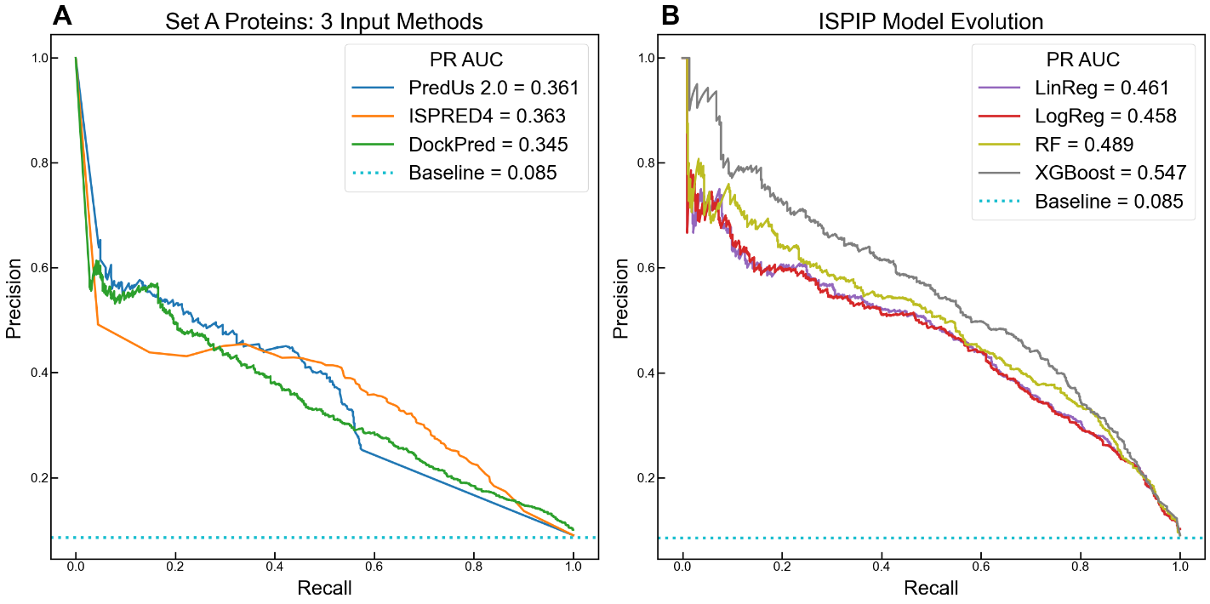
Supplementary Figure 3. PR illustrates enhanced ISPIP’s enhanced prediction on Set B proteins: (A, B) The model improvement observed for Set A proteins through the PR-AUC (Figure 1) can also be seen for Set B proteins.

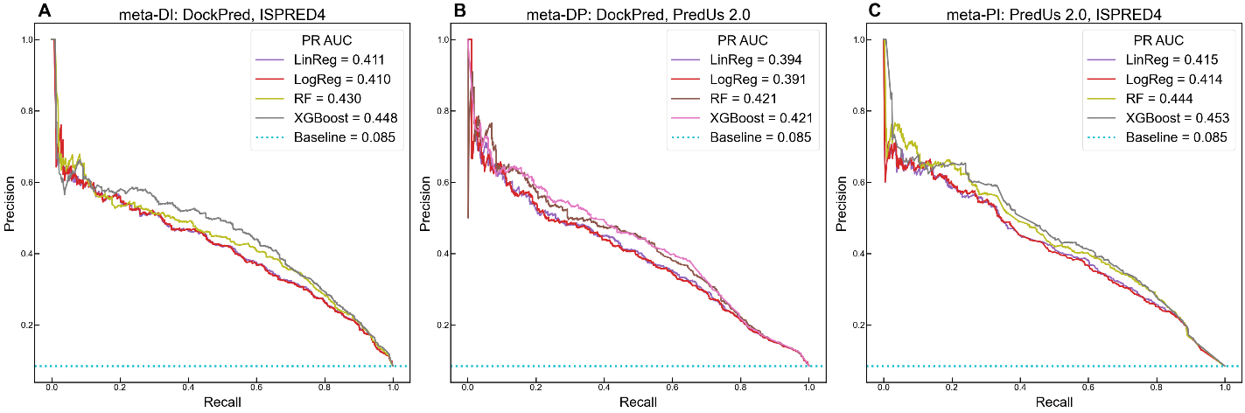
Supplementary Figure 4. ISPIP models trained only on 2 of the 3 input classifiers: (A) Similar to the complete ISPIP model, the one trained on only DockPred and ISPRED4 showed enhanced performance with increasing model complexity. (B) Method combination yields enhanced prediction, even without being trained on ISPRED4. (C) The model trained on ISPRED4 and PredUs 2.0 performs the best out of the models trained on 2 of the 3 input classifiers.

A B
- B
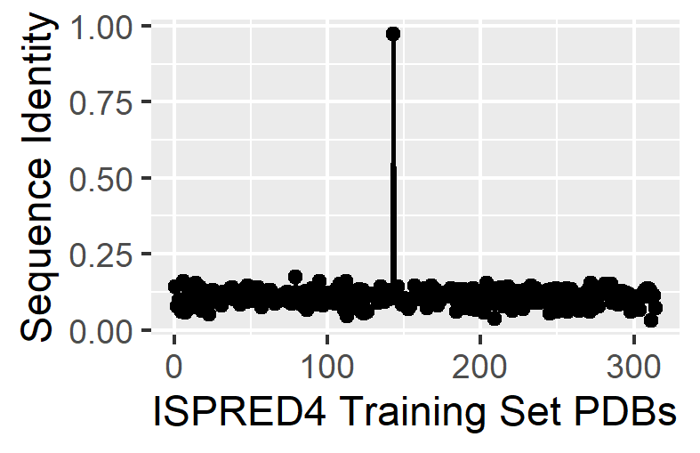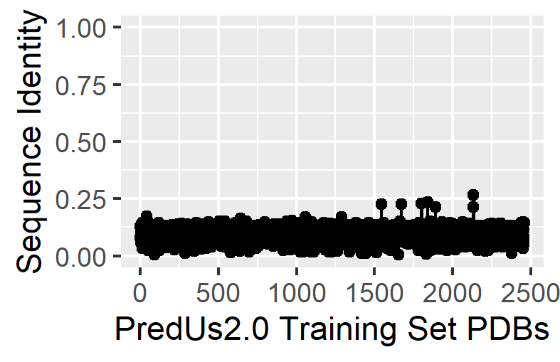

Supplementary Figure 5: Sequence identify distribution of a representative test set protein, 1KXP_D, with the training sets of ISPRED4 (A) and PredUs 2.0 (B).

A B
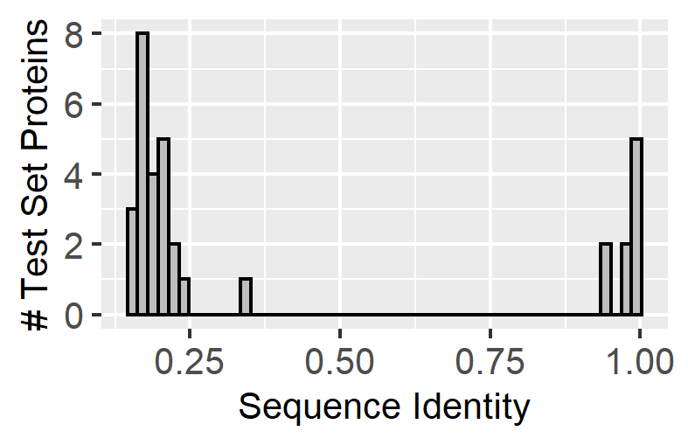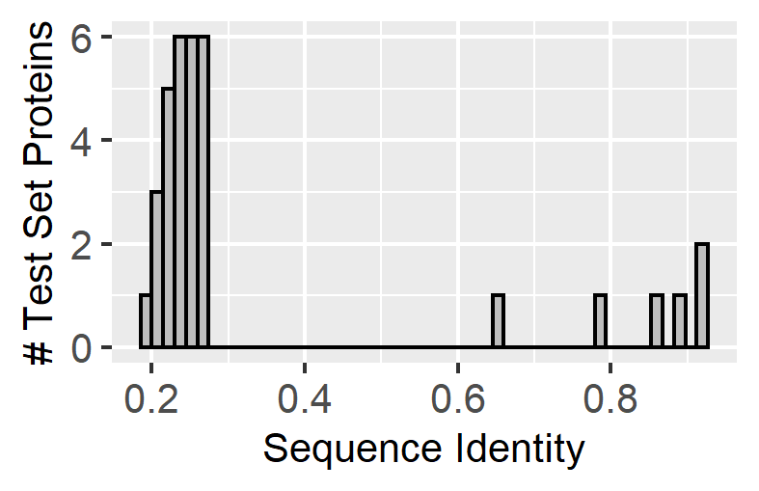
Supplementary Figure 6: Histogram of maximum sequence identify distribution of the ISPIP test set proteins with the training sets of ISPRED4 (A) and PredUs 2.0 (B).

