Supporting information for
A machine learning-based data mining in medical examination data: a group features-based biological age prediction model
Qing Yang^{1, †}, Sunan Gao^{2, †}, Junfen Lin¹, Ke Lyu³, Zexu Wu³, Yuhao Chen³, Yinwei Qiu¹, Yanrong Zhao¹, Wei Wang¹, Tianxiang Lin¹, Huiyun Pan⁴ and Ming Chen^{3, 4,} *
¹ Zhejiang Provincial Center for Disease Control and Prevention, Hangzhou 310051, China
² College of Biosystems Engineering and Food Science, Zhejiang University, Hangzhou 310058, China
³ College of Life Sciences, Zhejiang University, Hangzhou 310058, China
⁴ The First Affiliated Hospital of School of Medicine, Zhejiang University, Hangzhou 310058, China
† These authors contributed equally to this work

Fig. S1 Optimized lambda selection (A) and feature selection (B) in Lasso regression
Fig. S2 Feature importance values in the Stacking model.
Fig. S3 Schematic diagrams of the process for introducing missing values and interpolation in MCAR (A) and MNAR (B).
Table S1. Parameter optimization results of KNN and MICE in MCAR.
Table S2. Parameter optimization results of KNN and MICE in MNAR.
Table S3. The optimized parameters of AE and RRLR.
Table S4. The interpolation time consumed by the different models.
Table S5. Coefficients of biological features in Lasso regression (lambda = 0.00072).
Table S6. Parameter optimization results of GAM (splines), AdaBoost, CNN, DNN, Extra Trees, GBDT, LGBM, CatBoost, XGBoosts.
Table S7. The results and parameters of two XGBoost models.
Table S8. The variable importance values of the sub-models in the Stacking model.
Table S9. Associations of STK-BA and XGB-BAs with health risk indicators.
Table S10. Associations of STK-BA and XGB-BAs with health risk indicators (Quintile, ABSI).
Table S11. Associations of STK-BA and XGB-BAs with health risk indicators (Quintile, WHtR).
Table S12. Predicted increase in STK-BA and XGB-BAs for each disease count.
Table S13. The associations between each disease and STK-BA, XGB-BAs.
Table S14. The 19 biological features’ attributes of study participants (n=77,144).
Table S15. The disease status of study population (n=77, 144).

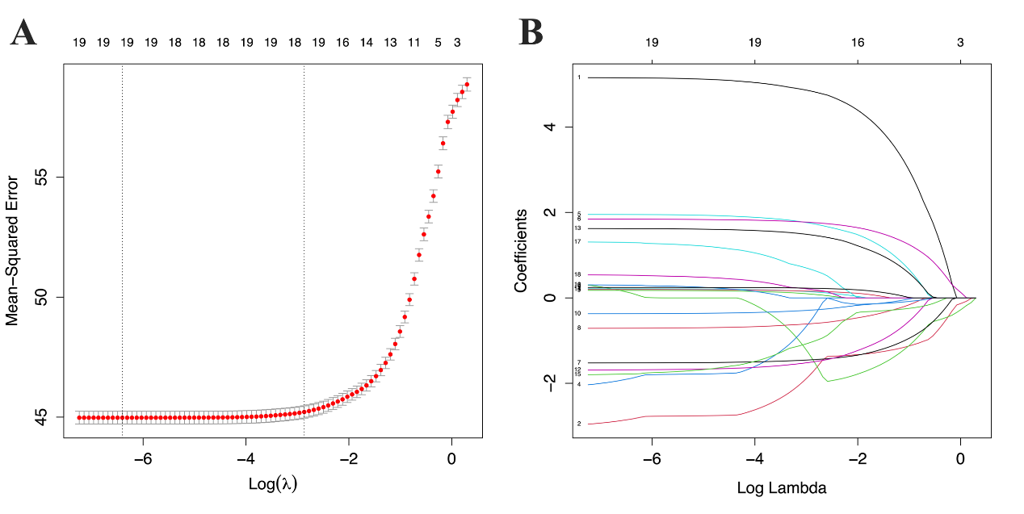
Fig. S1 Optimized lambda selection (A) and feature selection (B) in Lasso regression.

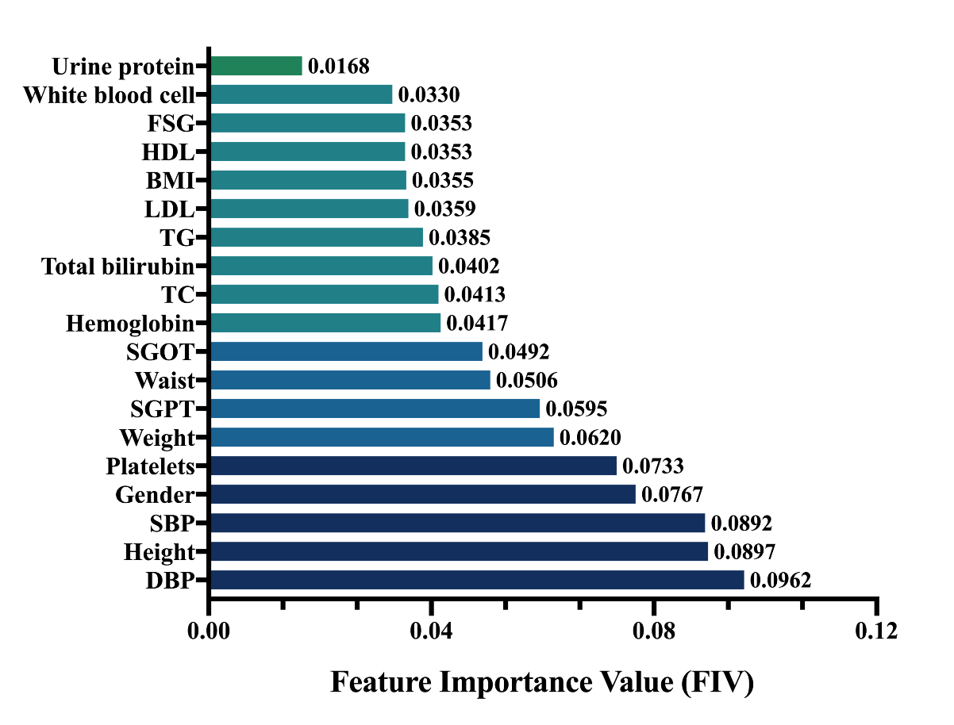

Fig. S2 Feature importance values in the Stacking model.

Fig. S3 Schematic diagrams of the process for introducing missing values and interpolation in MCAR (A) and MNAR (B).
* In our clinical data, considering that only specific variables were missing more than 2%, indicating that missing data may only depend on the variables themselves, thus we performed MNAR simulation. In addition, considering that the study data were only a random subset of the study population and that the probability of missing data was not observed to be affected by other variables obviously, thus we performed MCAR simulations.

Table S1. Parameter optimization results of KNN and MICE in MCAR.
Method | Missing Ratio |  | Parameters | Train Set |  | Valid Set
KNN |  |  |  | MSE | R² |  | MSE | R²
KNN | 30% | 5 |  | 1.1297 | 1.0312 |  | -0.1291 | -0.0117
KNN |  | 15 |  | 1.1148 | 1.0233 |  | -0.1097 | -0.0229
KNN |  | 30 |  | 1.1393 | 1.0306 |  | -0.1347 | -0.0377
KNN |  | 50 |  | 1.1224 | 1.0294 |  | -0.1222 | -0.0222
KNN | 20% | 5 |  | 1.0405 | 0.9458 |  | -0.0325 | 0.0505
KNN |  | 15 |  | 1.0408 | 0.9302 |  | -0.0541 | 0.0617
KNN |  | 30 |  | 1.0312 | 0.9254 |  | -0.0234 | 0.0661
KNN |  | 50 |  | 1.0458 | 0.9509 |  | -0.0424 | 0.0445
KNN | 10% | 5 |  | 0.9705 | 0.9015 |  | 0.043 | 0.0865
KNN |  | 15 |  | 0.9369 | 0.8869 |  | 0.062 | 0.0964
KNN |  | 30 |  | 0.963 | 0.8605 |  | 0.042 | 0.1307
KNN |  | 50 |  | 0.9549 | 0.8751 |  | 0.0347 | 0.0894
KNN | 5% | 5 |  | 0.9288 | 0.8771 |  | 0.0696 | 0.1439
KNN |  | 15 |  | 0.9366 | 0.8427 |  | 0.093 | 0.1112
KNN |  | 30 |  | 0.9124 | 0.8336 |  | 0.0666 | 0.1724
KNN |  | 50 |  | 0.9146 | 0.8741 |  | 0.094 | 0.135
MICE | 30% | 1 |  | 1.0346 | 1.0331 |  | -0.0303 | -0.0401
MICE |  | 3 |  | 0.9143 | 0.9113 |  | 0.0856 | 0.0868
MICE |  | 5 |  | 0.8837 | 0.8806 |  | 0.1119 | 0.1156
MICE |  | 10 |  | 0.8797 | 0.865 |  | 0.1232 | 0.124
MICE | 20% | 1 |  | 0.9652 | 0.9738 |  | 0.0328 | 0.0399
MICE |  | 3 |  | 0.8726 | 0.8582 |  | 0.1349 | 0.1293
MICE |  | 5 |  | 0.8375 | 0.8512 |  | 0.1613 | 0.1531
MICE |  | 10 |  | 0.8369 | 0.8403 |  | 0.1664 | 0.152
MICE | 10% | 1 |  | 0.8901 | 0.9017 |  | 0.1088 | 0.0792
MICE |  | 3 |  | 0.8168 | 0.8071 |  | 0.1886 | 0.186
MICE |  | 5 |  | 0.7825 | 0.8164 |  | 0.2065 | 0.1999
MICE |  | 10 |  | 0.7956 | 0.809 |  | 0.2139 | 0.198
MICE | 5% | 1 |  | 0.8644 | 0.8907 |  | 0.1341 | 0.1305
MICE |  | 3 |  | 0.8061 | 0.7553 |  | 0.2193 | 0.2034
MICE |  | 5 |  | 0.7445 | 0.7804 |  | 0.2384 | 0.2253
MICE |  | 10 |  | 0.7668 | 0.7852 |  | 0.2404 | 0.223

* The nearest neighbor value for KNN was chosen from 5, 15, 30, and 50, and the number of mean match candidates for MICE was chosen from 1, 3, 5, and 10.

Table S2. Parameter optimization results of KNN and Mice in MNAR.
Method | Parameters | Train Set |  | Valid Set
KNN |  | MSE | R² | MSE | R²
KNN | 5 | 1.0195 | 1.0191 | -0.0223 | -0.025
KNN | 15 | 0.9149 | 0.9057 | 0.0826 | 0.0891
KNN | 30 | 0.8912 | 0.8853 | 0.1063 | 0.1096
KNN | 50 | 0.8848 | 0.8866 | 0.1128 | 0.1083
MICE | 1 | 0.9253 | 0.8396 | 0.0721 | 0.1555
MICE | 3 | 0.9189 | 0.8377 | 0.0786 | 0.1574
MICE | 5 | 0.9173 | 0.8064 | 0.0801 | 0.1889
MICE | 10 | 0.9273 | 0.8426 | 0.0701 | 0.1525

* The nearest neighbor value for KNN was chosen from 5, 15, 30, and 50, and the number of mean match candidates for MICE was chosen from 1, 3, 5, and 10.

Table S3. The optimized parameters of AE and RRLR.
 | Optimized parameters
RRLR | max_iter = 20, tol = 0.001, n_nearest_features = None, initial_strategy = 'median',  imputation_order = 'ascending' (IterativeImputer function in Python)
AE (MCAR) | batch size = 64, epochs = 200, Encoder = {64,16}, Decoder = {23},  optimizer = adam, loss = mse, metrics = mae, learning rate = 0.001,  activation = relu (keras package in Python)
AE (MNAR) | batch size = 32, epochs = 150, Encoder = {64,16}, Decoder = {23},  optimizer = adam, loss = mse, metrics = mae, learning rate = 0.001,  activation = relu (keras package in Python)

Table S4. The interpolation time consumed by the different models.
 | Missing ratio |  | Time consumption (s)
MCAR |  | Mean |  | KNN | RRLR | MICE | AE
MCAR | 30% | 4.2 |  | 15.2 | 8.4 | 43 | 1.7
MCAR | 20% | 7.3 |  | 9.6 | 9.4 | 54 | 1.3
MCAR | 10% | 5.9 |  | 5.1 | 6.1 | 56 | 1.1
MCAR | 5% | 2.7 |  | 4.2 | 11.5 | 10 | 1.2
MNAR | / | 1.7 |  | 4.6 | 2.1 | 17.9 | 2.4
* The time it took to interpolate once based on optimized parameters on Macbook pro (3.1 GHz Intel Core i5, 8 GB 2133 MHz).

Table S5. Coefficients of biological features in Lasso regression (lambda = 0.00166).
Variable | Coefficient | Variable | Coefficient
Gender | 5.150 | SGPT | -1.685
Height | -2.839 | SGOT | 1.622
Weight | 0.111 | Total bilirubin | 0.197
BMI | -1.884 | Total cholesterol | -1.781
Waist | 1.951 | Triglyceride | 0.296
SBP | 1.842 | LDL | 1.295
DBP | -1.524 | HDL | 0.529
Hemoglobin | -0.710 | Urine protein | 0.245
White blood cell | 0.175 | Urine sugar | .
Platelet | -0.370 | Urine ketone bodies | .
Fasting serum glucose | 0.213 | Urine occult blood | .

Table S6. Parameter optimization results of GAM (splines), AdaBoost, CNN, DNN, Extra Trees, GBDT, LGBM, CatBoost, XGBoosts.
 | Optimized parameters
GAM(splines) | Smooth spline regression with 4 degrees of freedom was adopted for all variables
AdaBoost | n_estimators=1000, learning_rate=0.29, loss = ‘linear’
CNN | batch size = 64, epochs = 250, optimizer = adam, loss = mse, activation = relu  Layer = {Conv1D(128,3), Maxpooling(2), Conv1D(64, 3), MaxPooling1D(2), layers.Flatten(), Dense(32), Dense(1)} (keras package in Python)
DNN | batch size = 50, epochs = 100, loss = mse, activation = relu  optimizer = adam_v2.Adam(learning_rate=0.0001, decay=lr/epochs)  Layer = {64, 32, 32, 1} (keras package in Python)
Extra Trees | n_estimators=100, criterion="mse", min_samples_split=2, min_samples_leaf=1
GBDT | n_estimators=1500, loss='ls', learning_rate=0.1, subsample=1, max_depth=3  criterion='friedman_mse', min_samples_split=2, min_samples_leaf=1
LGBM | n_estimators=1500, boosting_type='gbdt', num_leaves=31, max_depth=6  learning_rate=0.1, min_child_weight=0.001, min_child_samples=20, subsample=1
CatBoost | Iterations=3000, border_count=235, depth=9, l2_leaf_reg=10.66  learn_rate=0.077, loss_function='RMSE'
Xgboost | n_estimators=2000, learning_rate=0.2, max_depth=3, min_child_weight=5
*Parameters that are not displayed are the default parameters in the model package.

Table S7. The results and parameters of two XGBoost models.
 | Training set |  |  |  | Test set
 | RMSE | R² | MAE | Pearson  correlation | RMSE | R² | MAE | Pearson  correlation
XGB-BA1 | 4.988 | 0.578 | 3.780 | 0.760 | 5.869 | 0.414 | 4.489 | 0.643
XGB-BA2 | 3.915 | 0.740 | 2.890 | 0.860 | 5.918 | 0.404 | 4.507 | 0.636
 | Model parameter
XGB-BA1 | n_estimators=2000, learning_rate=0.2, max_depth=3, min_child_weight=5
XGB-BA2 | n_estimators=2500, learning_rate=0.2, max_depth=4, min_child_weight=5
*Parameters that are not displayed are the default parameters in the model package.

Table S8. The variable importance values of the sub-models in the Stacking model.
Feature | Xgboost | GBDT | ETR | LGBM | Catboost | Total
DBP | 0.0725 | 0.1314 | 0.0844 | 0.0782 | 0.1144 | 0.0962
Height | 0.0870 | 0.1291 | 0.1071 | 0.0574 | 0.0679 | 0.0897
SBP | 0.0788 | 0.1211 | 0.0749 | 0.0658 | 0.1056 | 0.0892
Gender | 0.2206 | 0.0799 | 0.0220 | 0.0098 | 0.0514 | 0.0767
Platelets | 0.0660 | 0.0949 | 0.0746 | 0.0657 | 0.0655 | 0.0733
Weight | 0.0633 | 0.0769 | 0.0699 | 0.0514 | 0.0484 | 0.0620
SGPT | 0.0632 | 0.0739 | 0.0516 | 0.0504 | 0.0584 | 0.0595
Waistline | 0.0538 | 0.0448 | 0.0589 | 0.0429 | 0.0527 | 0.0506
SGOT | 0.0481 | 0.0495 | 0.0487 | 0.0484 | 0.0513 | 0.0492
hemoglobin | 0.0270 | 0.0254 | 0.0545 | 0.0569 | 0.0447 | 0.0417
TC | 0.0229 | 0.0334 | 0.0419 | 0.0613 | 0.0469 | 0.0413
Total bilirubin | 0.0220 | 0.0222 | 0.0441 | 0.0656 | 0.0472 | 0.0402
TG | 0.0208 | 0.0252 | 0.0429 | 0.0599 | 0.0435 | 0.0385
LDL | 0.0172 | 0.0183 | 0.0399 | 0.0605 | 0.0438 | 0.0359
BMI | 0.0210 | 0.0223 | 0.0440 | 0.0540 | 0.0361 | 0.0355
HDL | 0.0148 | 0.0166 | 0.0416 | 0.0618 | 0.0417 | 0.0353
FSG | 0.0194 | 0.0162 | 0.0438 | 0.0563 | 0.0406 | 0.0353
White blood cells | 0.0197 | 0.0151 | 0.0424 | 0.0520 | 0.0360 | 0.0330
Urine protein | 0.0618 | 0.0038 | 0.0128 | 0.0018 | 0.0038 | 0.0168

Table S9. Associations of STK-BA and XGB-BAs with health risk indicators.
 |  | Model 1 |  |  | Model 2
 |  | Coef (SE) | t-value | P | Coef (SE) | t-value | P
ABSI | STK-BA | 30.85 (0.32) | 97.23 | <0.001 | 17.62 (0.25) | 69.94 | <0.001
ABSI | XGB1-BA | 30.27 (0.33) | 92.63 | <0.001 | 15.09 (0.23) | 64.82 | <0.001
ABSI | XGB2-BA | 30.46 (0.36) | 83.99 | <0.001 | 11.87 (0.22) | 54.50 | <0.001
WHtR | STK-BA | 14.88 (0.33) | 45.53 | <0.001 | 30.31 (0.35) | 86.80 | <0.001
WHtR | XGB1-BA | 14.53 (0.34) | 43.34 | <0.001 | 25.96 (0.32) | 80.36 | <0.001
WHtR | XGB2-BA | 14.58 (0.37) | 39.46 | <0.001 | 20.27 (0.30) | 66.77 | <0.001

Table S10. Associations of STK-BA and XGB-BAs with health risk indicators (Quintile, ABSI).
Age | Model | ABSI (Quintile)
Age | Model | Q1 | Q2 |  | Q3 |  | Q4 |  | Q5
Age | Model |  | Coef (SE) | P | Coef (SE) | P
STK-BA | Model 1 | Ref | 0.765 (0.054) | <0.001 | 1.467 (0.054) | <0.001 | 2.500 (0.054) | <0.001 | 4.693 (0.054) | <0.001
STK-BA | Model 2 | Ref | 0.436 (0.041) | <0.001 | 0.850 (0.041) | <0.001 | 1.462 (0.042) | <0.001 | 2.674 (0.043) | <0.001
XGB-BA1 | Model 1 | Ref | 0.760 (0.056) | <0.001 | 1.460 (0.056) | <0.001 | 2.499 (0.056) | <0.001 | 4.623 (0.056) | <0.001
XGB-BA1 | Model 2 | Ref | 0.386 (0.038) | <0.001 | 0.747 (0.038) | <0.001 | 1.300 (0.038) | <0.001 | 2.308 (0.039) | <0.001
XGB-BA2 | Model 1 | Ref | 0.729 (0.062) | <0.001 | 1.466 (0.062) | <0.001 | 2.509 (0.062) | <0.001 | 4.647 (0.062) | <0.001
XGB-BA2 | Model 2 | Ref | 0.271 (0.036) | <0.001 | 0.589 (0.036) | <0.001 | 1.028 (0.036) | <0.001 | 1.812 (0.037) | <0.001

Table S11. Associations of STK-BA and XGB-BAs with health risk indicators (Quintile, WHtR).
Age | Model | WHtR (Quintile)
Age | Model | Q1 | Q2 |  | Q3 |  | Q4 |  | Q5
Age | Model |  | Coef (SE) | P | Coef (SE) | P | Coef (SE) | P | Coef (SE) | P
STK-BA | Model 1 | Ref | 0.233 (0.057) | <0.001 | 0.548 (0.057) | <0.001 | 0.921 (0.057) | <0.001 | 2.183 (0.057) | <0.001
STK-BA | Model 2 | Ref | 0.867 (0.042) | <0.001 | 1.514 (0.044) | <0.001 | 2.262 (0.047) | <0.001 | 4.035 (0.046) | <0.001
XGB-BA1 | Model 1 | Ref | 0.207 (0.058) | <0.001 | 0.528 (0.058) | <0.001 | 0.880 (0.058) | <0.001 | 2.134 (0.058) | <0.001
XGB-BA1 | Model 2 | Ref | 0.720 (0.039) | <0.001 | 1.293 (0.041) | <0.001 | 1.921 (0.044) | <0.001 | 3.465 (0.051) | <0.001
XGB-BA2 | Model 1 | Ref | 0.266 (0.064) | <0.001 | 0.545 (0.064) | <0.001 | 0.867 (0.064) | <0.001 | 2.163 (0.064) | <0.001
XGB-BA2 | Model 2 | Ref | 0.609 (0.037) | <0.001 | 1.023 (0.038) | <0.001 | 1.476 (0.041) | <0.001 | 2.734 (0.048) | <0.001

Table S12. Predicted increase in STK-BA and XGB-BAs for each disease count.
Age | Model | Disease Counts
Age | Model | 0 | 1 |  | 2+
Age | Model |  | Coef (SE) | P | Coef (SE) | P
STK-BA | Model 1 | Reference | 0.998 (0.036) | <0.001 | 2.422 (0.136) | <0.001
STK-BA | Model 2 | Reference | 0.170 (0.028) | <0.001 | 0.461 (0.103) | <0.001
XGB-BA1 | Model 1 | Reference | 1.053 (0.038) | <0.001 | 2.623 (0.140) | <0.001
XGB-BA1 | Model 2 | Reference | 0.100 (0.025) | <0.001 | 0.372 (0.095) | <0.001
XGB-BA2 | Model 1 | Reference | 1.240 (0.041) | <0.001 | 3.047 (0.153) | <0.001
XGB-BA2 | Model 2 | Reference | 0.069 (0.024) | 0.004 | 0.284 (0.088) | 0.001

Table S13. The associations between each disease and STK-BA, XGB-BAs
 | Model 1 |  |  | Model 2
 | OR (95% CI) | z-score | P | OR (95% CI) | z-score | P
Kidney
STK-BA | 1.05 (1.01, 1.10) | 2.23 | 0.026 | 1.07 (1.00, 1.13) | 2.11 | 0.035
XGB1-BA | 1.04 (1.00, 1.09) | 1.86 | 0.063 | 1.05 (0.99, 1.13) | 1.68 | 0.092
XGB2-BA | 1.03 (0.99, 1.07) | 1.00 | 0.143 | 1.04 (0.97, 1.12) | 1.16 | 0.247
Vascular
STK-BA | 1.02 (0.99, 1,04) | 1.28 | 0.202 | 0.98 (0.95, 1.01) | -1.30 | 0.190
XGB1-BA | 1.01 (0.99, 1.04) | 1.23 | 0.209 | 0.97 (0.94, 1.00) | -1.89 | 0.059
XGB2-BA | 1.02 (1.00, 1.04) | 1.52 | 0.128 | 0.96 (0.93, 0.99) | -2.30 | 0.021
Heart
STK-BA | 1.09 (1.07, 1.11) | 10.14 | <0.001 | 1.02 (1.00, 1.05) | 2.18 | 0.030
XGB1-BA | 1.10 (1.08, 1.11) | 11.88 | <0.001 | 1.04 (1.01, 1.06) | 3.00 | 0.002
XGB2-BA | 1.09 (1.08, 1.11) | 12.51 | <0.001 | 1.04 (1.01, 1.06) | 2.72 | 0.007
Cerebrovascular
STK-BA | 1.10 (1.09, 1.12) | 15.43 | <0.001 | 1.05 (1.03, 1.06) | 5.23 | <0.001
XGB1-BA | 1.10 (1.09, 1.12) | 16.33 | <0.001 | 1.04 (1.02, 1.06) | 4.61 | <0.001
XGB2-BA | 1.10 (1.09, 1.11) | 17.10 | <0.001 | 1.04 (1.02, 1.06) | 4.21 | <0.001
Eye
STK-BA | 1.14 (1.10, 1.18) | 7.61 | <0.001 | 1.09 (1.04, 1.14) | 3.84 | <0.001
XGB1-BA | 1.12 (1.09, 1.16) | 7.33 | <0.001 | 1.07 (1.02, 1.12) | 2.85 | 0.004
XGB2-BA | 1.11 (1.08, 1.14) | 7.34 | <0.001 | 1.07 (1.01, 1.12) | 1.88 | 0.060
Nervous System
STK-BA | 0.93 (0.89, 0.97) | -3.22 | 0.001 | 1.08 (1.02, 1.15) | 2.77 | 0.006
XGB1-BA | 0.90 (0.87, 0.94) | -4.76 | <0.001 | 1.06 (1.00, 1.13) | 1.87 | 0.062
XGB2-BA | 0.89 (0.86, 0.93) | -5.77 | <0.001 | 1.05 (0.99, 1.12) | 1.62 | 0.105
Other System
STK-BA | 1.04 (1.03, 1.04) | 24.77 | <0.001 | 1.01 (1.01, 1.01) | 5.14 | <0.001
XGB1-BA | 1.04 (1.03, 1.04) | 25.47 | <0.001 | 1.01 (1.00, 1.01) | 3.00 | 0.003
XGB2-BA | 1.04 (1.03, 1.04) | 27.39 | <0.001 | 1.00 (1.00, 1.01) | 2.02 | 0.044

Table S14. The 19 biological features’ attributes of study participants (n=77,144).
Variables | <60  years old | 60-70  years old | 70-80  years old | >80  years old | P
Males, n(%) | 2830  (26.1) | 20240  (49.3) | 9627  (48.3) | 2223  (42.0) | <0.001
Body measurement
Height (cm) | 159  (155,164) | 160  (154,165) | 158  (151,164) | 155  (149,162) | <0.001
Weight (kg) | 60.0  (54.7,67.0) | 60.2  (54.8,67.1) | 58.0  (52.0,65.0) | 54.7  (48.0,61.4) | <0.001
BMI (kg/m2) | 23.7  (21.8,25.8) | 23.7  (21.8,25.8) | 23.4  (21.4,25.6) | 22.6  (20.6,24.7) | <0.001
Waist (cm) | 81  (76,86) | 82  (77,88) | 82  (77,88) | 81  (76,87) | <0.001
SBP (mmHg) | 133  (125,140) | 136  (128，145) | 139  (130,148) | 140  (130,150) | <0.001
DBP (mmHg) | 82  (77,87) | 81  (77,86) | 80  (75,85) | 79  (74,84) | <0.001
Blood routine examination
Hemoglobin (g/L) | 135  (127,144) | 137  (128,148) | 135  (125,145) | 130  (121,140) | <0.001
White blood cell (×10^9/L) | 5.5  (4.7,6.5) | 5.5  (4.7,6.6) | 5.5  (4.6,6.5) | 5.5  (4.6,6.5) | <0.001
Platelets (×10^9/L) | 188  (150,226) | 179  (145,215) | 171  (136,208) | 162  (129,201) | <0.001
Serum biochemical indexes
Triglycerides (mmol/L) | 1.32  (1.00,1.90) | 1.23  (0.90,1.75) | 1.20  (0.90,1.63) | 1.12  (0.90,1.54) | <0.001
Total bilirubin (mmol/L) | 13.1  (9.7,17.5) | 13.8  (10.3,18.2) | 14.1  (10.6,18.5) | 13.8  (10.2,18.0) | <0.001
Total cholesterol (mmol/L) | 5.06  (4.48,5.6) | 4.94  (4.34,5.58) | 4.84  (4.23,5.49) | 4.74  (4.14,5.39) | <0.001
Urine protein, n(%) | 538  (5.0) | 2864  (7.0) | 1846  (9.3) | 525  (9.9) | <0.001
HDL (mmol/L) | 1.40  (1.21,1.59) | 1.41  (1.22,1.61) | 1.42  (1.22,1.63) | 1.44  (1.22,1.65) | <0.001
LDL (mmol/L) | 2.79  (2.35,3.28) | 2.77  (2.32,3.25) | 2.72  (2.26,3.23) | 2.68  (2.22,3.19) | <0.001
FSG (mmol/L) | 5.2  (4.8,5.7) | 5.2  (4.8,5.8) | 5.2  (4.8,5.8) | 5.2  (4.7,5.8) | <0.001
SGPT (U/L) | 18  (14,24) | 18  (14,24) | 17  (13,23) | 15  (12,21) | <0.001
SGOT (U/L) | 21  (17,25) | 22  (19,26) | 23  (19,28) | 23  (19,28) | <0.001
a. Urine protein was defined into two levels, positive and negative.
b. Compared by using Kruskal-Wallis tests (for continuous variables) and Chi-square tests (for categorical variables).
Table S15. The disease status of study population (n=77, 144).
Variables | <60 | 60-70 | 70-80 | >80 | P
Variables | years old | years old | years old | years old | P
Family disease, n(%) | 1143(10.1) | 4185(10.2) | 2018(10.1) | 499(9.4) | <0.001
Disease count, n(%) |  |  |  |  | <0.001
0 | 7066(65.1) | 23907(58.2) | 9245(46.4) | 2468(46.6)
1 | 3713(34.2) | 16581(40.4) | 10130(50.8) | 2642(50.0)
>=2 | 77(0.71) | 573(1.40) | 555(2.78) | 187(3.53)
Specific disease
Cerebrovascular disease, n(%) | 58(0.53) | 437(1.06) | 467(2.34) | 174(3.28) | <0.001
Kidney disease, n(%) | 32(0.29) | 128(0.31) | 96(0.48) | 39(0.74) | <0.001
Heart disease, n(%) | 45(0.41) | 296(0.72) | 264(1.32) | 118(2.23) | <0.001
Vascular disease, n(%) | 53(0.49) | 251(0.61) | 163(0.82) | 61(1.15) | <0.001
Eye disease, n(%) | 30(0.28) | 138(0.34) | 137(0.69) | 50(0.94) | <0.001
Nervous system disease, n(%) | 30(0.28) | 35(0.09) | 6(0.03) | 1(0.02) | <0.001
Other system diseases, n(%) | 3745(34.5) | 16918(41.2) | 10498(52.7) | 2758(52.1) | <0.001
Disease counts were defined into three levels, “0”, “1”, and “>=2”. The level “>=2” includes disease counts equal to 2,3, and 4.
- Compared by using Chi-square tests (for categorical variables).

