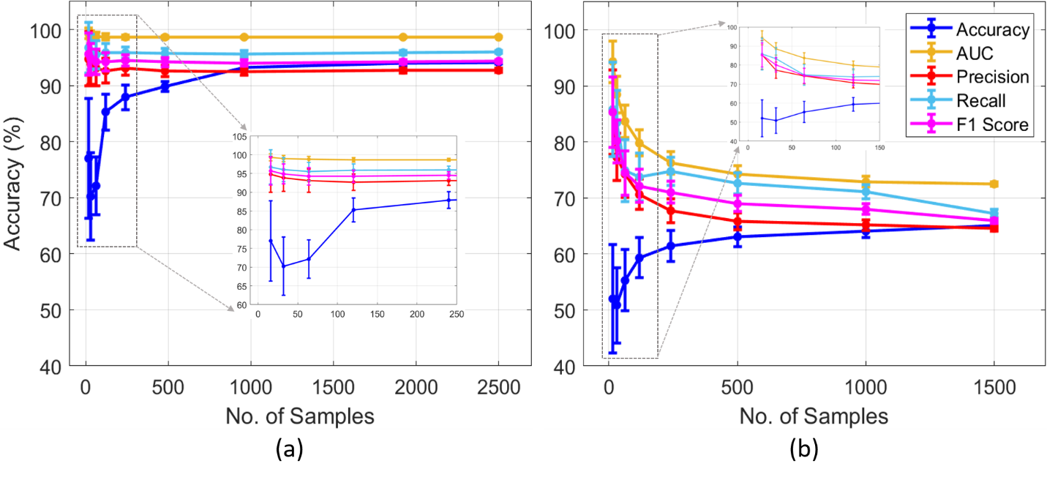
Supplementary Figure 1: Assessment of logistic regression classifier with different methods by using (a) arrhythmia dataset (b) sleep dataset.

