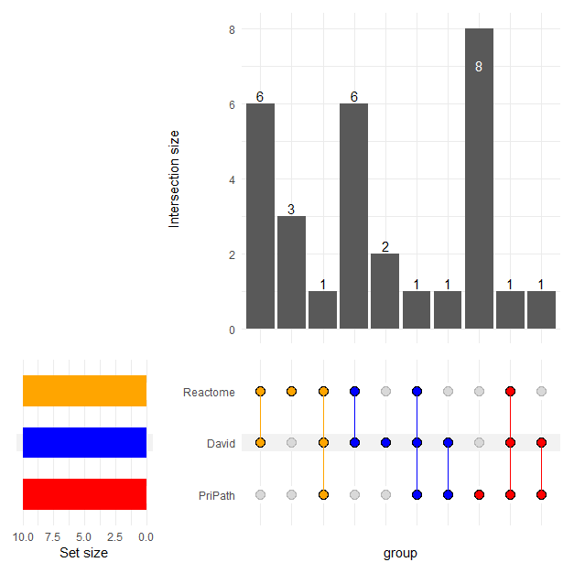
Additional File 1. Comparative Evaluation of PriPath with enrichment analysis provided by Reactome and DAVID for the GDS1962 dataset.

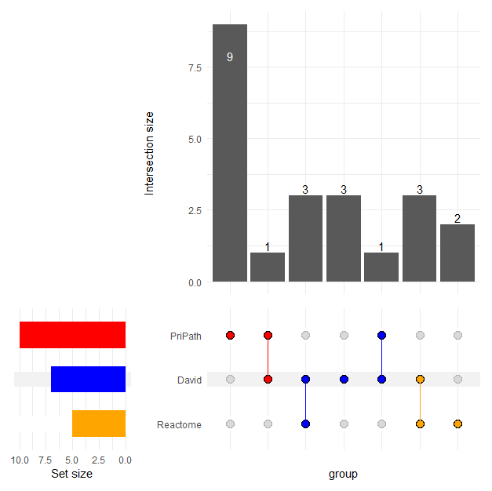
Supplementary Figure 2. Comparative Evaluation with traditional enrichment tools for GDS2547 dataset.

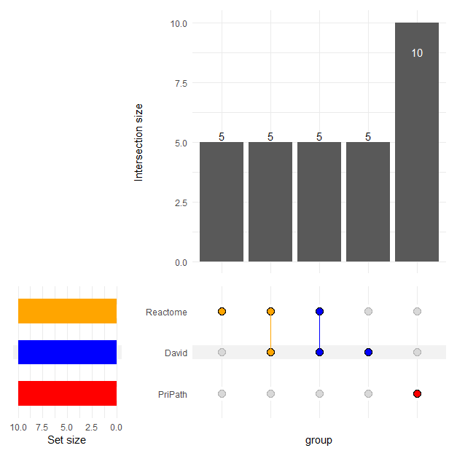
Supplementary Figure 3. Comparative Evaluation with traditional enrichment tools for GDS2609 dataset.

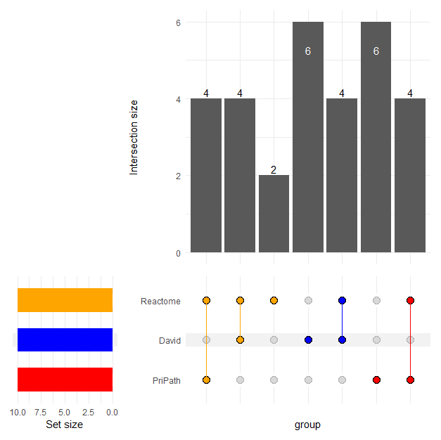

Supplementary Figure 4. Comparative Evaluation with traditional enrichment tools for GDS3268 dataset.

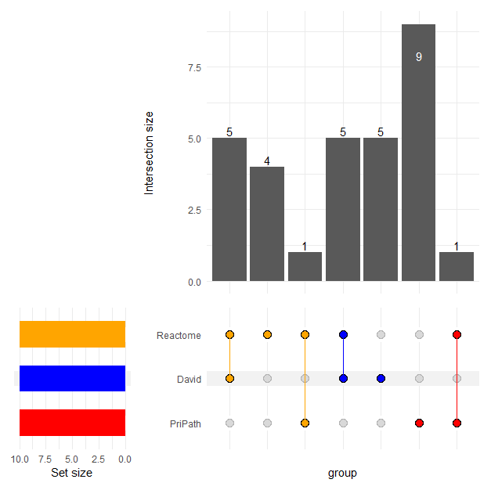

Supplementary Figure 5. Comparative Evaluation with traditional enrichment tools for GDS3646 dataset.

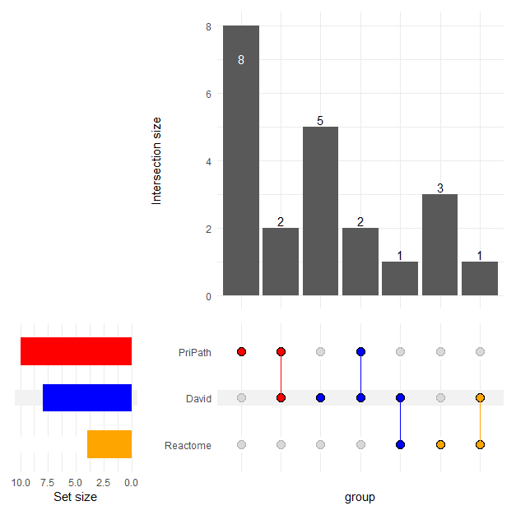

Supplementary Figure 6. Comparative Evaluation with traditional enrichment tools for GDS3794 dataset.

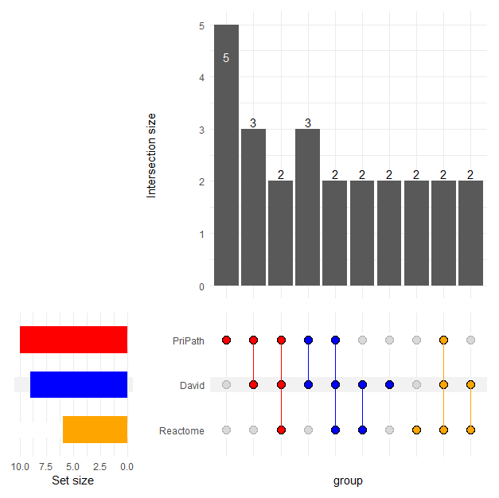
Supplementary Figure 7. Comparative Evaluation with traditional enrichment tools for GDS3837 dataset.

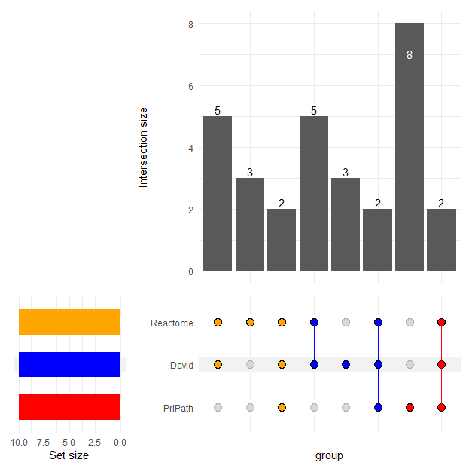Supplementary Figure 8. Comparative Evaluation with traditional enrichment tools for GDS3874 dataset.

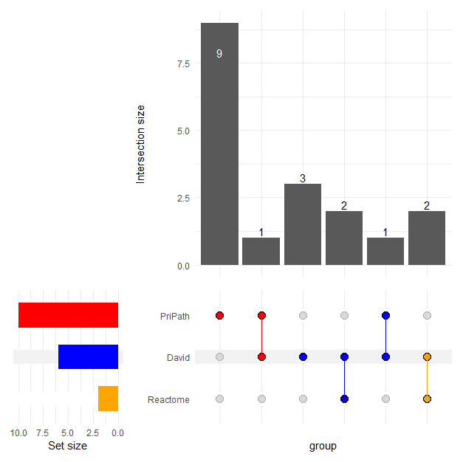
Supplementary Figure 9. Comparative Evaluation with traditional enrichment tools for GDS3875 dataset.

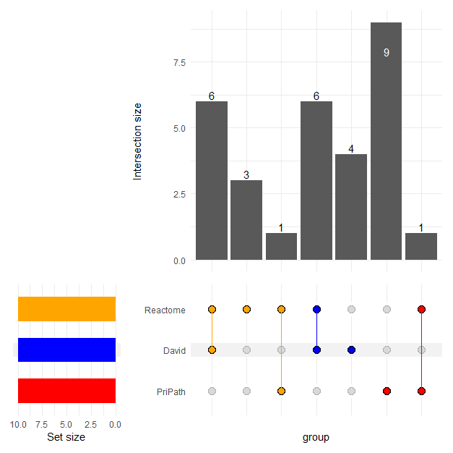

Supplementary Figure 10. Comparative Evaluation with traditional enrichment tools for GDS4516 dataset.

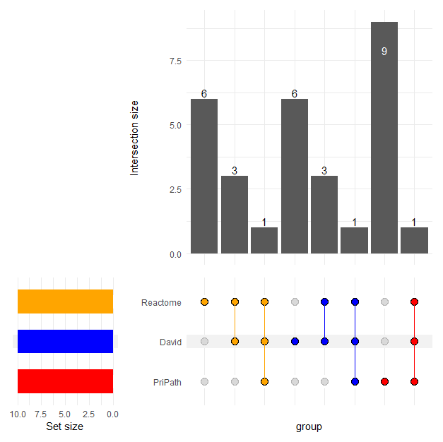

Supplementary Figure 11. Comparative Evaluation with traditional enrichment tools for GDS4824 dataset.

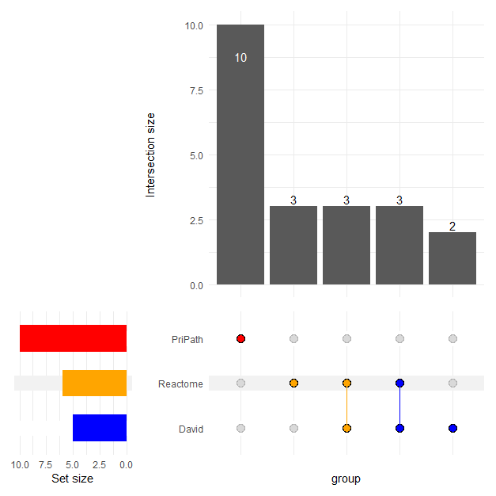

Supplementary Figure 12. Comparative Evaluation with traditional enrichment tools for GDS5037 dataset.

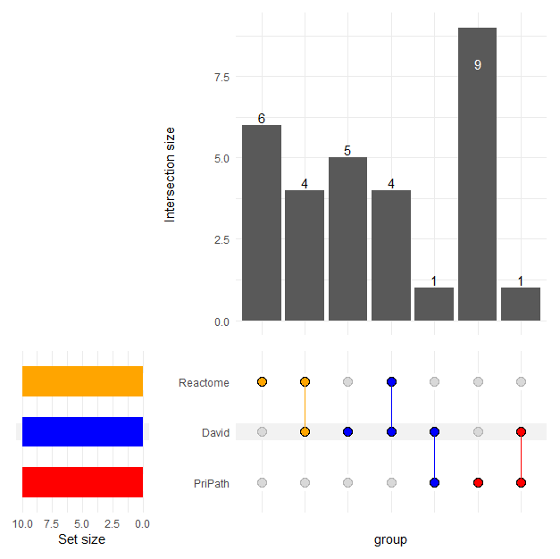

Supplementary Figure 13. Comparative Evaluation with traditional enrichment tools for GDS5499 dataset.

