Supplementary Table1. The performance of our strategy on reducing false negative rate
for sample sets of identified multi-copy regions compared with known 16S rRNA genes.

Target Organisms | Known rRNA Genes | Known Copy Numbers | Alignment of sequences between  De Novo Biomarkers and  known rRNA Genes | Distribution of  Copy Numbers of  De Novo Biomarkers
Mycobacterium tuberculosis | IS6110 | 10,15 | 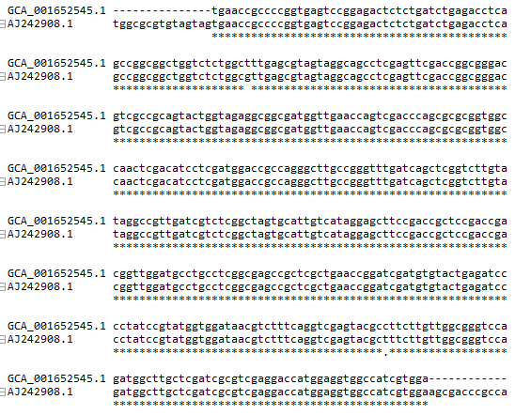 | GCA_001652545.1_246_copy:8(8-10)  0(7)|1(63)|2(43)|3(23)|4(25)|5(4)|6(3)|7(6)|8(5)|9(11)|10(7)|11(11)|12(14)|13(17)|14(14)|15(23)|16(17)|17(13)|18(8)|19(4)|20(1)|21(9)|22(2)|23(3)|24(4)|25(2)| * 97.9%[332/339] 8.37463126843658
Mycobacterium Africanum | IS6110 | 20
Mycobacterium bovis | IS6110 | 1,20
Mycobacterium tuberculosis | IS1081 | 5,6 | 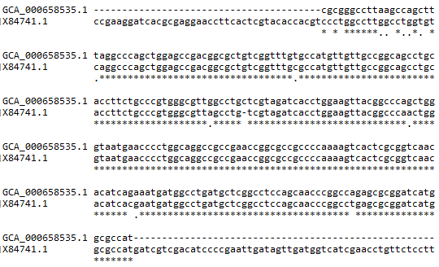 | GCA_000658535.1_410_copy:5(2-5)  0(1)|1(2)|2(6)|3(28)|4(65)|5(236)|7(1)| * 99.7%[338/339] 4.55752212389381
Mycobacterium Africanum | IS1081 | 5,6
Mycobacterium bovis | IS1081 | 5,6
Tuberculosis complex | PGRS | 26,30 | 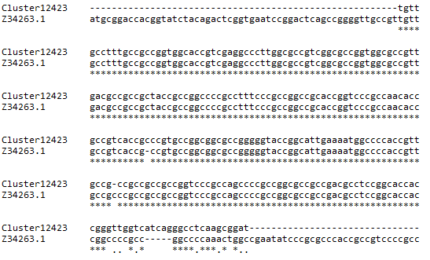 | CP054014.1|3361564-3361841|2|copy:5(3-5)|length:278|1-278
Bordetella pertussis;  Bordetella parapertussis | IS1002 | 6;  4--8;  9;  90 | 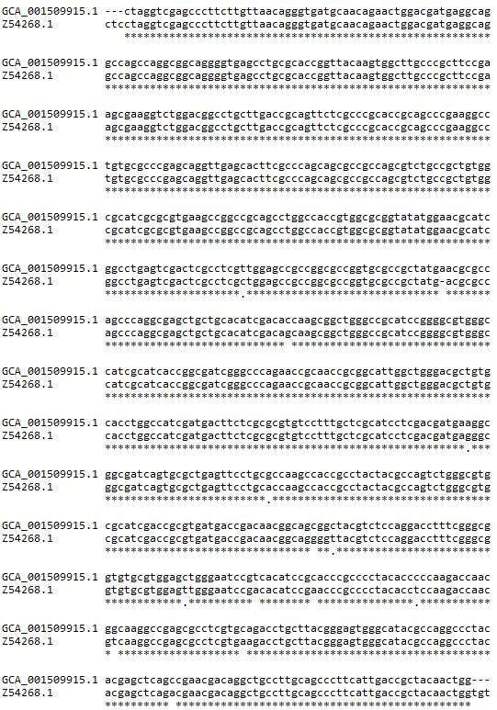 | GCA_001509915.1_74_copy:3(3-3)  0(179)|1(144)|2(15)|3(1)| 47.2%[160/339] 0.52212389380531
Bordetella pertussis;  Bordetella holmesii | IS481 | 239;  100;  >50;  8--10 | 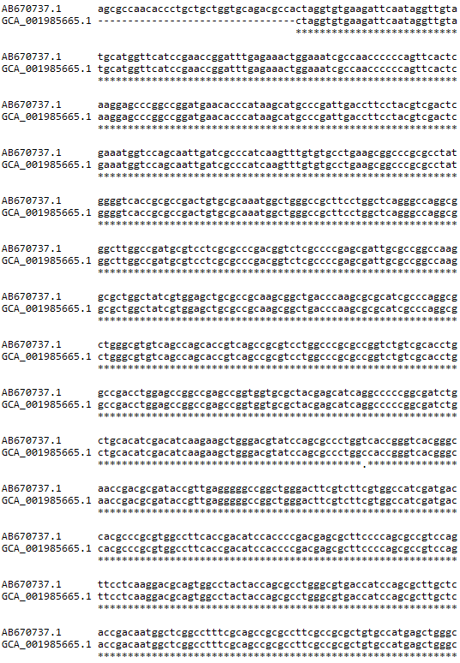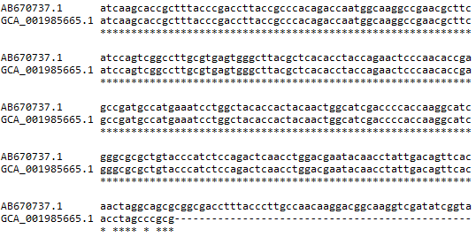 | GCA_001985665.1_53_copy:26(2-26)  0(23)|1(229)|2(84)|3(1)|4(2)| * 93.2%[316/339] 1.20353982300885
Bordetella pertussis | IS1663 | 17 | 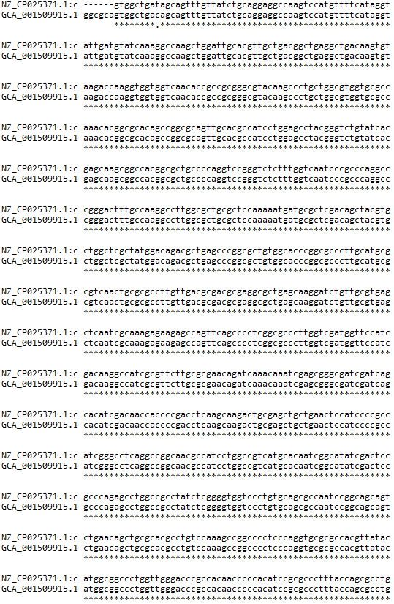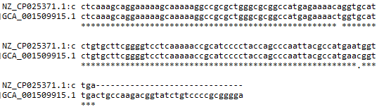 | GCA_001509915.1_17_copy:5(2-6)  0(1)|15(1)|16(82)| * 98.8%[83/84] 15.797619047619
Bordetella parapertussis;  Bordetella bronchiseptica | IS1001 | 20;  22  1--7;  0; | 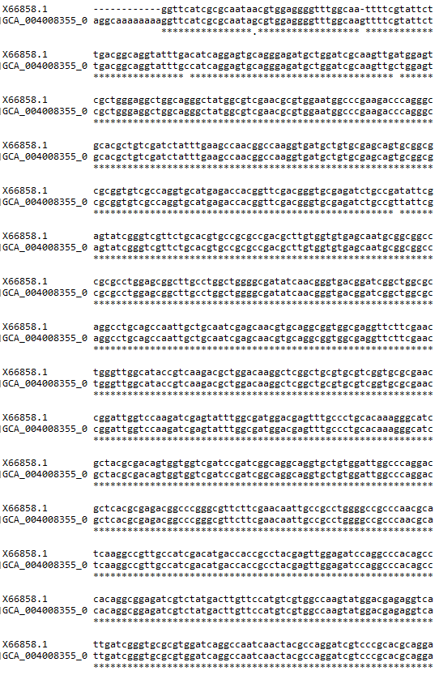  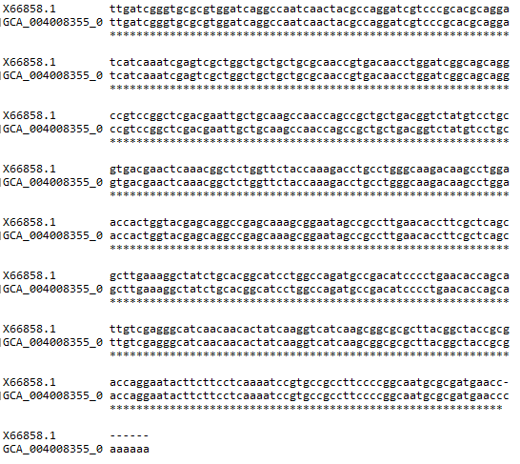 | GCA_004008355_0_copy:8(2-8)  22(21)|23(1)|24(1)| * 100.0%[23/23] 22.1304347826087
Mycoplasma pneumoniae | RepMP2/3 | 10 | 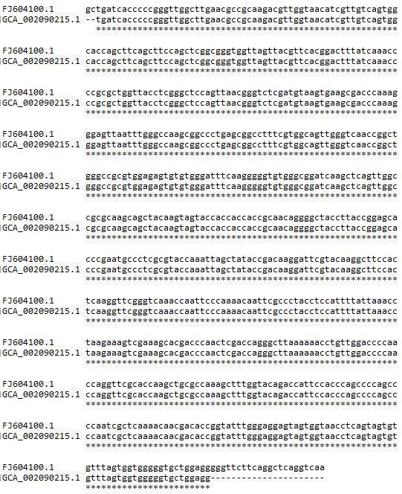 | GCA_002090215.1_89_copy:6(3-7)  0(1)|1(9)| * 90.0%[9/10] 0.9
Mycoplasma pneumoniae | RepMP4 | 8 | 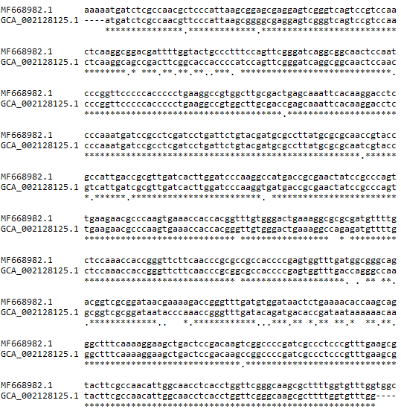 | GCA_002128125.1_490_copy:6(2-7)  1(8)|2(2)| * 100.0%[10/10] 1.2
Mycoplasma pneumoniae | RepMP5 | 7，9 | 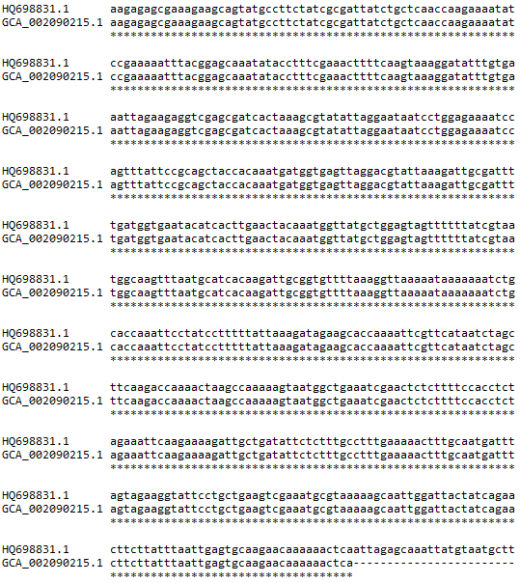 | GCA_002090215.1_316_copy:4(2-4)  4(10)| * 100.0%[10/10] 4
Mycoplasma pneumoniae | RepMP1 | 14 | 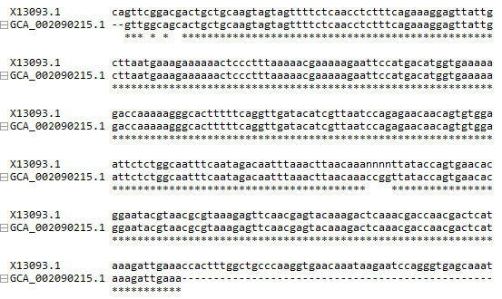 | GCA_002090215.1_182_copy:8(3-8)  10(2)|11(8)| * 100.0%[10/10] 10.8
Streptococcus agalactiae | GBSi1 | 2 | 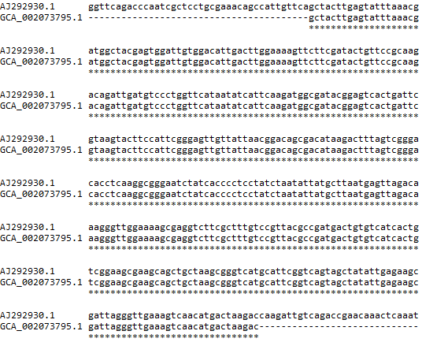 | GCA_002073795.1_71_copy:3(3-3)  0(5)|3(1)|20(1)| 28.6%[2/7] 3.28571428571429
Helicobacter pylori | cagA | 1.4-3.7 | 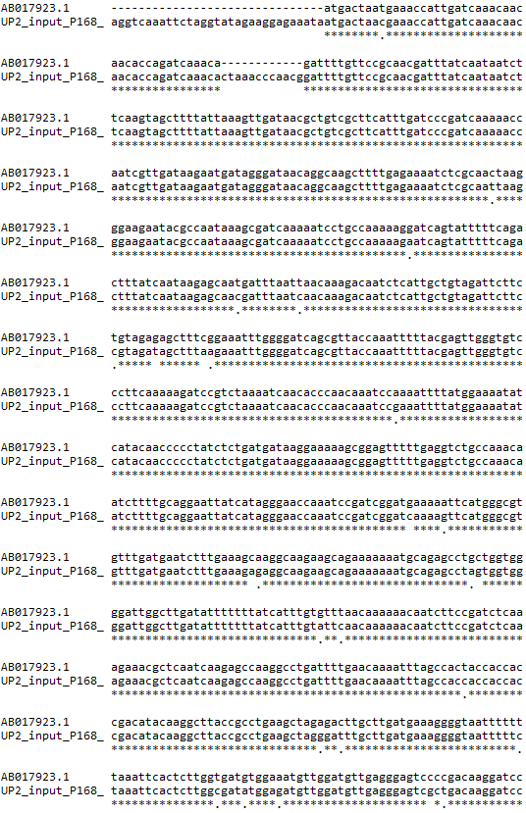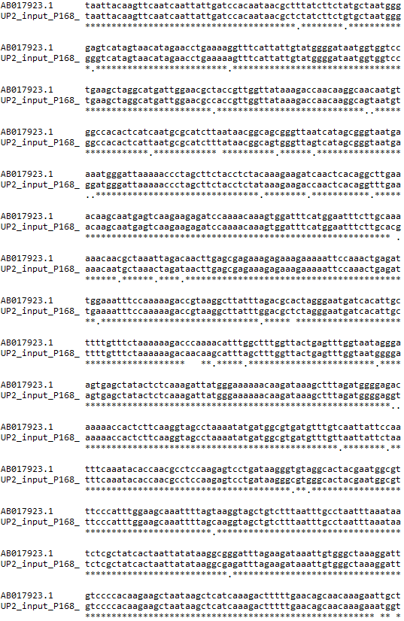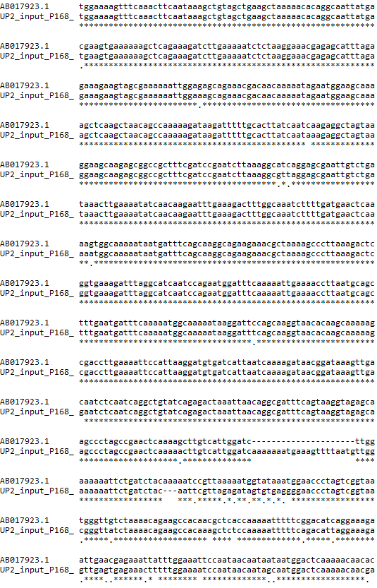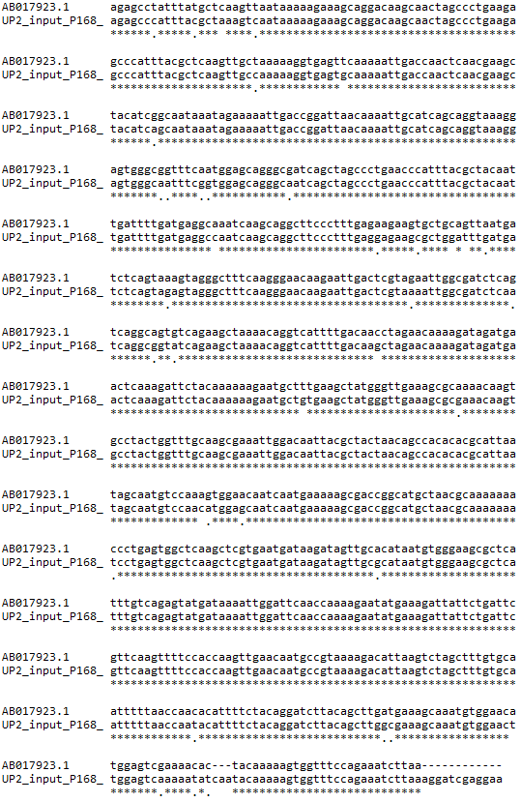 | FR666836.1_ copy:2(2-2)

Supplementary Table2. The performance of our strategy on reducing false positive rate
for sample sets of identified newly discovered species or subspecies specific multi-copy regions.

Target Organisms | Distribution of  Copy Numbers of  De Novo Biomarkers | Sequences of identified newly discovered  species or subspecies specific multi-copy regions.
Mycobacterium tuberculosis | 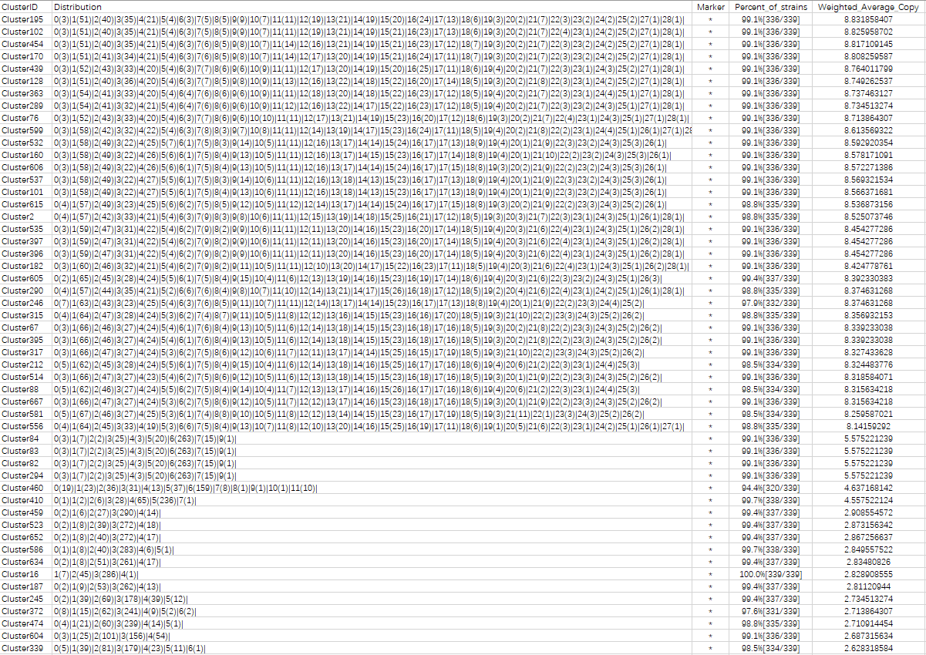 | 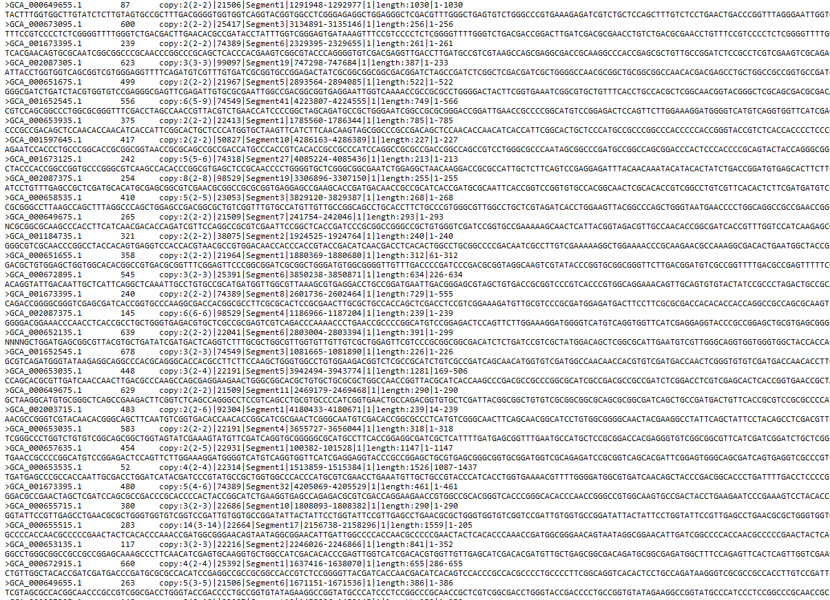
Bordetella pertussis | 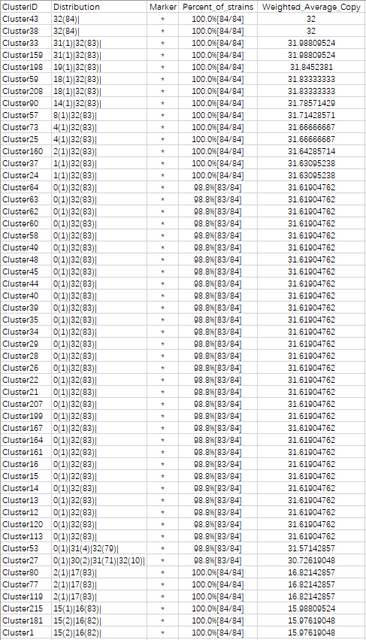 | 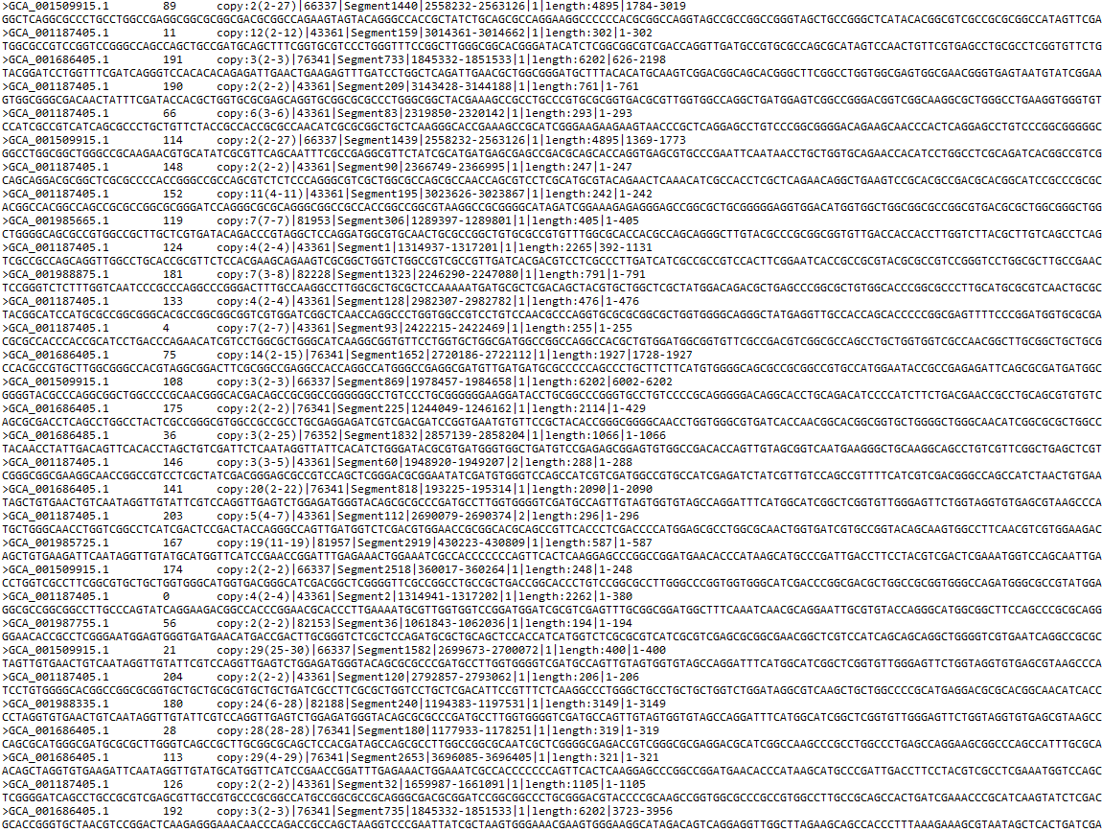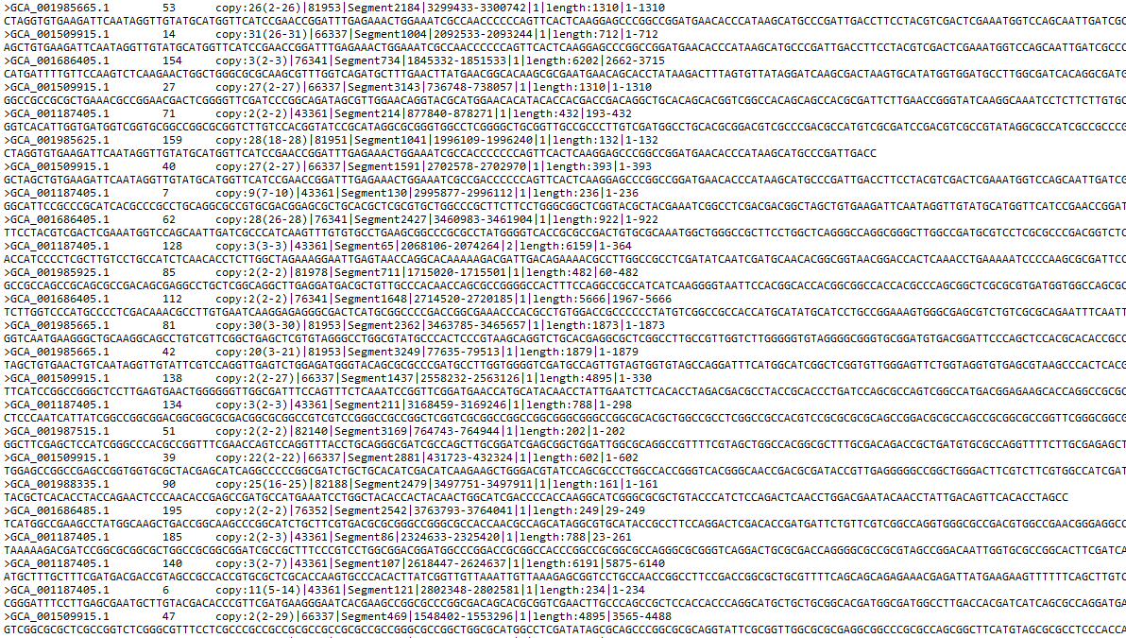
Bordetella parapertussis | 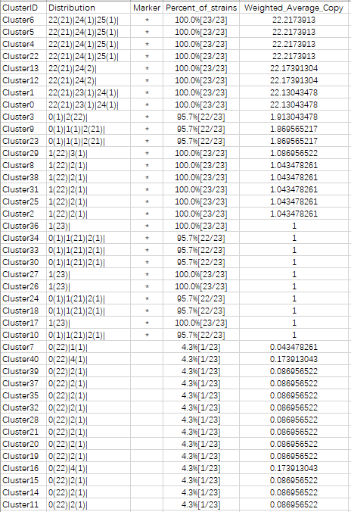 | 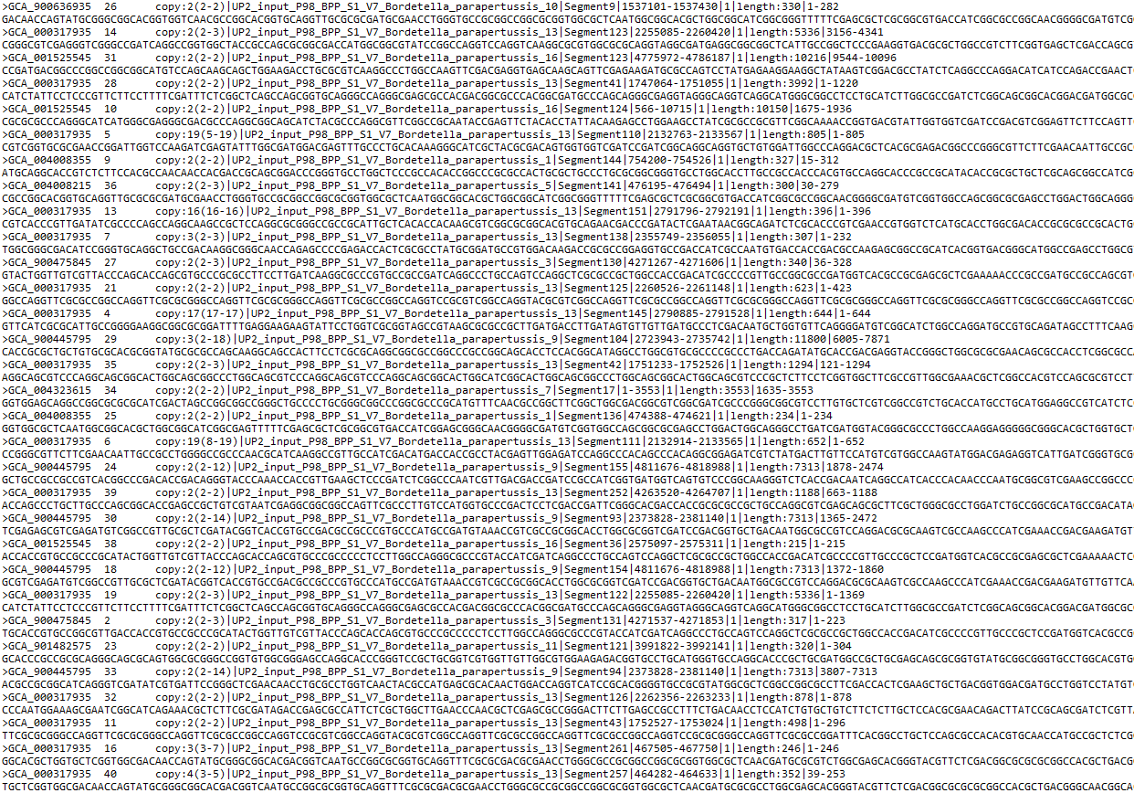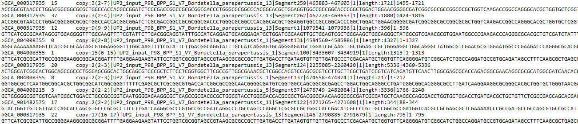
Mycoplasma pneumoniae | 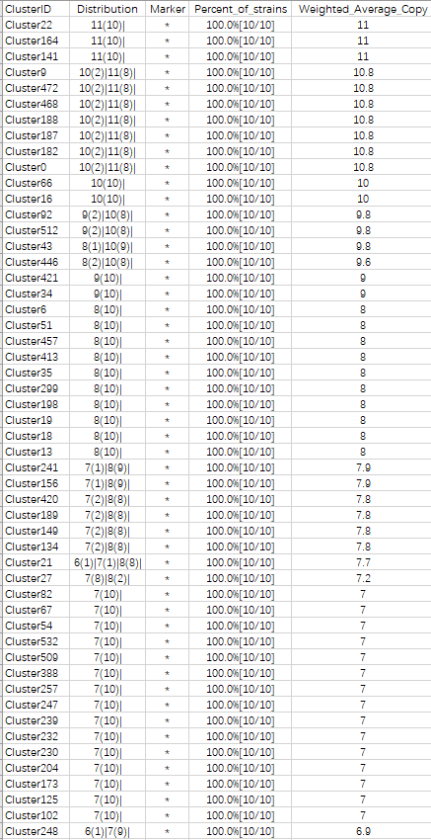 | 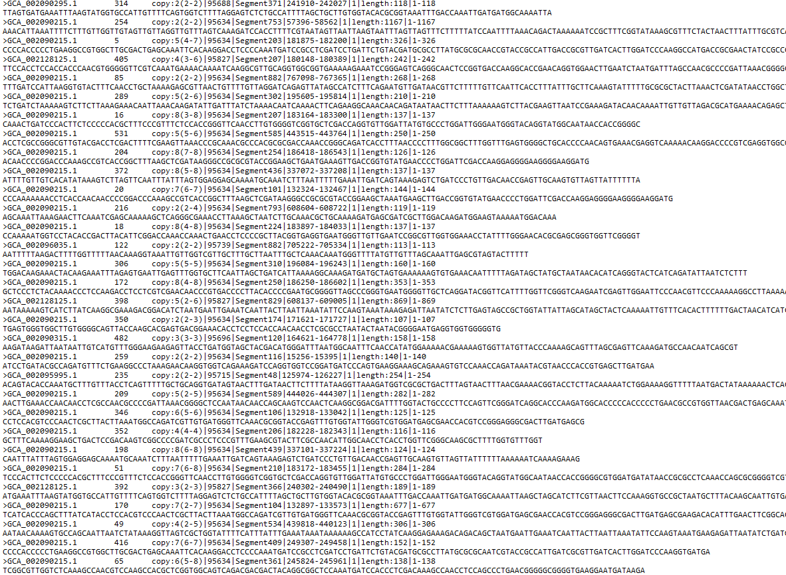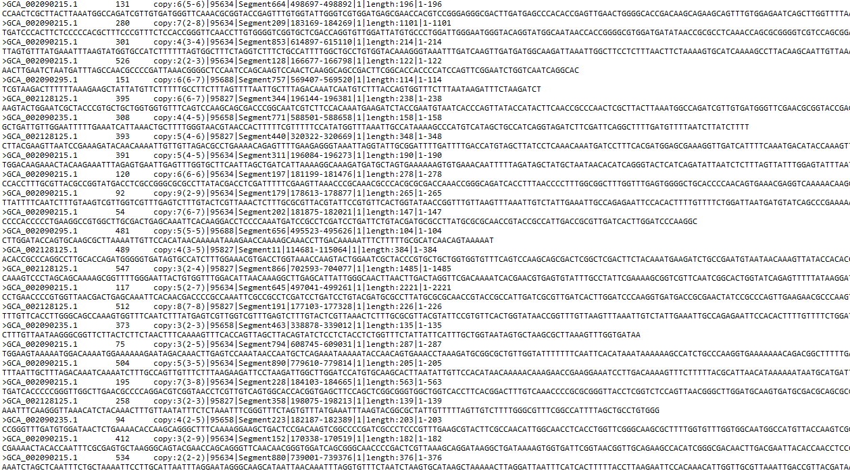
Streptococcus agalactiae | 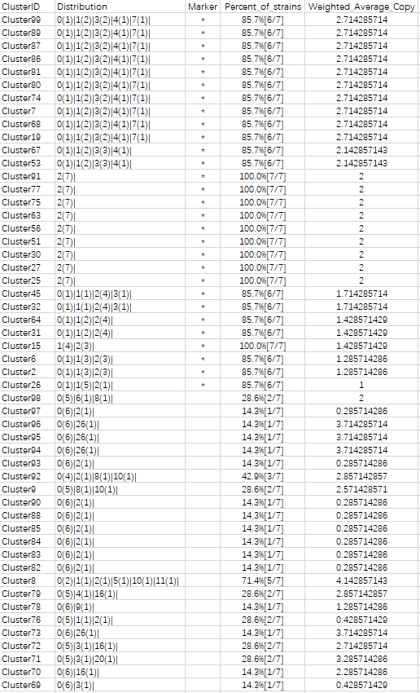 | 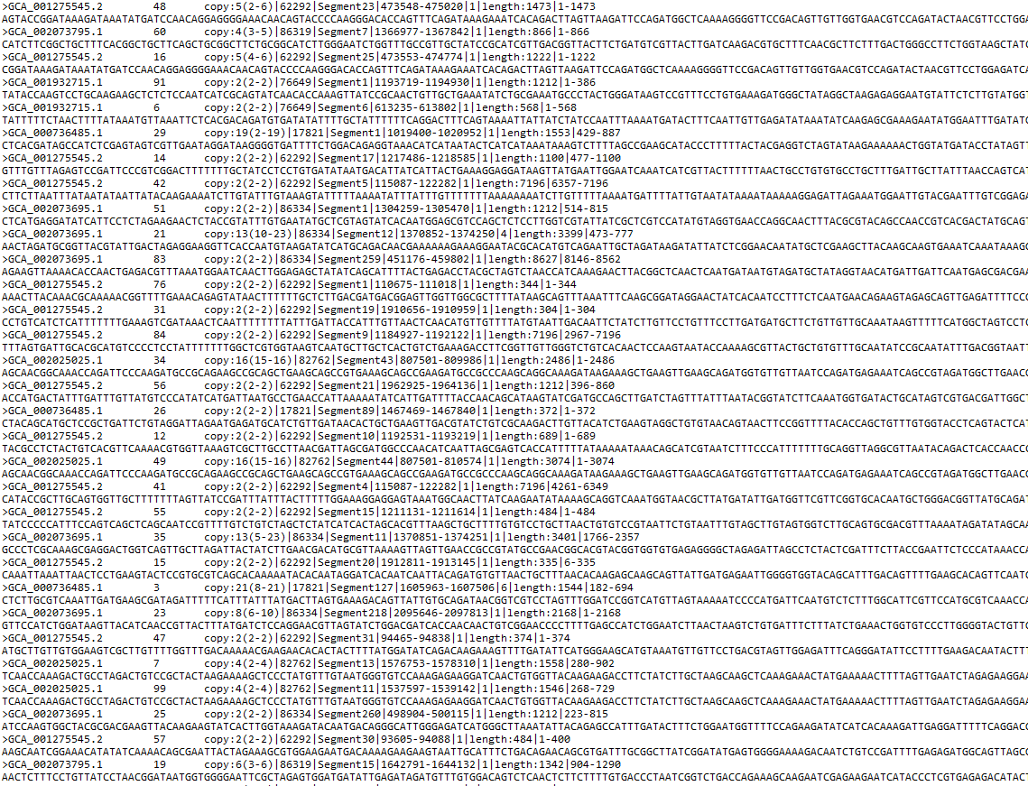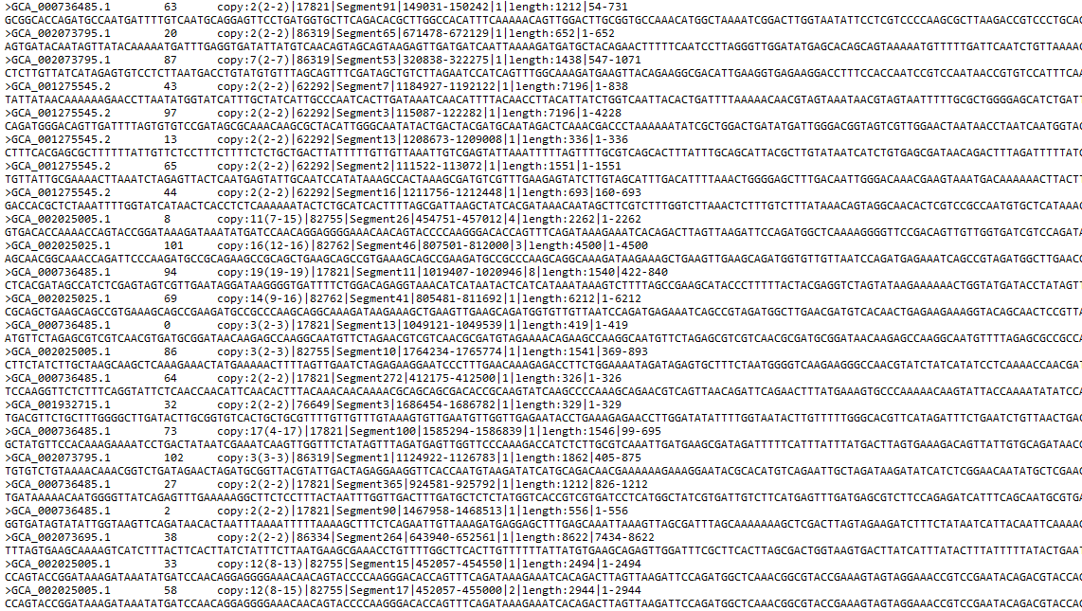
Helicobacter pylori | 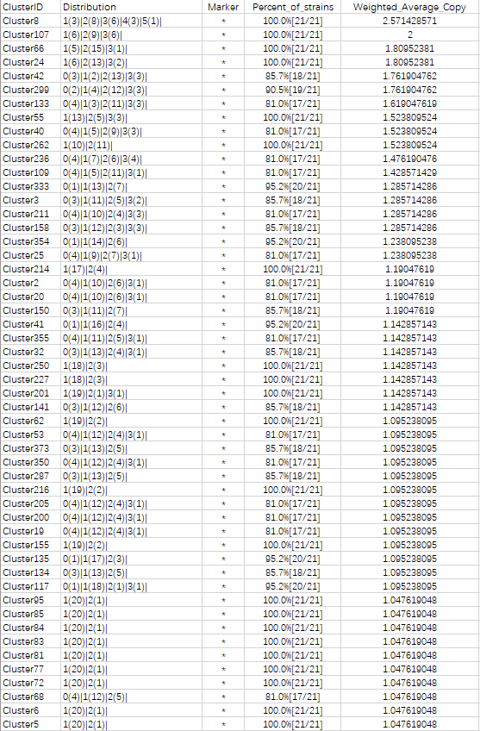 | 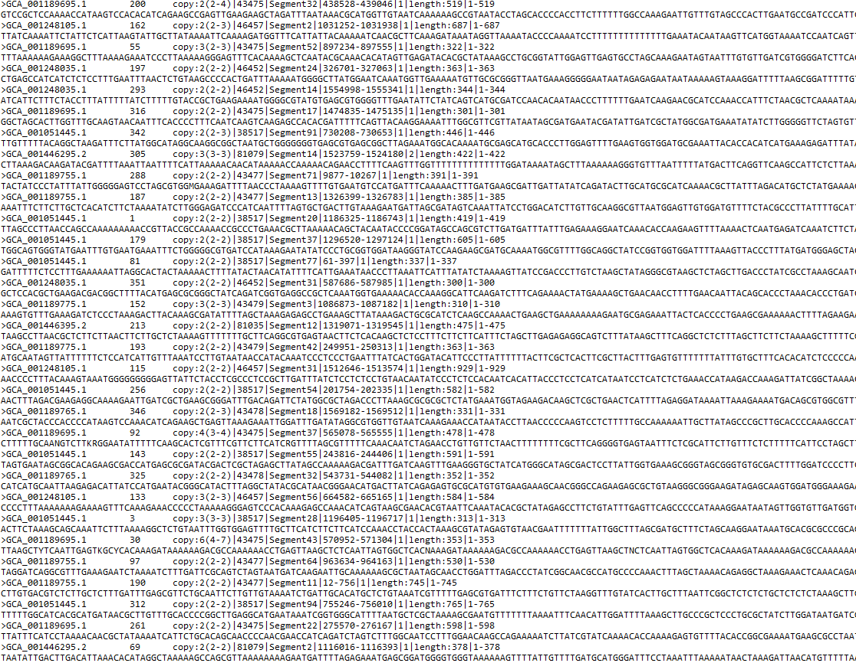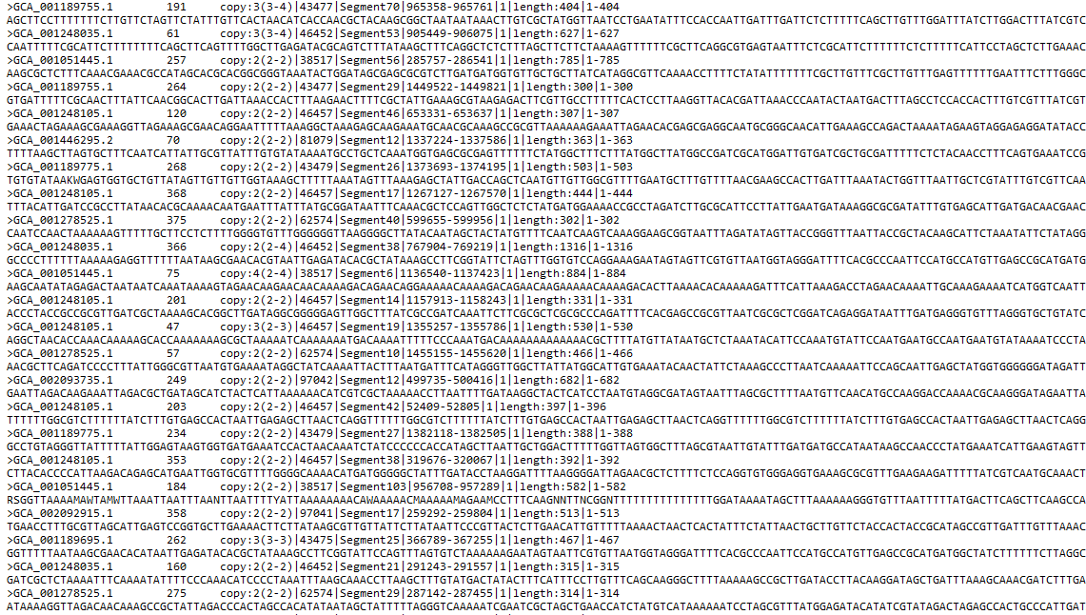
Legionella pneumophila | 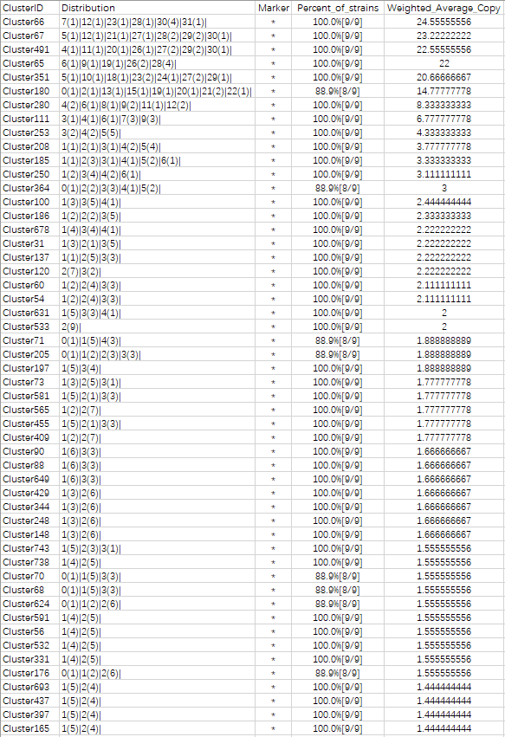 | 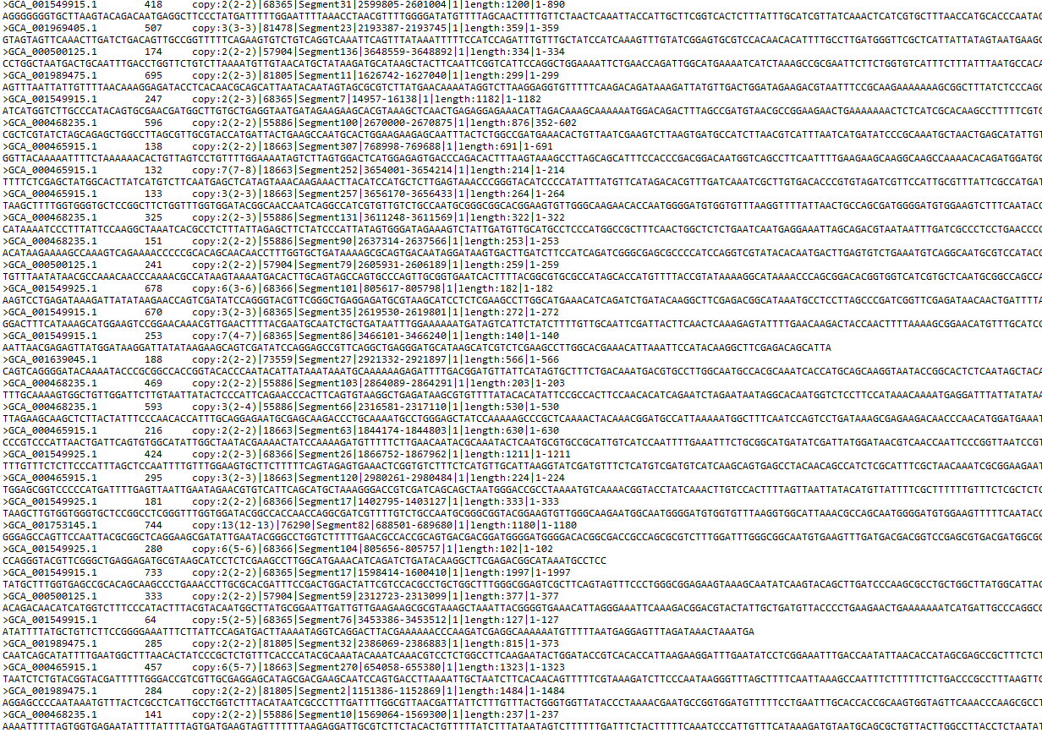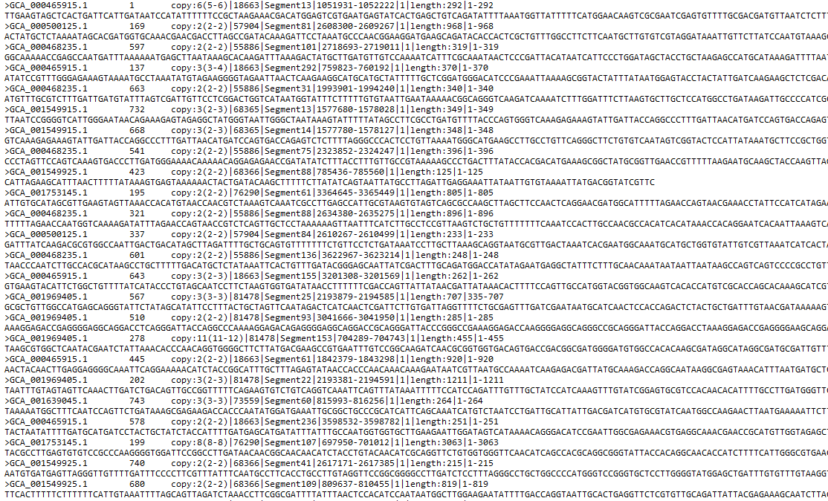
Candida auris | 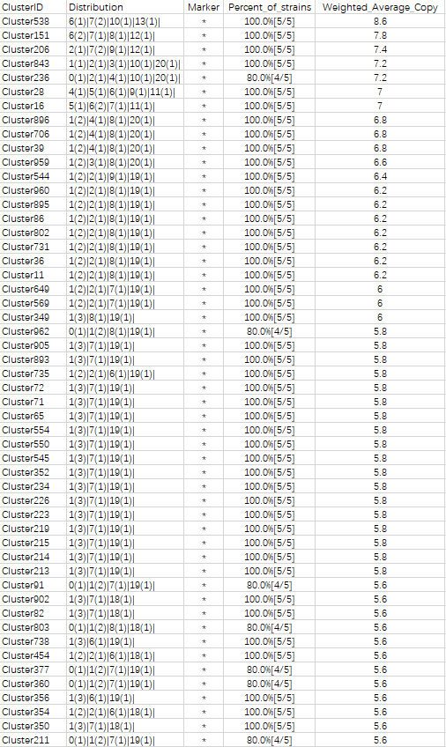 | 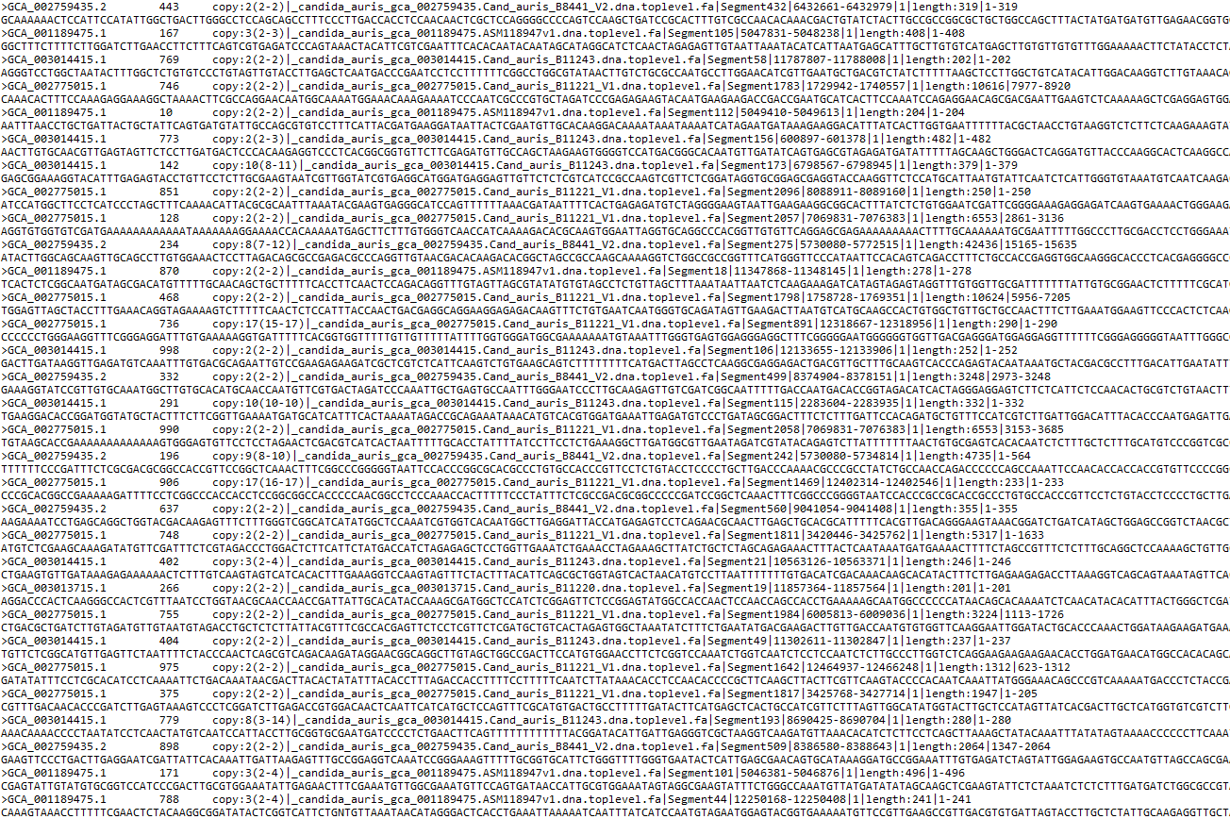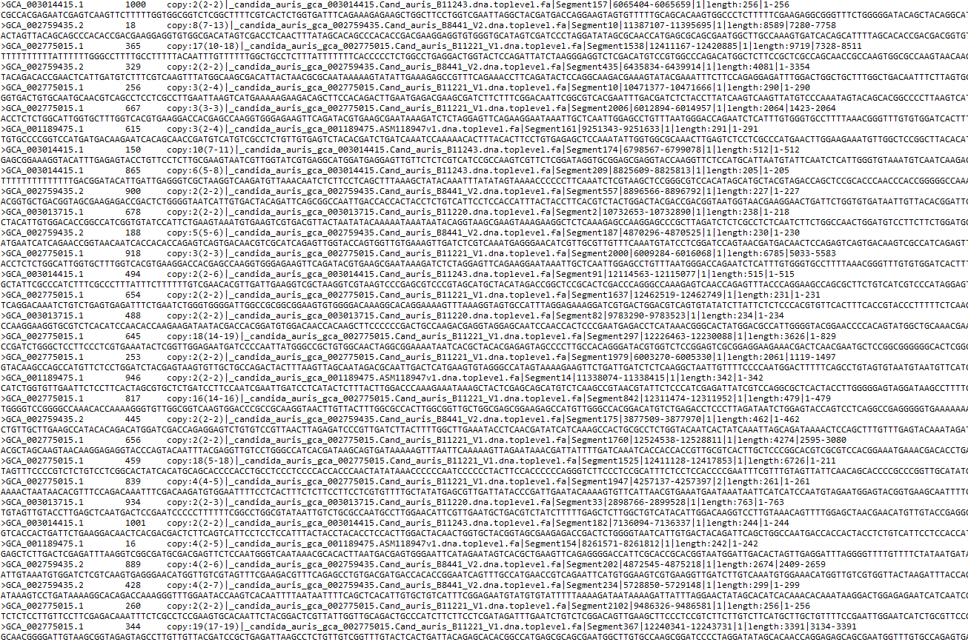

Supplementary Table3.
Cluster sets of identified undiscovered multicopy regions from Mycobacterium tuberculosis, Mycobacterium Africanum, Mycobacterium bovis, Tuberculosis complex.

ClusterID | Distribution | Marker | Percent_of_strains | Weighted_Average_Copy
Cluster195 | 0(3)|1(51)|2(40)|3(35)|4(21)|5(4)|6(3)|7(5)|8(5)|9(9)|10(7)|11(11)|12(19)|13(21)|14(19)|15(20)|16(24)|17(13)|18(6)|19(3)|20(2)|21(7)|22(3)|23(2)|24(2)|25(2)|27(1)|28(1)| | * | 99.1%[336/339] | 8.831858407
Cluster102 | 0(3)|1(51)|2(40)|3(35)|4(21)|5(4)|6(3)|7(5)|8(5)|9(9)|10(7)|11(11)|12(19)|13(21)|14(19)|15(21)|16(23)|17(13)|18(6)|19(3)|20(2)|21(7)|22(4)|23(1)|24(2)|25(2)|27(1)|28(1)| | * | 99.1%[336/339] | 8.825958702
Cluster454 | 0(3)|1(51)|2(40)|3(35)|4(21)|5(4)|6(3)|7(6)|8(5)|9(8)|10(7)|11(14)|12(16)|13(21)|14(19)|15(21)|16(23)|17(12)|18(7)|19(3)|20(2)|21(7)|22(3)|23(2)|24(2)|25(2)|27(1)|28(1)| | * | 99.1%[336/339] | 8.817109145
Cluster170 | 0(3)|1(51)|2(41)|3(34)|4(21)|5(4)|6(3)|7(6)|8(5)|9(8)|10(7)|11(14)|12(17)|13(20)|14(19)|15(21)|16(24)|17(11)|18(7)|19(3)|20(2)|21(7)|22(3)|23(2)|24(2)|25(2)|27(1)|28(1)| | * | 99.1%[336/339] | 8.808259587
Cluster439 | 0(3)|1(52)|2(43)|3(33)|4(20)|5(4)|6(3)|7(7)|8(6)|9(6)|10(9)|11(11)|12(17)|13(20)|14(19)|15(20)|16(25)|17(11)|18(6)|19(4)|20(2)|21(7)|22(3)|23(1)|24(3)|25(2)|27(1)|28(1)| | * | 99.1%[336/339] | 8.764011799
Cluster128 | 0(3)|1(51)|2(40)|3(36)|4(20)|5(4)|6(3)|7(7)|8(5)|9(8)|10(9)|11(13)|12(16)|13(22)|14(18)|15(22)|16(20)|17(14)|18(5)|19(3)|20(2)|21(8)|22(3)|23(1)|24(2)|25(2)|27(1)|28(1)| | * | 99.1%[336/339] | 8.749262537
Cluster363 | 0(3)|1(54)|2(41)|3(33)|4(20)|5(4)|6(4)|7(6)|8(6)|9(6)|10(9)|11(11)|12(18)|13(20)|14(18)|15(22)|16(23)|17(12)|18(5)|19(4)|20(2)|21(7)|22(3)|23(1)|24(4)|25(1)|27(1)|28(1)| | * | 99.1%[336/339] | 8.737463127
Cluster289 | 0(3)|1(54)|2(41)|3(32)|4(21)|5(4)|6(4)|7(6)|8(6)|9(6)|10(9)|11(12)|12(16)|13(22)|14(17)|15(22)|16(23)|17(12)|18(5)|19(4)|20(2)|21(7)|22(3)|23(2)|24(3)|25(1)|27(1)|28(1)| | * | 99.1%[336/339] | 8.734513274
Cluster76 | 0(3)|1(52)|2(43)|3(33)|4(20)|5(4)|6(3)|7(7)|8(6)|9(6)|10(10)|11(11)|12(17)|13(21)|14(19)|15(23)|16(20)|17(12)|18(6)|19(3)|20(2)|21(7)|22(4)|23(1)|24(3)|25(1)|27(1)|28(1)| | * | 99.1%[336/339] | 8.713864307
Cluster599 | 0(3)|1(58)|2(42)|3(32)|4(22)|5(4)|6(3)|7(8)|8(3)|9(7)|10(8)|11(11)|12(14)|13(19)|14(17)|15(23)|16(24)|17(11)|18(5)|19(4)|20(2)|21(8)|22(2)|23(1)|24(4)|25(1)|26(1)|27(1)|28(1)| | * | 99.1%[336/339] | 8.613569322
Cluster532 | 0(3)|1(58)|2(49)|3(22)|4(25)|5(7)|6(1)|7(5)|8(3)|9(14)|10(5)|11(11)|12(16)|13(17)|14(14)|15(24)|16(17)|17(13)|18(9)|19(4)|20(1)|21(9)|22(3)|23(2)|24(3)|25(3)|26(1)| | * | 99.1%[336/339] | 8.592920354
Cluster160 | 0(3)|1(58)|2(49)|3(22)|4(26)|5(6)|6(1)|7(5)|8(4)|9(13)|10(5)|11(11)|12(16)|13(17)|14(15)|15(23)|16(17)|17(14)|18(8)|19(4)|20(1)|21(10)|22(2)|23(2)|24(3)|25(3)|26(1)| | * | 99.1%[336/339] | 8.578171091
Cluster606 | 0(3)|1(58)|2(49)|3(22)|4(26)|5(6)|6(1)|7(5)|8(4)|9(13)|10(5)|11(11)|12(16)|13(17)|14(14)|15(24)|16(17)|17(15)|18(8)|19(3)|20(2)|21(9)|22(2)|23(2)|24(3)|25(3)|26(1)| | * | 99.1%[336/339] | 8.572271386
Cluster537 | 0(3)|1(58)|2(49)|3(22)|4(27)|5(5)|6(1)|7(5)|8(3)|9(14)|10(6)|11(11)|12(16)|13(18)|14(13)|15(23)|16(17)|17(13)|18(9)|19(4)|20(1)|21(9)|22(3)|23(2)|24(3)|25(3)|26(1)| | * | 99.1%[336/339] | 8.569321534
Cluster101 | 0(3)|1(58)|2(49)|3(22)|4(27)|5(5)|6(1)|7(5)|8(4)|9(13)|10(6)|11(11)|12(16)|13(18)|14(13)|15(23)|16(17)|17(13)|18(9)|19(4)|20(1)|21(9)|22(3)|23(2)|24(3)|25(3)|26(1)| | * | 99.1%[336/339] | 8.566371681
Cluster615 | 0(4)|1(57)|2(49)|3(23)|4(25)|5(6)|6(2)|7(5)|8(5)|9(12)|10(5)|11(12)|12(14)|13(17)|14(14)|15(24)|16(17)|17(15)|18(8)|19(3)|20(2)|21(9)|22(2)|23(3)|24(3)|25(2)|26(1)| | * | 98.8%[335/339] | 8.536873156
Cluster2 | 0(4)|1(57)|2(42)|3(33)|4(21)|5(4)|6(3)|7(9)|8(3)|9(8)|10(6)|11(11)|12(15)|13(19)|14(18)|15(25)|16(21)|17(12)|18(5)|19(3)|20(3)|21(7)|22(3)|23(1)|24(3)|25(1)|26(1)|28(1)| | * | 98.8%[335/339] | 8.525073746
Cluster535 | 0(3)|1(59)|2(47)|3(31)|4(22)|5(4)|6(2)|7(9)|8(2)|9(9)|10(6)|11(11)|12(11)|13(20)|14(16)|15(23)|16(20)|17(14)|18(5)|19(4)|20(3)|21(6)|22(4)|23(1)|24(3)|25(1)|26(2)|28(1)| | * | 99.1%[336/339] | 8.454277286
Cluster397 | 0(3)|1(59)|2(47)|3(31)|4(22)|5(4)|6(2)|7(9)|8(2)|9(9)|10(6)|11(11)|12(11)|13(20)|14(16)|15(23)|16(20)|17(14)|18(5)|19(4)|20(3)|21(6)|22(4)|23(1)|24(3)|25(1)|26(2)|28(1)| | * | 99.1%[336/339] | 8.454277286
Cluster396 | 0(3)|1(59)|2(47)|3(31)|4(22)|5(4)|6(2)|7(9)|8(2)|9(9)|10(6)|11(11)|12(11)|13(20)|14(16)|15(23)|16(20)|17(14)|18(5)|19(4)|20(3)|21(6)|22(4)|23(1)|24(3)|25(1)|26(2)|28(1)| | * | 99.1%[336/339] | 8.454277286
Cluster182 | 0(3)|1(60)|2(46)|3(32)|4(21)|5(4)|6(2)|7(9)|8(2)|9(11)|10(5)|11(11)|12(10)|13(20)|14(17)|15(22)|16(23)|17(11)|18(5)|19(4)|20(3)|21(6)|22(4)|23(1)|24(3)|25(1)|26(2)|28(1)| | * | 99.1%[336/339] | 8.424778761
Cluster605 | 0(2)|1(65)|2(45)|3(28)|4(24)|5(5)|6(1)|7(5)|8(4)|9(15)|10(4)|11(6)|12(13)|13(19)|14(16)|15(23)|16(19)|17(14)|18(6)|19(4)|20(3)|21(6)|22(3)|23(2)|24(3)|25(1)|26(3)| | * | 99.4%[337/339] | 8.392330383
Cluster290 | 0(4)|1(57)|2(44)|3(35)|4(21)|5(2)|6(6)|7(6)|8(4)|9(8)|10(7)|11(10)|12(14)|13(21)|14(17)|15(26)|16(18)|17(12)|18(5)|19(2)|20(4)|21(6)|22(4)|23(1)|24(2)|25(1)|26(1)|28(1)| | * | 98.8%[335/339] | 8.374631268
Cluster246 | 0(7)|1(63)|2(43)|3(23)|4(25)|5(4)|6(3)|7(6)|8(5)|9(11)|10(7)|11(11)|12(14)|13(17)|14(14)|15(23)|16(17)|17(13)|18(8)|19(4)|20(1)|21(9)|22(2)|23(3)|24(4)|25(2)| | * | 97.9%[332/339] | 8.374631268
Cluster315 | 0(4)|1(64)|2(47)|3(28)|4(24)|5(3)|6(2)|7(4)|8(7)|9(11)|10(5)|11(8)|12(12)|13(16)|14(15)|15(23)|16(16)|17(20)|18(5)|19(3)|21(10)|22(2)|23(3)|24(3)|25(2)|26(2)| | * | 98.8%[335/339] | 8.356932153
Cluster67 | 0(3)|1(66)|2(46)|3(27)|4(24)|5(4)|6(1)|7(6)|8(4)|9(13)|10(5)|11(6)|12(14)|13(18)|14(15)|15(23)|16(18)|17(16)|18(5)|19(3)|20(2)|21(8)|22(2)|23(3)|24(3)|25(2)|26(2)| | * | 99.1%[336/339] | 8.339233038
Cluster395 | 0(3)|1(66)|2(46)|3(27)|4(24)|5(4)|6(1)|7(6)|8(4)|9(13)|10(5)|11(6)|12(14)|13(18)|14(15)|15(23)|16(18)|17(16)|18(5)|19(3)|20(2)|21(8)|22(2)|23(3)|24(3)|25(2)|26(2)| | * | 99.1%[336/339] | 8.339233038
Cluster317 | 0(3)|1(66)|2(47)|3(27)|4(24)|5(3)|6(2)|7(5)|8(6)|9(12)|10(6)|11(7)|12(11)|13(17)|14(14)|15(25)|16(15)|17(19)|18(5)|19(3)|21(10)|22(2)|23(3)|24(3)|25(2)|26(2)| | * | 99.1%[336/339] | 8.327433628
Cluster212 | 0(5)|1(62)|2(45)|3(28)|4(24)|5(5)|6(1)|7(5)|8(4)|9(15)|10(4)|11(6)|12(14)|13(18)|14(16)|15(25)|16(17)|17(16)|18(6)|19(4)|20(6)|21(2)|22(3)|23(1)|24(4)|25(3)| | * | 98.5%[334/339] | 8.324483776
Cluster514 | 0(3)|1(66)|2(47)|3(27)|4(23)|5(4)|6(2)|7(5)|8(6)|9(12)|10(5)|11(6)|12(13)|13(18)|14(15)|15(23)|16(18)|17(16)|18(5)|19(3)|20(1)|21(9)|22(2)|23(3)|24(3)|25(2)|26(2)| | * | 99.1%[336/339] | 8.318584071
Cluster88 | 0(5)|1(62)|2(46)|3(27)|4(24)|5(5)|6(2)|7(5)|8(4)|9(14)|10(4)|11(7)|12(13)|13(17)|14(16)|15(26)|16(17)|17(16)|18(6)|19(4)|20(6)|21(2)|22(3)|23(1)|24(4)|25(3)| | * | 98.5%[334/339] | 8.315634218
Cluster667 | 0(3)|1(66)|2(47)|3(27)|4(24)|5(3)|6(2)|7(5)|8(6)|9(12)|10(5)|11(7)|12(12)|13(17)|14(16)|15(23)|16(18)|17(16)|18(5)|19(3)|20(1)|21(9)|22(2)|23(3)|24(3)|25(2)|26(2)| | * | 99.1%[336/339] | 8.315634218
Cluster581 | 0(5)|1(67)|2(46)|3(27)|4(25)|5(3)|6(1)|7(4)|8(8)|9(10)|10(5)|11(8)|12(12)|13(14)|14(15)|15(23)|16(17)|17(19)|18(5)|19(3)|21(11)|22(1)|23(3)|24(3)|25(2)|26(2)| | * | 98.5%[334/339] | 8.259587021
Cluster556 | 0(4)|1(64)|2(45)|3(33)|4(19)|5(3)|6(6)|7(5)|8(4)|9(13)|10(7)|11(8)|12(10)|13(20)|14(16)|15(25)|16(19)|17(11)|18(6)|19(1)|20(5)|21(6)|22(3)|23(1)|24(2)|25(1)|26(1)|27(1)| | * | 98.8%[335/339] | 8.14159292
Cluster84 | 0(3)|1(7)|2(2)|3(25)|4(3)|5(20)|6(263)|7(15)|9(1)| | * | 99.1%[336/339] | 5.575221239
Cluster83 | 0(3)|1(7)|2(2)|3(25)|4(3)|5(20)|6(263)|7(15)|9(1)| | * | 99.1%[336/339] | 5.575221239
Cluster82 | 0(3)|1(7)|2(2)|3(25)|4(3)|5(20)|6(263)|7(15)|9(1)| | * | 99.1%[336/339] | 5.575221239
Cluster294 | 0(3)|1(7)|2(2)|3(25)|4(3)|5(20)|6(263)|7(15)|9(1)| | * | 99.1%[336/339] | 5.575221239
Cluster460 | 0(19)|1(23)|2(36)|3(31)|4(13)|5(37)|6(159)|7(8)|8(1)|9(1)|10(1)|11(10)| | * | 94.4%[320/339] | 4.637168142
Cluster410 | 0(1)|1(2)|2(6)|3(28)|4(65)|5(236)|7(1)| | * | 99.7%[338/339] | 4.557522124
Cluster459 | 0(2)|1(6)|2(27)|3(290)|4(14)| | * | 99.4%[337/339] | 2.908554572
Cluster523 | 0(2)|1(8)|2(39)|3(272)|4(18)| | * | 99.4%[337/339] | 2.873156342
Cluster652 | 0(2)|1(8)|2(40)|3(272)|4(17)| | * | 99.4%[337/339] | 2.867256637
Cluster586 | 0(1)|1(8)|2(40)|3(283)|4(6)|5(1)| | * | 99.7%[338/339] | 2.849557522
Cluster634 | 0(2)|1(8)|2(51)|3(261)|4(17)| | * | 99.4%[337/339] | 2.83480826
Cluster16 | 1(7)|2(45)|3(286)|4(1)| | * | 100.0%[339/339] | 2.828908555
Cluster187 | 0(2)|1(9)|2(53)|3(262)|4(13)| | * | 99.4%[337/339] | 2.81120944
Cluster245 | 0(2)|1(39)|2(69)|3(178)|4(39)|5(12)| | * | 99.4%[337/339] | 2.734513274
Cluster372 | 0(8)|1(15)|2(62)|3(241)|4(9)|5(2)|6(2)| | * | 97.6%[331/339] | 2.713864307
Cluster474 | 0(4)|1(21)|2(60)|3(239)|4(14)|5(1)| | * | 98.8%[335/339] | 2.710914454
Cluster604 | 0(3)|1(25)|2(101)|3(156)|4(54)| | * | 99.1%[336/339] | 2.687315634
Cluster339 | 0(5)|1(39)|2(81)|3(179)|4(23)|5(11)|6(1)| | * | 98.5%[334/339] | 2.628318584
Cluster510 | 0(5)|1(41)|2(83)|3(178)|4(19)|5(12)|6(1)| | * | 98.5%[334/339] | 2.604719764
Cluster117 | 0(1)|1(20)|2(97)|3(220)|4(1)| | * | 99.7%[338/339] | 2.589970501
Cluster295 | 0(13)|1(51)|2(76)|3(177)|4(11)|5(10)|6(1)| | * | 96.2%[326/339] | 2.460176991
Cluster32 | 0(11)|1(58)|2(81)|3(166)|4(13)|5(9)|6(1)| | * | 96.8%[328/339] | 2.421828909
Cluster98 | 0(4)|1(25)|2(224)|3(3)|4(83)| | * | 98.8%[335/339] | 2.401179941
Cluster56 | 0(10)|1(60)|2(86)|3(163)|4(10)|5(9)|6(1)| | * | 97.1%[329/339] | 2.395280236
Cluster139 | 0(4)|1(31)|2(217)|3(4)|4(83)| | * | 98.8%[335/339] | 2.386430678
Cluster248 | 0(4)|1(31)|2(218)|3(3)|4(83)| | * | 98.8%[335/339] | 2.383480826
Cluster258 | 0(1)|1(29)|2(225)|3(24)|4(60)| | * | 99.7%[338/339] | 2.333333333
Cluster526 | 0(1)|1(22)|2(233)|3(35)|4(48)| | * | 99.7%[338/339] | 2.315634218
Cluster354 | 0(1)|1(22)|2(233)|3(35)|4(48)| | * | 99.7%[338/339] | 2.315634218
Cluster564 | 0(2)|1(35)|2(221)|3(21)|4(60)| | * | 99.4%[337/339] | 2.300884956
Cluster654 | 0(1)|1(15)|2(255)|3(18)|4(50)| | * | 99.7%[338/339] | 2.297935103
Cluster231 | 1(20)|2(255)|3(13)|4(51)| | * | 100.0%[339/339] | 2.280235988
Cluster49 | 1(20)|2(258)|3(10)|4(51)| | * | 100.0%[339/339] | 2.271386431
Cluster573 | 0(2)|1(42)|2(158)|3(137)| | * | 99.4%[337/339] | 2.268436578
Cluster681 | 0(1)|1(25)|2(246)|3(17)|4(50)| | * | 99.7%[338/339] | 2.265486726
Cluster651 | 0(2)|1(60)|2(196)|3(8)|4(73)| | * | 99.4%[337/339] | 2.265486726
Cluster255 | 1(24)|2(251)|3(14)|4(50)| | * | 100.0%[339/339] | 2.265486726
Cluster87 | 0(13)|1(29)|2(216)|3(21)|4(60)| | * | 96.2%[326/339] | 2.253687316
Cluster105 | 0(13)|1(31)|2(214)|3(21)|4(60)| | * | 96.2%[326/339] | 2.247787611
Cluster261 | 0(2)|1(30)|2(243)|3(14)|4(50)| | * | 99.4%[337/339] | 2.235988201
Cluster80 | 1(32)|2(249)|3(7)|4(51)| | * | 100.0%[339/339] | 2.227138643
Cluster21 | 1(31)|2(251)|3(6)|4(51)| | * | 100.0%[339/339] | 2.227138643
Cluster17 | 0(5)|1(28)|2(242)|3(14)|4(50)| | * | 98.5%[334/339] | 2.224188791
Cluster1 | 0(3)|1(32)|2(240)|3(14)|4(50)| | * | 99.1%[336/339] | 2.224188791
Cluster125 | 0(2)|1(31)|2(247)|3(8)|4(51)| | * | 99.4%[337/339] | 2.221238938
Cluster59 | 0(3)|1(31)|2(245)|3(9)|4(51)| | * | 99.1%[336/339] | 2.218289086
Cluster345 | 0(3)|1(31)|2(245)|3(9)|4(51)| | * | 99.1%[336/339] | 2.218289086
Cluster650 | 0(4)|1(33)|2(238)|3(14)|4(50)| | * | 98.8%[335/339] | 2.215339233
Cluster557 | 0(3)|1(31)|2(247)|3(7)|4(51)| | * | 99.1%[336/339] | 2.212389381
Cluster547 | 0(5)|1(32)|2(238)|3(14)|4(50)| | * | 98.5%[334/339] | 2.212389381
Cluster269 | 0(5)|1(32)|2(238)|3(14)|4(50)| | * | 98.5%[334/339] | 2.212389381
Cluster570 | 0(8)|1(27)|2(241)|3(13)|4(50)| | * | 97.6%[331/339] | 2.206489676
Cluster583 | 0(1)|1(32)|2(253)|3(3)|4(50)| | * | 99.7%[338/339] | 2.203539823
Cluster453 | 0(23)|1(29)|2(206)|3(23)|4(58)| | * | 93.2%[316/339] | 2.18879056
Cluster50 | 0(11)|1(28)|2(237)|3(13)|4(50)| | * | 96.8%[328/339] | 2.185840708
Cluster292 | 0(11)|1(28)|2(237)|3(13)|4(50)| | * | 96.8%[328/339] | 2.185840708
Cluster70 | 0(3)|1(38)|2(246)|3(2)|4(50)| | * | 99.1%[336/339] | 2.171091445
Cluster657 | 0(24)|1(29)|2(227)|3(8)|4(51)| | * | 92.9%[315/339] | 2.097345133
Cluster633 | 0(3)|1(61)|2(183)|3(90)|4(2)| | * | 99.1%[336/339] | 2.079646018
Cluster366 | 0(29)|1(25)|2(226)|3(8)|4(51)| | * | 91.4%[310/339] | 2.079646018
Cluster356 | 0(2)|1(71)|2(172)|3(87)|4(7)| | * | 99.4%[337/339] | 2.076696165
Cluster399 | 0(1)|1(130)|2(53)|3(154)|4(1)| | * | 99.7%[338/339] | 2.07079646
Cluster48 | 0(32)|1(25)|2(223)|3(8)|4(51)| | * | 90.6%[307/339] | 2.061946903
Cluster447 | 0(32)|1(25)|2(223)|3(8)|4(51)| | * | 90.6%[307/339] | 2.061946903
Cluster282 | 0(32)|1(25)|2(223)|3(8)|4(51)| | * | 90.6%[307/339] | 2.061946903
Cluster179 | 0(32)|1(26)|2(222)|3(8)|4(51)| | * | 90.6%[307/339] | 2.05899705
Cluster361 | 0(4)|1(63)|2(184)|3(86)|4(2)| | * | 98.8%[335/339] | 2.056047198
Cluster408 | 1(45)|2(248)|3(30)|4(16)| | * | 100.0%[339/339] | 2.050147493
Cluster458 | 0(3)|1(42)|2(247)|3(31)|4(16)| | * | 99.1%[336/339] | 2.044247788
Cluster52 | 0(19)|1(44)|2(228)|3(2)|4(46)| | * | 94.4%[320/339] | 2.03539823
Cluster608 | 0(1)|1(49)|2(244)|3(29)|4(16)| | * | 99.7%[338/339] | 2.029498525
Cluster436 | 0(1)|1(50)|2(243)|3(29)|4(16)| | * | 99.7%[338/339] | 2.026548673
Cluster369 | 0(10)|1(71)|2(165)|3(86)|4(7)| | * | 97.1%[329/339] | 2.026548673
Cluster402 | 0(3)|1(47)|2(245)|3(28)|4(16)| | * | 99.1%[336/339] | 2.020648968
Cluster73 | 0(2)|1(54)|2(239)|3(28)|4(16)| | * | 99.4%[337/339] | 2.005899705
Cluster69 | 1(4)|2(332)|3(3)| | * | 100.0%[339/339] | 1.997050147
Cluster466 | 1(4)|2(332)|3(3)| | * | 100.0%[339/339] | 1.997050147
Cluster528 | 0(1)|1(1)|2(336)|3(1)| | * | 99.7%[338/339] | 1.994100295
Cluster613 | 0(6)|1(76)|2(173)|3(83)|4(1)| | * | 98.2%[333/339] | 1.991150442
Cluster94 | 0(1)|1(139)|2(70)|3(124)|4(4)|5(1)| | * | 99.7%[338/339] | 1.982300885
Cluster448 | 0(10)|1(77)|2(163)|3(88)|4(1)| | * | 97.1%[329/339] | 1.979351032
Cluster120 | 0(2)|1(8)|2(328)|4(1)| | * | 99.4%[337/339] | 1.970501475
Cluster565 | 0(10)|1(75)|2(171)|3(82)|4(1)| | * | 97.1%[329/339] | 1.967551622
Cluster401 | 0(2)|1(8)|2(329)| | * | 99.4%[337/339] | 1.96460177
Cluster631 | 0(3)|1(8)|2(327)|3(1)| | * | 99.1%[336/339] | 1.961651917
Cluster230 | 0(4)|1(15)|2(316)|3(4)| | * | 98.8%[335/339] | 1.943952802
Cluster412 | 0(1)|1(20)|2(316)|3(2)| | * | 99.7%[338/339] | 1.94100295
Cluster538 | 0(2)|1(133)|2(91)|3(110)|4(3)| | * | 99.4%[337/339] | 1.938053097
Cluster374 | 1(24)|2(315)| | * | 100.0%[339/339] | 1.92920354
Cluster334 | 0(4)|1(17)|2(317)|3(1)| | * | 98.8%[335/339] | 1.92920354
Cluster497 | 0(1)|1(23)|2(315)| | * | 99.7%[338/339] | 1.926253687
Cluster664 | 0(1)|1(24)|2(314)| | * | 99.7%[338/339] | 1.923303835
Cluster39 | 0(2)|1(141)|2(86)|3(105)|4(5)| | * | 99.4%[337/339] | 1.911504425
Cluster267 | 0(8)|1(15)|2(315)|3(1)| | * | 97.6%[331/339] | 1.911504425
Cluster656 | 0(4)|1(30)|2(301)|3(4)| | * | 98.8%[335/339] | 1.899705015
Cluster542 | 0(9)|1(32)|2(285)|3(12)|4(1)| | * | 97.3%[330/339] | 1.89380531
Cluster227 | 0(9)|1(32)|2(284)|3(14)| | * | 97.3%[330/339] | 1.89380531
Cluster472 | 0(6)|1(41)|2(281)|3(10)|4(1)| | * | 98.2%[333/339] | 1.879056047
Cluster367 | 0(11)|1(21)|2(305)|3(2)| | * | 96.8%[328/339] | 1.879056047
Cluster569 | 0(3)|1(108)|2(186)|3(12)|4(30)| | * | 99.1%[336/339] | 1.876106195
Cluster333 | 0(3)|1(108)|2(186)|3(12)|4(30)| | * | 99.1%[336/339] | 1.876106195
Cluster679 | 0(7)|1(38)|2(286)|3(7)|4(1)| | * | 97.9%[332/339] | 1.873156342
Cluster207 | 0(7)|1(42)|2(278)|3(12)| | * | 97.9%[332/339] | 1.87020649
Cluster232 | 0(6)|1(35)|2(296)|3(2)| | * | 98.2%[333/339] | 1.867256637
Cluster443 | 0(6)|1(44)|2(280)|3(8)|4(1)| | * | 98.2%[333/339] | 1.864306785
Cluster166 | 0(3)|1(111)|2(184)|3(11)|4(30)| | * | 99.1%[336/339] | 1.864306785
Cluster438 | 0(30)|1(100)|2(110)|3(85)|4(14)| | * | 91.2%[309/339] | 1.861356932
Cluster389 | 0(3)|1(56)|2(267)|3(12)|4(1)| | * | 99.1%[336/339] | 1.85840708
Cluster568 | 0(14)|1(49)|2(261)|3(2)|4(13)| | * | 95.9%[325/339] | 1.855457227
Cluster165 | 0(4)|1(112)|2(183)|3(10)|4(30)| | * | 98.8%[335/339] | 1.852507375
Cluster159 | 0(4)|1(52)|2(275)|3(7)|4(1)| | * | 98.8%[335/339] | 1.849557522
Cluster321 | 0(8)|1(41)|2(288)|3(2)| | * | 97.6%[331/339] | 1.837758112
Cluster663 | 0(5)|1(113)|2(182)|3(11)|4(28)| | * | 98.5%[334/339] | 1.83480826
Cluster461 | 0(5)|1(112)|2(184)|3(10)|4(28)| | * | 98.5%[334/339] | 1.83480826
Cluster673 | 0(5)|1(63)|2(260)|3(11)| | * | 98.5%[334/339] | 1.817109145
Cluster414 | 0(7)|1(49)|2(283)| | * | 97.9%[332/339] | 1.814159292
Cluster670 | 0(8)|1(61)|2(257)|3(13)| | * | 97.6%[331/339] | 1.81120944
Cluster624 | 0(10)|1(59)|2(256)|3(14)| | * | 97.1%[329/339] | 1.808259587
Cluster585 | 0(11)|1(56)|2(260)|3(12)| | * | 96.8%[328/339] | 1.805309735
Cluster578 | 0(7)|1(120)|2(175)|3(9)|4(28)| | * | 97.9%[332/339] | 1.796460177
Cluster590 | 0(14)|1(56)|2(257)|3(12)| | * | 95.9%[325/339] | 1.787610619
Cluster609 | 0(7)|1(89)|2(216)|3(27)| | * | 97.9%[332/339] | 1.775811209
Cluster601 | 0(13)|1(63)|2(252)|3(11)| | * | 96.2%[326/339] | 1.769911504
Cluster299 | 0(7)|1(91)|2(215)|3(26)| | * | 97.9%[332/339] | 1.766961652
Cluster118 | 0(11)|1(62)|2(264)|3(2)| | * | 96.8%[328/339] | 1.758112094
Cluster473 | 0(3)|1(94)|2(232)|3(8)|4(2)| | * | 99.1%[336/339] | 1.740412979
Cluster218 | 0(31)|1(109)|2(123)|3(70)|4(5)|5(1)| | * | 90.9%[308/339] | 1.740412979
Cluster303 | 0(3)|1(95)|2(231)|3(8)|4(2)| | * | 99.1%[336/339] | 1.737463127
Cluster384 | 1(93)|2(245)|3(1)| | * | 100.0%[339/339] | 1.728613569
Cluster268 | 0(21)|1(110)|2(156)|3(45)|4(6)|5(1)| | * | 93.8%[318/339] | 1.728613569
Cluster558 | 0(41)|1(30)|2(256)|3(12)| | * | 87.9%[298/339] | 1.705014749
Cluster119 | 0(40)|1(31)|2(257)|3(11)| | * | 88.2%[299/339] | 1.705014749
Cluster632 | 0(16)|1(82)|2(240)|3(1)| | * | 95.3%[323/339] | 1.666666667
Cluster446 | 0(10)|1(129)|2(186)|3(3)|4(11)| | * | 97.1%[329/339] | 1.634218289
Cluster40 | 0(13)|1(131)|2(182)|3(2)|4(11)| | * | 96.2%[326/339] | 1.607669617
Cluster91 | 0(34)|1(102)|2(175)|3(27)|4(1)| | * | 90.0%[305/339] | 1.584070796
Cluster359 | 0(14)|1(117)|2(208)| | * | 95.9%[325/339] | 1.572271386
Cluster310 | 0(9)|1(231)|2(13)|3(79)|4(3)|5(4)| | * | 97.3%[330/339] | 1.551622419
Cluster44 | 0(23)|1(137)|2(151)|3(27)|4(1)| | * | 93.2%[316/339] | 1.545722714
Cluster320 | 0(14)|1(139)|2(182)|3(2)|4(2)| | * | 95.9%[325/339] | 1.525073746
Cluster416 | 0(13)|1(138)|2(187)|3(1)| | * | 96.2%[326/339] | 1.519174041
Cluster636 | 0(30)|1(142)|2(139)|3(27)|4(1)| | * | 91.2%[309/339] | 1.489675516
Cluster612 | 0(4)|1(189)|2(133)|3(2)|4(11)| | * | 98.8%[335/339] | 1.489675516
Cluster431 | 0(3)|1(171)|2(163)|3(2)| | * | 99.1%[336/339] | 1.483775811
Cluster440 | 0(50)|1(103)|2(160)|3(25)|4(1)| | * | 85.3%[289/339] | 1.480825959
Cluster683 | 0(36)|1(133)|2(143)|3(26)|4(1)| | * | 89.4%[303/339] | 1.477876106
Cluster592 | 0(5)|1(183)|2(145)|3(4)|4(2)| | * | 98.5%[334/339] | 1.454277286
Cluster72 | 0(5)|1(191)|2(137)|3(4)|4(2)| | * | 98.5%[334/339] | 1.430678466
Cluster539 | 0(42)|1(137)|2(152)|3(8)| | * | 87.6%[297/339] | 1.371681416
Cluster296 | 0(12)|1(194)|2(129)|3(3)|4(1)| | * | 96.5%[327/339] | 1.371681416
Cluster193 | 0(20)|1(196)|2(121)|3(1)|4(1)| | * | 94.1%[319/339] | 1.312684366
Cluster403 | 0(12)|1(216)|2(108)|3(3)| | * | 96.5%[327/339] | 1.300884956
Cluster36 | 0(6)|1(232)|2(97)|3(4)| | * | 98.2%[333/339] | 1.292035398
Cluster192 | 0(20)|1(210)|2(105)|3(4)| | * | 94.1%[319/339] | 1.274336283
Cluster279 | 0(36)|1(216)|2(52)|3(31)|4(3)|5(1)| | * | 89.4%[303/339] | 1.268436578
Cluster580 | 0(3)|1(249)|2(84)|4(3)| | * | 99.1%[336/339] | 1.265486726
Cluster167 | 0(3)|1(249)|2(84)|4(3)| | * | 99.1%[336/339] | 1.265486726
Cluster441 | 0(19)|1(215)|2(104)|3(1)| | * | 94.4%[320/339] | 1.256637168
Cluster336 | 0(9)|1(239)|2(86)|3(5)| | * | 97.3%[330/339] | 1.256637168
Cluster276 | 0(46)|1(165)|2(124)|3(4)| | * | 86.4%[293/339] | 1.253687316
Cluster260 | 0(1)|1(260)|2(76)|3(2)| | * | 99.7%[338/339] | 1.233038348
Cluster548 | 0(9)|1(251)|2(76)|3(3)| | * | 97.3%[330/339] | 1.215339233
Cluster387 | 0(11)|1(247)|2(78)|3(3)| | * | 96.8%[328/339] | 1.215339233
Cluster291 | 0(13)|1(244)|2(78)|3(4)| | * | 96.2%[326/339] | 1.215339233
Cluster71 | 0(58)|1(155)|2(124)|3(2)| | * | 82.9%[281/339] | 1.206489676
Cluster545 | 0(25)|1(222)|2(90)|3(2)| | * | 92.6%[314/339] | 1.203539823
Cluster53 | 0(23)|1(229)|2(84)|3(1)|4(2)| | * | 93.2%[316/339] | 1.203539823
Cluster168 | 0(39)|1(232)|2(37)|3(28)|4(1)|5(2)| | * | 88.5%[300/339] | 1.191740413
Cluster467 | 1(297)|2(37)|3(5)| | * | 100.0%[339/339] | 1.138643068
Cluster191 | 0(3)|1(286)|2(50)| | * | 99.1%[336/339] | 1.138643068
Cluster587 | 1(300)|2(39)| | * | 100.0%[339/339] | 1.115044248
Cluster172 | 1(300)|2(39)| | * | 100.0%[339/339] | 1.115044248
Cluster455 | 0(41)|1(225)|2(73)| | * | 87.9%[298/339] | 1.09439528
Cluster531 | 0(9)|1(303)|2(21)|4(6)| | * | 97.3%[330/339] | 1.088495575
Cluster562 | 1(317)|2(22)| | * | 100.0%[339/339] | 1.064896755
Cluster371 | 0(17)|1(290)|2(30)|3(1)|4(1)| | * | 95.0%[322/339] | 1.053097345
Cluster206 | 0(9)|1(309)|2(18)|4(3)| | * | 97.3%[330/339] | 1.053097345
Cluster20 | 0(10)|1(308)|2(18)|4(3)| | * | 97.1%[329/339] | 1.050147493
Cluster465 | 0(51)|1(232)|2(45)|3(11)| | * | 85.0%[288/339] | 1.04719764
Cluster158 | 0(51)|1(232)|2(45)|3(11)| | * | 85.0%[288/339] | 1.04719764
Cluster490 | 0(42)|1(240)|2(57)| | * | 87.6%[297/339] | 1.044247788
Cluster198 | 0(11)|1(308)|2(17)|4(3)| | * | 96.8%[328/339] | 1.044247788
Cluster157 | 0(52)|1(233)|2(43)|3(11)| | * | 84.7%[287/339] | 1.038348083
Cluster541 | 1(331)|2(8)| | * | 100.0%[339/339] | 1.02359882
Cluster420 | 0(1)|1(336)|3(1)|7(1)| | * | 99.7%[338/339] | 1.020648968
Cluster591 | 0(19)|1(295)|2(25)| | * | 94.4%[320/339] | 1.017699115
Cluster506 | 0(1)|1(332)|2(5)|3(1)| | * | 99.7%[338/339] | 1.017699115
Cluster346 | 0(4)|1(326)|2(9)| | * | 98.8%[335/339] | 1.014749263
Cluster121 | 1(337)|2(1)|5(1)| | * | 100.0%[339/339] | 1.014749263
Cluster677 | 1(338)|4(1)| | * | 100.0%[339/339] | 1.008849558
Cluster674 | 0(2)|1(332)|2(5)| | * | 99.4%[337/339] | 1.008849558
Cluster661 | 1(336)|2(3)| | * | 100.0%[339/339] | 1.008849558
Cluster35 | 0(2)|1(333)|2(3)|3(1)| | * | 99.4%[337/339] | 1.008849558
Cluster671 | 1(337)|2(2)| | * | 100.0%[339/339] | 1.005899705
Cluster653 | 1(337)|2(2)| | * | 100.0%[339/339] | 1.005899705
Cluster561 | 1(337)|2(2)| | * | 100.0%[339/339] | 1.005899705
Cluster525 | 1(337)|2(2)| | * | 100.0%[339/339] | 1.005899705
Cluster46 | 0(4)|1(329)|2(6)| | * | 98.8%[335/339] | 1.005899705
Cluster383 | 1(337)|2(2)| | * | 100.0%[339/339] | 1.005899705
Cluster358 | 1(337)|2(2)| | * | 100.0%[339/339] | 1.005899705
Cluster264 | 1(337)|2(2)| | * | 100.0%[339/339] | 1.005899705
Cluster194 | 0(1)|1(335)|2(3)| | * | 99.7%[338/339] | 1.005899705
Cluster162 | 0(1)|1(335)|2(3)| | * | 99.7%[338/339] | 1.005899705
Cluster13 | 1(337)|2(2)| | * | 100.0%[339/339] | 1.005899705
Cluster112 | 0(1)|1(335)|2(3)| | * | 99.7%[338/339] | 1.005899705
Cluster9 | 0(1)|1(337)|3(1)| | * | 99.7%[338/339] | 1.002949853
Cluster643 | 1(338)|2(1)| | * | 100.0%[339/339] | 1.002949853
Cluster639 | 1(338)|2(1)| | * | 100.0%[339/339] | 1.002949853
Cluster627 | 1(338)|2(1)| | * | 100.0%[339/339] | 1.002949853
Cluster598 | 0(2)|1(334)|2(3)| | * | 99.4%[337/339] | 1.002949853
Cluster501 | 1(338)|2(1)| | * | 100.0%[339/339] | 1.002949853
Cluster499 | 1(338)|2(1)| | * | 100.0%[339/339] | 1.002949853
Cluster486 | 1(338)|2(1)| | * | 100.0%[339/339] | 1.002949853
Cluster468 | 1(338)|2(1)| | * | 100.0%[339/339] | 1.002949853
Cluster463 | 1(338)|2(1)| | * | 100.0%[339/339] | 1.002949853
Cluster38 | 0(1)|1(336)|2(2)| | * | 99.7%[338/339] | 1.002949853
Cluster343 | 1(338)|2(1)| | * | 100.0%[339/339] | 1.002949853
Cluster34 | 1(338)|2(1)| | * | 100.0%[339/339] | 1.002949853
Cluster33 | 1(338)|2(1)| | * | 100.0%[339/339] | 1.002949853
Cluster325 | 1(338)|2(1)| | * | 100.0%[339/339] | 1.002949853
Cluster265 | 1(338)|2(1)| | * | 100.0%[339/339] | 1.002949853
Cluster174 | 1(338)|2(1)| | * | 100.0%[339/339] | 1.002949853
Cluster146 | 0(1)|1(336)|2(2)| | * | 99.7%[338/339] | 1.002949853
Cluster133 | 1(338)|2(1)| | * | 100.0%[339/339] | 1.002949853
Cluster645 | 1(339)| | * | 100.0%[339/339] | 1
Cluster641 | 0(2)|1(335)|2(2)| | * | 99.4%[337/339] | 1
Cluster524 | 0(51)|1(237)|2(51)| | * | 85.0%[288/339] | 1
Cluster502 | 0(2)|1(335)|2(2)| | * | 99.4%[337/339] | 1
Cluster498 | 1(339)| | * | 100.0%[339/339] | 1
Cluster487 | 0(1)|1(337)|2(1)| | * | 99.7%[338/339] | 1
Cluster430 | 1(339)| | * | 100.0%[339/339] | 1
Cluster423 | 1(339)| | * | 100.0%[339/339] | 1
Cluster286 | 0(1)|1(337)|2(1)| | * | 99.7%[338/339] | 1
Cluster285 | 0(1)|1(337)|2(1)| | * | 99.7%[338/339] | 1
Cluster254 | 1(339)| | * | 100.0%[339/339] | 1
Cluster23 | 0(1)|1(337)|2(1)| | * | 99.7%[338/339] | 1
Cluster228 | 0(2)|1(335)|2(2)| | * | 99.4%[337/339] | 1
Cluster199 | 0(3)|1(333)|2(3)| | * | 99.1%[336/339] | 1
Cluster156 | 0(4)|1(331)|2(4)| | * | 98.8%[335/339] | 1
Cluster142 | 1(339)| | * | 100.0%[339/339] | 1
Cluster141 | 1(339)| | * | 100.0%[339/339] | 1
Cluster124 | 0(1)|1(337)|2(1)| | * | 99.7%[338/339] | 1
Cluster11 | 0(1)|1(337)|2(1)| | * | 99.7%[338/339] | 1
Cluster669 | 0(2)|1(336)|2(1)| | * | 99.4%[337/339] | 0.997050147
Cluster644 | 0(2)|1(336)|2(1)| | * | 99.4%[337/339] | 0.997050147
Cluster610 | 0(3)|1(334)|2(2)| | * | 99.1%[336/339] | 0.997050147
Cluster504 | 0(2)|1(336)|2(1)| | * | 99.4%[337/339] | 0.997050147
Cluster188 | 0(2)|1(336)|2(1)| | * | 99.4%[337/339] | 0.997050147
Cluster186 | 0(3)|1(334)|2(2)| | * | 99.1%[336/339] | 0.997050147
Cluster540 | 0(3)|1(335)|2(1)| | * | 99.1%[336/339] | 0.994100295
Cluster533 | 0(3)|1(335)|2(1)| | * | 99.1%[336/339] | 0.994100295
Cluster527 | 0(2)|1(337)| | * | 99.4%[337/339] | 0.994100295
Cluster505 | 0(3)|1(335)|2(1)| | * | 99.1%[336/339] | 0.994100295
Cluster476 | 0(2)|1(337)| | * | 99.4%[337/339] | 0.994100295
Cluster421 | 0(2)|1(337)| | * | 99.4%[337/339] | 0.994100295
Cluster409 | 0(4)|1(333)|2(2)| | * | 98.8%[335/339] | 0.994100295
Cluster293 | 0(2)|1(337)| | * | 99.4%[337/339] | 0.994100295
Cluster151 | 0(2)|1(337)| | * | 99.4%[337/339] | 0.994100295
Cluster617 | 0(4)|1(334)|2(1)| | * | 98.8%[335/339] | 0.991150442
Cluster362 | 0(5)|1(332)|2(2)| | * | 98.5%[334/339] | 0.991150442
Cluster332 | 0(3)|1(336)| | * | 99.1%[336/339] | 0.991150442
Cluster259 | 0(25)|1(292)|2(22)| | * | 92.6%[314/339] | 0.991150442
Cluster655 | 0(4)|1(335)| | * | 98.8%[335/339] | 0.98820059
Cluster534 | 0(4)|1(335)| | * | 98.8%[335/339] | 0.98820059
Cluster427 | 0(4)|1(335)| | * | 98.8%[335/339] | 0.98820059
Cluster185 | 0(19)|1(305)|2(15)| | * | 94.4%[320/339] | 0.98820059
Cluster626 | 0(5)|1(334)| | * | 98.5%[334/339] | 0.985250737
Cluster434 | 0(6)|1(332)|2(1)| | * | 98.2%[333/339] | 0.985250737
Cluster386 | 0(5)|1(334)| | * | 98.5%[334/339] | 0.985250737
Cluster340 | 0(5)|1(334)| | * | 98.5%[334/339] | 0.985250737
Cluster225 | 0(5)|1(334)| | * | 98.5%[334/339] | 0.985250737
Cluster19 | 0(5)|1(334)| | * | 98.5%[334/339] | 0.985250737
Cluster428 | 0(6)|1(333)| | * | 98.2%[333/339] | 0.982300885
Cluster477 | 0(8)|1(330)|2(1)| | * | 97.6%[331/339] | 0.979351032
Cluster432 | 0(8)|1(330)|2(1)| | * | 97.6%[331/339] | 0.979351032
Cluster425 | 0(8)|1(330)|2(1)| | * | 97.6%[331/339] | 0.979351032
Cluster597 | 0(8)|1(331)| | * | 97.6%[331/339] | 0.97640118
Cluster422 | 0(19)|1(313)|2(5)|4(2)| | * | 94.4%[320/339] | 0.97640118
Cluster236 | 0(11)|1(326)|2(1)|3(1)| | * | 96.8%[328/339] | 0.97640118
Cluster183 | 0(9)|1(329)|2(1)| | * | 97.3%[330/339] | 0.97640118
Cluster687 | 0(9)|1(330)| | * | 97.3%[330/339] | 0.973451327
Cluster216 | 0(11)|1(326)|2(2)| | * | 96.8%[328/339] | 0.973451327
Cluster579 | 0(49)|1(253)|2(35)|3(2)| | * | 85.5%[290/339] | 0.970501475
Cluster110 | 0(12)|1(325)|2(2)| | * | 96.5%[327/339] | 0.970501475
Cluster549 | 0(15)|1(320)|2(4)| | * | 95.6%[324/339] | 0.967551622
Cluster147 | 0(17)|1(316)|2(6)| | * | 95.0%[322/339] | 0.967551622
Cluster308 | 0(14)|1(323)|2(2)| | * | 95.9%[325/339] | 0.96460177
Cluster407 | 0(13)|1(326)| | * | 96.2%[326/339] | 0.961651917
Cluster364 | 0(14)|1(324)|2(1)| | * | 95.9%[325/339] | 0.961651917
Cluster355 | 0(16)|1(320)|2(3)| | * | 95.3%[323/339] | 0.961651917
Cluster415 | 0(16)|1(321)|2(2)| | * | 95.3%[323/339] | 0.958702065
Cluster92 | 0(17)|1(321)|2(1)| | * | 95.0%[322/339] | 0.95280236
Cluster3 | 0(26)|1(303)|2(10)| | * | 92.3%[313/339] | 0.95280236
Cluster244 | 0(16)|1(323)| | * | 95.3%[323/339] | 0.95280236
Cluster114 | 0(21)|1(313)|2(5)| | * | 93.8%[318/339] | 0.95280236
Cluster31 | 0(51)|1(256)|2(30)|3(2)| | * | 85.0%[288/339] | 0.949852507
Cluster323 | 0(19)|1(319)|2(1)| | * | 94.4%[320/339] | 0.946902655
Cluster256 | 0(40)|1(277)|2(22)| | * | 88.2%[299/339] | 0.946902655
Cluster419 | 0(20)|1(318)|2(1)| | * | 94.1%[319/339] | 0.943952802
Cluster234 | 0(28)|1(302)|2(9)| | * | 91.7%[311/339] | 0.943952802
Cluster220 | 0(30)|1(299)|2(10)| | * | 91.2%[309/339] | 0.94100295
Cluster616 | 0(23)|1(315)|3(1)| | * | 93.2%[316/339] | 0.938053097
Cluster418 | 0(22)|1(316)|2(1)| | * | 93.5%[317/339] | 0.938053097
Cluster113 | 0(27)|1(306)|2(6)| | * | 92.0%[312/339] | 0.938053097
Cluster237 | 0(22)|1(317)| | * | 93.5%[317/339] | 0.935103245
Cluster215 | 0(26)|1(309)|2(4)| | * | 92.3%[313/339] | 0.935103245
Cluster57 | 0(29)|1(304)|2(6)| | * | 91.4%[310/339] | 0.932153392
Cluster509 | 0(24)|1(314)|2(1)| | * | 92.9%[315/339] | 0.932153392
Cluster375 | 0(30)|1(303)|2(6)| | * | 91.2%[309/339] | 0.92920354
Cluster123 | 0(27)|1(309)|2(3)| | * | 92.0%[312/339] | 0.92920354
Cluster278 | 0(27)|1(310)|2(2)| | * | 92.0%[312/339] | 0.926253687
Cluster224 | 0(27)|1(310)|2(2)| | * | 92.0%[312/339] | 0.926253687
Cluster43 | 0(36)|1(296)|2(6)|5(1)| | * | 89.4%[303/339] | 0.923303835
Cluster214 | 0(27)|1(311)|2(1)| | * | 92.0%[312/339] | 0.923303835
Cluster14 | 0(27)|1(311)|2(1)| | * | 92.0%[312/339] | 0.923303835
Cluster456 | 0(29)|1(308)|2(2)| | * | 91.4%[310/339] | 0.920353982
Cluster106 | 0(28)|1(310)|2(1)| | * | 91.7%[311/339] | 0.920353982
Cluster481 | 0(33)|1(301)|2(5)| | * | 90.3%[306/339] | 0.91740413
Cluster108 | 0(38)|1(295)|2(5)|4(1)| | * | 88.8%[301/339] | 0.911504425
Cluster378 | 0(32)|1(306)|2(1)| | * | 90.6%[307/339] | 0.908554572
Cluster127 | 0(37)|1(297)|2(4)|3(1)| | * | 89.1%[302/339] | 0.908554572
Cluster536 | 0(39)|1(295)|2(4)|4(1)| | * | 88.5%[300/339] | 0.90560472
Cluster479 | 0(37)|1(298)|2(4)| | * | 89.1%[302/339] | 0.902654867
Cluster342 | 0(55)|1(264)|2(19)|3(1)| | * | 83.8%[284/339] | 0.899705015
Cluster470 | 0(37)|1(301)|2(1)| | * | 89.1%[302/339] | 0.89380531
Cluster603 | 0(47)|1(283)|2(9)| | * | 86.1%[292/339] | 0.887905605
Cluster270 | 0(40)|1(297)|2(2)| | * | 88.2%[299/339] | 0.887905605
Cluster503 | 0(50)|1(280)|2(9)| | * | 85.3%[289/339] | 0.879056047
Cluster660 | 0(51)|1(281)|2(7)| | * | 85.0%[288/339] | 0.87020649
Cluster445 | 0(49)|1(285)|2(5)| | * | 85.5%[290/339] | 0.87020649
Cluster444 | 0(49)|1(285)|2(5)| | * | 85.5%[290/339] | 0.87020649
Cluster219 | 0(45)|1(293)|2(1)| | * | 86.7%[294/339] | 0.87020649
Cluster301 | 0(47)|1(291)|2(1)| | * | 86.1%[292/339] | 0.864306785
Cluster614 | 0(48)|1(290)|2(1)| | * | 85.8%[291/339] | 0.861356932
Cluster566 | 0(51)|1(286)|2(2)| | * | 85.0%[288/339] | 0.855457227
Cluster331 | 0(53)|1(284)|2(1)|4(1)| | * | 84.4%[286/339] | 0.855457227
Cluster388 | 0(52)|1(285)|2(2)| | * | 84.7%[287/339] | 0.852507375
Cluster529 | 0(54)|1(283)|2(2)| | * | 84.1%[285/339] | 0.84660767
Cluster607 | 0(64)|1(268)|2(7)| | * | 81.1%[275/339] | 0.831858407
Cluster341 | 0(66)|1(265)|2(8)| | * | 80.5%[273/339] | 0.8289085545

Supplementary Table4.Cluster sets of identified undiscovered multicopy regions from B. pertussis, B. parapertussis, B. holmesii.

ClusterID | Distribution | Marker | Percent_of_strains | Weighted_Average_Copy
Cluster43 | 32(84)| | * | 100.0%[84/84] | 32
Cluster38 | 32(84)| | * | 100.0%[84/84] | 32
Cluster33 | 31(1)|32(83)| | * | 100.0%[84/84] | 31.98809524
Cluster159 | 31(1)|32(83)| | * | 100.0%[84/84] | 31.98809524
Cluster198 | 19(1)|32(83)| | * | 100.0%[84/84] | 31.8452381
Cluster59 | 18(1)|32(83)| | * | 100.0%[84/84] | 31.83333333
Cluster208 | 18(1)|32(83)| | * | 100.0%[84/84] | 31.83333333
Cluster90 | 14(1)|32(83)| | * | 100.0%[84/84] | 31.78571429
Cluster57 | 8(1)|32(83)| | * | 100.0%[84/84] | 31.71428571
Cluster73 | 4(1)|32(83)| | * | 100.0%[84/84] | 31.66666667
Cluster25 | 4(1)|32(83)| | * | 100.0%[84/84] | 31.66666667
Cluster160 | 2(1)|32(83)| | * | 100.0%[84/84] | 31.64285714
Cluster37 | 1(1)|32(83)| | * | 100.0%[84/84] | 31.63095238
Cluster24 | 1(1)|32(83)| | * | 100.0%[84/84] | 31.63095238
Cluster64 | 0(1)|32(83)| | * | 98.8%[83/84] | 31.61904762
Cluster63 | 0(1)|32(83)| | * | 98.8%[83/84] | 31.61904762
Cluster62 | 0(1)|32(83)| | * | 98.8%[83/84] | 31.61904762
Cluster60 | 0(1)|32(83)| | * | 98.8%[83/84] | 31.61904762
Cluster58 | 0(1)|32(83)| | * | 98.8%[83/84] | 31.61904762
Cluster49 | 0(1)|32(83)| | * | 98.8%[83/84] | 31.61904762
Cluster48 | 0(1)|32(83)| | * | 98.8%[83/84] | 31.61904762
Cluster45 | 0(1)|32(83)| | * | 98.8%[83/84] | 31.61904762
Cluster44 | 0(1)|32(83)| | * | 98.8%[83/84] | 31.61904762
Cluster40 | 0(1)|32(83)| | * | 98.8%[83/84] | 31.61904762
Cluster39 | 0(1)|32(83)| | * | 98.8%[83/84] | 31.61904762
Cluster35 | 0(1)|32(83)| | * | 98.8%[83/84] | 31.61904762
Cluster34 | 0(1)|32(83)| | * | 98.8%[83/84] | 31.61904762
Cluster29 | 0(1)|32(83)| | * | 98.8%[83/84] | 31.61904762
Cluster28 | 0(1)|32(83)| | * | 98.8%[83/84] | 31.61904762
Cluster26 | 0(1)|32(83)| | * | 98.8%[83/84] | 31.61904762
Cluster22 | 0(1)|32(83)| | * | 98.8%[83/84] | 31.61904762
Cluster21 | 0(1)|32(83)| | * | 98.8%[83/84] | 31.61904762
Cluster207 | 0(1)|32(83)| | * | 98.8%[83/84] | 31.61904762
Cluster199 | 0(1)|32(83)| | * | 98.8%[83/84] | 31.61904762
Cluster167 | 0(1)|32(83)| | * | 98.8%[83/84] | 31.61904762
Cluster164 | 0(1)|32(83)| | * | 98.8%[83/84] | 31.61904762
Cluster161 | 0(1)|32(83)| | * | 98.8%[83/84] | 31.61904762
Cluster16 | 0(1)|32(83)| | * | 98.8%[83/84] | 31.61904762
Cluster15 | 0(1)|32(83)| | * | 98.8%[83/84] | 31.61904762
Cluster14 | 0(1)|32(83)| | * | 98.8%[83/84] | 31.61904762
Cluster13 | 0(1)|32(83)| | * | 98.8%[83/84] | 31.61904762
Cluster12 | 0(1)|32(83)| | * | 98.8%[83/84] | 31.61904762
Cluster120 | 0(1)|32(83)| | * | 98.8%[83/84] | 31.61904762
Cluster113 | 0(1)|32(83)| | * | 98.8%[83/84] | 31.61904762
Cluster53 | 0(1)|31(4)|32(79)| | * | 98.8%[83/84] | 31.57142857
Cluster27 | 0(1)|30(2)|31(71)|32(10)| | * | 98.8%[83/84] | 30.72619048
Cluster80 | 2(1)|17(83)| | * | 100.0%[84/84] | 16.82142857
Cluster77 | 2(1)|17(83)| | * | 100.0%[84/84] | 16.82142857
Cluster119 | 2(1)|17(83)| | * | 100.0%[84/84] | 16.82142857
Cluster215 | 15(1)|16(83)| | * | 100.0%[84/84] | 15.98809524
Cluster181 | 15(2)|16(82)| | * | 100.0%[84/84] | 15.97619048
Cluster1 | 15(2)|16(82)| | * | 100.0%[84/84] | 15.97619048
Cluster10 | 15(2)|16(82)| | * | 100.0%[84/84] | 15.97619048
Cluster23 | 0(1)|15(1)|16(82)| | * | 98.8%[83/84] | 15.79761905
Cluster17 | 0(1)|15(1)|16(82)| | * | 98.8%[83/84] | 15.79761905
Cluster20 | 0(1)|8(1)|9(1)|10(4)|11(9)|12(18)|13(16)|14(20)|15(7)|16(5)|18(2)| | * | 98.8%[83/84] | 12.86904762
Cluster19 | 0(1)|8(1)|9(2)|10(7)|11(14)|12(22)|13(21)|14(10)|15(3)|16(2)|18(1)| | * | 98.8%[83/84] | 12.16666667
Cluster79 | 4(1)|5(2)|6(81)| | * | 100.0%[84/84] | 5.952380952
Cluster122 | 4(1)|5(2)|6(81)| | * | 100.0%[84/84] | 5.952380952
Cluster95 | 2(1)|5(2)|6(81)| | * | 100.0%[84/84] | 5.928571429
Cluster74 | 2(1)|5(2)|6(81)| | * | 100.0%[84/84] | 5.928571429
Cluster41 | 2(1)|5(2)|6(81)| | * | 100.0%[84/84] | 5.928571429
Cluster200 | 2(1)|5(2)|6(81)| | * | 100.0%[84/84] | 5.928571429
Cluster156 | 2(1)|5(2)|6(81)| | * | 100.0%[84/84] | 5.928571429
Cluster36 | 2(1)|4(2)|5(81)| | * | 100.0%[84/84] | 4.94047619
Cluster91 | 3(84)| | * | 100.0%[84/84] | 3
Cluster46 | 3(84)| | * | 100.0%[84/84] | 3
Cluster30 | 3(84)| | * | 100.0%[84/84] | 3
Cluster219 | 3(84)| | * | 100.0%[84/84] | 3
Cluster194 | 3(84)| | * | 100.0%[84/84] | 3
Cluster193 | 3(84)| | * | 100.0%[84/84] | 3
Cluster192 | 3(84)| | * | 100.0%[84/84] | 3
Cluster191 | 3(84)| | * | 100.0%[84/84] | 3
Cluster176 | 3(84)| | * | 100.0%[84/84] | 3
Cluster155 | 3(84)| | * | 100.0%[84/84] | 3
Cluster154 | 3(84)| | * | 100.0%[84/84] | 3
Cluster140 | 3(84)| | * | 100.0%[84/84] | 3
Cluster137 | 3(84)| | * | 100.0%[84/84] | 3
Cluster135 | 3(84)| | * | 100.0%[84/84] | 3
Cluster131 | 3(84)| | * | 100.0%[84/84] | 3
Cluster118 | 3(84)| | * | 100.0%[84/84] | 3
Cluster110 | 3(84)| | * | 100.0%[84/84] | 3
Cluster108 | 3(84)| | * | 100.0%[84/84] | 3
Cluster123 | 0(1)|1(15)|2(38)|3(27)|4(3)| | * | 98.8%[83/84] | 2.19047619
Cluster98 | 2(83)|4(1)| | * | 100.0%[84/84] | 2.023809524
Cluster97 | 2(83)|4(1)| | * | 100.0%[84/84] | 2.023809524
Cluster96 | 2(83)|4(1)| | * | 100.0%[84/84] | 2.023809524
Cluster3 | 2(83)|4(1)| | * | 100.0%[84/84] | 2.023809524
Cluster2 | 2(83)|4(1)| | * | 100.0%[84/84] | 2.023809524
Cluster210 | 2(83)|4(1)| | * | 100.0%[84/84] | 2.023809524
Cluster201 | 2(83)|4(1)| | * | 100.0%[84/84] | 2.023809524
Cluster169 | 2(83)|4(1)| | * | 100.0%[84/84] | 2.023809524
Cluster158 | 2(83)|4(1)| | * | 100.0%[84/84] | 2.023809524
Cluster127 | 2(83)|4(1)| | * | 100.0%[84/84] | 2.023809524
Cluster124 | 2(83)|4(1)| | * | 100.0%[84/84] | 2.023809524
Cluster115 | 2(83)|4(1)| | * | 100.0%[84/84] | 2.023809524
Cluster100 | 2(83)|4(1)| | * | 100.0%[84/84] | 2.023809524
Cluster190 | 2(83)|3(1)| | * | 100.0%[84/84] | 2.011904762
Cluster153 | 2(83)|3(1)| | * | 100.0%[84/84] | 2.011904762
Cluster84 | 2(84)| | * | 100.0%[84/84] | 2
Cluster71 | 2(84)| | * | 100.0%[84/84] | 2
Cluster52 | 2(84)| | * | 100.0%[84/84] | 2
Cluster31 | 1(1)|2(82)|3(1)| | * | 100.0%[84/84] | 2
Cluster217 | 2(84)| | * | 100.0%[84/84] | 2
Cluster195 | 2(84)| | * | 100.0%[84/84] | 2
Cluster177 | 2(84)| | * | 100.0%[84/84] | 2
Cluster175 | 2(84)| | * | 100.0%[84/84] | 2
Cluster168 | 2(84)| | * | 100.0%[84/84] | 2
Cluster163 | 2(84)| | * | 100.0%[84/84] | 2
Cluster126 | 2(84)| | * | 100.0%[84/84] | 2
Cluster117 | 2(84)| | * | 100.0%[84/84] | 2
Cluster109 | 2(84)| | * | 100.0%[84/84] | 2
Cluster72 | 1(1)|2(83)| | * | 100.0%[84/84] | 1.988095238
Cluster54 | 0(1)|1(1)|2(80)|3(2)| | * | 98.8%[83/84] | 1.988095238
Cluster47 | 1(1)|2(83)| | * | 100.0%[84/84] | 1.988095238
Cluster216 | 1(1)|2(83)| | * | 100.0%[84/84] | 1.988095238
Cluster18 | 1(1)|2(83)| | * | 100.0%[84/84] | 1.988095238
Cluster178 | 1(1)|2(83)| | * | 100.0%[84/84] | 1.988095238
Cluster142 | 1(1)|2(83)| | * | 100.0%[84/84] | 1.988095238
Cluster141 | 0(1)|1(1)|2(80)|3(2)| | * | 98.8%[83/84] | 1.988095238
Cluster138 | 1(1)|2(83)| | * | 100.0%[84/84] | 1.988095238
Cluster136 | 1(1)|2(83)| | * | 100.0%[84/84] | 1.988095238
Cluster114 | 1(1)|2(83)| | * | 100.0%[84/84] | 1.988095238
Cluster111 | 1(1)|2(83)| | * | 100.0%[84/84] | 1.988095238
Cluster81 | 0(1)|2(83)| | * | 98.8%[83/84] | 1.976190476
Cluster42 | 0(1)|2(83)| | * | 98.8%[83/84] | 1.976190476
Cluster89 | 0(1)|1(1)|2(82)| | * | 98.8%[83/84] | 1.964285714
Cluster88 | 0(1)|1(1)|2(82)| | * | 98.8%[83/84] | 1.964285714
Cluster197 | 0(1)|1(1)|2(82)| | * | 98.8%[83/84] | 1.964285714
Cluster87 | 1(5)|2(79)| | * | 100.0%[84/84] | 1.94047619
Cluster206 | 1(6)|2(78)| | * | 100.0%[84/84] | 1.928571429
Cluster174 | 1(9)|2(75)| | * | 100.0%[84/84] | 1.892857143
Cluster61 | 1(22)|2(62)| | * | 100.0%[84/84] | 1.738095238
Cluster92 | 1(61)|2(23)| | * | 100.0%[84/84] | 1.273809524
Cluster56 | 1(65)|2(19)| | * | 100.0%[84/84] | 1.226190476
Cluster182 | 1(70)|2(14)| | * | 100.0%[84/84] | 1.166666667
Cluster205 | 1(80)|2(4)| | * | 100.0%[84/84] | 1.047619048
Cluster86 | 1(82)|2(2)| | * | 100.0%[84/84] | 1.023809524
Cluster75 | 1(83)|2(1)| | * | 100.0%[84/84] | 1.011904762
Cluster165 | 1(83)|2(1)| | * | 100.0%[84/84] | 1.011904762
Cluster139 | 1(83)|2(1)| | * | 100.0%[84/84] | 1.011904762
Cluster112 | 1(83)|2(1)| | * | 100.0%[84/84] | 1.011904762
Cluster99 | 1(84)| | * | 100.0%[84/84] | 1
Cluster94 | 1(84)| | * | 100.0%[84/84] | 1
Cluster93 | 1(84)| | * | 100.0%[84/84] | 1
Cluster9 | 1(84)| | * | 100.0%[84/84] | 1
Cluster85 | 1(84)| | * | 100.0%[84/84] | 1
Cluster83 | 1(84)| | * | 100.0%[84/84] | 1
Cluster82 | 1(84)| | * | 100.0%[84/84] | 1
Cluster8 | 1(84)| | * | 100.0%[84/84] | 1
Cluster78 | 1(84)| | * | 100.0%[84/84] | 1
Cluster76 | 1(84)| | * | 100.0%[84/84] | 1
Cluster70 | 1(84)| | * | 100.0%[84/84] | 1
Cluster69 | 1(84)| | * | 100.0%[84/84] | 1
Cluster67 | 1(84)| | * | 100.0%[84/84] | 1
Cluster66 | 1(84)| | * | 100.0%[84/84] | 1
Cluster65 | 1(84)| | * | 100.0%[84/84] | 1
Cluster6 | 1(84)| | * | 100.0%[84/84] | 1
Cluster55 | 1(84)| | * | 100.0%[84/84] | 1
Cluster5 | 1(84)| | * | 100.0%[84/84] | 1
Cluster51 | 1(84)| | * | 100.0%[84/84] | 1
Cluster50 | 0(1)|1(82)|2(1)| | * | 98.8%[83/84] | 1
Cluster4 | 1(84)| | * | 100.0%[84/84] | 1
Cluster32 | 1(84)| | * | 100.0%[84/84] | 1
Cluster222 | 1(84)| | * | 100.0%[84/84] | 1
Cluster221 | 1(84)| | * | 100.0%[84/84] | 1
Cluster220 | 1(84)| | * | 100.0%[84/84] | 1
Cluster218 | 1(84)| | * | 100.0%[84/84] | 1
Cluster213 | 1(84)| | * | 100.0%[84/84] | 1
Cluster212 | 1(84)| | * | 100.0%[84/84] | 1
Cluster211 | 1(84)| | * | 100.0%[84/84] | 1
Cluster209 | 1(84)| | * | 100.0%[84/84] | 1
Cluster204 | 1(84)| | * | 100.0%[84/84] | 1
Cluster203 | 1(84)| | * | 100.0%[84/84] | 1
Cluster202 | 1(84)| | * | 100.0%[84/84] | 1
Cluster196 | 1(84)| | * | 100.0%[84/84] | 1
Cluster189 | 1(84)| | * | 100.0%[84/84] | 1
Cluster188 | 1(84)| | * | 100.0%[84/84] | 1
Cluster187 | 1(84)| | * | 100.0%[84/84] | 1
Cluster186 | 1(84)| | * | 100.0%[84/84] | 1
Cluster185 | 1(84)| | * | 100.0%[84/84] | 1
Cluster184 | 1(84)| | * | 100.0%[84/84] | 1
Cluster183 | 1(84)| | * | 100.0%[84/84] | 1
Cluster179 | 1(84)| | * | 100.0%[84/84] | 1
Cluster173 | 1(84)| | * | 100.0%[84/84] | 1
Cluster172 | 1(84)| | * | 100.0%[84/84] | 1
Cluster171 | 1(84)| | * | 100.0%[84/84] | 1
Cluster170 | 1(84)| | * | 100.0%[84/84] | 1
Cluster166 | 0(1)|1(82)|2(1)| | * | 98.8%[83/84] | 1
Cluster162 | 1(84)| | * | 100.0%[84/84] | 1
Cluster157 | 1(84)| | * | 100.0%[84/84] | 1
Cluster152 | 1(84)| | * | 100.0%[84/84] | 1
Cluster151 | 1(84)| | * | 100.0%[84/84] | 1
Cluster150 | 1(84)| | * | 100.0%[84/84] | 1
Cluster149 | 1(84)| | * | 100.0%[84/84] | 1
Cluster148 | 1(84)| | * | 100.0%[84/84] | 1
Cluster147 | 1(84)| | * | 100.0%[84/84] | 1
Cluster146 | 1(84)| | * | 100.0%[84/84] | 1
Cluster145 | 1(84)| | * | 100.0%[84/84] | 1
Cluster144 | 1(84)| | * | 100.0%[84/84] | 1
Cluster143 | 1(84)| | * | 100.0%[84/84] | 1
Cluster134 | 1(84)| | * | 100.0%[84/84] | 1
Cluster133 | 1(84)| | * | 100.0%[84/84] | 1
Cluster132 | 1(84)| | * | 100.0%[84/84] | 1
Cluster130 | 1(84)| | * | 100.0%[84/84] | 1
Cluster129 | 1(84)| | * | 100.0%[84/84] | 1
Cluster128 | 1(84)| | * | 100.0%[84/84] | 1
Cluster125 | 1(84)| | * | 100.0%[84/84] | 1
Cluster116 | 1(84)| | * | 100.0%[84/84] | 1
Cluster11 | 1(84)| | * | 100.0%[84/84] | 1
Cluster107 | 1(84)| | * | 100.0%[84/84] | 1
Cluster106 | 1(84)| | * | 100.0%[84/84] | 1
Cluster105 | 1(84)| | * | 100.0%[84/84] | 1
Cluster104 | 1(84)| | * | 100.0%[84/84] | 1
Cluster103 | 1(84)| | * | 100.0%[84/84] | 1
Cluster102 | 1(84)| | * | 100.0%[84/84] | 1
Cluster101 | 1(84)| | * | 100.0%[84/84] | 1
Cluster0 | 1(84)| | * | 100.0%[84/84] | 1
Cluster7 | 0(7)|1(77)| | * | 91.7%[77/84] | 0.916666667
Cluster68 | 0(7)|1(77)| | * | 91.7%[77/84] | 0.916666667
Cluster214 | 0(39)|1(45)| |  |  | 53.6%[45/84]
Cluster180 | 0(73)|1(9)|2(2)| |  |  | 13.1%[11/84]
Cluster121 | 0(69)|1(13)|2(2)| |  |  | 17.9%[15/84]

Supplementary Table5.
Cluster sets of identified undiscovered multicopy regions from B. parapertussis, B. bronchiseptica.

ClusterID | Distribution | Marker | Percent_of_strains | Weighted_Average_Copy
Cluster9 | 22(16)|24(1)|25(1)| | * | 100.0%[18/18] | 22.27777778
Cluster8 | 22(16)|24(1)|25(1)| | * | 100.0%[18/18] | 22.27777778
Cluster25 | 22(16)|24(1)|25(1)| | * | 100.0%[18/18] | 22.27777778
Cluster10 | 22(16)|24(1)|25(1)| | * | 100.0%[18/18] | 22.27777778
Cluster19 | 22(16)|24(2)| | * | 100.0%[18/18] | 22.22222222
Cluster18 | 22(16)|24(2)| | * | 100.0%[18/18] | 22.22222222
Cluster1 | 22(16)|23(1)|24(1)| | * | 100.0%[18/18] | 22.16666667
Cluster0 | 22(16)|23(1)|24(1)| | * | 100.0%[18/18] | 22.16666667
Cluster40 | 2(1)|3(17)| | * | 100.0%[18/18] | 2.944444444
Cluster3 | 2(1)|3(17)| | * | 100.0%[18/18] | 2.944444444
Cluster28 | 2(1)|3(17)| | * | 100.0%[18/18] | 2.944444444
Cluster27 | 2(1)|3(17)| | * | 100.0%[18/18] | 2.944444444
Cluster4 | 1(1)|2(5)|3(12)| | * | 100.0%[18/18] | 2.611111111
Cluster37 | 2(11)|3(7)| | * | 100.0%[18/18] | 2.388888889
Cluster32 | 2(15)|3(3)| | * | 100.0%[18/18] | 2.166666667
Cluster26 | 2(15)|3(3)| | * | 100.0%[18/18] | 2.166666667
Cluster63 | 2(18)| | * | 100.0%[18/18] | 2

Supplementary Table6.
Cluster sets of identified undiscovered multicopy regions from M. pneumoniae strain M129.

ClusterID | Distribution | Marker | Percent_of_strains | Weighted_Average_Copy
Cluster22 | 11(10)| | * | 100.0%[10/10] | 11
Cluster164 | 11(10)| | * | 100.0%[10/10] | 11
Cluster141 | 11(10)| | * | 100.0%[10/10] | 11
Cluster9 | 10(2)|11(8)| | * | 100.0%[10/10] | 10.8
Cluster472 | 10(2)|11(8)| | * | 100.0%[10/10] | 10.8
Cluster468 | 10(2)|11(8)| | * | 100.0%[10/10] | 10.8
Cluster188 | 10(2)|11(8)| | * | 100.0%[10/10] | 10.8
Cluster187 | 10(2)|11(8)| | * | 100.0%[10/10] | 10.8
Cluster182 | 10(2)|11(8)| | * | 100.0%[10/10] | 10.8
Cluster0 | 10(2)|11(8)| | * | 100.0%[10/10] | 10.8
Cluster66 | 10(10)| | * | 100.0%[10/10] | 10
Cluster16 | 10(10)| | * | 100.0%[10/10] | 10
Cluster92 | 9(2)|10(8)| | * | 100.0%[10/10] | 9.8
Cluster512 | 9(2)|10(8)| | * | 100.0%[10/10] | 9.8
Cluster43 | 8(1)|10(9)| | * | 100.0%[10/10] | 9.8
Cluster446 | 8(2)|10(8)| | * | 100.0%[10/10] | 9.6
Cluster421 | 9(10)| | * | 100.0%[10/10] | 9
Cluster34 | 9(10)| | * | 100.0%[10/10] | 9
Cluster6 | 8(10)| | * | 100.0%[10/10] | 8
Cluster51 | 8(10)| | * | 100.0%[10/10] | 8
Cluster457 | 8(10)| | * | 100.0%[10/10] | 8
Cluster413 | 8(10)| | * | 100.0%[10/10] | 8
Cluster35 | 8(10)| | * | 100.0%[10/10] | 8
Cluster299 | 8(10)| | * | 100.0%[10/10] | 8
Cluster198 | 8(10)| | * | 100.0%[10/10] | 8
Cluster19 | 8(10)| | * | 100.0%[10/10] | 8
Cluster18 | 8(10)| | * | 100.0%[10/10] | 8
Cluster13 | 8(10)| | * | 100.0%[10/10] | 8
Cluster241 | 7(1)|8(9)| | * | 100.0%[10/10] | 7.9
Cluster156 | 7(1)|8(9)| | * | 100.0%[10/10] | 7.9
Cluster420 | 7(2)|8(8)| | * | 100.0%[10/10] | 7.8
Cluster189 | 7(2)|8(8)| | * | 100.0%[10/10] | 7.8
Cluster149 | 7(2)|8(8)| | * | 100.0%[10/10] | 7.8
Cluster134 | 7(2)|8(8)| | * | 100.0%[10/10] | 7.8
Cluster21 | 6(1)|7(1)|8(8)| | * | 100.0%[10/10] | 7.7
Cluster27 | 7(8)|8(2)| | * | 100.0%[10/10] | 7.2
Cluster82 | 7(10)| | * | 100.0%[10/10] | 7
Cluster67 | 7(10)| | * | 100.0%[10/10] | 7
Cluster54 | 7(10)| | * | 100.0%[10/10] | 7
Cluster532 | 7(10)| | * | 100.0%[10/10] | 7
Cluster509 | 7(10)| | * | 100.0%[10/10] | 7
Cluster388 | 7(10)| | * | 100.0%[10/10] | 7
Cluster257 | 7(10)| | * | 100.0%[10/10] | 7
Cluster247 | 7(10)| | * | 100.0%[10/10] | 7
Cluster239 | 7(10)| | * | 100.0%[10/10] | 7
Cluster232 | 7(10)| | * | 100.0%[10/10] | 7
Cluster230 | 7(10)| | * | 100.0%[10/10] | 7
Cluster204 | 7(10)| | * | 100.0%[10/10] | 7
Cluster173 | 7(10)| | * | 100.0%[10/10] | 7
Cluster125 | 7(10)| | * | 100.0%[10/10] | 7
Cluster102 | 7(10)| | * | 100.0%[10/10] | 7
Cluster248 | 6(1)|7(9)| | * | 100.0%[10/10] | 6.9
Cluster343 | 6(2)|7(8)| | * | 100.0%[10/10] | 6.8
Cluster100 | 6(2)|7(8)| | * | 100.0%[10/10] | 6.8
Cluster491 | 5(1)|6(1)|7(8)| | * | 100.0%[10/10] | 6.7
Cluster205 | 5(2)|7(8)| | * | 100.0%[10/10] | 6.6
Cluster351 | 5(1)|6(5)|7(4)| | * | 100.0%[10/10] | 6.3
Cluster131 | 6(8)|7(2)| | * | 100.0%[10/10] | 6.2
Cluster77 | 6(10)| | * | 100.0%[10/10] | 6
Cluster531 | 6(10)| | * | 100.0%[10/10] | 6
Cluster497 | 6(10)| | * | 100.0%[10/10] | 6
Cluster426 | 6(10)| | * | 100.0%[10/10] | 6
Cluster416 | 6(10)| | * | 100.0%[10/10] | 6
Cluster377 | 6(10)| | * | 100.0%[10/10] | 6
Cluster328 | 6(10)| | * | 100.0%[10/10] | 6
Cluster226 | 6(10)| | * | 100.0%[10/10] | 6
Cluster20 | 6(10)| | * | 100.0%[10/10] | 6
Cluster120 | 6(10)| | * | 100.0%[10/10] | 6
Cluster119 | 6(10)| | * | 100.0%[10/10] | 6
Cluster53 | 5(1)|6(9)| | * | 100.0%[10/10] | 5.9
Cluster319 | 5(2)|6(8)| | * | 100.0%[10/10] | 5.8
Cluster317 | 5(2)|6(8)| | * | 100.0%[10/10] | 5.8
Cluster305 | 5(2)|6(8)| | * | 100.0%[10/10] | 5.8
Cluster126 | 5(2)|6(8)| | * | 100.0%[10/10] | 5.8
Cluster11 | 5(2)|6(8)| | * | 100.0%[10/10] | 5.8
Cluster144 | 5(3)|6(7)| | * | 100.0%[10/10] | 5.7
Cluster65 | 5(4)|6(6)| | * | 100.0%[10/10] | 5.6
Cluster2 | 4(2)|6(8)| | * | 100.0%[10/10] | 5.6
Cluster190 | 5(4)|6(6)| | * | 100.0%[10/10] | 5.6
Cluster60 | 5(8)|6(2)| | * | 100.0%[10/10] | 5.2
Cluster5 | 5(8)|6(2)| | * | 100.0%[10/10] | 5.2
Cluster264 | 5(8)|6(2)| | * | 100.0%[10/10] | 5.2
Cluster124 | 5(8)|6(2)| | * | 100.0%[10/10] | 5.2
Cluster52 | 5(10)| | * | 100.0%[10/10] | 5
Cluster506 | 5(10)| | * | 100.0%[10/10] | 5
Cluster499 | 5(10)| | * | 100.0%[10/10] | 5
Cluster46 | 4(3)|5(4)|6(3)| | * | 100.0%[10/10] | 5
Cluster453 | 5(10)| | * | 100.0%[10/10] | 5
Cluster414 | 5(10)| | * | 100.0%[10/10] | 5
Cluster40 | 5(10)| | * | 100.0%[10/10] | 5
Cluster384 | 5(10)| | * | 100.0%[10/10] | 5
Cluster357 | 5(10)| | * | 100.0%[10/10] | 5
Cluster352 | 5(10)| | * | 100.0%[10/10] | 5
Cluster315 | 5(10)| | * | 100.0%[10/10] | 5
Cluster306 | 5(10)| | * | 100.0%[10/10] | 5
Cluster289 | 5(10)| | * | 100.0%[10/10] | 5
Cluster246 | 5(10)| | * | 100.0%[10/10] | 5
Cluster24 | 5(10)| | * | 100.0%[10/10] | 5
Cluster176 | 5(10)| | * | 100.0%[10/10] | 5
Cluster167 | 5(10)| | * | 100.0%[10/10] | 5
Cluster138 | 5(10)| | * | 100.0%[10/10] | 5
Cluster123 | 4(1)|5(8)|6(1)| | * | 100.0%[10/10] | 5
Cluster293 | 4(1)|5(9)| | * | 100.0%[10/10] | 4.9
Cluster174 | 4(1)|5(9)| | * | 100.0%[10/10] | 4.9
Cluster386 | 4(2)|5(8)| | * | 100.0%[10/10] | 4.8
Cluster345 | 4(2)|5(8)| | * | 100.0%[10/10] | 4.8
Cluster298 | 4(2)|5(8)| | * | 100.0%[10/10] | 4.8
Cluster282 | 4(2)|5(8)| | * | 100.0%[10/10] | 4.8
Cluster8 | 3(2)|5(8)| | * | 100.0%[10/10] | 4.6
Cluster56 | 4(5)|5(5)| | * | 100.0%[10/10] | 4.5
Cluster543 | 4(6)|5(4)| | * | 100.0%[10/10] | 4.4
Cluster522 | 4(8)|5(1)|6(1)| | * | 100.0%[10/10] | 4.3
Cluster489 | 4(8)|5(2)| | * | 100.0%[10/10] | 4.2
Cluster395 | 4(8)|5(2)| | * | 100.0%[10/10] | 4.2
Cluster387 | 4(8)|5(2)| | * | 100.0%[10/10] | 4.2
Cluster346 | 4(8)|5(2)| | * | 100.0%[10/10] | 4.2
Cluster312 | 4(8)|5(2)| | * | 100.0%[10/10] | 4.2
Cluster287 | 4(8)|5(2)| | * | 100.0%[10/10] | 4.2
Cluster197 | 4(8)|5(2)| | * | 100.0%[10/10] | 4.2
Cluster191 | 4(8)|5(2)| | * | 100.0%[10/10] | 4.2
Cluster97 | 4(9)|5(1)| | * | 100.0%[10/10] | 4.1
Cluster549 | 4(9)|5(1)| | * | 100.0%[10/10] | 4.1
Cluster208 | 4(9)|5(1)| | * | 100.0%[10/10] | 4.1
Cluster166 | 4(9)|5(1)| | * | 100.0%[10/10] | 4.1
Cluster153 | 4(9)|5(1)| | * | 100.0%[10/10] | 4.1
Cluster148 | 4(9)|5(1)| | * | 100.0%[10/10] | 4.1
Cluster71 | 4(10)| | * | 100.0%[10/10] | 4
Cluster57 | 4(10)| | * | 100.0%[10/10] | 4
Cluster544 | 4(10)| | * | 100.0%[10/10] | 4
Cluster537 | 4(10)| | * | 100.0%[10/10] | 4
Cluster533 | 4(10)| | * | 100.0%[10/10] | 4
Cluster527 | 4(10)| | * | 100.0%[10/10] | 4
Cluster473 | 4(10)| | * | 100.0%[10/10] | 4
Cluster465 | 4(10)| | * | 100.0%[10/10] | 4
Cluster463 | 4(10)| | * | 100.0%[10/10] | 4
Cluster450 | 4(10)| | * | 100.0%[10/10] | 4
Cluster443 | 4(10)| | * | 100.0%[10/10] | 4
Cluster438 | 4(10)| | * | 100.0%[10/10] | 4
Cluster424 | 4(10)| | * | 100.0%[10/10] | 4
Cluster417 | 4(10)| | * | 100.0%[10/10] | 4
Cluster391 | 4(10)| | * | 100.0%[10/10] | 4
Cluster390 | 4(10)| | * | 100.0%[10/10] | 4
Cluster385 | 4(10)| | * | 100.0%[10/10] | 4
Cluster37 | 4(10)| | * | 100.0%[10/10] | 4
Cluster370 | 4(10)| | * | 100.0%[10/10] | 4
Cluster367 | 4(10)| | * | 100.0%[10/10] | 4
Cluster365 | 4(10)| | * | 100.0%[10/10] | 4
Cluster360 | 4(10)| | * | 100.0%[10/10] | 4
Cluster355 | 4(10)| | * | 100.0%[10/10] | 4
Cluster326 | 4(10)| | * | 100.0%[10/10] | 4
Cluster32 | 4(10)| | * | 100.0%[10/10] | 4
Cluster316 | 4(10)| | * | 100.0%[10/10] | 4
Cluster296 | 4(10)| | * | 100.0%[10/10] | 4
Cluster284 | 4(10)| | * | 100.0%[10/10] | 4
Cluster271 | 4(10)| | * | 100.0%[10/10] | 4
Cluster262 | 4(10)| | * | 100.0%[10/10] | 4
Cluster240 | 4(10)| | * | 100.0%[10/10] | 4
Cluster236 | 4(10)| | * | 100.0%[10/10] | 4
Cluster228 | 4(10)| | * | 100.0%[10/10] | 4
Cluster217 | 4(10)| | * | 100.0%[10/10] | 4
Cluster215 | 4(10)| | * | 100.0%[10/10] | 4
Cluster210 | 4(10)| | * | 100.0%[10/10] | 4
Cluster206 | 4(10)| | * | 100.0%[10/10] | 4
Cluster186 | 4(10)| | * | 100.0%[10/10] | 4
Cluster184 | 4(10)| | * | 100.0%[10/10] | 4
Cluster118 | 4(10)| | * | 100.0%[10/10] | 4
Cluster112 | 4(10)| | * | 100.0%[10/10] | 4
Cluster104 | 4(10)| | * | 100.0%[10/10] | 4
Cluster72 | 3(2)|4(8)| | * | 100.0%[10/10] | 3.8
Cluster64 | 3(2)|4(8)| | * | 100.0%[10/10] | 3.8
Cluster492 | 3(2)|4(8)| | * | 100.0%[10/10] | 3.8
Cluster474 | 3(2)|4(8)| | * | 100.0%[10/10] | 3.8
Cluster448 | 3(2)|4(8)| | * | 100.0%[10/10] | 3.8
Cluster33 | 3(2)|4(8)| | * | 100.0%[10/10] | 3.8
Cluster324 | 3(4)|4(4)|5(2)| | * | 100.0%[10/10] | 3.8
Cluster295 | 3(2)|4(8)| | * | 100.0%[10/10] | 3.8
Cluster14 | 3(2)|4(8)| | * | 100.0%[10/10] | 3.8
Cluster12 | 3(2)|4(8)| | * | 100.0%[10/10] | 3.8
Cluster242 | 3(3)|4(7)| | * | 100.0%[10/10] | 3.7
Cluster29 | 2(2)|4(8)| | * | 100.0%[10/10] | 3.6
Cluster216 | 2(2)|4(8)| | * | 100.0%[10/10] | 3.6
Cluster76 | 3(8)|5(2)| | * | 100.0%[10/10] | 3.4
Cluster336 | 3(8)|5(2)| | * | 100.0%[10/10] | 3.4
Cluster23 | 3(8)|4(1)|6(1)| | * | 100.0%[10/10] | 3.4
Cluster441 | 0(2)|1(1)|2(1)|5(6)| | * | 80.0%[8/10] | 3.3
Cluster95 | 3(8)|4(2)| | * | 100.0%[10/10] | 3.2
Cluster91 | 3(8)|4(2)| | * | 100.0%[10/10] | 3.2
Cluster513 | 3(8)|4(2)| | * | 100.0%[10/10] | 3.2
Cluster3 | 3(8)|4(2)| | * | 100.0%[10/10] | 3.2
Cluster151 | 3(8)|4(2)| | * | 100.0%[10/10] | 3.2
Cluster111 | 3(8)|4(2)| | * | 100.0%[10/10] | 3.2
Cluster78 | 3(9)|4(1)| | * | 100.0%[10/10] | 3.1
Cluster529 | 2(2)|3(5)|4(3)| | * | 100.0%[10/10] | 3.1
Cluster393 | 3(9)|4(1)| | * | 100.0%[10/10] | 3.1
Cluster196 | 3(9)|4(1)| | * | 100.0%[10/10] | 3.1
Cluster165 | 3(9)|4(1)| | * | 100.0%[10/10] | 3.1
Cluster96 | 3(10)| | * | 100.0%[10/10] | 3
Cluster63 | 3(10)| | * | 100.0%[10/10] | 3
Cluster58 | 3(10)| | * | 100.0%[10/10] | 3
Cluster540 | 3(10)| | * | 100.0%[10/10] | 3
Cluster539 | 3(10)| | * | 100.0%[10/10] | 3
Cluster535 | 2(1)|3(8)|4(1)| | * | 100.0%[10/10] | 3
Cluster482 | 3(10)| | * | 100.0%[10/10] | 3
Cluster47 | 3(10)| | * | 100.0%[10/10] | 3
Cluster456 | 3(10)| | * | 100.0%[10/10] | 3
Cluster455 | 3(10)| | * | 100.0%[10/10] | 3
Cluster451 | 3(10)| | * | 100.0%[10/10] | 3
Cluster449 | 3(10)| | * | 100.0%[10/10] | 3
Cluster439 | 3(10)| | * | 100.0%[10/10] | 3
Cluster42 | 3(10)| | * | 100.0%[10/10] | 3
Cluster415 | 3(10)| | * | 100.0%[10/10] | 3
Cluster404 | 3(10)| | * | 100.0%[10/10] | 3
Cluster39 | 3(10)| | * | 100.0%[10/10] | 3
Cluster383 | 3(10)| | * | 100.0%[10/10] | 3
Cluster382 | 3(10)| | * | 100.0%[10/10] | 3
Cluster376 | 3(10)| | * | 100.0%[10/10] | 3
Cluster361 | 3(10)| | * | 100.0%[10/10] | 3
Cluster358 | 3(10)| | * | 100.0%[10/10] | 3
Cluster348 | 3(10)| | * | 100.0%[10/10] | 3
Cluster335 | 3(10)| | * | 100.0%[10/10] | 3
Cluster333 | 3(10)| | * | 100.0%[10/10] | 3
Cluster332 | 3(10)| | * | 100.0%[10/10] | 3
Cluster329 | 3(10)| | * | 100.0%[10/10] | 3
Cluster265 | 2(2)|3(6)|4(2)| | * | 100.0%[10/10] | 3
Cluster260 | 3(10)| | * | 100.0%[10/10] | 3
Cluster243 | 3(10)| | * | 100.0%[10/10] | 3
Cluster227 | 3(10)| | * | 100.0%[10/10] | 3
Cluster223 | 3(10)| | * | 100.0%[10/10] | 3
Cluster214 | 3(10)| | * | 100.0%[10/10] | 3
Cluster212 | 3(10)| | * | 100.0%[10/10] | 3
Cluster207 | 3(10)| | * | 100.0%[10/10] | 3
Cluster193 | 3(10)| | * | 100.0%[10/10] | 3
Cluster170 | 3(10)| | * | 100.0%[10/10] | 3
Cluster163 | 3(10)| | * | 100.0%[10/10] | 3
Cluster145 | 3(10)| | * | 100.0%[10/10] | 3"

Supplementary Table7.
Cluster sets of identified undiscovered multicopy regions from Streptococcus agalactiae.

ClusterID | Distribution | Marker | Percent_of_strains | Weighted_Average_Copy
Cluster99 | 0(1)|1(2)|3(2)|4(1)|7(1)| | * | 85.7%[6/7] | 2.714285714
Cluster89 | 0(1)|1(2)|3(2)|4(1)|7(1)| | * | 85.7%[6/7] | 2.714285714
Cluster87 | 0(1)|1(2)|3(2)|4(1)|7(1)| | * | 85.7%[6/7] | 2.714285714
Cluster86 | 0(1)|1(2)|3(2)|4(1)|7(1)| | * | 85.7%[6/7] | 2.714285714
Cluster81 | 0(1)|1(2)|3(2)|4(1)|7(1)| | * | 85.7%[6/7] | 2.714285714
Cluster80 | 0(1)|1(2)|3(2)|4(1)|7(1)| | * | 85.7%[6/7] | 2.714285714
Cluster74 | 0(1)|1(2)|3(2)|4(1)|7(1)| | * | 85.7%[6/7] | 2.714285714
Cluster7 | 0(1)|1(2)|3(2)|4(1)|7(1)| | * | 85.7%[6/7] | 2.714285714
Cluster68 | 0(1)|1(2)|3(2)|4(1)|7(1)| | * | 85.7%[6/7] | 2.714285714
Cluster19 | 0(1)|1(2)|3(2)|4(1)|7(1)| | * | 85.7%[6/7] | 2.714285714
Cluster67 | 0(1)|1(2)|3(3)|4(1)| | * | 85.7%[6/7] | 2.142857143
Cluster53 | 0(1)|1(2)|3(3)|4(1)| | * | 85.7%[6/7] | 2.142857143

Supplementary Table8.
Cluster sets of identified undiscovered multicopy regions from H. pylori UA802, H. pylori strain PMSS1, H. pylori strain 7.13.

ClusterID | Distribution | Marker | Percent_of_strains | Weighted_Average_Copy
Cluster8 | 1(3)|2(8)|3(6)|4(3)|5(1)| | * | 100.0%[21/21] | 2.571428571
Cluster107 | 1(6)|2(9)|3(6)| | * | 100.0%[21/21] | 2
Cluster66 | 1(5)|2(15)|3(1)| | * | 100.0%[21/21] | 1.80952381
Cluster24 | 1(6)|2(13)|3(2)| | * | 100.0%[21/21] | 1.80952381
Cluster42 | 0(3)|1(2)|2(13)|3(3)| | * | 85.7%[18/21] | 1.761904762
Cluster299 | 0(2)|1(4)|2(12)|3(3)| | * | 90.5%[19/21] | 1.761904762
Cluster133 | 0(4)|1(3)|2(11)|3(3)| | * | 81.0%[17/21] | 1.619047619
Cluster55 | 1(13)|2(5)|3(3)| | * | 100.0%[21/21] | 1.523809524
Cluster40 | 0(4)|1(5)|2(9)|3(3)| | * | 81.0%[17/21] | 1.523809524
Cluster262 | 1(10)|2(11)| | * | 100.0%[21/21] | 1.523809524
Cluster236 | 0(4)|1(7)|2(6)|3(4)| | * | 81.0%[17/21] | 1.476190476
Cluster109 | 0(4)|1(5)|2(11)|3(1)| | * | 81.0%[17/21] | 1.428571429
Cluster333 | 0(1)|1(13)|2(7)| | * | 95.2%[20/21] | 1.285714286
Cluster3 | 0(3)|1(11)|2(5)|3(2)| | * | 85.7%[18/21] | 1.285714286
Cluster211 | 0(4)|1(10)|2(4)|3(3)| | * | 81.0%[17/21] | 1.285714286
Cluster158 | 0(3)|1(12)|2(3)|3(3)| | * | 85.7%[18/21] | 1.285714286
Cluster354 | 0(1)|1(14)|2(6)| | * | 95.2%[20/21] | 1.238095238
Cluster25 | 0(4)|1(9)|2(7)|3(1)| | * | 81.0%[17/21] | 1.238095238
Cluster214 | 1(17)|2(4)| | * | 100.0%[21/21] | 1.19047619
Cluster2 | 0(4)|1(10)|2(6)|3(1)| | * | 81.0%[17/21] | 1.19047619
Cluster20 | 0(4)|1(10)|2(6)|3(1)| | * | 81.0%[17/21] | 1.19047619
Cluster150 | 0(3)|1(11)|2(7)| | * | 85.7%[18/21] | 1.19047619
Cluster41 | 0(1)|1(16)|2(4)| | * | 95.2%[20/21] | 1.142857143
Cluster355 | 0(4)|1(11)|2(5)|3(1)| | * | 81.0%[17/21] | 1.142857143
Cluster32 | 0(3)|1(13)|2(4)|3(1)| | * | 85.7%[18/21] | 1.142857143
Cluster250 | 1(18)|2(3)| | * | 100.0%[21/21] | 1.142857143
Cluster227 | 1(18)|2(3)| | * | 100.0%[21/21] | 1.142857143
Cluster201 | 1(19)|2(1)|3(1)| | * | 100.0%[21/21] | 1.142857143
Cluster141 | 0(3)|1(12)|2(6)| | * | 85.7%[18/21] | 1.142857143
Cluster62 | 1(19)|2(2)| | * | 100.0%[21/21] | 1.095238095
Cluster53 | 0(4)|1(12)|2(4)|3(1)| | * | 81.0%[17/21] | 1.095238095
Cluster373 | 0(3)|1(13)|2(5)| | * | 85.7%[18/21] | 1.095238095
Cluster350 | 0(4)|1(12)|2(4)|3(1)| | * | 81.0%[17/21] | 1.095238095
Cluster287 | 0(3)|1(13)|2(5)| | * | 85.7%[18/21] | 1.095238095
Cluster216 | 1(19)|2(2)| | * | 100.0%[21/21] | 1.095238095
Cluster205 | 0(4)|1(12)|2(4)|3(1)| | * | 81.0%[17/21] | 1.095238095
Cluster200 | 0(4)|1(12)|2(4)|3(1)| | * | 81.0%[17/21] | 1.095238095
Cluster19 | 0(4)|1(12)|2(4)|3(1)| | * | 81.0%[17/21] | 1.095238095
Cluster155 | 1(19)|2(2)| | * | 100.0%[21/21] | 1.095238095
Cluster135 | 0(1)|1(17)|2(3)| | * | 95.2%[20/21] | 1.095238095
Cluster134 | 0(3)|1(13)|2(5)| | * | 85.7%[18/21] | 1.095238095
Cluster117 | 0(1)|1(18)|2(1)|3(1)| | * | 95.2%[20/21] | 1.095238095
Cluster95 | 1(20)|2(1)| | * | 100.0%[21/21] | 1.047619048
Cluster85 | 1(20)|2(1)| | * | 100.0%[21/21] | 1.047619048
Cluster84 | 1(20)|2(1)| | * | 100.0%[21/21] | 1.047619048
Cluster83 | 1(20)|2(1)| | * | 100.0%[21/21] | 1.047619048
Cluster81 | 1(20)|2(1)| | * | 100.0%[21/21] | 1.047619048
Cluster77 | 1(20)|2(1)| | * | 100.0%[21/21] | 1.047619048
Cluster72 | 1(20)|2(1)| | * | 100.0%[21/21] | 1.047619048
Cluster68 | 0(4)|1(12)|2(5)| | * | 81.0%[17/21] | 1.047619048
Cluster6 | 1(20)|2(1)| | * | 100.0%[21/21] | 1.047619048
Cluster5 | 1(20)|2(1)| | * | 100.0%[21/21] | 1.047619048
Cluster44 | 0(2)|1(16)|2(3)| | * | 90.5%[19/21] | 1.047619048
Cluster4 | 1(20)|2(1)| | * | 100.0%[21/21] | 1.047619048
Cluster374 | 1(20)|2(1)| | * | 100.0%[21/21] | 1.047619048
Cluster341 | 1(20)|2(1)| | * | 100.0%[21/21] | 1.047619048
Cluster338 | 1(20)|2(1)| | * | 100.0%[21/21] | 1.047619048
Cluster316 | 0(2)|1(16)|2(3)| | * | 90.5%[19/21] | 1.047619048
Cluster313 | 1(20)|2(1)| | * | 100.0%[21/21] | 1.047619048
Cluster310 | 1(20)|2(1)| | * | 100.0%[21/21] | 1.047619048
Cluster309 | 1(20)|2(1)| | * | 100.0%[21/21] | 1.047619048
Cluster306 | 0(1)|1(18)|2(2)| | * | 95.2%[20/21] | 1.047619048
Cluster298 | 1(20)|2(1)| | * | 100.0%[21/21] | 1.047619048
Cluster292 | 1(20)|2(1)| | * | 100.0%[21/21] | 1.047619048
Cluster283 | 1(20)|2(1)| | * | 100.0%[21/21] | 1.047619048
Cluster258 | 1(20)|2(1)| | * | 100.0%[21/21] | 1.047619048
Cluster254 | 1(20)|2(1)| | * | 100.0%[21/21] | 1.047619048
Cluster253 | 1(20)|2(1)| | * | 100.0%[21/21] | 1.047619048
Cluster204 | 1(20)|2(1)| | * | 100.0%[21/21] | 1.047619048
Cluster202 | 1(20)|2(1)| | * | 100.0%[21/21] | 1.047619048
Cluster198 | 1(20)|2(1)| | * | 100.0%[21/21] | 1.047619048
Cluster185 | 1(20)|2(1)| | * | 100.0%[21/21] | 1.047619048
Cluster179 | 1(20)|2(1)| | * | 100.0%[21/21] | 1.047619048
Cluster177 | 0(4)|1(12)|2(5)| | * | 81.0%[17/21] | 1.047619048
Cluster149 | 1(20)|2(1)| | * | 100.0%[21/21] | 1.047619048
Cluster143 | 1(20)|2(1)| | * | 100.0%[21/21] | 1.047619048
Cluster11 | 1(20)|2(1)| | * | 100.0%[21/21] | 1.047619048
Cluster70 | 1(21)| | * | 100.0%[21/21] | 1
Cluster375 | 1(21)| | * | 100.0%[21/21] | 1
Cluster301 | 1(21)| | * | 100.0%[21/21] | 1
Cluster284 | 0(1)|1(19)|2(1)| | * | 95.2%[20/21] | 1
Cluster273 | 1(21)| | * | 100.0%[21/21] | 1
Cluster256 | 0(1)|1(19)|2(1)| | * | 95.2%[20/21] | 1
Cluster223 | 0(1)|1(19)|2(1)| | * | 95.2%[20/21] | 1
Cluster212 | 0(1)|1(19)|2(1)| | * | 95.2%[20/21] | 1
Cluster146 | 1(21)| | * | 100.0%[21/21] | 1
Cluster98 | 0(2)|1(18)|2(1)| | * | 90.5%[19/21] | 0.952380952
Cluster45 | 0(4)|1(15)|2(1)|3(1)| | * | 81.0%[17/21] | 0.952380952
Cluster362 | 0(2)|1(18)|2(1)| | * | 90.5%[19/21] | 0.952380952
Cluster359 | 0(2)|1(18)|2(1)| | * | 90.5%[19/21] | 0.952380952
Cluster344 | 0(1)|1(20)| | * | 95.2%[20/21] | 0.952380952
Cluster339 | 0(2)|1(18)|2(1)| | * | 90.5%[19/21] | 0.952380952
Cluster336 | 0(4)|1(14)|2(3)| | * | 81.0%[17/21] | 0.952380952
Cluster286 | 0(1)|1(20)| | * | 95.2%[20/21] | 0.952380952
Cluster249 | 0(4)|1(14)|2(3)| | * | 81.0%[17/21] | 0.952380952
Cluster240 | 0(1)|1(20)| | * | 95.2%[20/21] | 0.952380952
Cluster232 | 0(1)|1(20)| | * | 95.2%[20/21] | 0.952380952
Cluster187 | 0(1)|1(20)| | * | 95.2%[20/21] | 0.952380952
Cluster144 | 0(2)|1(18)|2(1)| | * | 90.5%[19/21] | 0.952380952
Cluster129 | 0(1)|1(20)| | * | 95.2%[20/21] | 0.952380952
Cluster100 | 0(2)|1(18)|2(1)| | * | 90.5%[19/21] | 0.952380952
Cluster57 | 0(4)|1(15)|2(2)| | * | 81.0%[17/21] | 0.904761905
Cluster377 | 0(3)|1(17)|2(1)| | * | 85.7%[18/21] | 0.904761905
Cluster308 | 0(3)|1(17)|2(1)| | * | 85.7%[18/21] | 0.904761905
Cluster293 | 0(4)|1(15)|2(2)| | * | 81.0%[17/21] | 0.904761905
Cluster243 | 0(3)|1(17)|2(1)| | * | 85.7%[18/21] | 0.904761905
Cluster191 | 0(4)|1(16)|3(1)| | * | 81.0%[17/21] | 0.904761905
Cluster170 | 0(4)|1(15)|2(2)| | * | 81.0%[17/21] | 0.904761905
Cluster108 | 0(3)|1(17)|2(1)| | * | 85.7%[18/21] | 0.904761905
Cluster378 | 0(3)|1(18)| | * | 85.7%[18/21] | 0.857142857
Cluster285 | 0(4)|1(16)|2(1)| | * | 81.0%[17/21] | 0.857142857
Cluster241 | 0(3)|1(18)| | * | 85.7%[18/21] | 0.857142857
Cluster221 | 0(4)|1(16)|2(1)| | * | 81.0%[17/21] | 0.857142857
Cluster219 | 0(4)|1(16)|2(1)| | * | 81.0%[17/21] | 0.857142857
Cluster151 | 0(4)|1(16)|2(1)| | * | 81.0%[17/21] | 0.857142857
Cluster99 | 0(16)|1(2)|2(3)| |  |  | 23.8%[5/21]
Cluster97 | 0(17)|1(3)|2(1)| |  |  | 19.0%[4/21]
Cluster96 | 0(20)|2(1)| |  |  | 4.8%[1/21]
Cluster94 | 0(17)|1(3)|2(1)| |  |  | 19.0%[4/21]
Cluster93 | 0(20)|2(1)| |  |  | 4.8%[1/21]
Cluster92 | 0(20)|3(1)| |  |  | 4.8%[1/21]
Cluster91 | 0(20)|3(1)| |  |  | 4.8%[1/21]
Cluster9 | 0(8)|1(12)|2(1)| |  |  | 61.9%[13/21]
Cluster90 | 0(9)|1(11)|2(1)| |  |  | 57.1%[12/21]
Cluster89 | 0(15)|1(3)|4(2)|5(1)| |  |  | 28.6%[6/21]
Cluster88 | 0(20)|2(1)| |  |  | 4.8%[1/21]
Cluster87 | 0(20)|5(1)| |  |  | 4.8%[1/21]
Cluster86 | 0(17)|1(3)|2(1)| |  |  | 19.0%[4/21]
Cluster82 | 0(18)|1(2)|2(1)| |  |  | 14.3%[3/21]
Cluster80 | 0(5)|1(15)|2(1)| |  |  | 76.2%[16/21]
Cluster79 | 0(6)|1(12)|2(2)|3(1)| |  |  | 71.4%[15/21]
Cluster78 | 0(14)|1(6)|2(1)| |  |  | 33.3%[7/21]
Cluster76 | 0(12)|1(8)|2(1)| |  |  | 42.9%[9/21]
Cluster75 | 0(20)|2(1)| |  |  | 4.8%[1/21]
Cluster74 | 0(16)|1(5)| |  |  | 23.8%[5/21]
Cluster73 | 0(19)|1(2)| |  |  | 9.5%[2/21]
Cluster71 | 0(11)|1(5)|2(5)| |  |  | 47.6%[10/21]
Cluster7 | 0(20)|2(1)| |  |  | 4.8%[1/21]
Cluster69 | 0(14)|1(4)|2(3)| |  |  | 33.3%[7/21]
Cluster67 | 0(14)|1(7)| |  |  | 33.3%[7/21]
Cluster65 | 0(13)|1(7)|2(1)| |  |  | 38.1%[8/21]
Cluster64 | 0(5)|1(14)|2(2)| |  |  | 76.2%[16/21]
Cluster63 | 0(5)|1(12)|2(4)| |  |  | 76.2%[16/21]
Cluster61 | 0(18)|1(3)| |  |  | 14.3%[3/21]
Cluster60 | 0(19)|1(1)|2(1)| |  |  | 9.5%[2/21]
Cluster59 | 0(11)|1(9)|2(1)| |  |  | 47.6%[10/21]
Cluster58 | 0(5)|1(12)|2(4)| |  |  | 76.2%[16/21]
Cluster56 | 0(18)|1(2)|3(1)| |  |  | 14.3%[3/21]
Cluster54 | 0(5)|1(5)|2(9)|3(2)| |  |  | 76.2%[16/21]
Cluster52 | 0(18)|1(2)|2(1)| |  |  | 14.3%[3/21]
Cluster51 | 0(20)|2(1)| |  |  | 4.8%[1/21]
Cluster50 | 0(21)| |  |  | 0.0%[0/21]
Cluster49 | 0(5)|1(8)|2(5)|3(3)| |  |  | 76.2%[16/21]
Cluster48 | 0(9)|1(5)|2(3)|3(4)| |  |  | 57.1%[12/21]
Cluster47 | 0(20)|1(1)| |  |  | 4.8%[1/21]
Cluster46 | 0(20)|3(1)| |  |  | 4.8%[1/21]
Cluster43 | 0(20)|1(1)| |  |  | 4.8%[1/21]
Cluster39 | 0(15)|1(5)|2(1)| |  |  | 28.6%[6/21]
Cluster38 | 0(15)|1(4)|2(1)|3(1)| |  |  | 28.6%[6/21]
Cluster380 | 0(5)|1(6)|2(7)|3(1)|4(2)| |  |  | 76.2%[16/21]
Cluster379 | 0(17)|1(4)| |  |  | 19.0%[4/21]
Cluster376 | 0(8)|1(11)|2(2)| |  |  | 61.9%[13/21]
Cluster372 | 0(16)|1(5)| |  |  | 23.8%[5/21]
Cluster371 | 0(19)|1(1)|3(1)| |  |  | 9.5%[2/21]
Cluster37 | 0(13)|1(8)| |  |  | 38.1%[8/21]
Cluster370 | 0(12)|1(8)|2(1)| |  |  | 42.9%[9/21]
Cluster369 | 0(19)|1(1)|2(1)| |  |  | 9.5%[2/21]
Cluster368 | 0(20)|2(1)| |  |  | 4.8%[1/21]
Cluster367 | 0(18)|1(2)|2(1)| |  |  | 14.3%[3/21]
Cluster366 | 0(20)|2(1)| |  |  | 4.8%[1/21]
Cluster365 | 0(16)|1(5)| |  |  | 23.8%[5/21]
Cluster364 | 0(18)|1(1)|2(2)| |  |  | 14.3%[3/21]
Cluster363 | 0(5)|1(16)| |  |  | 76.2%[16/21]
Cluster361 | 0(12)|1(1)|2(6)|4(2)| |  |  | 42.9%[9/21]
Cluster36 | 0(20)|1(1)| |  |  | 4.8%[1/21]
Cluster360 | 0(20)|3(1)| |  |  | 4.8%[1/21]
Cluster358 | 0(19)|2(2)| |  |  | 9.5%[2/21]
Cluster357 | 0(19)|1(2)| |  |  | 9.5%[2/21]
Cluster356 | 0(12)|1(8)|2(1)| |  |  | 42.9%[9/21]
Cluster353 | 0(20)|2(1)| |  |  | 4.8%[1/21]
Cluster352 | 0(18)|1(2)|2(1)| |  |  | 14.3%[3/21]
Cluster351 | 0(9)|1(9)|2(3)| |  |  | 57.1%[12/21]
Cluster35 | 0(20)|2(1)| |  |  | 4.8%[1/21]
Cluster349 | 0(20)|2(1)| |  |  | 4.8%[1/21]
Cluster348 | 0(5)|1(15)|2(1)| |  |  | 76.2%[16/21]
Cluster347 | 0(19)|1(1)|2(1)| |  |  | 9.5%[2/21]
Cluster346 | 0(10)|1(10)|2(1)| |  |  | 52.4%[11/21]
Cluster345 | 0(20)|2(1)| |  |  | 4.8%[1/21]
Cluster343 | 0(8)|1(12)|2(1)| |  |  | 61.9%[13/21]
Cluster342 | 0(8)|1(12)|2(1)| |  |  | 61.9%[13/21]
Cluster34 | 0(8)|1(6)|2(7)| |  |  | 61.9%[13/21]
Cluster340 | 0(20)|2(1)| |  |  | 4.8%[1/21]
Cluster337 | 0(12)|1(7)|2(2)| |  |  | 42.9%[9/21]
Cluster335 | 0(17)|1(3)|2(1)| |  |  | 19.0%[4/21]
Cluster334 | 0(20)|3(1)| |  |  | 4.8%[1/21]
Cluster332 | 0(19)|1(1)|2(1)| |  |  | 9.5%[2/21]
Cluster331 | 0(7)|1(13)|2(1)| |  |  | 66.7%[14/21]
Cluster33 | 0(10)|1(8)|2(3)| |  |  | 52.4%[11/21]
Cluster330 | 0(15)|1(2)|2(3)|3(1)| |  |  | 28.6%[6/21]
Cluster329 | 0(16)|1(4)|2(1)| |  |  | 23.8%[5/21]
Cluster328 | 0(17)|1(4)| |  |  | 19.0%[4/21]
Cluster327 | 0(20)|1(1)| |  |  | 4.8%[1/21]
Cluster326 | 0(18)|1(2)|2(1)| |  |  | 14.3%[3/21]
Cluster325 | 0(12)|1(9)| |  |  | 42.9%[9/21]
Cluster324 | 0(20)|3(1)| |  |  | 4.8%[1/21]
Cluster323 | 0(16)|1(4)|2(1)| |  |  | 23.8%[5/21]
Cluster322 | 0(13)|1(5)|2(3)| |  |  | 38.1%[8/21]
Cluster321 | 0(17)|1(4)| |  |  | 19.0%[4/21]
Cluster320 | 0(15)|1(2)|2(1)|3(1)|4(1)|5(1)| |  |  | 28.6%[6/21]
Cluster319 | 0(20)|4(1)| |  |  | 4.8%[1/21]
Cluster318 | 0(19)|1(1)|2(1)| |  |  | 9.5%[2/21]
Cluster317 | 0(19)|1(1)|2(1)| |  |  | 9.5%[2/21]
Cluster315 | 0(19)|1(1)|2(1)| |  |  | 9.5%[2/21]
Cluster314 | 0(7)|1(13)|2(1)| |  |  | 66.7%[14/21]
Cluster312 | 0(8)|1(12)|2(1)| |  |  | 61.9%[13/21]
Cluster311 | 0(19)|1(1)|2(1)| |  |  | 9.5%[2/21]
Cluster31 | 0(11)|1(9)|2(1)| |  |  | 47.6%[10/21]
Cluster307 | 0(5)|1(15)|2(1)| |  |  | 76.2%[16/21]
Cluster305 | 0(9)|1(8)|2(3)|3(1)| |  |  | 57.1%[12/21]
Cluster304 | 0(16)|1(4)|2(1)| |  |  | 23.8%[5/21]
Cluster303 | 0(7)|1(14)| |  |  | 66.7%[14/21]
Cluster302 | 0(10)|1(9)|2(2)| |  |  | 52.4%[11/21]
Cluster30 | 0(18)|3(1)|4(1)|5(1)| |  |  | 14.3%[3/21]
Cluster300 | 0(20)|1(1)| |  |  | 4.8%[1/21]
Cluster297 | 0(15)|1(3)|3(1)|4(1)|5(1)| |  |  | 28.6%[6/21]
Cluster296 | 0(18)|1(2)|2(1)| |  |  | 14.3%[3/21]
Cluster295 | 0(19)|2(2)| |  |  | 9.5%[2/21]
Cluster294 | 0(7)|1(13)|2(1)| |  |  | 66.7%[14/21]
Cluster291 | 0(20)|3(1)| |  |  | 4.8%[1/21]
Cluster29 | 0(20)|2(1)| |  |  | 4.8%[1/21]
Cluster290 | 0(21)| |  |  | 0.0%[0/21]
Cluster289 | 0(20)|3(1)| |  |  | 4.8%[1/21]
Cluster288 | 0(16)|1(2)|2(3)| |  |  | 23.8%[5/21]
Cluster282 | 0(11)|1(9)|2(1)| |  |  | 47.6%[10/21]
Cluster281 | 0(9)|1(11)|2(1)| |  |  | 57.1%[12/21]
Cluster28 | 0(10)|1(10)|2(1)| |  |  | 52.4%[11/21]
Cluster280 | 0(5)|1(11)|2(5)| |  |  | 76.2%[16/21]
Cluster279 | 0(5)|1(6)|2(7)|3(2)|4(1)| |  |  | 76.2%[16/21]
Cluster278 | 0(16)|1(5)| |  |  | 23.8%[5/21]
Cluster277 | 0(16)|1(4)|2(1)| |  |  | 23.8%[5/21]
Cluster276 | 0(11)|1(9)|2(1)| |  |  | 47.6%[10/21]
Cluster275 | 0(13)|1(8)| |  |  | 38.1%[8/21]
Cluster274 | 0(16)|1(4)|2(1)| |  |  | 23.8%[5/21]
Cluster272 | 0(5)|1(13)|2(3)| |  |  | 76.2%[16/21]
Cluster271 | 0(21)| |  |  | 0.0%[0/21]
Cluster27 | 0(5)|1(11)|2(4)|3(1)| |  |  | 76.2%[16/21]
Cluster270 | 0(14)|1(4)|2(3)| |  |  | 33.3%[7/21]
Cluster269 | 0(11)|1(9)|2(1)| |  |  | 47.6%[10/21]
Cluster268 | 0(16)|1(4)|2(1)| |  |  | 23.8%[5/21]
Cluster267 | 0(16)|1(5)| |  |  | 23.8%[5/21]
Cluster266 | 0(18)|1(2)|2(1)| |  |  | 14.3%[3/21]
Cluster265 | 0(20)|2(1)| |  |  | 4.8%[1/21]
Cluster264 | 0(13)|1(3)|2(5)| |  |  | 38.1%[8/21]
Cluster263 | 0(12)|1(7)|2(2)| |  |  | 42.9%[9/21]
Cluster261 | 0(5)|1(14)|2(2)| |  |  | 76.2%[16/21]
Cluster26 | 0(12)|1(4)|2(3)|4(2)| |  |  | 42.9%[9/21]
Cluster260 | 0(20)|4(1)| |  |  | 4.8%[1/21]
Cluster259 | 0(20)|2(1)| |  |  | 4.8%[1/21]
Cluster257 | 0(6)|1(14)|2(1)| |  |  | 71.4%[15/21]
Cluster255 | 0(18)|1(2)|2(1)| |  |  | 14.3%[3/21]
Cluster252 | 0(20)|2(1)| |  |  | 4.8%[1/21]
Cluster251 | 0(10)|1(6)|2(4)|3(1)| |  |  | 52.4%[11/21]
Cluster248 | 0(11)|1(10)| |  |  | 47.6%[10/21]
Cluster247 | 0(6)|1(13)|2(2)| |  |  | 71.4%[15/21]
Cluster246 | 0(9)|1(9)|2(3)| |  |  | 57.1%[12/21]
Cluster245 | 0(14)|1(5)|2(2)| |  |  | 33.3%[7/21]
Cluster244 | 0(19)|1(1)|2(1)| |  |  | 9.5%[2/21]
Cluster242 | 0(20)|3(1)| |  |  | 4.8%[1/21]
Cluster239 | 0(18)|1(2)|2(1)| |  |  | 14.3%[3/21]
Cluster238 | 0(18)|1(2)|2(1)| |  |  | 14.3%[3/21]
Cluster237 | 0(20)|2(1)| |  |  | 4.8%[1/21]
Cluster235 | 0(16)|1(3)|2(2)| |  |  | 23.8%[5/21]
Cluster234 | 0(5)|1(15)|2(1)| |  |  | 76.2%[16/21]
Cluster233 | 0(16)|1(4)|2(1)| |  |  | 23.8%[5/21]
Cluster231 | 0(13)|1(7)|3(1)| |  |  | 38.1%[8/21]
Cluster23 | 0(17)|1(1)|2(1)|4(2)| |  |  | 19.0%[4/21]
Cluster230 | 0(20)|2(1)| |  |  | 4.8%[1/21]
Cluster229 | 0(15)|1(5)|2(1)| |  |  | 28.6%[6/21]
Cluster228 | 0(19)|1(1)|5(1)| |  |  | 9.5%[2/21]
Cluster226 | 0(5)|1(14)|2(2)| |  |  | 76.2%[16/21]
Cluster225 | 0(20)|5(1)| |  |  | 4.8%[1/21]
Cluster224 | 0(20)|1(1)| |  |  | 4.8%[1/21]
Cluster222 | 0(20)|2(1)| |  |  | 4.8%[1/21]
Cluster22 | 0(19)|2(1)|3(1)| |  |  | 9.5%[2/21]
Cluster220 | 0(5)|1(12)|2(4)| |  |  | 76.2%[16/21]
Cluster218 | 0(19)|2(2)| |  |  | 9.5%[2/21]
Cluster217 | 0(18)|1(3)| |  |  | 14.3%[3/21]
Cluster215 | 0(12)|1(6)|2(3)| |  |  | 42.9%[9/21]
Cluster213 | 0(9)|1(9)|2(3)| |  |  | 57.1%[12/21]
Cluster21 | 0(20)|2(1)| |  |  | 4.8%[1/21]
Cluster210 | 0(16)|1(4)|2(1)| |  |  | 23.8%[5/21]
Cluster209 | 0(14)|1(6)|2(1)| |  |  | 33.3%[7/21]
Cluster208 | 0(14)|1(6)|2(1)| |  |  | 33.3%[7/21]
Cluster207 | 0(10)|1(9)|2(2)| |  |  | 52.4%[11/21]
Cluster206 | 0(20)|3(1)| |  |  | 4.8%[1/21]
Cluster203 | 0(19)|1(2)| |  |  | 9.5%[2/21]
Cluster199 | 0(20)|2(1)| |  |  | 4.8%[1/21]
Cluster197 | 0(20)|2(1)| |  |  | 4.8%[1/21]
Cluster196 | 0(8)|1(10)|2(3)| |  |  | 61.9%[13/21]
Cluster195 | 0(8)|1(9)|2(4)| |  |  | 61.9%[13/21]
Cluster194 | 0(8)|1(11)|2(2)| |  |  | 61.9%[13/21]
Cluster193 | 0(20)|2(1)| |  |  | 4.8%[1/21]
Cluster192 | 0(8)|1(11)|2(2)| |  |  | 61.9%[13/21]
Cluster190 | 0(18)|1(2)|2(1)| |  |  | 14.3%[3/21]
Cluster189 | 0(16)|1(4)|2(1)| |  |  | 23.8%[5/21]
Cluster188 | 0(20)|2(1)| |  |  | 4.8%[1/21]
Cluster186 | 0(18)|2(1)|4(1)|5(1)| |  |  | 14.3%[3/21]
Cluster184 | 0(9)|1(7)|2(5)| |  |  | 57.1%[12/21]
Cluster183 | 0(14)|1(6)|2(1)| |  |  | 33.3%[7/21]
Cluster182 | 0(20)|2(1)| |  |  | 4.8%[1/21]
Cluster181 | 0(18)|1(2)|2(1)| |  |  | 14.3%[3/21]
Cluster18 | 0(20)|2(1)| |  |  | 4.8%[1/21]
Cluster180 | 0(11)|1(9)|2(1)| |  |  | 47.6%[10/21]
Cluster178 | 0(9)|1(11)|2(1)| |  |  | 57.1%[12/21]
Cluster176 | 0(7)|1(12)|2(2)| |  |  | 66.7%[14/21]
Cluster175 | 0(5)|1(12)|2(4)| |  |  | 76.2%[16/21]
Cluster174 | 0(16)|1(4)|2(1)| |  |  | 23.8%[5/21]
Cluster173 | 0(12)|1(7)|2(2)| |  |  | 42.9%[9/21]
Cluster172 | 0(11)|1(9)|2(1)| |  |  | 47.6%[10/21]
Cluster171 | 0(6)|1(14)|4(1)| |  |  | 71.4%[15/21]
Cluster17 | 0(15)|1(3)|2(1)|3(1)|5(1)| |  |  | 28.6%[6/21]
Cluster169 | 0(7)|1(13)|2(1)| |  |  | 66.7%[14/21]
Cluster168 | 0(20)|2(1)| |  |  | 4.8%[1/21]
Cluster167 | 0(15)|1(5)|2(1)| |  |  | 28.6%[6/21]
Cluster166 | 0(20)|2(1)| |  |  | 4.8%[1/21]
Cluster165 | 0(8)|1(8)|2(4)|3(1)| |  |  | 61.9%[13/21]
Cluster164 | 0(8)|1(8)|2(5)| |  |  | 61.9%[13/21]
Cluster163 | 0(13)|1(6)|2(2)| |  |  | 38.1%[8/21]
Cluster162 | 0(19)|1(1)|2(1)| |  |  | 9.5%[2/21]
Cluster161 | 0(7)|1(11)|2(3)| |  |  | 66.7%[14/21]
Cluster16 | 0(9)|1(11)|2(1)| |  |  | 57.1%[12/21]
Cluster160 | 0(19)|2(2)| |  |  | 9.5%[2/21]
Cluster159 | 0(16)|1(4)|2(1)| |  |  | 23.8%[5/21]
Cluster157 | 0(20)|2(1)| |  |  | 4.8%[1/21]
Cluster156 | 0(8)|1(9)|2(4)| |  |  | 61.9%[13/21]
Cluster154 | 0(16)|1(3)|2(2)| |  |  | 23.8%[5/21]
Cluster153 | 0(5)|1(3)|2(11)|3(2)| |  |  | 76.2%[16/21]
Cluster152 | 0(11)|1(9)|2(1)| |  |  | 47.6%[10/21]
Cluster15 | 0(12)|1(3)|2(4)|4(2)| |  |  | 42.9%[9/21]
Cluster148 | 0(18)|1(3)| |  |  | 14.3%[3/21]
Cluster147 | 0(18)|1(2)|2(1)| |  |  | 14.3%[3/21]
Cluster145 | 0(20)|2(1)| |  |  | 4.8%[1/21]
Cluster142 | 0(19)|1(1)|2(1)| |  |  | 9.5%[2/21]
Cluster14 | 0(14)|1(4)|2(3)| |  |  | 33.3%[7/21]
Cluster140 | 0(20)|2(1)| |  |  | 4.8%[1/21]
Cluster139 | 0(9)|1(8)|2(4)| |  |  | 57.1%[12/21]
Cluster138 | 0(12)|1(7)|2(2)| |  |  | 42.9%[9/21]
Cluster137 | 0(16)|1(5)| |  |  | 23.8%[5/21]
Cluster136 | 0(5)|1(6)|2(7)|3(1)|4(2)| |  |  | 76.2%[16/21]
Cluster132 | 0(13)|1(6)|2(2)| |  |  | 38.1%[8/21]
Cluster131 | 0(9)|1(5)|2(4)|3(3)| |  |  | 57.1%[12/21]
Cluster13 | 0(11)|1(9)|2(1)| |  |  | 47.6%[10/21]
Cluster130 | 0(12)|1(1)|2(6)|3(2)| |  |  | 42.9%[9/21]
Cluster128 | 0(12)|1(3)|2(5)|3(1)| |  |  | 42.9%[9/21]
Cluster127 | 0(6)|1(15)| |  |  | 71.4%[15/21]
Cluster126 | 0(17)|1(3)|3(1)| |  |  | 19.0%[4/21]
Cluster125 | 0(17)|1(3)|3(1)| |  |  | 19.0%[4/21]
Cluster124 | 0(20)|3(1)| |  |  | 4.8%[1/21]
Cluster123 | 0(20)|3(1)| |  |  | 4.8%[1/21]
Cluster122 | 0(7)|1(11)|2(3)| |  |  | 66.7%[14/21]
Cluster121 | 0(20)|3(1)| |  |  | 4.8%[1/21]
Cluster12 | 0(20)|2(1)| |  |  | 4.8%[1/21]
Cluster120 | 0(11)|1(9)|2(1)| |  |  | 47.6%[10/21]
Cluster119 | 0(14)|1(5)|2(2)| |  |  | 33.3%[7/21]
Cluster118 | 0(15)|1(5)|2(1)| |  |  | 28.6%[6/21]
Cluster116 | 0(12)|1(7)|2(2)| |  |  | 42.9%[9/21]
Cluster115 | 0(16)|1(4)|2(1)| |  |  | 23.8%[5/21]
Cluster114 | 0(20)|2(1)| |  |  | 4.8%[1/21]
Cluster113 | 0(20)|2(1)| |  |  | 4.8%[1/21]
Cluster112 | 0(7)|1(13)|2(1)| |  |  | 66.7%[14/21]
Cluster111 | 0(16)|1(4)|2(1)| |  |  | 23.8%[5/21]
Cluster110 | 0(20)|5(1)| |  |  | 4.8%[1/21]
Cluster106 | 0(5)|1(4)|2(11)|3(1)| |  |  | 76.2%[16/21]
Cluster105 | 0(14)|1(6)|2(1)| |  |  | 33.3%[7/21]
Cluster104 | 0(18)|2(1)|3(2)| |  |  | 14.3%[3/21]
Cluster103 | 0(16)|1(2)|2(3)| |  |  | 23.8%[5/21]
Cluster102 | 0(12)|1(1)|2(6)|3(1)|4(1)| |  |  | 42.9%[9/21]
Cluster1 | 0(13)|1(7)|2(1)| |  |  | 38.1%[8/21]
Cluster101 | 0(16)|1(3)|2(2)| |  |  | 23.8%[5/21]
Cluster10 | 0(12)|1(8)|2(1)| |  |  | 42.9%[9/21]
Cluster0 | 0(10)|1(10)|2(1)| |  |  | 52.4%[11/21]

Supplementary Table9.
Cluster sets of identified undiscovered multicopy regions from Legionella pneumophila.

ClusterID | Distribution | Marker | Percent_of_strains | Weighted_Average_Copy
Cluster66 | 7(1)|12(1)|23(1)|28(1)|30(4)|31(1)| | * | 100.0%[9/9] | 24.55555556
Cluster67 | 5(1)|12(1)|21(1)|27(1)|28(2)|29(2)|30(1)| | * | 100.0%[9/9] | 23.22222222
Cluster491 | 4(1)|11(1)|20(1)|26(1)|27(2)|29(2)|30(1)| | * | 100.0%[9/9] | 22.55555556
Cluster65 | 6(1)|9(1)|19(1)|26(2)|28(4)| | * | 100.0%[9/9] | 22
Cluster351 | 5(1)|10(1)|18(1)|23(2)|24(1)|27(2)|29(1)| | * | 100.0%[9/9] | 20.66666667
Cluster180 | 0(1)|2(1)|13(1)|15(1)|19(1)|20(1)|21(2)|22(1)| | * | 88.9%[8/9] | 14.77777778
Cluster280 | 4(2)|6(1)|8(1)|9(2)|11(1)|12(2)| | * | 100.0%[9/9] | 8.333333333
Cluster111 | 3(1)|4(1)|6(1)|7(3)|9(3)| | * | 100.0%[9/9] | 6.777777778
Cluster253 | 3(2)|4(2)|5(5)| | * | 100.0%[9/9] | 4.333333333
Cluster208 | 1(1)|2(1)|3(1)|4(2)|5(4)| | * | 100.0%[9/9] | 3.777777778
Cluster185 | 1(1)|2(3)|3(1)|4(1)|5(2)|6(1)| | * | 100.0%[9/9] | 3.333333333
Cluster250 | 1(2)|3(4)|4(2)|6(1)| | * | 100.0%[9/9] | 3.111111111
Cluster364 | 0(1)|2(2)|3(3)|4(1)|5(2)| | * | 88.9%[8/9] | 3
Cluster100 | 1(3)|3(5)|4(1)| | * | 100.0%[9/9] | 2.444444444
Cluster186 | 1(2)|2(2)|3(5)| | * | 100.0%[9/9] | 2.333333333
Cluster678 | 1(4)|3(4)|4(1)| | * | 100.0%[9/9] | 2.222222222
Cluster31 | 1(3)|2(1)|3(5)| | * | 100.0%[9/9] | 2.222222222
Cluster137 | 1(1)|2(5)|3(3)| | * | 100.0%[9/9] | 2.222222222
Cluster120 | 2(7)|3(2)| | * | 100.0%[9/9] | 2.222222222
Cluster60 | 1(2)|2(4)|3(3)| | * | 100.0%[9/9] | 2.111111111
Cluster54 | 1(2)|2(4)|3(3)| | * | 100.0%[9/9] | 2.111111111
Cluster631 | 1(5)|3(3)|4(1)| | * | 100.0%[9/9] | 2
Cluster533 | 2(9)| | * | 100.0%[9/9] | 2

Supplementary Table10.
Cluster sets of identified undiscovered multicopy regions from Candida auris.

ClusterID | Distribution | Marker | Percent_of_strains | Weighted_Average_Copy
Cluster538 | 6(1)|7(2)|10(1)|13(1)| | * | 100.0%[5/5] | 8.6
Cluster151 | 6(2)|7(1)|8(1)|12(1)| | * | 100.0%[5/5] | 7.8
Cluster206 | 2(1)|7(2)|9(1)|12(1)| | * | 100.0%[5/5] | 7.4
Cluster843 | 1(1)|2(1)|3(1)|10(1)|20(1)| | * | 100.0%[5/5] | 7.2
Cluster236 | 0(1)|2(1)|4(1)|10(1)|20(1)| | * | 80.0%[4/5] | 7.2
Cluster28 | 4(1)|5(1)|6(1)|9(1)|11(1)| | * | 100.0%[5/5] | 7
Cluster16 | 5(1)|6(2)|7(1)|11(1)| | * | 100.0%[5/5] | 7
Cluster896 | 1(2)|4(1)|8(1)|20(1)| | * | 100.0%[5/5] | 6.8
Cluster706 | 1(2)|4(1)|8(1)|20(1)| | * | 100.0%[5/5] | 6.8
Cluster39 | 1(2)|4(1)|8(1)|20(1)| | * | 100.0%[5/5] | 6.8
Cluster959 | 1(2)|3(1)|8(1)|20(1)| | * | 100.0%[5/5] | 6.6
Cluster544 | 1(2)|2(1)|9(1)|19(1)| | * | 100.0%[5/5] | 6.4
Cluster960 | 1(2)|2(1)|8(1)|19(1)| | * | 100.0%[5/5] | 6.2
Cluster895 | 1(2)|2(1)|8(1)|19(1)| | * | 100.0%[5/5] | 6.2
Cluster86 | 1(2)|2(1)|8(1)|19(1)| | * | 100.0%[5/5] | 6.2
Cluster802 | 1(2)|2(1)|8(1)|19(1)| | * | 100.0%[5/5] | 6.2
Cluster731 | 1(2)|2(1)|8(1)|19(1)| | * | 100.0%[5/5] | 6.2
Cluster36 | 1(2)|2(1)|8(1)|19(1)| | * | 100.0%[5/5] | 6.2
Cluster11 | 1(2)|2(1)|8(1)|19(1)| | * | 100.0%[5/5] | 6.2
Cluster649 | 1(2)|2(1)|7(1)|19(1)| | * | 100.0%[5/5] | 6
Cluster569 | 1(2)|2(1)|7(1)|19(1)| | * | 100.0%[5/5] | 6
Cluster349 | 1(3)|8(1)|19(1)| | * | 100.0%[5/5] | 6
Cluster962 | 0(1)|1(2)|8(1)|19(1)| | * | 80.0%[4/5] | 5.8
Cluster905 | 1(3)|7(1)|19(1)| | * | 100.0%[5/5] | 5.8
Cluster893 | 1(3)|7(1)|19(1)| | * | 100.0%[5/5] | 5.8
Cluster735 | 1(2)|2(1)|6(1)|19(1)| | * | 100.0%[5/5] | 5.8
Cluster72 | 1(3)|7(1)|19(1)| | * | 100.0%[5/5] | 5.8
Cluster71 | 1(3)|7(1)|19(1)| | * | 100.0%[5/5] | 5.8
Cluster65 | 1(3)|7(1)|19(1)| | * | 100.0%[5/5] | 5.8
Cluster554 | 1(3)|7(1)|19(1)| | * | 100.0%[5/5] | 5.8
Cluster550 | 1(3)|7(1)|19(1)| | * | 100.0%[5/5] | 5.8
Cluster545 | 1(3)|7(1)|19(1)| | * | 100.0%[5/5] | 5.8
Cluster352 | 1(3)|7(1)|19(1)| | * | 100.0%[5/5] | 5.8
Cluster234 | 1(3)|7(1)|19(1)| | * | 100.0%[5/5] | 5.8
Cluster226 | 1(3)|7(1)|19(1)| | * | 100.0%[5/5] | 5.8
Cluster223 | 1(3)|7(1)|19(1)| | * | 100.0%[5/5] | 5.8
Cluster219 | 1(3)|7(1)|19(1)| | * | 100.0%[5/5] | 5.8
Cluster215 | 1(3)|7(1)|19(1)| | * | 100.0%[5/5] | 5.8
Cluster214 | 1(3)|7(1)|19(1)| | * | 100.0%[5/5] | 5.8
Cluster213 | 1(3)|7(1)|19(1)| | * | 100.0%[5/5] | 5.8
Cluster91 | 0(1)|1(2)|7(1)|19(1)| | * | 80.0%[4/5] | 5.6
Cluster902 | 1(3)|7(1)|18(1)| | * | 100.0%[5/5] | 5.6
Cluster82 | 1(3)|7(1)|18(1)| | * | 100.0%[5/5] | 5.6
Cluster803 | 0(1)|1(2)|8(1)|18(1)| | * | 80.0%[4/5] | 5.6
Cluster738 | 1(3)|6(1)|19(1)| | * | 100.0%[5/5] | 5.6
Cluster454 | 1(2)|2(1)|6(1)|18(1)| | * | 100.0%[5/5] | 5.6
Cluster377 | 0(1)|1(2)|7(1)|19(1)| | * | 80.0%[4/5] | 5.6
Cluster360 | 0(1)|1(2)|7(1)|19(1)| | * | 80.0%[4/5] | 5.6
Cluster356 | 1(3)|6(1)|19(1)| | * | 100.0%[5/5] | 5.6
Cluster354 | 1(2)|2(1)|6(1)|18(1)| | * | 100.0%[5/5] | 5.6
Cluster350 | 1(3)|7(1)|18(1)| | * | 100.0%[5/5] | 5.6
Cluster211 | 0(1)|1(2)|7(1)|19(1)| | * | 80.0%[4/5] | 5.6
Cluster210 | 1(3)|7(1)|18(1)| | * | 100.0%[5/5] | 5.6
Cluster801 | 1(3)|7(1)|17(1)| | * | 100.0%[5/5] | 5.4
Cluster73 | 0(1)|1(1)|2(1)|5(1)|19(1)| | * | 80.0%[4/5] | 5.4
Cluster521 | 1(2)|2(1)|7(1)|16(1)| | * | 100.0%[5/5] | 5.4
Cluster452 | 0(1)|1(2)|7(1)|18(1)| | * | 80.0%[4/5] | 5.4
Cluster353 | 0(1)|1(2)|5(1)|19(1)| | * | 80.0%[4/5] | 5.2
Cluster208 | 1(1)|5(1)|6(2)|8(1)| | * | 100.0%[5/5] | 5.2
Cluster165 | 2(1)|4(2)|7(1)|9(1)| | * | 100.0%[5/5] | 5.2
Cluster967 | 0(1)|1(2)|4(1)|19(1)| | * | 80.0%[4/5] | 5
Cluster645 | 0(1)|1(2)|7(1)|16(1)| | * | 80.0%[4/5] | 5
Cluster346 | 0(1)|1(2)|4(1)|17(1)| | * | 80.0%[4/5] | 4.6
Cluster361 | 0(1)|1(2)|6(1)|14(1)| | * | 80.0%[4/5] | 4.4
Cluster968 | 0(1)|1(3)|18(1)| | * | 80.0%[4/5] | 4.2
Cluster647 | 0(1)|1(3)|18(1)| | * | 80.0%[4/5] | 4.2
Cluster63 | 0(1)|1(1)|2(1)|4(1)|14(1)| | * | 80.0%[4/5] | 4.2
Cluster644 | 0(1)|1(3)|17(1)| | * | 80.0%[4/5] | 4
Cluster87 | 0(1)|1(2)|7(1)|10(1)| | * | 80.0%[4/5] | 3.8
Cluster772 | 0(1)|4(2)|5(1)|6(1)| | * | 80.0%[4/5] | 3.8
Cluster400 | 0(1)|4(2)|5(1)|6(1)| | * | 80.0%[4/5] | 3.8
Cluster813 | 1(1)|3(1)|4(2)|6(1)| | * | 100.0%[5/5] | 3.6
Cluster778 | 0(1)|4(2)|5(2)| | * | 80.0%[4/5] | 3.6
Cluster585 | 2(1)|3(1)|4(2)|5(1)| | * | 100.0%[5/5] | 3.6
Cluster523 | 1(3)|2(1)|13(1)| | * | 100.0%[5/5] | 3.6
Cluster125 | 0(1)|3(1)|5(3)| | * | 80.0%[4/5] | 3.6
Cluster7 | 2(1)|3(1)|4(3)| | * | 100.0%[5/5] | 3.4
Cluster204 | 2(1)|3(1)|4(3)| | * | 100.0%[5/5] | 3.4
Cluster804 | 0(1)|3(1)|4(2)|5(1)| | * | 80.0%[4/5] | 3.2
Cluster715 | 0(1)|1(1)|3(1)|5(1)|6(1)| | * | 80.0%[4/5] | 3
Cluster620 | 0(1)|2(1)|4(2)|5(1)| | * | 80.0%[4/5] | 3
Cluster414 | 0(1)|2(1)|4(2)|5(1)| | * | 80.0%[4/5] | 3
Cluster966 | 0(1)|1(1)|4(2)|5(1)| | * | 80.0%[4/5] | 2.8
Cluster398 | 1(1)|2(1)|3(2)|5(1)| | * | 100.0%[5/5] | 2.8
Cluster865 | 1(3)|2(1)|8(1)| | * | 100.0%[5/5] | 2.6
Cluster435 | 1(1)|2(2)|3(1)|5(1)| | * | 100.0%[5/5] | 2.6
Cluster235 | 0(1)|1(2)|3(1)|8(1)| | * | 80.0%[4/5] | 2.6
Cluster660 | 0(1)|1(1)|3(1)|4(2)| | * | 80.0%[4/5] | 2.4
Cluster518 | 0(1)|2(1)|3(2)|4(1)| | * | 80.0%[4/5] | 2.4
Cluster51 | 1(2)|3(2)|4(1)| | * | 100.0%[5/5] | 2.4
Cluster899 | 0(1)|1(1)|2(1)|4(2)| | * | 80.0%[4/5] | 2.2
Cluster595 | 1(2)|2(2)|5(1)| | * | 100.0%[5/5] | 2.2
Cluster388 | 0(1)|1(2)|4(1)|5(1)| | * | 80.0%[4/5] | 2.2
Cluster205 | 1(1)|2(2)|3(2)| | * | 100.0%[5/5] | 2.2
Cluster199 | 0(1)|1(1)|2(1)|4(2)| | * | 80.0%[4/5] | 2.2
Cluster173 | 1(3)|3(1)|5(1)| | * | 100.0%[5/5] | 2.2
Cluster640 | 0(1)|1(2)|3(1)|5(1)| | * | 80.0%[4/5] | 2
Cluster52 | 0(1)|2(3)|4(1)| | * | 80.0%[4/5] | 2
Cluster460 | 0(1)|1(2)|3(1)|5(1)| | * | 80.0%[4/5] | 2
Cluster321 | 0(1)|1(2)|3(1)|5(1)| | * | 80.0%[4/5] | 2
Cluster104 | 0(1)|1(2)|3(1)|5(1)| | * | 80.0%[4/5] | 2
Cluster953 | 1(1)|2(4)| | * | 100.0%[5/5] | 1.8
Cluster941 | 1(3)|2(1)|4(1)| | * | 100.0%[5/5] | 1.8
Cluster869 | 0(1)|1(2)|2(1)|5(1)| | * | 80.0%[4/5] | 1.8
Cluster8 | 0(1)|1(1)|2(1)|3(2)| | * | 80.0%[4/5] | 1.8
Cluster769 | 1(1)|2(4)| | * | 100.0%[5/5] | 1.8
Cluster708 | 1(1)|2(4)| | * | 100.0%[5/5] | 1.8
Cluster707 | 0(1)|1(1)|2(1)|3(2)| | * | 80.0%[4/5] | 1.8
Cluster700 | 0(1)|1(2)|2(1)|5(1)| | * | 80.0%[4/5] | 1.8
Cluster675 | 0(1)|1(1)|2(1)|3(2)| | * | 80.0%[4/5] | 1.8
Cluster540 | 0(1)|1(2)|2(1)|5(1)| | * | 80.0%[4/5] | 1.8
Cluster539 | 1(1)|2(4)| | * | 100.0%[5/5] | 1.8
Cluster42 | 0(1)|1(1)|2(1)|3(2)| | * | 80.0%[4/5] | 1.8
Cluster337 | 1(1)|2(4)| | * | 100.0%[5/5] | 1.8
Cluster313 | 0(1)|2(3)|3(1)| | * | 80.0%[4/5] | 1.8
Cluster200 | 1(1)|2(4)| | * | 100.0%[5/5] | 1.8
Cluster17 | 1(1)|2(4)| | * | 100.0%[5/5] | 1.8
Cluster168 | 0(1)|1(2)|3(1)|4(1)| | * | 80.0%[4/5] | 1.8
Cluster995 | 1(2)|2(3)| | * | 100.0%[5/5] | 1.6
Cluster994 | 0(1)|1(1)|2(2)|3(1)| | * | 80.0%[4/5] | 1.6
Cluster961 | 1(2)|2(3)| | * | 100.0%[5/5] | 1.6
Cluster957 | 0(1)|1(2)|2(1)|4(1)| | * | 80.0%[4/5] | 1.6
Cluster949 | 1(3)|2(1)|3(1)| | * | 100.0%[5/5] | 1.6
Cluster934 | 1(2)|2(3)| | * | 100.0%[5/5] | 1.6
Cluster874 | 1(2)|2(3)| | * | 100.0%[5/5] | 1.6
Cluster812 | 1(2)|2(3)| | * | 100.0%[5/5] | 1.6
Cluster782 | 1(2)|2(3)| | * | 100.0%[5/5] | 1.6
Cluster774 | 1(2)|2(3)| | * | 100.0%[5/5] | 1.6
Cluster724 | 1(2)|2(3)| | * | 100.0%[5/5] | 1.6
Cluster676 | 0(1)|1(1)|2(2)|3(1)| | * | 80.0%[4/5] | 1.6
Cluster433 | 1(2)|2(3)| | * | 100.0%[5/5] | 1.6
Cluster424 | 1(2)|2(3)| | * | 100.0%[5/5] | 1.6
Cluster330 | 0(1)|1(2)|3(2)| | * | 80.0%[4/5] | 1.6
Cluster292 | 1(2)|2(3)| | * | 100.0%[5/5] | 1.6
Cluster170 | 1(2)|2(3)| | * | 100.0%[5/5] | 1.6
Cluster990 | 1(4)|3(1)| | * | 100.0%[5/5] | 1.4
Cluster988 | 1(4)|3(1)| | * | 100.0%[5/5] | 1.4
Cluster986 | 1(4)|3(1)| | * | 100.0%[5/5] | 1.4
Cluster984 | 1(4)|3(1)| | * | 100.0%[5/5] | 1.4
Cluster978 | 1(4)|3(1)| | * | 100.0%[5/5] | 1.4
Cluster977 | 1(4)|3(1)| | * | 100.0%[5/5] | 1.4
Cluster973 | 1(4)|3(1)| | * | 100.0%[5/5] | 1.4
Cluster951 | 0(1)|1(1)|2(3)| | * | 80.0%[4/5] | 1.4
Cluster926 | 1(4)|3(1)| | * | 100.0%[5/5] | 1.4
Cluster925 | 1(4)|3(1)| | * | 100.0%[5/5] | 1.4
Cluster924 | 1(4)|3(1)| | * | 100.0%[5/5] | 1.4
Cluster919 | 1(4)|3(1)| | * | 100.0%[5/5] | 1.4
Cluster917 | 1(4)|3(1)| | * | 100.0%[5/5] | 1.4
Cluster910 | 1(4)|3(1)| | * | 100.0%[5/5] | 1.4
Cluster909 | 1(4)|3(1)| | * | 100.0%[5/5] | 1.4
Cluster901 | 1(4)|3(1)| | * | 100.0%[5/5] | 1.4
Cluster878 | 1(3)|2(2)| | * | 100.0%[5/5] | 1.4
Cluster875 | 0(1)|1(2)|2(1)|3(1)| | * | 80.0%[4/5] | 1.4
Cluster847 | 1(4)|3(1)| | * | 100.0%[5/5] | 1.4
Cluster846 | 1(4)|3(1)| | * | 100.0%[5/5] | 1.4
Cluster844 | 1(4)|3(1)| | * | 100.0%[5/5] | 1.4
Cluster836 | 1(4)|3(1)| | * | 100.0%[5/5] | 1.4
Cluster832 | 1(4)|3(1)| | * | 100.0%[5/5] | 1.4
Cluster831 | 1(4)|3(1)| | * | 100.0%[5/5] | 1.4
Cluster830 | 1(4)|3(1)| | * | 100.0%[5/5] | 1.4
Cluster828 | 1(4)|3(1)| | * | 100.0%[5/5] | 1.4
Cluster827 | 1(4)|3(1)| | * | 100.0%[5/5] | 1.4
Cluster824 | 1(4)|3(1)| | * | 100.0%[5/5] | 1.4
Cluster821 | 1(4)|3(1)| | * | 100.0%[5/5] | 1.4
Cluster811 | 0(1)|1(1)|2(3)| | * | 80.0%[4/5] | 1.4
Cluster786 | 0(1)|1(2)|2(1)|3(1)| | * | 80.0%[4/5] | 1.4
Cluster760 | 1(4)|3(1)| | * | 100.0%[5/5] | 1.4
Cluster756 | 1(4)|3(1)| | * | 100.0%[5/5] | 1.4
Cluster754 | 1(4)|3(1)| | * | 100.0%[5/5] | 1.4
Cluster749 | 1(4)|3(1)| | * | 100.0%[5/5] | 1.4
Cluster745 | 1(4)|3(1)| | * | 100.0%[5/5] | 1.4
Cluster727 | 0(1)|1(3)|4(1)| | * | 80.0%[4/5] | 1.4
Cluster714 | 0(1)|1(2)|2(1)|3(1)| | * | 80.0%[4/5] | 1.4
Cluster673 | 1(4)|3(1)| | * | 100.0%[5/5] | 1.4
Cluster672 | 1(4)|3(1)| | * | 100.0%[5/5] | 1.4
Cluster671 | 1(4)|3(1)| | * | 100.0%[5/5] | 1.4
Cluster658 | 1(4)|3(1)| | * | 100.0%[5/5] | 1.4
Cluster655 | 1(4)|3(1)| | * | 100.0%[5/5] | 1.4
Cluster654 | 1(4)|3(1)| | * | 100.0%[5/5] | 1.4
Cluster653 | 1(4)|3(1)| | * | 100.0%[5/5] | 1.4
Cluster642 | 1(4)|3(1)| | * | 100.0%[5/5] | 1.4
Cluster622 | 1(4)|3(1)| | * | 100.0%[5/5] | 1.4
Cluster584 | 1(3)|2(2)| | * | 100.0%[5/5] | 1.4
Cluster578 | 1(4)|3(1)| | * | 100.0%[5/5] | 1.4
Cluster577 | 1(4)|3(1)| | * | 100.0%[5/5] | 1.4
Cluster574 | 1(4)|3(1)| | * | 100.0%[5/5] | 1.4
Cluster573 | 1(4)|3(1)| | * | 100.0%[5/5] | 1.4
Cluster570 | 1(4)|3(1)| | * | 100.0%[5/5] | 1.4
Cluster563 | 1(4)|3(1)| | * | 100.0%[5/5] | 1.4
Cluster562 | 1(4)|3(1)| | * | 100.0%[5/5] | 1.4
Cluster560 | 1(4)|3(1)| | * | 100.0%[5/5] | 1.4
Cluster559 | 1(4)|3(1)| | * | 100.0%[5/5] | 1.4
Cluster558 | 1(4)|3(1)| | * | 100.0%[5/5] | 1.4
Cluster556 | 1(4)|3(1)| | * | 100.0%[5/5] | 1.4
Cluster511 | 0(1)|1(3)|4(1)| | * | 80.0%[4/5] | 1.4
Cluster505 | 0(1)|1(1)|2(3)| | * | 80.0%[4/5] | 1.4
Cluster480 | 1(4)|3(1)| | * | 100.0%[5/5] | 1.4
Cluster479 | 1(4)|3(1)| | * | 100.0%[5/5] | 1.4
Cluster475 | 1(4)|3(1)| | * | 100.0%[5/5] | 1.4
Cluster474 | 1(4)|3(1)| | * | 100.0%[5/5] | 1.4
Cluster472 | 1(4)|3(1)| | * | 100.0%[5/5] | 1.4
Cluster471 | 1(4)|3(1)| | * | 100.0%[5/5] | 1.4
Cluster466 | 1(4)|3(1)| | * | 100.0%[5/5] | 1.4
Cluster465 | 1(4)|3(1)| | * | 100.0%[5/5] | 1.4
Cluster464 | 1(4)|3(1)| | * | 100.0%[5/5] | 1.4
Cluster463 | 1(4)|3(1)| | * | 100.0%[5/5] | 1.4
Cluster43 | 1(3)|2(2)| | * | 100.0%[5/5] | 1.4
Cluster425 | 1(3)|2(2)| | * | 100.0%[5/5] | 1.4
Cluster422 | 0(1)|1(1)|2(3)| | * | 80.0%[4/5] | 1.4
Cluster412 | 0(1)|1(1)|2(3)| | * | 80.0%[4/5] | 1.4
Cluster383 | 1(4)|3(1)| | * | 100.0%[5/5] | 1.4
Cluster382 | 1(4)|3(1)| | * | 100.0%[5/5] | 1.4
Cluster381 | 1(4)|3(1)| | * | 100.0%[5/5] | 1.4
Cluster380 | 1(4)|3(1)| | * | 100.0%[5/5] | 1.4
Cluster375 | 1(4)|3(1)| | * | 100.0%[5/5] | 1.4
Cluster308 | 1(3)|2(2)| | * | 100.0%[5/5] | 1.4
Cluster297 | 0(1)|1(3)|4(1)| | * | 80.0%[4/5] | 1.4
Cluster29 | 0(1)|1(2)|2(1)|3(1)| | * | 80.0%[4/5] | 1.4
Cluster259 | 1(4)|3(1)| | * | 100.0%[5/5] | 1.4
Cluster247 | 1(4)|3(1)| | * | 100.0%[5/5] | 1.4
Cluster241 | 1(4)|3(1)| | * | 100.0%[5/5] | 1.4
Cluster240 | 1(4)|3(1)| | * | 100.0%[5/5] | 1.4
Cluster238 | 1(4)|3(1)| | * | 100.0%[5/5] | 1.4
Cluster237 | 1(4)|3(1)| | * | 100.0%[5/5] | 1.4
Cluster202 | 0(1)|1(2)|2(1)|3(1)| | * | 80.0%[4/5] | 1.4
Cluster183 | 0(1)|1(1)|2(3)| | * | 80.0%[4/5] | 1.4
Cluster180 | 0(1)|1(2)|2(1)|3(1)| | * | 80.0%[4/5] | 1.4
Cluster164 | 1(3)|2(2)| | * | 100.0%[5/5] | 1.4
Cluster132 | 1(3)|2(2)| | * | 100.0%[5/5] | 1.4
Cluster130 | 1(4)|3(1)| | * | 100.0%[5/5] | 1.4
Cluster128 | 1(4)|3(1)| | * | 100.0%[5/5] | 1.4
Cluster127 | 1(4)|3(1)| | * | 100.0%[5/5] | 1.4
Cluster122 | 1(4)|3(1)| | * | 100.0%[5/5] | 1.4
Cluster12 | 1(3)|2(2)| | * | 100.0%[5/5] | 1.4
Cluster121 | 1(4)|3(1)| | * | 100.0%[5/5] | 1.4
Cluster120 | 1(4)|3(1)| | * | 100.0%[5/5] | 1.4
Cluster119 | 1(4)|3(1)| | * | 100.0%[5/5] | 1.4
Cluster108 | 1(4)|3(1)| | * | 100.0%[5/5] | 1.4
Cluster101 | 0(1)|1(2)|2(1)|3(1)| | * | 80.0%[4/5] | 1.4
Cluster989 | 1(4)|2(1)| | * | 100.0%[5/5] | 1.2
Cluster987 | 0(1)|1(3)|3(1)| | * | 80.0%[4/5] | 1.2
Cluster985 | 0(1)|1(2)|2(2)| | * | 80.0%[4/5] | 1.2
Cluster983 | 1(4)|2(1)| | * | 100.0%[5/5] | 1.2
Cluster981 | 1(4)|2(1)| | * | 100.0%[5/5] | 1.2
Cluster980 | 1(4)|2(1)| | * | 100.0%[5/5] | 1.2
Cluster976 | 0(1)|1(3)|3(1)| | * | 80.0%[4/5] | 1.2
Cluster975 | 0(1)|1(3)|3(1)| | * | 80.0%[4/5] | 1.2
Cluster972 | 0(1)|1(2)|2(2)| | * | 80.0%[4/5] | 1.2
Cluster963 | 0(1)|1(2)|2(2)| | * | 80.0%[4/5] | 1.2
Cluster947 | 0(1)|1(2)|2(2)| | * | 80.0%[4/5] | 1.2
Cluster923 | 1(4)|2(1)| | * | 100.0%[5/5] | 1.2
Cluster922 | 1(4)|2(1)| | * | 100.0%[5/5] | 1.2
Cluster918 | 0(1)|1(3)|3(1)| | * | 80.0%[4/5] | 1.2
Cluster913 | 1(4)|2(1)| | * | 100.0%[5/5] | 1.2
Cluster911 | 1(4)|2(1)| | * | 100.0%[5/5] | 1.2
Cluster908 | 0(1)|1(3)|3(1)| | * | 80.0%[4/5] | 1.2
Cluster897 | 1(4)|2(1)| | * | 100.0%[5/5] | 1.2
Cluster885 | 1(4)|2(1)| | * | 100.0%[5/5] | 1.2
Cluster884 | 1(4)|2(1)| | * | 100.0%[5/5] | 1.2
Cluster883 | 1(4)|2(1)| | * | 100.0%[5/5] | 1.2
Cluster882 | 1(4)|2(1)| | * | 100.0%[5/5] | 1.2
Cluster848 | 1(4)|2(1)| | * | 100.0%[5/5] | 1.2
Cluster845 | 0(1)|1(3)|3(1)| | * | 80.0%[4/5] | 1.2
Cluster837 | 1(4)|2(1)| | * | 100.0%[5/5] | 1.2
Cluster826 | 0(1)|1(3)|3(1)| | * | 80.0%[4/5] | 1.2
Cluster808 | 1(4)|2(1)| | * | 100.0%[5/5] | 1.2
Cluster787 | 0(1)|1(2)|2(2)| | * | 80.0%[4/5] | 1.2
Cluster775 | 1(4)|2(1)| | * | 100.0%[5/5] | 1.2
Cluster759 | 1(4)|2(1)| | * | 100.0%[5/5] | 1.2
Cluster755 | 0(1)|1(3)|3(1)| | * | 80.0%[4/5] | 1.2
Cluster753 | 0(1)|1(3)|3(1)| | * | 80.0%[4/5] | 1.2
Cluster751 | 1(4)|2(1)| | * | 100.0%[5/5] | 1.2
Cluster744 | 0(1)|1(3)|3(1)| | * | 80.0%[4/5] | 1.2
Cluster743 | 0(1)|1(3)|3(1)| | * | 80.0%[4/5] | 1.2
Cluster742 | 0(1)|1(3)|3(1)| | * | 80.0%[4/5] | 1.2
Cluster725 | 0(1)|1(2)|2(2)| | * | 80.0%[4/5] | 1.2
Cluster722 | 1(4)|2(1)| | * | 100.0%[5/5] | 1.2
Cluster720 | 1(4)|2(1)| | * | 100.0%[5/5] | 1.2
Cluster716 | 0(1)|1(2)|2(2)| | * | 80.0%[4/5] | 1.2
Cluster709 | 1(4)|2(1)| | * | 100.0%[5/5] | 1.2
Cluster667 | 0(1)|1(3)|3(1)| | * | 80.0%[4/5] | 1.2
Cluster665 | 1(4)|2(1)| | * | 100.0%[5/5] | 1.2
Cluster664 | 0(1)|1(3)|3(1)| | * | 80.0%[4/5] | 1.2
Cluster657 | 1(4)|2(1)| | * | 100.0%[5/5] | 1.2
Cluster652 | 0(1)|1(3)|3(1)| | * | 80.0%[4/5] | 1.2
Cluster630 | 0(1)|1(2)|2(2)| | * | 80.0%[4/5] | 1.2
Cluster616 | 1(4)|2(1)| | * | 100.0%[5/5] | 1.2
Cluster587 | 1(4)|2(1)| | * | 100.0%[5/5] | 1.2
Cluster583 | 0(1)|1(2)|2(2)| | * | 80.0%[4/5] | 1.2
Cluster576 | 1(4)|2(1)| | * | 100.0%[5/5] | 1.2
Cluster575 | 0(1)|1(3)|3(1)| | * | 80.0%[4/5] | 1.2
Cluster571 | 1(4)|2(1)| | * | 100.0%[5/5] | 1.2
Cluster568 | 0(1)|1(3)|3(1)| | * | 80.0%[4/5] | 1.2
Cluster567 | 1(4)|2(1)| | * | 100.0%[5/5] | 1.2
Cluster565 | 1(4)|2(1)| | * | 100.0%[5/5] | 1.2
Cluster564 | 1(4)|2(1)| | * | 100.0%[5/5] | 1.2
Cluster561 | 0(1)|1(3)|3(1)| | * | 80.0%[4/5] | 1.2
Cluster55 | 1(4)|2(1)| | * | 100.0%[5/5] | 1.2
Cluster531 | 0(1)|1(2)|2(2)| | * | 80.0%[4/5] | 1.2
Cluster528 | 1(4)|2(1)| | * | 100.0%[5/5] | 1.2
Cluster526 | 1(4)|2(1)| | * | 100.0%[5/5] | 1.2
Cluster516 | 1(4)|2(1)| | * | 100.0%[5/5] | 1.2
Cluster514 | 1(4)|2(1)| | * | 100.0%[5/5] | 1.2
Cluster512 | 1(4)|2(1)| | * | 100.0%[5/5] | 1.2
Cluster5 | 0(1)|1(3)|3(1)| | * | 80.0%[4/5] | 1.2
Cluster49 | 1(4)|2(1)| | * | 100.0%[5/5] | 1.2
Cluster482 | 0(1)|1(2)|2(2)| | * | 80.0%[4/5] | 1.2
Cluster478 | 1(4)|2(1)| | * | 100.0%[5/5] | 1.2
Cluster477 | 1(4)|2(1)| | * | 100.0%[5/5] | 1.2
Cluster469 | 1(4)|2(1)| | * | 100.0%[5/5] | 1.2
Cluster467 | 1(4)|2(1)| | * | 100.0%[5/5] | 1.2
Cluster434 | 0(1)|1(2)|2(2)| | * | 80.0%[4/5] | 1.2
Cluster418 | 0(1)|1(2)|2(2)| | * | 80.0%[4/5] | 1.2
Cluster397 | 1(4)|2(1)| | * | 100.0%[5/5] | 1.2
Cluster396 | 1(4)|2(1)| | * | 100.0%[5/5] | 1.2
Cluster387 | 0(1)|1(3)|3(1)| | * | 80.0%[4/5] | 1.2
Cluster379 | 1(4)|2(1)| | * | 100.0%[5/5] | 1.2
Cluster373 | 0(1)|1(2)|2(2)| | * | 80.0%[4/5] | 1.2
Cluster372 | 1(4)|2(1)| | * | 100.0%[5/5] | 1.2
Cluster371 | 1(4)|2(1)| | * | 100.0%[5/5] | 1.2
Cluster368 | 0(1)|1(3)|3(1)| | * | 80.0%[4/5] | 1.2
Cluster367 | 0(1)|1(3)|3(1)| | * | 80.0%[4/5] | 1.2
Cluster366 | 0(1)|1(3)|3(1)| | * | 80.0%[4/5] | 1.2
Cluster340 | 1(4)|2(1)| | * | 100.0%[5/5] | 1.2
Cluster332 | 1(4)|2(1)| | * | 100.0%[5/5] | 1.2
Cluster329 | 1(4)|2(1)| | * | 100.0%[5/5] | 1.2
Cluster318 | 1(4)|2(1)| | * | 100.0%[5/5] | 1.2
Cluster314 | 0(1)|1(2)|2(2)| | * | 80.0%[4/5] | 1.2
Cluster312 | 0(1)|1(2)|2(2)| | * | 80.0%[4/5] | 1.2
Cluster31 | 0(1)|1(3)|3(1)| | * | 80.0%[4/5] | 1.2
Cluster301 | 0(1)|1(2)|2(2)| | * | 80.0%[4/5] | 1.2
Cluster269 | 1(4)|2(1)| | * | 100.0%[5/5] | 1.2
Cluster267 | 1(4)|2(1)| | * | 100.0%[5/5] | 1.2
Cluster260 | 1(4)|2(1)| | * | 100.0%[5/5] | 1.2
Cluster255 | 0(1)|1(3)|3(1)| | * | 80.0%[4/5] | 1.2
Cluster254 | 0(1)|1(3)|3(1)| | * | 80.0%[4/5] | 1.2
Cluster253 | 0(1)|1(3)|3(1)| | * | 80.0%[4/5] | 1.2
Cluster252 | 1(4)|2(1)| | * | 100.0%[5/5] | 1.2
Cluster250 | 0(1)|1(3)|3(1)| | * | 80.0%[4/5] | 1.2
Cluster248 | 1(4)|2(1)| | * | 100.0%[5/5] | 1.2
Cluster244 | 0(1)|1(3)|3(1)| | * | 80.0%[4/5] | 1.2
Cluster242 | 0(1)|1(3)|3(1)| | * | 80.0%[4/5] | 1.2
Cluster198 | 1(4)|2(1)| | * | 100.0%[5/5] | 1.2
Cluster197 | 1(4)|2(1)| | * | 100.0%[5/5] | 1.2
Cluster182 | 1(4)|2(1)| | * | 100.0%[5/5] | 1.2
Cluster161 | 1(4)|2(1)| | * | 100.0%[5/5] | 1.2
Cluster160 | 0(1)|1(2)|2(2)| | * | 80.0%[4/5] | 1.2
Cluster152 | 0(1)|1(2)|2(2)| | * | 80.0%[4/5] | 1.2
Cluster147 | 1(4)|2(1)| | * | 100.0%[5/5] | 1.2
Cluster146 | 0(1)|1(2)|2(2)| | * | 80.0%[4/5] | 1.2
Cluster129 | 0(1)|1(3)|3(1)| | * | 80.0%[4/5] | 1.2
Cluster126 | 0(1)|1(3)|3(1)| | * | 80.0%[4/5] | 1.2
Cluster115 | 1(4)|2(1)| | * | 100.0%[5/5] | 1.2
Cluster113 | 1(4)|2(1)| | * | 100.0%[5/5] | 1.2
Cluster111 | 0(1)|1(3)|3(1)| | * | 80.0%[4/5] | 1.2
Cluster110 | 1(4)|2(1)| | * | 100.0%[5/5] | 1.2
Cluster107 | 1(4)|2(1)| | * | 100.0%[5/5] | 1.2
Cluster1002 | 1(4)|2(1)| | * | 100.0%[5/5] | 1.2
Cluster982 | 0(1)|1(3)|2(1)| | * | 80.0%[4/5] | 1
Cluster979 | 0(1)|1(3)|2(1)| | * | 80.0%[4/5] | 1
Cluster955 | 0(1)|1(3)|2(1)| | * | 80.0%[4/5] | 1
Cluster952 | 1(5)| | * | 100.0%[5/5] | 1
Cluster948 | 0(1)|1(3)|2(1)| | * | 80.0%[4/5] | 1
Cluster937 | 1(5)| | * | 100.0%[5/5] | 1
Cluster932 | 0(1)|1(3)|2(1)| | * | 80.0%[4/5] | 1
Cluster929 | 0(1)|1(3)|2(1)| | * | 80.0%[4/5] | 1
Cluster912 | 0(1)|1(3)|2(1)| | * | 80.0%[4/5] | 1
Cluster900 | 0(1)|1(3)|2(1)| | * | 80.0%[4/5] | 1
Cluster898 | 0(1)|1(3)|2(1)| | * | 80.0%[4/5] | 1
Cluster876 | 1(5)| | * | 100.0%[5/5] | 1
Cluster864 | 1(5)| | * | 100.0%[5/5] | 1
Cluster853 | 1(5)| | * | 100.0%[5/5] | 1
Cluster840 | 0(1)|1(3)|2(1)| | * | 80.0%[4/5] | 1
Cluster838 | 0(1)|1(3)|2(1)| | * | 80.0%[4/5] | 1
Cluster809 | 0(1)|1(3)|2(1)| | * | 80.0%[4/5] | 1
Cluster805 | 0(1)|1(3)|2(1)| | * | 80.0%[4/5] | 1
Cluster798 | 0(1)|1(3)|2(1)| | * | 80.0%[4/5] | 1
Cluster768 | 0(1)|1(3)|2(1)| | * | 80.0%[4/5] | 1
Cluster767 | 1(5)| | * | 100.0%[5/5] | 1
Cluster746 | 0(1)|1(3)|2(1)| | * | 80.0%[4/5] | 1
Cluster702 | 0(1)|1(3)|2(1)| | * | 80.0%[4/5] | 1
Cluster697 | 1(5)| | * | 100.0%[5/5] | 1
Cluster695 | 1(5)| | * | 100.0%[5/5] | 1
Cluster687 | 1(5)| | * | 100.0%[5/5] | 1
Cluster683 | 1(5)| | * | 100.0%[5/5] | 1
Cluster682 | 1(5)| | * | 100.0%[5/5] | 1
Cluster681 | 1(5)| | * | 100.0%[5/5] | 1
Cluster678 | 1(5)| | * | 100.0%[5/5] | 1
Cluster670 | 0(1)|1(3)|2(1)| | * | 80.0%[4/5] | 1
Cluster656 | 0(1)|1(3)|2(1)| | * | 80.0%[4/5] | 1
Cluster638 | 1(5)| | * | 100.0%[5/5] | 1
Cluster637 | 1(5)| | * | 100.0%[5/5] | 1
Cluster635 | 0(1)|1(3)|2(1)| | * | 80.0%[4/5] | 1
Cluster634 | 0(1)|1(3)|2(1)| | * | 80.0%[4/5] | 1
Cluster631 | 0(1)|1(3)|2(1)| | * | 80.0%[4/5] | 1
Cluster614 | 1(5)| | * | 100.0%[5/5] | 1
Cluster612 | 0(1)|1(3)|2(1)| | * | 80.0%[4/5] | 1
Cluster608 | 0(1)|1(3)|2(1)| | * | 80.0%[4/5] | 1
Cluster604 | 0(1)|1(3)|2(1)| | * | 80.0%[4/5] | 1
Cluster589 | 1(5)| | * | 100.0%[5/5] | 1
Cluster579 | 0(1)|1(3)|2(1)| | * | 80.0%[4/5] | 1
Cluster572 | 0(1)|1(3)|2(1)| | * | 80.0%[4/5] | 1
Cluster541 | 0(1)|1(3)|2(1)| | * | 80.0%[4/5] | 1
Cluster515 | 0(1)|1(3)|2(1)| | * | 80.0%[4/5] | 1
Cluster508 | 1(5)| | * | 100.0%[5/5] | 1
Cluster488 | 1(5)| | * | 100.0%[5/5] | 1
Cluster486 | 1(5)| | * | 100.0%[5/5] | 1
Cluster485 | 1(5)| | * | 100.0%[5/5] | 1
Cluster473 | 0(1)|1(3)|2(1)| | * | 80.0%[4/5] | 1
Cluster468 | 0(1)|1(3)|2(1)| | * | 80.0%[4/5] | 1
Cluster449 | 1(5)| | * | 100.0%[5/5] | 1
Cluster444 | 0(1)|1(3)|2(1)| | * | 80.0%[4/5] | 1
Cluster443 | 0(1)|1(3)|2(1)| | * | 80.0%[4/5] | 1
Cluster430 | 0(1)|1(3)|2(1)| | * | 80.0%[4/5] | 1
Cluster429 | 0(1)|1(3)|2(1)| | * | 80.0%[4/5] | 1
Cluster415 | 0(1)|1(3)|2(1)| | * | 80.0%[4/5] | 1
Cluster405 | 1(5)| | * | 100.0%[5/5] | 1
Cluster404 | 1(5)| | * | 100.0%[5/5] | 1
Cluster394 | 0(1)|1(3)|2(1)| | * | 80.0%[4/5] | 1
Cluster385 | 0(1)|1(3)|2(1)| | * | 80.0%[4/5] | 1
Cluster316 | 0(1)|1(3)|2(1)| | * | 80.0%[4/5] | 1
Cluster309 | 1(5)| | * | 100.0%[5/5] | 1
Cluster283 | 1(5)| | * | 100.0%[5/5] | 1
Cluster278 | 1(5)| | * | 100.0%[5/5] | 1
Cluster273 | 0(1)|1(3)|2(1)| | * | 80.0%[4/5] | 1
Cluster271 | 0(1)|1(3)|2(1)| | * | 80.0%[4/5] | 1
Cluster27 | 0(1)|1(3)|2(1)| | * | 80.0%[4/5] | 1
Cluster266 | 1(5)| | * | 100.0%[5/5] | 1
Cluster264 | 1(5)| | * | 100.0%[5/5] | 1
Cluster263 | 0(1)|1(3)|2(1)| | * | 80.0%[4/5] | 1
Cluster258 | 0(1)|1(3)|2(1)| | * | 80.0%[4/5] | 1
Cluster249 | 0(1)|1(3)|2(1)| | * | 80.0%[4/5] | 1
Cluster245 | 0(1)|1(3)|2(1)| | * | 80.0%[4/5] | 1
Cluster176 | 0(1)|1(3)|2(1)| | * | 80.0%[4/5] | 1
Cluster154 | 0(1)|1(3)|2(1)| | * | 80.0%[4/5] | 1
Cluster123 | 0(1)|1(3)|2(1)| | * | 80.0%[4/5] | 1
Cluster118 | 0(1)|1(3)|2(1)| | * | 80.0%[4/5] | 1
Cluster1003 | 1(5)| | * | 100.0%[5/5] | 1
Cluster1000 | 1(5)| | * | 100.0%[5/5] | 1
Cluster944 | 0(1)|1(4)| | * | 80.0%[4/5] | 0.8
Cluster943 | 0(1)|1(4)| | * | 80.0%[4/5] | 0.8
Cluster933 | 0(1)|1(4)| | * | 80.0%[4/5] | 0.8
Cluster930 | 0(1)|1(4)| | * | 80.0%[4/5] | 0.8
Cluster877 | 0(1)|1(4)| | * | 80.0%[4/5] | 0.8
Cluster863 | 0(1)|1(4)| | * | 80.0%[4/5] | 0.8
Cluster781 | 0(1)|1(4)| | * | 80.0%[4/5] | 0.8
Cluster770 | 0(1)|1(4)| | * | 80.0%[4/5] | 0.8
Cluster713 | 0(1)|1(4)| | * | 80.0%[4/5] | 0.8
Cluster712 | 0(1)|1(4)| | * | 80.0%[4/5] | 0.8
Cluster680 | 0(1)|1(4)| | * | 80.0%[4/5] | 0.8
Cluster677 | 0(1)|1(4)| | * | 80.0%[4/5] | 0.8
Cluster632 | 0(1)|1(4)| | * | 80.0%[4/5] | 0.8
Cluster615 | 0(1)|1(4)| | * | 80.0%[4/5] | 0.8
Cluster599 | 0(1)|1(4)| | * | 80.0%[4/5] | 0.8
Cluster591 | 0(1)|1(4)| | * | 80.0%[4/5] | 0.8
Cluster537 | 0(1)|1(4)| | * | 80.0%[4/5] | 0.8
Cluster446 | 0(1)|1(4)| | * | 80.0%[4/5] | 0.8
Cluster426 | 0(1)|1(4)| | * | 80.0%[4/5] | 0.8
Cluster417 | 0(1)|1(4)| | * | 80.0%[4/5] | 0.8
Cluster406 | 0(1)|1(4)| | * | 80.0%[4/5] | 0.8
Cluster392 | 0(1)|1(4)| | * | 80.0%[4/5] | 0.8
Cluster336 | 0(1)|1(4)| | * | 80.0%[4/5] | 0.8
Cluster279 | 0(1)|1(4)| | * | 80.0%[4/5] | 0.8
Cluster277 | 0(1)|1(4)| | * | 80.0%[4/5] | 0.8
Cluster265 | 0(1)|1(4)| | * | 80.0%[4/5] | 0.8
Cluster207 | 0(1)|1(4)| | * | 80.0%[4/5] | 0.8
Cluster177 | 0(1)|1(4)| | * | 80.0%[4/5] | 0.8

