SUPPORTING INFORMATION
Accelerating genomic workflows using NVIDIA Parabricks

Kyle O’Connell , Zelaikha Yosufzai, Ross Campbell, Collin Lobb, Haley Engelken, Laura Gorrell, Thad Carlson, Josh Catana, Dina Mikdadi, Vivien Bonazzi, Juergen Klenk

Table S1. Results of benchmarking for in AWS with p4 machine family with A100 GPUs.

Platform | Pipeline | VM-Type | Variant-Caller | Time (min) | Time (hours) | Cost ($) | Fold Acceleration | % Cost-Savings
AWS | Germline | C6i.8xlarge | DeepVariant | 1317.3 | 21.96 | 29.9 | _ | _
 |  | GPU2 |  | 116.7 | 1.94 | 63.7 | 11.3 | -113.4
 |  | GPU4 |  | 61.2 | 1.02 | 33.4 | 21.5 | -11.9
 |  | GPU8 |  | 42.9 | 0.72 | 23.5 | 30.7 | 21.5
AWS | Germline | C6i.8xlarge | HaplotypeCaller | 2175.9 | 36.26 | 49.32 | _ | _
 |  | GPU2 |  | 85.6 | 1.4 | 46.8 | 25.4 | 5.2
 |  | GPU4 |  | 49.2 | 0.82 | 26.9 | 44.2 | 45.5
 |  | GPU8 |  | 33.4 | 0.56 | 18.3 | 65.1 | 63
AWS | Somatic | C6i.8xlarge | LoFreq | 180.2 | 3 | 4.1 | _ | _
 |  | GPU2 |  | 114.9 | 1.92 | 62.8 | 1.6 | -1437.2
 |  | GPU4 |  | 72.2 | 1.20 | 39.4 | 2.5 | -865.3
 |  | GPU8 |  | 49.1 | 0.82 | 26.8 | 3.7 | -557.1
 |  | GPU8 |  | 49.5 | 0.83 | _ | _ | _
AWS | Somatic | C6i.8xlarge | Muse | 425.1 | 7.09 | 9.6 | _ | _
 |  | GPU2 |  | 29.7 | 0.49 | 16.2 | 14.3 | -68.1
 |  | GPU4 |  | 22.5 | 0.37 | 12.3 | 18.9 | -27.5
 |  | GPU8 |  | 27.5 | 0.46 | 15 | 15.5 | -55.8
AWS | Somatic | C6i.8xlarge | Mutect2 | 414.51 | 6.91 | 9.40 | _ | _
 |  | GPU2 |  | 18.8 | 0.31 | 10.3 | 22.06 | -9.25
 |  | GPU4 |  | 17.89 | 0.30 | 9.8 | 23.17 | -4
 |  | GPU8 |  | 28 | 0.47 | 15.3 | 14.80 | -62.78
AWS | Somatic | C6i.8xlarge | SomaticSniper | 391.9 | 6.53 | 8.88 | _ | _
 |  | GPU2 |  | 52.8 | 0.88 | 28.9 | 7.4 | -224.9
 |  | GPU4 |  | 50.8 | 0.85 | 27.7 | 7.7 | -212.4
 |  | GPU8 |  | 93.4 | 1.56 | 51 | 0.6 | -474.6
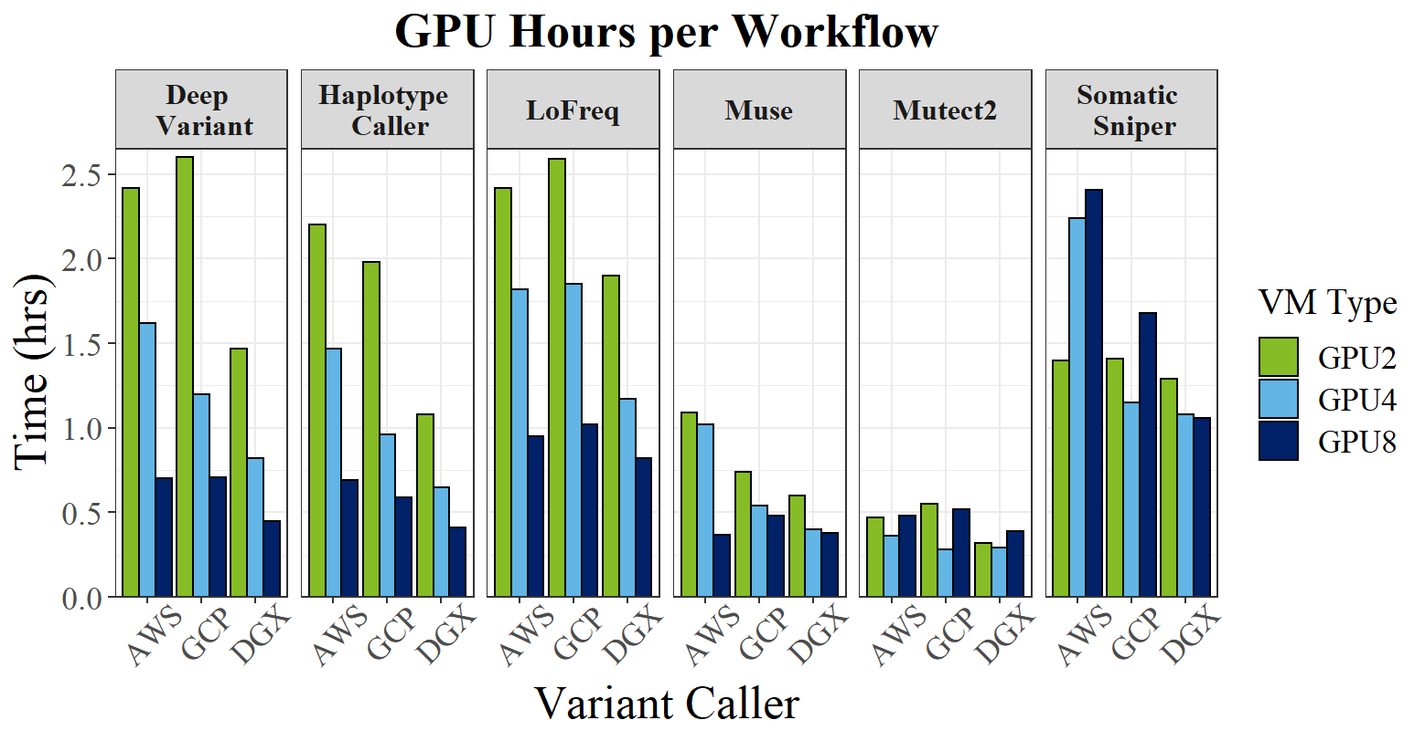
Figure S1: GPU benchmarking results for AWS, GCP, and NVIDIA DGX with the V100 GPUs on AWS.
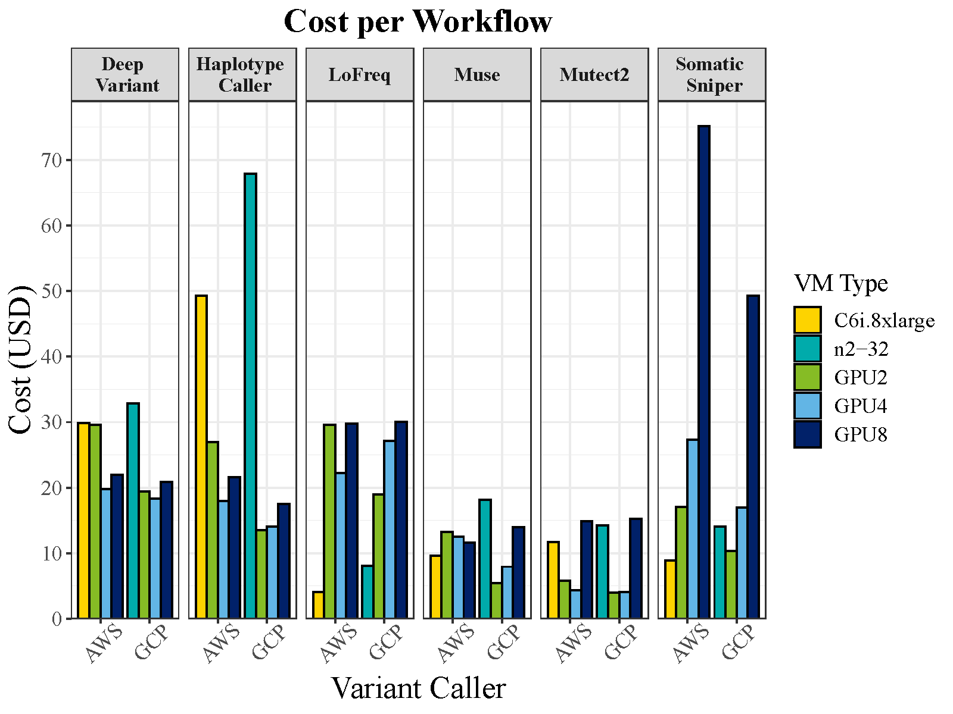
Figure S2: Cost per workflow (V100 machine on AWS) comparing CPU to GPU costs for each machine type.

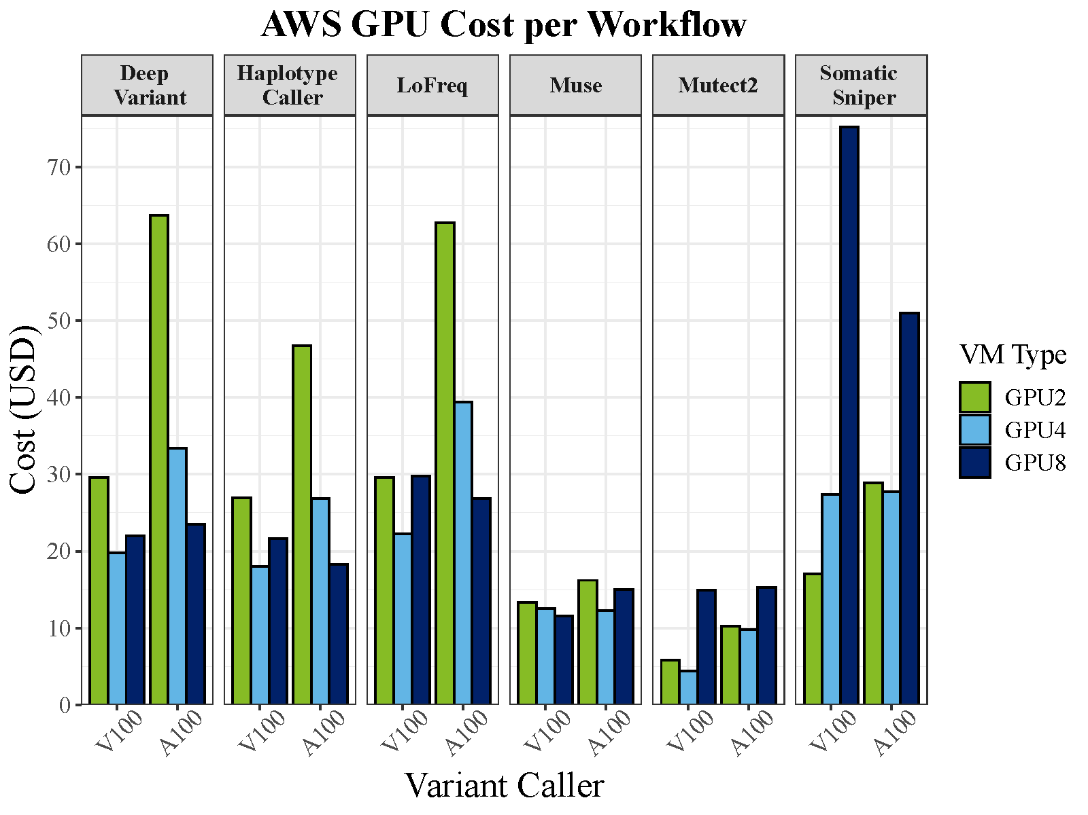
Figure S3: Cost differences between A100 and V100 GPU machines on AWS.

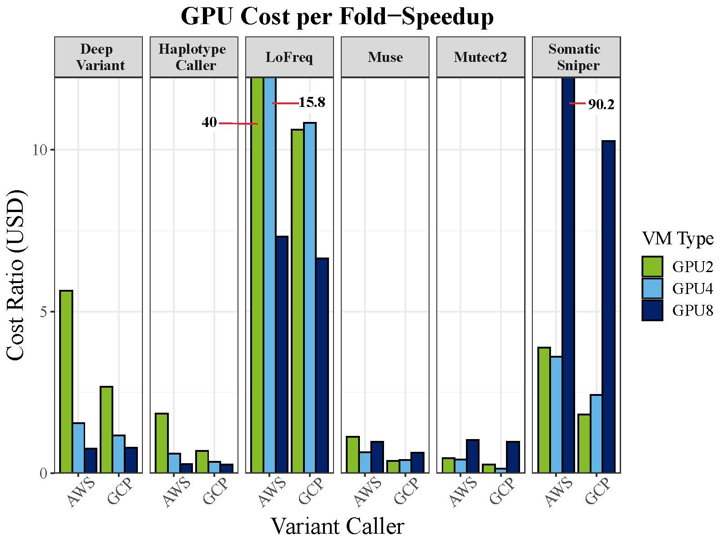

Figure S4. Comparison of AWS (A100 machine) vs. GCP GPU cost ratio per variant caller. Cost ratio being the ratio between cost per hour and fold speed-up. Cost per fold-speedup shows the benefit of harnessing GPU over CPU in select algorithms, while other algorithms are more cost-efficient with CPUs.

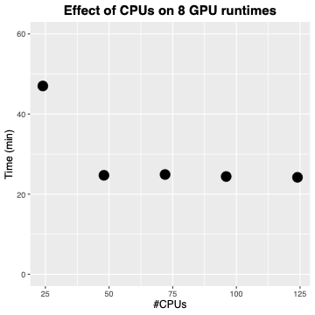

Figure S5: HaplotypeCaller runtime (in minutes) with 8 A100 GPUs on the NVIDIA DGX plotted by number of CPUs allocated per run. X axis shows runs with 24, 48, 74, 96, and 124 CPUs.

