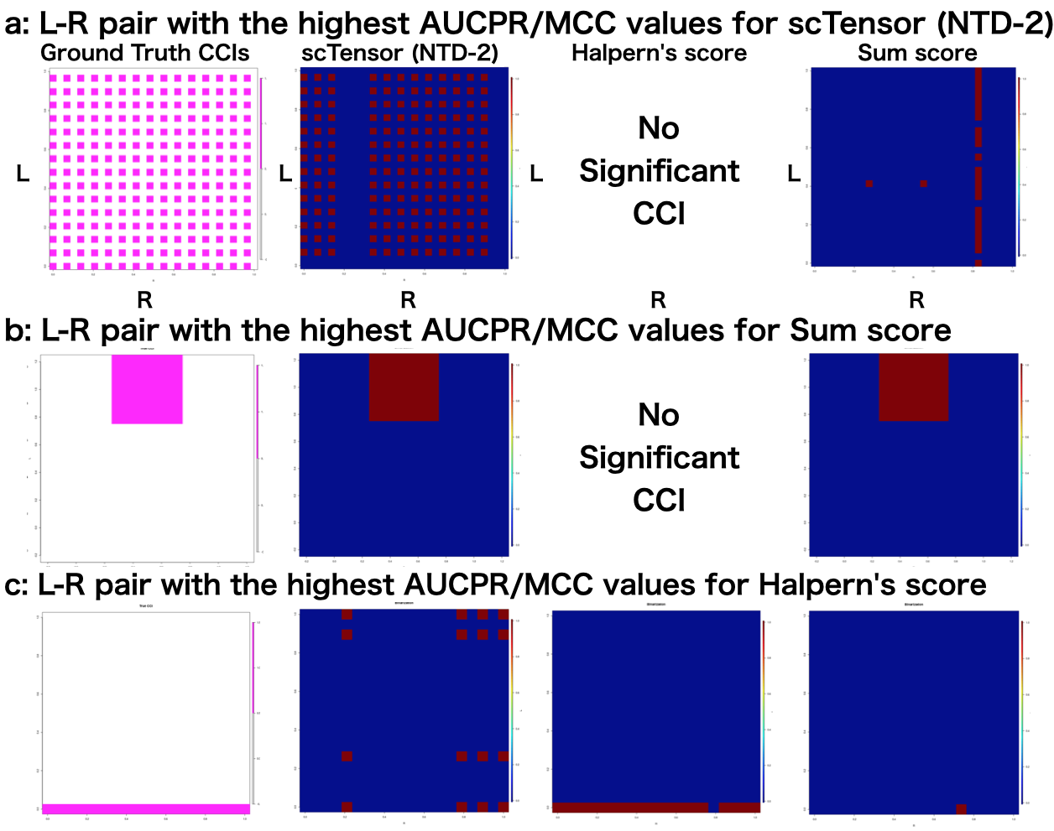
Fig S1 Three L-R pairs in which each of the three methods excelled Summary of the number of significant cell-cell interactions (CCIs) with (a) three cell types, one CCI types, one-to-one CCI style, and 1st-CCI type; (b) 20 cell types, five CCI types, many-to-many CCI style, 2nd-CCI type; and (c) 30 cell types, five CCI types, many-to-many CCI style, 5th-CCI type. The y-axis (L) and x-axis (R) indicate the ligand-expressing cell types and the receptor-expressing cell types, respectively.

