Supplementary Materials for
SingleScan: a comprehensive resource for single-cell sequencing data processing and mining
Kun Wang^{1,#}, Xiao Zhang^{2,3,#}, Hansen Cheng¹, Wenhao Ma¹,Guangchao Bao¹, Liting Dong¹, Yixiong Gou¹, Jian Yang^{1,*}, Haoyang Cai^{1,*}
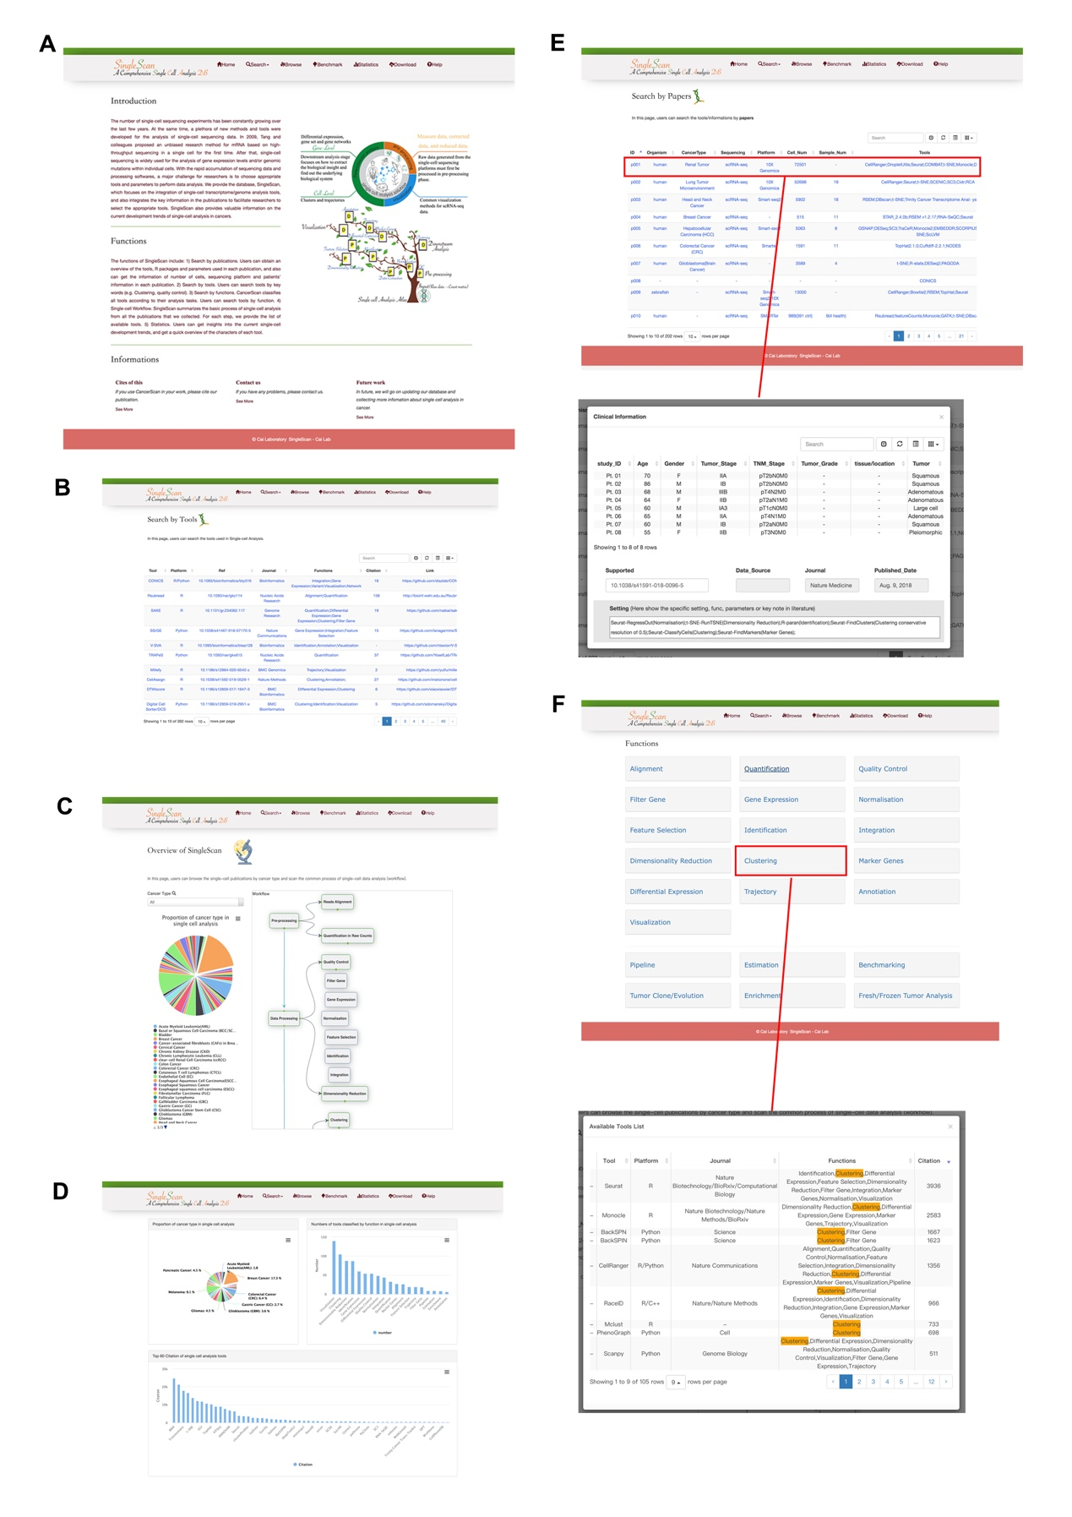
Figure S1. The main interface of SingleScan. (A) The ‘Home’ page of SingleScan. (B)’Search by Tools’ page shows the quick view of tools. (C) The ‘Browser’ page shows the pipelines of single-cell data analysis. (D) Statistical analysis. (E) The ‘Search by paper’ page shows the details of each research, including sample number, clinical information, etc. (F) The ‘Search by function’ page shows the tools of each functional module.

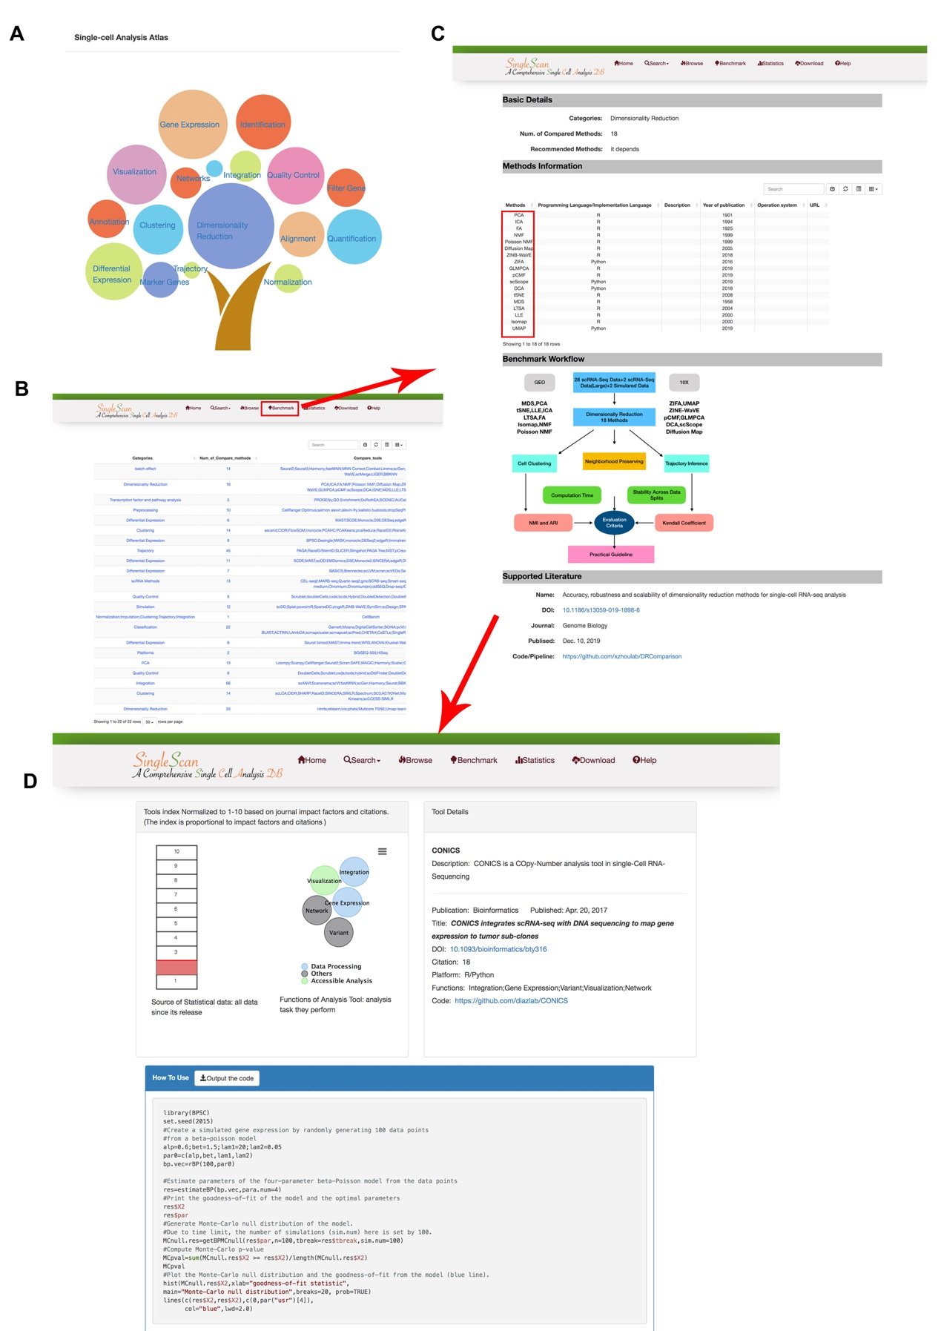
Figure S2. Details of a functional module and its associated benchmark repertoires. (A) single-cell tools with different modules. (B) A quick view of ‘benchmark’ page. (C) A benchmark of single-cell methods for each tool category. (D) Detailed information about a tool.

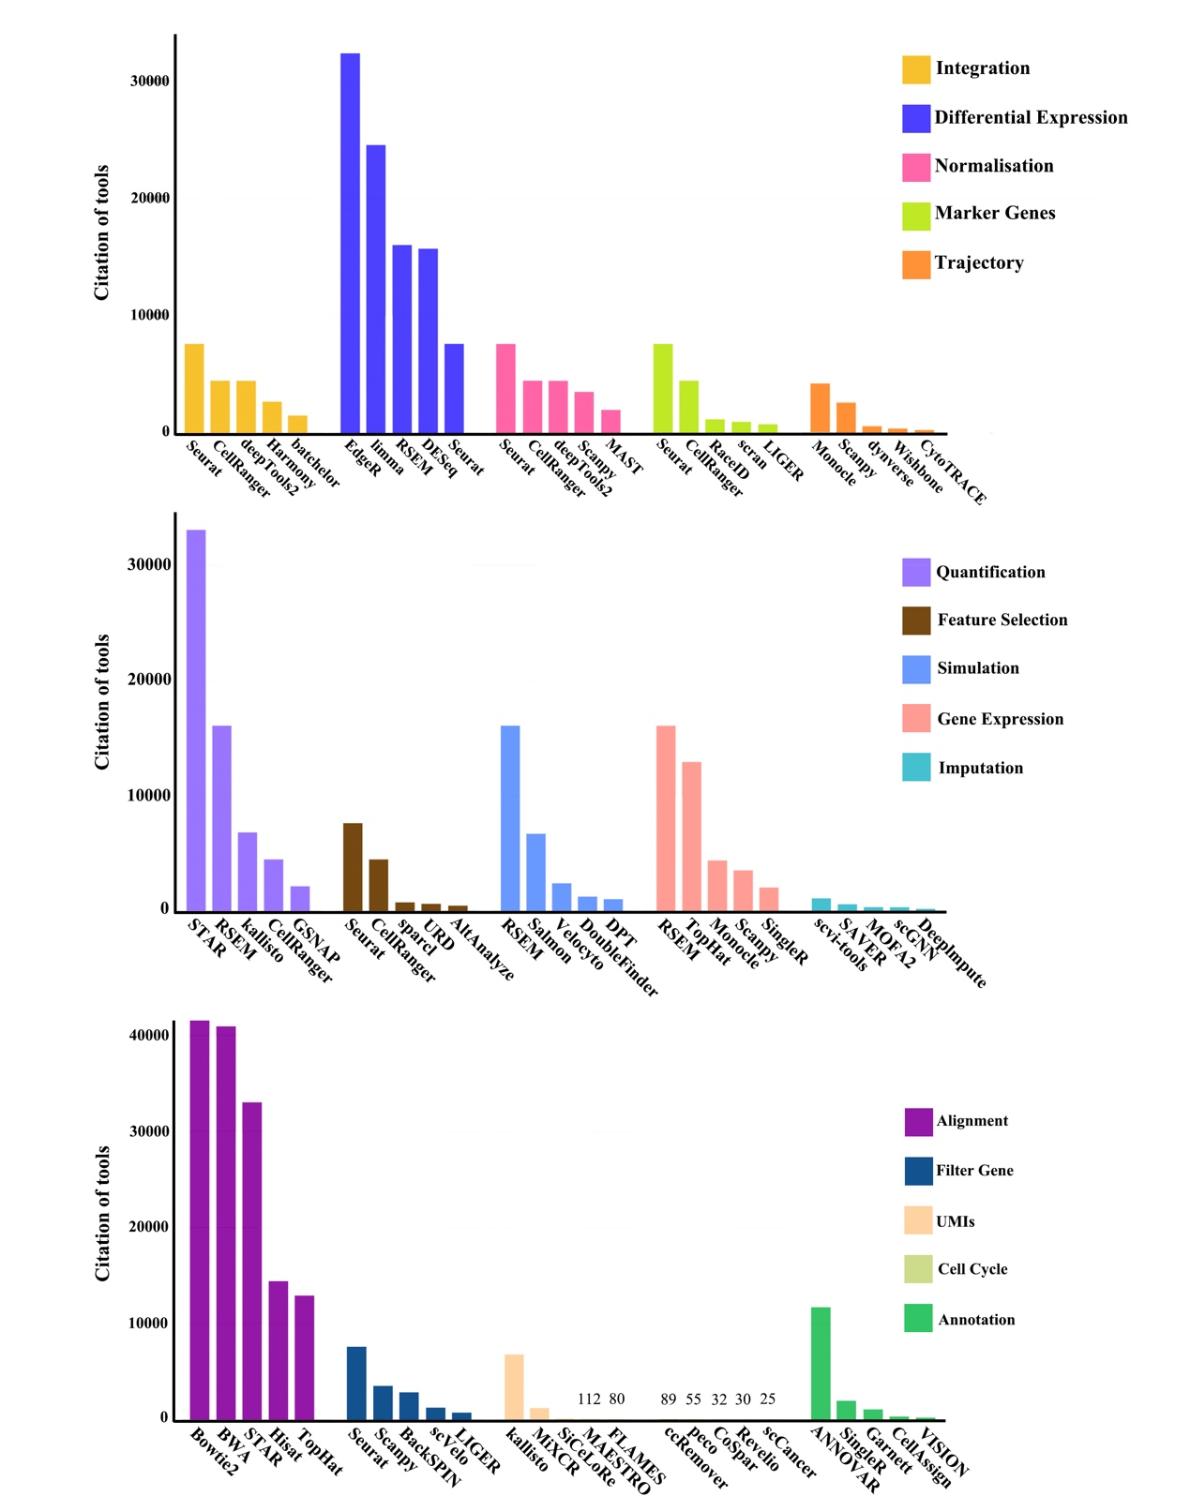
Figure S3. Tools are sorted by citations separately within each functional group (the remaining 15 functions in Figure 3C).

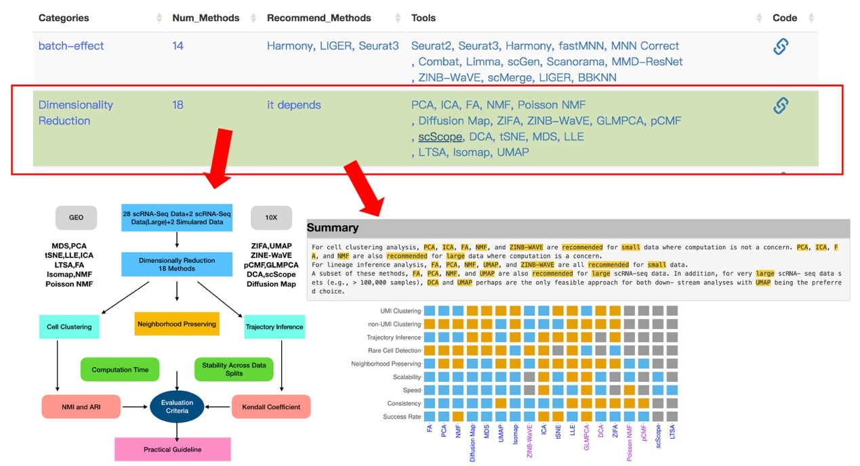
Figure S4. An example of ‘Benchmark’ page.

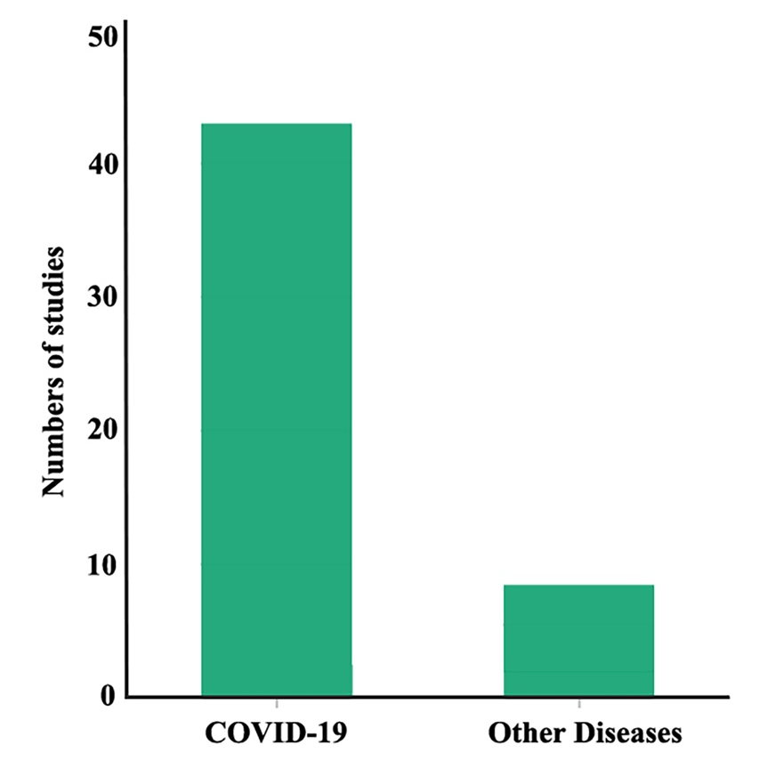
Figure S5. Number of publications on disease.

Table S1. The description of function modules
Functions | Description
Alignment | Genome alignment, align reads to a reference genome
UMIs | Processing Unique Molecular Identifiers (UMI) sequence
Quantification | Quantification from reads to gene expression (matrix)
Quality Control | Remove low-quality cells based on setting conditions
cell cycle | Remove the impact of cycling cells on analysis
Filter Gene | Remove lowly-expressed genes
Gene Expression | Inferring gene expression programs from single-cell sequencing data
Normalisation | Normalization addresses unwanted variation by e.g. scaling count data to obtain correct relative gene expression abundances between cells
Feature Selection | Filtered to keep only genes that are “informative” of the variability in data. Highly variable genes (HVGs) are often used
Identification | Identify cell types according to a reference dataset
Integration | Integration of single-cell sequencing datasets with other single-cell data
Networks | Co-regulated gene networks analysis
Dimensionality Reduction | Project cells from high-dimensional space to low-dimensional space
Clustering | Cell grouping based on expression profiles
Marker Genes | Calculate the representative genes of each cell-type after clustering
Differential Expression | Test for differential expression across cell-types
Trajectory | Trajectory analysis the data are regarded as a snapshot of a dynamic process
Imputation | Estimation of expression observed zeros in the gene-cell expression matrix of the single-cell sequencing datasets
Annotation | Automatically annotate the cell type according to some database
Visualization | Visualizing the results of single-cell sequencing data analysis

