Utilizing genomic signatures to gain insights into the dynamics of SARS-CoV-2 through machine and deep learning techniques.

Ahmed M. A. Elsherbini ¹, Amr Hassan Elkholy ¹, Youssef M. Fadel ¹, Gleb Goussarov ², Ahmed Mohamed Elshal ¹, Mohamed El-Hadidi¹, Mohamed Mysara ^{1,2*}
¹ Bioinformatics group, Center for Informatics Science, School of Information Technology and Computer Science, Nile University, Giza, Egypt
² Microbiology Unit, Belgian Nuclear Research Centre (SCK•CEN), Mol, Belgium
*Corresponding email: mmaysara@nu.edu.eg

Supplementary tables

Supplementary Table 1. RF model and DL performance measures of different a) clades b) continents in the main dataset
a)
Model / Clades | RF |  |  | DL
Model / Clades | precision | recall | F1-score | precision | recall | F1-score
Clade_G | 0.77 | 0.76 | 0.77 | 0.78 | 0.8 | 0.79
Clade_GH | 0.8 | 0.81 | 0.81 | 0.89 | 0.8 | 0.84
Clade_GK | 0.91 | 0.93 | 0.92 | 0.94 | 0.95 | 0.95
Clade_GR | 0.81 | 0.74 | 0.78 | 0.82 | 0.77 | 0.79
Clade_GRA | 0.94 | 0.96 | 0.95 | 0.98 | 0.97 | 0.97
Clade_GRY | 0.88 | 0.94 | 0.91 | 0.9 | 0.95 | 0.93
Clade_GV | 0.9 | 0.87 | 0.88 | 0.86 | 0.92 | 0.89

b)
Model /  Continents | RF |  |  | DL
Model /  Continents | precision | recall | F1-score | precision | recall | F1-score
Africa | 0.89 | 0.17 | 0.28 | 0.14 | 0.27 | 0.18
Asia | 0.89 | 0.49 | 0.63 | 0.74 | 0.49 | 0.59
Europe | 0.8 | 0.9 | 0.85 | 0.82 | 0.83 | 0.82
North America | 0.76 | 0.78 | 0.77 | 0.76 | 0.8 | 0.78
Oceania | 0.96 | 0.45 | 0.61 | 0.92 | 0.51 | 0.66
South America | 0.81 | 0.52 | 0.64 | 0.7 | 0.63 | 0.66
Unknown | 0.86 | 0.12 | 0.21 | 0.64 | 0.08 | 0.15

Supplementary Table 2. Comparison of K-mer frequencies tools similar to GenoSig.
 | GenoSig | SeekR | PaSiT/GenDiscal | Seqrequester | Jellyfish | MerCat2
 | Our work GitHub repo | https://github.com/CalabreseLab/seekr | https://github.com/LM-UGent/GenDisCal | https://github.com/marbl/seqrequester | https://github.com/gmarcais/Jellyfish | https://github.com/raw-lab/mercat2
Language | C++ | Python | C++ | C | C++ | Python
Aim of the tool | Di- and/or Trinucleotide (k-mer) frequencies. | Classification of nucleotide sequences based on k-mer frequencies. | Bacterial genome distance Calculator based on modified (k-mer) signature. | 1- Histogram of sequence lengths.  2- GC3. di- and trinucleotide kmer. | K-mer counter | 1- K-mer counter.  2- K-mer diversity estimator.
Input | FASTA | FASTA | FASTA | FASTA/ FASTQ | FASTA/ FASTQ | FASTA/ FASTQ
Output | Signal per contig | Signal per contig | Signal per file | Signal per file | Signal per file | Signal per file
Reference |  | (39) | (28) | N/A | (40) | (41)

Supplementary figures
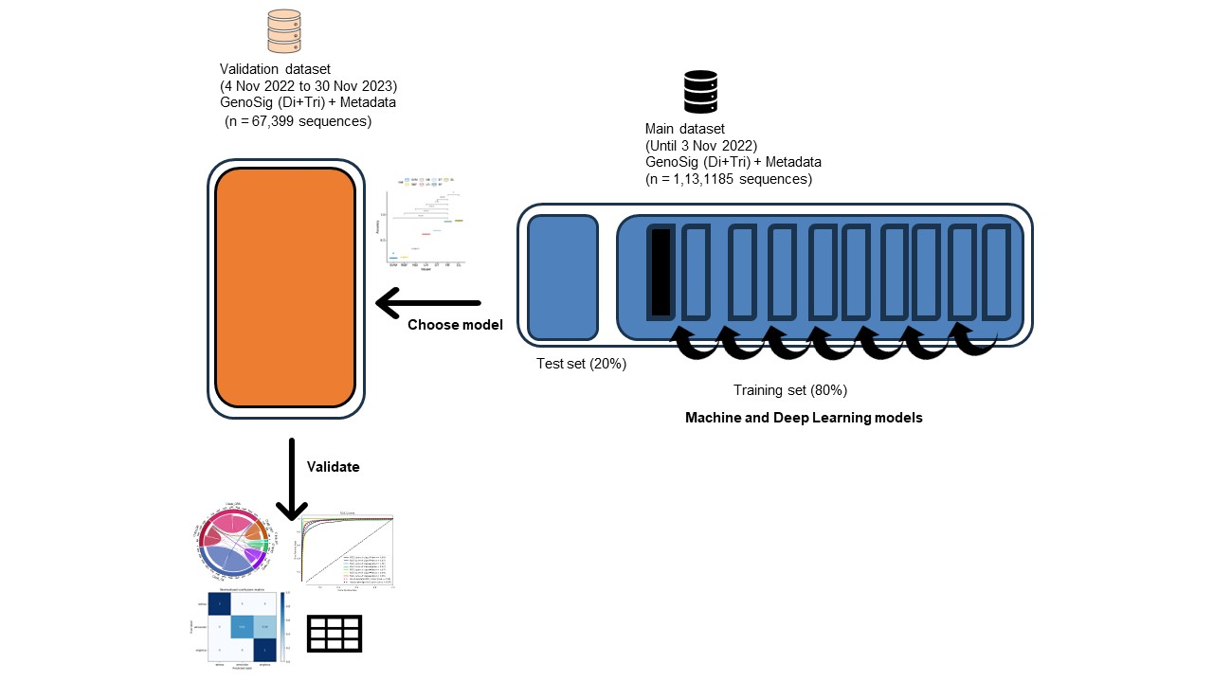
Supplementary Fig. 1 Summary graph showing used datasets splitting approach for training and testing, allowing shuffling in each iteration.

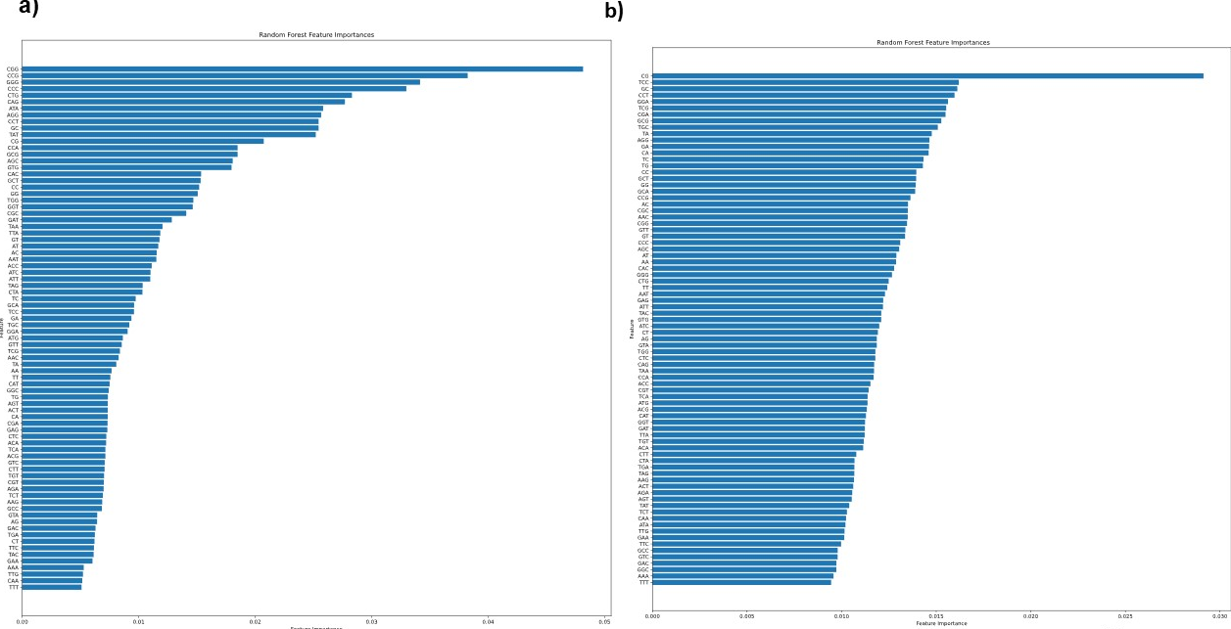
Supplementary Fig. 2
Features importance for RF a) clades b) continents. for DL c) clades d) continents. From the models that were trained on the main dataset.

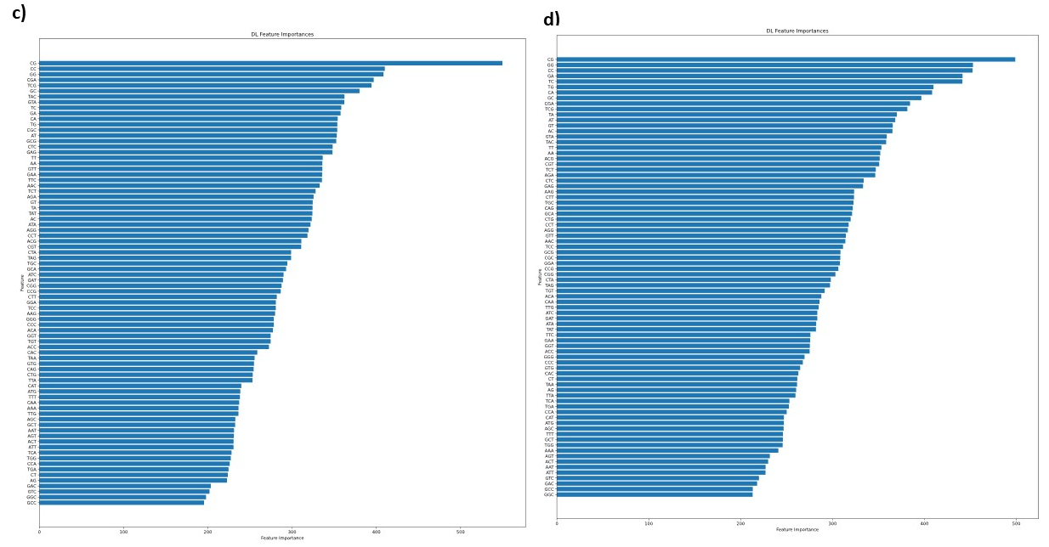
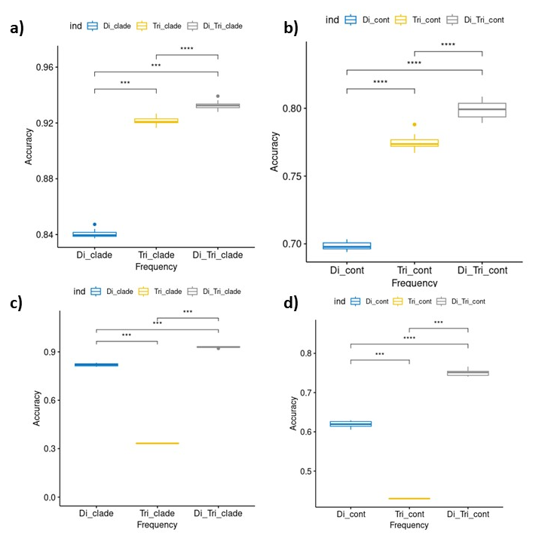
Supplementary Fig. 3 Employing the validation dataset, re-training model using di nucleotide only, tri nucleotide only and combined signal Di and Tri on RF model a) clades b) continents and DL c) clades d) continents.

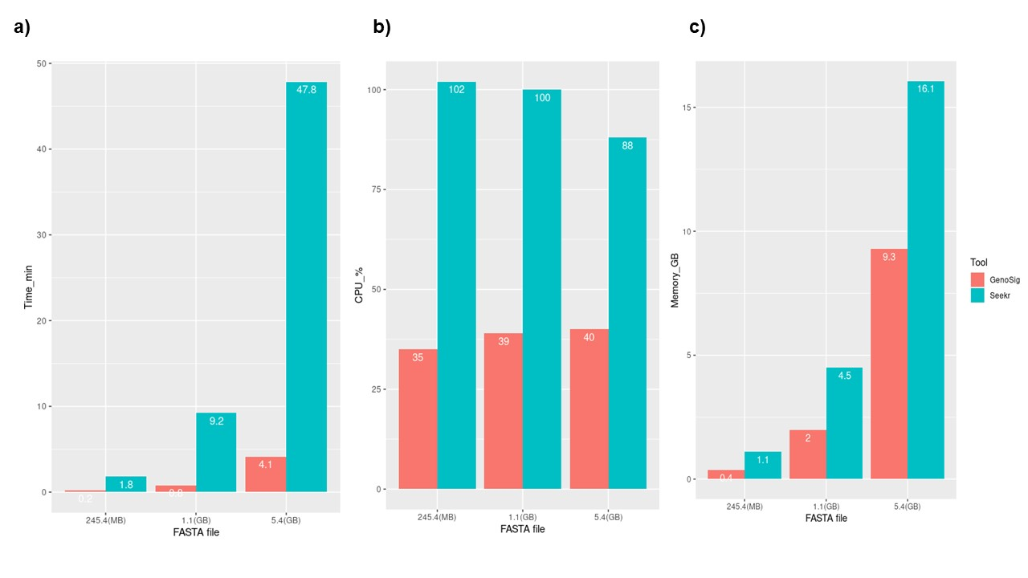
Supplementary Fig. 4 Comparing GenoSig versus SeekR in terms of a) Time (minutes), b) CPU%, C) Memory (GB)
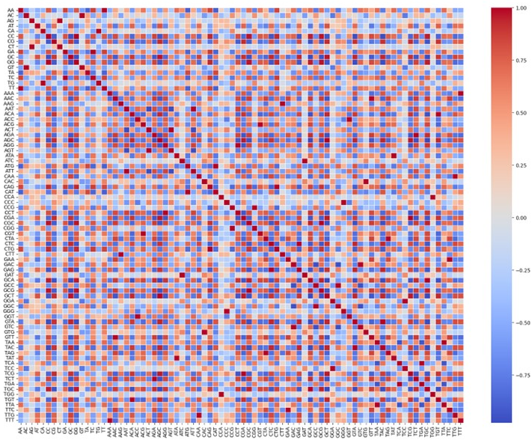
Supplementary Fig 5. Summary graph showing correlation (0,1) among the 80 Di and Tri frequency produced from the main dataset.

