Supplementary Figure
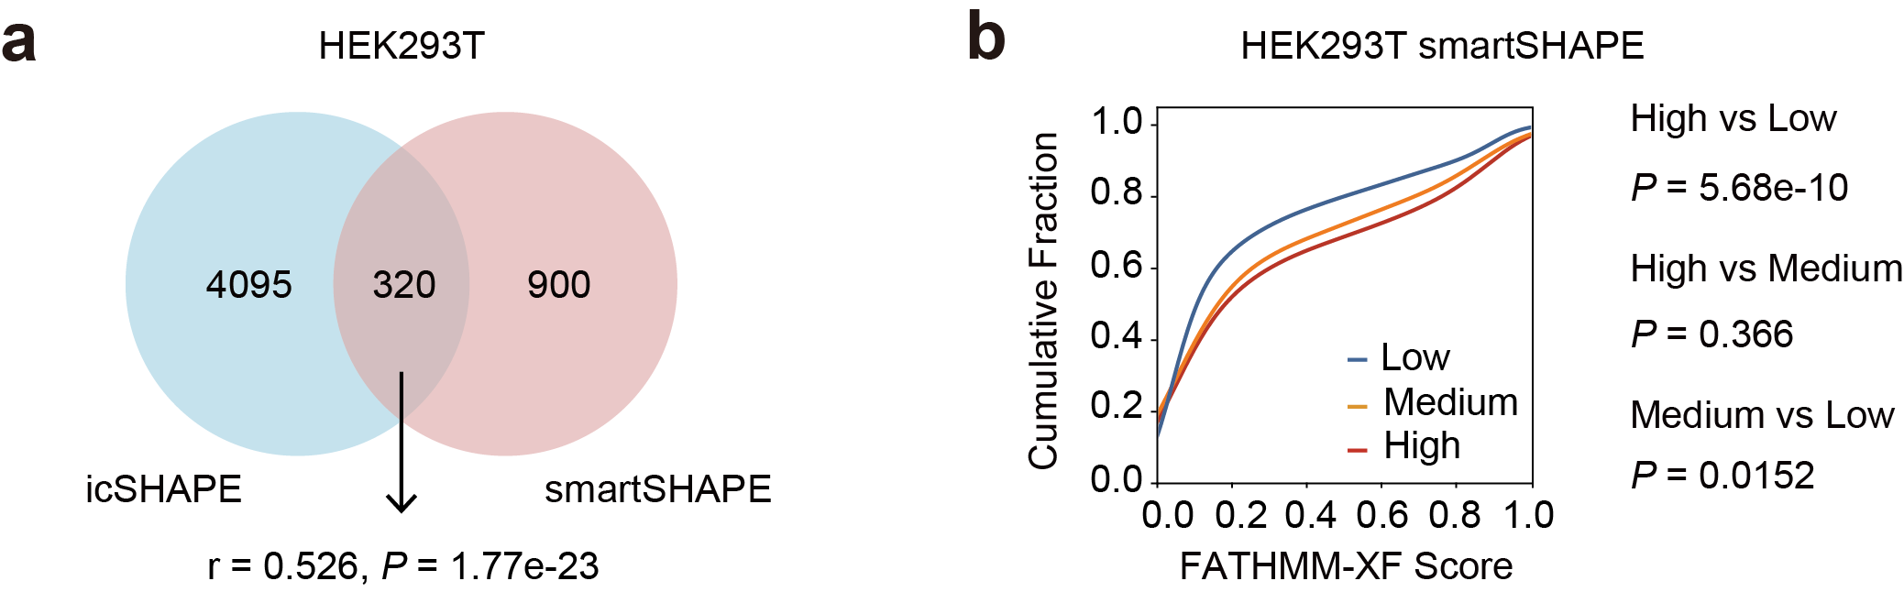
Supplementary Figure 1. AStruct in smartSHAPE. a, Venn diagram of icSHAPE and smartSHAPE results. Pearson Correlation was calculated using the AStruct scores of the intersection set. b, The cumulative distribution curve of the FATHMM-XF score for three AStruct groups identified using smartSHAPE.

Supplementary Table

Supplementary Table 1 ASRS SNPs in ‘High’ group result in allele-specific RNA-protein-interaction of PPIG protein in HepG2 cell line.
Chr | Position | Ref | Alt | rsID | Gene | eCLIP Counts | RNA-Seq Counts | P Value
chr1 | 11840380 | T | C | rs198412 | CLCN6 | 15|6 | 7|14 | 2.937e-2
chr1 | 21852751 | C | T | rs35669711 | HSPG2 | 17|2 | 10|12 | 3.763e-3
chr1 | 43619068 | C | T | rs1143701 | PTPRF | 9|14 | 78|46 | 3.941e-2
chr1 | 43981741 | G | C | rs1859728 | B4GALT2 | 31|2 | 104|57 | 6.404e-4
chr2 | 27238100 | A | G | rs1141313 | CAD | 4|30 | 39|26 | 4.065e-6
chr2 | 55617309 | T | C | rs782594 | PPP4R3B | 12|2 | 12|33 | 1.277e-4
chr2 | 131516901 | G | A | rs13010688 | LOC150776 | 56|10 | 36|24 | 2.382e-3
chr2 | 207624377 | C | A | rs4234080 | METTL21A | 13|3 | 43|56 | 6.355e-3
chr2 | 238238715 | G | A | rs77852620 | HES6 | 2|18 | 120|202 | 1.456e-2
chr3 | 48415297 | G | A | rs765476248 | PLXNB1 | 22|43 | 65|60 | 2.129e-2
chr3 | 191369951 | A | T | rs35380043 | CCDC50 | 12|21 | 69|52 | 4.857e-2
chr5 | 146013801 | C | T | rs758037 | SH3RF2 | 11|3 | 8|12 | 3.818e-2
chr6 | 130869698 | G | A | rs17059736 | EPB41L2 | 32|2 | 29|9 | 4.992e-2
chr7 | 5308283 | G | A | rs11554710 | TNRC18 | 2|14 | 30|28 | 8.807e-3
chr7 | 100149507 | G | A | rs12878 | LAMTOR4 | 18|10 | 95|136 | 2.575e-2
chr8 | 18071302 | C | T | rs1071645 | ASAH1 | 6|17 | 78|52 | 3.086e-3
chr8 | 94529074 | A | G | rs957448 | VIRMA | 23|4 | 4|6 | 1.163e-2
chr9 | 17727 | G | A | rs771704615 | WASHC1 | 66|10 | 201|80 | 6.962e-3
chr10 | 27186515 | T | C | rs10741130 | MASTL | 6|3 | 11|39 | 1.272e-2
chr10 | 92689976 | G | A | rs117639730 | HHEX | 3|8 | 9|2 | 2.997e-2
chr12 | 102917201 | T | G | rs2280615 | PAH | 6|4 | 10|42 | 1.390e-2
chr12 | 132659414 | C | T | rs5744857 | POLE | 16|34 | 23|17 | 1.925e-2
chr13 | 72775221 | G | C | rs7332388 | DIS3 | 16|8 | 5|14 | 1.390e-2
chr16 | 2114210 | G | A | rs74488735 | PKD1 | 253|51 | 10|19 | 5.666e-8
chr16 | 67657765 | A | G | rs6979 | ACD | 5|2 | 59|124 | 4.421e-2
chr16 | 68356794 | C | T | rs61733486 | PRMT7 | 27|21 | 79|171 | 1.619e-3
chr16 | 70269677 | G | A | rs2070203 | AARS | 25|23 | 38|93 | 7.583e-3
chr16 | 88652144 | G | A | rs11076693 | MVD | 41|35 | 416|178 | 5.897e-3
chr16 | 88713331 | A | G | rs11549837 | CTU2 | 4|20 | 67|33 | 1.391e-5
chr16 | 88725050 | G | A | rs11645197 | PIEZO1 | 47|23 | 29|49 | 3.053e-4
chr17 | 1474649 | A | G | rs2286873 | MYO1C | 19|9 | 12|22 | 2.086e-2

Supplementary Table 2 ASRS SNPs in ‘High’ group result in allele-specific m6A modification in HeLa cell line.
Chr | Position | Ref | Alt | rsID | Gene | MeRIP IP  Counts | MeRIP Input Counts | P Value
chr1 | 15429559 | T | C | rs1329757295 | EFHD2 | 856|2 | 474|9 | 2.476e-3
chr1 | 158098554 | A | G | rs3820677 | KIRREL1 | 127|54 | 48|53 | 2.073e-4
chr1 | 175989442 | T | C | rs111531372 | COP1 | 8|42 | 78|117 | 1.450e-3
chr3 | 9384260 | G | C | rs1046788 | THUMPD3 | 107|110 | 322|184 | 3.785e-4
chr5 | 177090990 | T | C | rs45526036 | FGFR4 | 88|19 | 63|39 | 1.137e-3
chr7 | 6153890 | G | C | rs61729726 | USP42 | 8|16 | 49|32 | 2.174e-2
chr7 | 150336793 | A | G | rs3735171 | LRRC61 | 196|867 | 21|155 | 4.134e-2
chr8 | 19458575 | G | A | rs12155539 | CSGALNACT1 | 243|62 | 256|24 | 5.967e-5
chr8 | 23144475 | A | G | rs1133782 | TNFRSF10D | 27|97 | 6|72 | 1.033e-2
chr9 | 93476296 | C | T | rs10821135 | FAM120A | 192|425 | 181|676 | 1.575e-5
chr9 | 137716669 | A | T | rs76684726 | EHMT1 | 1193|203 | 351|94 | 1.422e-3
chr11 | 20508346 | A | G | rs74772442 | PRMT3 | 124|24 | 181|82 | 9.515e-4
chr11 | 27340812 | T | G | rs17244028 | CCDC34 | 1040|695 | 259|219 | 2.419e-2
chr11 | 32103432 | T | C | rs4876 | RCN1 | 3759|2271 | 3895|2161 | 2.469e-2
chr11 | 47183430 | G | C | rs901747 | PACSIN3 | 2|11 | 4|2 | 4.603e-2
chr11 | 61800254 | T | C | rs1127959 | FADS1 | 315|6 | 207|11 | 4.581e-2
chr11 | 62532473 | A | C | rs11231130 | AHNAK | 215|326 | 114|126 | 4.950e-2
chr11 | 68903951 | C | T | rs4930624 | IGHMBP2 | 35|36 | 10|28 | 2.510e-2
chr11 | 69667426 | C | T | rs116600405 | ORAOV1 | 16|60 | 24|16 | 6.586e-5
chr12 | 53041211 | C | G | rs1961466 | EIF4B | 446|227 | 511|363 | 1.839e-3
chr12 | 56242441 | T | G | rs1592385681 | ANKRD52 | 243|6 | 140|14 | 3.919e-3
chr14 | 60165381 | T | A | rs568729153 | DHRS7 | 2|12 | 5|2 | 1.729e-2
chr14 | 91947643 | G | A | rs7149187 | FBLN5 | 18|7 | 14|28 | 2.725e-3
chr15 | 40335644 | G | A | rs55641696 | CCDC9B | 117|108 | 40|14 | 3.593e-3
chr15 | 41523318 | G | C | rs8027526 | RPAP1 | 49|111 | 62|74 | 1.126e-2
chr15 | 43769604 | C | T | rs1053492 | PDIA3 | 1713|725 | 1336|656 | 2.254e-2

