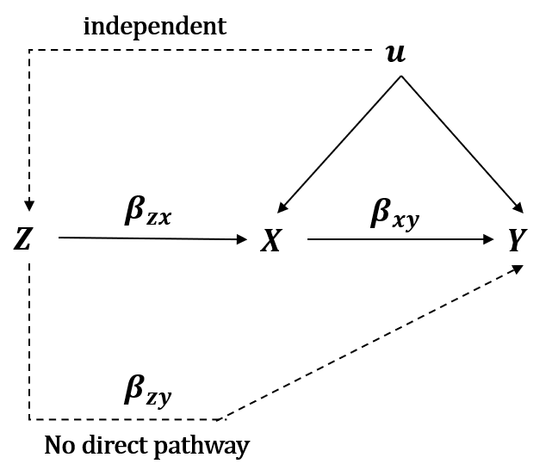
Supplementary Fig. 1 A directed acyclic graph for Mendelian randomization.

