Supplementary Figures

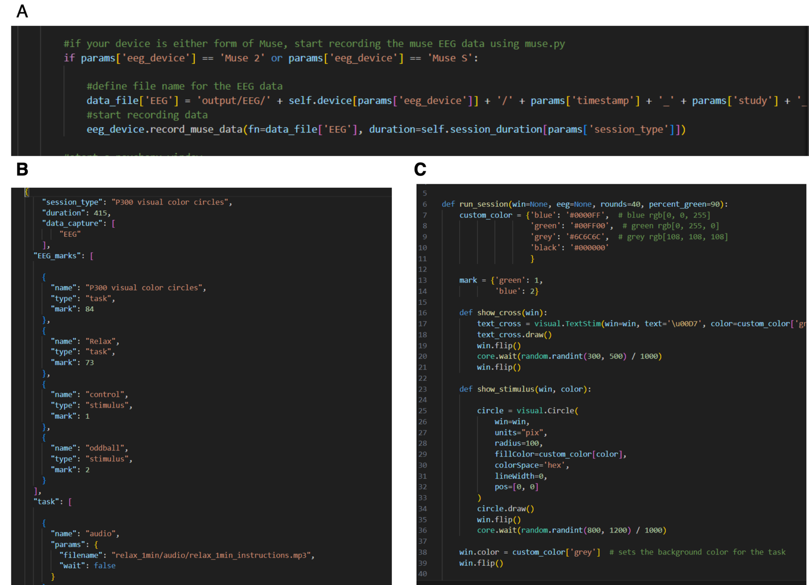
Supplementary Figure 1| HEROIC is easily customizable. A. Code sample showing the selection of the device leading to a specific function for collecting the data. B. Code sample showing the definition of stimuli for a visual oddball session, including markers and references to files to access media. C. Code sample showing the definition of a session configuration. Functions provide instructions on how to present the stimuli later as part of a sequence.

 | Temporal-parietal (TP) |  | Anterior-frontal (AF)
Power band | TP9 | TP10 | AF7 | AF8
Delta, δ | 0.249 | 0.366 | ***1.15e-57 | ***2.23e -108
Theta, θ | ***1.47e-58 | ***6.11e-51 | ***8.94e-15 | *** 4.01e-19
Alpha, α | ***1.08e-66 | *** 1.45e-84 | 0.546 | 0.198
Beta, β | ***2.05e-14 | ***3.62e-13 | ***1.56e-76 | ***1.66e-145
Gamma, γ | ***6.56e-08 | ***3.521e-8 | ***6.82e-127 | ***2.98e-162
Supplemental Table 1| Summary of symmetrical changes across scalp. P-values by spectral changes across the scalp. Significant changes in power spectra frequency bands change from eyes-closed to eyes-open resting state conditions by brain regions in control participants. Overall, controls show symmetrical changes in brain activity between left (TP9) and right (TP10) temporal-parietal regions, and between left (AF7) and right (AF8) anterior-frontal regions.
*** p<0.0001, ns non significant, green boxes indicate an increase from eyes-closed to eyes open, red boxes indicate a decrease from eyes-closed to eyes-open.

