Supplementary Materials
Zhongning Jiang¹, Wei Huang¹, Raymond H. W. Lam^{*,1,2} and Wei Zhang^{*,3}

¹ Department of Biomedical Engineering, City University of Hong Kong, Hong Kong, China
² City University of Hong Kong Shenzhen Research Institute, Shenzhen, Guangdong, China
³ Center of Intelligent Medicine, School of Control Science and Engineering, Shandong University, Jinan, Shandong 250061, China

* To whom correspondence should be addressed. Email: zw@sdu.edu.cn, rhwlam@cityu.edu.hk

Data processing and model training
1.1 Selection on feature genes
Prior to model training, we preprocessed and performed feature selection on the scRNA-seq data. Leveraging the annotations associated with the scRNA-seq data, we conducted a differential expression analysis for each cell subtype using the Wilcoxon Rank-Sum test provided by the Python package SCANPY [1]. Specifically, after performing log1p transformation, identifying highly variable genes, and applying PCA dimensionality reduction, we utilized the rank_genes_groups() function to obtain a ranked list of differential genes for each cell type. We then selected the top 30 differential genes from each category as genetic markers for each subtype. These feature genes were subsequently used to filter both the SRT and scRNA-seq data.
1.2 Performing spatial domain clustering analysis
Upon obtaining the cell composition proportion for all spots using Spall, we directly employed this cellular proportion data for clustering to identify spatial domains. Specifically, we used the cell proportion data as features and applied SCANPY's pp.neighbor() and tl.leiden() functions for clustering. The parameters were set to n_neighbor=10 for the neighbor() function and resolution=0.2 for the leiden() function, resulting in cluster annotations for each spot.
1.3 Performing domain-specific differential gene expression analysis
Following the spatial domain clustering analysis, we conducted differential gene expression analysis for each domain to identify domain-specific marker genes. We grouped the spots based on their previously obtained cluster annotations and then utilized SCANPY's rank_genes_groups() function to rank differential genes for each spatial domain.
1.4 Model training
We implemented Spall based on the PyTorch package [2]. The construction of the graph neural network relied on the PyG package [3]. During the training process, as the graph neural network training is semi-supervised, we were able to use all the data for training. The labeled Pseudo spots were divided into training and validation sets at an 8:2 ratio. The parameters of the model are: Number of the attention head, 8; Number of the hidden layers. [256, 128]; Number of the training epochs, 3000; Number of the patience of early stopping, 300; Dropout ratio, 0.1.
The training platform hardware consisted of an Intel Core 12600K CPU, NVIDIA GeForce RTX 4070 GPU, and 64 GB DDR4 RAM.
1.5 Key Parameters of Graph Construction
For KNN-based graph construction, we first apply PCA to reduce the dimensionality of the original feature data, with the parameter set to n_component=50. We then use KNN for graph construction, with the parameter n_neighbors=8. For Random Projection Forest-based graph construction, we use 10 Random Projection Trees, where the dimension of the random projection in each tree is set to the length of the feature dimension minus one. Additionally, the number of leaf nodes required for each tree to converge is set to 20.

2. Reference
- Wolf FA, Angerer P, Theis FJ. SCANPY: large-scale single-cell gene expression data analysis. Genome Biol. 2018; 19:15
- Paszke A, Gross S, Massa F, et al. PyTorch: An Imperative Style, High-Performance Deep Learning Library. Adv Neural Inf Process Syst. 2019; 32:8026-8037
- Fey M, Lenssen JE. Fast Graph Representation Learning with PyTorch Geometric. ICLR Workshop on Representation Learning on Graphs and Manifolds. 2019

Supplementary Figures
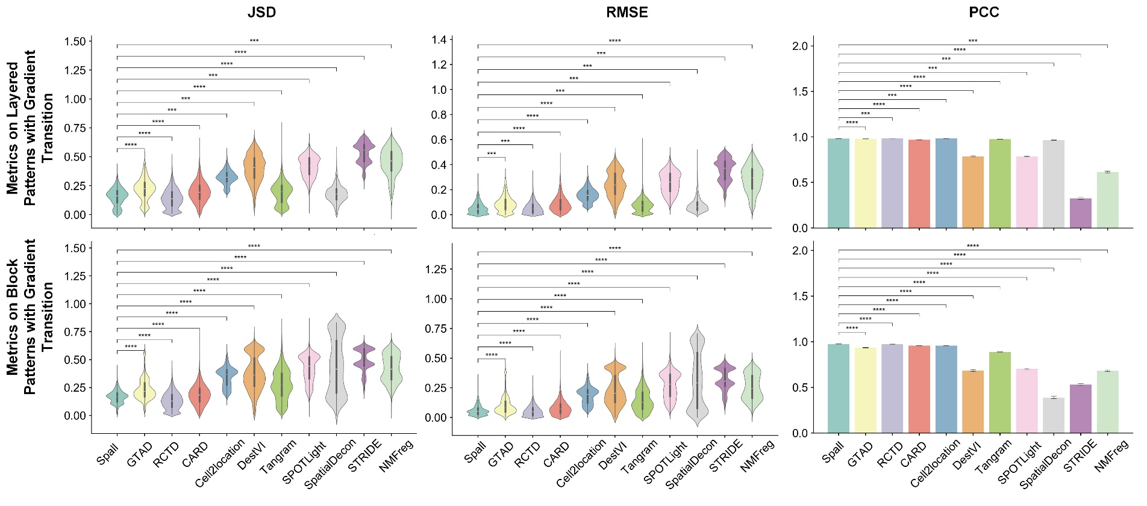
Figure S1. The performance across two spatial patterns with gradient transition generated using scRNA-seq. In the violin plots: the center line represents the median; box limits denote the upper and lower quartiles; whiskers extend to 1.5× the interquartile range. In the bar plot: bar height represents the mean value, with whiskers indicating the mean ± 95% confidence intervals; The experiments were repeated for 10 times. (p-values indicate the significance level under one-sided t-test for positive correlation. ****p ≤ 0.0001, ***p ≤ 0.001, **p ≤ 0.01, *p ≤ 0.05, ⋅p ≤ 0.1, ns: p > 0.1.)

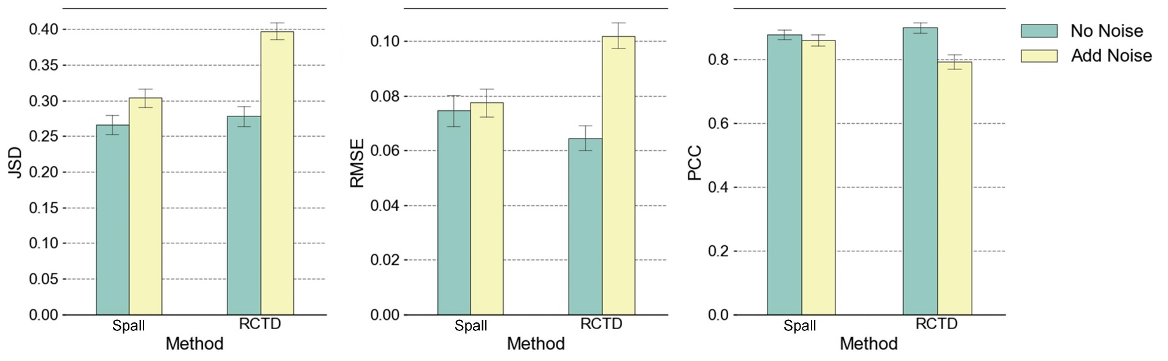
Figure S2. Comparison of cell-type decomposition performance between Spall and RCTD under the condition of adding noise (Gaussian noise with SNR=15 dB).

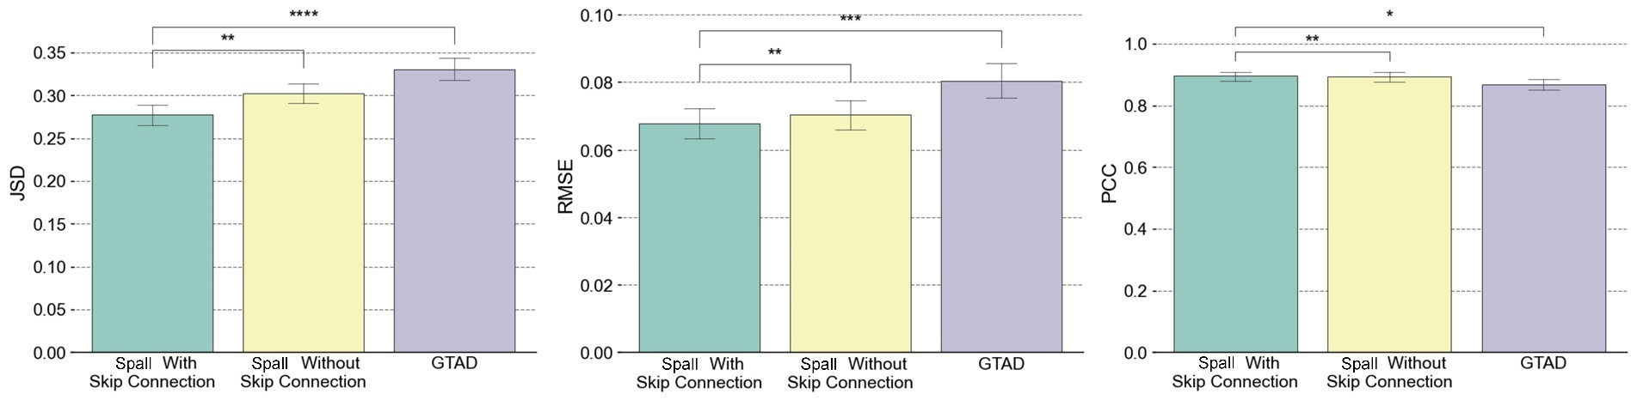
Figure S3. Decomposition performance comparison between Spall using with or without skip connections and GTAD.

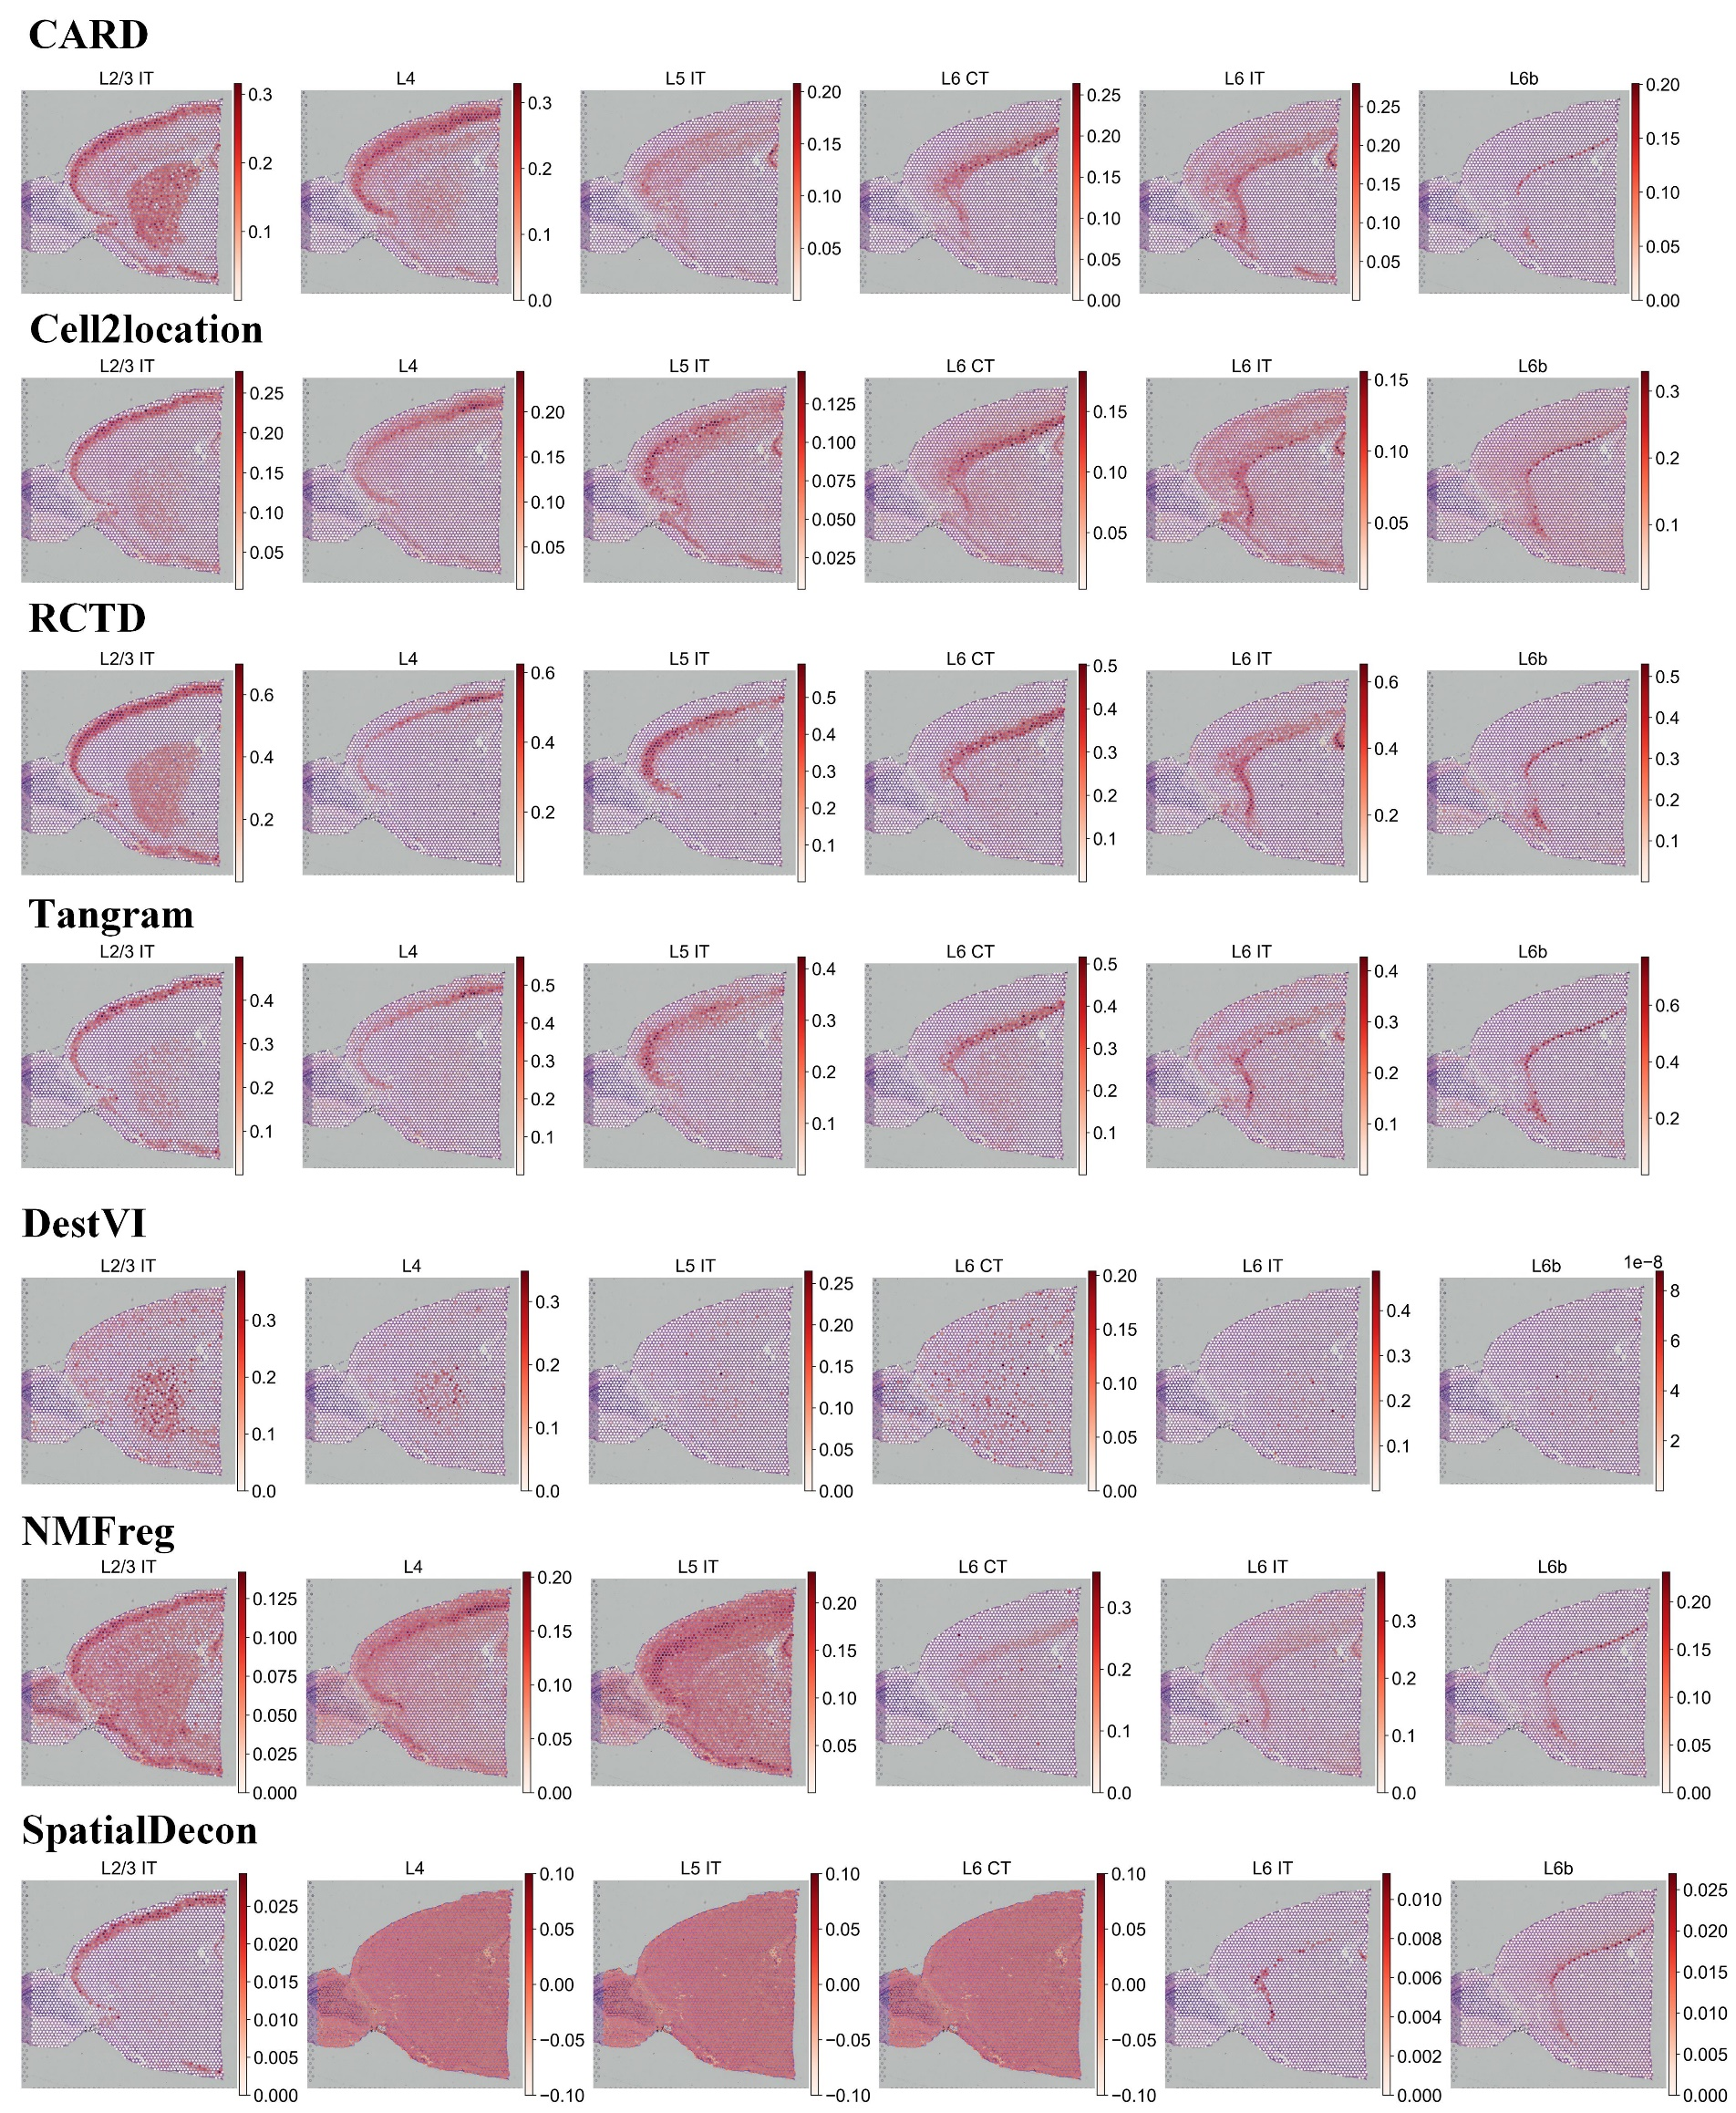
Figure S4. The spatial proportions of 6 layer-specific neurons predicted by other methods.

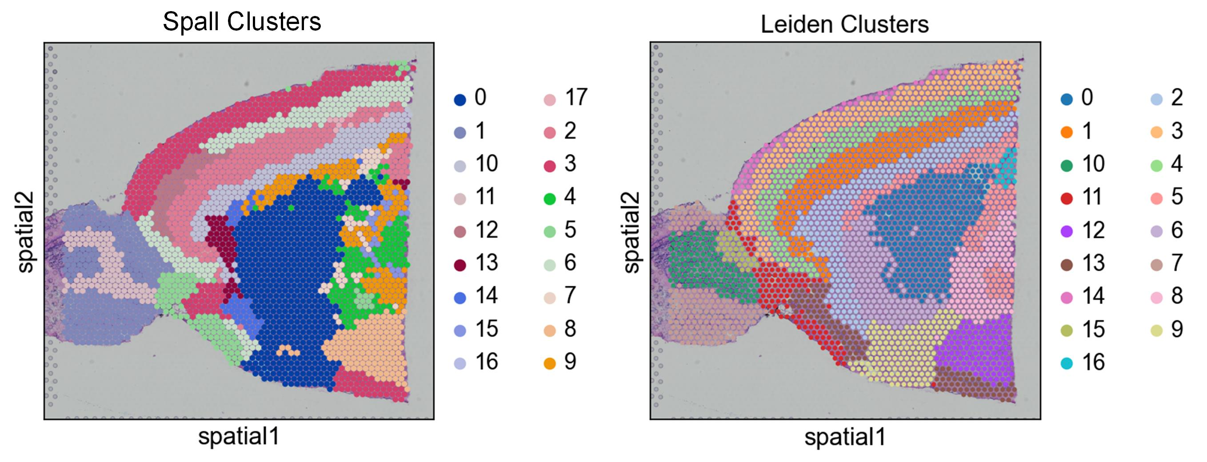
Figure S5 Spatial domain clustering results using Spall’s cell proportion and using gene-expression profile directly.

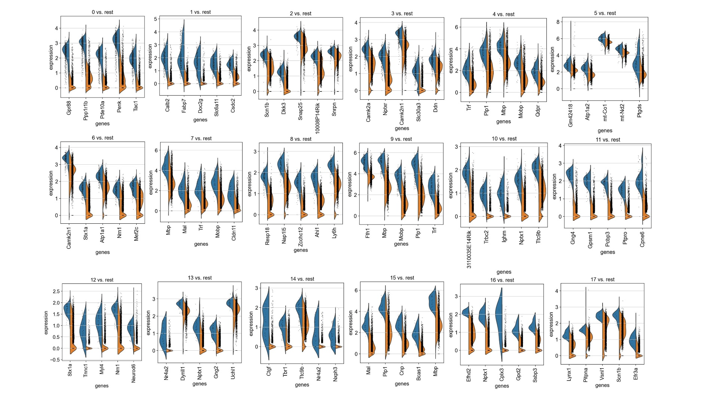
Figure S6. Violin plot of top 5 differential expressed genes.

