Identifying Risk Factors for Alzheimer's Disease from Multivariate Longitudinal Clinical Data using Temporal Pattern Mining
Supplementary Results
MAS Dataset
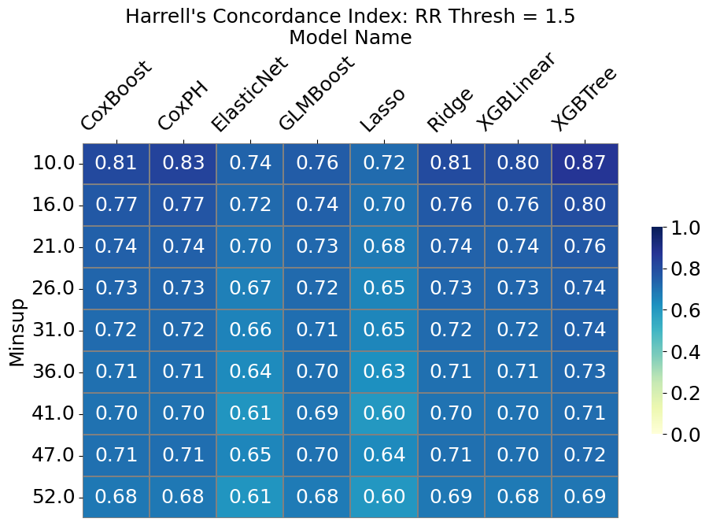
Figure S1 - Performance of the machine learning algorithms, measured by Harrell’s C- Index, Index, applied to the patterns discovered in the MAS dataset by C-TPM, for different values of minsup, using a relative risk threshold of 1.5.
Minsup | CoxBoost | CoxPH | ElasticNet | GLMBoost | Lasso | Ridge | XGBLinear | XGBTree
10 | 0.81 (±0.02) | 0.83 (±0.03) | 0.74 (±0.08) | 0.76 (±0.02) | 0.72 (±0.08) | 0.81 (±0.02) | 0.80 (±0.02) | 0.87 (±0.07)
16 | 0.77 (±0.03) | 0.77 (±0.03) | 0.72 (±0.07) | 0.74 (±0.03) | 0.7 (±0.09) | 0.76 (±0.03) | 0.76 (±0.03) | 0.80 (±0.06)
21 | 0.74 (±0.03) | 0.74 (±0.04) | 0.70 (±0.08) | 0.73 (±0.03) | 0.68 (±0.08) | 0.74 (±0.03) | 0.74 (±0.03) | 0.76 (±0.04)
26 | 0.73 (±0.04) | 0.73 (±0.04) | 0.67 (±0.1) | 0.72 (±0.04) | 0.65 (±0.1) | 0.73 (±0.04) | 0.73 (±0.04) | 0.74 (±0.06)
31 | 0.72 (±0.05) | 0.72 (±0.05) | 0.66 (±0.1) | 0.71 (±0.04) | 0.65 (±0.1) | 0.72 (±0.04) | 0.72 (±0.04) | 0.74 (±0.06)
36 | 0.71 (±0.06) | 0.71 (±0.05) | 0.64 (±0.1) | 0.7 (±0.05) | 0.63 (±0.09) | 0.71 (±0.05) | 0.71 (±0.05) | 0.73 (±0.06)
41 | 0.70 (±0.05) | 0.70 (±0.05) | 0.61 (±0.11) | 0.69 (±0.05) | 0.6 (±0.11) | 0.7 (±0.05) | 0.70 (±0.05) | 0.71 (±0.06)
47 | 0.71 (±0.08) | 0.71 (±0.07) | 0.65 (±0.11) | 0.70 (±0.07) | 0.64 (±0.1) | 0.71 (±0.07) | 0.70 (±0.07) | 0.72 (±0.07)
52 | 0.68 (±0.06) | 0.68 (±0.06) | 0.61 (±0.11) | 0.68 (±0.06) | 0.6 (±0.1) | 0.69 (±0.06) | 0.68 (±0.06) | 0.69 (±0.06)
Table S1 –Performance of the machine learning algorithms, measured by Harrell’s C- Index, Index, applied to the patterns discovered in the MAS dataset by C-TPM, for different values of minsup, using a relative risk threshold of 1.5, with standard errors.

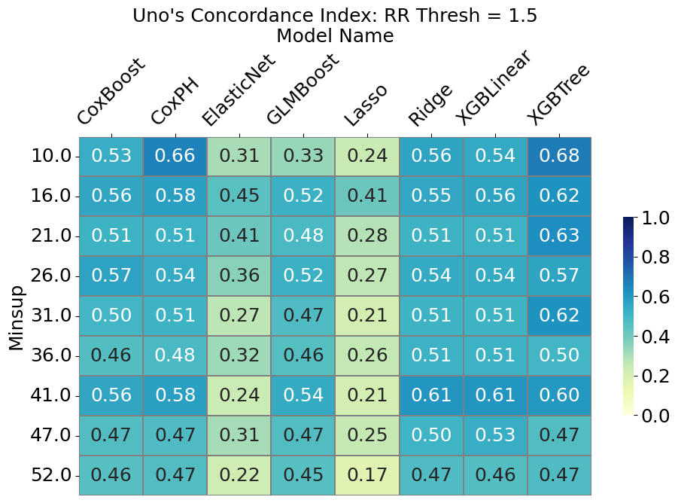
Figure S2 - Performance of the machine learning algorithms, measured by Uno’s C- Index, applied to the patterns discovered in the MAS dataset by C-TPM, for different values of minsup, using a relative risk threshold of 1.5
Minsup | CoxBoost | CoxPH | ElasticNet | GLMBoost | Lasso | Ridge | XGBLinear | XGBTree
10 | 0.53 (±0.28) | 0.66 (±0.28) | 0.31 (±0.32) | 0.33 (±0.25) | 0.24 (±0.3) | 0.56 (±0.27) | 0.54 (±0.26) | 0.68 (±0.29)
16 | 0.56 (±0.25) | 0.58 (±0.26) | 0.45 (±0.28) | 0.52 (±0.25) | 0.41 (±0.3) | 0.55 (±0.24) | 0.56 (±0.24) | 0.62 (±0.25)
21 | 0.51 (±0.24) | 0.51 (±0.24) | 0.41 (±0.31) | 0.48 (±0.25) | 0.28 (±0.27) | 0.51 (±0.22) | 0.51 (±0.00) | 0.63 (±0.00)
26 | 0.57 (±0.26) | 0.54 (±0.26) | 0.36 (±0.33) | 0.52 (±0.25) | 0.27 (±0.29) | 0.54 (±0.25) | 0.54 (±0.00) | 0.57 (±0.00)
31 | 0.5 (±0.22) | 0.51 (±0.23) | 0.27 (±0.3) | 0.47 (±0.26) | 0.21 (±0.27) | 0.51 (±0.24) | 0.51 (±0.00) | 0.62 (±0.00)
36 | 0.46 (±0.26) | 0.48 (±0.25) | 0.32 (±0.3) | 0.46 (±0.25) | 0.26 (±0.26) | 0.51 (±0.25) | 0.51 (±0.00) | 0.50 (±0.00)
41 | 0.56 (±0.24) | 0.58 (±0.25) | 0.24 (±0.3) | 0.54 (±0.24) | 0.21 (±0.3) | 0.61 (±0.24) | 0.61 (±0.00) | 0.60 (±0.00)
47 | 0.47 (±0.27) | 0.47 (±0.26) | 0.31 (±0.3) | 0.47 (±0.00) | 0.25 (±0.26) | 0.5 (±0.28) | 0.53 (±0.00) | 0.47 (±0.00)
52 | 0.46 (±0.21) | 0.47 (±0.21) | 0.22 (±0.28) | 0.45 (±0.00) | 0.17 (±0.22) | 0.47 (±0.21) | 0.46 (±0.00) | 0.47 (±0.00)
Table S2 - Performance of the machine learning algorithms, measured by Uno’s C- Index, applied to the patterns discovered in the MAS dataset by C-TPM, for different values of minsup, using a relative risk threshold of 1.5, with standard errors.
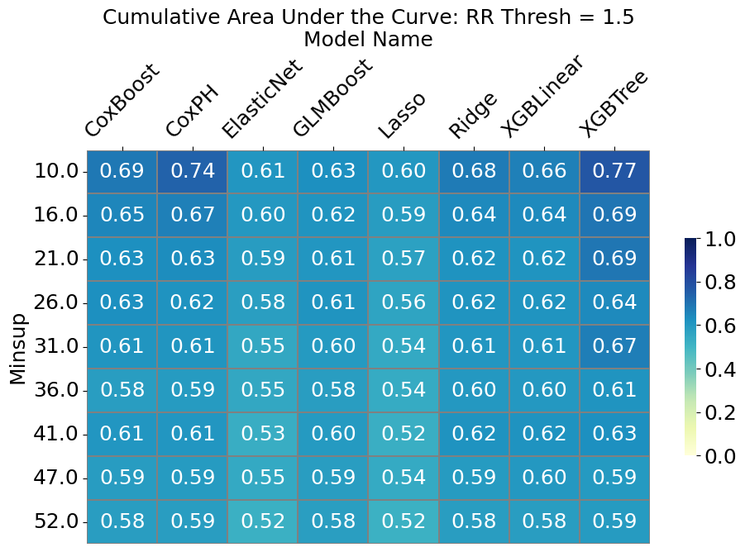
Figure S3 - Performance of the machine learning algorithms, measured by Uno’s iAUC, applied to the patterns discovered in the MAS dataset by C-TPM, for different values of minsup, using a relative risk threshold of 1.5
Minsup | CoxBoost | CoxPH | ElasticNet | GLMBoost | Lasso | Ridge | XGBLinear | XGBTree
10 | 0.69 (±0.1) | 0.74 (±0.13) | 0.61 (±0.1) | 0.63 (±0.1) | 0.6 (±0.09) | 0.68 (±0.11) | 0.66 (±0.11) | 0.77 (±0.16)
16 | 0.65 (±0.1) | 0.67 (±0.1) | 0.60 (±0.1) | 0.62 (±0.09) | 0.59 (±0.1) | 0.64 (±0.09) | 0.64 (±0.1) | 0.69 (±0.12)
21 | 0.63 (±0.11) | 0.63 (±0.11) | 0.59 (±0.1) | 0.61 (±0.1) | 0.57 (±0.1) | 0.62 (±0.1) | 0.62 (±0.00) | 0.69 (±0.00)
26 | 0.63 (±0.11) | 0.62 (±0.1) | 0.58 (±0.11) | 0.61 (±0.1) | 0.56 (±0.09) | 0.62 (±0.1) | 0.62 (±0.00) | 0.64 (±0.00)
31 | 0.61 (±0.1) | 0.61 (±0.1) | 0.55 (±0.09) | 0.60 (±0.1) | 0.54 (±0.09) | 0.61 (±0.1) | 0.61 (±0.00) | 0.67 (±0.00)
36 | 0.58 (±0.1) | 0.59 (±0.1) | 0.55 (±0.1) | 0.58 (±0.1) | 0.54 (±0.1) | 0.60 (±0.1) | 0.60 (±0.00) | 0.61 (±0.00)
41 | 0.61 (±0.1) | 0.61 (±0.1) | 0.53 (±0.08) | 0.60 (±0.1) | 0.52 (±0.08) | 0.62 (±0.11) | 0.62 (±0.00) | 0.63 (±0.00)
47 | 0.59 (±0.11) | 0.59 (±0.11) | 0.55 (±0.1) | 0.59 (±0.27) | 0.54 (±0.1) | 0.59 (±0.11) | 0.60 (±0.00) | 0.59 (±0.00)
52 | 0.58 (±0.08) | 0.59 (±0.08) | 0.52 (±0.07) | 0.58 (±0.22) | 0.52 (±0.07) | 0.58 (±0.08) | 0.58 (±0.00) | 0.59 (±0.00)
Table S3 - Performance of the machine learning algorithms, measured by Uno’s iAUC, applied to the patterns discovered in the MAS dataset by C-TPM, for different values of minsup, using a relative risk threshold of 1.5, with standard errors.

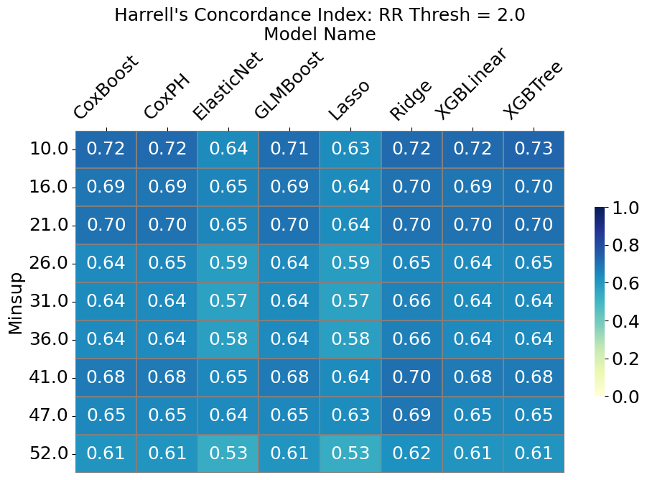
Figure S4 - Performance of the machine learning algorithms, measured by Harrell’s C- Index, applied to the patterns discovered in the MAS dataset by C-TPM, for different values of minsup, using a relative risk threshold of 2.0.
Minsup | CoxBoost | CoxPH | ElasticNet | GLMBoost | Lasso | Ridge | XGBLinear | XGBTree
10 | 0.72 (±0.06) | 0.72 (±0.05) | 0.64 (±0.11) | 0.71 (±0.05) | 0.63 (±0.11) | 0.72 (±0.05) | 0.72 (±0.05) | 0.73 (±0.06)
16 | 0.69 (±0.06) | 0.69 (±0.06) | 0.65 (±0.09) | 0.69 (±0.06) | 0.64 (±0.09) | 0.7 (±0.05) | 0.69 (±0.04) | 0.7 (±0.04)
21 | 0.7 (±0.04) | 0.7 (±0.03) | 0.65 (±0.09) | 0.7 (±0.04) | 0.64 (±0.09) | 0.7 (±0.04) | 0.70 (±0.00) | 0.70 (±0.00)
26 | 0.64 (±0.08) | 0.65 (±0.08) | 0.59 (±0.1) | 0.64 (±0.08) | 0.59 (±0.1) | 0.65 (±0.08) | 0.64 (±0.00) | 0.65 (±0.00)
31 | 0.64 (±0.09) | 0.64 (±0.09) | 0.57 (±0.1) | 0.64 (±0.09) | 0.57 (±0.1) | 0.66 (±0.08) | 0.64 (±0.00) | 0.64 (±0.00)
36 | 0.64 (±0.08) | 0.64 (±0.08) | 0.58 (±0.1) | 0.64 (±0.08) | 0.58 (±0.1) | 0.66 (±0.07) | 0.64 (±0.00) | 0.64 (±0.00)
41 | 0.68 (±0.07) | 0.68 (±0.07) | 0.65 (±0.11) | 0.68 (±0.00) | 0.64 (±0.1) | 0.7 (±0.06) | 0.68 (±0.00) | 0.68 (±0.00)
47 | 0.65 (±0.09) | 0.65 (±0.09) | 0.64 (±0.1) | 0.65 (±0.00) | 0.63 (±0.09) | 0.69 (±0.06) | 0.65 (±0.00) | 0.65 (±0.00)
52 | 0.61 (±0.07) | 0.61 (±0.07) | 0.53 (±0.07) | 0.61 (±0.00) | 0.53 (±0.07) | 0.62 (±0.07) | 0.61 (±0.00) | 0.61 (±0.00)
Table S4 - Performance of the machine learning algorithms, measured by Harrell’s C- Index, applied to the patterns discovered in the MAS dataset by C-TPM, for different values of minsup, using a relative risk threshold of 2.0, with standard errors.

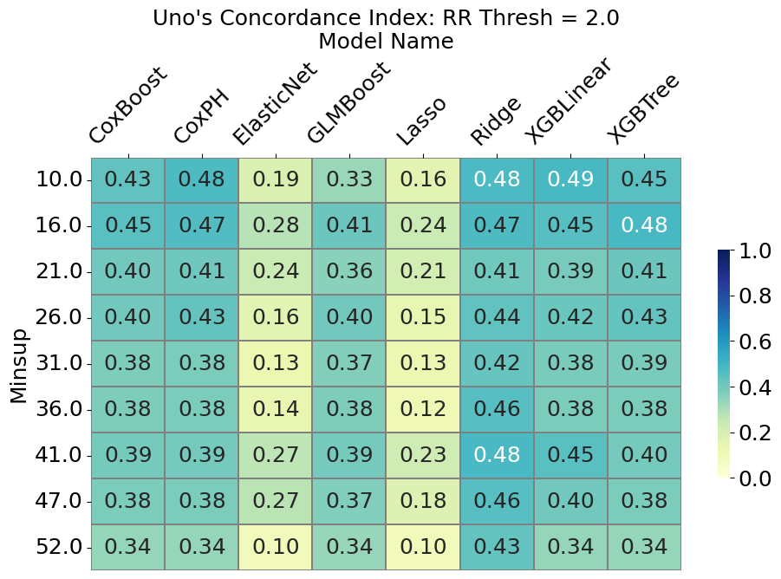
Figure S5 - Performance of the machine learning algorithms, measured by Uno’s C- Index, applied to the patterns discovered in the MAS dataset by C-TPM, for different values of minsup, using a relative risk threshold of 2.0
Minsup | CoxBoost | CoxPH | ElasticNet | GLMBoost | Lasso | Ridge | XGBLinear | XGBTree
10 | 0.43 (±0.25) | 0.48 (±0.25) | 0.19 (±0.21) | 0.33 (±0.23) | 0.16 (±0.2) | 0.48 (±0.24) | 0.49 (±0.24) | 0.45 (±0.26)
16 | 0.45 (±0.26) | 0.47 (±0.26) | 0.28 (±0.27) | 0.41 (±0.25) | 0.24 (±0.24) | 0.47 (±0.24) | 0.42 (±0.26) | 0.42 (±0.26)
21 | 0.40 (±0.22) | 0.41 (±0.22) | 0.24 (±0.23) | 0.36 (±0.19) | 0.21 (±0.22) | 0.41 (±0.21) | 0.39 (±0.00) | 0.41 (±0.00)
26 | 0.40 (±0.27) | 0.43 (±0.26) | 0.16 (±0.27) | 0.40 (±0.26) | 0.15 (±0.26) | 0.44 (±0.25) | 0.42 (±0.00) | 0.43 (±0.00)
31 | 0.38 (±0.24) | 0.38 (±0.25) | 0.13 (±0.21) | 0.37 (±0.24) | 0.13 (±0.21) | 0.42 (±0.23) | 0.38 (±0.00) | 0.39 (±0.00)
36 | 0.38 (±0.26) | 0.38 (±0.26) | 0.14 (±0.27) | 0.38 (±0.26) | 0.12 (±0.21) | 0.46 (±0.22) | 0.38 (±0.00) | 0.38 (±0.00)
41 | 0.39 (±0.24) | 0.39 (±0.24) | 0.27 (±0.3) | 0.39 (±0.00) | 0.23 (±0.25) | 0.48 (±0.26) | 0.45 (±0.00) | 0.40 (±0.00)
47 | 0.38 (±0.28) | 0.38 (±0.28) | 0.27 (±0.31) | 0.37 (±0.00) | 0.18 (±0.19) | 0.46 (±0.24) | 0.40 (±0.00) | 0.38 (±0.00)
52 | 0.34 (±0.24) | 0.34 (±0.24) | 0.10 (±0.23) | 0.34 (±0.00) | 0.10 (±0.23) | 0.43 (±0.24) | 0.34 (±0.00) | 0.34 (±0.00)
Table S5 - Performance of the machine learning algorithms, measured by Uno’s C- Index, applied to the patterns discovered in the MAS dataset by C-TPM, for different values of minsup, using a relative risk threshold of 2.0, with standard errors.

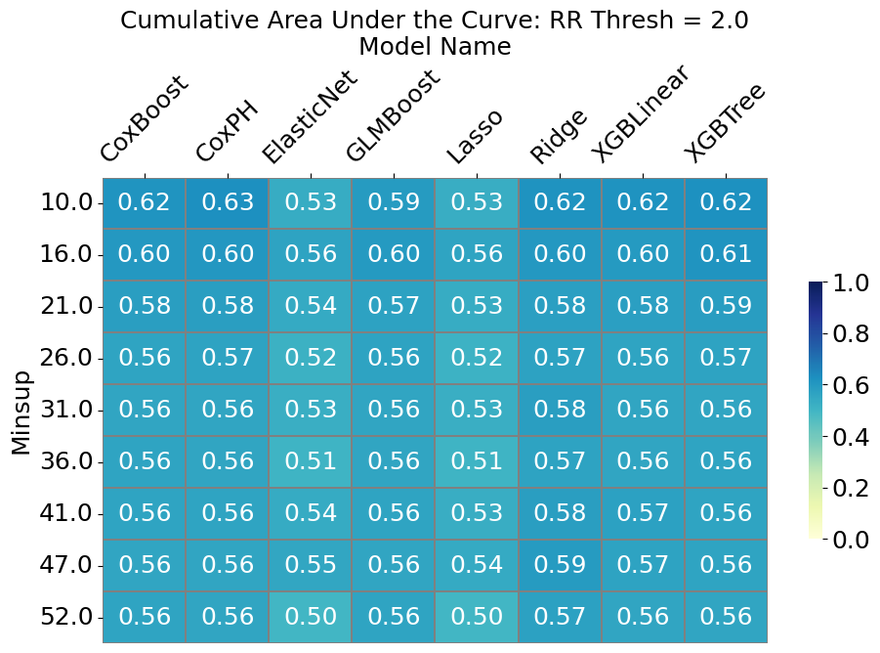
Figure S6 - Performance of the machine learning algorithms, measured by Uno’s iAUC, applied to the patterns discovered in the MAS dataset by C-TPM, for different values of minsup, using a relative risk threshold of 2.0
Minsup | CoxBoost | CoxPH | ElasticNet | GLMBoost | Lasso | Ridge | XGBLinear | XGBTree
10 | 0.62 (±0.12) | 0.63 (±0.12) | 0.53 (±0.09) | 0.59 (±0.11) | 0.53 (±0.09) | 0.62 (±0.11) | 0.62 (±0.11) | 0.62 (±0.12)
16 | 0.60 (±0.09) | 0.60 (±0.09) | 0.56 (±0.09) | 0.60 (±0.09) | 0.56 (±0.09) | 0.60 (±0.09) | 0.59 (±0.07) | 0.61 (±0.07)
21 | 0.58 (±0.1) | 0.58 (±0.1) | 0.54 (±0.1) | 0.57 (±0.09) | 0.53 (±0.09) | 0.58 (±0.1) | 0.58 (±0.00) | 0.59 (±0.00)
26 | 0.56 (±0.11) | 0.57 (±0.11) | 0.52 (±0.09) | 0.56 (±0.11) | 0.52 (±0.09) | 0.57 (±0.11) | 0.56 (±0.00) | 0.57 (±0.00)
31 | 0.56 (±0.11) | 0.56 (±0.11) | 0.53 (±0.07) | 0.56 (±0.11) | 0.53 (±0.07) | 0.58 (±0.09) | 0.56 (±0.00) | 0.56 (±0.00)
36 | 0.56 (±0.08) | 0.56 (±0.08) | 0.51 (±0.07) | 0.56 (±0.08) | 0.51 (±0.07) | 0.57 (±0.08) | 0.56 (±0.00) | 0.56 (±0.00)
41 | 0.56 (±0.08) | 0.56 (±0.08) | 0.54 (±0.09) | 0.56 (±0.00) | 0.53 (±0.09) | 0.58 (±0.1) | 0.57 (±0.00) | 0.56 (±0.00)
47 | 0.56 (±0.1) | 0.56 (±0.1) | 0.55 (±0.08) | 0.56 (±0.00) | 0.54 (±0.08) | 0.59 (±0.08) | 0.57 (±0.00) | 0.56 (±0.00)
52 | 0.56 (±0.07) | 0.56 (±0.08) | 0.5 (±0.03) | 0.56 (±0.00) | 0.50 (±0.03) | 0.57 (±0.08) | 0.56 (±0.00) | 0.56 (±0.00)
Table S6 - Performance of the machine learning algorithms, measured by Uno’s iAUC, applied to the patterns discovered in the MAS dataset by C-TPM, for different values of minsup, using a relative risk threshold of 2.0, with standard errors.

OATS Dataset

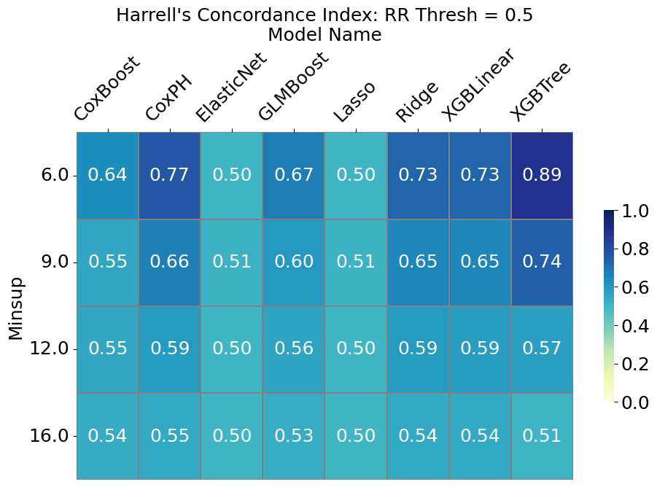
Figure S7 - Performance of the machine learning algorithms, measured by Harrell’s C- Index, Index, applied to the patterns discovered in the OATS dataset by C-TPM, for different values of minsup, using a relative risk threshold of 0.5.
Minsup | CoxBoost | CoxPH | ElasticNet | GLMBoost | Lasso | Ridge | XGBLinear | XGBTree
6 | 0.64 (± 0.14) | 0.77 (± 0.07) | 0.50 (± 0.00) | 0.67 (± 0.06) | 0.50 (± 0.00) | 0.73 (± 0.08) | 0.73 (± 0.08) | 0.89 (± 0.12)
9 | 0.55 (± 0.09) | 0.66 (± 0.08) | 0.51 (± 0.06) | 0.60 (± 0.08) | 0.51 (± 0.06) | 0.65 (± 0.08) | 0.65 (± 0.08) | 0.74 (± 0.12)
12 | 0.55 (± 0.06) | 0.59 (± 0.05) | 0.50 (± 0.01) | 0.56 (± 0.04) | 0.50 (± 0.01) | 0.59 (± 0.05) | 0.59 (± 0.05) | 0.57 (± 0.09)
16 | 0.54 (± 0.01) | 0.55 (± 0.02) | 0.50 (± 0.00) | 0.53 (± 0.00) | 0.50 (± 0.00) | 0.54 (± 0.02) | 0.54 (± 0.02) | 0.51 (± 0.01)
Table S7 –Performance of the machine learning algorithms, measured by Harrell’s C- Index, Index, applied to the patterns discovered in the OATS dataset by C-TPM, for different values of minsup, using a relative risk threshold of 0.5, with standard errors.

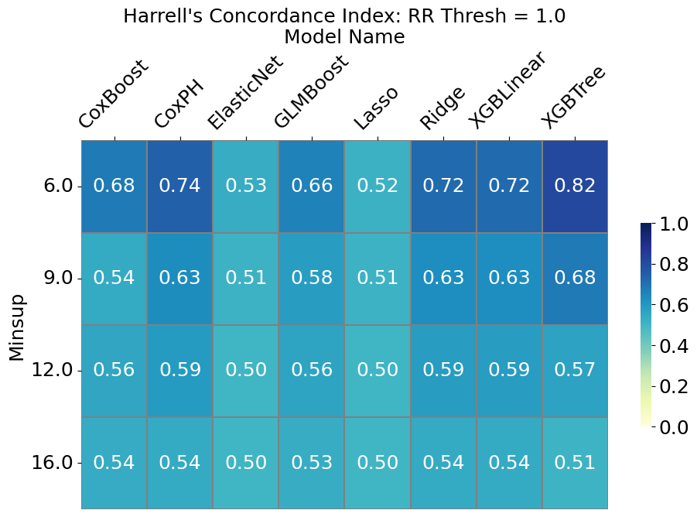
Figure S8 - Performance of the machine learning algorithms, measured by Harrell’s C- Index, Index, applied to the patterns discovered in the OATS dataset by C-TPM, for different values of minsup, using a relative risk threshold of 1.0.
Minsup | CoxBoost | CoxPH | ElasticNet | GLMBoost | Lasso | Ridge | XGBLinear | XGBTree
6 | 0.68 (± 0.11) | 0.74 (± 0.08) | 0.53 (± 0.09) | 0.66 (± 0.08) | 0.52 (± 0.07) | 0.72 (± 0.08) | 0.72 (± 0.08) | 0.82 (± 0.11)
9 | 0.54 (± 0.10) | 0.63 (± 0.08) | 0.51 (± 0.06) | 0.58 (± 0.08) | 0.51 (± 0.06) | 0.63 (± 0.08) | 0.63 (± 0.08) | 0.68 (± 0.12)
12 | 0.56 (± 0.06) | 0.59 (± 0.05) | 0.50 (± 0.01) | 0.56 (± 0.04) | 0.50 (± 0.01) | 0.59 (± 0.05) | 0.59 (± 0.05) | 0.57 (± 0.06)
16 | 0.54 (± 0.01) | 0.54 (± 0.02) | 0.50 (± 0.00) | 0.53 (± 0.01) | 0.50 (± 0.00) | 0.54 (± 0.02) | 0.54 (± 0.02) | 0.51 (± 0.02)
Table S8 –Performance of the machine learning algorithms, measured by Harrell’s C- Index, Index, applied to the patterns discovered in the OATS dataset by C-TPM, for different values of minsup, using a relative risk threshold of 1.0, with standard errors.

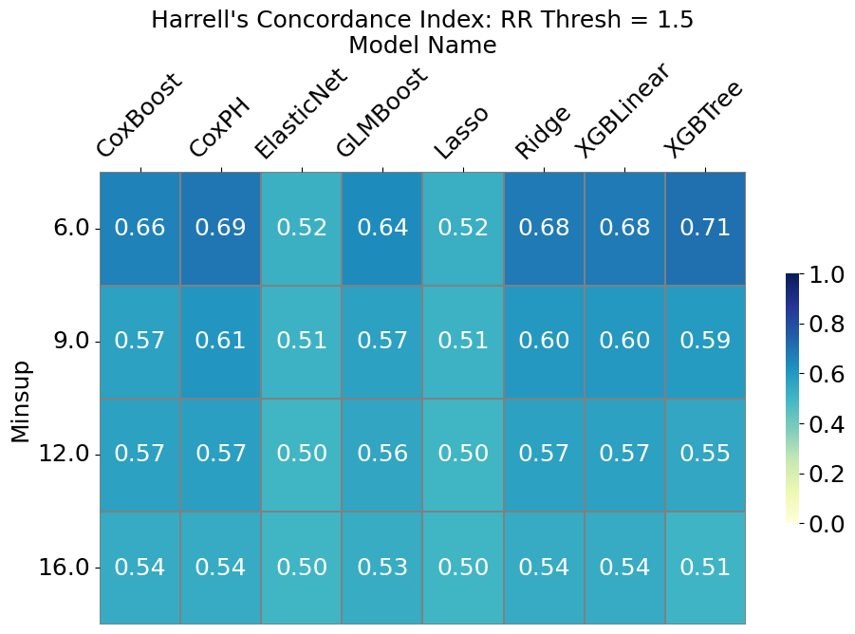
Figure S9 - Performance of the machine learning algorithms, measured by Harrell’s C- Index, Index, applied to the patterns discovered in the OATS dataset by C-TPM, for different values of minsup, using a relative risk threshold of 1.5.
Minsup | CoxBoost | CoxPH | ElasticNet | GLMBoost | Lasso | Ridge | XGBLinear | XGBTree
6 | 0.66 (± 0.08) | 0.69 (± 0.05) | 0.52 (± 0.07) | 0.64 (± 0.06) | 0.52 (± 0.07) | 0.68 (± 0.06) | 0.68 (± 0.06) | 0.71 (± 0.09)
9 | 0.57 (± 0.09) | 0.61 (± 0.08) | 0.51 (± 0.06) | 0.57 (± 0.07) | 0.51 (± 0.06) | 0.60 (± 0.08) | 0.60 (± 0.08) | 0.59 (± 0.10)
12 | 0.57 (± 0.04) | 0.57 (± 0.04) | 0.50 (± 0.01) | 0.56 (± 0.04) | 0.50 (± 0.01) | 0.57 (± 0.04) | 0.57 (± 0.04) | 0.55 (± 0.05)
16 | 0.54 (± 0.01) | 0.54 (± 0.01) | 0.50 (± 0.00) | 0.53 (± 0.01) | 0.50 (± 0.00) | 0.54 (± 0.01) | 0.54 (± 0.01) | 0.51 (± 0.01)
Table S9 –Performance of the machine learning algorithms, measured by Harrell’s C- Index, Index, applied to the patterns discovered in the OATS dataset by C-TPM, for different values of minsup, using a relative risk threshold of 1.5, with standard errors.
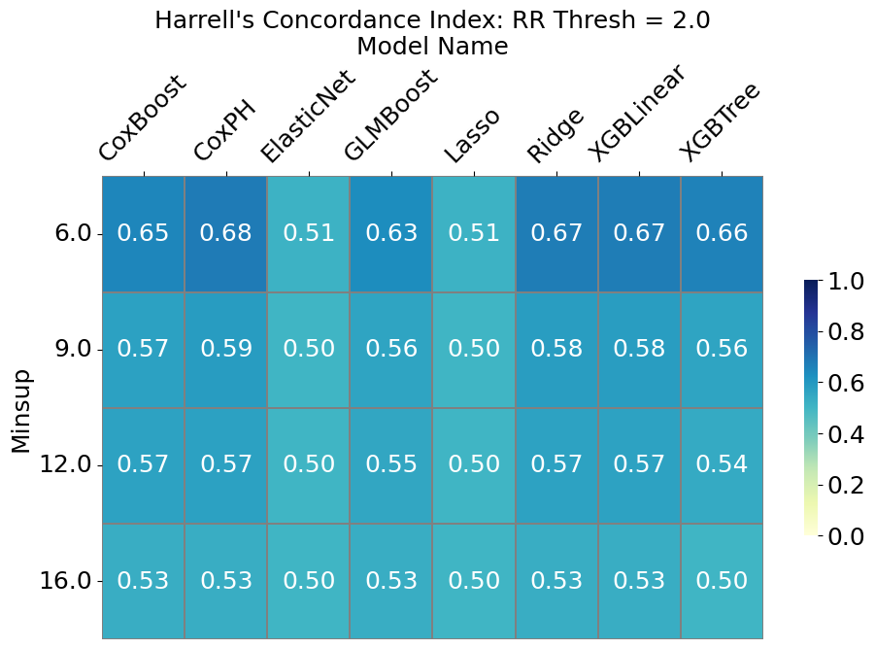
Figure S10 - Performance of the machine learning algorithms, measured by Harrell’s C- Index, Index, applied to the patterns discovered in the OATS dataset by C-TPM, for different values of minsup, using a relative risk threshold of 2.0.
Minsup | CoxBoost | CoxPH | ElasticNet | GLMBoost | Lasso | Ridge | XGBLinear | XGBTree
6 | 0.65 (± 0.10) | 0.68 (± 0.09) | 0.51 (± 0.05) | 0.63 (± 0.07) | 0.51 (± 0.04) | 0.67 (± 0.09) | 0.67 (± 0.09) | 0.66 (± 0.10)
9 | 0.57 (± 0.05) | 0.59 (± 0.04) | 0.50 (± 0.02) | 0.56 (± 0.03) | 0.50 (± 0.02) | 0.58 (± 0.04) | 0.58 (± 0.04) | 0.56 (± 0.05)
12 | 0.57 (± 0.04) | 0.57 (± 0.04) | 0.50 (± 0.01) | 0.55 (± 0.03) | 0.50 (± 0.01) | 0.57 (± 0.04) | 0.57 (± 0.04) | 0.54 (± 0.05)
16 | 0.53 (± 0.00) | 0.53 (± 0.00) | 0.50 (± 0.00) | 0.53 (± 0.00) | 0.50 (± 0.00) | 0.53 (± 0.00) | 0.53 (± 0.00) | 0.50 (± 0.00)
Table S10 –Performance of the machine learning algorithms, measured by Harrell’s C- Index, Index, applied to the patterns discovered in the OATS dataset by C-TPM, , for different values of minsup, using a relative risk threshold of 2.0.

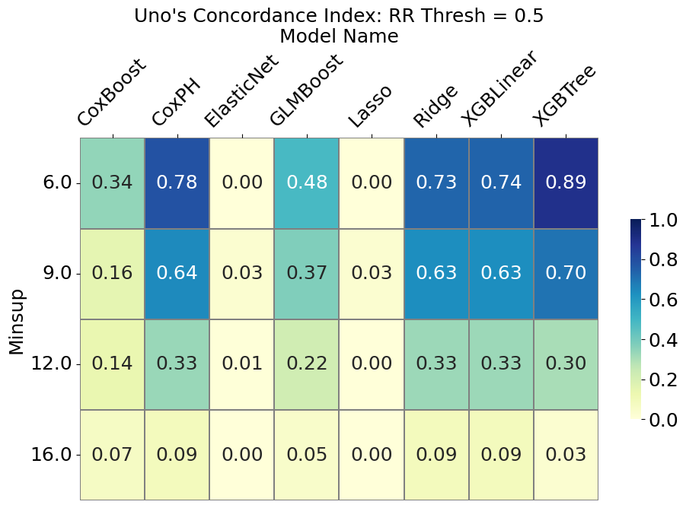
Figure S11 - Performance of the machine learning algorithms, measured by Uno’s C- Index, applied to the patterns discovered in the OATS dataset by C-TPM, for different values of minsup, using a relative risk threshold of 0.5
Minsup | CoxBoost | CoxPH | ElasticNet | GLMBoost | Lasso | Ridge | XGBLinear | XGBTree
6 | 0.34 (± 0.33) | 0.78 (± 0.08) | 0.00 (± 0.00) | 0.48 (± 0.14) | 0.00 (± 0.00) | 0.73 (± 0.07) | 0.74 (± 0.07) | 0.89 (± 0.12)
9 | 0.16 (± 0.26) | 0.64 (± 0.09) | 0.03 (± 0.14) | 0.37 (± 0.15) | 0.03 (± 0.14) | 0.63 (± 0.09) | 0.63 (± 0.09) | 0.70 (± 0.15)
12 | 0.14 (± 0.17) | 0.33 (± 0.17) | 0.01 (± 0.03) | 0.22 (± 0.14) | 0.00 (± 0.02) | 0.33 (± 0.16) | 0.33 (± 0.16) | 0.30 (± 0.21)
16 | 0.07 (± 0.05) | 0.09 (± 0.07) | 0.00 (± 0.00) | 0.05 (± 0.02) | 0.00 (± 0.00) | 0.09 (± 0.07) | 0.09 (± 0.07) | 0.03 (± 0.05)
Table S11 - Performance of the machine learning algorithms, measured by Uno’s C- Index, applied to the patterns discovered in the OATS dataset by C-TPM, for different values of minsup, using a relative risk threshold of 0.5, with standard errors.
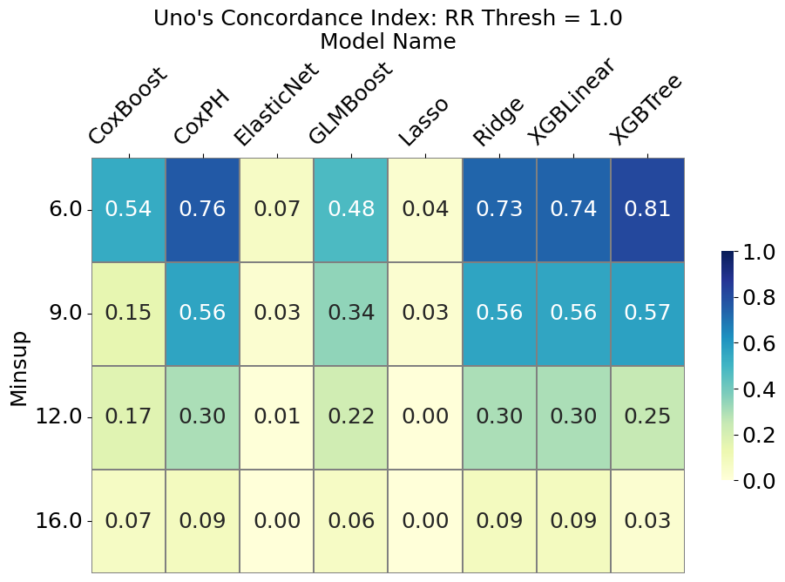
Figure S12 - Performance of the machine learning algorithms, measured by Uno’s C- Index, applied to the patterns discovered in the OATS dataset by C-TPM, for different values of minsup, using a relative risk threshold of 1.0
Minsup | CoxBoost | CoxPH | ElasticNet | GLMBoost | Lasso | Ridge | XGBLinear | XGBTree
6 | 0.54 (± 0.28) | 0.76 (± 0.08) | 0.07 (± 0.18) | 0.48 (± 0.14) | 0.04 (± 0.13) | 0.73 (± 0.09) | 0.74 (± 0.09) | 0.81 (± 0.12)
9 | 0.15 (± 0.24) | 0.56 (± 0.13) | 0.03 (± 0.14) | 0.34 (± 0.12) | 0.03 (± 0.14) | 0.56 (± 0.13) | 0.56 (± 0.13) | 0.57 (± 0.17)
12 | 0.17 (± 0.19) | 0.30 (± 0.19) | 0.01 (± 0.03) | 0.22 (± 0.14) | 0.00 (± 0.02) | 0.30 (± 0.18) | 0.30 (± 0.18) | 0.25 (± 0.20)
16 | 0.07 (± 0.05) | 0.09 (± 0.06) | 0.00 (± 0.00) | 0.06 (± 0.04) | 0.00 (± 0.00) | 0.09 (± 0.06) | 0.09 (± 0.06) | 0.03 (± 0.06)
Table S12 - Performance of the machine learning algorithms, measured by Uno’s C- Index, applied to the patterns discovered in the OATS dataset by C-TPM, for different values of minsup, using a relative risk threshold of 1.0, with standard errors.
rs. 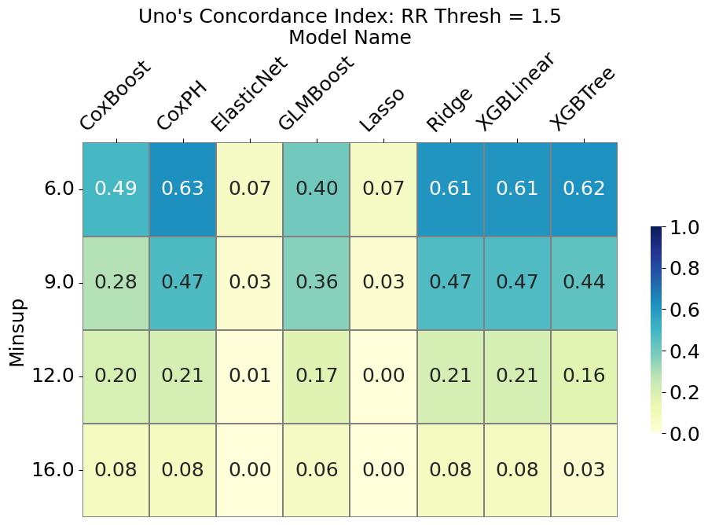
Figure S13 - Performance of the machine learning algorithms, measured by Uno’s C- Index, applied to the patterns discovered in the OATS dataset by C-TPM, for different values of minsup, using a relative risk threshold of 1.5
Minsup | CoxBoost | CoxPH | ElasticNet | GLMBoost | Lasso | Ridge | XGBLinear | XGBTree
6 | 0.49 (± 0.24) | 0.63 (± 0.18) | 0.07 (± 0.20) | 0.40 (± 0.17) | 0.07 (± 0.21) | 0.61 (± 0.17) | 0.61 (± 0.17) | 0.62 (± 0.20)
9 | 0.28 (± 0.26) | 0.47 (± 0.17) | 0.03 (± 0.14) | 0.36 (± 0.16) | 0.03 (± 0.14) | 0.47 (± 0.17) | 0.47 (± 0.17) | 0.44 (± 0.19)
12 | 0.20 (± 0.17) | 0.21 (± 0.17) | 0.01 (± 0.03) | 0.17 (± 0.15) | 0.00 (± 0.02) | 0.21 (± 0.17) | 0.21 (± 0.17) | 0.16 (± 0.19)
16 | 0.08 (± 0.07) | 0.08 (± 0.07) | 0.00 (± 0.00) | 0.06 (± 0.04) | 0.00 (± 0.00) | 0.08 (± 0.07) | 0.08 (± 0.07) | 0.03 (± 0.06)
Table S13 - Performance of the machine learning algorithms, measured by Uno’s C- Index, applied to the patterns discovered in the OATS dataset by C-TPM, for different values of minsup, using a relative risk threshold of 1.5, with standard errors.
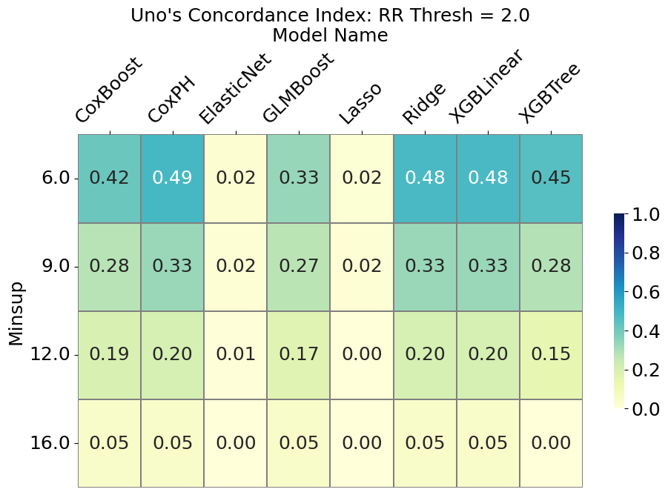
Figure S14 - Performance of the machine learning algorithms, measured by Uno’s C- Index, applied to the patterns discovered in the OATS dataset by C-TPM, for different values of minsup, using a relative risk threshold of 1.5
Minsup | CoxBoost | CoxPH | ElasticNet | GLMBoost | Lasso | Ridge | XGBLinear | XGBTree
6 | 0.42 (± 0.27) | 0.49 (± 0.22) | 0.02 (± 0.08) | 0.33 (± 0.17) | 0.02 (± 0.07) | 0.48 (± 0.21) | 0.48 (± 0.21) | 0.45 (± 0.23)
9 | 0.28 (± 0.21) | 0.33 (± 0.18) | 0.02 (± 0.08) | 0.27 (± 0.15) | 0.02 (± 0.08) | 0.33 (± 0.18) | 0.33 (± 0.18) | 0.28 (± 0.18)
12 | 0.19 (± 0.18) | 0.20 (± 0.17) | 0.01 (± 0.03) | 0.17 (± 0.15) | 0.00 (± 0.02) | 0.20 (± 0.17) | 0.20 (± 0.17) | 0.15 (± 0.18)
16 | 0.05 (± 0.02) | 0.05 (± 0.02) | 0.00 (± 0.00) | 0.05 (± 0.02) | 0.00 (± 0.00) | 0.05 (± 0.02) | 0.05 (± 0.02) | 0.00 (± 0.00)
Table S14 - Performance of the machine learning algorithms, measured by Uno’s C- Index, applied to the patterns discovered in the OATS dataset by C-TPM, for different values of minsup, using a relative risk threshold of 1.5, with standard errors.

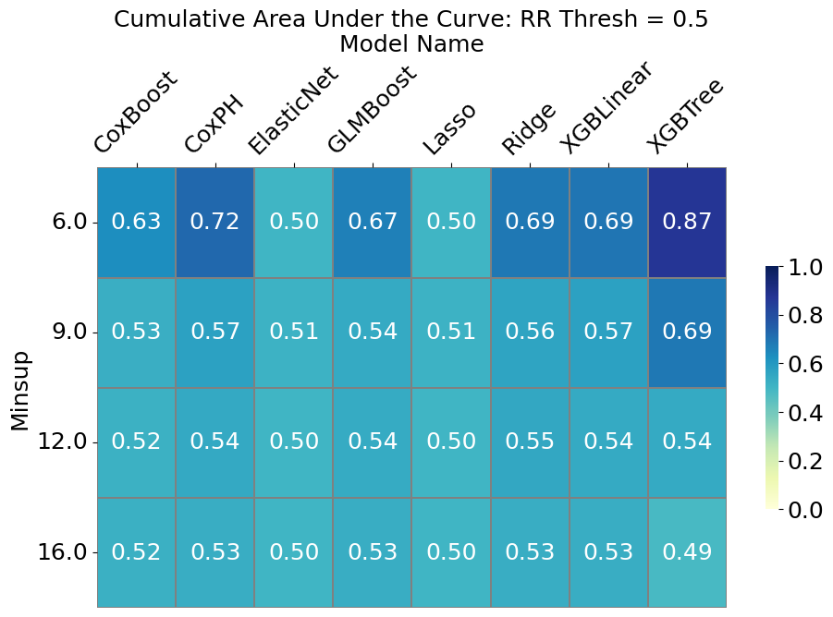
Figure S15 - Performance of the machine learning algorithms, measured by Uno’s iAUC, applied to the patterns discovered in the OATS dataset by C-TPM, for different values of minsup, using a relative risk threshold of 0.5
Minsup | CoxBoost | CoxPH | ElasticNet | GLMBoost | Lasso | Ridge | XGBLinear | XGBTree
6 | 0.63 (± 0.15) | 0.72 (± 0.12) | 0.50 (± 0.00) | 0.67 (± 0.12) | 0.50 (± 0.00) | 0.69 (± 0.13) | 0.69 (± 0.13) | 0.87 (± 0.15)
9 | 0.53 (± 0.10) | 0.57 (± 0.16) | 0.51 (± 0.07) | 0.54 (± 0.15) | 0.51 (± 0.07) | 0.56 (± 0.16) | 0.57 (± 0.16) | 0.69 (± 0.18)
12 | 0.52 (± 0.08) | 0.54 (± 0.11) | 0.50 (± 0.01) | 0.54 (± 0.10) | 0.50 (± 0.01) | 0.55 (± 0.11) | 0.54 (± 0.10) | 0.54 (± 0.11)
16 | 0.52 (± 0.05) | 0.53 (± 0.06) | 0.50 (± 0.00) | 0.53 (± 0.03) | 0.50 (± 0.00) | 0.53 (± 0.06) | 0.53 (± 0.06) | 0.49 (± 0.03)
Table S15 - Performance of the machine learning algorithms, measured by Uno’s iAUC, applied to the patterns discovered in the OATS dataset by C-TPM, for different values of minsup, using a relative risk threshold of 0.5, with standard errors.
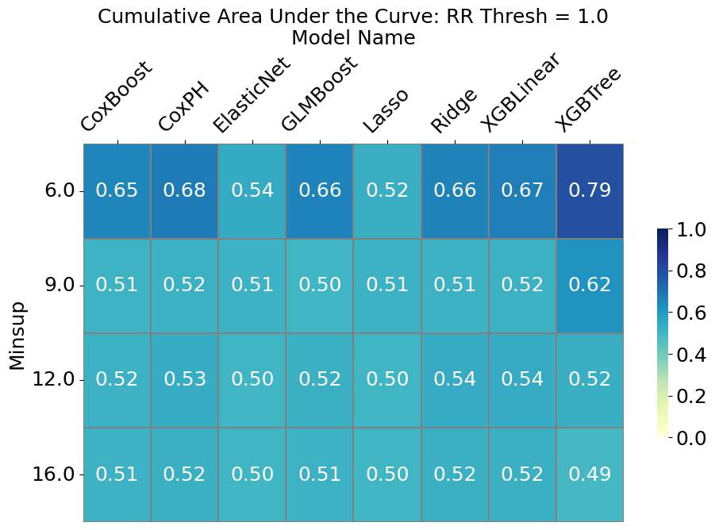
Figure S16 - Performance of the machine learning algorithms, measured by Uno’s iAUC, applied to the patterns discovered in the OATS dataset by C-TPM, for different values of minsup, using a relative risk threshold of 1.0
Minsup | CoxBoost | CoxPH | ElasticNet | GLMBoost | Lasso | Ridge | XGBLinear | XGBTree
6 | 0.65 (± 0.15) | 0.68 (± 0.13) | 0.54 (± 0.12) | 0.66 (± 0.14) | 0.52 (± 0.09) | 0.66 (± 0.15) | 0.67 (± 0.15) | 0.79 (± 0.15)
9 | 0.51 (± 0.13) | 0.52 (± 0.15) | 0.51 (± 0.07) | 0.50 (± 0.15) | 0.51 (± 0.07) | 0.51 (± 0.15) | 0.52 (± 0.14) | 0.62 (± 0.20)
12 | 0.52 (± 0.08) | 0.53 (± 0.10) | 0.50 (± 0.01) | 0.52 (± 0.10) | 0.50 (± 0.01) | 0.54 (± 0.11) | 0.54 (± 0.11) | 0.52 (± 0.10)
16 | 0.51 (± 0.01) | 0.52 (± 0.04) | 0.50 (± 0.00) | 0.51 (± 0.02) | 0.50 (± 0.00) | 0.52 (± 0.04) | 0.52 (± 0.04) | 0.49 (± 0.02)
Table S16 - Performance of the machine learning algorithms, measured by Uno’s iAUC, applied to the patterns discovered in the OATS dataset by C-TPM, for different values of minsup, using a relative risk threshold of 1.0, with standard errors.
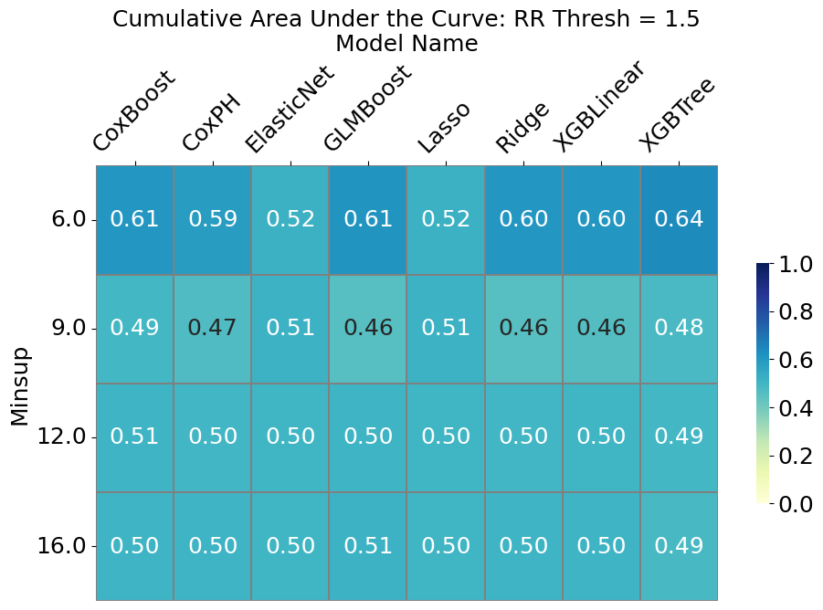
Figure S17 - Performance of the machine learning algorithms, measured by Uno’s iAUC, applied to the patterns discovered in the OATS dataset by C-TPM, for different values of minsup, using a relative risk threshold of 1.5
Minsup | CoxBoost | CoxPH | ElasticNet | GLMBoost | Lasso | Ridge | XGBLinear | XGBTree
6 | 0.61 (± 0.10) | 0.59 (± 0.09) | 0.52 (± 0.06) | 0.61 (± 0.10) | 0.52 (± 0.06) | 0.60 (± 0.09) | 0.60 (± 0.09) | 0.64 (± 0.13)
9 | 0.49 (± 0.11) | 0.47 (± 0.13) | 0.51 (± 0.07) | 0.46 (± 0.13) | 0.51 (± 0.07) | 0.46 (± 0.13) | 0.46 (± 0.13) | 0.48 (± 0.14)
12 | 0.51 (± 0.08) | 0.50 (± 0.09) | 0.50 (± 0.01) | 0.50 (± 0.08) | 0.50 (± 0.01) | 0.50 (± 0.09) | 0.50 (± 0.08) | 0.49 (± 0.08)
16 | 0.50 (± 0.03) | 0.50 (± 0.03) | 0.50 (± 0.00) | 0.51 (± 0.02) | 0.50 (± 0.00) | 0.50 (± 0.03) | 0.50 (± 0.03) | 0.49 (± 0.03)
Table S17 - Performance of the machine learning algorithms, measured by Uno’s iAUC, applied to the patterns discovered in the OATS dataset by C-TPM, for different values of minsup, using a relative risk threshold of 1.5, with standard errors.
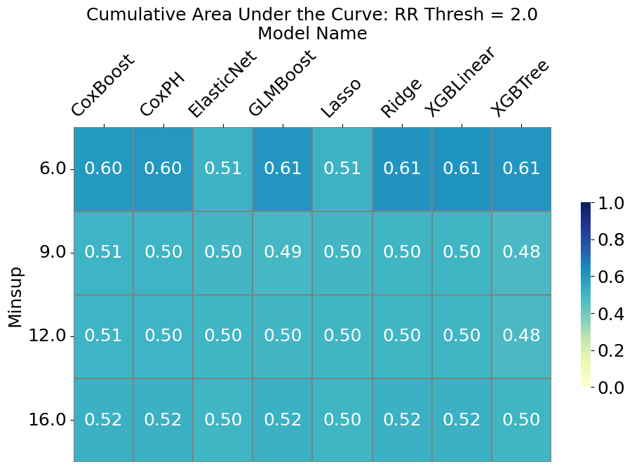
Figure S18 - Performance of the machine learning algorithms, measured by Uno’s iAUC, applied to the patterns discovered in the OATS dataset by C-TPM, for different values of minsup, using a relative risk threshold of 2.0
Minsup | CoxBoost | CoxPH | ElasticNet | GLMBoost | Lasso | Ridge | XGBLinear | XGBTree
6 | 0.60 (± 0.14) | 0.60 (± 0.13) | 0.51 (± 0.05) | 0.61 (± 0.14) | 0.51 (± 0.05) | 0.61 (± 0.14) | 0.61 (± 0.14) | 0.61 (± 0.15)
9 | 0.51 (± 0.06) | 0.50 (± 0.07) | 0.50 (± 0.01) | 0.49 (± 0.08) | 0.50 (± 0.01) | 0.50 (± 0.07) | 0.50 (± 0.07) | 0.48 (± 0.08)
12 | 0.51 (± 0.08) | 0.50 (± 0.08) | 0.50 (± 0.01) | 0.50 (± 0.09) | 0.50 (± 0.01) | 0.50 (± 0.08) | 0.50 (± 0.08) | 0.48 (± 0.08)
16 | 0.52 (± 0.00) | 0.52 (± 0.00) | 0.50 (± 0.00) | 0.52 (± 0.00) | 0.50 (± 0.00) | 0.52 (± 0.00) | 0.52 (± 0.00) | 0.50 (± 0.00)
Table S18 - Performance of the machine learning algorithms, measured by Uno’s iAUC, applied to the patterns discovered in the OATS dataset by C-TPM, for different values of minsup, using a relative risk threshold of 2.0, with standard errors.

