Supporting Information:
getphylo: rapid and automatic generation of multi-locus phylogenetic trees
T. J. Booth^{1*}, S. Shaw¹ P. Cruz-Morales¹ and T. Weber¹
¹The Novo Nordisk Foundation Center for Biosustainability, Danmarks Tekniske Universitet, Kongens Lyngby, Denmark
*email: thoboo@biosustain.dtu.dk

Contents
Performance Benchmarking 3
Data Curation 3
Figure S1: Interdependency of benchmarking datasets 3
Run Parameters 4
Job Time 6
Figure S2: Comparison of run times between getphylo, autoMLST and GTDB-tk 6
Branch Support and Tree Topology 7
Figure S3: Comparison of branch support values 7
Figure S4: Proportion of supported branches in output trees 8
Figure S5: Comparison of the consensus of individual gene trees between getphylo and autoMLST 9
Figure S6: NSUMRF values for output trees 10
Figure S7: Number of informative sites in combined alignments 10
Table S1: Comparison of tree topologies from 10 genome datasets 11
Table S2: Comparison of tree topologies from 100 genome datasets 11
Case Studies 12
Case Study 1: Bacterial Genomic DNA 12
Figure S8: Bacterial phylogeny 12
Table S3: Genomes used for bacterial phylogeny 13
Table S4: Loci from E. coli used for bacterial phylogeny 13
Case Study 2: Resorculin Biosynthetic Gene Cluster 14
Figure S9: Graphical summary of getphylo’s analysis of the rsn BGC 15
Figure S10: Phylogeny of the rsn BGC (RsnE and RsnF) 16
Case Study 3: Primate Genomic DNA 17
Figure S11: Primate phylogeny 17
Table S5: Species used for primate phylogeny 17
Table S6: Loci from Carlito syrichta selected for primate phylogeny. 18
Case Study 4: Eurotiomycete Fungal Genomic DNA 21
Figure S12: Phylogeny of Eurotiomycete Fungi 22
Table S7: Marker loci selected from Arthrocladium fulminans CBS 136243 23
Explanatory Figures 26
Figure S13: Simplified flow charts comparing getphylo and clustering algorithms. 26
Figure S14: Cartoon of orthologue selection comparing getphylo and clustering algorithms 27
References 28

Performance Benchmarking
All benchmarking data and associated scripts are available at: https://github.com/drboothtj/getphylo_benchmarking.

Data Curation
For benchmarking, we decided to test getphylo using Streptomyces genomes. First, we identified all genomes in the NCBI database with an N50 > 1 Mb and consisting of fewer than 20 contigs. From these genomes, we randomly selected two sets of 100 genomes. A third set of 100 genomes was constructed using 50 genomes each from the original sets. A subset of 10 genomes were selected from each of the original three sets of 100, maintaining the relationship between them (Figure S1). These six datasets were used for all the following benchmarking experiments. The list of accession numbers for each dataset are available at:
https://github.com/drboothtj/getphylo_benchmarking/tree/main/benchmarking/accessions.

Figure S1: Interdependency of benchmarking datasets
A Venn diagram detailing the interdependency of the benchmarking data sets. Numbers indicate the number of Streptomyces genomes in each dataset.
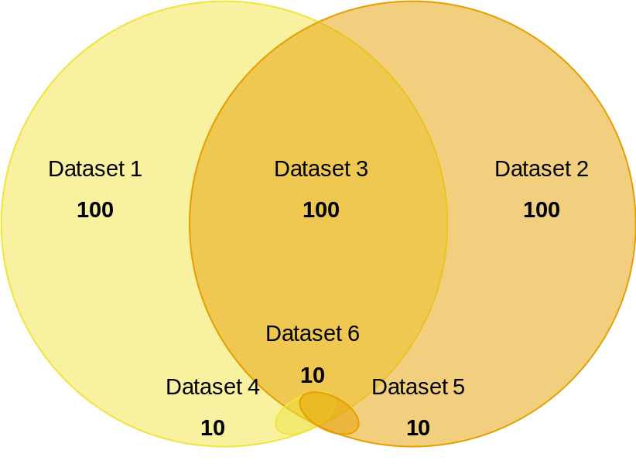

Run Parameters
For benchmarking, we compared getphylo to autoMLST¹ and GTDB-tk². Runs were designed to be as comparable as possible. However, both autoMLST and GTDB-tk were designed primarily for taxonomic classification purposes and require significant modification to produce output comparable to getphylo. With this in mind, these results are only intended as a rough comparison to demonstrate the utility of getphylo.
All runs were completed on a Standard D8sv3 virtual machine hosted on Microsoft Azure (8 vCPUs, 32GiB RAM).
The details of how each run was implemented follow.
getphylo
getphylo was run on each dataset using the following command:
getphylo -c 8 -l DEBUG
To assess the effect restricting the number of loci has on the analysis, getphylo was also run a second time each dataset limiting the number of loci to 10, as follows:
getphylo -c 8 -l DEBUG -maxl 10
autoMLST
autoMLST was run as implemented in the autoMLST simplified wrapper (https://github.com/KatSteinke/automlst-simplified-wrapper). The script for identifying genes loci (getmlstgenes.py) can be modified to vary the maximum number of loci. Two variants were made as follows:
1. To find all available loci:
-def findsingles(db,minnum=7,minorg=0.8,maxgenes=30,dnds="",outdir="",keepgenes="",lf=""):
+def findsingles(db,minnum=7,minorg=0.8,maxgenes=1000,dnds="",outdir="",keepgenes="",lf=""):
2. To find 10 maximum loci:
-def findsingles(db,minnum=7,minorg=0.8,maxgenes=30,dnds="",outdir="",keepgenes="",lf=""):
+def findsingles(db,minnum=7,minorg=0.8,maxgenes=1000,dnds="",outdir="",keepgenes="",lf=""):

As with getphylo, the analysis was run twice: once using all available loci and once restricting the number of loci to 10.

GTDB-tk
Although GTDB-tk offers a ‘de novo’ workflow, it includes several additional steps for rooting and decorating the output trees. Therefore, we implemented a custom wrapper script sequentially running the identify, align and infer modules (it can be found at: https://github.com/drboothtj/getphylo_benchmarking/blob/main/scripts/gtdbtk_unrooted.py). These modules produce an unrooted tree comparable to those produced by getphylo and autoMLST. The number of loci could not be varied GTDB-tk, so each dataset was run once totalling six runs.

Job Time
Job times for getphylo were consistently faster than the other software across all runs. This difference was more significant as the amount of data increased. Job time was noticeably faster the more data was analysed. For 10 genomes, getphylo averaged 19 seconds for a 10 locus tree and 281 seconds (4 minutes 41 seconds) for a 512 – 614 locus tree (Figure S2). For 100 genomes getphylo averaged 164 seconds (2 minutes 44 seconds) for a 10-locus tree and 712 seconds (11 minutes 52 seconds) for a 84 - 100 locus tree.

Figure S2: Comparison of run times between getphylo, autoMLST and GTDB-tk
Run times dependent upon varying job parameters. For runs where all available loci were used, the number of loci and standard deviation are shown.
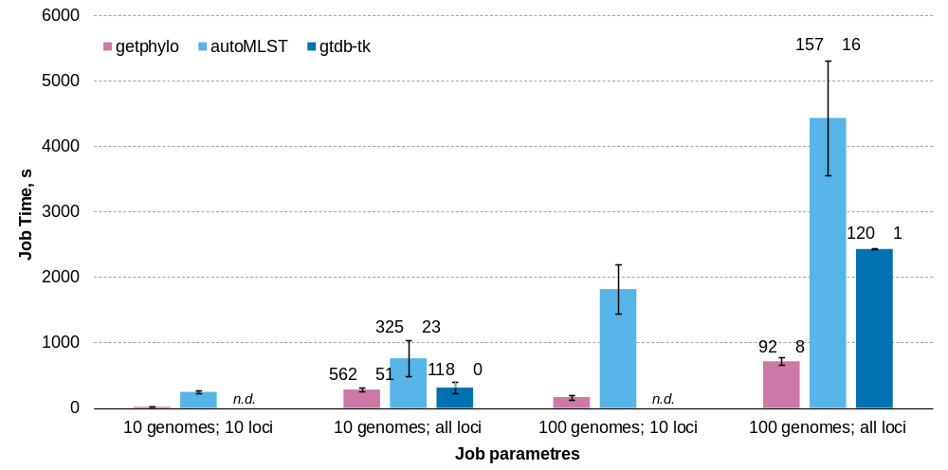

Branch Support and Tree Topology
Overall, trees produced by getphylo have higher average branch support (Figure S3) and a higher proportion of fully supported branches (Figure S4) than the other tools. This is likely because getphylo samples significantly more informative sites than the other software (Figure S5). This trend can be observed directly in the difference in support between the runs with 10 loci compared to runs where all loci were used. These metrics were calculated with the custom scripts (https://github.com/drboothtj/getphylo_benchmarking/tree/main/scripts).
There is no objective measure for comparing tree topologies^{3,4}. However, subjective metrics do exist. The most popular is the Robinson-Foulds (RF) metric³. We used the tree comparison tool as implemented in ETE3⁵ to compare output trees. Importantly, the RF variation was comparable between all software (Tables S1 and S2) and the normalised sum of the RF values for getphylo were generally the lower when all loci were used (Figure S6). This means that under default conditions, getphylo produced the trees that were the least dissimilar to other trees in the dataset.
All output trees are available at:
https://github.com/drboothtj/getphylo_benchmarking/tree/main/benchmarking/trees.

Figure S3: Comparison of branch support values
Average branch support across all branches in output trees for between getphylo, autoMLST and GTDB-tk.
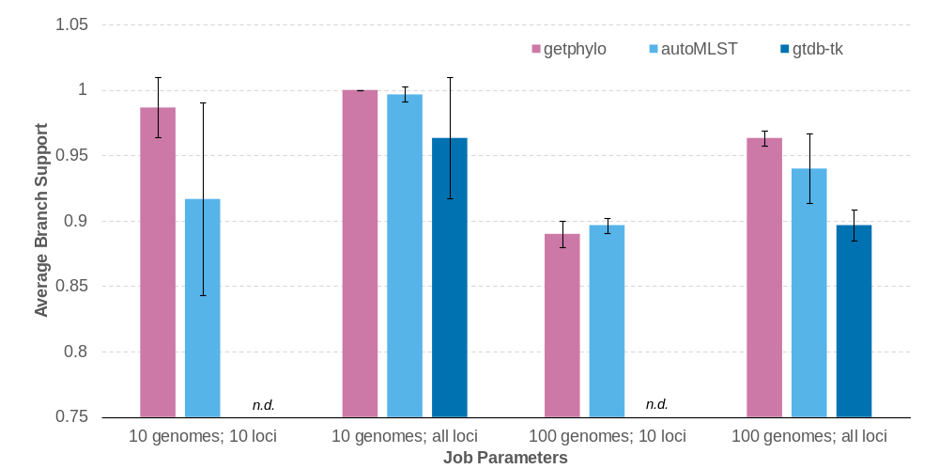

Figure S4: Proportion of supported branches in output trees
Percentage of branches that have the maximum support value for between getphylo, autoMLST and GTDB-tk.
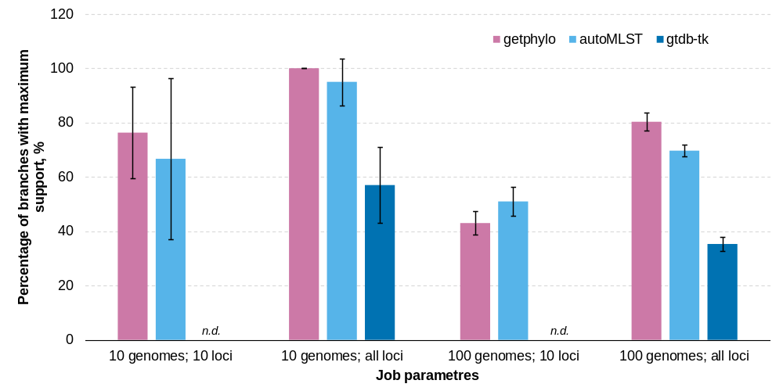

Figure S5: Comparison of the consensus of individual gene trees between getphylo and autoMLST
Comparison of the consensus trees formed from individual gene trees as curated produced by getphylo and autoMLST when analysing the three 100-genome datasets. Each graph shows the number of branches in a given tree (maximum 99) with at least 25, 50, 75 or 100 percent consensus. The data is shown when using all available loci (see above) or when limiting to 40, 20 and 10 loci to demonstrate that this effect is not sample size dependent. Individual trees available at: https://github.com/drboothtj/getphylo_benchmarking/tree/main/consensus_analysis.
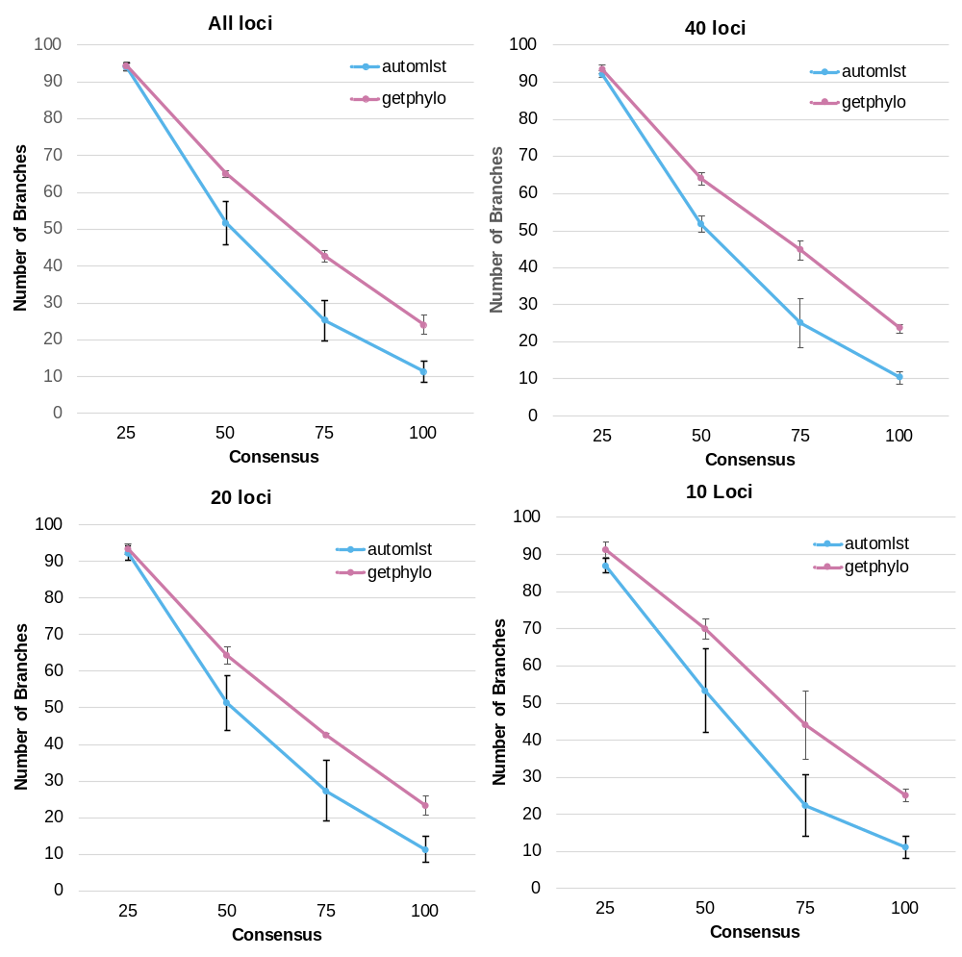

Figure S6: NSUMRF values for output trees
The sum of the Robinson-Foulds values between each set of trees (Table S1 and S2), normalised by dividing by the number of comparisons. Lower values indicate that trees are more similar to other trees in the dataset.
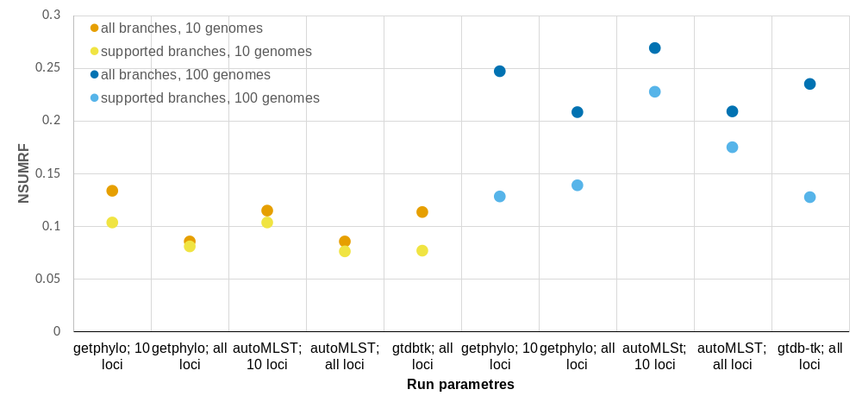

Figure S7: Number of informative sites in combined alignments
The number of informative sites in each combined alignment from between getphylo, autoMLST and GTDB-tk. Informative sites are calculated as all sites in an alignment containing at least two different characters (excluding missing or ambiguous data and gaps) excluding sites where only a single strain has a unique character.

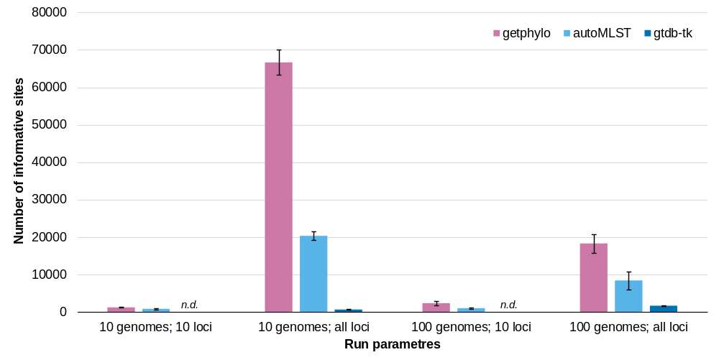

Table S1: Comparison of tree topologies from 10 genome datasets
Normalised Robinson–Foulds (RF) distance between different output trees for 10 genome datasets. The first value shows the RF distance between trees with unsupported branches removed. Values for the whole tree regardless of support are shown in brackets.
 | gtdb-tk | getphylo; 10 loci | getphylo; all loci | autoMLST; 10 loci | autoMLST; all loci
gtdb-tk | 0 | 0.13 (0.24) | 0.03 (0.05) | 0.15 (0.19) | 0.06 (0.09)
getphylo; 10 loci |  | 0 | 0.18 (0.19) | 0.08 (0.10) | 0.13 (0.14)
getphylo; all loci |  |  | 0 | 0.14 (0.14) | 0.05 (0.05)
autoMLST; 10 loci |  |  |  | 0 | 0.14 (0.14)
autoMLST; all loci |  |  |  |  | 0

Table S2: Comparison of tree topologies from 100 genome datasets
Normalised Robinson–Foulds (RF) distance between different output trees for 100 genome datasets. The first value shows the RF distance between trees with unsupported branches removed. Values for the whole tree regardless of support are shown in brackets.
 | gtdb-tk | getphylo; 10 loci | getphylo; all loci | autoMLST; 10 loci | autoMLST; all loci
gtdb-tk | 0 | 0.05 (0.32) | 0.14 (0.28) | 0.27 (0.34) | 0.17 (0.23)
getphylo; 10 loci |  | 0 | 0.08 (0.22) | 0.28 (0.38) | 0.22 (0.30)
getphylo; all loci |  |  | 0 | 0.29 (0.32) | 0.18 (0.22)
autoMLST; 10 loci |  |  |  | 0 | 0.30 (0.30)
autoMLST; all loci |  |  |  |  | 0

Case Studies

Case Study 1: Bacterial Genomic DNA
18 bacterial genomes were selected to build the phylogeny (Supplementary Table 1). getphylo was run with the following command:
getphylo -g ‘*.gb’ -l INFO -cp 8
12 loci were identified (Supplementary Table 2) representing 3,685 informative sites. The run took 30 seconds. The resulting phylogeny had an average branch support of 1.0 with 10/15 branches fully supported. The resulting topology matched existing bacterial phylogenies⁶.
All genbank files, the combined alignment, partition data and the resulting tree can be found at:
https://github.com/drboothtj/getphylo_benchmarking/tree/main/case_studies/case_study_1

Figure S8: Bacterial phylogeny
Phylogeny of bacteria generated by getphylo. The tree was visualised using iTOL⁷ and taxonomic groups are labelled.
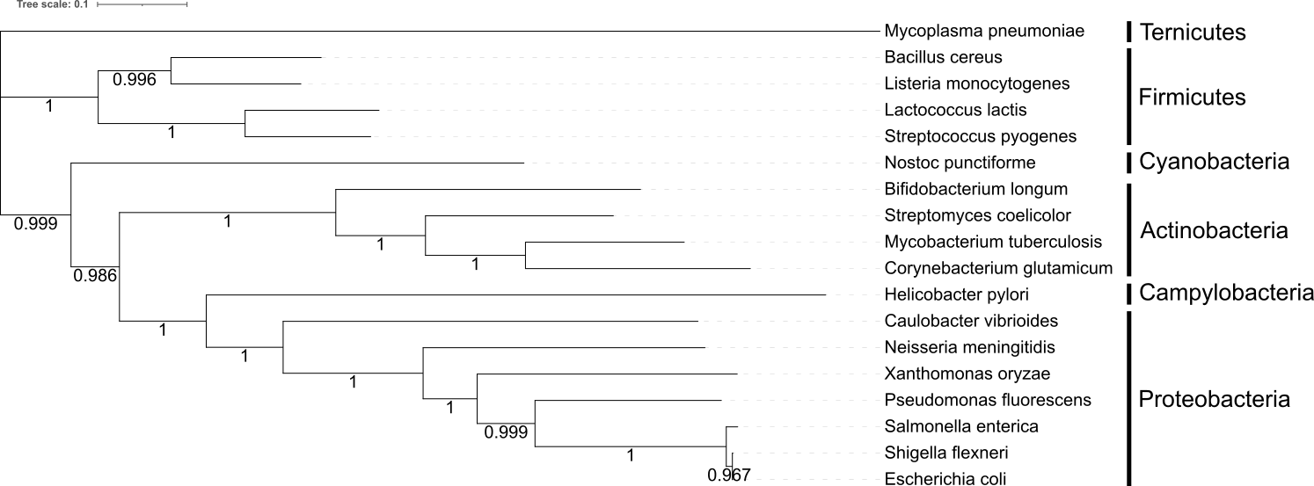

Table S3: Genomes used for bacterial phylogeny
A list of species used for the bacterial phylogeny. Species names and accession numbers are provided.
Species | Accession
Bacillus cereus | AP007209.1
Bifidobacterium longum | NZ_CP010453.1
Caulobacter vibrioides | NZ_CP034122.1
Corynebacterium glutamicum | NZ_CP025533.1
Escherichia coli | NZ_CP082327.1
Helicobacter pylori | FM991728.1
Lactococcus lactis | AP018499.1
Listeria monocytogenes | NZ_CP021325.1
Mycobacterium tuberculosis | AP018036.1
Mycoplasma pneumoniae | NZ_CP014267.1
Neisseria meningitidis | AL157959.1
Nostoc punctiforme | CP001037.1
Pseudomonas fluorescens | OV986001.1
Salmonella enterica | CP003278.1
Shigella flexneri | AE014073.1
Streptococcus pyogenes | AE009949.1
Streptomyces coelicolor | AL645882.2
Xanthomonas oryzae | NZ_CP092971.1

Table S4: Loci from E. coli used for bacterial phylogeny
A list of loci identified by getphylo to infer the bacterial phylogeny.
Locus | Length | Description
RS01985 | 209 | 50S ribosomal protein uL3
RS02000 | 273 | ribosomal protein L2
RS02015 | 233 | ribosomal protein S3
RS03825 | 384 | S-adenosylmethionine synthetase
RS03890 | 387 | phosphoglycerate kinase
RS05265 | 255 | RNA (guanine-N(1)-)-methyltransferase
RS09750 | 327 | Phenylalanyl-tRNA synthetase alpha subunit
RS18435 | 283 | Translation elongation factor EF-Ts
RS18440 | 241 | 30S ribosomal protein S2
RS18875 | 313 | 16S rRNA C1402 N4-methylase RsmH
RS21210 | 1342 | DNA-directed RNA polymerase subunit beta
RS21225 | 234 | ribosomal protein L1, bacterial/chloroplast

Case Study 2: Resorculin Biosynthetic Gene Cluster
To test the ability of getphylo to produce phylogeny of small genetic elements, we build a phylogeny of the resorculin biosynthetic gene cluster. The resorculin BGC is a hybrid NRPS PKS and shares homology with both polyketides and glycopeptides⁸. A subset of 218 BGCs (Supplementary Table 4) from the MiBiG database⁹ sharing at least three hosmologous genes with the rsn BGC was identified with cblaster¹⁰ and analysed with getphylo using the following command:
getphylo -s rsn.gbk -p 10 -l INFO -cp 8
getphylo automatically removes taxa containing all missing data. Therefore, a final tree was constructed from only 22 BGCs. RsnE and RsnF were identified as suitable loci for phylogenetic analysis These proteins constitute the polyketide synthase system involved in the biosynthesis of 3,5‐dihydroxyphenylacetyl‐CoA. The resulting tree (Supplementary Figure 3) matched previously hypothesised relationships⁸. The run took 10 seconds. The resulting tree had an average support of 0.86 with 7/19 branches having maximum support.
The rsn BGC sequence, a list of MiBiG accession numbers, the combined alignment, partition data and the resulting tree can be found at:
https://github.com/drboothtj/getphylo_benchmarking/blob/main/case_studies/case_study_2/combined_alignment.tree

Figure S9: Graphical summary of getphylo’s analysis of the rsn BGC
Example comparison of the resorculin biosynthetic gene cluster (BGC)⁸ with the BGCs for teicoplanin¹¹ and venemycin¹² (a). The example shows how getphylo identifies genes that are present as singletons across all gene clusters (green) and excludes genes that are duplicated or not present in enough BGCs. In this case, the conserved genes encode RsnE and RsnF that synthesis the production of 3,5‐dihydroxyphenylacetyl‐CoA. (b). The conservation of this biosynthetic unit in the final products is also shown (c).
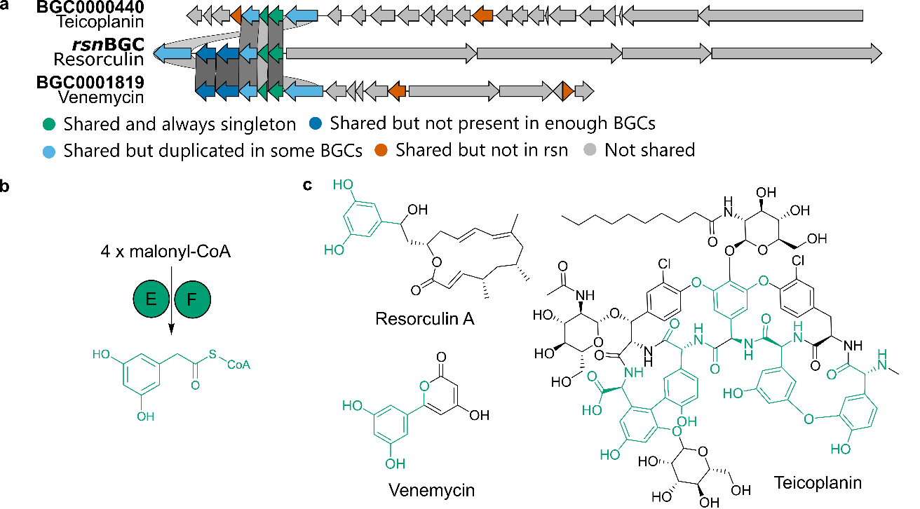

Figure S10: Phylogeny of the rsn BGC (RsnE and RsnF)
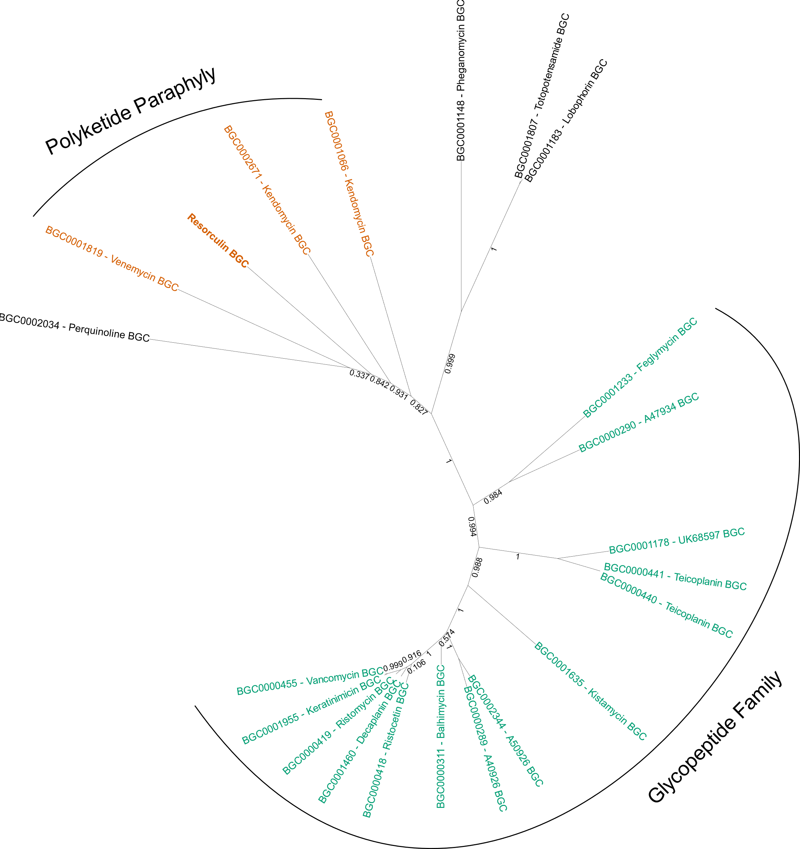

Case Study 3: Primate Genomic DNA
getphylo was used to build a phylogeny from ten primate genomes. The species used and accession numbers are shown in Supplementary Table 5. The analysis was run using the command:
getphylo -ia -l DEBUG -t protein_id -c 8 -s Microcebus_murinus.gbk
82 suitable loci were identified (Supplementary Table 6), and the full analysis took 28 minutes and 53 seconds. The tree was visualised in iTOL⁷ and rooted on the lemurs as a known outgroup (Microbeus murinus and Otolemur garnettii). The tree (Supplementary Figure 4) showed full branch support at every position and was congruent with previously described primate taxonomies^{13,14}.
The list of accessions, the combined alignment, partition data and the resulting tree can be found at:
https://github.com/drboothtj/getphylo_benchmarking/tree/main/case_studies/case_study_3.

Figure S11: Primate phylogeny
Phylogeny of primates generated by getphylo. The tree was visualised using iTOL⁷ and taxonomic groups are labelled.
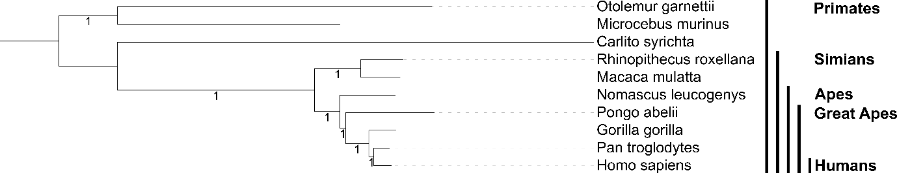

Table S5: Species used for primate phylogeny
Species names and accessions for the ten species used to build the primate phylogeny.
Species | Assembly
Carlito syrichta | GCF_000164805.1
Homo sapiens | GCF_000001405.40
Macaca mulatta | GCF_003339765.1
Otolemur garnettii | GCF_000181295.1
Pongo abelii | GCA_002880775.3
Gorilla gorilla | GCF_008122165.1
Nomascus leucogenys | GCF_006542625.1
Pan troglodytes | GCF_002880755.1
Rhinopithecus roxellana | GCF_007565055.1
Microcebus murinus | GCF_000165445.2

Table S6: Loci from Carlito syrichta selected for primate phylogeny.
Protein coding sequences selected by getphylo to build the primate phylogeny. Each protein coding sequence was present in all primate genomes and existed as a singleton in all genomes. The length of each sequence and the description of the protein (supplied by eggNOG-mapper¹⁵) is shown.
Protein ID | Length (aa) | Description
XP_008046802.1 | 530 | dolichol kinase
XP_008047812.1 | 529 | Exocyst complex component 8
XP_008048263.1 | 860 | Coiled-coil domain containing 87
XP_008048804.1 | 225 | Hermansky-Pudlak syndrome 6 protein
XP_008048916.2 | 474 | outer dense fiber of sperm tails 1
XP_008050096.1 | 223 | Clarin 2
XP_008050758.1 | 349 | Starch-binding domain-containing protein 1
XP_008051426.1 | 328 | Coiled-coil domain containing 54
XP_008051450.1 | 250 | recombinational repair
XP_008051524.1 | 221 | RING finger protein 186
XP_008052536.2 | 241 | Transcriptional regulator
XP_008052537.1 | 381 | Actin-binding Rho activating protein
XP_008052800.2 | 375 | Domain of unknown function (DUF4678)
XP_008052954.1 | 225 | Slow voltage-gated potassium channel
XP_008053048.1 | 232 | Fibroblast growth factor binding protein 1
XP_008053391.1 | 360 | Fanconi anemia, complementation group F
XP_008053434.2 | 296 | Tumour necrosis factor family.
XP_008054351.1 | 215 | FORKHEAD
XP_008054714.1 | 525 | Solute carrier family 32 (GABA vesicular transporter), member 1
XP_008054732.1 | 421 | Immunoglobulin like
XP_008054736.1 | 395 | NHL repeat containing E3 ubiquitin protein ligase 1
XP_008054829.1 | 211 | Nudix (nucleoside diphosphate linked moiety X)-type motif 19
XP_008055220.1 | 775 | GRIP and coiled-coil
XP_008055857.1 | 213 | Transmembrane protein 186
XP_008057321.1 | 476 | Coiled-coil domain containing 6
XP_008057336.1 | 1017 | Retinol binding protein 3, interstitial
XP_008057798.1 | 439 | Microfibrillar-associated protein 1
XP_008058617.1 | 299 | C-terminal duplication domain of Friend of PRMT1
XP_008058889.1 | 685 | SPT2, Suppressor of Ty, domain containing 1 (S. cerevisiae)
XP_008059339.1 | 596 | MFS_1 like family
XP_008060056.1 | 206 | Keratin associated protein 27-1
XP_008060057.1 | 253 | PMG protein
XP_008060458.1 | 275 | negative regulation of pre-miRNA processing
XP_008060737.1 | 213 | protein C10orf62 homolog
XP_008060897.1 | 415 | protein O-linked mannosylation
XP_008061195.1 | 212 | Fin bud initiation factor homologue
XP_008061396.1 | 384 | Calcium-binding protein, spermatid-specific 1
Protein ID | Length (aa) | Description
XP_008061402.1 | 472 | UTP3, small subunit (SSU) processome component, homolog (S. cerevisiae)
XP_008061608.1 | 227 | Serine hydrolase (FSH1)
XP_008061666.1 | 298 | Proline rich 32
XP_008062727.1 | 224 | TIMP metallopeptidase inhibitor 4
XP_008063395.1 | 856 | trichohyalin-like
XP_008064068.1 | 265 | Keratinocyte-associated transmembrane protein 2
XP_008064379.1 | 231 | Ribosomal silencing factor during starvation
XP_008064812.1 | 280 | Leucine rich repeat containing 10
XP_008065422.1 | 345 | Chromosome 8 open reading frame
XP_008065660.1 | 200 | Ciliary neurotrophic factor
XP_008066040.1 | 395 | Phosphorylated adaptor for RNA export
XP_008066474.1 | 991 | Smg8_Smg9
XP_008066512.1 | 386 | Kelch repeat and BTB
XP_008066932.1 | 628 | B3/4 domain
XP_008068423.1 | 270 | PCO_ADO
XP_008068789.1 | 316 | sialoprotein
XP_008069355.1 | 339 | SHS2 domain found in N terminus of Rpb7p/Rpc25p/MJ0397
XP_008069597.1 | 273 | Fatty acid hydroxylase superfamily
XP_008069884.2 | 495 | DC-STAMP-like protein
XP_008070203.1 | 232 | Inhibitor of bone morphogenetic proteins (BMP) signaling which is required for growth and patterning of the neural tube and somite
XP_008070978.1 | 228 | Ferric-chelate reductase 1-like
XP_008071690.1 | 486 | C-type lectin domain family 14 member A
XP_008072396.1 | 524 | HERV-H LTR-associating
XP_008072517.1 | 624 | Coiled-coil domain containing 185
XP_008072620.1 | 369 | Apolipoprotein B mRNA editing enzyme catalytic
XP_021562621.1 | 220 | Ras family
XP_021564077.1 | 274 | Protein of unknown function (DUF2477)
XP_021565449.1 | 460 | Cytoskeleton-associated protein 4
XP_021565649.1 | 877 | Domain of unknown function
XP_021566753.1 | 228 | Chromosome 3 open reading frame 70
XP_021567008.1 | 1131 | Chromosome 2 open reading frame 71
XP_021568074.1 | 240 | Wnt and FGF inhibitory regulator
XP_021568331.1 | 201 | Sclerostin (SOST)
XP_021568398.1 | 203 | Folliculogenesis specific bHLH transcription factor
XP_021568738.1 | 230 | Chromosome 6 open reading frame 229
XP_021569666.1 | 296 | RIO1 family
XP_021571310.1 | 356 | Protein KTI12 homolog
XP_021571535.1 | 288 | receptor 88
XP_021571680.1 | 321 | Barttin CLCNK-type chloride channel accessory beta subunit
XP_021572163.1 | 728 | receptor 149
XP_021572513.1 | 320 | Centromere protein B dimerisation domain
Protein ID | Length (aa) | Description
XP_021574653.1 | 360 | Nephrin and CD2AP-binding protein, Dendrin
XP_021575074.1 | 280 | Transmembrane protein 247

Case Study 4: Eurotiomycete Fungal Genomic DNA
As a final case study, we chose to build a phylogeny of Eurotiomycete fungi. In this case, we used a curated set of fungal proteomes totalling 166 taxa representing 30 genera of Eurotiomycetes. Using proteomes allow us to demonstrate getphylo’s checkpoint system. In cases where we do not have the original genbank files, we can simply point to the location of the fasta files (-g 'output/fasta/*.fasta'’) and set the correct checkpoint (-cp FASTA_EXTRACTED).
getphylo -c 8 -cp FASTA_EXTRACTED -g 'output/fasta/*.fasta' -s CBS_136243.fasta -l INFO –-maxloci 100 -r 111
The run took 2 hr 10 min 7 seconds. The combined alignment consisted of 100 loci comprising 87,002 informative sites. The tree had an average branch support of 0.97 and 91% of branches showed maximum support (Figure S6). The tree was mostly monophyletic to known genera and matched the relationships from a recently published genomic scale phylogeny of fungi¹⁶. Cases where groups were not monophyletic are either previously reported taxonomic inconsistencies (e.g. the non-monophyletic relationships of Exophiala, Cladophialophora and Fonsecaea^{17,18}) or instances where there is not enough information to assume that the taxonomic classification is correct (e.g. Aspergillus sp. MCCF 102). Overall, getphylo shows great promise as a tool to automate the production of fungal phylogenies.
A full list of strains, the combined alignment, partition data and the resulting tree can be found at:
https://github.com/drboothtj/getphylo_benchmarking/tree/main/case_studies/case_study_4

Figure S12: Phylogeny of Eurotiomycete Fungi
Phylogeny of Eurotiomycete Fungi generated by getphylo. The tree was visualised using iTOL⁷ and rooted by the midpoint.
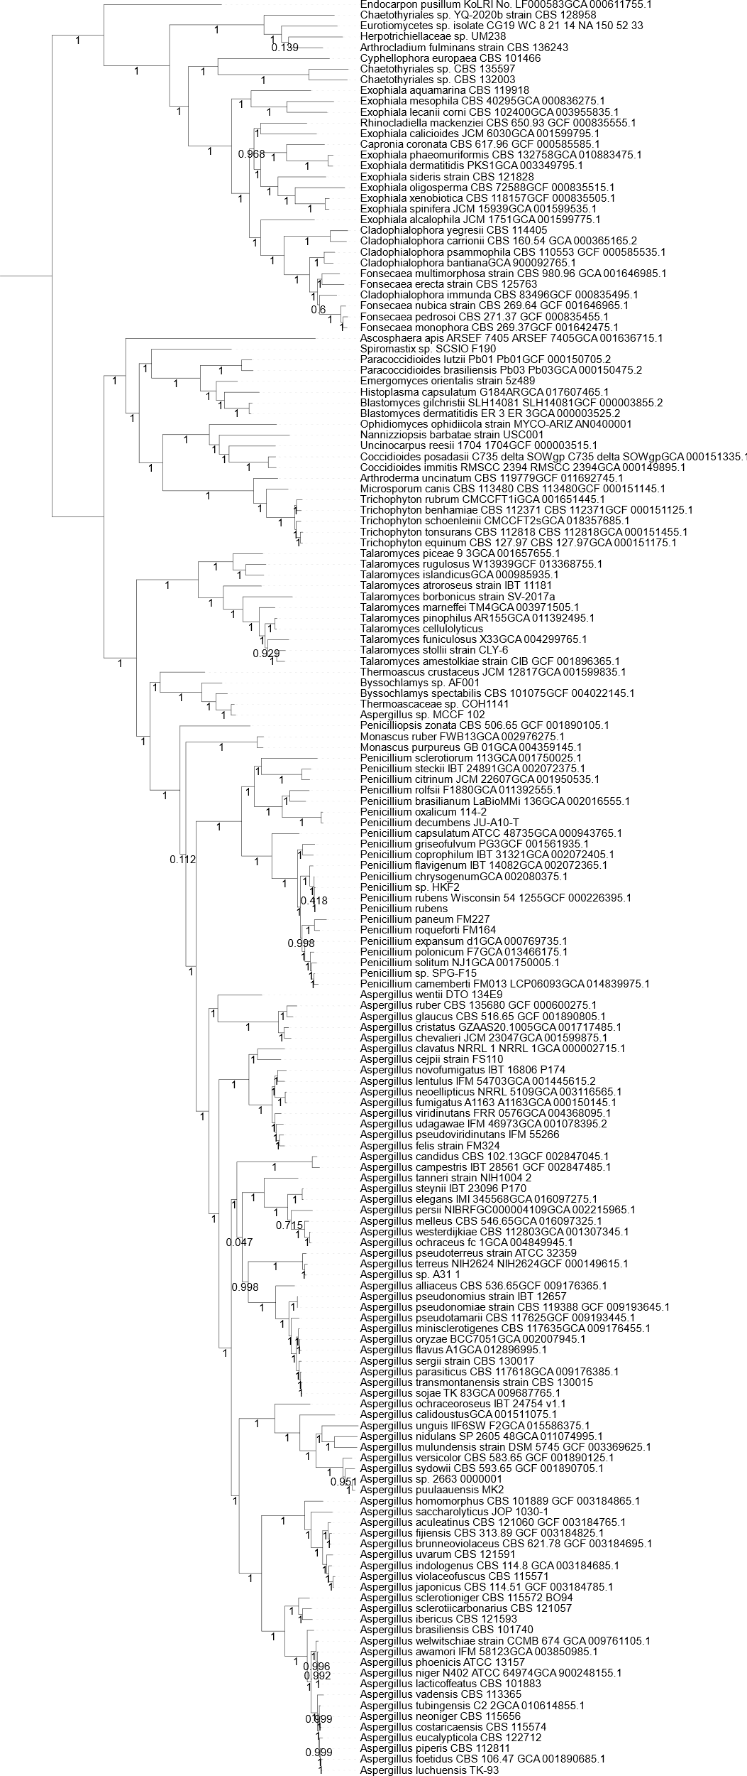

Table S7: Marker loci selected from Arthrocladium fulminans CBS 136243
Protein coding sequences selected by getphylo to build the Eurotiomycete phylogeny. Each protein coding sequence was present in all genomes and existed as a singleton in all genomes. The length of each sequence and the description of the protein (supplied by eggNOG-mapper¹⁵) is shown.
Protein | Length (aa) | Description
peg.1195 | 658 | Component of the NOP7 complex
peg.1459 | 885 | Plays a role in vesicular protein sorting
peg.1509 | 569 | AMP-binding enzyme
peg.1613 | 549 | RNA polymerase III subunit
peg.1895 | 308 | Phosphoadenosine ph,osphosulfate reductase
peg.1907 | 201 | VPS29 family
peg.2037 | 202 | ribosomal protein uL6 family
peg.2076 | 627 | Signal-recognition-particle assembly
peg.2158 | 323 | Component of the SWR1 complex remodeling
peg.2218 | 699 | Homeobox domain containing protein
peg.2223 | 204 | eukaryotic ribosomal protein eL6 family
peg.2269 | 480 | PPP4R2
peg.2276 | 534 | Senescence-associated protein
peg.2308 | 1005 | Nup85 Nucleoporin
peg.2550 | 1246 | Transcription initiation factor TFIID
peg.2971 | 497 | Catalytic component of the histone acetylase B (HAT-B) complex.
peg.3114 | 491 | tRNA methyltransferase complex GCD14 subunit
peg.3146 | 283 | CBF/Mak21 family
peg.3176 | 940 | 1-phosphatidylinositol-4-phosphate 5-kinase
peg.3180 | 719 | Dynein intermediate chain, cytosolic
peg.3276 | 416 | Leucine Rich repeat
peg.3290 | 496 | 26S proteasome subunit RPN7
peg.3303 | 736 | Endonuclease/Exonuclease/phosphatase family
peg.3527 | 644 | Translation initiation factor SUI1
peg.3684 | 507 | Essential subunit of the N-oligosaccharyl transferase (OST) complex
peg.3732 | 326 | SYF2 splicing factor
peg.3771 | 426 | Translation initiation factor
peg.3779 | 564 | Component of the FACT complex polymerase II
peg.3834 | 285 | LUC7 N_terminus
peg.3934 | 630 | Sorting nexin-41
peg.3994 | 531 | Cell division cycle protein 37
peg.4075 | 692 | Atypical ABC1 ABC1-C protein kinase
peg.4298 | 912 | Secretory pathway protein Sec39
peg.4440 | 1303 | mRNA-binding protein
peg.4472 | 467 | Phosphoglycerate mutase family
peg.4517 | 510 | Nuclear segregation protein
peg.4570 | 580 | GTP1/OBG
peg.4576 | 415 | Catalyzes radical-mediated insertion of sulfur atoms
peg.4785 | 203 | eukaryotic ribosomal  protein eS7 family
Protein | Length (aa) | Description
peg.4794 | 530 | Putative stress-responsive nuclear envelope protein
peg.4875 | 388 | Chalcone isomerase like
peg.4877 | 286 | Required for the assembly and or stability of the 40S ribosomal subunit
peg.4951 | 538 | UTP15 C terminal
peg.5026 | 532 | Acid phosphatase homologues
peg.5072 | 256 | Transcription initiation factor IID, 18kD subunit
peg.5077 | 740 | SUZ domain
peg.5119 | 434 | Eukaryotic peptide chain release factor subunit 1
peg.5215 | 370 | Autophagy-related protein 3
peg.5242 | 476 | SecY SEC61-alpha family
peg.5257 | 489 | Golgin subfamily A member 7/ERF4 family
peg.5261 | 306 | Dcp1-like decapping family
peg.5273 | 441 | Phosphoserine aminotransferase
peg.5470 | 600 | WSTF, HB1, Itc1p, MBD9 motif 1
peg.5595 | 657 | class-I aminoacyl-tRNA synthetase family
peg.5644 | 408 | Torus domain
peg.5731 | 486 | Low temperature viability protein
peg.5829 | 395 | diphosphomevalonate decarboxylase family
peg.5991 | 860 | component of the eukaryotic translation initiation factor 3  (eIF-3) complex
peg.6012 | 396 | DNA-binding protein HGH1
peg.6195 | 826 | 5-methylcytosine g t mismatch-specific dna
peg.6283 | 433 | WD repeat SEC13 family
peg.6297 | 554 | Low-density lipoprotein receptor domain class A
peg.6325 | 441 | Arginine methyltransferase
peg.6464 | 322 | Cytochrome c1, heme protein, mitochondrial
peg.6848 | 1127 | Forkhead domain
peg.6854 | 506 | USP8 dimerisation domain
peg.6861 | 1421 | Plays a role in maintenance of chromatin structure
peg.7133 | 793 | VID27 cytoplasmic protein
peg.7005 | 801 | DNA translocase
peg.7155 | 621 | Not1 N-terminal domain, CCR4-Not complex component
peg.7217 | 378 | Exosome complex component RRP4
peg.7221 | 570 | Hypothetical protein (DUF2410)
peg.7600 | 662 | COMPASS (Complex proteins associated with Set1p)  component shg1
peg.7629 | 490 | Belongs to the GHMP kinase family.  Mevalonate kinase subfamily
peg.7664 | 324 | UBX domain protein
peg.7694 | 416 | Phosphatidylethanolamine-binding protein
peg.7761 | 446 | Zinc finger protein
peg.7814 | 273 | Rhomboid family
peg.7947 | 250 | pre-mRNA-splicing factor isy1
peg.7982 | 585 | Pseudouridylate synthase
peg.8005 | 937 | HEAT-like repeat
peg.8026 | 467 | RPR
Protein | Length (aa) | Description
peg.8074 | 406 | Belongs to the universal ribosomal protein uS5 family
peg.8102 | 782 | Acyltransferase
peg.8151 | 443 | Component of the ERMES MDM
peg.8186 | 279 | rRNA 2'-O-methyltransferase fibrillarin
peg.8265 | 523 | phenylalanyl-tRNA synthetase alpha chain
peg.8358 | 739 | -
peg.8394 | 374 | Pex19 protein family
peg.8481 | 422 | ethanolamine kinase
peg.8488 | 995 | Mitochondrial small ribosomal subunit Rsm22
peg.8630 | 386 | Conserved hypothetical ATP binding protein
peg.8631 | 237 | 60S ribosomal protein L9-B
peg.8692 | 474 | Specifically methylates the N1 position of guanosine
peg.8721 | 1499 | Functions as a sorting receptor in the Golgi
peg.9008 | 520 | RNA recognition motif
peg.9014 | 593 | mRNA cap-binding component of the eukaryotic translation initiation factor 3 (eIF-3) complex
peg.9123 | 320 | Functions as actin-binding component of the Arp2 3 complex mediates the formation of branched actin networks
peg.955 | 731 | Transcriptional adapter 2-alpha
peg.978 | 786 | Nuclear condensing complex subunits, C-term domain

Explanatory Figures
These figures are provided to aid in the description of getphylo’s workflow. These figures are designed to be human readable and do not necessarily reflect a given algorithm verbatim. As such, they are provided purely for explanatory purposes.

Figure S13: Simplified flow charts comparing getphylo and clustering algorithms.
Simplified flow charts for (a) getphylo and (b) and an idealised clustering workflow. The flow charts show how a gene or coding sequence (CDS) might be classified as a single copy orthologue of a given group.
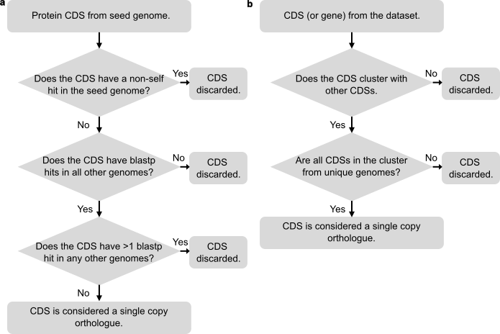

Figure S14: Cartoon of orthologue selection comparing getphylo and clustering algorithms
A cartoon illustrating a scenario whereby an orthologous group is (a) agreed upon by both getphylo and an idealised clustering algorithm or (b) identified by a clustering algorithm but rejected by getphylo’s strict heuristic. CDSs are represented by coloured circles, where the colour indicates the source genome; thick lines represent a high identity hit and; dotted lines represent a low identity hit . In case a, CDSs are present as single copies with no identify between the genes from the same genome, so getphylo identifies them as two separate orthologous groups. In case b, there is low identity between CDSs from the same genome and so they are considered as part of the same orthologous group by getphylo and discarded.
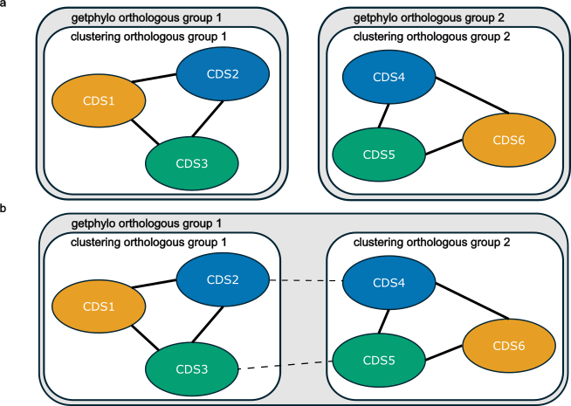

References
1. Alanjary, M., Steinke, K. & Ziemert, N. AutoMLST: an automated web server for generating multi-locus species trees highlighting natural product potential. Nucleic Acids Res 47, W276–W282 (2019).
2. Chaumeil, P. A., Mussig, A. J., Hugenholtz, P. & Parks, D. H. GTDB-Tk: a toolkit to classify genomes with the Genome Taxonomy Database. Bioinform 36, 1925–1927 (2020).
3. Robinson, D. F. & Foulds, L. R. Comparison of phylogenetic trees. Math Biosci 53, 131–147 (1981).
4. Marcet-Houben, M. & Gabaldón, T. TreeKO: a duplication-aware algorithm for the comparison of phylogenetic trees. Nucleic Acids Res 39, e66 (2011).
5. Huerta-Cepas, J., Serra, F. & Bork, P. ETE 3: Reconstruction, Analysis, and Visualization of Phylogenomic Data. Mol Biol Evol 33, 1635–1638 (2016).
6. Coleman, G. A. et al. A rooted phylogeny resolves early bacterial evolution. Science (1979) 372, eabe0511 (2021).
7. Letunic, I. & Bork, P. Interactive tree of life (iTOL) v3: an online tool for the display and annotation of phylogenetic and other trees. Nucleic Acids Res 44, W242-5 (2016).
8. Lacey, H. J. et al. Organic & Biomolecular Chemistry Resorculins: hybrid polyketide macrolides from Streptomyces sp. MST-91080 †. Org. Biomol. Chem 21, 2531 (2023).
9. Terlouw, B. R. et al. MIBiG 3.0: a community-driven effort to annotate experimentally validated biosynthetic gene clusters. Nucleic Acids Res 51, D603–D610 (2023).
10. Gilchrist, C. L. M. et al. cblaster: a remote search tool for rapid identification and visualisation of homologous gene clusters. Bioinform Adv 1, 1–10 (2021).
11. Sosio, M. et al. Organization of the teicoplanin gene cluster in Actinoplanes teichomyceticus. Microbiol (Reading) 150, 95–102 (2004).
12. Thanapipatsiri, A. et al. Discovery of Unusual Biaryl Polyketides by Activation of a Silent Streptomyces venezuelae Biosynthetic Gene Cluster. Chembiochem 17, 2189–2198 (2016).
13. Perelman, P. et al. A molecular phylogeny of living primates. PLoS Genet 7, e1001342 (2011).
14. Pozzi, L. et al. Primate phylogenetic relationships and divergence dates inferred from complete mitochondrial genomes. Mol Phylogenet Evol 75, 165–183 (2014).
15. Cantalapiedra, C. P., Hern̗andez-Plaza, A., Letunic, I., Bork, P. & Huerta-Cepas, J. eggNOG-mapper v2: Functional Annotation, Orthology Assignments, and Domain Prediction at the Metagenomic Scale. Mol Biol Evol 38, 5825–5829 (2021).
16. Li, Y. et al. A genome-scale phylogeny of the kingdom Fungi In Brief A genome-scale phylogeny of the kingdom Fungi. Curr Biol 31, (2021).
17. De Azevedo, C. M. P. S. et al. Fonsecaea pugnacius, a novel agent of disseminated chromoblastomycosis. J Clin Microbiol 53, 2674–2685 (2015).
18. Mora Montes, H. et al. Comparative Genomics of Sibling Species of Fonsecaea Associated with Human Chromoblastomycosis. Front Microbiology 8, (2017).

