Supplementary Materials: Using individual barcodes to increase quantification power of Massively Parallel Reporter Assays

Pia Keukeleire, Jonathan D. Rosen, Angelina Göbel-Knapp, Kilian Salomon, Max Schubach and Martin Kircher

Supplementary Figure 1
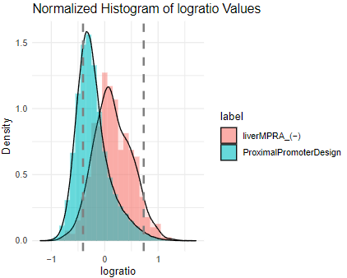
Supplementary Figure 1: BCalm plotting functionality shows logratios of tested and negative control groups, as well as a threshold at a user defined percentile of the negative controls (default: 0.95).

Supplementary Table 1: Analyzing the lentiMPRA variant library with BCalm and mpralm with and without separate barcode outlier removal. While the number of significant variants increases considerably for mpralm when outliers are filtered separately, BCalm finds more significant variants in both settings.
Method | Outlier removal | Number of significant variants
Mpralm | Yes | 2780
BCalm | Yes | 3856
Mpralm | No | 3289
BCalm | No | 3328

Supplementary Table 2: Computational requirements as measured by runtime for each method on a barcode input of 5,000 simulated variants. Resources were measured using R and SLURM’s “seff” command using 2 cores in a SLURM HPC environment.
Data set | Method | Runtime | Memory
Simulated | MPRAnalyze aggregated | 9.03 minutes | 897MB
Simulated | MPRAnalyze barcodes | 487.59 minutes | 1.76GB
Simulated | Mpralm | 0.07 minutes | 96KB
Simulated | BCalm | 1.47 minutes | 1.85GB
HepG2 lentiMPRA | Mpralm | 1.29 minutes | 5.7GB
HepG2 lentiMPRA | BCalm | 10.33 minutes | 9.7GB

Supplementary Table 3: Comparison of the methods using the properties statistical power, robustness to outlier, speed, Type I error (i.e. false positives), Type II error (i.e. false negatives), and the statistical model used to fit the data.
 | MPRAnalyze | mpralm | BCalm
statistical power | high | middle | high
robustness to outlier | high | low | high
speed | low | high | high
Type I error | middle | low | low
Type II error | low | middle | low
statistical model | negative binomial distribution | limma-voom | limma-voom

