GNNs and ensemble models enhance the prediction of new sRNA-mRNA interactions in unseen conditions

Shani Cohen, Lior Rokach, and Isana Veksler-Lublinsky

Supplementary data

Background

Experimental methods
Experimental methods for capturing sRNA targets can be divided into two groups; RNA-centric methods, such as MAPS [1] and GRIL-seq [2] intended for identifying the direct targets of individual sRNAs, and protein-centric methods, such as RIL-seq [3] and CLASH [4], [5] intended for identifying sRNA-target interactions that are facilitated by RNA binding protein (RBP) [6].
The MAPS (MS2 affinity purification coupled with RNA-sequencing) method is based on fusing the MS2 coat protein-binding sequence to a specific sRNA, then capturing the sRNA-target complex with the MS2 and sequencing the RNAs, regardless of the target RNA type or mode of regulation [1]. GRIL-seq (global sRNA target identification by ligation and sequencing) identifies direct targets of a specific sRNA by co-expressing the sRNA and T4 RNA ligase in live bacteria (in vivo). The ligation of the sRNA to its targets is followed by RNA-sequencing to identify the chimeras [2].
The fact that many sRNA-target interactions are facilitated by a globally acting regulatory protein, such as Hfq or ProQ, led to the development of protein-centric methods that can capture thousands of putative interactions of multiple sRNAs in a single experiment [6]. For example, the RIL-seq (RNA interaction by ligation and sequencing) method integrates experimental and computational tools for in vivo transcriptome-wide identification of sRNA-target interactions that are mediated by Hfq [3]. Its experimental workflow includes capturing crosslinked Hfq-RNA complexes with antibodies, A/T1 digestion, RNA ligation, proteinase K digestion, and sequencing, followed by a computational pipeline to determine statistically significant RNA-RNA interactions [3]. An alternative method, CLASH (crosslinking, ligation, and sequencing of hybrids) applies more stringent purification steps to capture sRNA-target interactions that are associated with proteins, such as RNase E [4] or Hfq [5]. It includes in vivo protein-RNA crosslinking, purification under stringent and denaturing conditions, RNA ligation, protein removal, sequencing, and analysis of the chimeric reads. In this work, we collected sRNA-mRNA interactions captured by some of these high-throughput techniques for Escherichia coli K12 MG1655 (see Table 1 in the main text).

ML-based methods
sRNARFTarget [7] was designed for transcriptome-wide sRNA target prediction and is applicable to any sRNA. It leverages the Random Forest algorithm to model sRNA-mRNA interactions, using the 3-mers frequency differences between the sRNA and the mRNA sequences as features. The model was trained on interacting sRNA-mRNA pairs (positive samples) from 37 bacterial species, with half of the interactions derived from E. coli. An equal number of negative samples were generated by randomly swapping the sRNAs in the sRNA-mRNA pairs. The model was then evaluated on its ability to predict new interactions, both in E. coli (which had interactions included in the train set) and in bacterial species that were not part of the train set. In this train-test evaluation, sRNARFTarget learned from all available interactions across species, regardless of experimental conditions, to predict new interactions, outperforming IntaRNA but being surpassed by CopraRNA in terms of ROC AUC and the ranking of known interactions.
TargetRNA3 [8] is a gradient-boosting classifier also designed for transcriptome-wide sRNA target prediction, regardless of the sRNA conservation status. It utilizes the nine most informative features selected from an initial set of 111, including the 3-mer frequency differences suggested by sRNARFTarget, hybridization-based features adapted from sInterBase [9], homology-based features, and more. The dataset consisted of positive sRNA-mRNA interactions from 13 genomes, with negative interactions randomly sampled from the remaining sRNA-mRNA pairs in these genomes, maintaining a ratio of 1:3 between positive and negative samples. The dataset was split into a train set of 65 sRNAs and a test set of 12 sRNAs, ensuring that none of the genomes for the test sRNAs were represented in the train data. Since the majority of the sRNAs (61) originated from E.coli, it follows that E.coli data was used exclusively for training and not for testing. Consequently, the tool was evaluated on its ability to predict interactions in new genomes not present in the training data without accounting for environmental conditions. In this evaluation, TargetRNA3 outperformed five other tools, including sRNARFTarget and CopraRNA, based on ROC AUC and sensitivity at 95% specificity.

Methods

Feature extraction

Local-interaction-based features
We used the RNAup software to generate an interaction duplex for each pair of sRNA and mRNA input sequences (see Figure S1 below).
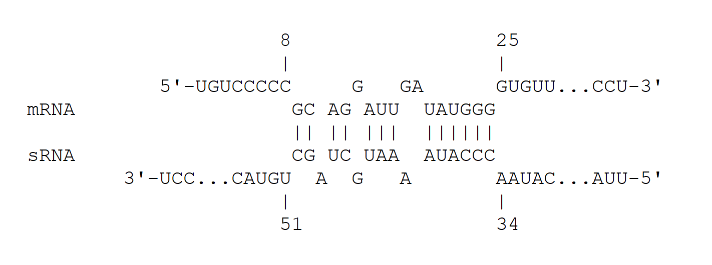
Figure S1. An illustration of the sRNA-mRNA interaction duplex generated for the sequences of cyaR (sRNA) and smpB (mRNA) in E.coil K12 MG1655.

Interaction features description
Our decision forest models, sInterRF and sInterXGB utilized a heterogeneous set of features, including local-interaction-based features and trinucleotide frequency differences (3-mer-diff) features. A detailed description of the 23 local-interaction-based features is provided per category in Table S1. The trinucleotide frequency differences (3-mer-diff) composed an initial set of 64 features, namely: [AAA, AAT, AAG, AAC, ATA, ATT, ATG, ATC, AGA, AGT, AGG, AGC, ACA, ACT, ACG, ACC, TAA, TAT, TAG, TAC, TTA, TTT, TTG, TTC, TGA, TGT, TGG, TGC, TCA, TCT, TCG, TCC, GAA, GAT, GAG, GAC, GTA, GTT, GTG, GTC, GGA, GGT, GGG, GGC, GCA, GCT, GCG, GCC, CAA, CAT, CAG, CAC, CTA, CTT, CTG, CTC, CGA, CGT, CGG, CGC, CCA, CCT, CCG, CCC]. Each feature in this set was computed by first obtaining the 3-mer frequency for both sRNA and mRNA sequences separately, then subtracting the sRNA frequency from the mRNA frequency.

Table S1. Description of the 23 local-interaction-based features by category.
Category | Feature name | Description
Energy  (by RNAup) | Total energy | The free energy of the binding, formally:  $∆G=∆G_{h}+ ∆G_{u, sRNA}+∆G_{u, mRNA}$; ($∆G<0$)
Energy  (by RNAup) | Hybridization energy | $∆G_{h}$ = the energy gained from the hybridization at the binding site ($∆G_{h}<0$)
Energy  (by RNAup) | sRNA unfolding energy | $∆G_{u, sRNA}$ = the energy that is necessary to expose the binding site in the sRNA conformation ($∆G_{u, sRNA}>0$)
Energy  (by RNAup) | mRNA unfolding energy | $∆G_{u, mRNA}$ = the energy that is necessary to expose the binding site in the mRNA conformation ($∆G_{u, mRNA}>0$)
Duplex structure | Alignment length (nt) | Alignment length (nt)
Duplex structure | Base pairs (no.) | Number of all base pairs
Duplex structure | Mismatches (no.) | Number of mismatches
Duplex structure | sRNA bulges (no.) | Number of bulges in the sRNA
Duplex structure | mRNA bulges (no.) | Number of bulges in the mRNA
Duplex structure | Base pairs (prop.) | Number of all base pairs out of the alignment length
Duplex structure | Max consecutive bps (prop.) | Number of max consecutive base pairs out of the alignment length
Duplex structure | Mismatches (prop.) | Number of mismatches out of the alignment length
Duplex structure | sRNA bulges (prop.) | Number of bulges in the sRNA out of the alignment length
Duplex structure | mRNA bulges (prop.) | Number of bulges in the mRNA out of the alignment length
Duplex structure | GC base pairs (prop.) | Number of GC base pairs out of all base pairs
Duplex structure | AU base pairs (prop.) | Number of AU base pairs out of all base pairs
Duplex structure | GU base pairs (prop.) | Number of GU base pairs out of all base pairs
Target context | Flanking U nts (prop.) | U nt count out of all the nts in the mRNA flanking region
Target context | Flanking A nts (prop.) | A nt count out of all the nts in the mRNA flanking region
Target context | Flanking G nts (prop.) | G nt count out of all the nts in the mRNA flanking region
Target context | Flanking C nts (prop.) | C nt count out of all the nts in the mRNA flanking region
Target context | Flanking A+U nts (prop.) | A+U nt count out of all the nts in the mRNA flanking region
Target context | Flanking G+C nts (prop.) | G+C nt count out of all the nts in the mRNA flanking region
Duplex structure refers to features describing the base-pairing patterns of the RNAup duplex formed between the sRNA and the mRNA. No. = number, prop. = proportion.

Machine-learning models

Graph neural networks
The GraphRNA and kGraphRNA models were trained with binary cross-entropy loss and a learning rate of 0.001. GraphRNA was trained with 25 epochs, and kGraphRNA was trained with 120 epochs. The loss curves of the training and validation sets along the training epochs of each model in the HT-to-LT evaluation are presented in Figure S2.
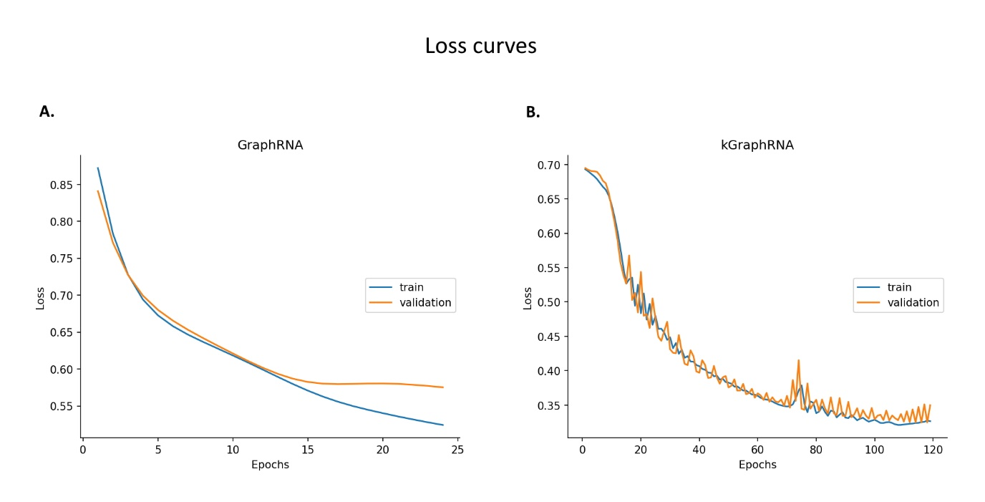
Figure S2. Binary cross-entropy loss along the training epochs of A. GraphRNA and B. kGraphRNA in the HT-to-LT evaluation.

Results

Comparison to other methods

CopraRNA
CopraRNA utilizes IntaRNA to predict favorable interacting regions within each organism, based on the intermolecular hybridization energy, the presence of a seed region composed of consecutive base pairs, and the accessibility of the binding sites on both the sRNA and the mRNA [10]. To calculate a combined p-value for each putative target, a comparative model is applied over IntaRNA's predictions, in a way that higher weight is given to interactions that are conserved across species [10]. The CopraRNA p-values range from 0 to 1, and lower values are given to more significant putative targets.
To derive CopraRNA scores for sRNA-mRNA interactions in Escherichia coli K12 MG1655 (NC_000913), we executed several steps. Initially, we utilized the stand-alone BLAST software [11] to identify the homologous sequences of Escherichia coli K12 MG1655 (NC_000913) sRNAs, with a minimum of 70% coverage across the genomes of Salmonella enterica serovar Typhimurium LT2 (NC_003197), Citrobacter koseri ATCC BAA-895 (NC_009792), Escherichia fergusonii ATCC 35469 (NC_011740), Citrobacter rodentium ICC168 (NC_013716), Bacillus subtilis 168 (NC_000964), and Shigella dysenteriae Sd197 (NC_007606). Subsequently, sRNAs possessing at least three homologous sRNA sequences from three distinct organisms (including Escherichia coli K12 MG1655) were compiled into input files for the stand-alone CopraRNA software. CopraRNA was then employed to assign a p-value (ranges between 0 to 1) for putative mRNA targets of each Escherichia coli sRNA. Note that for some sRNA-mRNA pairs, CopraRNA could not provide p-values, either because (1) the given sRNA has less than three homologs which are required to run the tool (e.g, dicF, ralA, ryeG, sdsN, sroH, gadF, and C0293 in our datasets), or (2) when running CopraRNA for a given sRNA, the output file did not include the relevant mRNA since the mRNA may not have enough homologs in the set of organisms chosen for the analysis (e.g., omrA-gntP, omrA-glcD, etc.). In the specific case that the output file included the relevant mRNA, but no p-value was assigned to it (i.e., p-value = null), we assigned the mRNA a p-value of 1 (lowest rank) and included the interaction in the comparative evaluation.
Given a pair of sRNA and mRNA, each of our models provides a prediction score so that the higher the score, the higher the probability of interaction. To compare our models to CopraRNA, and to combine CopraRNA scores with other models’ predictions in the Summation Ensemble Models (SEM), we converted CopraRNA p-values to ‘probability-like’ scores by applying the $y=1-x$ function, which simply reverses the original ranking so that higher scores (max =1) are assigned to higher-ranked targets. We set a default CopraRNA score of 0.5 for interactions lacking CopraRNA prediction.

RNAup and sRNARFTarget
The RNAup tool identifies the optimal local interaction site between two RNA sequences based on MFE and accessibility calculations. It outputs a predicted interaction duplex and four energy features including hybridization, unfolding the sRNA, unfolding the mRNA, and total. When comparing our models to RNAup, we used the absolute value of the total energy provided by the tool as the ranking score, while setting a zero energy value in case RNAup could not form a duplex between the sRNA and the mRNA. The sRNARFTarget model was retrained and evaluated with the parameters suggested in the original paper [7], i.e., 500 trees, log2 of features for split, and a maximum tree depth of 9. This model provided a prediction score for all interaction samples.
References
[1] D. Lalaouna et al., “A 3′ External Transcribed Spacer in a tRNA Transcript Acts as a Sponge for Small RNAs to Prevent Transcriptional Noise,” Mol. Cell, vol. 58, no. 3, pp. 393–405, May 2015, doi: 10.1016/j.molcel.2015.03.013.
[2] K. Han, B. Tjaden, and S. Lory, “GRIL-seq provides a method for identifying direct targets of bacterial small regulatory RNA by in vivo proximity ligation,” Nat. Microbiol., vol. 2, no. 3, p. 16239, Mar. 2017, doi: 10.1038/nmicrobiol.2016.239.
[3] S. Melamed et al., “Global Mapping of Small RNA-Target Interactions in Bacteria,” Mol. Cell, vol. 63, no. 5, pp. 884–897, 2016, doi: 10.1016/j.molcel.2016.07.026.
[4] S. A. Waters et al., “Small RNA interactome of pathogenic E. coli revealed through crosslinking of RNase E,” EMBO J., vol. 36, no. 3, pp. 374–387, Feb. 2017, doi: 10.15252/embj.201694639.
[5] I. A. Iosub et al., “Hfq CLASH uncovers sRNA-target interaction networks linked to nutrient availability adaptation,” Elife, vol. 9, pp. 1–33, May 2020, doi: 10.7554/eLife.54655.
[6] J. Hör, S. A. Gorski, and J. Vogel, “Bacterial RNA Biology on a Genome Scale,” Mol. Cell, vol. 70, no. 5, pp. 785–799, Jun. 2018, doi: 10.1016/j.molcel.2017.12.023.
[7] K. Naskulwar and L. Peña-Castillo, “sRNARFTarget: a fast machine-learning-based approach for transcriptome-wide sRNA target prediction,” RNA Biol., vol. 19, no. 1, pp. 44–54, Dec. 2022, doi: 10.1080/15476286.2021.2012058.
[8] B. Tjaden, “TargetRNA3: predicting prokaryotic RNA regulatory targets with machine learning,” Genome Biol., vol. 24, no. 1, p. 276, Dec. 2023, doi: 10.1186/s13059-023-03117-2.
[9] S. Cohen, E. Maximof, S. Rokach, M. Tadeski, and I. Veksler-Lublinsky, “sInterBase: a comprehensive database of Escherichia coli sRNA–mRNA interactions,” Bioinformatics, vol. 39, no. 4, pp. 1–3, Apr. 2023, doi: 10.1093/bioinformatics/btad172.
[10] P. R. Wright et al., “CopraRNA and IntaRNA: predicting small RNA targets, networks and interaction domains,” Nucleic Acids Res., vol. 42, no. W1, pp. W119–W123, Jul. 2014, doi: 10.1093/nar/gku359.
[11] S. Altschul, “Gapped BLAST and PSI-BLAST: a new generation of protein database search programs,” Nucleic Acids Res., vol. 25, no. 17, pp. 3389–3402, Sep. 1997, doi: 10.1093/nar/25.17.3389.

