Supplementary material

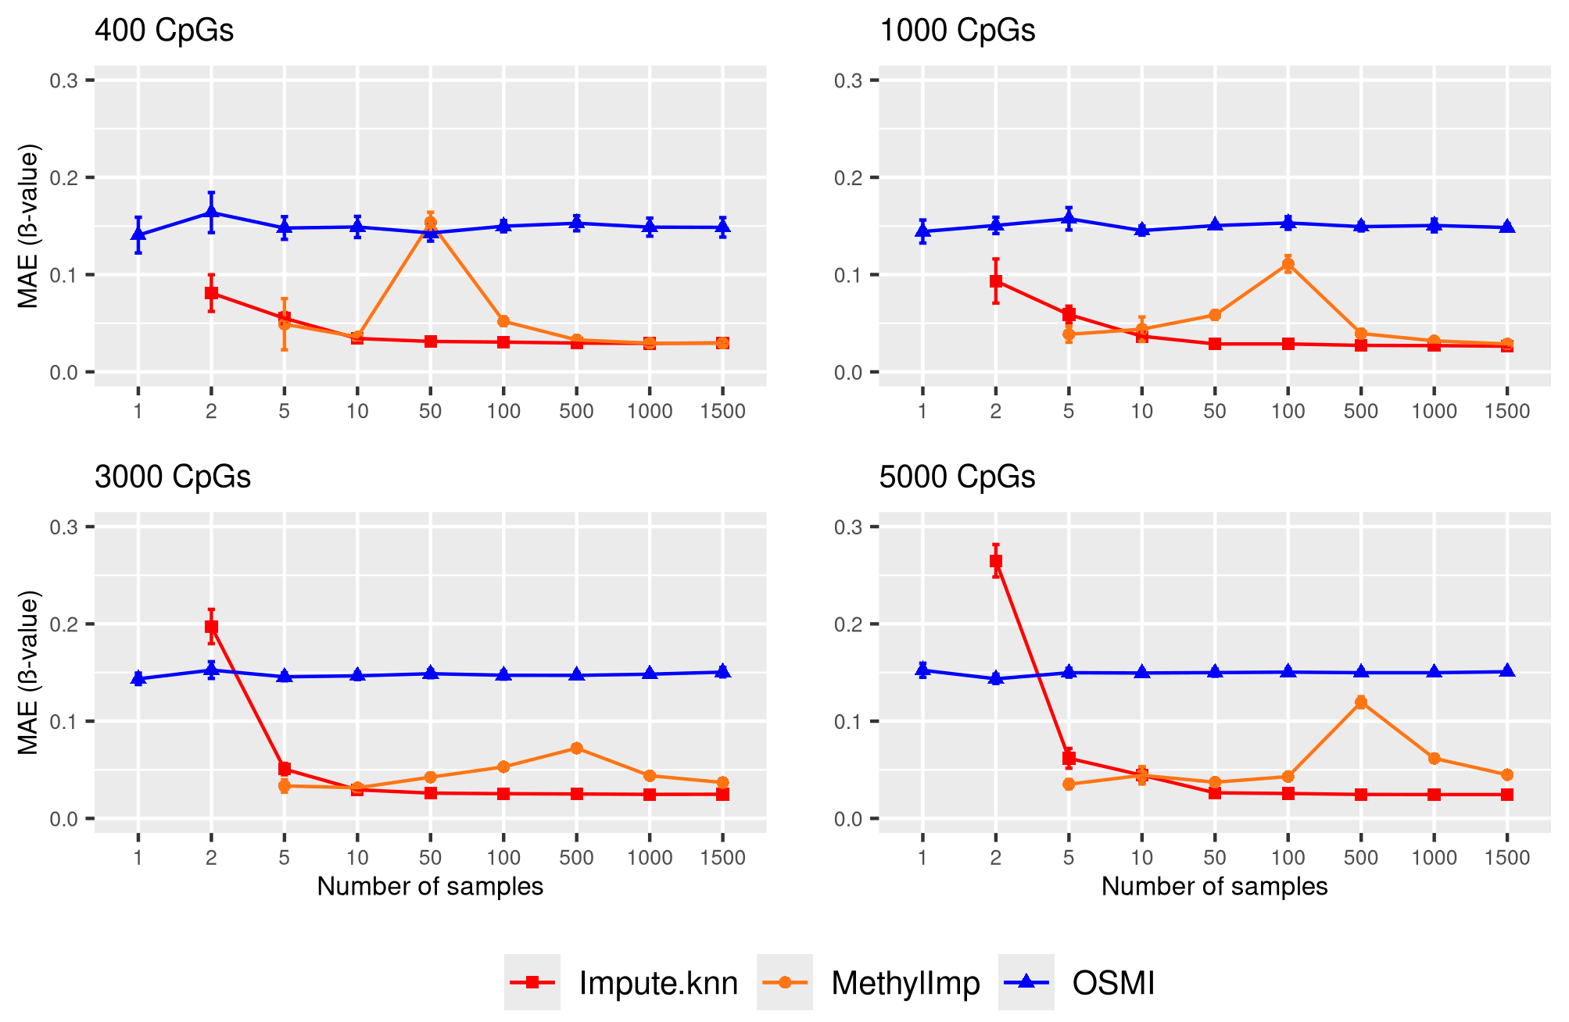

Figure 1 Suppl: Accuracy of missing DNA-methylation value imputation with impute.knn, methyLImp, and OSMI for varying number of samples and CpG sites in the blood data set. Markers represent mean MAEs and error bars represent standard errors of the mean. MAEs are reported in -value units (range: 0-1).

