Supplementary Figures
A)
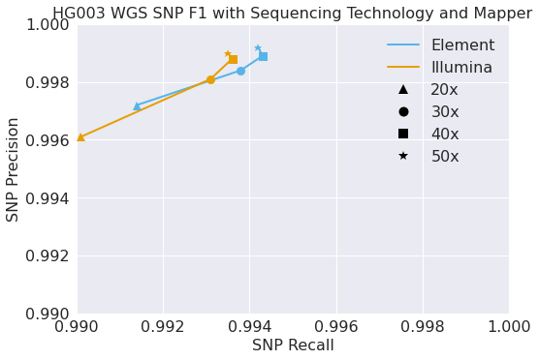
B)
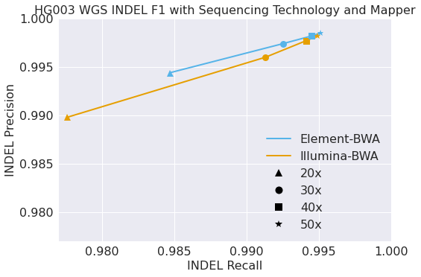
Supplementary Figure 1. Variant calling accuracy for Element and Illumina sequencing separating SNP and Indels. (A) SNP Variant calling accuracy (precision and recall) with 20x-50x sequencing depth assessed by Genome in a Bottle. (B) Indel Variant calling accuracy (precision and recall) with 20x-50x sequencing depth assessed by Genome in a Bottle.

A)

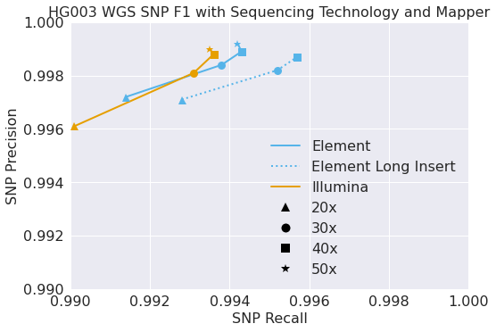
B)
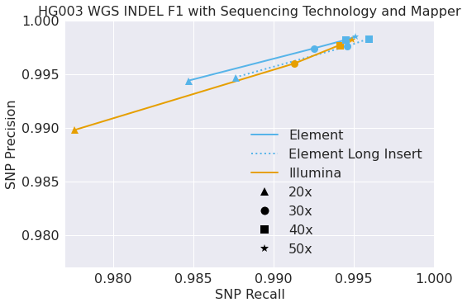
Supplementary Figure 2. Longer sequencing inserts improve genome analysis accuracy for Element data separating SNPs and Indels. (A) SNP Variant calling accuracy (precision and recall) with 20x-50x sequencing depth assessed by Genome in a Bottle. (B) Indel Variant calling accuracy (precision and recall) with 20x-50x sequencing depth assessed by Genome in a Bottle.

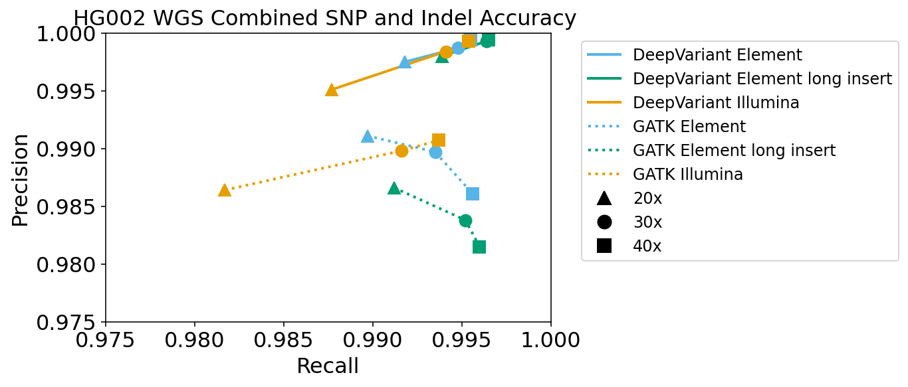
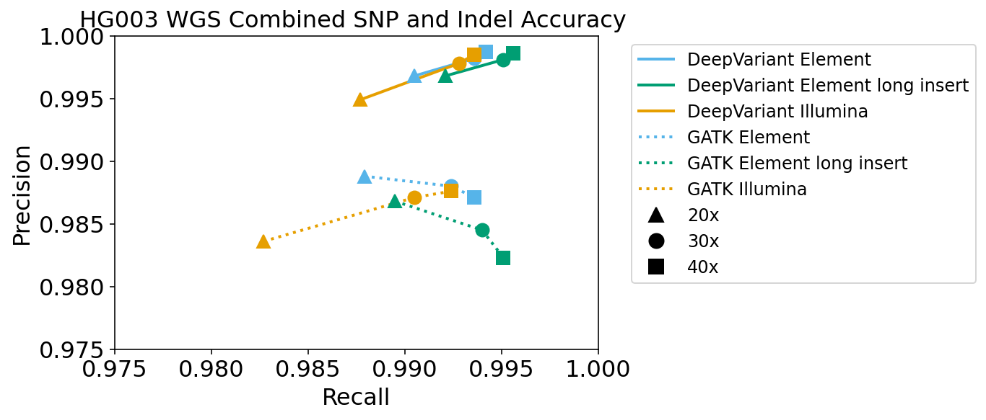

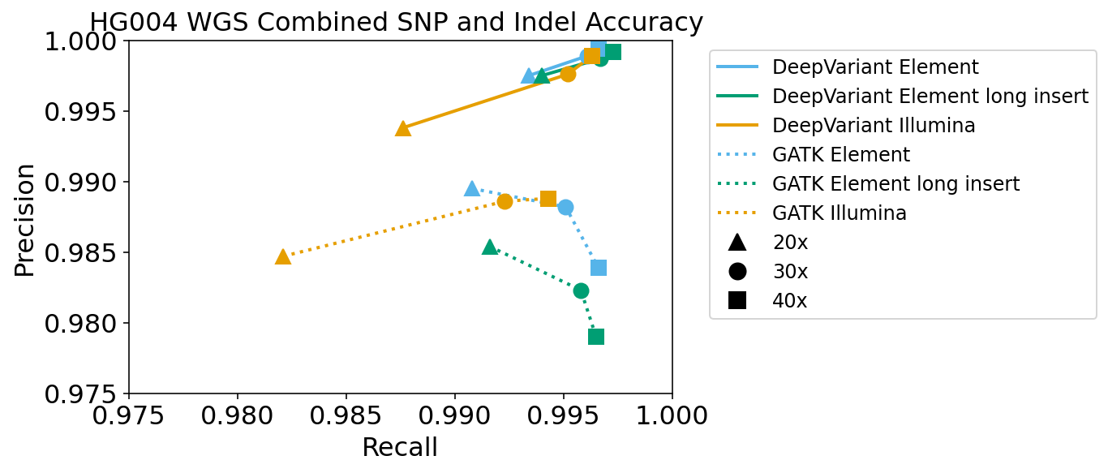
Supplementary Figure 3. Comparisons between Illumina and Element standard and long insert analyzed with both DeepVariant and GATK. For three samples: (A) HG002, (B) HG003, (C) HG004 at 20x, 30x, and 40x sequencing depth assessed by Genome in a Bottle. Analyses with DeepVariant are shown in solid lines and with GATK in dotted lines.

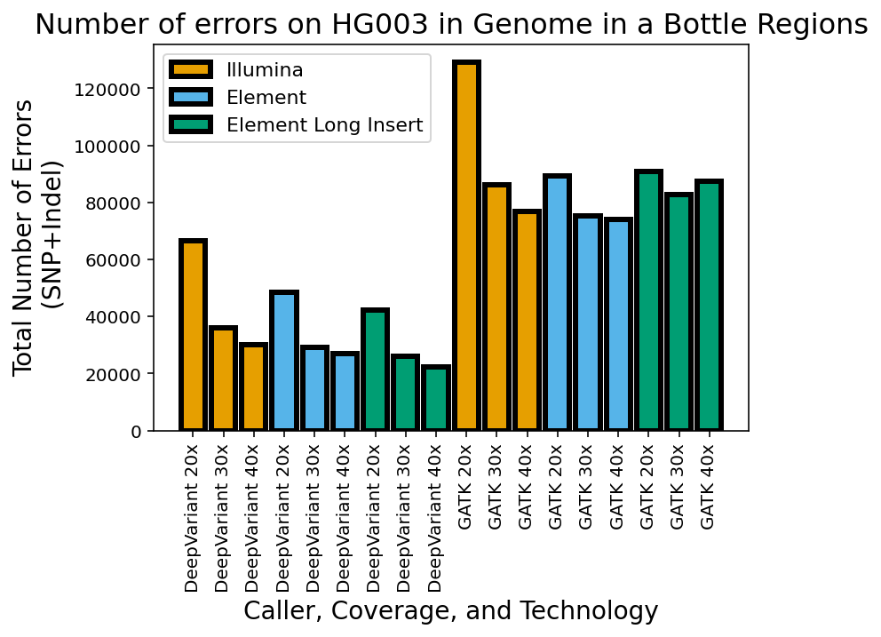
Supplementary Figure 4. Total errors with Illumina, Element, and Long-Insert Element data analyzed with both DeepVariant and GATK at different coverages. Errors are the combination of false negatives and false positives summed for both SNP and Indels across the Genome in a Bottle regions v4.2.1.

