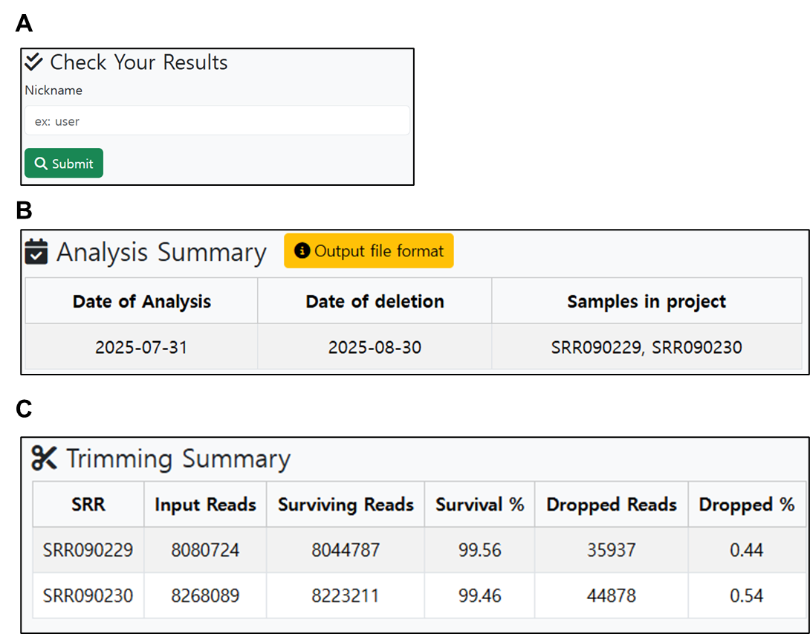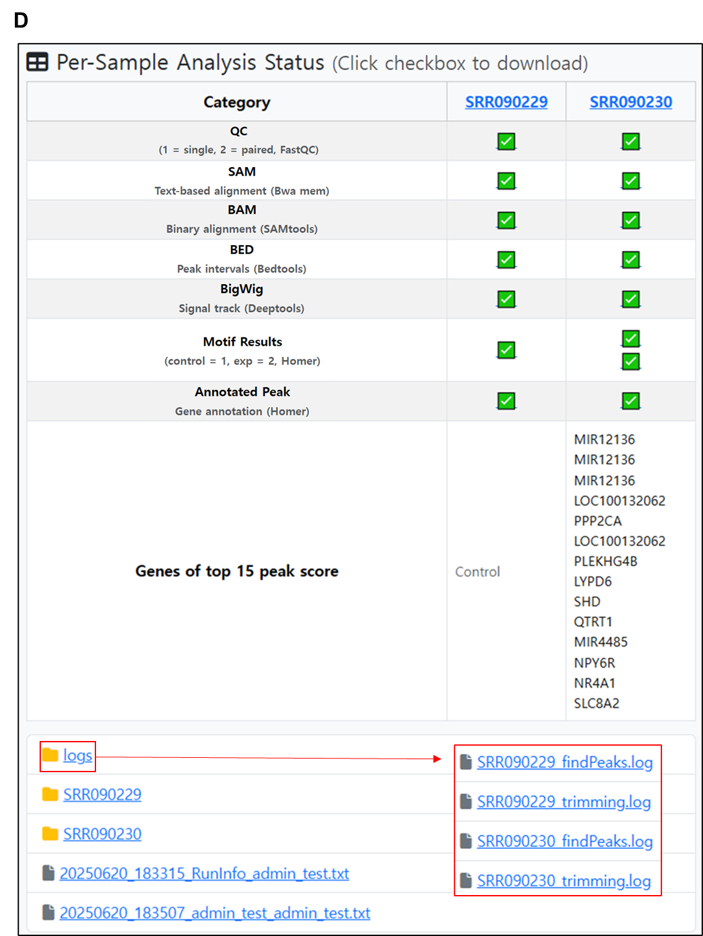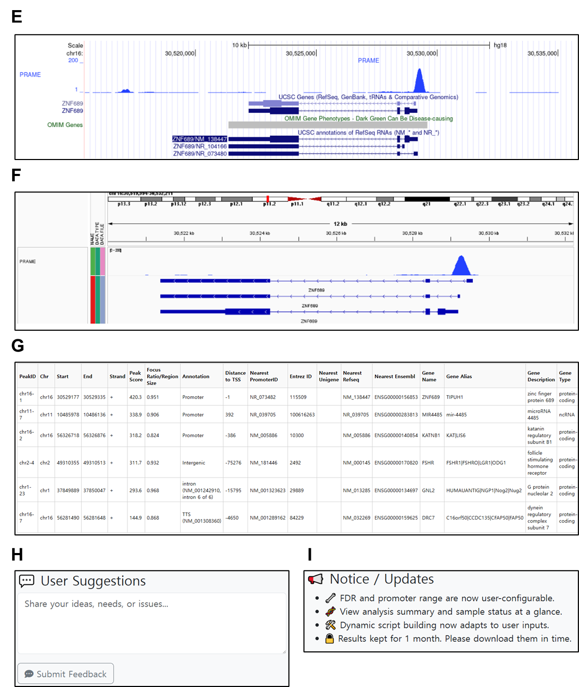
Supplementary Fig. 1. Results access interface and output visualization in H³NGST. (A) Users retrieve completed analyses by entering the nickname used during submission. (B) The analysis summary displays the analysis date, scheduled deletion date, and associated SRR sample IDs. Output file icons are included, with descriptions summarized in Table 2. (C) The trimming summary shows input read counts, surviving reads, survival percentages, and dropped read statistics for each sample. (D) The per-sample analysis status table provides visual confirmation of completed steps across QC, alignment (SAM/BAM), file conversion (BED/BigWig), motif finding, and peak calling. Top 15 target genes are listed based on peak scores. (E) BigWig signal tracks are visualized in the UCSC Genome Browser, highlighting locus-specific ChIP-seq signal enrichment around the PRAME locus. (F) Read alignments and gene annotations are displayed in the Integrative Genomics Viewer (IGV) for high-resolution inspection of ChIP-seq coverage and structure. (G) A representative peak annotation table generated by HOMER and processed by H³NGST includes genomic coordinates, annotation categories, distances to transcription start sites (TSS), associated genes, and enrichment scores. (H) A user feedback form allows for submission of feature requests and issue reports directly through the platform. (I) Public announcements and recent platform updates are clearly displayed.

