Supplementary file of “MLGCN-Driver: A Cancer Driver Gene Identification Method based on Multi-layer Graph Convolutional Neural Network”

Supplementary Tables
Table S1 Parameter settings for three networks on pan-cancer dataset.
Parameter/network | GGNet | PathNet | PPNet
α_{l} | 0.85 | 0.4 | 0.4
λ | 1.5 | 0.9 | 1.5
GCN layers | 8 | 4 | 8
GCN channels | 8 | 64 | 32
Dropout rate | 0.4 | 0.6 | 0.4
Drop adj rate | 0 | 0 | 0
θ | 0.8 | 0.8 | 0.8
ω | 0.8 | 0.2 | 0.2
Epoch | 970 | 970 | 970
Learning rate | 0.001 | 0.001 | 0.001
Weigh_decay | 1e-6 | 5e-6 | 1e-6

Table S2 Experimental results of the layer number selection on GGNet, PathNet and PPNet.
GCN layers | GGNet |  | PathNet |  | PPNet
 | AUROC | AUPR | AUROC | AUPR | AUROC | AUPR
2 | 0.8321 | 0.7783 | 0.8609 | 0.8531 | 0.8660 | 0.8293
4 | 0.8478 | 0.7959 | 0.8729 | 0.8659 | 0.8680 | 0.8322
6 | 0.8489 | 0.7978 | 0.8723 | 0.8612 | 0.8767 | 0.8429
8 | 0.8502 | 0.8010 | 0.8720 | 0.8605 | 0.8773 | 0.8440
10 | 0.8408 | 0.7958 | 0.8624 | 0.8506 | 0.8765 | 0.8430

Table S3 The standard deviation results of AUROC and AUPR for GGNet, PathNet, and PPNet.
STD | GGNet |  | PathNet |  | PPNet
STD | AUC | AUPR | AUC | AUPR | AUC | AUPR
MLGCN-Driver | 0.017 | 0.024 | 0.017 | 0.022 | 0.014 | 0.022
HGDC | 0.020 | 0.024 | 0.022 | 0.024 | 0.020 | 0.028
MTGCN | 0.017 | 0.028 | 0.020 | 0.024 | 0.020 | 0.028
EMOGI | 0.017 | 0.022 | 0.020 | 0.028 | 0.020 | 0.028
GCN | 0.036 | 0.032 | 0.030 | 0.037 | 0.022 | 0.035
GAT | 0.026 | 0.033 | 0.026 | 0.040 | 0.020 | 0.033
Chebnet | 0.017 | 0.024 | 0.017 | 0.026 | 0.022 | 0.030
SVM | 0.017 | 0.020 | 0.024 | 0.022 | 0.017 | 0.020

Table S4 The standard deviation results of AUROC and AUPR for BRCA BLCA LUAD and LIHC.
STD | BRCA |  |  | BLCA |  |  | LUAD |  |  | LIHC
STD | AUC |  | AUPR | AUC |  | AUPR | AUC |  | AUPR | AUC |  | AUPR
MLGCN-Driver | 0.024 | 0.063 |  | 0.022 | 0.087 |  | 0.034 | 0.099 |  | 0.040 | 0.139
HGDC | 0.021 | 0.021 |  | 0.022 | 0.022 |  | 0.024 | 0.024 |  | 0.024 | 0.024
MTGCN | 0.026 | 0.0671 |  | 0.022 | 0.101 |  | 0.043 | 0.102 |  | 0.048 | 0.138
Chebnet | 0.024 | 0.049 |  | 0.022 | 0.092 |  | 0.038 | 0.096 |  | 0.048 | 0.143
GCN | 0.056 | 0.783 |  | 0.030 | 0.067 |  | 0.032 | 0.055 |  | 0.050 | 0.918
GAT | 0.066 | 0.116 |  | 0.026 | 0.082 |  | 0.042 | 0.074 |  | 0.037 | 0.064
SVM | 0.013 | 0.020 |  | 0.017 | 0.030 |  | 0.022 | 0.045 |  | 0.023 | 0.042

Table S5 The results of AUROC and AUPR for different values of p and q.
 |  | PPNet | PathNet | GGNet
p=0.25 q=0.25 | AUROC | 0.8758 | 0.8719 | 0.8445
p=0.25 q=0.25 | AUPR | 0.8330 | 0.8599 | 0.7935
p=0.25 q=0.5 | AUROC | 0.8762 | 0.8737 | 0.8480
p=0.25 q=0.5 | AUPR | 0.8350 | 0.8619 | 0.7990
p=0.25 q=1 | AUROC | 0.8540 | 0.8738 | 0.8465
p=0.25 q=1 | AUPR | 0.8285 | 0.8617 | 0.7945
p=0.25 q=2 | AUROC | 0.8525 | 0.8731 | 0.8450
p=0.25 q=2 | AUPR | 0.8270 | 0.8607 | 0.7930
p=0.5 q=0.25 | AUROC | 0.8769 | 0.8738 | 0.8470
p=0.5 q=0.25 | AUPR | 0.8340 | 0.8616 | 0.7980
p=0.5 q=0.5 | AUROC | 0.8773 | 0.8729 | 0.8502
p=0.5 q=0.5 | AUPR | 0.8440 | 0.8659 | 0.8010
p=0.5 q=1 | AUROC | 0.8532 | 0.8727 | 0.8477
p=0.5 q=1 | AUPR | 0.8290 | 0.8609 | 0.7956
p=0.5 q=2 | AUROC | 0.8520 | 0.8714 | 0.8460
p=0.5 q=2 | AUPR | 0.8260 | 0.8594 | 0.7940
p=1 q=0.25 | AUROC | 0.8770 | 0.8730 | 0.8460
p=1 q=0.25 | AUPR | 0.8325 | 0.8613 | 0.7950
p=1 q=0.5 | AUROC | 0.8766 | 0.8720 | 0.8451
p=1 q=0.5 | AUPR | 0.8320 | 0.8600 | 0.7943
p=1 q=1 | AUROC | 0.8535 | 0.8736 | 0.8485
p=1 q=1 | AUPR | 0.8295 | 0.8622 | 0.7995
p=1 q=2 | AUROC | 0.8518 | 0.8716 | 0.8455
p=1 q=2 | AUPR | 0.8255 | 0.8590 | 0.7935
p=2 q=0.25 | AUROC | 0.8750 | 0.8699 | 0.8430
p=2 q=0.25 | AUPR | 0.8310 | 0.8589 | 0.7920
p=2 q=0.5 | AUROC | 0.8755 | 0.8709 | 0.8465
p=2 q=0.5 | AUPR | 0.8325 | 0.8604 | 0.7960
p=2 q=1 | AUROC | 0.8528 | 0.8706 | 0.8440
p=2 q=1 | AUPR | 0.8280 | 0.8581 | 0.7925
p=2 q=2 | AUROC | 0.8510 | 0.8719 | 0.8435
p=2 q=2 | AUPR | 0.8250 | 0.8605 | 0.7915

As established in the study of node2vec¹, the setup of the parameters of p and q are typically optimized via grid search over $p,q∈\{0.25, 0.5, 1, 2\}$. Following your comments, we have conducted the grid search for p and q, with the full corresponding results provided in the Supplementary file Table S5. Table S5 demonstrates that performance is relatively robust across parameter choices. Specifically, on PPNet and GGNet datasets, it achieves the best performance with p=0.5 and q=0.5. While on PathNet, the best performance occurs at different values, it achieves competitive performance. From the overall view, we set p=q=0.5. Critically, this balanced configuration (p=q=0.5) allows simultaneous incorporation of local neighborhood structure and global topological exploration. We therefore deem this parameterization methodologically consistent and empirically justified for cross-dataset comparability.

Table S6 The computational time required for GGNet, PathNet, and PPNet.
 | GGNet | PathNet | PPNet
MLGCN-Driver | 2223s | 1150s | 2933s
HGDC | 147s | 80s | 140s
MTGCN | 166510s | 22410s | 74120s
EMOGI | 9025s | 4950s | 4825s
GCN | 3250s | 870s | 1690s
GAT | 4570s | 1200s | 2360s
Chebnet | 3530s | 880s | 1810s
SVM | 2s | 2s | 2s

Supplementary Text
Text S1. Performance of MLGCN-Driver on novel cancer driver genes in PathNet and PPNet
Analysis on PathNet
For the novel driver genes predicted based on PathNet network, we further performed literature mining analysis. Specifically, we examined genes that were assigned high prediction scores by our model but were not included in the NCG database. Through a comprehensive review of recent literature, we found that many of these genes have been reported to play important roles in cancer-related processes, supporting the reliability and biological relevance of our predictions. For instance, Cai et al.² demonstrates that SOS1 mutations found in lung adenocarcinoma are oncogenic. The ectopic expression of lung adenocarcinoma–derived mutants of SOS1 induces anchorage-independent cell growth in vitro and tumor formation in vivo².EpHA2 has been reported as a poor prognostic marker in stage II/III colorectal cancer, which may be due to its ability to promote cell migration and invasion³. And the EphA2 shows significantly higher expression levels in colorectal tumors tissues compared with matched normal tissue, which positively correlated with high CD44 and Lgr5 expression levels³. Heidegger et al.⁴ scrutinized the effect of insulin receptor (INSR) in addition to IGF1R in PCa using in vitro and in vivo models⁴. In-vitro overexpression of IGF1R and INSRA-but not INSRB-increased cell proliferation, colony formation, migration, invasion and resistance to apoptosis in prostate cancer cells (DU145, LNCaP, PC3) ⁴. In addition, recent studies have reported mutations in SLX4 in a new subtype of Fanconi anemia (FA-P). Monoallelic defects in several FA genes are known to confer susceptibility to breast and ovarian cancers⁵. And the experimental results indicate that loss-of-function mutations in the SLX4 gene may contribute to the development of breast cancer in very rare cases⁵. Sp1 is frequently over-expressed in various cancers and is associated with poor prognosis⁶. It plays a dual regulatory role by activating or repressing the expression of a number of essential oncogenes and tumor suppressors, as well as genes involved in essential cellular functions, including proliferation, differentiation, the DNA damage response, apoptosis, senescence and angiogenesis⁶.
Analysis on PPNet
In addition, the literature mining analysis on the results of PPNet network also revealed that many novel driver genes are associated with key cancer-related biological process. For example, PRKDC is an essential gene required for CRC cell proliferation/survival, which may represent as a potential prognostic biomarker and an ideal therapeutic target for Colorectal cancer (CRC)⁷. It indicates that transient knockdown of PRKDC suppresses the proliferation/survival of HCT116 and DLD1 cells in colorectal cancer. PRKDC is up-regulated in cancerous tissues compared with normal tissues⁷. And patients with high PRKDC expression show poorer overall survival. MDC1 is essential for DNA damage response⁸. Wang et al. ⁸ demonstrates that MDC1 facilitates the association between AR and histone acetyl transferase GCN5, thereby increasing histone H3 acetylation level on cis-regulatory elements of AR target genes⁸. MDC1 knockdown have been found to enhance PCa (prostate cancer) cells growth and migration⁸. In addition, non-erythroid spectrin αII (SPTAN1), a protein of the cytoskeleton, is thought to be involved in CRC development and progression⁸. Furthermore, frameshift mutations of the MED1 gene have been reported in human colorectal, gastric, endometrial, and pancreatic cancer¹⁰. Finally, AGO1 has been shown to potentiate the recruitment of RNA polymerase II to the promoter regions of genes pertinent to cellular growth and survival, particularly in prostate cancer cells¹¹. It also facilitates transcriptional activation of cancer-associated genes, which occurs in a manner contingent upon the presence of AT repeats within the promoter sequence, has been implicated in the neoplastic progression of malignancies originating from diverse tissue types¹¹.

Text S2. GO and KEGG pathway enrichment analysis on PathNet and PPNet
Analysis on PathNet
The GO and KEGG pathway enrichment results are shown in Fig. S1. For GO analysis, in terms of biological process (Fig. S1(a)), the top 100 genes exhibit significant enrichment in key biological processes, including the peptidyl-tyrosine phosphorylation, peptidyl-tyrosine modification, and protein kinase B signaling etc. In peptidyl-tyrosine phosphorylation and peptidyl-tyrosine modification, a study sequenced 1,408 key cancer-related genes in primary tumors and matched lymph node metastases from 37 non-small cell lung cancer (NSCLC) patients, revealing more mutations in primary lesions than in lymph node metastases¹². Additionally, lymph node metastasis-exclusive somatic mutations (LME-SMs) are enriched in functions of peptidyl-tyrosine phosphorylation, peptidyl-tyrosine modification, protein tyrosine kinase activity, and transmembrane receptor protein kinase¹². Protein Kinase B (PKB), also known as Akt, is a key intracellular signaling molecule, and its abnormal activation plays a critical role in cancer development. Under normal conditions, PKB/Akt is activated via the PI3K (phosphatidylinositol 3-kinase) pathway¹³. However, deregulation of this pathway in cancer—such as PI3K mutations or loss of the tumor suppressor gene PTEN—leads to persistent Akt activation¹³. Akt enhances tumor cell survival by phosphorylating multiple apoptosis-related proteins, blocking apoptotic signals, and inhibiting cell apoptosis¹³. In terms of molecular functions (Fig. S1(b)), these top 100 genes possess key functions such as transmembrane receptor protein tyrosine kinase activity and protein tyrosine kinase activity. The dysregulated activity of transmembrane receptor protein tyrosine kinases (RTKs), such as the epidermal growth factor receptor (EGFR), is closely linked to cancer development¹⁴. Cohen et al. pioneered this research field, describing epidermal growth factor (EGF), its receptor (EGFR), and their biochemical functions¹⁴. Notably, EGFR was the first receptor to provide evidence for the association between receptor overexpression and cancer, establishing a foundational link between RTK dysregulation and oncogenesis¹⁴. In terms of cellular components (Fig. S1(c)), these top 100 genes are significantly enriched in transcription regulator complex and RNA polymerase Il transcription regulator complex. It has been reported that the paralogous zinc-finger proteins – CTCF and brother of the regulator of imprinted sites (BORIS), directly contribute to transcriptional regulation of NY-ESO-1 in lung cancer cells¹⁵. RNA polymerase III (pol III) is responsible for synthesizing essential molecules such as transfer RNAs (tRNAs), 5S ribosomal RNA (5S rRNA), and others critical for protein synthesis and trafficking. Its high transcriptional activity is fundamental for cell growth, yet numerous tumor cell types exhibit significantly elevated expression of pol III products. Mechanisms underlying this transcriptional dysregulation include: transforming factors stimulating the expression of pol III-specific transcription factors TFIIIB or TFIIIC2, oncogenic proteins (e.g., c-Myc) binding to and activating TFIIIB, and the loss of tumor suppressors RB and p53-mediated inhibition of TFIIIB in tumors, where RB/p53 function is impaired¹⁶.
The enriched KEGG pathways (Fig. S1(d)) further reveal several cancer types, including prostate cancer and breast cancer. Additionally, the enrichment of the MAPK and PI3K-Akt pathways is also observed. As the most commonly aberrantly activate pathways in cancer, they serve as central drivers of tumorigenesis by regulating cell proliferation, survival, metabolism, and metastasis. These enrichment results support the biological relevance of the genes predicted by MLGCN-Driver, demonstrating its potential for effective identification of cancer-related genes.
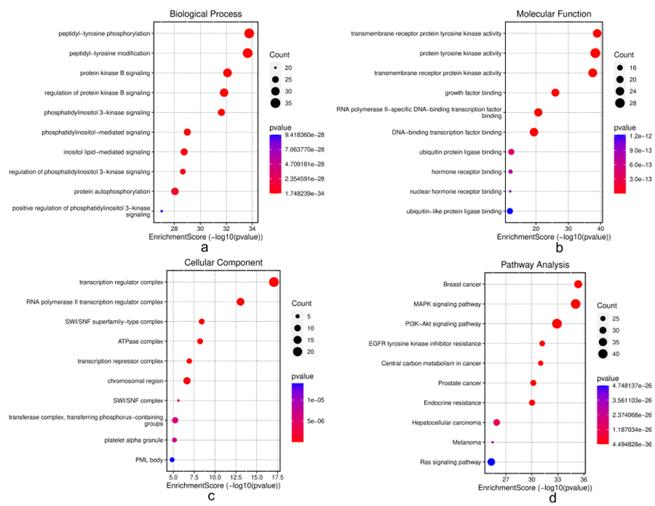
Fig. S1 The GO and KEGG enrichment analysis results of the top 100 driver genes predicted on PathNet. (a) Results of GO enrichment analysis for biological process. (b) Results of GO enrichment analysis for molecular function. (c) Results of GO enrichment analysis for cellular component. (d) Results of KEGG enrichment for pathway analysis.
Analysis on PPNet
The GO and KEGG pathway enrichment results are shown in Fig. S2. For GO analysis, in terms of biological process (Fig. S2(a)), these top 100 genes play significant roles in gland development, regulation of myeloid cell differentiation, etc. The mammary gland is composed of a diverse array of cell types that form intricate interaction networks essential for its normal development and physiologic function. Abnormalities in these interactions play an important role throughout different stages of tumorigenesis¹⁷. Regulation of myeloid cell differentiation is well established that tumor growth is associated with accumulation of immature myeloid cells (ImC)¹⁸. They play an important role in tumor-associated immune suppression¹⁸. In terms of molecular functions (Fig. S2(b)), these top 100 genes possess key functions such as DNA-binding transcription factor binding, transcription co-activator activity. Lambert et al.¹⁹ reviewed multiple strategies to target transcription factors in cancer models including modulating their expression or degradation, blocking protein/protein interactions, targeting the transcription factor itself to prevent its DNA binding either through a binding pocket or at the DNA-interacting site. Several of these inhibitors have already used or evaluated for cancer treatment. Regrading transcription co-activator activity, AIB1(amplified in breast cancer 1) is a transcriptional co-activator that promotes the transcriptional activity of multiple nuclear receptors and a number of other transcription factors. At the same time, AIB1 is a member of the p160 nuclear receptor co-activator family and is considered as an important oncogene in breast cancer²⁰. In terms of cellular components (Fig. S2(c)), these top 100 genes are significantly enriched in transcription regulator complex and RNA polymerase Il transcription regulator complex. It has been reported that the paralogous zinc-finger proteins – CTCF and brother of the regulator of imprinted sites (BORIS), directly contribute to transcriptional regulation of NY-ESO-1 in lung cancer cells¹⁵. RNA polymerase III (pol III) is responsible for synthesizing essential molecules such as transfer RNAs (tRNAs), 5S ribosomal RNA (5S rRNA), and others critical for protein synthesis and trafficking. Its high transcriptional activity is fundamental for cell growth, yet numerous tumor cell types exhibit significantly elevated expression of pol III products. Mechanisms underlying this transcriptional dysregulation include: transforming factors stimulating the expression of pol III-specific transcription factors TFIIIB or TFIIIC2; oncogenic proteins (e.g., c-Myc) binding to and activating TFIIIB; and the loss of tumor suppressors RB and p53-mediated inhibition of TFIIIB in tumors, where RB/p53 function is impaired¹⁶.
KEGG pathway results (Fig. S2(d)) reveal enrichment in many kinds of cancers like prostate cancer, breast cancer, endometrial cancer, gastric cancer, hepatocellular carcinoma and pancreatic cancer. It indicates that MLGCN-Driver's prediction results have certain biological significance in cancer and can effectively predict cancer-related genes.
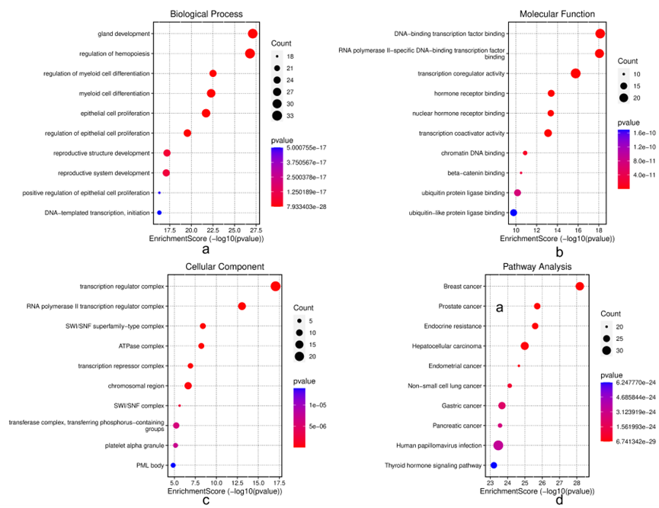
Fig. S2 The GO and KEGG enrichment analysis results of the top 100 driver genes predicted on PPNet. (a) Results of GO enrichment analysis for biological process. (b) Results of GO enrichment analysis for molecular function. (c) Results of GO enrichment analysis for cellular component. (d) Results of KEGG enrichment for pathway analysis.

References
- Grover, Aditya, and Jure Leskovec. node2vec: Scalable feature learning for networks. In Proceedings of the 22nd ACM SIGKDD international conference on Knowledge discovery and data mining, 2016, 855-864.
- Cai D, Choi P S, Gelbard M, et al. Identification and characterization of oncogenic SOS1 mutations in lung adenocarcinoma[J]. Molecular Cancer Research, 2019, 17(4): 1002-1012.
- Dunne P D, Dasgupta S, Blayney J K, et al. EphA2 expression is a key driver of migration and invasion and a poor prognostic marker in colorectal cancer[J]. Clinical Cancer Research, 2016, 22(1): 230-242.
- Heidegger I, Kern J, Ofer P, et al. Oncogenic functions of IGF1R and INSR in prostate cancer include enhanced tumor growth, cell migration and angiogenesis[J]. Oncotarget, 2014, 5(9): 2723.
- Shah S, Kim Y, Ostrovnaya I, et al. Assessment of SLX4 mutations in hereditary breast cancers[J]. PloS one, 2013, 8(6): e66961.
- Beishline K, Azizkhan‐Clifford J. Sp1 and the ‘hallmarks of cancer’[J]. The FEBS journal, 2015, 282(2): 224-258.
- Sun S, Cheng S, Zhu Y, et al. Identification of PRKDC (Protein Kinase, DNA-Activated, Catalytic Polypeptide) as an essential gene for colorectal cancer (CRCs) cells[J]. Gene, 2016, 584(1): 90-96.
- Wang C, Sun H, Zou R, et al. MDC1 functionally identified as an androgen receptor co-activator participates in suppression of prostate cancer[J]. Nucleic acids research, 2015, 43(10): 4893-4908.
- Schrecker C, Behrens S, Schönherr R, et al. Sptan1 expression predicts treatment and survival outcomes in colorectal cancer[J]. Cancers, 2021, 13(14): 3638.
- Bellacosa A. Role of MED1 (MBD4) Gene in DNA repair and human cancer[J]. Journal of cellular physiology, 2001, 187(2): 137-144.
- Nowak I, Sarshad A A. Argonaute proteins take center stage in cancers[J]. Cancers, 2021, 13(4): 788.
- Chen Y, Mao B, Peng X, et al. A comparative study of genetic profiles of key oncogenesis-related genes between primary lesions and matched lymph nodes metastasis in lung cancer[J]. Journal of Cancer, 2019, 10(7): 1642.
- Woodgett J R. Recent advances in the protein kinase B signaling pathway[J]. Current opinion in cell biology, 2005, 17(2): 150-157.
- Roskoski Jr R. The ErbB/HER family of protein-tyrosine kinases and cancer[J]. Pharmacological research, 2014, 79: 34-74.
- Kang Y, Hong J A, Chen G A, et al. Dynamic transcriptional regulatory complexes including BORIS, CTCF and Sp1 modulate NY-ESO-1 expression in lung cancer cells[J]. Oncogene, 2007, 26(30): 4394-4403.
- White R J. RNA polymerase III transcription and cancer[J]. oncogene, 2004, 23(18): 3208-3216.
- Polyak K, Kalluri R. The role of the microenvironment in mammary gland development and cancer[J]. Cold Spring Harbor perspectives in biology, 2010, 2(11): a003244.
- Kusmartsev S, Gabrilovich D I. Inhibition of myeloid cell differentiation in cancer: the role of reactive oxygen species[J]. Journal of Leucocyte Biology, 2003, 74(2): 186-196.
- Lambert M, Jambon S, Depauw S, et al. Targeting transcription factors for cancer treatment[J]. Molecules, 2018, 23(6): 1479.
- Lahusen T, Henke R T, Kagan B L, et al. The role and regulation of the nuclear receptor co-activator AIB1 in breast cancer[J]. Breast cancer research and treatment, 2009, 116: 225-237.

