Supplementary Materials for “Graph Convolution Network Based on Meta-Paths and Mutual Information for Drug-Target Interaction Prediction”

Supplementary Figures
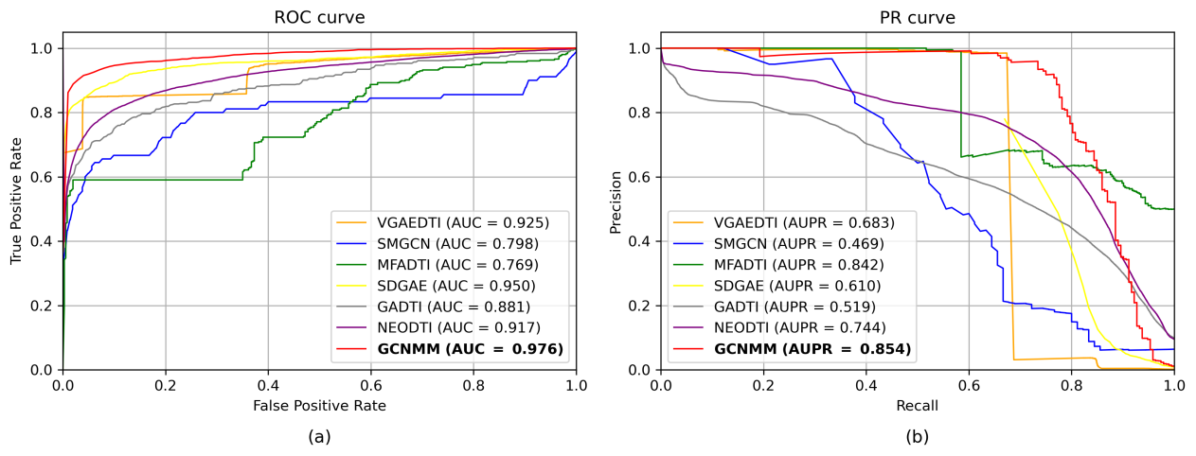
Fig. S1 The ROC curves and PR curves of baseline models on Luo’s dataset

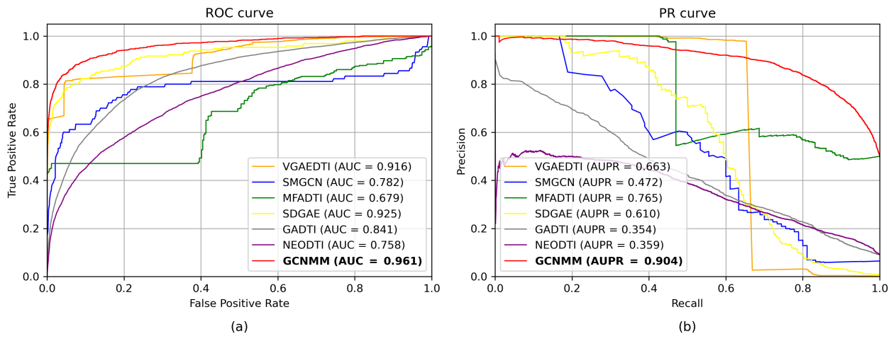
Fig. S2 The ROC curves and PR curves of baseline models on Li’s dataset

Supplementary Tables
Table S1 The ablation results on two datasets
Dataset | Model | AUC | AUPR | Recall | F1-score
Luo’s dataset | w./o. Meta | 0.937 | 0.693 | 0.614 | 0.531
 | w./o. STC | 0.968 | 0.736 | 0.786 | 0.502
 | w./o. MI | 0.966 | 0.764 | 0.753 | 0.644
 | w./o. Meta STC | 0.925 | 0.633 | 0.696 | 0.326
 | w./o. Meta MI | 0.929 | 0.656 | 0.640 | 0.346
 | w./o. STC MI | 0.961 | 0.736 | 0.798 | 0.407
 | w./o. Meta STC MI | 0.929 | 0.617 | 0.692 | 0.325
 | GCNMM | 0.976 | 0.854 | 0.825 | 0.719
Li’s dataset | w./o. Meta | 0.932 | 0.753 | 0.712 | 0.734
 | w./o. STC | 0.948 | 0.786 | 0.754 | 0.815
 | w./o. MI | 0.952 | 0.832 | 0.80 | 0.844
 | w./o. Meta STC | 0.901 | 0.676 | 0.563 | 0.626
 | w./o. Meta MI | 0.910 | 0.706 | 0.610 | 0.703
 | w./o. STC MI | 0.941 | 0.638 | 0.657 | 0.688
 | w./o. Meta STC MI | 0.890 | 0.615 | 0.514 | 0.585
 | GCNMM | 0.960 | 0.906 | 0.890 | 0.853

Table S2 The top 15 predicted targets of Methysergide
Rank | Uniprot ID | Target | Result | Evidence
1 | P08908 | HTR1A | True | DrugBank
2 | P28222 | HTR1B | True | DrugBank
3 | P28223 | HTR2A | True | DrugBank
4 | P08913 | ADRA2A | True | Drug Central
5 | P14416 | DRD2 | True | Drug Central
6 | P41595 | HTR2B | True | DrugBank
7 | P28335 | HTR2C | True | DrugBank
8 | P21728 | DRD1 | True | Drug Central
9 | P35462 | DRD3 | True | Drug Central
10 | P21918 | DRD5 | False | Unconfirmed
11 | P18089 | ADRA2B | True | Drug Central
12 | P28221 | HTR1D | True | Drug Central
13 | P34969 | HTR7 | True | DrugBank
14 | P18825 | ADRA2C | True | Drug Central
15 | P08684 | CYP3A4 | True | DrugBank

Table S3 The top 15 predicted targets of Epinephrine
Rank | Uniprot ID | Target | Result | Evidence
1 | P35348 | ADRA1A | True | DrugBank
2 | P35368 | ADRA1B | True | DrugBank
3 | P07550 | ADRB2 | True | DrugBank
4 | P25100 | ADRA1D | True | DrugBank
5 | P18825 | ADRA2C | True | Drug Central
6 | P08588 | ADRB1 | True | DrugBank
7 | P08913 | ADRA2A | True | DrugBank
8 | Q12809 | KCNH2 | False | Unconfirmed
9 | P18089 | ADRA2B | True | DrugBank
10 | P14416 | DRD2 | True | Drug Central
11 | P28223 | HTR2A | False | Unconfirmed
12 | P21397 | MAOA | True | DrugBank
13 | P23975 | SLC6A2 | True | Drug Central
14 | Q01959 | SLC6A3 | False | Unconfirmed
15 | P27338 | MAOB | True | DrugBank

Table S4 The top 40 drug candidates which are predicted to interact with SLC6A4
Rank | DrugBank ID | Drug | Result | Rank | DrugBank ID | Drug | Result
1 | DB00476 | Duloxetine | True | 21 | DB00215 | Citalopram | True
2 | DB00285 | Venlafaxine | True | 22 | DB00656 | Trazodone | True
3 | DB00543 | Amoxapine | True | 23 | DB01104 | Sertraline | True
4 | DB00937 | Diethylpropion | True | 24 | DB01156 | Bupropion | True
5 | DB01577 | Methamphetamine | True | 25 | DB00370 | Mirtazapine | True
6 | DB00193 | Tramadol | True | 26 | DB00182 | Amphetamine | True
7 | DB00344 | Protriptyline | True | 27 | DB01114 | Chlorpheniramine | True
8 | DB00458 | Imipramine | True | 28 | DB01364 | Ephedrine | Unconfirmed
9 | DB01105 | Sibutramine | True | 29 | DB00176 | Fluvoxamine | True
10 | DB00422 | Methylphenidate | True | 30 | DB04896 | Milnacipran | True
11 | DB00540 | Nortriptyline | True | 31 | DB00472 | Fluoxetine | True
12 | DB00191 | Phentermine | True | 32 | DB00924 | Cyclobenzaprine | True
13 | DB01151 | Desipramine | True | 33 | DB00898 | Ethanol | True
14 | DB00321 | Amitriptyline | True | 34 | DB06204 | Tapentadol | True
15 | DB00715 | Paroxetine | True | 35 | DB01224 | Quetiapine | True
16 | DB01242 | Clomipramine | True | 36 | DB00496 | Darifenacin | True
17 | DB01142 | Doxepin | True | 37 | DB00721 | Procaine | True
18 | DB01149 | Nefazodone | True | 38 | DB00477 | Chlorpromazine | Unconfirmed
19 | DB00907 | Cocaine | True | 39 | DB00904 | Ondansetron | Unconfirmed
20 | DB00289 | Atomoxetine | True | 40 | DB00408 | Loxapine | True

Supplementary Notes

Parameter settings of classifiers
All classifiers are initialized with random seeds fixed at 42 to ensure reproducibility. For the XGBoost classifier, the count of decision trees is set to 1000, the learning rate is initialized to 0.02, the tree depth is 8, and the feature selection ratio is 0.9. For the LGB classifier, the quantity of leaf nodes is established at 80, the learning rate is configured to 0.02, the feature selection ratio is 0.9, the sampling ratio is 1, and the number of iterations is 5. For the AdaBoost classifier, the quantity of weak classifiers is 1000, and the learning rate is fixed at 0.02. For the MLP classifier, the Adam optimizer is configured with a learning rate fixed at 0.001 and weight decay at 0.0001, and the maximum iterations are configured to 1000. For the LR classifier, the optimization algorithm is L-BFGS, the regularization parameter is determined to be 1.0, and the maximum iterations are capped at 1000. For the RF classifier, the quantity of decision trees is established at 1000, the tree depth is set to 8, and the minimum sample size for division and leaf nodes is 2 and 1, respectively. For the CatBoost classifier, the iteration count is 1000, the learning rate is adjusted to 0.02, the tree depth is set to 8, and the weights for positive and negative classes are 10 and 1, respectively.

