Supplementary Material
1.KEGG pathway enrichment for global genes
We conducted KEGG pathway enrichment analysis to assess the functional significance of the identified global driver genes in breast cancer (BRCA), thyroid cancer (THCA), and gastric cancer (STAD). The analysis revealed all enriched pathways associated with predicted global driver genes in each cancer type (all p < 0.05), highlighting potential biological mechanisms underlying cancer progression.
Table S1: The top 50 enriched KEGG pathways associated with predicted global driver genes in breast cancer.
ID | Description | pvalue | p.adjust | Count
hsa05224 | Breast cancer | 1.98E-16 | 5.45E-14 | 31
hsa05215 | Prostate cancer | 1.35E-13 | 1.86E-11 | 23
hsa05205 | Proteoglycans in cancer | 3.44E-13 | 3.15E-11 | 32
hsa05213 | Endometrial cancer | 4.93E-13 | 3.39E-11 | 18
hsa05221 | Acute myeloid leukemia | 6.44E-13 | 3.54E-11 | 19
hsa04919 | Thyroid hormone signaling pathway | 2.43E-12 | 1.11E-10 | 24
hsa05165 | Human papillomavirus infection | 1.12E-11 | 4.40E-10 | 39
hsa05235 | PD-L1 expression and PD-1 checkpoint pathway in cancer | 1.65E-11 | 5.66E-10 | 20
hsa05163 | Human cytomegalovirus infection | 3.05E-11 | 9.32E-10 | 31
hsa05202 | Transcriptional misregulation in cancer | 7.61E-11 | 2.09E-09 | 28
hsa01522 | Endocrine resistance | 1.05E-10 | 2.61E-09 | 20
hsa01521 | EGFR tyrosine kinase inhibitor resistance | 1.40E-10 | 3.22E-09 | 18
hsa05230 | Central carbon metabolism in cancer | 1.62E-10 | 3.42E-09 | 17
hsa04550 | Signaling pathways regulating pluripotency of stem cells | 5.82E-10 | 1.09E-08 | 23
hsa05210 | Colorectal cancer | 6.11E-10 | 1.09E-08 | 18
hsa05220 | Chronic myeloid leukemia | 6.35E-10 | 1.09E-08 | 17
hsa04068 | FoxO signaling pathway | 7.00E-10 | 1.13E-08 | 22
hsa05207 | Chemical carcinogenesis - receptor activation | 9.84E-10 | 1.50E-08 | 28
hsa05161 | Hepatitis B | 1.35E-09 | 1.95E-08 | 24
hsa04151 | PI3K-Akt signaling pathway | 1.99E-09 | 2.73E-08 | 37
hsa05218 | Melanoma | 2.30E-09 | 3.01E-08 | 16
hsa04010 | MAPK signaling pathway | 2.51E-09 | 3.14E-08 | 33
hsa05225 | Hepatocellular carcinoma | 3.21E-09 | 3.81E-08 | 24
hsa04218 | Cellular senescence | 3.33E-09 | 3.81E-08 | 23
hsa05226 | Gastric cancer | 7.23E-09 | 7.96E-08 | 22
hsa04933 | AGE-RAGE signaling pathway in diabetic complications | 7.66E-09 | 8.10E-08 | 18
hsa04211 | Longevity regulating pathway | 8.06E-09 | 8.21E-08 | 17
hsa04662 | B cell receptor signaling pathway | 9.61E-09 | 9.44E-08 | 17
hsa05222 | Small cell lung cancer | 1.35E-08 | 1.28E-07 | 17
hsa05223 | Non-small cell lung cancer | 1.88E-08 | 1.72E-07 | 15
hsa05160 | Hepatitis C | 2.17E-08 | 1.92E-07 | 22
hsa05216 | Thyroid cancer | 2.54E-08 | 2.19E-07 | 11
hsa04929 | GnRH secretion | 2.99E-08 | 2.49E-07 | 14
hsa04210 | Apoptosis | 3.41E-08 | 2.75E-07 | 20
hsa05231 | Choline metabolism in cancer | 3.60E-08 | 2.83E-07 | 17
hsa05212 | Pancreatic cancer | 4.03E-08 | 3.08E-07 | 15
hsa04915 | Estrogen signaling pathway | 4.96E-08 | 3.69E-07 | 20
hsa05167 | Kaposi sarcoma-associated herpesvirus infection | 5.49E-08 | 3.98E-07 | 24
hsa04660 | T cell receptor signaling pathway | 1.60E-07 | 1.10E-06 | 18
hsa04935 | Growth hormone synthesis, secretion and action | 1.60E-07 | 1.10E-06 | 18
hsa05214 | Glioma | 2.40E-07 | 1.61E-06 | 14
hsa04150 | mTOR signaling pathway | 4.26E-07 | 2.79E-06 | 20
hsa05166 | Human T-cell leukemia virus 1 infection | 6.30E-07 | 4.03E-06 | 24
hsa04917 | Prolactin signaling pathway | 6.99E-07 | 4.37E-06 | 13
hsa04071 | Sphingolipid signaling pathway | 8.17E-07 | 4.99E-06 | 17
hsa05219 | Bladder cancer | 8.64E-07 | 5.17E-06 | 10
hsa04015 | Rap1 signaling pathway | 9.44E-07 | 5.52E-06 | 23
hsa04213 | Longevity regulating pathway - multiple species | 1.01E-06 | 5.80E-06 | 12
hsa04910 | Insulin signaling pathway | 1.05E-06 | 5.87E-06 | 18
hsa04012 | ErbB signaling pathway | 1.16E-06 | 6.28E-06 | 14
Table S2: The top 50 enriched KEGG pathways associated with predicted global driver genes in thyroid cancer
ID | Description | pvalue | p.adjust | Count
hsa04012 | ErbB signaling pathway | 1.02E-11 | 1.89E-09 | 27
hsa01522 | Endocrine resistance | 1.20E-11 | 1.89E-09 | 29
hsa04151 | PI3K-Akt signaling pathway | 4.81E-11 | 5.07E-09 | 61
hsa04722 | Neurotrophin signaling pathway | 8.36E-11 | 6.60E-09 | 31
hsa05165 | Human papillomavirus infection | 1.16E-10 | 7.31E-09 | 57
hsa05216 | Thyroid cancer | 8.03E-10 | 4.23E-08 | 16
hsa05213 | Endometrial cancer | 1.10E-09 | 4.97E-08 | 20
hsa04015 | Rap1 signaling pathway | 1.33E-09 | 5.27E-08 | 41
hsa05210 | Colorectal cancer | 2.79E-09 | 9.79E-08 | 24
hsa04510 | Focal adhesion | 4.15E-09 | 1.31E-07 | 39
hsa05215 | Prostate cancer | 7.62E-09 | 2.19E-07 | 25
hsa04210 | Apoptosis | 9.91E-09 | 2.61E-07 | 30
hsa04919 | Thyroid hormone signaling pathway | 1.23E-08 | 2.99E-07 | 28
hsa01521 | EGFR tyrosine kinase inhibitor resistance | 1.37E-08 | 3.09E-07 | 22
hsa05230 | Central carbon metabolism in cancer | 4.01E-08 | 8.46E-07 | 20
hsa04926 | Relaxin signaling pathway | 5.35E-08 | 1.06E-06 | 28
hsa04933 | AGE-RAGE signaling pathway in diabetic complications | 6.72E-08 | 1.21E-06 | 24
hsa05207 | Chemical carcinogenesis - receptor activation | 6.91E-08 | 1.21E-06 | 38
hsa05211 | Renal cell carcinoma | 1.68E-07 | 2.80E-06 | 19
hsa04935 | Growth hormone synthesis, secretion and action | 2.01E-07 | 3.17E-06 | 26
hsa05224 | Breast cancer | 2.70E-07 | 4.07E-06 | 29
hsa04014 | Ras signaling pathway | 3.68E-07 | 5.28E-06 | 39
hsa05167 | Kaposi sarcoma-associated herpesvirus infection | 5.40E-07 | 7.42E-06 | 34
hsa05235 | PD-L1 expression and PD-1 checkpoint pathway in cancer | 6.18E-07 | 8.13E-06 | 21
hsa04664 | Fc epsilon RI signaling pathway | 6.79E-07 | 8.29E-06 | 18
hsa05214 | Glioma | 6.82E-07 | 8.29E-06 | 19
hsa05220 | Chronic myeloid leukemia | 8.48E-07 | 9.92E-06 | 19
hsa04725 | Cholinergic synapse | 8.85E-07 | 9.99E-06 | 24
hsa04912 | GnRH signaling pathway | 1.10E-06 | 1.20E-05 | 21
hsa04929 | GnRH secretion | 1.33E-06 | 1.40E-05 | 17
hsa05223 | Non-small cell lung cancer | 1.67E-06 | 1.70E-05 | 18
hsa05161 | Hepatitis B | 2.19E-06 | 2.16E-05 | 29
hsa04625 | C-type lectin receptor signaling pathway | 2.35E-06 | 2.23E-05 | 22
hsa04934 | Cushing syndrome | 2.40E-06 | 2.23E-05 | 28
hsa05221 | Acute myeloid leukemia | 2.64E-06 | 2.38E-05 | 17
hsa04072 | Phospholipase D signaling pathway | 3.41E-06 | 3.00E-05 | 27
hsa04820 | Cytoskeleton in muscle cells | 3.88E-06 | 3.19E-05 | 36
hsa05226 | Gastric cancer | 3.90E-06 | 3.19E-05 | 27
hsa05205 | Proteoglycans in cancer | 3.94E-06 | 3.19E-05 | 33
hsa05166 | Human T-cell leukemia virus 1 infection | 4.07E-06 | 3.21E-05 | 35
hsa04917 | Prolactin signaling pathway | 4.99E-06 | 3.84E-05 | 17
hsa04010 | MAPK signaling pathway | 9.05E-06 | 6.73E-05 | 42
hsa04660 | T cell receptor signaling pathway | 9.16E-06 | 6.73E-05 | 23
hsa01524 | Platinum drug resistance | 1.10E-05 | 7.90E-05 | 17
hsa05417 | Lipid and atherosclerosis | 1.37E-05 | 9.63E-05 | 33
hsa05142 | Chagas disease | 2.22E-05 | 0.000152825 | 20
hsa04360 | Axon guidance | 2.51E-05 | 0.000168825 | 29
hsa04915 | Estrogen signaling pathway | 2.75E-05 | 0.000177083 | 24
hsa05162 | Measles | 2.75E-05 | 0.000177083 | 24
hsa04020 | Calcium signaling pathway | 3.04E-05 | 0.000192008 | 36

Table S3: The top 50 enriched KEGG pathways associated with predicted global driver genes in gastric cancer
ID | Description | pvalue | p.adjust | Count
hsa05205 | Proteoglycans in cancer | 5.48E-24 | 1.53E-21 | 53
hsa05165 | Human papillomavirus infection | 7.89E-22 | 1.10E-19 | 65
hsa05215 | Prostate cancer | 4.16E-20 | 3.88E-18 | 34
hsa05210 | Colorectal cancer | 7.02E-20 | 4.92E-18 | 32
hsa04919 | Thyroid hormone signaling pathway | 1.45E-18 | 8.10E-17 | 36
hsa05213 | Endometrial cancer | 1.54E-17 | 7.18E-16 | 25
hsa05212 | Pancreatic cancer | 2.19E-17 | 8.77E-16 | 28
hsa04151 | PI3K-Akt signaling pathway | 3.31E-17 | 1.16E-15 | 61
hsa05225 | Hepatocellular carcinoma | 1.14E-16 | 3.56E-15 | 40
hsa05224 | Breast cancer | 2.03E-16 | 5.61E-15 | 37
hsa05163 | Human cytomegalovirus infection | 2.20E-16 | 5.61E-15 | 46
hsa05220 | Chronic myeloid leukemia | 2.43E-16 | 5.67E-15 | 27
hsa05226 | Gastric cancer | 3.25E-16 | 7.01E-15 | 37
hsa05166 | Human T-cell leukemia virus 1 infection | 6.72E-16 | 1.34E-14 | 45
hsa01521 | EGFR tyrosine kinase inhibitor resistance | 7.38E-16 | 1.38E-14 | 27
hsa05161 | Hepatitis B | 9.58E-16 | 1.68E-14 | 38
hsa04218 | Cellular senescence | 1.60E-15 | 2.64E-14 | 37
hsa05223 | Non-small cell lung cancer | 6.06E-15 | 9.42E-14 | 25
hsa05169 | Epstein-Barr virus infection | 1.37E-14 | 2.02E-13 | 41
hsa05167 | Kaposi sarcoma-associated herpesvirus infection | 2.03E-14 | 2.85E-13 | 40
hsa04550 | Signaling pathways regulating pluripotency of stem cells | 2.22E-14 | 2.95E-13 | 34
hsa01522 | Endocrine resistance | 3.54E-14 | 4.50E-13 | 28
hsa04933 | AGE-RAGE signaling pathway in diabetic complications | 4.63E-13 | 5.63E-12 | 27
hsa05221 | Acute myeloid leukemia | 1.01E-12 | 1.17E-11 | 22
hsa04360 | Axon guidance | 1.65E-12 | 1.84E-11 | 36
hsa04068 | FoxO signaling pathway | 2.81E-12 | 3.03E-11 | 30
hsa05206 | MicroRNAs in cancer | 3.40E-12 | 3.43E-11 | 48
hsa04012 | ErbB signaling pathway | 3.43E-12 | 3.43E-11 | 24
hsa05207 | Chemical carcinogenesis - receptor activation | 4.36E-11 | 4.21E-10 | 37
hsa05214 | Glioma | 9.74E-11 | 9.09E-10 | 21
hsa04659 | Th17 cell differentiation | 1.07E-10 | 9.62E-10 | 25
hsa05222 | Small cell lung cancer | 1.45E-10 | 1.23E-09 | 23
hsa04010 | MAPK signaling pathway | 1.46E-10 | 1.23E-09 | 44
hsa05230 | Central carbon metabolism in cancer | 1.87E-10 | 1.54E-09 | 20
hsa05218 | Melanoma | 3.25E-10 | 2.60E-09 | 20
hsa04510 | Focal adhesion | 5.86E-10 | 4.56E-09 | 34
hsa05219 | Bladder cancer | 6.08E-10 | 4.60E-09 | 15
hsa05416 | Viral myocarditis | 8.24E-10 | 6.08E-09 | 19
hsa04520 | Adherens junction | 9.22E-10 | 6.62E-09 | 22
hsa04110 | Cell cycle | 1.26E-09 | 8.83E-09 | 29
hsa05160 | Hepatitis C | 1.47E-09 | 1.00E-08 | 29
hsa04935 | Growth hormone synthesis, secretion and action | 1.67E-09 | 1.11E-08 | 25
hsa05235 | PD-L1 expression and PD-1 checkpoint pathway in cancer | 2.92E-09 | 1.90E-08 | 21
hsa05203 | Viral carcinogenesis | 3.02E-09 | 1.92E-08 | 33
hsa01524 | Platinum drug resistance | 3.84E-09 | 2.39E-08 | 19
hsa04630 | JAK-STAT signaling pathway | 2.26E-08 | 1.38E-07 | 28
hsa04115 | p53 signaling pathway | 2.50E-08 | 1.49E-07 | 18
hsa04015 | Rap1 signaling pathway | 2.62E-08 | 1.53E-07 | 32
hsa05162 | Measles | 2.74E-08 | 1.56E-07 | 25
hsa05202 | Transcriptional misregulation in cancer | 3.67E-08 | 2.06E-07 | 30

2. Parameter setting
For the random walk model, we adjusted the damping factor α in increments of 0.1. The damping factor α indicates the extent to which the ranking scores of nodes depend on the structure of the functional interaction network and their inherent attributes. Following an optimization process, we determined the optimal parameter value that yielded the best final subtype classification results, which corresponds to a damping factor α of 0.9. Detailed information is provided in Supplementary Table S4.
Table S4: The F1 scores for each cancer type, with α values incrementing from 0 to 1.
α | BRCA | THCA | STAD
0.0 | 0.4940 | 0.7568 | 0.3918
0.1 | 0.5669 | 0.7949 | 0.4381
0.2 | 0.6307 | 0.8214 | 0.5047
0.3 | 0.7060 | 0.8570 | 0.5825
0.4 | 0.7694 | 0.8949 | 0.6581
0.5 | 0.8283 | 0.9071 | 0.7144
0.6 | 0.8641 | 0.9128 | 0.7845
0.7 | 0.8835 | 0.9131 | 0.8319
0.8 | 0.9194 | 0.9176 | 0.9130
0.9 | 0.9499 | 0.9674 | 0.9592
1.0 | 0.9253 | 0.8947 | 0.9427

For OAO-MSVM algorithm, we employed grid search algorithms to select optimal parameters for achieving the most accurate classification results of cancer subtypes. For BPR algorithm, we utilize the Optuna optimization algorithm to select the optimal combination of parameters. Specific details regarding the parameter analysis and the best parameter combinations are provided in Figure S1 and Supplementary Table S5, Figure S2 and Supplementary Table S6.
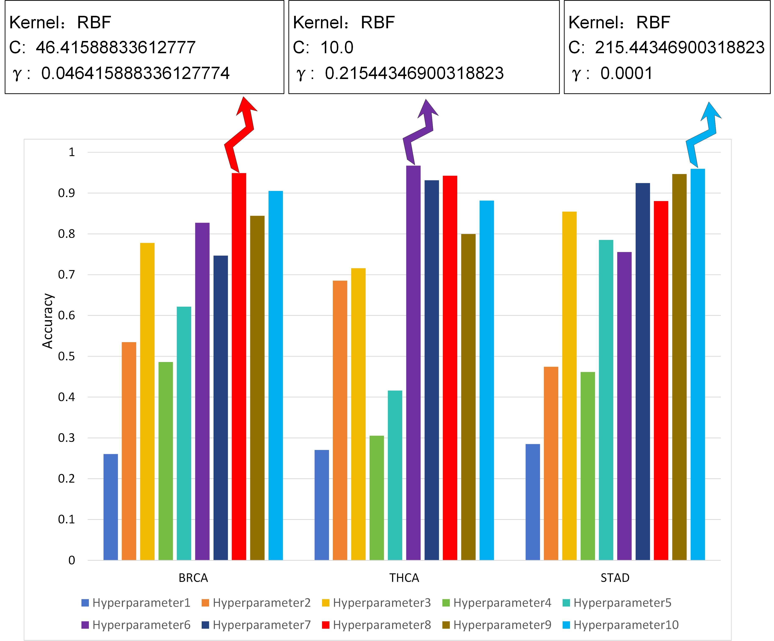
Figure S1: The parameter analysis and optimal parameter combinations for the three datasets within the OAO-MSVM model are presented.
Table S5: the hyperparameter combinations for different number
Hyperparameter | No.
C=0.1  γ=0.0001 | 1
C=0.1,  γ= 0.046415888336127774 | 2
C= 0.46415888336127786  γ=0.01 | 3
C= 2.1544346900318834  γ=0.0001 | 4
C=10  γ=0.0001 | 5
C=10  γ= 0.21544346900318823 | 6
C= 46.41588833612777  γ=0.0001 | 7
C= 46.41588833612777  γ= 0.046415888336127774 | 8
C= 215.44346900318823  γ= 0.0001 | 9
C= 215.44346900318823  γ= 0.00046415888336127773 | 10

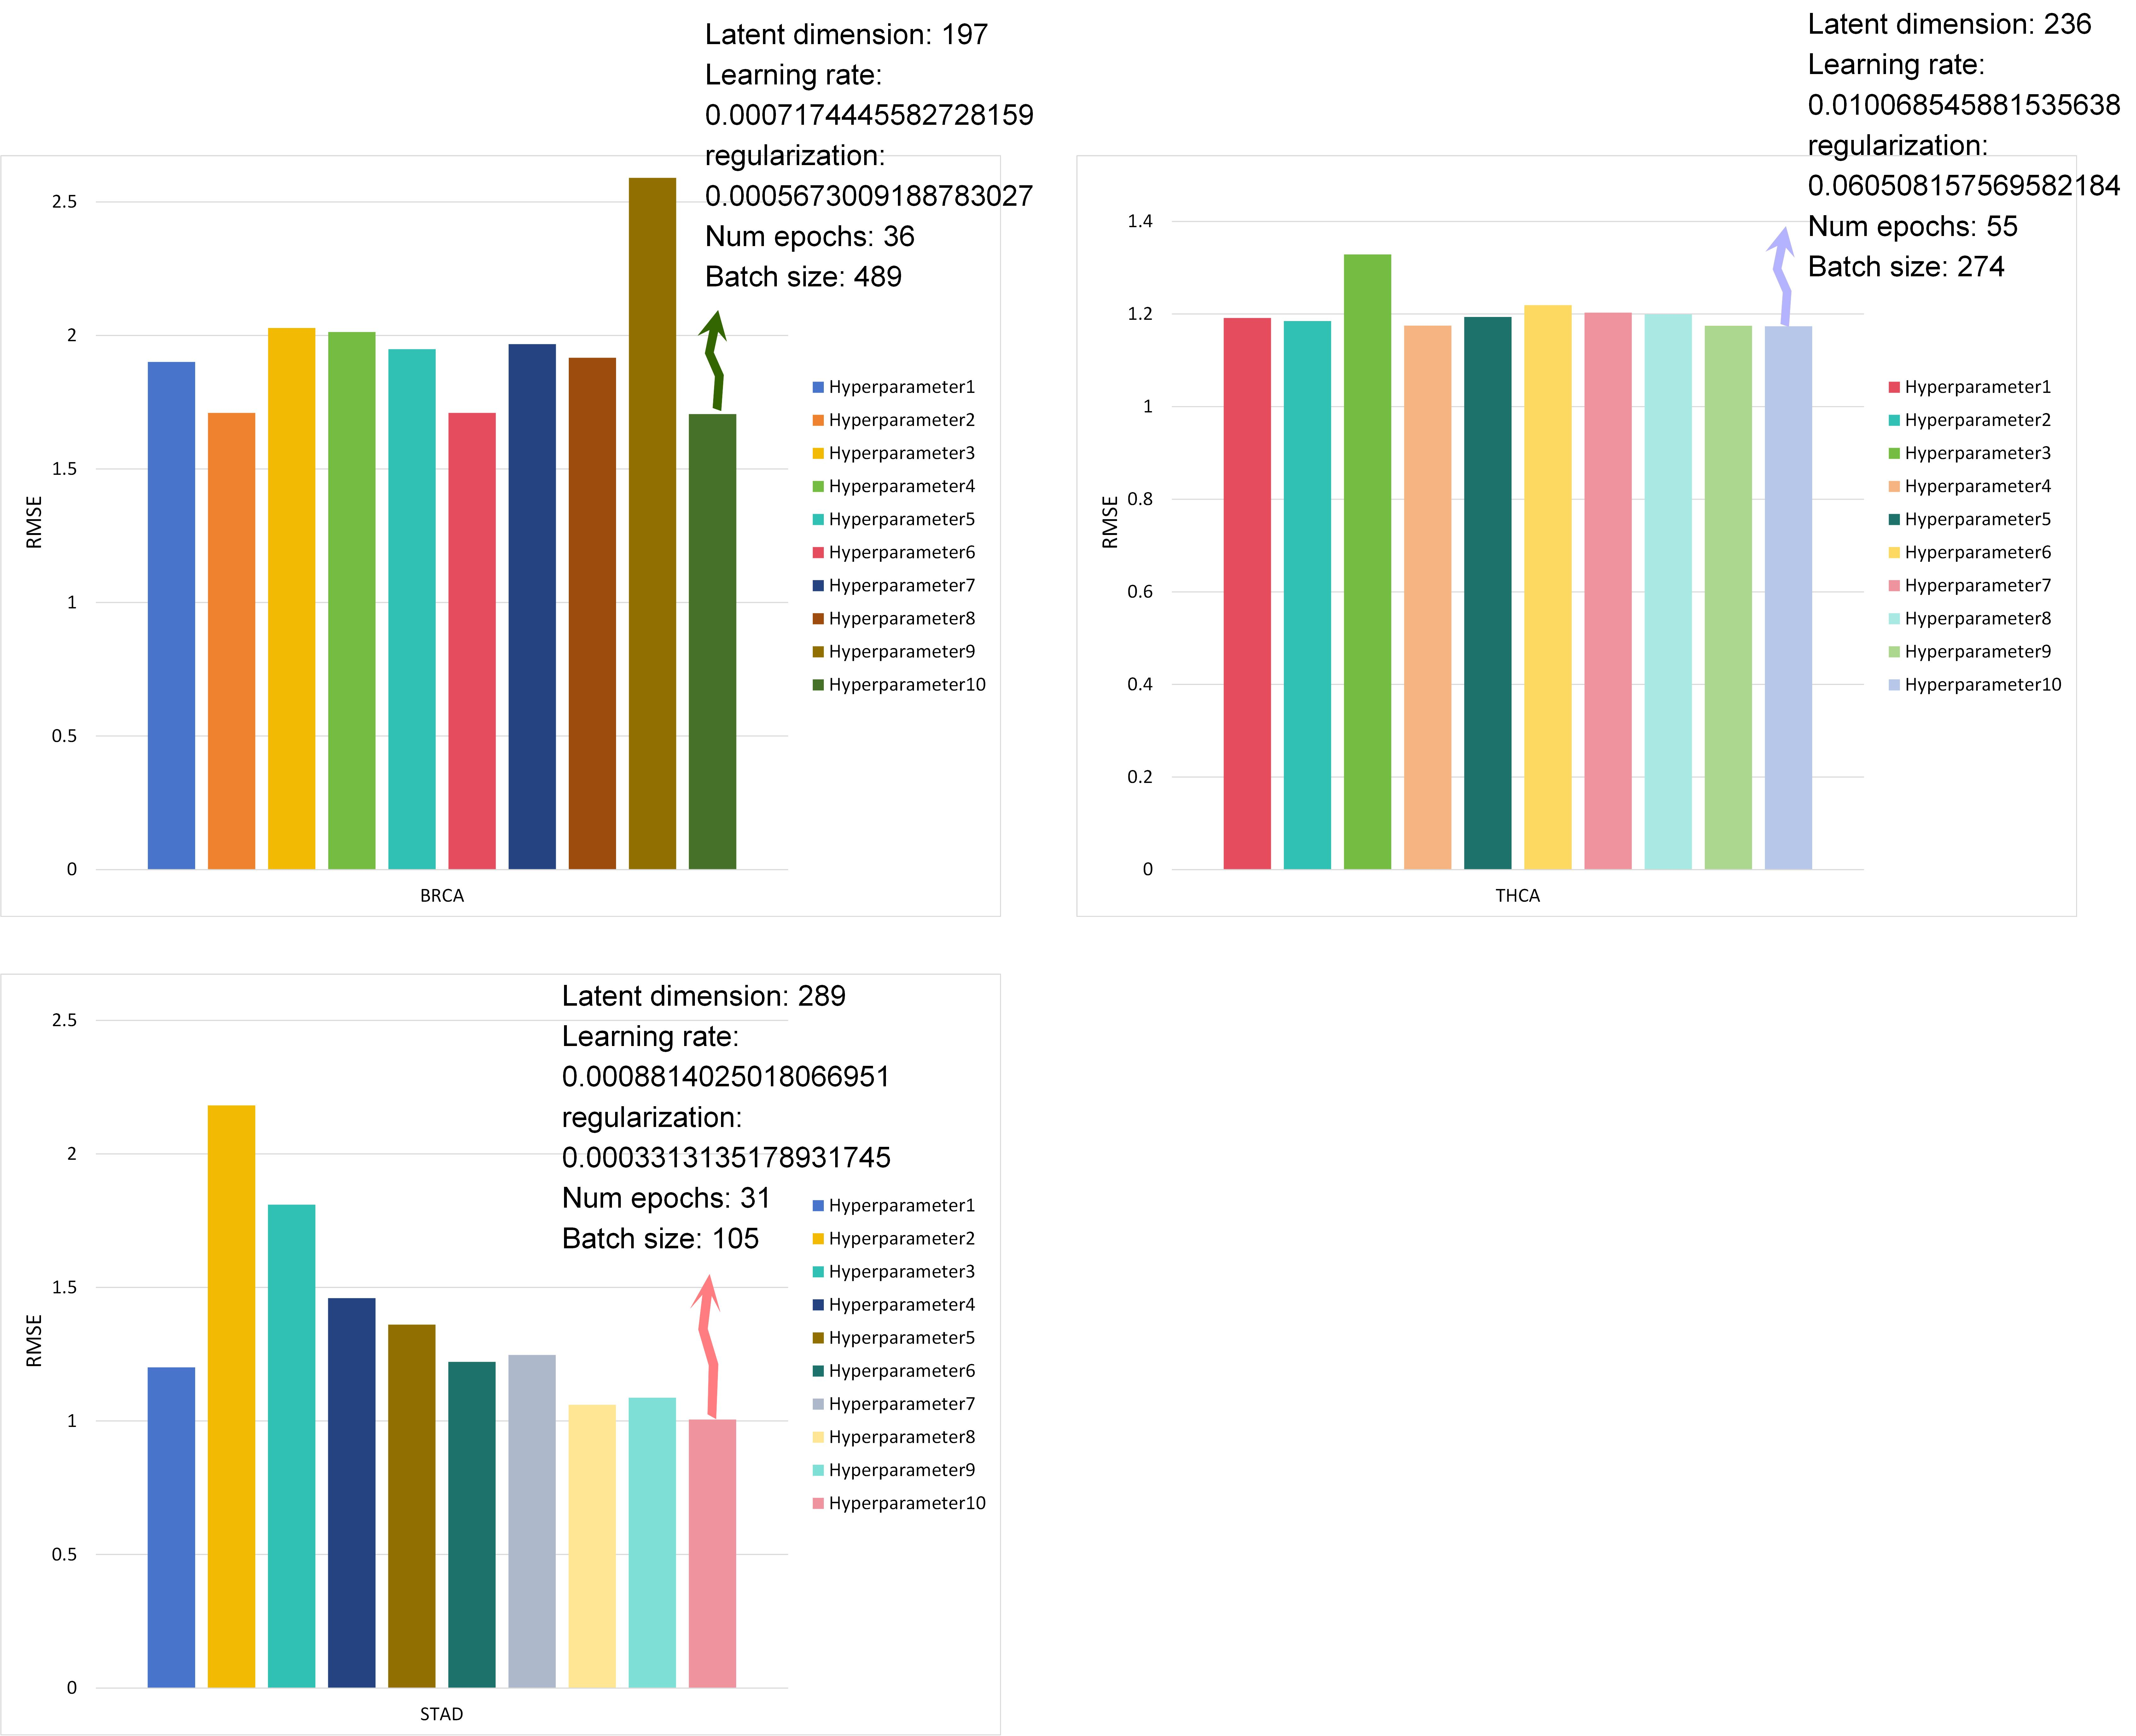
Figure S2: The parameter analysis and optimal parameter combinations for the three datasets within the BPR model are presented.
Table S6: the hyperparameter combinations for different number
Dataset: BRCA
Hyperparameter | No.
Latent dimension=251  Learning rate=0.0004048812625386594  Regularization parameter=0.04317341347469579  Number of epochs=13  Batch size=663 | 1
Latent dimension=65  Learning rate=0.0017155624980874262  Regularization parameter=0.017056609143336444  Number of epochs=88  Batch size=397 | 2
Latent dimension=322  Learning rate=0.0008273653845065252  Regularization parameter=0.0007462400563680572  Number of epochs=17  Batch size=821 | 3
Latent dimension=410  Learning rate=0.004678141589074288  Regularization parameter=0.0010815215991581777  Number of epochs=32  Batch size=586 | 4
Latent dimension=442  Learning rate=0.006876003529983497  Regularization parameter=0.011689448760269927  Number of epochs=73  Batch size=194 | 5
Latent dimension=256  Learning rate=0.0023903068310304892  Regularization parameter=0.00017250001420582718  Number of epochs=43  Batch size=499 | 6
Latent dimension=203  Learning rate=0.0003361352829584874  Regularization parameter=0.00010489613878689302  Number of epochs=27  Batch size=261 | 7
Latent dimension=304  Learning rate=0.04563430105282559  Regularization parameter=0.000766141283086815  Number of epochs=99  Batch size=441 | 8
Latent dimension=335  Learning rate=0.08300832984502034  Regularization parameter=0.03154590205880879  Number of epochs=61  Batch size=557 | 9
Latent dimension=197  Learning rate=0.0007174445582728159  Regularization parameter=0.0005673009188783027  Number of epochs=36  Batch size=489 | 10
Dataset: THCA
Hyperparameter | No.
Latent dimension=439  Learning rate=0.011059160944190318  Regularization parameter=0.010508157569582184  Number of epochs=38  Batch size=152 | 1
Latent dimension=189  Learning rate=0.017106404299835277  Regularization parameter=0.08146630155427868  Number of epochs=45  Batch size=193 | 2
Latent dimension=244  Learning rate=0.036192027009162075  Regularization parameter=0.001397111565421799  Number of epochs=98  Batch size=384 | 3
Latent dimension=158  Learning rate=0.004607596239453266  Regularization parameter=0.008214501252772054  Number of epochs=23  Batch size=720 | 4
Latent dimension=96  Learning rate=0.002943067765856888  Regularization parameter=0.0003162855524392583  Number of epochs=21  Batch size=459 | 5
Latent dimension=184  Learning rate=0.08290493786805585  Regularization parameter=0.09576646417130105  Number of epochs=39  Batch size=257 | 6
Latent dimension=263  Learning rate=0.0002394817930943659  Regularization parameter=0.0016178186688372105  Number of epochs=22  Batch size=575 | 7
Latent dimension=156  Learning rate=0.012949374794914283  Regularization parameter=0.07782026138900756  Number of epochs=45  Batch size=270 | 8
Latent dimension=157  Learning rate=0.02334808801824895  Regularization parameter=0.08805897880447441  Number of epochs=62  Batch size=149 | 9
Latent dimension=236  Learning rate=0.010068545881535638  Regularization parameter=0.060508157569582184  Number of epochs=55  Batch size=274 | 10
Dataset: STAD
Hyperparameter | No.
Latent dimension=240  Learning rate=0.0007959822908231067  Regularization parameter=0.00011200750438450581  Number of epochs=22  Batch size=115 | 1
Latent dimension=267  Learning rate=0.001212658340647363  Regularization parameter=0.020787691575985003  Number of epochs=63  Batch size=52 | 2
Latent dimension=85  Learning rate=0.0007525886657800259  Regularization parameter=0.011125117789816565  Number of epochs=93  Batch size=124 | 3
Latent dimension=207  Learning rate=0.023070497624913998  Regularization parameter=0.0003232905907584125  Number of epochs=75  Batch size=71 | 4
Latent dimension=162  Learning rate=0.0204046847657092  Regularization parameter=0.002684750522156966  Number of epochs=72  Batch size=185 | 5
Latent dimension=72  Learning rate=0.010068545881535638  Regularization parameter=0.010075129788756817  Number of epochs=41  Batch size=71 | 6
Latent dimension=175  Learning rate=0.002122341356652222  Regularization parameter=0.005078606229339158  Number of epochs=78  Batch size=273 | 7
Latent dimension=48  Learning rate=0.0002714744376172432  Regularization parameter=0.0014651486735279512  Number of epochs=32  Batch size=112 | 8
Latent dimension=300  Learning rate=0.00015003781181048732  Regularization parameter=0.08766473946298636  Number of epochs=40  Batch size=14 | 9
Latent dimension=289  Learning rate=0.0008814025018066951  Regularization parameter=0.0003313135178931745  Number of epochs=31  Batch size=105 | 10
3. Evaluation of the Accuracy of Identified Driver Genes
3.1 Evaluation of Personalized Driver Genes
To assess the overlap of the driver genes with known cancer genes, we calculated the average number of selected personalized driver genes that overlap with known driver genes listed in the Network of Cancer Genes (NCG) database[1] for each sample(see Figure S3 below).
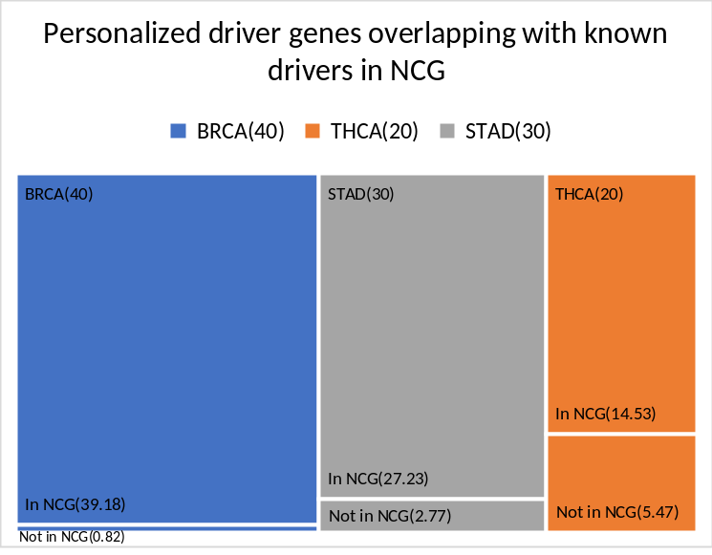
Figure S3. Personalized driver genes overlapping with known drivers in NCG
A high overlap is observed for BRCA (proportion = 39.18/40) and STAD (27.23/30), while THCA shows moderate overlap (14.53/20), indicating strong biological relevance in most cases. The results indicate that a substantial proportion of the identified genes overlap with known cancer-type-specific driver genes in the NCG database, with particularly prominent consistency observed in BRCA and STAD.
3.2 Evaluation of Global Driver Genes
To validate the global driver genes identified by the Condorcet aggregation method, we examined their overlap with known driver genes in the NCG database.
Table S7. Global driver genes overlapping with known NCG drivers
Dataset(global driver gene count) | BRCA(485) | THCA(1034) | STAD(697)
In NCG | 485 | 460 | 695
Not in NCG | 0 | 574 | 2
The majority of global driver genes identified by our model are covered by known NCG driver genes. These validation results suggest that both the sample-specific and global driver genes identified by DriverSub-SVM are enriched for with biologically relevant known cancer candidatesgenes, many of which are known recognized as drivers according to the in NCG database. This finding supports the reliability and interpretability of the feature selection process employed in our method.
4. Supplementary Section: Independent Validation and Parameter Selection Analysis
To address potential overfitting and information leakage due to reliance on cross-validation and parameter tuning, we performed additional experiments using a three-way data split (8:1:1) to provide independent validation and strictly separate parameter selection from model evaluation.
4.1. Independent Validation Performance
We partitioned each dataset into 80% training, 10% validation (for hyperparameter tuning), and 10% test (held out for final evaluation). The model was trained on the training set, tuned on the validation set, and evaluated on the independent test set. The results are presented in the following table:
Table S9: Model performance on independent validation and test sets across three cancer types.
Dataset | split | Accuracy | Precision | Recall | F1score | AUC | AUPR
BRCA | Training | 0.9858 | 0.9861 | 0.9857 | 0.9859 | 0.9994 | 0.9984
BRCA | Validation | 0.9223 | 0.9269 | 0.9260 | 0.9259 | 0.9958 | 0.9866
BRCA | Test | 0.9362 | 0.9344 | 0.9346 | 0.9343 | 0.9962 | 0.9842
THCA | Training | 0.9983 | 0.9979 | 0.9981 | 0.9980 | 1.0 | 1.0
THCA | Validation | 0.9767 | 0.9746 | 0.9760 | 0.9752 | 0.9982 | 0.9940
THCA | Test | 0.9688 | 0.9708 | 0.9654 | 0.9678 | 0.9973 | 0.9919
STAD | Training | 0.9908 | 0.9912 | 0.9908 | 0.9909 | 0.9999 | 0.9998
STAD | Validation | 0.9818 | 0.975 | 0.9807 | 0.9768 | 0.9995 | 0.9983
STAD | Test | 0.9630 | 0.9667 | 0.9583 | 0.9594 | 0.9990 | 0.9966
These results demonstrate strong performance and robustness of the proposed model on completely unseen data, providing further evidence for its generalization capability.
4.2. Number of Personalized Driver Genes: Parameter Selection without Leakage
To avoid any information leakage during the selection of the number of personalized driver genes, we relied solely on the validation set for parameter tuning and used the test set for final evaluation. The classification accuracy for different numbers of personalized driver genes on the test set is presented below:
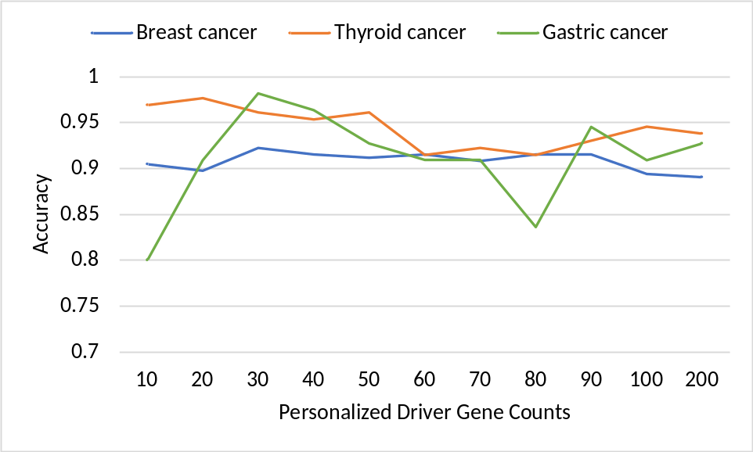
Figure S4: Impact of varying the number of personalized driver genes on cancer subtype classification accuracy.
These results confirm that parameter tuning was independent of evaluation, and illustrate the stable and effective performance of the model across various settings.
- Hyper geometric Test for Overlap Significance
To assess the statistical significance of the overlap between predicted subtypes and true subtype labels, we performed a hypergeometric test[2] for each subtype to calculate the corresponding p-value. The calculation is defined as follows:
$$\begin{aligned}p=P(X≥k)=\sum_{x=k}^{\min\left(K,n\right)}{\frac{\left({K \atop x}\right)\left({N-K \atop n-x}\right)}{\left({N \atop n}\right)}}\#\left(1\right)\end{aligned}$$
where 𝑁 is the total number of samples, 𝐾 the number of true samples in the subtype, 𝑛 the number of samples predicted as that subtype, and 𝑘 the number of correctly predicted samples belonging to it (i.e., the overlap). This test is conducted separately for each subtype based on the confusion matrix obtained from the classification experiment.
Table S10 presents the p-values corresponding to each subtype. The results indicate that all subtypes have p-values below 0.01, indicating that such overlaps are highly unlikely to occur under random prediction, thereby supporting the statistical reliability of the model in subtype classification.
Table S10: p-values from the hypergeometric test for overlap between predicted and true subtypes
DataSet | Subtype | P_value
BRCA | Normal | 6.96e-62
BRCA | LumA | 2.47e-35
BRCA | Her2 | 1.08e-55
BRCA | LumB | 3.14e-45
BRCA | Basal | 2.46e-56
THCA | Classical/usual | 4.81e-16
THCA | Follicular | 5.16e-23
THCA | Tall Cell | 6.41e-28
THCA | Other specify | 1.01e-27
STAD | GS | 8.14e-10
STAD | CIN | 2.75e-09
STAD | MSI | 4.74e-14
STAD | EBV | 1.15e-13
- Details of the Datasets
This section provides a detailed summary of the number of samples corresponding to each subtype across different cancer datasets. The table is intended to complement the brief description of dataset sizes in the main text, enabling readers to gain a clearer understanding of the sample distribution among subtypes and thereby supporting the rationale behind model training and classification results.
Table S11: details of the sample counts for each cancer subtype
DataSet | Subtype | Sample Count
BRCA | Normal | 40
BRCA | LumA | 565
BRCA | Her2 | 79
BRCA | LumB | 209
BRCA | Basal | 196
THCA | Classical/usual | 321
THCA | Follicular | 99
THCA | Tall Cell | 34
THCA | Other specify | 9
STAD | GS | 52
STAD | CIN | 136
STAD | MSI | 59
STAD | EBV | 25
- Evaluation Metrics
In our evaluation, we adopted the macro-level approach to ensure a fair and balanced assessment of the model's performance across all cancer subtypes. This method assigns equal weight to each subtype, which is crucial in imbalanced datasets where some subtypes have disproportionately small sample sizes. By using the macro approach, we prevent any single subtype from dominating the overall performance evaluation, ensuring a more equitable assessment. Specifically, the macro-average precision, recall, and F1 score are computed by first determining the precision, recall, and F1 score for each individual subtype. These values are then averaged arithmetically, without accounting for the size or frequency of each subtype. This method ensures that the performance metrics reflect the model's ability to classify all subtypes accurately, regardless of their sample sizes.
The formulas for these metrics are as follows:
$$\begin{aligned}Macro-Precision=\frac{\sum_{k=1}^{K}{{Precision}_{k}}}{K}\#\left(2\right)\end{aligned}$$
$$\begin{aligned}Macro-Recall=\frac{\sum_{k=1}^{K}{{Recall}_{k}}}{K}\#\left(3\right)\end{aligned}$$
$$\begin{aligned}Macro-F1score=\frac{\sum_{k=1}^{K}{{F1}_{k}}}{K}\#\left(4\right)\end{aligned}$$
Where K is the number of Subtypes, and ${Precision}_{k}$, ${Recall}_{k}$, and ${F1}_{k}$ are the precision, recall and F1 score for the $k$th subtype, respectively.

1. Dressler, L., et al., Comparative assessment of genes driving cancer and somatic evolution in non-cancer tissues: an update of the Network of Cancer Genes (NCG) resource. Genome biology, 2022. 23(1): p. 35.
2. Rivals, I., et al., Enrichment or depletion of a GO category within a class of genes: which test? Bioinformatics, 2007. 23(4): p. 401-407.

