Supplementary Materials
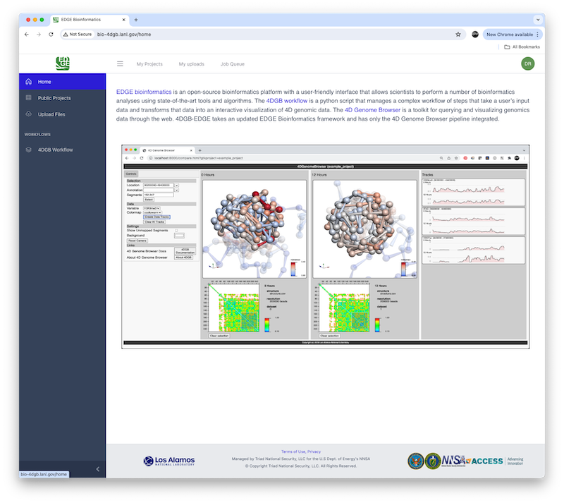
Figure S1: 4DGB on EDGE Screen capture of the 4DGB Edge home screen, showing a capture of the tool instructions and both side and top menus for access to web-based capabilities.
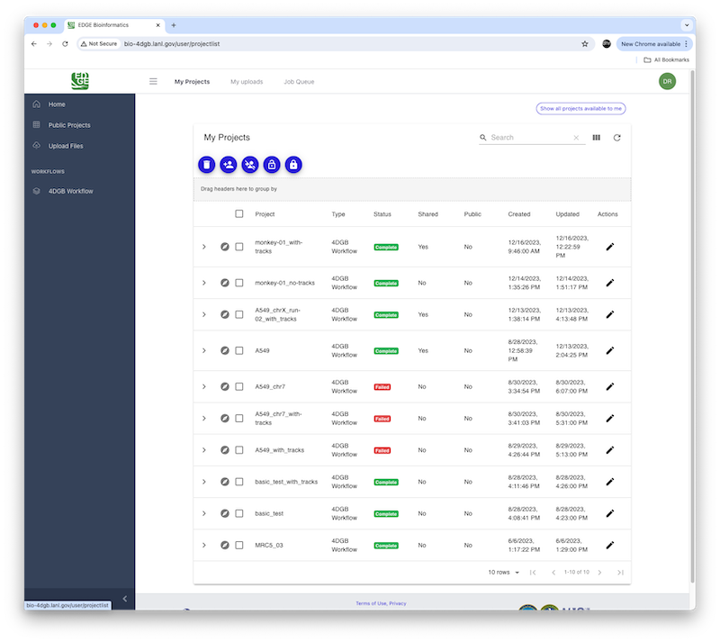
Figure S2: 4DGB on EDGE Screen capture of the 4DGB EDGE implementation, showing the list of existing jobs, which the user can navigate to view the final data products.

